Software Engineer

Department for Work and Pensions (DWP)

This pack provides information for you on the appointment of Software Engineerincluding details of how to apply.

It contains the following sections:

* A foreword from Chris Clark
* The Digital, Data and Technology Profession (DDaT)
* About the Department for Work and Pensions (DWP) and DWP Digital
* The Role
* Essential Criteria
* The Recruitment Process
* Application Instructions
* Indicative Timeline
* Frequently Asked Questions
* Annex A (Equal Opportunities Statement)

Thank you for your interest in our Software Engineer role.

This is an exciting time to join DWP Digital. We are transforming the way DWP delivers our services to meet the evolving needs of society and our workforce of 86,000. The Software Engineer role sits right at the heart of that transformation.

This role presents an exciting opportunity to work with Digital leaders within the department and across government as part of the 17,000 strong DDaT profession. As a Software Engineer you will develop and maintain software products that make up citizen services and contribute towards their design.

We are looking for a strong, talented individual to drive work to develop and implement our Digital Capability Strategy.

You will bring your experience of leading and delivering in digitally enabled transformation programmes. You will be a trusted advisor to senior officials, helping them make informed strategic choices in how they deliver their programmes.

This is a big challenge, but also a big opportunity. You will get the chance to work on one of the biggest, most ambitious Digital transformation programmes in the UK.

You will have the chance to use and stretch your abilities, strengthen your experience and continue your professional development in a supportive environment. You will work alongside people who care passionately about public service, making a difference and delivering for our customers.

If you have the skills and experience we are looking for then I hope you’ll decide to be part of our team.



This is an unprecedented time for digital, data and technology specialists as government harnesses digital technologies, skills and tools to [transform public services](https://www.gov.uk/government/news/the-future-of-public-service-government-transformation-strategy-launched) on a global scale.

There have never been more opportunities to work collectively and creatively as a profession to respond to the changing needs and expectations of millions of people, and deliver services that are simple and easy to use. The digital, data and technology profession comprises 17,000 digital, data and technology colleagues across government, and is rapidly scaling up nationwide in line with our strategy.

The UK is recognised as a world leader in digital government; it ranks at the top of the United Nations’ e-government index and countries like the US, Canada, Australia and New Zealand are modelling their digital transformation on ours.

In your capacity of Software Engineer at DWP you will join a network of digital, data and technology leaders that has developed into an avaessential forum for co-ordinating and driving transformation across government.

With your senior colleagues from other departments you will set standards and maintain a shared vision to deliver transformation. You’ll share best practice and drive collective efficiencies wherever possible; support and guide our cross government programmes to build digital, data and capability and make government a destination of choice for digital, data and technology professionals.

And you’ll be a role model and a relentless champion of government as a place where everyone can thrive and where diversity can flourish; a place that reflects the public we serve.

The potential to shape our society’s future is enormous and our purpose is to ensure the profession is equipped and inspired to deliver real, meaningful change for users; to do the work of transformation that makes government work better for everyone.

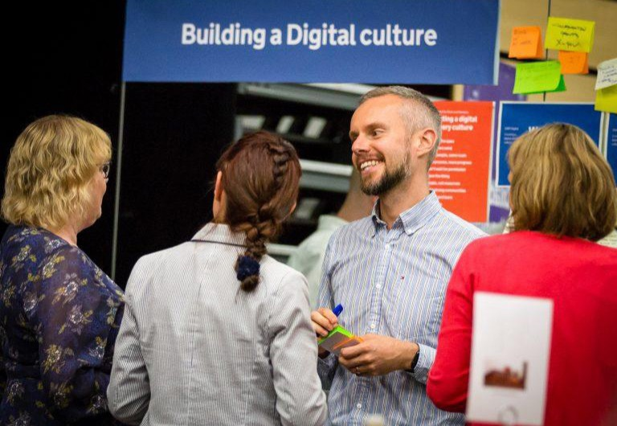

**Background to the DWP**

Often working in partnership with the private and voluntary sector, the Department of Work and Pensions (DWP) provides services and support to over 20 million people and is responsible for over 730 million benefit payments each year totalling £67 billion. At the same time, it is engaged in delivering a once in a generation programme of welfare reform to:

* tackle poverty and welfare dependency through a simplified welfare system that encourages people to find work, rewards responsible behaviour and protects the most vulnerable;
* promote high levels of employment by helping people who are out of work, including people in disadvantaged groups move into work;
* help people meet the challenges of an ageing society and maintain standards of living in retirement;
* provide opportunity, choice and independence to help disabled people to take an equal role in society.

For further information, please go to

[www.gov.uk/government/organisations/department-for-work-pensions](http://www.gov.uk/government/organisations/department-for-work-pensions).

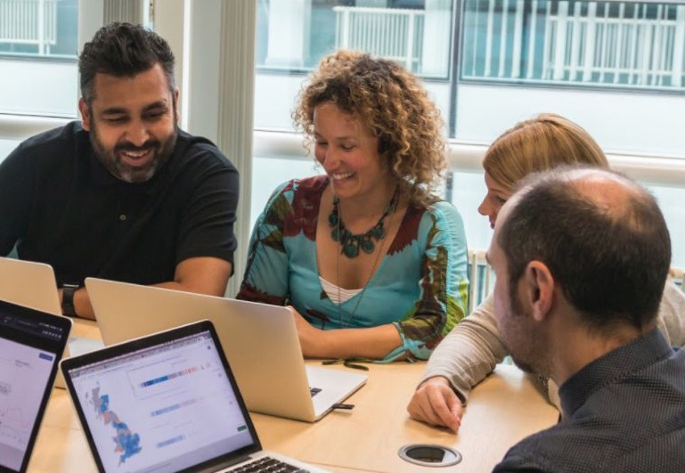

Everything we do in DWP Digital (known as ‘Digital Group’ internally) is driven by user needs – whether our 86,000 colleagues or 20 million customers. Our products enable delivery of support which helps millions of people, such as Universal Credit, Personal Independence Payment and New State Pension. Internally, we’re modernising one of Europe’s biggest IT estates across 800 locations, and creating a ‘digital workplace’ to help colleagues connect and collaborate.

We pioneer innovative use of data to drive business intelligence and automation, and share 10 million data records every day across government and with other partners. Our security team plays a vital role in protecting DWP’s customers, colleagues, data and systems from daily cyber-attacks.

We’re transforming public services on which millions rely at pace, driving continuous progress through fortnightly releases, and designing next-generation systems which can accommodate policy changes across successive parliaments.

We’re reducing reliance on big suppliers, designing and delivering more digital products ourselves, and - where we continue to outsource our work - working with a much wider range of innovative commercial partners.

Central to this transformation is a focus on culture and capability. Alongside developing the skills of our existing colleagues, we’re recruiting hundreds of specialists who are the very best in their fields. We value collaboration and creativity as much as technical capability. We’re building an organisation where colleagues are empowered to deliver.

Our leaders inspire DWP Digital to be the best at what we do: an innovative, outward-looking digital organisation which where people love what they do and are proud to make a positive difference to millions of people’s lives.

To find out more about our work and the people who deliver it, please:

* Follow @DWPDigital
* [read our regular blogs](https://dwpdigital.blog.gov.uk/)
* Check our Microsite <http://careers.dwp.gov.uk/>
* and our LinkedIn updates <https://www.linkedin.com/company/dwp/careers>

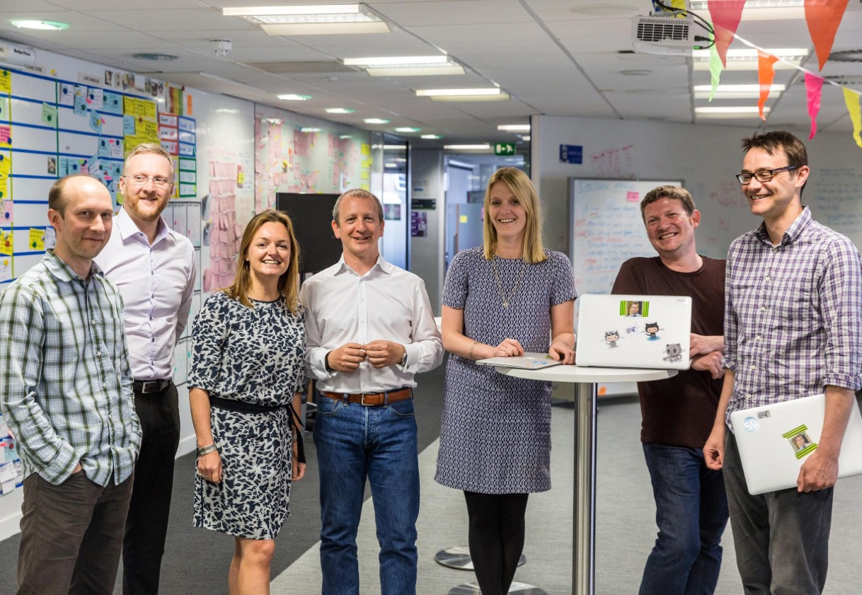

The location for this role is **Leeds.**

We’re looking for outstanding Software Engineers, who want to contribute to demanding and exciting digital services for the UK Government. Be part of creating Government digital services that will change the face of public services and have the potential to dramatically transform the future of millions of people.

Our Engineers to build and run applications as part of a multi-functional agile delivery teams. What really excites the successful candidate is problem-solving and the opportunity to deliver innovative technology that carries real value for users. The candidate will be expected to draw value from collaboration with others, actively seek input from colleagues and value a multidisciplinary team over hierarchy.

Software Engineers build, develop and maintain products that make up the DWPs digital services and contribute towards their design.

You will be responsible for the operational stability of the products you build, and are in a position to affect change in the on-going robustness and resilience of those products.

You will also work within, and contribute to, the overall Software Development Lifecycle Process as part of a multi-functional Agile delivery teams focused on one or more products.

**Responsibilities**

The roles and responsibilities for this job include, but are not restricted to the following:

* Deliver software products which make up services for our citizens to consume.
* Ensure system robustness, resilience and stability.
* Design and develop reusable libraries and services and promote reuse across the department.
* Assure there is a fit for purpose, robust automated test suite.
* Assist in the development of medium-long term strategies for products.
* Identify and resolve issues preventing delivery or continuation of software engineering activities.
* Collaborate across teams and liaise with Principal Software Engineers and Technical Architects to investigate technical solutions.
* Provide 3rd line support on products developed, including out of hours support as and when required.
* Contribute to community discussions about best practice within Software Engineering.
* Provide coaching and mentoring to Software Engineer colleagues and peers.



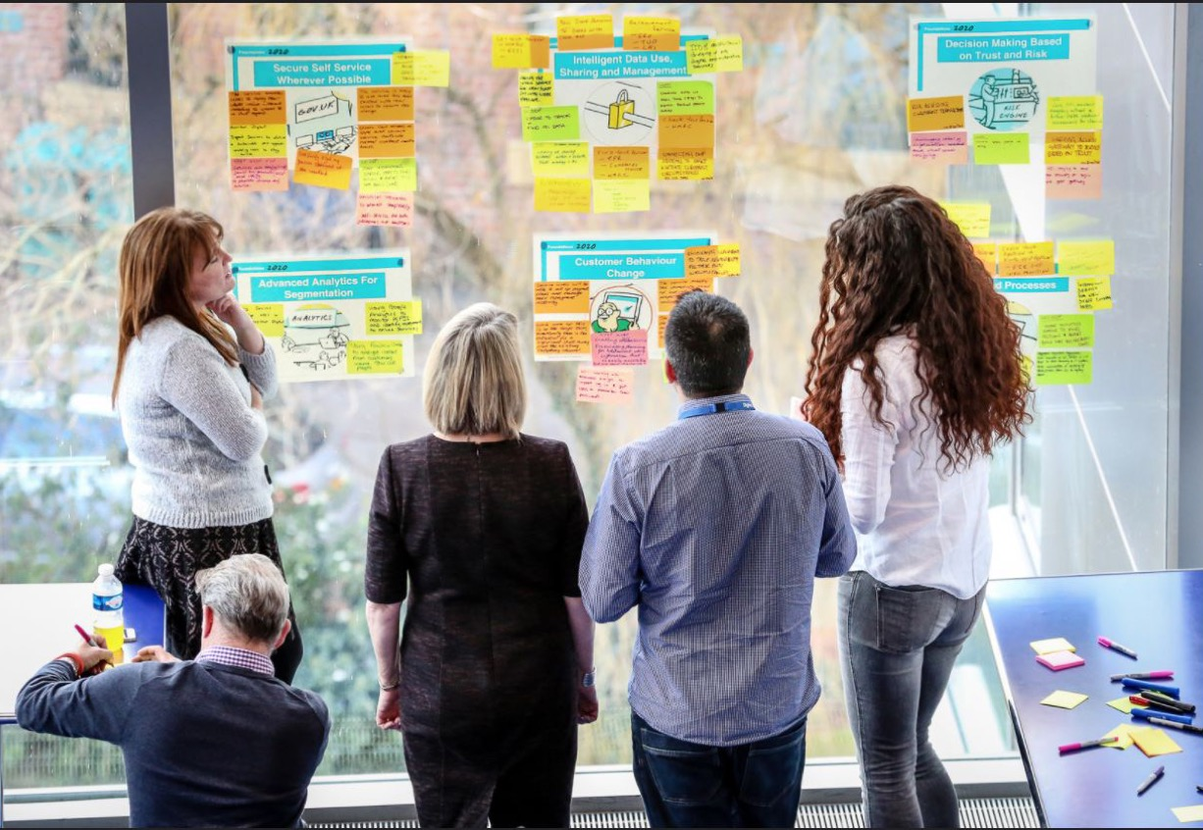The ideal candidate will be able to demonstrate the essential criteria listed below:

* Open source technologies like Java, JavaScript, Node.js.
* Developing on cloud based environments like AWS and Azure.
* Have a good understanding of TDD and BDD.
* SQL and noSQL database applications such as Postgres, MySQL, and MongoDB.
* Distributed version control systems such as Git.
* Containerisation – tools such as Docker and Kubernetes.
* Have the skills to build up a useful, robust automated test suite to support a continuous deployment environment.
* Have working knowledge of Unix-like operating systems such as Linux and/or Mac OS X.
* Knowledge and experience of APIs, RESTful services and Microservice Architectures.

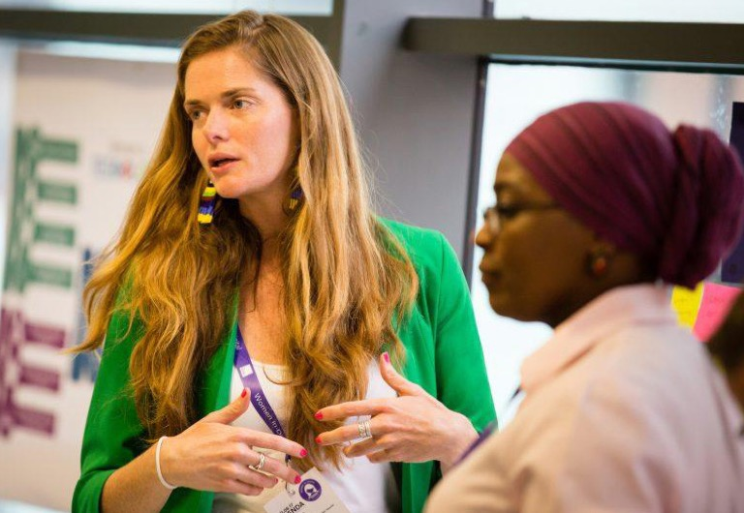

**Guaranteed Interview Scheme**

DWP is committed to the employment and career development of disabled people and will guarantee to interview anyone with a disability whose application meets the minimum criteria for the post.

**The selection process**

The role is being completed in accordance with the Civil Service Recruitment Principles. The selection process will be overseen by the Civil Service Commission through principles of merit and fair and open competition, as outlined in its recruitment principles.

**Sift and Interview dates and locations**

Applications will be sifted and interviews held at regular intervals from the date the posts are advertised, so please apply as soon as you can, do not wait until the end of the campaign.

Interviews to be conducted at our Leeds Hub.

**Stage 1:** The information you provide on your application form will be used to assess you against the essential criteria listed in the advert.

The sift panel will use the information relating to your employment history (your CV) and your personal statement to assess your experience, skills and knowledge.

When giving details of your employment history, you should therefore include details of the work and projects that you have been involved in, and your role therein.

**Applications must include:**

A. A completed Personal Details application form.

B. A curriculum vitae* with education and full employment history, giving details of key achievements relevant to the skills and experience outlined in this job description.

C. A personal statement outlining how you meet the essential criteria as detailed in the job advert (if applicable)

**A NOTE ON ANONYMISATION**

*Due to DWP’s use of anonymised recruitment practices it is not possible for applicants to upload/attach a CV; any information that you would customarily share on a CV should therefore be entered onto the application form. Please ensure you provide sufficient information to enable to sift panel to make an informed judgement about your suitability for this role.

**IMPORTANT INFORMATION**

Please include all other information that you would customarily provide when presenting a CV/cover letter, as the sift panel use this information to assess your application.

DWP operates an anonymised recruitment process. When entering information relating to your employment history you will be asked to remove any personal details that could be used to identify you. This relates to name and contact details which might usually appear on your CV/Cover letter.

Failure to do so will result in your application being withdrawn.

**Stage 2:** If successful at Sift you will be sent a technical test to complete and submit within a given deadline. This will be graded and successful candidates invited to interview.

**Stage 3:** The final stage of the process will be a face to face blended interview where you will be assessed against the Behaviours and Technical Skills detailed in the advert.

Only candidates that have been successful at the previous stage will be invited to attend.

If at any time through the selection process, you do not meet the minimum standard required for this role we may contact you to discuss an alternative position.

**Behaviours:**

Changing and Improving

Work with others to identify areas for improvement and simplify processes to use fewer resources. Use technology where possible to increase efficiency. Encourage ideas for change from a wide range of sources. Clearly explain the reasons for change to colleagues and how to implement them, supporting individuals with different needs to adapt to change. Encourage an environment where colleagues know that they can challenge decisions and issues safely. Take managed risks by fully considering the varied impacts changes could have on the diverse range of end users. (Level 3).

**Technical Skills:**

Programming and Build

Collaborates with others when necessary to review specifications and uses these agreed standards and tools to design, code, test, correct and document programmes or scripts of medium to high complexity, using the right standards and tools. (Level 3).

Systems Design

Translates logical designs into physical designs. Produces detailed designs and documents all work using required standards, methods and tools, including prototyping tools where appropriate. Designs systems characterised by managed levels of risk, manageable business and technical complexity and meaningful impact. Works with well-understood technology and identifies appropriate patterns. (Level 2).

Systems Integration

Able to build and test simple interfaces, or can work on more complex integration as part of a wider team. (Level 2).

Modern Standards Approach

Understands key principles of modern standards approach and how they apply to the work they are undertaking and will apply under guidance. (Level 2).



The final selection panel interview will be held in **Leeds.** You will be advised of the format in advance.

We may hold a reserve list for up to 6 months.

**Complaints**

DWP’s recruitment processes are underpinned by the principle of selection for appointment on merit on the basis of fair and open competition as outlined in the Civil Service Commissioners’ Recruitment Principles details of which can be found [here](http://civilservicecommission.independent.gov.uk/).

If you feel your application has not been treated in accordance with the Principles and you wish to make a complaint, in the first instance you should contact:

Angelo Reinoso

[Angelo.reinoso@dwp.gov.uk](mailto:Angelo.reinoso@dwp.gov.uk)

If you are not satisfied with the response you receive you can contact the Office of the Civil Service Commissioners.

**Please note:**

**Expenses incurred by candidates during the recruitment process will not be reimbursed by the DWP except in exceptional circumstances and only when agreed in advance with the Hiring Manager.**

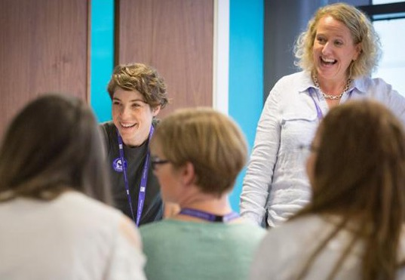Please include:

* Your CV with education and full employment history, giving details of key achievements relevant to the skills and experience outlined in this job description.
* A Personal Statement describing how you best meet the Job description and Essential criteria required for the role;
* A completed diversity questionnaire; and
* A completed Guaranteed Interview Scheme form (if applicable).

**Please note that at your interview, you will be required to provide proof of identity and, where necessary, permission to work as required by the government.**

Please note that the dates below are only indicative at this stage and could be subject to change. Please let us know in your application if you are unable to meet these timeframes.

The anticipated timetable is as follows:

|  |  |
| --- | --- |
| Closing Date | Please refer to Advert. |
| Sift Meeting | 48 hours after closing date. |
| Assessment Exercises | To be issued on an on-going basis with deadline provided. |
| Final Panel Interviews | Interviews will take place on an ongoing basis |

Candidates are asked to note the above timetable, exercising flexibility through the recruitment and selection process.

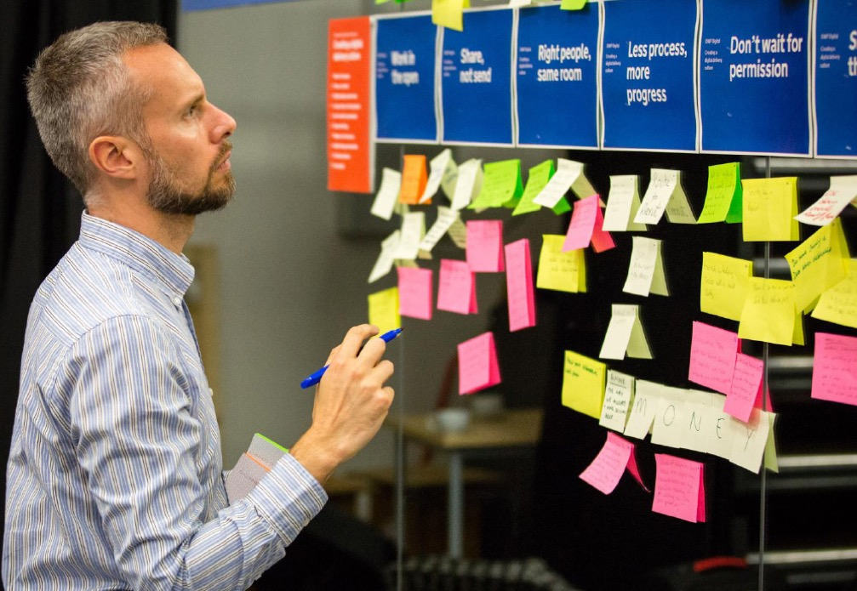

**Working Hours:** New entrants to the Civil Service and existing Civil Servants appointed on promotion - basic hours of work will be 37 hours per week, excluding lunch breaks.

Existing civil servants appointed on level transfer, your current contractual entitlements in relation to basic hours of work will continue to apply.

**Salary:** the salary for this role is up to £39,674 with an additional Digital Allowance of up to £6,330. Flexible starting pay up to this amount may apply to these roles.

In all cases any additional allowance is non-pensionable. The requirement to continue paying an additional allowance and the amount payable is subject to review at least annually.

**Tax-Free Childcare Scheme:** More information including eligibility can be found at:

<https://www.gov.uk/>

**Pension:** Entitled to membership of a Civil Service Pension Scheme. More information can be found at:

<http://www.civilservicepensionscheme.org.uk/>

**Please note:** If you previously worked for an employer who participated in the Civil Service Pension Scheme, different conditions may apply, as may your benefits if you left the Civil Service with an early retirement, severance, or redundancy package.

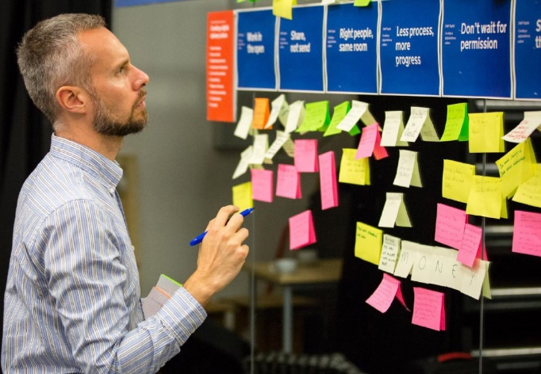

Abatement of pension may apply if you are in receipt of a public service pension. In addition, civil servants who have been granted early retirement (under the terms of the Compulsory Early Retirement, Compulsory Early Severance, Flexible Early Retirement or Flexible Early Severance schemes) may be required to repay all or part of their lump sum compensation payments if their re-employment commences during the period represented by the compensation payment.

**Annual leave:** New entrants to the Civil Service will be entitled to an annual leave allowance of 25 days in the first year.  This will increase to 30 days after 10 years.  In addition to this you are entitled to 8 public/bank holidays plus an additional day for the Queen’s Birthday.

**Nationality:** This post is open to UK Nationals, British Nationals Overseas, British Protected Persons, Commonwealth Citizens, EEA Nationals of other member states and certain non EEA family members and Swiss Nationals under the Swiss EU Agreement.

**Civil Service Code:** The Civil Service Code sets out the constitutional framework within which all civil servants work and the values they are expected to uphold.



**Pre-employment checks:** The responsibilities of the Department mean that we set very high standards for our staff. Honesty and integrity are essential and form part of the core values of the Civil Service.

We will always carefully check the suitability of new employees for employment at the DWP and are not tolerant of dishonest behaviour. We do not condone criminal activity in any way.

However, within these constraints, we recognise the contribution that ex-offenders can make to a workforce. Our aim is to ensure that potentially suitable candidates for employment are not automatically ruled out from employment with the DWP.

As such, having a criminal record will not automatically bar an individual from working with us.

**Security Clearance:** The successful candidate will be required to obtain security clearance (SC) level clearance before taking up post. Further information on what this involves can be obtained by contacting the SCS Recruitment team. Please note that individuals should normally have been resident in the UK for 5 years preceding their application for SC clearance.

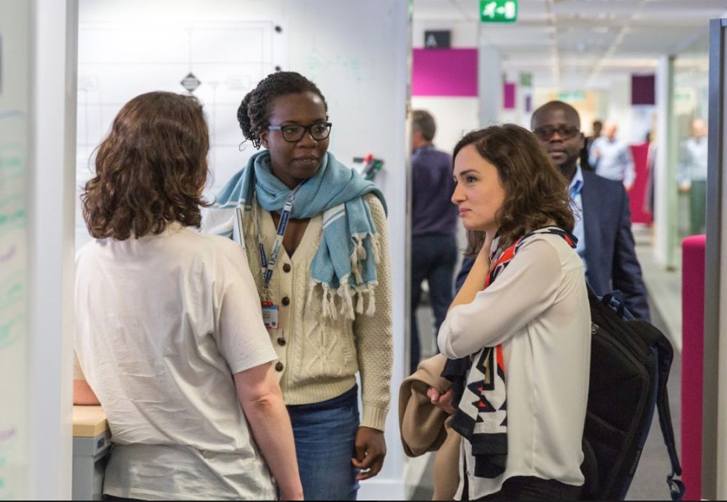

The DWP is committed to a policy of equal opportunity for all staff. We will not discriminate on grounds of gender, gender identity, race, disability, sexual orientation, religion or belief, age, those with caring responsibilities, part time workers or any other factor irrelevant to a person’s work.

We encourage a diverse workforce and aim to provide a working environment where all staff at all levels are valued and respected, and where discrimination, bullying, promotion of negative stereotyping and harassment are not tolerated.

Assessment for recruitment, selection, appraisal, training and career progression purposes is based both on the individual’s ability and suitability for the work.

We are committed to providing all staff with opportunities to maximise their skills and achieve their potential, offering flexible working arrangements wherever possible.

As a public authority the DWP has statutory duties placed on it that require it to promote equality of opportunity and eliminate unlawful discrimination. We expect all staff to assist the department in meeting these obligations. All staff should have due regard for the need to promote good relations between individuals from different groups and work towards achieving equality of opportunity for all.

The DWP has concluded that membership of any group or organisation that promotes hatred in its philosophy, aims, principles or policies based on gender, gender identity, race, disability, sexual orientation, religion or belief is incompatible with the work and values of the DWP.

# Contact us

If you would like to discuss the role in more detail, or have any questions, please contact

[PETER.SWEENEY1@DWP.GSI.GOV.UK](mailto:PETER.SWEENEY1@DWP.GSI.GOV.UK)