# Verification of Identity

|  |
| --- |
| **Important Notices:**   * **In order for us to verify your identity, you must produce certain documents at your interview as evidence of your eligibility to apply for this vacancy and allow GRS to conduct pre-employment checks.** * **If you do not produce the correct documents at interview this may delay your application or possibly lead to your application being rejected.** |

**This document is to help you decide which documents are the most appropriate for you to use as evidence.**

**It is split into 3 sections (A, B and C) and only one of these will apply to you.**

**Please refer to the *GRS – Identity Verification* *Routes* flowchart (below) to help you choose the correct section.**

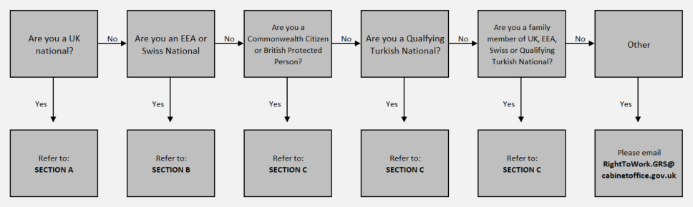

**Now please move on to Section A, B or C.**

|  |
| --- |
| **SECTION A** |
| **We have divided the documentation you can provide as evidence into 3 different groups. You must produce the following at your interview:**   * **1 x document from Group 1** * **1 x document from Group 2** * **1 x additional document from Group 1, 2 or 3**   **Only original documents will be accepted, photocopies and printed online documents (e.g. bank statement, e-bills, online P60 etc) will not be accepted.** |

|  |
| --- |
| **Important Notices:**   * **Candidates applying for a Home Office post must also produce a valid current passport.** * **Documents marked with an * in Group 2 must be dated within the last 3 months and clearly show your current address.** * **Full and short birth certificates are not permitted to be used in conjunction with each other.** * **Candidates who have had a legal name change and ID documents provided are in previous names, you will need to provide supporting evidence (i.e Marriage certificate, Deed Poll document)** |

|  |  |  |  |  |
| --- | --- | --- | --- | --- |
| **Group 1** |  | **Group 2** |  | **Group 3** |
| **Current British Passport** |  | **\* Bank, building society or credit card statement.**  UK, Channel Islands or EEA only. |  | **Current photo card driving licence.** Full or provisional.  UK, Isle of Man, Channel Islands and EU only. |
| **Full UK Birth or Adoption Certificate** The certificate must include the name(s) of at least one of your parents or adoptive parents. |  | **\* Original utility bill** Gas, Water, Electric, Insurance or Internet provider issued within the last 3 months. UK only. Mobile Phone bills and Motor Insurance documents are not acceptable. |  | **Current driving licence (old paper version).** UK, Isle of Man, Channel Islands and EU only. |
| **Certificates of Registration or Naturalisation as a British Citizen** |  | **Original letter confirming National Insurance Number (NINO) issued by Government Department (dated within the last three months)** P45, P60 (must be dated within the last 12 months and contain current address)  UK only. |  | **Marriage certificate** UK and Channel Islands only. |
|  |  | **\* Current evidence of entitlement to DWP benefits (e.g. Universal Credit)**  UK only but NINO must be shown. |  | **Civil Partnership certificate**  UK and Channel Islands only. |
|  |  | **Council Tax statement for the current year**  UK only. |  | **HM Forces identity card**  UK only. |
|  |  | **Mortgage Statement** UK or EEA only. |  | **Short UK Birth Certificate** |

|  |
| --- |
| **Photographic ID**  If you are unable to provide one piece of photographic ID from the groups above then you will need to provide a passport sized photograph of yourself. This will need to be endorsed on the back with the signature of a person of some standing in your community (e.g. a Justice of the Peace (JP), medical practitioner, officer of the armed forces, teacher, lecturer, lawyer, bank manager, civil servant, etc).  The passport photograph will need to be accompanied by a signed statement, completed by the same person, stating the period of time that the individual has known you (this must be a minimum 3 years). The statement must also contain the name, address and contact number of the individual who has endorsed the photo and completed the statement. |

|  |
| --- |
| **SECTION B** |
| **We have divided the documentation you can provide as evidence into 3 different groups. You must produce the following at your interview:**   * **1 x document from Group 1** * **1 x document from Group 2** * **1 x additional document from Group 1, 2 or 3**   **Only original documents will be accepted, photocopies and printed online documents (e.g. bank statement, e-bills, online P60 etc) will not be accepted.** |
| **Important Notices:**   * **Candidates applying for a Home Office post must also produce a valid current passport** * **Documents marked with an * in Group 2 must be dated within the last 3 months and clearly show your current address.** * **Candidates who have had a legal name change and ID documents provided are in previous names, you will need to provide supporting evidence (i.e Marriage certificate, Deed Poll document)** |

|  |  |  |  |  |
| --- | --- | --- | --- | --- |
| **Group 1** |  | **Group 2** |  | **Group 3** |
| **Current EEA or Swiss Passport** |  | **\* Bank, building society or credit card statement.**  UK, Channel Islands or EEA only. |  | **Current photo card driving licence.** Full or provisional.  UK, Isle of Man, Channel Islands and EU only. |
| **Registration Certificate or Document Certifying Permanent Residence issued by Home Office** |  | **\* Original utility bill** Gas, Water, Electric, Insurance or Internet provider issued within the last 3 months. UK only. Mobile Phone bills and Motor Insurance documents are not acceptable. |  | **Current driving licence (old paper version).** UK, Isle of Man, Channel Islands and EU only. |
|  |  | **Original letter confirming National Insurance Number (NINO) issued by Government Department (dated within the last three months)** P45, P60 (must be dated within the last 12 months and contain current address)  UK only. |  | **Marriage certificate** UK and Channel Islands only. |
|  |  | **\* Current evidence of entitlement to DWP benefits (e.g. Universal Credit)**  UK only. |  | **Civil Partnership certificate**  UK and Channel Islands only. |
|  |  | **Council Tax statement for the current year**  UK only. |  | **HM Forces identity card**  UK only. |
|  |  | **Mortgage Statement** UK or EEA only. |  | **EU National Identity Card**  Must still be valid. |

|  |
| --- |
| **Photographic ID**  If you are unable to provide one piece of photographic ID from the groups above then you will need to provide a passport sized photograph of yourself. This will need to be endorsed on the back with the signature of a person of some standing in your community (e.g. a Justice of the Peace (JP), medical practitioner, officer of the armed forces, teacher, lecturer, lawyer, bank manager, civil servant, etc).  The passport photograph will need to be accompanied by a signed statement, completed by the same person, stating the period of time that the individual has known you (this must be a minimum 3 years). The statement must also contain the name, address and contact number of the individual who has endorsed the photo and completed the statement. |

|  |
| --- |
| **SECTION C** |
| **We have divided the documentation you can provide as evidence into 3 different groups. You must produce the following at your interview:**   * **1 x document from Group 1** * **1 x document from Group 2** * **1 x additional document from Group 1, 2 or 3**   **Only original documents will be accepted, photocopies and printed online documents (e.g. bank statement, e-bills, online P60 etc) will not be accepted.** |

|  |
| --- |
| **Important Notices:**   * **Candidates applying for a Home Office post must also produce a valid current passportand must have no time restrictions upon their right to remain in the UK.** * **Visa details must be provided to accompany Group 1 documents.** * **Documents marked with an * in Group 2 must be dated within the last 3 months and clearly show your current address.** * **Candidates who have had a legal name change and ID documents provided are in previous names, you will need to provide supporting evidence (i.e Marriage certificate, Deed Poll document)** |

|  |  |  |  |  |
| --- | --- | --- | --- | --- |
| **Group 1** |  | **Group 2** |  | **Group 3** |
| **Current Passport from country of nationality** Including visa vignette if you do not have a biometric residence permit card |  | **\* Bank, building society or credit card statement.**  UK, Channel Islands or EEA only. |  | **Current photo card driving licence.** Full or provisional.  UK, Isle of Man, Channel Islands and EU only. |
| **Biometric Residence Permit Card** |  | **\* Original utility bill** Gas, Water, Electric, Insurance or Internet provider issued within the last 3 months. UK only. Mobile Phone bills and Motor Insurance documents are not acceptable. |  | **Current driving licence (old paper version).** UK, Isle of Man, Channel Islands and EU only. |
|  |  | **Original letter confirming National Insurance Number (NINO) issued by Government Department (dated within the last three months)** P45, P60 (must be dated within the last 12 months and contain current address)  UK only. |  | **Marriage certificate** UK and Channel Islands only. |
|  |  | **\* Current evidence of entitlement to DWP benefits (e.g. Universal Credit)**  UK only. |  | **Civil Partnership certificate**  UK and Channel Islands only. |
|  |  | **Council Tax statement for the current year**  UK only. |  | **HM Forces identity card**  UK only. |
|  |  | **Mortgage Statement** UK or EEA only. |  |  |