name : Liew Chin Tong ( DEPUTY MINISTER OF FINANCE )
birthdate : 27 November 1977
Education : Kwang Hua Private High School, Australian National University , Asia-Europe Institute, University of Malaya (UM)
work email : liewchintong@mof.gov.my
Work phone no : 03-8882 8968
mother : Choo Mee Lan
father : Liew Sooi Yong
Facebook : web.facebook.com/go.liewchintong
Twitter : twitter.com/LiewChinTong
LiewChinTong Web : liewchintong.com
wikipidia : https://en.wikipedia.org/wiki/Liew_Chin_Tong#
youtube channel : www.youtube.com/@LiewChinTong_Official

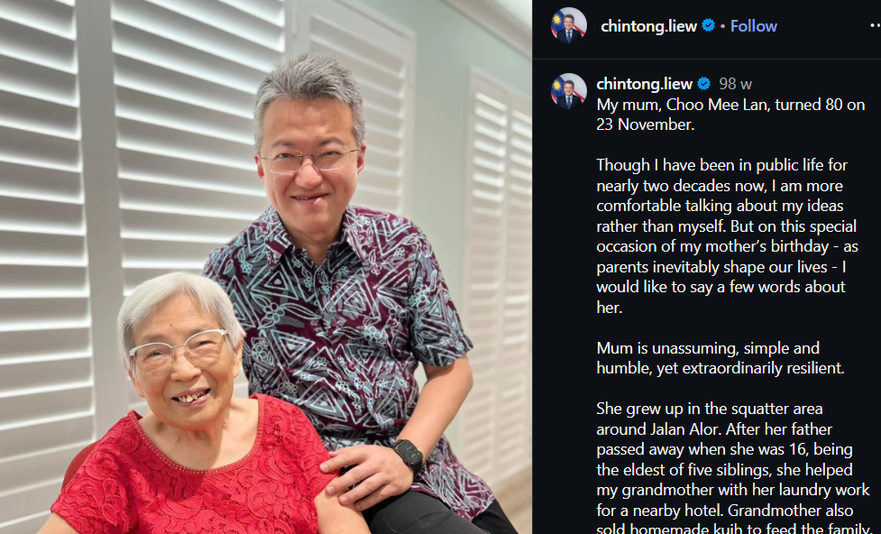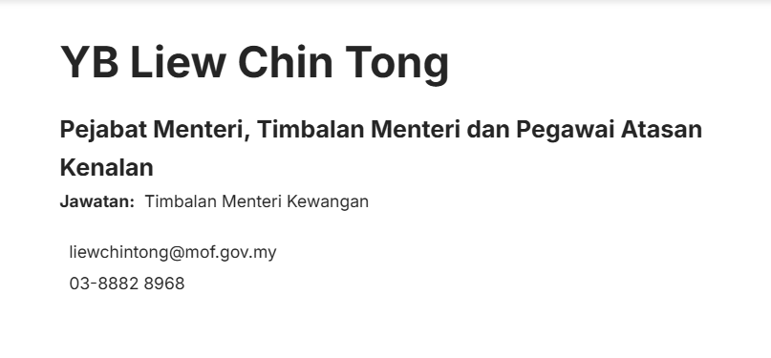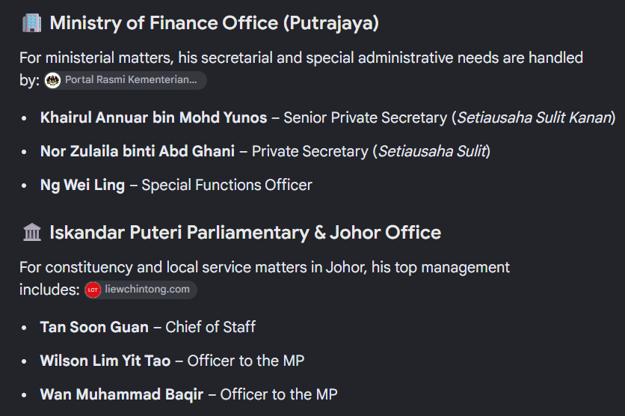

Name | Low Taek Jho ( China Name : Liu Tezuo )
Extra Info | - Low was the youngest of three children
X | https://x.com/jho_low
Birthdate | 4 November 1981
Hometown | George Town, Penang
Grandfather | Tan Sri Dato’ Low Meng Tak
Linkedin | https://linkedin.com/in/lowtaekjho  https://www.linkedin.com/in/jholow/  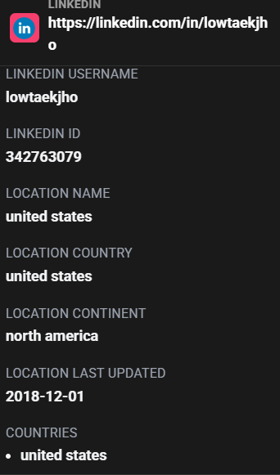
Company | Jinwei Financial Co. Ltd / address: 19/F, 50 Connaught Road Central, Hong Kong
University | University of Pennsylvania
High School | Chung Ling High School  The International School of Penang  Harrow School
Instagram | https://www.instagram.com/jholowjynwel/?hl=en
New Pasport | 