ZSOA
Zurich Services Oriented Architecture

Address Standardization
Technical Design

Version 1.0.0



NA Competency Center

Copyright Zurich Financial Services
Document History

Version | Date | Author | Comment
1.0 | 10/01/2008 | Emmanuel Ameh

Table of Contents
1 About this Document 1
1.1 Introduction 1
1.2 Intended Audience 1
1.3 How this document is organized 1
1.4 Service Overview 1
2 Orchestration Layer Components 2
2.1 ESB Components 2
2.1.1 ALSB 2
2.1.2 Client interface 3
2.1.3 Message flow 3
2.1.4 Transformations 3
2.1.5 Routing 3
3 Service Enablement Layer Components 4
3.1 Interface 4
3.1.1 Functionality Required 4
3.1.2 Inputs 4
3.1.3 Outputs 4
3.1.4 Faults 4
3.1.5 Data Modifications 5
3.1.6 Logical Flowchart 5
4 Implementation Layer Components 7
4.1 Mainframe Programs 7
4.1.1 <<Program Name>> 7
4.2 EJB’s 7
4.3 Database\Stored Procedures 7
5 Functional\Non-functional requirements 8
5.1 Functional 8
5.1.1 Throughput expectations 8
5.2 Non-functional 9
5.2.1 Security 9
5.2.2 Logging 9
5.2.3 Monitoring 9
5.2.4 Business exception handling 9
5.2.5 Response time 9
5.2.6 Availability 9

About this Document

Introduction
This document describes the design artifacts and implementation model of the Address Standardization service. Although external systems (upstream and downstream) are referenced in this document, their detailed behavior falls outside the scope of this document. Overall system requirements are covered in the requirements and use case document and, therefore, also fall outside the scope of this document.

Intended Audience
This document is intended for the team members who will be responsible for development of this service.

How this document is organized
The design for the Address Standardization service is presented in 6 areas of interest as outlined below.
- Orchestration Layer Components: Presents the services, components and information pertinent to this level. The primary focus here is on the Enterprise Service Bus and the activities carried out there.
- Service Enablement Layer Components: Describes the design and pertinent aspects needed to develop the atomic services as well as any other aspects implemented at this level.
- Implementation Layer Components: This deals primarily with backend or legacy data sources and the design to follow in exposing their services to the enterprise.
- Functional\Non-functional Requirements: This section outlines the functional and non-functional requirements identified for this service.

Service Overview
This section provides a brief overview of the to-be-built service.
Enterprise Service Bus
Transformation engine
Orchestrated
(
proxy,transactional)
Services
External Service Provider
StandardizeAddress
Transformation Engine
Service Consumers
MilesDriven
PEGA
----------------------------
WAS
Map Info
Service

Orchestration Layer Components

ESB Components

ALSB

Business Service
This section contains the detail necessary to define the business service in the ESB.

General Configuration
Service Name | Address Standardization
Description | Address standardization is performed for residence/mailing address, different mailing address, billing Address, and lien holder/other interest address.
Service Type | WSDL Port is the service type; Business service is based on the WSDL resource originally created by Service Provider.  SOAP over HTTP Business Service is a AquaLogic Service Bus definitions of intermediary Web services that are hosted remotely on external vendor called MAP INFO.
Transport Configuration
Protocol | HTTP.
Load balancing | Basically ALSB implements Round Robin algorithm, Random and Random –Weighted Algorithms.  The Load balancing Algorithm, there is no multiple enpoints for Address Standardization service, so, select none because load balancing is relevant only when a service specifies multiple end points.  In the case that multiple endpoints and a load balancing algorithm are specified, if one endpoint is overloaded or not available at run time, the message can be dispatched to the next service in the list of endpoint URIs. In this Address Standardization case there is only one service, therefore accepting the default behaviour or selecting none does not affect the behaviour of the proxy service at run time.
Endpoint URI | http://mapinfo.com:8080/AddressStandardization/ - Verify endpoint URI with MAP INFO technical team.
Retry count | 3 - The number of times a list of URLs is retried. The number of retries is for the list of URIs.
Retry interval | 3 sec - the number of seconds' wait time between retries.
HTTP Transport Configuration
Timeout | 30 secs. The timeout interval, in seconds, before the connection is dropped.
HTTP Request Method | HTTP GET - Information is passed as a sequence of characters appended to the request URL in a query string.
Authentication | Basic authentication instructs WebLogic Server to authenticate the client using a username and password against the authentication providers configured in the security realm, such as a Lightweight Directory Access Protocol (LDAP) directory service and Windows Active Directory.
Follow HTTP redirects | No redirects
SOAP Binding Configuration
Enforce WS-I Compliance | YES

Proxy Service
This section contains the detail necessary to define the proxy service in the ESB.

General Configuration
Service Name | Standardize Address
Description | BEA AquaLogic Service Bus enables message routing between business services in the internal/ external environment. Messages will be routed from Pega java client through the AquaLogic Service Bus intermediary, to the appropriate Standardize Address business service on MapInfo. BEA AquaLogic Service Bus routes messages to one or more destinations based on the actions taken on the messages.
Service Type | WSDL Port is the service type, Proxy service is based on the WSDL resource service modeler originally created.  WSDL Binding
Proxy Service Provider | ALSB on IBM AIX high end P Series Server.
Protocol | HTTP
Endpoint URI | We need set the Endpoint URI to /EASY/Standardize Address. This is the URI to which the PEGA eAUTO client will be sending its messages. Service Implementation (WIPRO) team and GITO will finalize the endpoint URIs.
Get All Headers | Yes – Choose Get All Headers
Headers | SOAP Headers
HTTP Transport Configuration
Authentication | There is no BASIC Authentication – requirement from Easy technical and business team because this service accessed by all internal farmers applications only. Leave it blank to specify that basic authentication is not required. Basic authentication instructs WebLogic Server to authenticate the client using a username and password against the authentication providers configured in the security realm, such as a Lightweight Directory Access Protocol (LDAP) directory.
Message Level Security Configuration
Custom Authentication | There is no message level security requirement from Easy business and technical team and there is no security policy defined for the Address Standardization service, so we no need to change configuration settings of the Proxy service.
Operation Selection Configuration
Enforce WS-I Compliance | YES
Selection Algorithm | Default SOAP Body Type is the Algorithm.  Service Monitoring should be turned on StandardizeAddress proxy service in the Resources panel.

WSDL
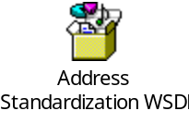

Client interface:

BEA AquaLogic Service Bus to route eAgent applications service request to appropriate business services based on the service requested. eAuto client sends a standardize address request to a proxy service named StandardizeAddress proxy service. Request is routed to the Address Standardization business service. This service uses the wrapped document literal binding style. The request/response messages are in IAA canonical format and the consumer has the responsibility to map the XML message structure to their internal format. The target MapInfo Address Standardization business service returns a response message to the proxy service and then proxy service returns the response message to the client interface. Static Stub: A Java class generated using the Address Standardization WSDL that statically bound to the Address Standardization proxy service. A stub, or a client proxy object, defines all the methods that the service endpoint interface defines. Therefore, the client can invoke methods of a web service directly via the stub.

Message flow: Message Flows are the definitions of AquaLogic Service Bus proxy services. Pipelines (Request and Response pipelines), branch nodes, and route nodes define the implementation of AquaLogic Service Bus proxy services. There will be a Pipeline Pair required to handle the request and response, and Route node required and there is no requirement for branch nodes. ALSB provides a route node is used to perform request/response communication with Proxy service and Address Standardization business service running on the MapInfo. The route node supports conditional routing as well as request and response transformations.

Transformations: Data transformation is the mapping of data from one format to another. DataPower transforms messages from IAA format to MapInfo format. It uses the Xquery, XSLT transformation and XPath language for data composition and transformation for service endpoints. Data power supports data mapping that uses XQuery and the eXtensible Stylesheet Language Transformation (XSLT) standards. You need transform IAA service request (IAA message) to MapInfo service request.

Routing

Service Enablement Layer Components

Interface
Define the interface to be service enabled.
Web Service Definitions
WSDL | <<MapInfo >>
Service | <<AddressSandardization >>
Port | 8080
Language | Java
Program Name | AddressStandardization.java
Default unbounded sequence length
Default unbounded string length

Functionality Required
Define functionality specific to each interface.

Inputs
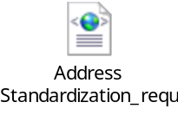
Use Case Parameter | Element Name | Type | Schema
Param1 | Address | String
Param2 | City | String
Param3 | State | String
Param4 | Zip (9 digit) | String

Outputs
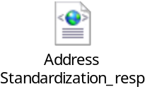
Use Case Parameter | Element Name | Type | Schema
Param1 | Address | String
Param2 | City | String
Param3 | State | String
Param4 | Zip (9 digit) | String

Logical Flowchart
Include a flowchart which clarifies the logical flow of the service enablement layer. An example is included below.
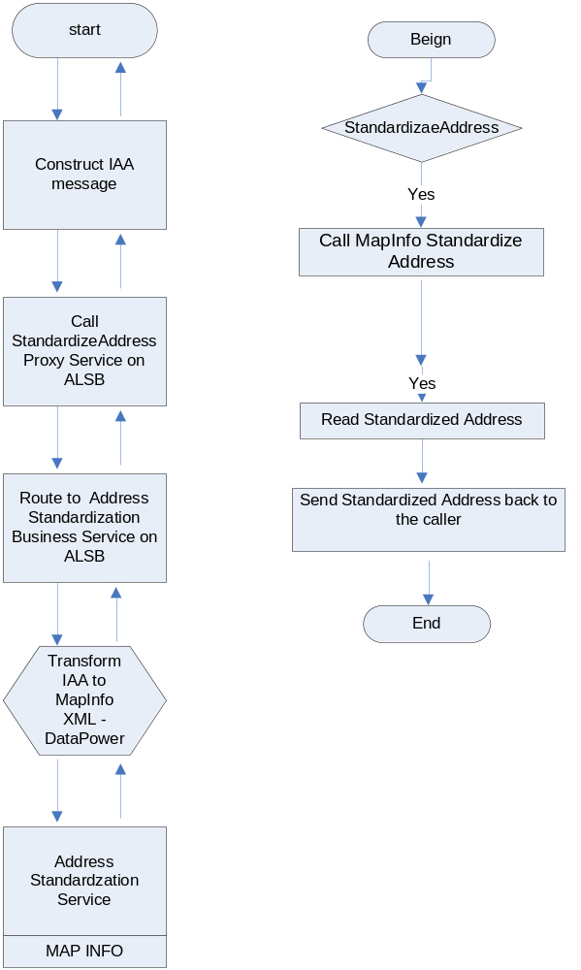

Implementation Layer Components
This section addresses any legacy implementation layer components (e.g. CICS programs, EJBs, stored procedures, etc.)
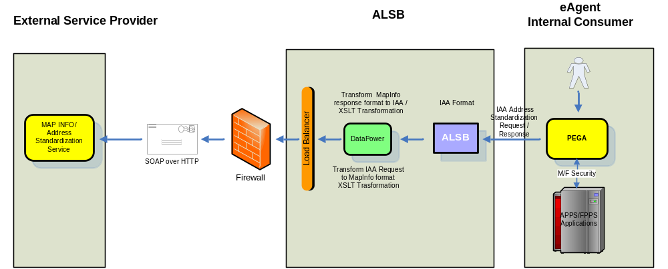

Functional\Non-functional requirements
The following functional\non-functional requirements have been identified for this service.

Functional

Throughput expectations
Interface Name | Consumer | Provider | Description/ Business Impact | Frequency | Timing | Message Volume | Message Size
StandardizeAddress | Pega/ eBusiness | MapInfo | Real-time Inquiries | Daily |  | Medium | Low

Non-functional

Security
ALSB security features ensure message confidentiality and integrity (message-level security through Web Services Security), secure connections (between ALSB Servers, service clients, and business services through transport-level security) and authentication and authorization (access control).
Transport-Level Security
Transport-level security ensures that the connection is secure. ALSB allows you to configure transport security between client applications and AquaLogic Service Bus proxy services and between AquaLogic Service Bus and business services.
Message-Level Security (Web Services Security)
Message-level security provides a level of flexibility not present in transport-level security. ALSB supports WS-Security that provides message integrity and message confidentiality. AquaLogic Service Bus supports the following WS-Security token profiles
Web Services Security: Username Token Profile 1.0
Web Services Security X.509 Token Profile 1.0
Web Services Security SAML Token Profile 1.0

SAML Support
AquaLogic Service Bus provides support for Security Assertion Markup Language (SAML), which defines a framework for exchanging information between online business partners.
Identity Propagation through ALSB SAML Support
AquaLogic Service Bus uses SAML as the enabling technology to support identity propagation. Identity propagation governs secure passage of the AquaLogic Service Bus client's identity to the business service routed to by the proxy service. The identity is propagated in a SAML token inside the WS-Security security header included in the SOAP message.

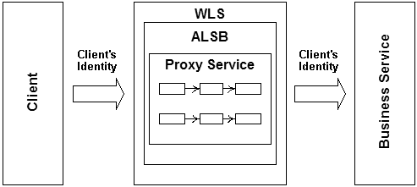

Logging
Define logging expectations for the service (e.g. message logging, security faults, etc.). These should be realized via policies defined in the Web Services Management solution.

Monitoring
BEA AquaLogic Service Bus provides the capability to monitor operational health and collect run-time information for systems operations purposes.
AquaLogic Service Bus aggregates run-time statistics that admins can view on a customizable Dashboard. The Dashboard allows you to monitor the health of the system and alerts you to problems in your messaging services. With this information, you can quickly and easily isolate and diagnose problems as they occur. The Service Monitoring Details Page displays the following set of information:
Alert Status, Message Count , Minimum Response Time ,Maximum Response Time , Average Execution Time ,Performance, Overall Average Execution Time, Total Number of Messages, Messages With Errors, Success Ratio, Failure Ratio.
BEA AquaLogic Service Bus delivers message data and alerts to one or more reporting providers. Message data can be captured from the body of the message and from other variables associated with the message, such as header or inbound variables. Alert data contains information about Service Level Agreement (SLA) violations that you can configure to monitor proxy services. You can use the message or alert data delivered to the reporting provider for functions such as tracking messages or regulatory auditing.

Business exception handling
Define business exception handling expectations for the service.

Return code | Result
(e.g. No policies associated with party (' ')) | (e.g. Returns empty response.)

Response time
Define response time expectations for the service (e.g. 3500 ms). These should be realized via policies defined in the Web Services Management solution.

Availability
A clustered AquaLogic Service Bus domain provides high availability. The basic components of a highly available AquaLogic Service Bus environment include the following:
An administration server
A set of managed servers in a cluster
An HTTP load balancer (router)
Physically shared, highly-available disk subsystems for managed server data—Whole server migration requires that all data on a managed server be located on a multi-ported disk. A typical and recommended way to do this is by using a multi-ported disk subsystem or SAN, and allowing two or more servers to mount file systems within the disk subsystem. The file system must not be simultaneously shared; it is only necessary for one server to mount a file system at any one time.
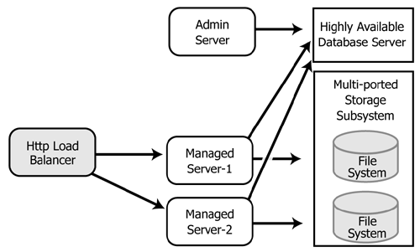

Clustering allows AquaLogic Service Bus to run on a group of servers that can be managed as a single unit. In a clustered environment, multiple machines share the processing load. AquaLogic Service Bus provides load balancing so that resource requests are distributed proportionately across all machines. An AquaLogic Service Bus deployment can use clustering and load balancing to improve scalability by distributing the workload across nodes. Clustering provides a deployment platform that is more scalable than a single server.

