Farmers ZSOA
Zurich Services Oriented Architecture

Billing Services
Technical Design

Version 0.2



Farmers Service Competency Center

Revision History
Date | Version | Description | Author
04/22/2008 | 0.1 | Initial Draft | Emmanuel Ameh
04/27/2008 | 0.2 | Draft | Emmanuel Ameh

Table of Contents
1. Introduction 4
1.1 Purpose 4
1.2 Intended Audience 4
1.3 Services Overview 4
2. Architecture 5
2.1 Reference Architecture 5
2.2 Solution Architecture 6
2.3 eAgent/PLA – ALSB Communication 7
2.4 R2P – ALSB Communication 8
3. Orchestration Layer Components 9
3.1 ESB Components 9
3.1.1 ALSB 9
3.1.2 Client interface 10
3.1.3 Message flow 10
3.1.4 Transformations 10
3.1.5 Routing 10
4. Service Enablement Layer Components 11
4.1 Interfaces 11
4.1.1 Data Mapping 11
4.1.2 Inputs – Samples SOAP XML 11
4.1.3 Outputs – Sample SOAP XML 11
4.1.4 Faults 11
4.1.5 Data Modifications 11
5. Functional Requirements 12
6. Non-Functional Information 13
6.1.1 Availability 13
6.1.2 Security 13
6.1.3 Business Contacts 13
7. Appendix-1 14
7.1 Connectivity to SAP using ALSB 14
7.1.1 Service Account Information 14

Introduction

Purpose
This document describes the design artifacts and implementation model of the billing services for the Billing Simplification Project. Although the external systems such as R2P, CICS and SAP FS-CD are referenced in this document, their detailed behavior falls outside the scope of this document. The solution explained in this document can be followed for integrating the ERP systems using web services.

Intended Audience
This document is intended for the team members who will be responsible for development of this service.

Services Overview
As part of Billing Simplification Project, the following are the services that will be developed as part of AP1 release.
- maintainAccountInformation – This service creates/updates the account information such as business partner, contract account and insurance objects that has been passed to it as part of its request information and returns the status (success/failure) as part of the response.
- retrieveAccountInformation – This service retrieves the account information based on the criteria such as account number, household number, policy number and effective date and the service codes to indicate the information provided by the SAP service.

Architecture

Reference Architecture

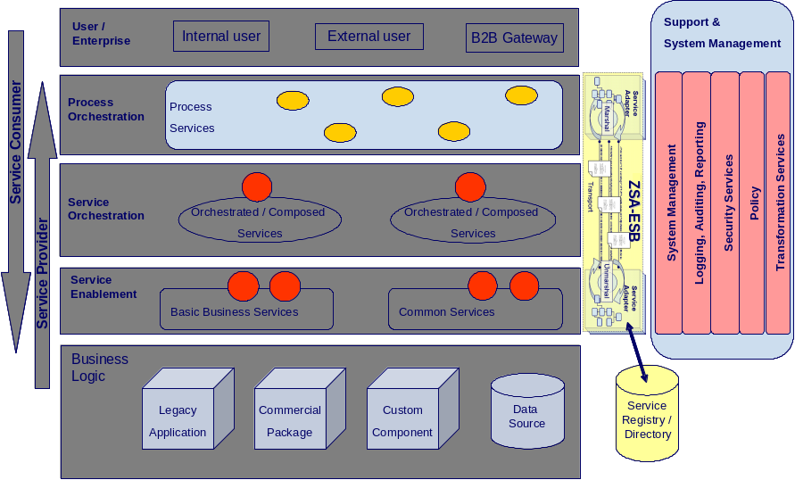

As shown in the above diagram, the billing services will follow the reference architecture defined in the ZSOA Technical Reference Architecture document. Refer ZSA Tech-Ref-Architecture_V1.0.doc for more information.

Solution Architecture

The Billing services will be consumed by the following two consumers for the SAP FS-CD services exposed over ALSB as shown in the diagram.
- eAgent/CICS
- Pre-Processor or R2P

The end-to-end flow will follow the steps shown in the diagram:

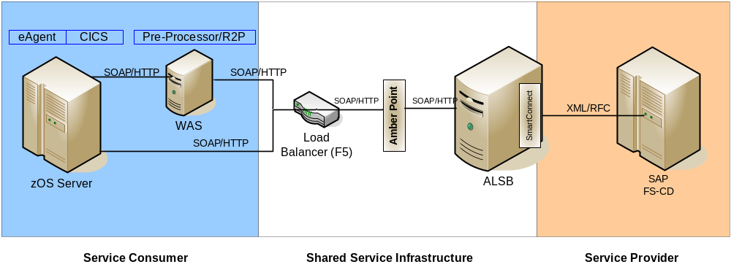

The steps in the diagram are explained below:
- The eAgent/CICS or R2P systems will make a webservice request (SOAP over HTTP) to AquaLogic Service Bus (ALSB) through a load balancer based on IAA format.

- The webservice request based on IAA format will be intercepted by AmberPoint agent as shown in the diagram.

- The AmberPoint agent will receive the requests and perform a lookup for the requested service in the Service Registry.

- If the service is found, then the AmberPoint agent invokes the service on the ALSB. If the service is not found then the error response is sent back by AmberPoint.

- ALSB receives the request and will make XML over RFC request to SAP FS-CD using SmartConnect Adapter.

- SAP FS-CD executes the RFC function and returns the response back to ALSB in the form of an XML.

- ALSB using SmartConnect converts the response to SOAP response based on IAA format and sends it back to the eAgent/R2P systems through the Amber point agent.

eAgent/PLA – ALSB Communication
The Account Information Service SAP FS-CD will be consumed by the eAgent/PLA over ALSB as shown in the diagram. The end-to-end flows will follow the steps shown in the diagram:

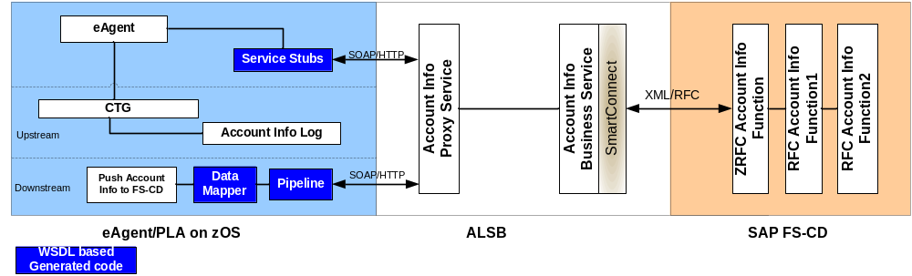

As depicted in the above diagram, there are two end to end flows from the eAgent/PLA to SAP-FSCD. One from the eAgent for the inquiry will be developed using java and the other to push the account information into FS-CD from the COBOL/CICS region. The steps in the diagram are explained below:

Flow1 – Account Inquiry from eAgent
- The eAgent will make a webservice call to inquire Account Information in IAA format using generated service stubs to the Account Info Proxy Service on ALSB.

- The Account Info Proxy Service on the ALSB will route the inquiry request to the Account Info Business Service on the ALSB.

- The Account Info Business Service receives the request and will make XML over RFC request to ZRFC function in SAP FS-CD using SmartConnect Adapter.

- SAP FS-CD executes the ZRFC functions and returns the response back to ALSB in the form of an XML.

- ALSB using SmartConnect converts the response to SOAP response based on IAA format and sends it back to the eAgent.

- The eAgent system receives the response and display to the end user.

Flow2 – Post Account Info from eAgent
- The eAgent from the CICS region will make a webservice call to post Account Information in IAA format using generated datamapper and pipeline components to the Account Info Proxy Service on ALSB.

- The Account Info Proxy Service on the ALSB will route the post Account Information request to the Account Info Business Service on the ALSB.

- The Account Info Business Service receives the request and will make XML over RFC request to ZRFC function in SAP FS-CD using SmartConnect Adapter.

- SAP FS-CD executes the ZRFC functions for saving Account Information and returns the response back to ALSB in the form of an XML.

- ALSB using SmartConnect converts the response to SOAP response based on IAA format and sends it back to the eAgent or CICS Program.
- The CICS program updates the received status to a log file.

R2P – ALSB Communication
The Receivable Service SAP FS-CD will be consumed by the Pre-Processor or R2P over ALSB as shown in the diagram. The end-to-end flow will follow the steps shown in the diagram:

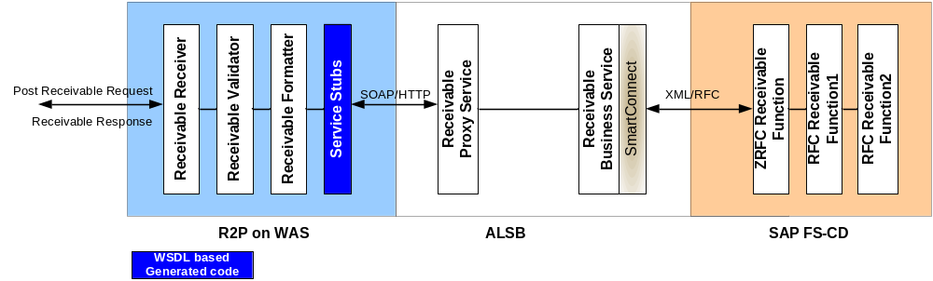

The steps in the diagram are explained below:

- The R2P system on Websphere Application Server will receive a webservice request (SOAP over HTTP) to post a receivable to the SAP FS-CD.

- The R2P system will validate the received receivable and formats the receivable to make a call to ALSB.

- The R2P system will make a webservice call to post receivable in IAA format using generated service stubs to the Receivable Proxy Service.

- The Receivable Proxy Service on the ALSB will route the receivable posting request to the Receivable Business Service on the ALSB.

- The Receivable Business Service receives the request and will make XML over RFC request to ZRFC function in SAP FS-CD using SmartConnect Adapter.

- SAP FS-CD executes the ZRFC functions and returns the response back to ALSB in the form of an XML.

- ALSB using SmartConnect converts the response to SOAP response based on IAA format and sends it back to the R2P systems.

- The R2P system sends the response in turn back to the consumer who requested for post receivable.

Orchestration Layer Components

ESB Components

ALSB

Business Service – CREATE/UPDATE MASTER DATA

General Configuration
Service Name
Description
Service Type | Any XML Service
Transport Configuration
Protocol | Mysap
Load balancing | Round-robin
Endpoint URI | mysap://isdsrv2:00
Retry count | 2
Retry interval | 30
MYSAP Transport Configuration
Target Type | Application Server
Client | <<800>>
Language | EN
EDI Version | 3

Business Service – GET MASTER DATA

General Configuration
Service Name
Description
Service Type | Any XML Service
Transport Configuration
Protocol | mysap
Load balancing | Round-robin
Endpoint URI | mysap://isdrv2:00
Retry count | 2
Retry interval | 30
MYSAP Transport Configuration
Target Type | Application Server
Client | <<800>>
Language | EN
EDI version | 3

Proxy Service

General Configuration
Service Name
Description | This services fronts the primary business service
Service Type | WSDL Web Service
Proxy Service Provider
Protocol | HTTP
Endpoint URI | http://services.farmersinsurance.com/services/<<tbd>>_proxyService
Get All Headers | Yes
Headers | SOAP Headers
HTTP Transport Configuration
Authentication | None
Message Level Security Configuration
Custom Authentication | No
Operation Selection Configuration
Enforce WS-I Compliance | Yes
Selection Algorithm | Default SOAP Body Type is the Algorithm.

WSDL

Client interface

Message flow

Transformations

Routing

Service Enablement Layer Components

Interfaces

Data Mapping

Inputs – Samples SOAP XML

Outputs – Sample SOAP XML

Faults

Please refer to the service Use Case Document for details covering all faults.

Data Modifications
Logging, Auditing, Reporting
System Management
Orchestrated / Composed
Services
B2B Gateway
Service
Registry /
Directory
User / Enterprise
Field Name | Modifications
None | None

Functional Requirements

Non-Functional Information

Availability
Service components to be available 24 x 7, except during normal scheduled maintenance periods. Please refer to the service contract for further details.

Security

Business Contacts

Appendix-1

Connectivity to SAP using ALSB
This section describes information needed to create a Service Account in AquaLogic Service Bus (ALSB) that can be used to authenticate a connection to the mySAP system when using Business Services.

Service Account Information
The following is the information required to create a service account in the ALSB.

General Configuration
Resource Name |  | mySAP_Static_SA
Resource Description |  | Selecting a Static Resource Type for the Service Account
Resource Type |  | Static
Static Credentials
User ID | Userid
Password | ********

Refer Section 7 for creating the Service Account before the creation of Business Services.

