Michael T. Smith

Mike Odom

CIT 230 Web Frontend

Site Plan

* An appropriate site name (not "The Weather Site") and domain name

Unrelated Weather

* The site purpose

To provide weather reports for several unrelated communities

* A description of the target audience including personas with at least five scenarios

Targeted audience would be anyone who lived in any of the included areas. This site is particular in its attempt to monitor and report on various locals on the east coast to track major storms.

Personas:

1. Someone looking for weather in specific location
2. Someone looking for weather not included on the site.
3. Someone tracking a storm headed to the included area.
4. Someone looking for more information on named storms.
5. Someone looking for areas damaged by recent storms.

* A simple sitemap

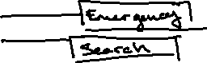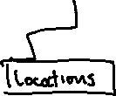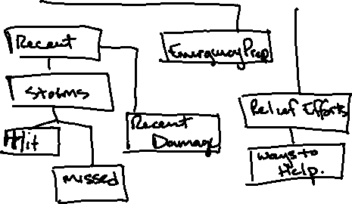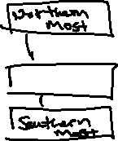

A color scheme with references to elements/content

|  |  |  |  |  |
| --- | --- | --- | --- | --- |
| Site Header | Arial | 40px | A3C6C4 | Sample |
| Primary Navigation | Arial | 30px | E0E7E9 | Sample |
| Footer Navigation | Arial | 20px | 354649 | Sample |
| Heading 1 (h1) | Arial | 30px | 354649a | Sample |
| Heading 2 (h2) | Arial | 25px | 354649a | Sample |
| Heading 3 (h3) | Arial | 20px | 354649a | Sample |
| Paragraph text (p) | Arial | 16px | 6C7A89 | Sample |

* Typography selections with references to elements/content (which is OK to combine in the report with the color scheme)

*You will not need to complete wireframe sketches. A town page wireframe sketch is provided to you from which to glean information about the content and layout of the page as you begin to build it in HTML.*