FICTIONAL / UNCLASSIFIED TRAINING SURROGATE

Background
An unclassified fictional Gulf air base defends its runway, aircraft, and support area from a synthetic one-way attack UAS wave while protected support traffic transits the operating area.
This brief describes a synthetic counter-UAS exercise. It does not describe a real installation, current force posture, readiness condition, or operational plan.

Scope
The scenario runs for 150 seconds at 1-second decision intervals with seed 17. It contains 16 moving actors, 2 abstract sensor nodes, 1 generic response elements, and 1 protected zones.
Out of scope are real coordinates, routes, unit identities, communications, storage locations, current defensive positions, readiness, and physical weak points.

Relevant Authorities and Coordination
No real command authority, rules of engagement, legal authority, or agency tasking is encoded. Scenario relationships control eligibility inside the simulator.
- defense treats threat as opponent.
- defense treats support as protected.
- threat treats defense as opponent.
- threat treats support as neutral.
- support treats threat as neutral.
- support treats defense as neutral.

Base Overview and Protected Assets
The fictional Gulf-desert scene includes one runway, a parallel taxiway, generic aprons, shelters, hangars, operations and support buildings, a tower, a fire station, warehouses, tanks, service yards, and abstract counter-UAS props.
Scene aircraft and vehicles are visual set dressing unless they also appear in the actor roster. Geometry and placements are scenario assumptions.
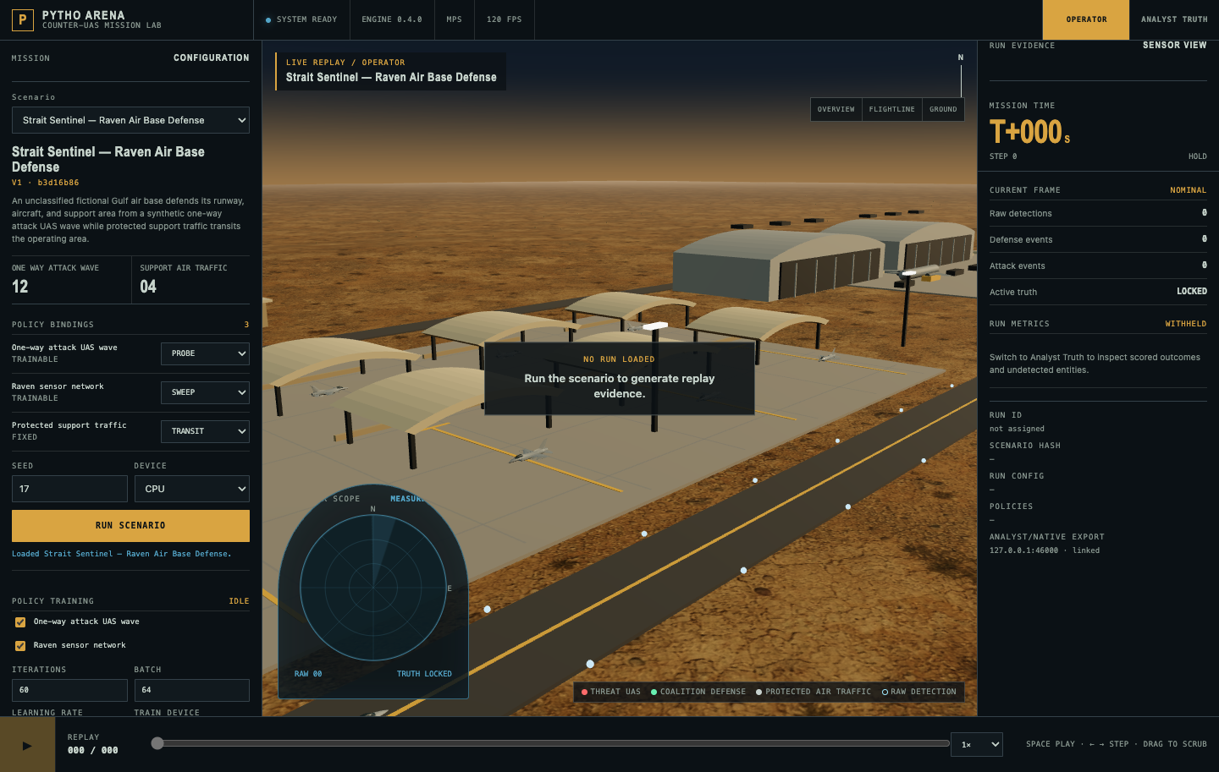
Figure 1 - Fictional scenario environment

Threat Surveillance Capabilities
- 12 synthetic generic actors in one way attack wave use a attack objective mission. Speed and outcome probability are normalized simulation inputs, not real-system performance.
Platform attribution, payload, launch point, route geometry, and real-system capability claims are not part of this scenario.

Blue Surveillance and Tracking
Sensor values below are synthetic. Positions and headings are intentionally omitted.
Sensor | Capacity | FOV | Detection | Noise | Range
Fused Sensor Node | 10 | 115° | 0.88 | 0.7 | 60 normalized
Fused Sensor Node | 10 | 115° | 0.84 | 0.9 | 60 normalized
Operator view shows noisy measurements. Analyst truth remains separate from the operator track picture.

Blue Effectors
Response elements are generic scoring resources. Rendered vehicles do not identify a fielded weapon or imply current capability.
Response | Capacity/step | Effectiveness | Range
Raven Response Alpha | 2 | 0.62 | 38 normalized
Weapon type, emplacement, inventory, reload, readiness, response timing, and real engagement ranges are not modeled.

Detection and Synthetic Performance Views
Operator view presents detections and current events while withholding active truth and aggregate outcomes. Analyst view adds replay truth, entity focus, detection and defense rates, intercepts, objective attempts, and protected-traffic status.
Results may identify synthetic missed detections, capacity saturation, unsuccessful responses, or protected-traffic effects. They do not identify a real coverage gap, attack route, installation weakness, or readiness condition.

References
- Pytho Arena scenario JSON and immutable content hash.
- Pytho Arena operator/analyst replay and relationship behavior.
- Pytho Arena docs/SCENARIO_BASIS.md (scenario and public visual-reference basis).
- U.S. Central Command, public releases cited in SCENARIO_BASIS.md (regional context only).
- U.S. Air Forces Central, DVIDS, and USACE public imagery cited in SCENARIO_BASIS.md (visual context only).

Traceability
Statement | Source | Class | Limitation
Actor, sensor, response counts | Scenario JSON | Repository fact | Synthetic inputs
Environment and static assets | Visualization spec | Scenario assumption | Fictional geometry
Operator/analyst views | Arena UI contract | Repository fact | Exercise display only
Regional visual context | SCENARIO_BASIS.md | Public context | No real layout copied

