Disease Prediction Report

This is the report generated from the analysis of video captured by the drone

# Statistical analysis

The below graph shows the distribution of various disease as per our prediction. The prediction is done on the video captured from the drone

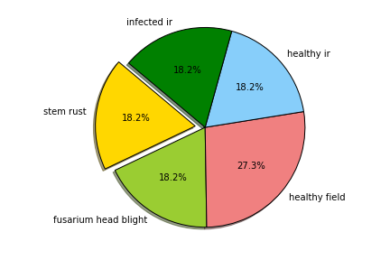

# Most Severe Disease

The two most severe diseases are:

1. stem rust
2. fusarium head blight

# Symptoms and Signs of Fusarium Head Blight

Individual plants of cereal crops (e.g. wheat) produce multiple stems, and each stem produces a single seed spike which emerges at the end of the stem. The spike is composed of multiple spikelets positioned on alternate sides of the spike’s stem. Each spikelet is composed of flowering structures where seed develops. The first symptoms of Fusarium head blight occur shortly after flowering. Diseased spikelets exhibit premature bleaching as the pathogen grows and spreads within the head

# Cure Of Fusarium Head Blight

Select rust-resistant plant varieties when available.Pick off and destroy infected leaves and frequently rake under plants to remove all fallen debris.Water in the early morning hours — avoiding overhead sprinklers — to give plants time to dry out during the day.Use a slow-release, organic fertilizer on crops and avoid excess nitrogen.Apply copper sprays or sulfur powders to prevent infection of susceptible plants. For best results, apply early or at first sign of disease. Spray all plant parts thoroughly and repeat every 7-10 days up to the day of harvest.Prune or stake plants and remove weeds to improve air circulation.Use a thick layer of mulch or organic compost to cover the soil after you have raked and cleaned it well. Mulch will prevent the disease spores from splashing back up onto the leaves

# Cure Of Diseases Found

Cure Of Since 1990, an extensive research endeavor has focused on development and use of resistant cereal cultivars and integrated pest management systems for the control of Fusarium head blight. Thousands of plant lines are subjected to artificial inoculation with F. graminearum (Figure 18). Those lines having reduced fungal growth and low levels of seed contamination with the mycotoxin DON are selected and advanced in additional breeding trials. To date, sources of resistance conferring complete resistance to FHB have not been identified in wheat. Quantitative Trait Loci (QTL) composed of one or more genes, such as Fhb1 derived from the Chinese wheat cultivar Sumai 3, have been identified in wheat. However, these genes confer only partial resistance to FHB, and many of the initial sources of resistance were not well adapted to most of the grain production regions of the U.S. While some success has been made in transferring FHB resistance from such exotic sources into adapted cultivars, identification and deployment of FHB resistance already present in local native germplasm and cultivars is providing another means to achieve this goal. Ultimately, control of FHB, to meet the very low DON limits in wheat grain, will require an integrated approach including development of cultivars having multiple resistance genes and use of fungicides.

# Detailed Analysis

Below is the indepth report

|  |  |  |
| --- | --- | --- |
| Name | Disease1 | Disease2 |
| D1.jpg | stem rust | fusarium head blight |
| D2.jpg | fusarium head blight | stem rust |
| D3.jpg | stem rust | fusarium head blight |