Project 3
Joo Seok Hwang

Introduction and Overview
In this project, I wrangled the data for machine learning and tried two different models which were Logistic Regression and Random Forest Classifier. To figure out which model performed better, I compared the AUCs. As a result, Random Forest Classifier showed a better performance.
 | Logistic Regression | Random Forest Classifier
AUC for Training (%) | 94.96 | 99.42
AUC for Testing (%) | 95.29 | 100.0

Data Cleaning and Preparation
I took data preparation through the process below.
- Drop single entity columns
  - There were two columns (x4, x30) containing single entity. Since these columns had no meaning for ML, just dropped these columns
- Convert string data to numerical data
  - There were two types of string data. Converted them using proper methods
    - Numerical data within string (x2, x29): Extracted numerical data using slicing and changed data type
    - Categorical data (x3, x25, x26): Converted each category to binary format (0, 1)
- Drop inappropriate rows
  - Dropped rows containing blank or NaNs
- Drop duplicate rows
- Convert infinity values
  - Col x31 contained infinities and numerical data ranging from 0 to 2. Converted infinities to 10 which was big enough to be distinguished and not too far from others to be normalized
- Check by correlation
  - Found highly related column sets (x5-x6, x23-x24) reviewing correlation heatmap, dropped ones of them (x6, x24)
- Normalization
  - Inspected the .describe() table, found columns (x2, x23, x29) having too wide range of data. Normalized those columns
- Reset index and export data

Part A – Logistic Regression Model
Logistic regression is a way to predict a variable’s classification. It is based on the sigmoid function and loss function. During the training stage, it updates parameters of the sigmoid function in the direction to reduce loss function.
Logistic regression is basically linear; therefore, it fits on linear data the best, and interpretability is very high. Due to its simplicity, training speed is also high. However, it is sensitive to data features such as outliers and wide scale.
In this project, I cleaned data to minimize disadvantages of the logistic regression model. I would have tried additional data wrangling skills if I got bad results from the data. However, it showed decent results.

- Default Logistic Regression
  - AUC results (%)
Training | Testing
94.96 | 95.29

  - Testing scores (%)
Accuracy | Testing | Recall | F1 Score
89.1 | 88.0 | 86.5 | 87.2

  - Confusion Matrix
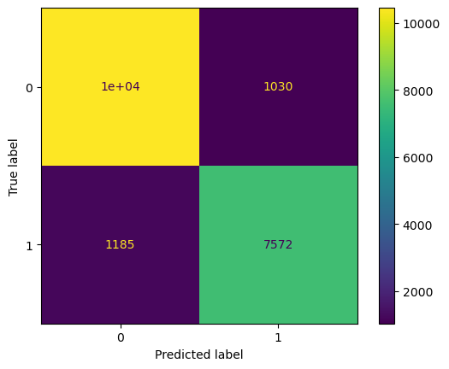

- Hyper-parameter tuning
  - Got parameters using GridSearchCV and calculated AUC. However, default parameters showed slightly higher AUC than hyper tuned parameters
    - In addition, GridSearchCV included 5-fold cross validation as a default
Parameters | C | Max_iter | Penalty | Solver | AUC for testing (%)
Default | 1.0 | 100 | l2 | lbfgs | 95.2930
Hyper Tuned | 10 | 10 | l2 | liblinear | 95.2923

Part B – Random Forest Classifier Model
Random forest classifier is a developed version of decision tree model. The decision tree model has many disadvantages. It is susceptible to overfitting and very unstable because small changes in early decision can change the whole tree.
The random forest model improves these weak points. It randomly takes a part of the whole data and makes many small decision trees. And when new data comes, it lets the small trees make decisions and take the average of those decisions. Through the process of random and average, it can get stability and robustness.
However, it takes relatively long for training. For example, the random forest model took more than 10 times of time than logistic regression model doing GridSearchCV in this project.
I used the same clean data as the logistic regression analysis. And the random forest model showed higher performance than the logistic regression model.

- Default Random Forest
  - AUC results (%)
Training | Testing
100.0 | 99.42

  - Testing scores (%)
Accuracy | Testing | Recall | F1 Score
96.4 | 97.5 | 94.2 | 95.8

  - Confusion Matrix
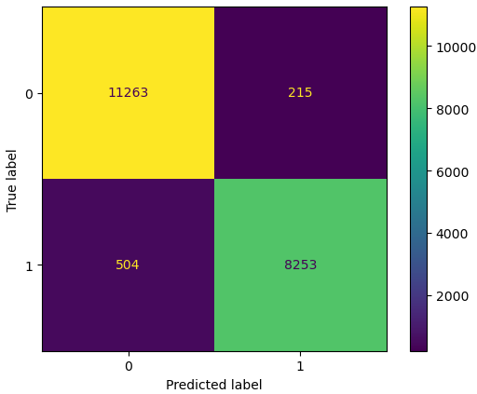

- Hyper-parameter tuning
  - Got parameters using GridSearchCV and calculated AUC. The hyper tuned model showed slightly higher AUC. However, it took over 3 hours to find the best parameters
    - In addition, GridSearchCV included 5-fold cross validation as a default
Parameters | Max_depth | Max_features | Min_samples  _leaf | N_estimators | AUC for testing (%)
Default | None | sqrt | 1 | 100 | 99.4153
Hyper Tuned | 30 | Log2 | 1 | 600 | 99.4402

Discussions
In this project, non-logistic model (Random Forest Classifier) showed better performance than logistic model (Logistic Regression). Applying hyper-parameter tuning, the random forest model showed improvement despite time consuming. In contrast, the logistic regression model output lower performance. Therefore, the best model for the data of this project is random forest model using default setting.
I would like to suggest to my business partner only two facts to understand him that the random forest model is a better model. First, the random forest model recorded 100% of on-target ratio. I do not need to explain anything in detail. All I have to do is just emphasize the symbolic output: 100%. Second, I want to tell him that less data wrangling is needed for the random forest model. It is true that the random forest model can handle non-linear data and usually does not need normalization. Moreover, it is more robust on outliers. The only thing that the logistic regression model can win is processing speed. However, it is worth taking longer time for the better performance that the random forest showed.

