Project 3 Report
Introduction and Overview
This project applies machine learning classification methods to a binary-labeled dataset consisting of 94 observations and 107,732 features. The primary tasks to perform were to clean and prepare the data, build and evaluate a logistic regression model, build and evaluate a non-logistic regression model, and compare the performance, advantages, and disadvantages of the approaches.
Data Cleaning and Preparation
I started by loading my dataset and explored the data which allowed me to determine the feature types, summary of the statistics, uniqueness, and binary class distribution. I also learned that the dataset only contained numeric columns and there were no object/string columns or datetime columns.
I checked for missing data to determine if there were rows or columns that needed to be dropped or if other inputs were required. Then, I found the duplicated rows and dropped the duplicated data.
To understand if the data was correlated, I calculated the correlation matrix and created a heatmap. The results showed me that there were some highly correlated values and so I dropped the feature that was redundant. I converted any categorical variables to dummy variables. This can allow machine learning models to interpret categorical information properly.
To visualize the data, I plotted histograms for all numeric features to examine their distributions. I also binned the x5 variable into five groups, which helped me identify whether the data was skewed and detect any potential issues such as outliers or uneven distribution. I also created a bar plot of the columns with missing values to visually compare the amount of missing data across features.
Part A – Logistic Regression Model
Logistic regression is a supervised classification algorithm that is used to model the probability that a binary outcome belongs to class 1 or 0. It models the probability of an event occurring with the outcomes of 1 (it occurs) or 0 (it does not). Logistic regression is simple and easy to interpret, and it works well when the relationship between features is linear. However, if there are nonlinear interactions or outliers and multicollinearity, it’s performance can decline.
Before modeling, I cleaned my data. However, in Part A, I still needed to drop some features during preprocessing and double check some other information about the data to verify it was ready to be used. I binned x5 into 5 groups to assess nonlinearity of the data and improve interpretability. I also converted any object columns to numeric dummy variables.
Next, I used correlation analysis, coefficient inspection and principal component analysis. I also applied k-fold cross-validation through RandomizedSearchCV to tune important parameters. This helped reduce overfitting and improved the performance of the model.
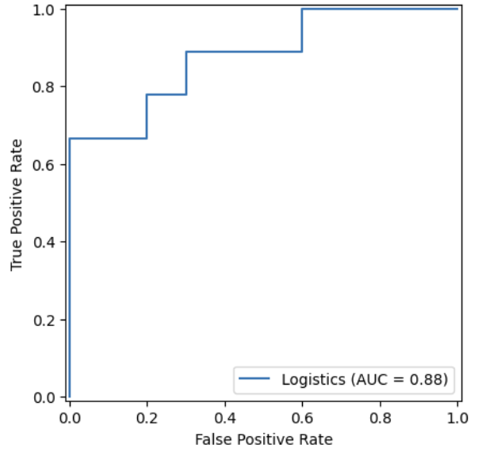
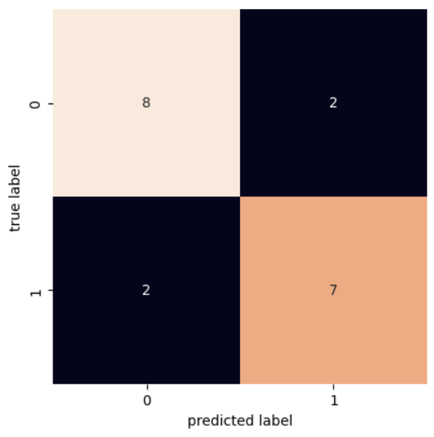
Finally, I evaluated the model on validation and test data sets using common classification metrics (accuracy, precision, recall, and F1 score), generated the confusion matric and plotted the ROC Curve with the AUC value.
Figure 1: Logistic Regression ROC Curve
Figure 2: Logistic Regression Confusion Matrix
The results of the confusion matrix show the validation AUC of 0.966, and test AUC of 0.844 which indicate that the logistic regression model is performing well and can distinguish between class 0 and class 1 effectively. The slight drop in AUC from validation to testing is expected and suggests mild generalization loss but not overfitting. The ROC curve rises smoothly toward the upper-left corner, showing strong true positive rates across thresholds and confirming that the model is reliably separating positive and negative cases. Overall, the model demonstrates good predictive performance and remains stable when evaluated on unseen test data.
Part B – Non-Logistic Model
For the non-logistic model portion of the assignment, I chose a Random Forest classifier. This is a tree-based ensemble method that builds decision trees and then averages their predictions. This model is known to be very accurate, reduce overfitting, and can handle large datasets. However, it requires more computations and therefore more time to run, and the results can be more difficult to interpret. I used RandomizedSearchCV with 5-fold cross-validation and tuned hyperparameters such as the number of trees, tree depth, node split, and max features.
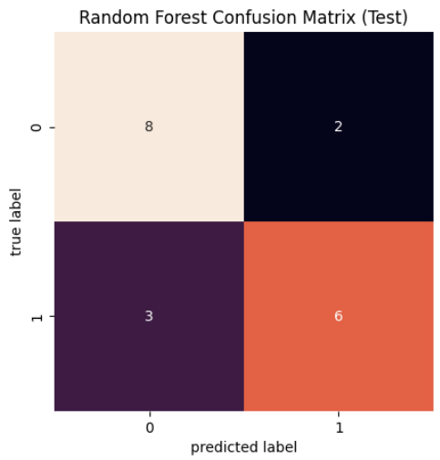
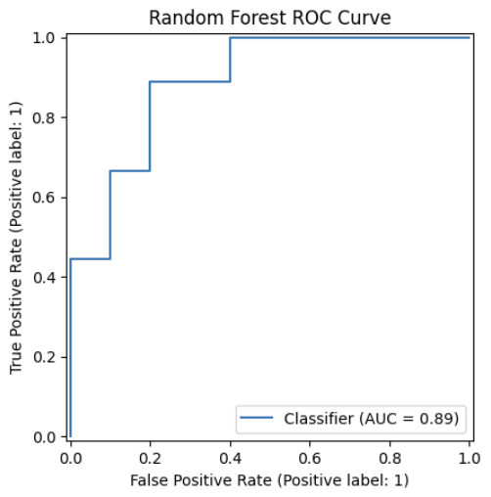
The model performed well and had a validation AUC of 0.95 and a test AUC of 0.89. This indicates strong generalization and good separation between positive and negative classes. The confusion matrix shows that the model correctly predicted most cases and only had a few misclassifications. The ROC curve shows that the model maintains a high true positive rate.
Figure 4: Random Forest ROC Curve
Figure 3: Random Forest Confusion Matrix
I didn’t have any particularly difficult challenges when training this model from the practice and labs that we had done previously to the assignment.
Discussion
Both models performed well, but their strengths varied in different areas. The logistic regression model had strong validation performance and produced stable, interpretable predictions. The random forest model found more complex patterns in the data and had a slightly higher test performance. It better identified the positive classes and more strongly separated the classes.
Summary Table: Performance comparison between two models
 | Model 1 – logistic regression | Model 2 – non-logistic
AUC for Training | 1.0 | 0.997
AUC for Validation | 0.966 | 0.955
AUC for Testing | 0.844 | 0.889
If I were to discuss my results with a business partner, I would explain that both models perform well and make good predictions. However, the random forest model is better at finding more patterns in the data that are difficult to catch. While the logistic regression model may provide clear reasoning behind its predictions, the random forest model delivers more accurate results.

