**Python Virtual Environment**

**Topics:**

1. What is Python Virtual Environment?
2. Why do we need Python Virtual Environment?
3. How to create a Python Virtual Environment?
4. Packages installation
5. Execute a program against Python Virtual environment
6. Configure python script in Autosys to run against virtual environment
7. **What is Python Virtual Environment?**

A cooperatively isolated runtime environment that allows Python users and applications to install and upgrade Python distribution packages without interfering with the behavior of other Python applications running on the same system.

1. **Why do we need Python Virtual Environment?**

Project-A and Project-B are two independent projects and both has dependency on a package "lib-A" however Project-A is depending on "lib-A V1.0" and Project-B is depending on "lib-A V2.0" in such case there is no easy way to differentiate as all site packages are being saved at the same location, Thus, Both projects would be required to use the same lib version which is unacceptable in many cases. That’s we need an intelligent way to handle this problem.

**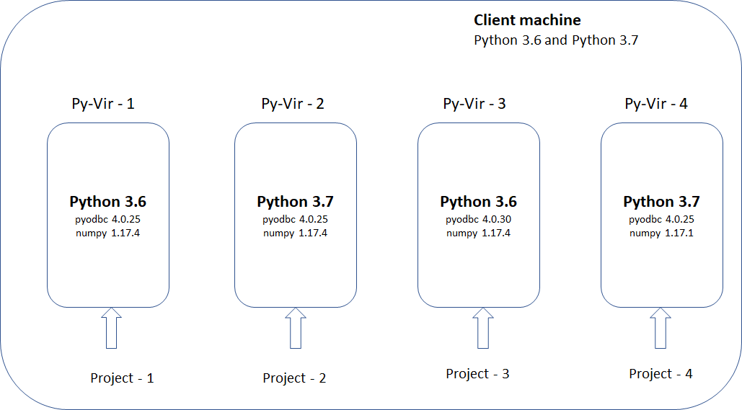**

1. **How to create a Python Virtual Environment?**

Use CD or PUSHD commands to change into the directory where you wanted to create the Virtual environment.

Command: "**python -m venv <Suneel-Python\_vir>"**

Machine generated alternative text:
H: \SUNEEL\PYTHON>python -m venv Suneel-python_vir 
H: \SUNEEL \ PYTHON> 

Machine generated alternative text:
Suneel- Python_vir 
nclude 
v Lib 
site- packages 
pycache 
pip-g.O.I .dist-info 
pkg_ 
setuptools 
setuptooIs-28.8.O.dist-info 
tc18.6 
Scripts 

**Activating the virtual environment:**

Command: “**Suneel-Python\_vir\Scripts\activate**”



1. **Packages installation**

**Command:** Pip install <pckgname>

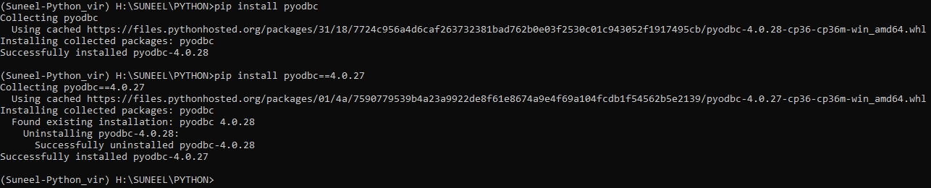

**Find out the packages installed in your VE**

**Command:** pip list

Machine generated alternative text:
(Suneel 
Package 
PI p 
pyodbc 
Python_vir) H: \SUNEEL\PYTHON>pip list 
setuptools 
Version 
19.3.1 
4.8.27 
28.8.ø 

pip freeze will produce a similar list of the installed packages, but the output uses the format that pip install expects. A common convention is to put this list in a requirements.txt file:

**Command:** pip freeze > requirements.txt

Machine generated alternative text:
(Suneel-python_vir) H: \SUNEEL\PYTHON>pip freeze > requirements . txt 
(Suneel-python_vir) H: \SUNEEL\PYTHON>type requirements . txt 
pyodbc==4.8.27 

**Install packages listed in requirements.txt**

**Command:** pip install -r requirements.txt



**Deactivating the virtual environment:**

Command: **“deactivate“**



1. **Execute a program against Python Virtual environment**

Provide complete path of newly created python virtual environment and supply the python’s file full path as parameter to execute the program.

**Command: <**Vir Python path> <python script path>



1. **Configure python script in Autosys to run against virtual environment:**

If you’ve created your virtual environment in your local machine and wanted to push the entire folder to another location for executing an Autosys job then please make sure you update the **activate.bat** located at “Suneel-Python\_vir\Scripts\”

**Example:**

VIRTUAL\_ENV=”[\\houdev01\apps\Analytic\SUNEEL\_APT\_2020\Suneel-Python\_vir](file:///\\houdev01\apps\Analytic\SUNEEL_APT_2020\Suneel-Python_vir)”

insert\_job: PNC-CPRK-INVLDN-APT\_2020-TRAINING job\_type: c

command: "\\houdev01\apps\Analytic\SUNEEL\_APT\_2020\Suneel-Python\_vir\Scripts\python.exe" "\\houdev01\apps\Analytic\SUNEEL\_APT\_2020\test\_python.py"

machine: vir-equity-2016

owner: ushou-asyswdv@corp

permission:

description: C\*\*\*\*L\*\*\*\*} Test job for Python training

term\_run\_time: 60

std\_out\_file: \\houdev01\apps\Analytic\SUNEEL\_APT\_2020\LOGS\TRAINING.out

std\_err\_file: \\houdev01\apps\Analytic\SUNEEL\_APT\_2020\LOGS\TRAINING.err

alarm\_if\_fail: 1

group: 7c5eef3dd9e52d807d1833ec9dac23ec

1. **Process to access Autosys non-prod server:**

Autosys team(EST) allowing us to access our project’s non-production Autosys servers and create virtual environments as per our requirement. The build solution can be used to run your scripts in production environment. This would avoid asking any package installation as you will have control over your virtual environment.

* 1. Create an l-account(Ex: “l-arasas”) for yourself by submitting a service request in ServiceNow
  2. Add your l-account to the AD group: “CORP\USHOU-G-App-VC Autosys General Developers”
  3. Configure your l-account in Cyber ark [**https://cyberark.prd.invesco.net**](https://cyberark.prd.invesco.net)
  4. Loginto VSphere using your l-account credentials <https://usvmivcsalp101.corp.amvescap.net/ui/#?extensionId=vsphere.core.tasks.domainView&forceNavigate>
  5. Launch your Autosys Server from the console.