Step 1:

Execute the python script Bibtex_Comparator.py

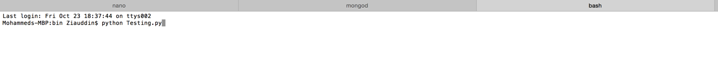

Step 2:

Select the local file and the master file

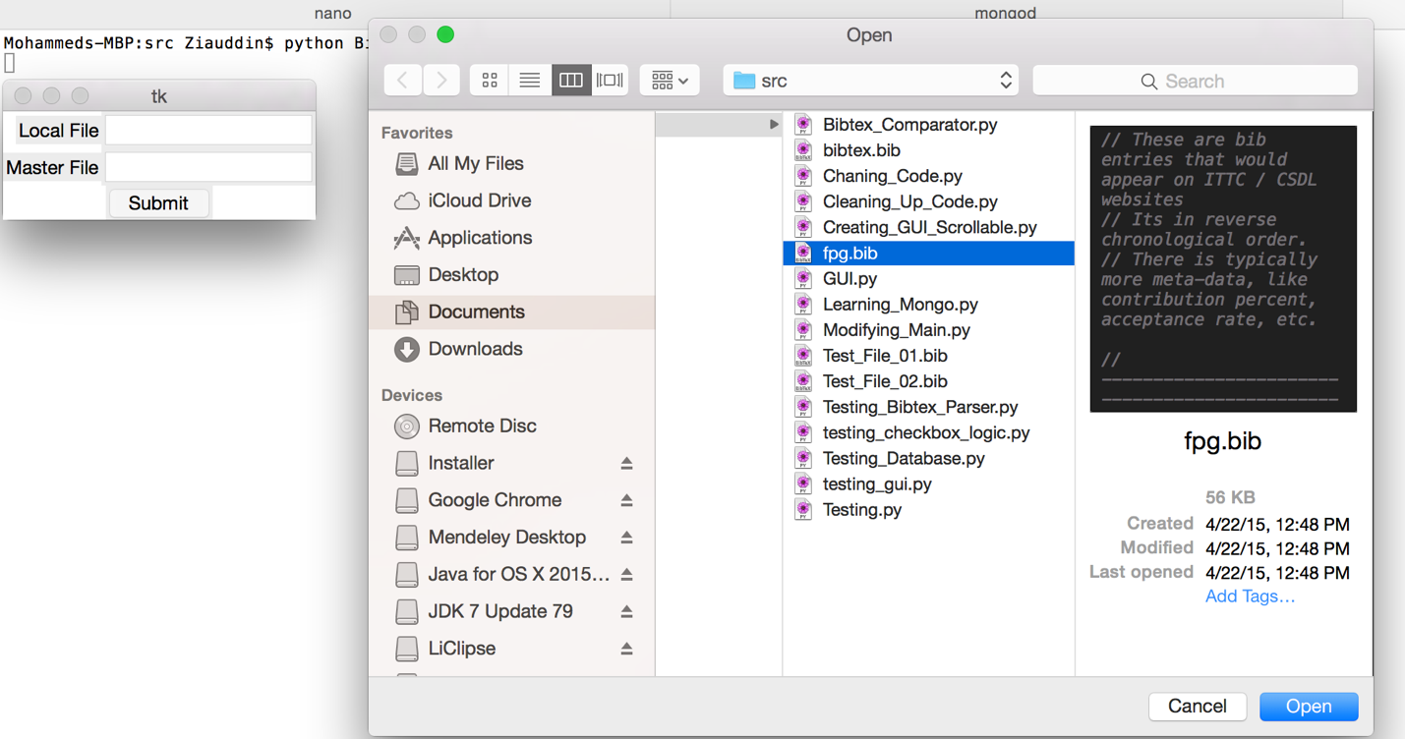

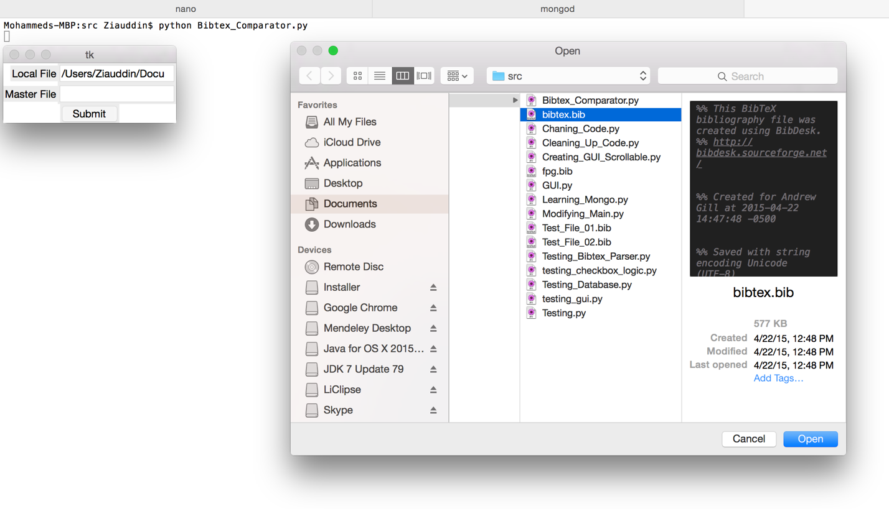

Press the submit button.

Step 3: Select the changes to be made to the local file

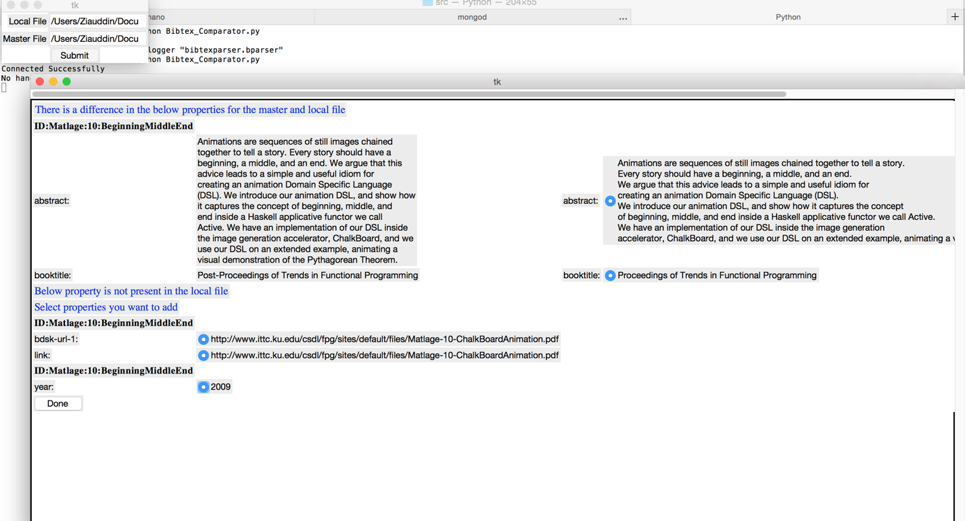

Press done.

Step 4:

To verify whether local file was updated repeat steps 1-2.

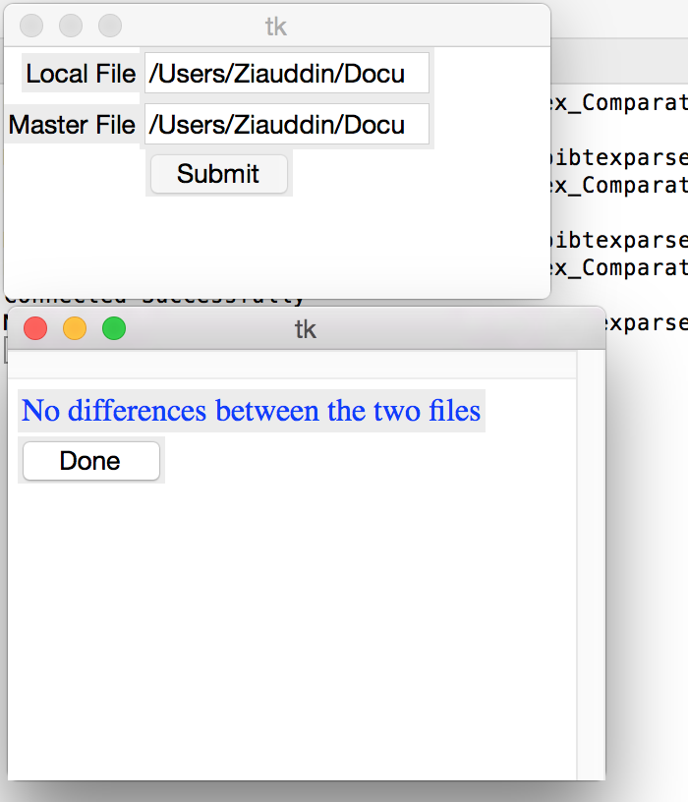

A dialog box is displayed which shows the message “No difference between the two files “

Note:

Files used here can be found in the bibtex files folder