OpenDXMC

07 February 2016

Erlend Andersen

erlend.andersen@sshf.no

## Introduction

OpenDXMC is a Monte Carlo application to estimate radiation doses from conventional x-ray and CT examinations. The application consists of a dose scoring library and currently a GUI to easily import and set up dose simulations of CT scans. A GUI to estimate doses from conventional radiographs is planned in the future. Currently the application allows for dose simulations on patient images by importing a CT series, only DiCOM images are supported. In addition, phantoms from the Virtual Human Database created by [Helmholtz Zentrum research center](http://www.helmholtz-muenchen.de/en/amsd/service/scientific-services/virtual-human-database/) (<http://www.helmholtz-muenchen.de/en/amsd/service/scientific-services/virtual-human-database/>) are supported. The application is still in early development, so there are some issues to be aware of:

* Maximum tube potential to simulate is 150 keV, and limited by the photon spectrum generator.
* No Bowtie filter is currently modeled, if CTDIvol is used to normalize simulated dose the dose will be overestimated. However, CTDIair will give more accurate estimates.
* BUG: After cancelling a simulation the application will not start a new simulation. It will however resume a new started simulation after restart.
* AEC profiles are currently not implemented for digital phantoms.
* The Monte Carlo Code is not yet validated

### Overview of the CT User Interface

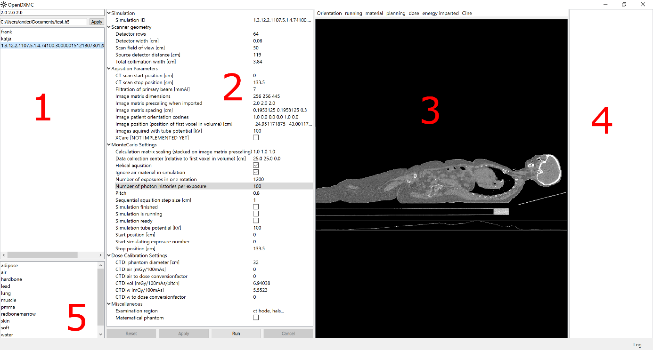

1. List of imported DiCOM series or phantoms, to import images/phantom drag a folder containing the items into this list.
2. Available simulation and scan properties for the current simulation.
3. Viewport to visualize CT images, tissue material composition, energy imparted and doses. Change orientation by the Orientation button, view through the stack by the mouse scroll wheel. Obtain an image of the current view by dragging from the viewport. To use the Cine function to generate a movie of the current view, [ffmpeg](https://www.ffmpeg.org/) needs to be installed and available from your PATH variable.
4. List of organ doses, this will however only be populated if the simulation is on a digital phantom.
5. List of default materials available, it is possible to add new materials, see the materials chapter.

## Implementation Details

To run a Monte Carlo simulation of a CT scan some preprocessing of the original data is necessary. Typically the array of CT numbers must be converted or transformed into a material array, where the attenuation coefficients for each material at relevant energies are used in the simulation. Another concern is memory usage. To make the Monte Carlo simulation fast enough to be of practical use, the whole 3D dose array and material array needs to be loaded in memory. While computers today typical have plenty of memory, a 32bit system/OS[1] limits available memory for an application to less than 2GB. If using the 32bit version of OpenDXMC, it is recommended to downscale the imported CT series if it consists of many slices. The text field above the simulation list 1) allows setting an import scaling for each axis of the imported CT series[2]. Similar a downscaling of the dose array may also be set in the field “Calculation matrix scaling” under available scan/simulation properties.

### Database

A simple hierarchical database is implemented in OpenDXMC. The database is based on the HDF5 library/dataformat using PyTables, the database can easily be viewed in the [viTables](http://vitables.org/) application, a sister project of the PyTables library. The field directly above the displayed simulation list allows for changing or creating a new database.

### Available Materials

Attenuation coefficients for various materials included in OpenDXMC is obtained from the [NIST XCOM database](http://www.nist.gov/pml/data/xcom/). Standard materials included in the application are imported into the database when it is created. The included materials file can be found in

path_to_opendxmc_package/opendxmc/data/materials/

To add additional materials an attenuation file needs to be created. Name the file your_material.txt in lowercase letters and copy it to the attinuation folder. Edit the file densities.txt to include your material and the nominal density in grams per cm3 [g/cm3]. To allow the material to be used when segmenting CT numbers to materials, the file organics.txt must also include the added material name. Note that new materials will only be imported when creating a new database, however importing new materials is planned to be easier in future updates of the application.

### X-ray spectrum generator

An x-ray spectrum generator is implemented in OpenDXMC to generate a photon spectrum from a tungsten-only target. The available energies range from 50kVp to 150kVp tube potentials. The spectrum is generated by the methods developed by G. G. Poludniowski et al (1) (2). Essentially, electrons hitting the tungsten target is modeled by a forward- and back-propagating probability density functions allowing a more accurate calculation of electron penetration depth in a tungsten target. A Modified Elwert-corrected Bethe Heitler cross section for bremsstrahlung emission is used to estimate the spectrum intensities for each energy interval.

### Segmenting CT series to obtain material array

Monte Carlo simulations is not done on the original CT data, but requires segmentation of CT numbers into materials with available attenuation coefficients. This is done by simple thresholding where each threshold interval corresponds to the estimated CT number for each material. The average attenuation intensity for each material is given by:

Where is the specter intensity at photon energy , is material density. The corresponding CT number for a material is then:

The intersection between the materials CT numbers is then used as threshold values in the segmentation.

### Monte Carlo implementation

The current Monte Carlo photon transport implementation is fairly naïve in the sense that no advanced variance reduction techniques are used. However basic Woodcock tracking (3) is implemented to reduce computation time. As in all Monte Carlo computations the calculation relies on a pseudo random number generator (PRNG) that is reasonable fast but more importantly have a long period before repeating itself. OpenDXMC uses the xorshift128+ algorithm with a period of about 2128.

When starting a simulation the estimated shortest free path of a photon is calculated, as this is needed to apply Woodcock tracking. A photon is then randomly drawn from a source, where the photon’s direction is uniformly distributed inside the beam collimation. The photon energy is randomly sampled according to the specified spectrum. The mean free path to a photon in a homogeneous media is given by where μ is the total mass attenuation coefficient for the medium. A step length before the photon interacts can then be sampled by

where s is the step length and r is a random number between (0, 1). In a heterogeneous media the step length may be drawn from:

Where is the largest total mass attenuation constant for all materials. An interaction after step lenght *s* is accepted by the probability

When an interaction occurs, the type of interaction is drawn from the attenuation coefficients of Rayleigh scattering, Photoelectric effect and Compton scattering. In case of photoelectric effect or Compton scattering the absorbed energy deposited at the current voxel. The Compton scattering kinematics is similar to the Geant4 implementation (4). For Compton scattering events three random numbers in the interval (0, 1) are drawn. The scatter angle and energy are drawn from the Klein-Nishina differential cross section. The minimum scatter photon energy fraction is given by

The Klein Nishina cross section may be written as

Where is the scattering angle and

*If* use else use *.* Now sample the distributions*:*

* For
* For

Nowwhere

If the scattered energy fraction and scatter angle is accepted, else draw three new random numbers and start over.

The angular distribution for Rayleigh or coherent scatter is simplified in OpenDXMC. The differential cross section for coherent scattering is given by:

Where is the atomic form factor and where is the photon energy in electron volts. may be measured experimentally or calculated for a material compound (5). Rayleigh attenuation coefficients are small compared photoelectric effect and Compton scattering for diagnostic energy levels except for very low energies where the form factor does not affect the angular distribution. In water the ratio of coherent cross section to the total cross section for 10keV and 30keV photons is about 6% and 0.8%. To avoid tabulating atomic from factors the coherent scattering angle is sampled according to with an isotropic from factor, see Figure 1. This means we will underestimate the forward scattering component for photon energies above 5 keV. However the impact on dose scoring for the approximation is assumed to be small due to the small ratio of coherent cross section to the total cross section. A validation of the current implementation will be performed in the future.

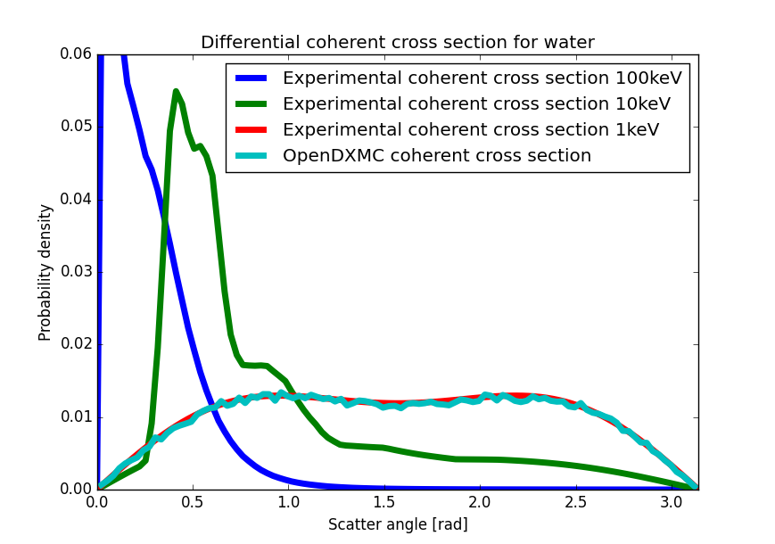

Figure 1 Differential coherent cross sections for water. The differential crossection in OpenDXMC is sampled independent of photoen energy.

The sampling of coherent scattering is implemented in OpenDXMC accordingly:

Draw a random number *r* in the interval (0, 1). Then scatter angle is sampled as

The distribution of 50,000 coherent scatter angle events is illustrated in Figure **1**.

# References

1. **Poludniowski, Gavin George and Evans, Philip M.** Calculation of x-ray spectra emerging from an x-ray tube. Part 1. Electron penetration characteristics in x-ray targets. *Medical Physics 34.* June 2007.

2. **Poludniowski, Gavin George.** Calculation of x-ray spectra emerging from an x-ray tube. Part 2. X-ray production and filtration in x-ray targets. *Medical Physics 34.* June 2007.

3. *Techniques used in the GEM code for Monte Carlo neutronics calculations in reactors and other systems of complex geometry.* **Woodcock, E., Murphy, T., Hemmings, P., and Longworth, T.** s.l. : Conference on the Application of Computing Methods to Reactor Problems, ANL-7050, 557--579, 1965.

4. *Geant4 Physics Reference Manual.* CERN : s.n., 2015.

5. **Peplow, D. E. and Verghese, K.** Measured molecular coherent scattering form factors of animal tissues, plastics and human breast tissue. *Phys. Med. Biol.* 43, 1998.

1. This is mostly applicable to MS Windows operating systems.
2. A benefit to downscale the image array is a notable decrease in simulation time.