Problem
Measuring the drone distance from the camera.
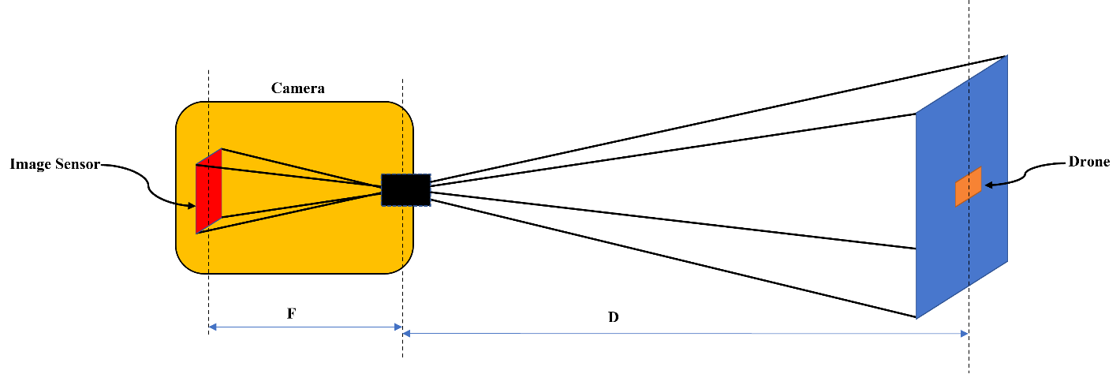
Figure 1: Schematic of problem
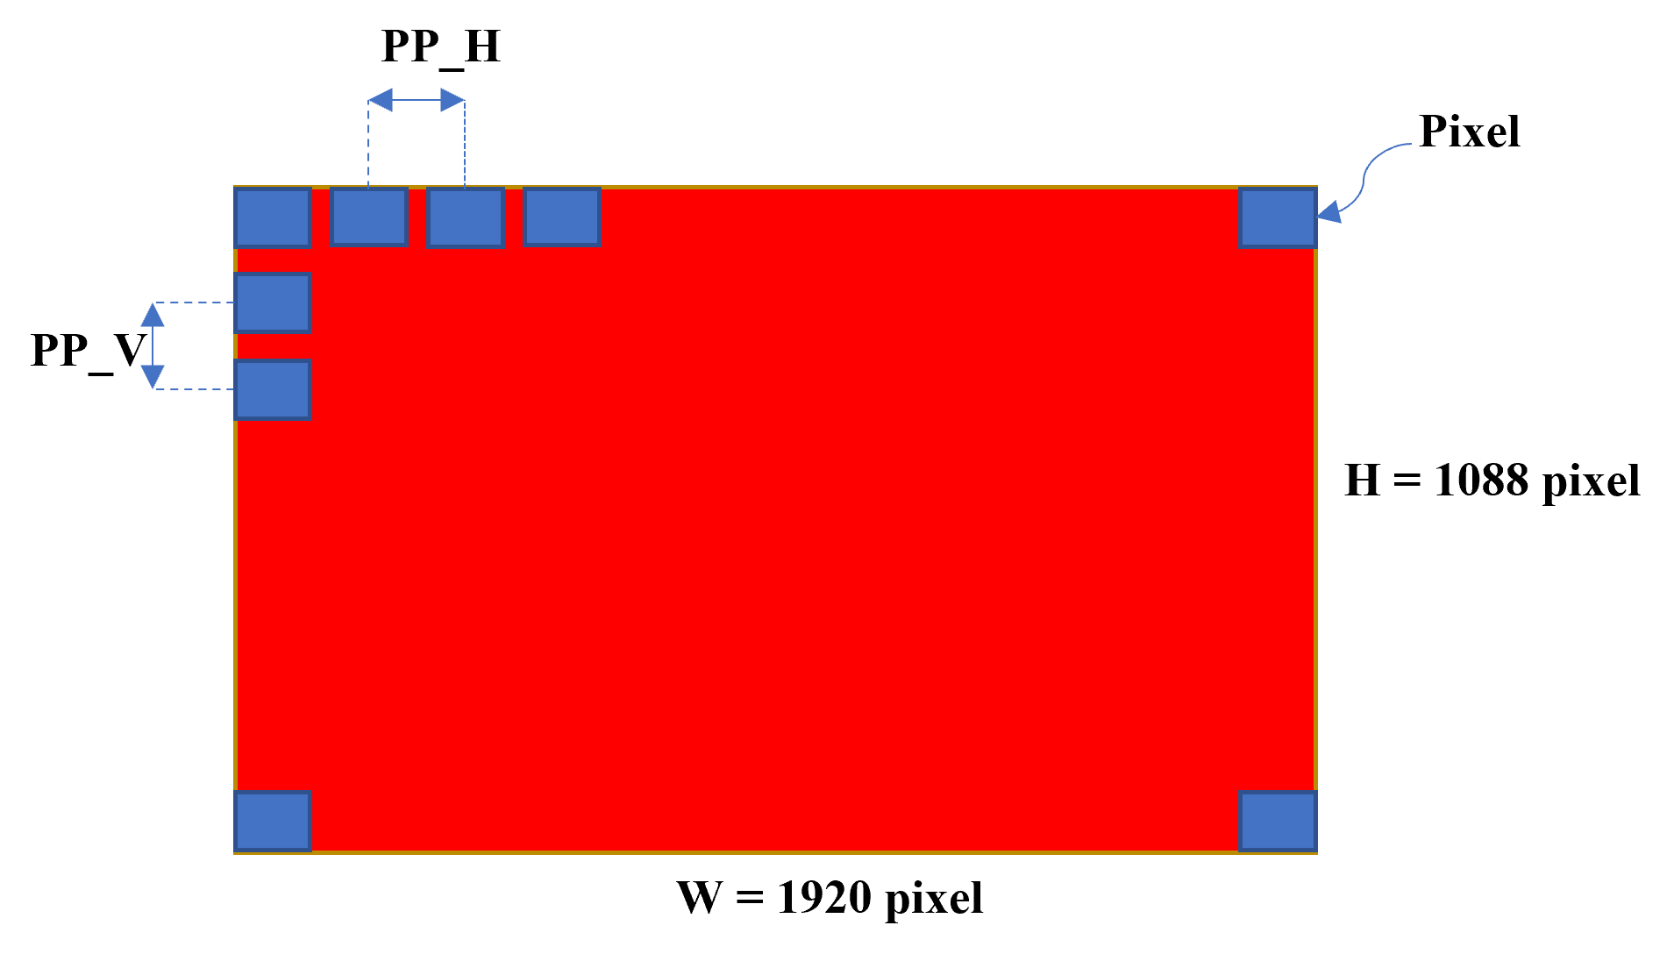
Figure 2: Image sensor
Solution:
Table 1: Nomenclature
Image Sensor Height
Image Sensor Width
Horizontal Pixel Pitch
Vertical Pixel Pitch
Captured Image Width
Captured Image Height
Horizontal Field of View
Vertical Field of View
Focal Length
Drone Width in Reality
Drone Width in Captured Image
Number of the Drone Pixel in Captured Image
Distance of Drone to Camera
As it is obvious from Figure 1,

From Eq. 1 and 4,

Also, from planar geometry

From Eq. 5,

From Figure 2, it can be derived that,

From Eq. 5, 7, and 8,

With a bit simplifying,

In this problem, the number of drone pixels (N) was known, however, if we didn’t have any information about N, then, it must be calculated with the help of image processing methods. After detection of drone in the image this number can be easily calculated and used for measuring the distance.
Code Description
This code has been implemented in Python. There are six different functions.
- readJson: To load json file (annotation.json).
- droneOrientation: To extract the dimensions of the rectangle enclosed to the drone.
- droneImage: To illustrate the position of drone and enclosed rectangle (Figure 3).
- distanceCaclulation: To calculate distance of the drone from camera.
- addJson: To append value of distance to existing json file.
- main: To call other functions and run the program.

- Note 1: In “dunder” if condition, the main function has been called.
- Note 2: Initial condition of “line 47” is disable, however, if you want to see the drone image with enclosed rectangle for every image, you can enable this line.
- Note 3: In main function and “line 78” you can define the number of images that you want to check. If you want to check all of the images in “img” folder, define imageNumber = 462
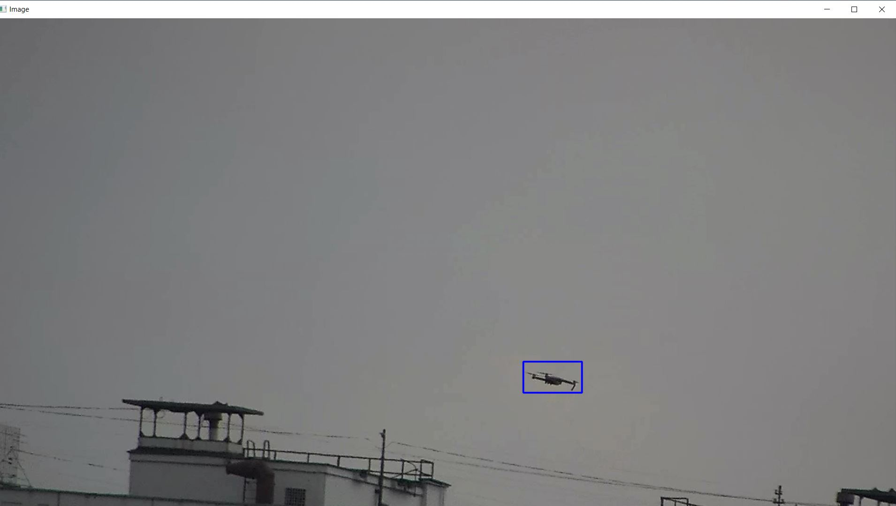
Figure 3: Output of droneImage function

