Girt bash downloads

<https://git-scm.com/downloads>

**git clone url ---------------------- clones the project from server to local**

**cd url (webdesignusingReacjs)------------------ entry into the url folder of the cloned url**

**cd webdesignusingReacjs --------------------- view into the cloned url**

**git config –list secure entry into the git**

git config --global user.name “swamykankipati”

git config --global user.email “[ka507@gmail.com](mailto:ka507@gmail.com)”

**touch text1 addition of file into the folder**

**Text1 Text2**

**ls   ,ls -a addition of the files**

**git  add filename.extenstion adding oF FILES**

git  add --all

Save commit

git  commit -am “added firstday files”

git log

git push origin main

git log --oneline

Git checkout 8digcode

# creation of repository in github

Go to the <github.com> and click on **+** symbol to create the new repository as seen the screenshot below

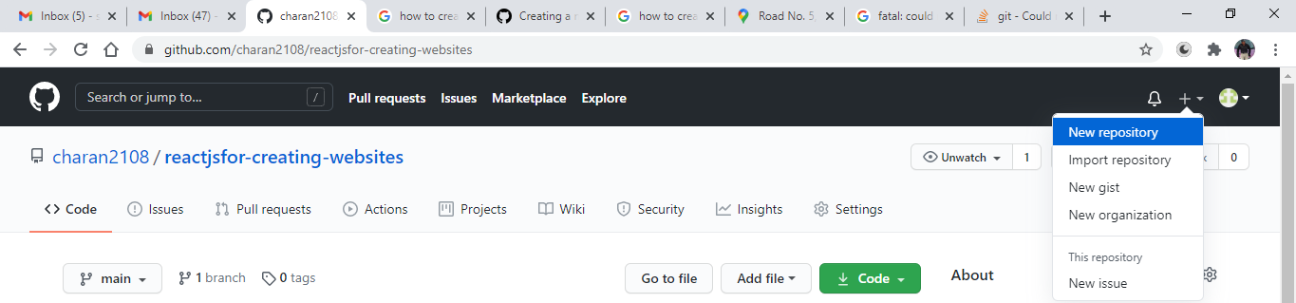

After clicking on the new repository and you will go into the following repository and name the repository as reactjsfor-creating-for-websites

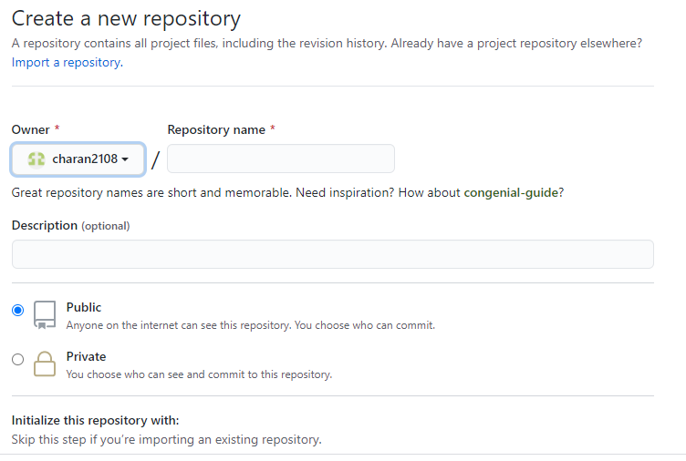

And select the public or private as per requirement and tick mark the add a readme file and click the button to create the repository

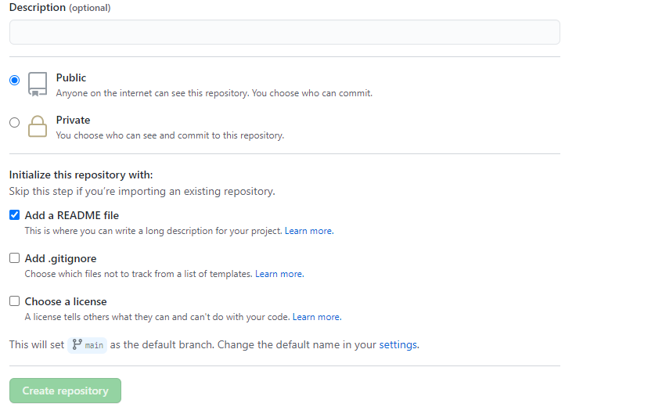

After creating the repository the following looks like the following in below screenshot

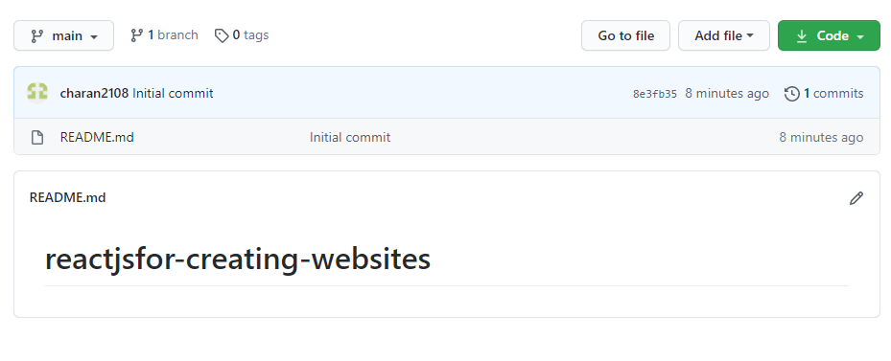

# connecting or creating the local file in the desktop via github

First type in the command **cd** and hit the enter and the following appears as



Now type the following command to clone the repository in the local

**Git clone and the url created in the github**

**Git clone** [**https://github.com/charan2108/reactjsfor-creating-websites.git**](https://github.com/charan2108/reactjsfor-creating-websites.git)

And press the enter and the following folder reactjsfor-creating-websites

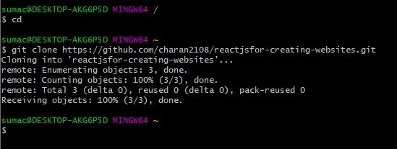

the folder is created in the drive which is default

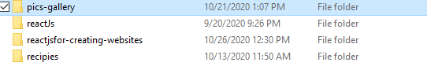

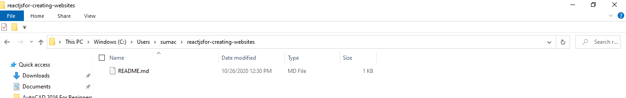

# entering into the folder

Use the following command to enter into the folder as given below

**cd url (webdesignusingReacjs)(example)**

**cd reactjsfor-creating-websites**

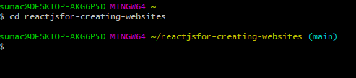

# git configuration of the user

Use the following for the configuration of the git command and and check ur account is configured

**git config --list**

git config --global user.name “abcd”

git config --global user.email “[abcd@gmail.com](mailto:abcd@gmail.com)”

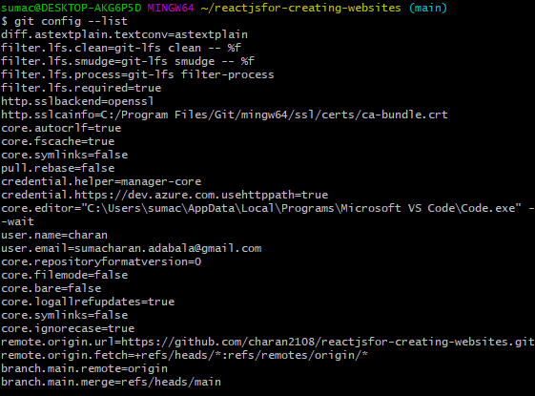

# Addition of text i github

**Touch text1**

Using the following command we add the text into the github repository and the file is added

