

**FINAL REPORT**

**SMART ESCAPE FIRE SYSTEM**

**Group 11**

**Nguyễn Lâm Quốc Tỷ**

**Hứa Nhật Quang**

**Nguyễn Tuấn Huy**

**Đặng Thạch Long**

**Contents**

**1. Introduction**

**1.1 What is Smart Escape Fire system?**

**1.2 Purpose**

**1.3 Product scope**

**2. Overall Description**

**2.1 Product perspective**

**2.2 Product function**

**2.3 User Classes and Characteristics**

**2.4 Operation Environments**

**3. Design**

**3.1Scrum Board**

**3.2 GUI**

**3.3 UML Diagram**

**3.4 Database Diagram**

**4. Features**

* 1. **Detect fire and alarm**

1. **Introduction**
   1. **What is Smart Escape Fire System**

Smart Escape is an early detection and warning system for high-rise buildings. It can notify users about emergency situations when a fire occurs, as well as monitor the victim's location inside a fire and provide information on the escape directions in a building. In addition, the system also provides data, information on victims, the situation of continuous fire for the management to give the right response.

* 1. **Product Scope**

Smart Escape can be used together with surveillance cameras installed in buildings, apartments, hotels, shops, etc., where fire incidents can be detected as quickly as possible, to reduce minimal damage.

* 1. **Purpose**

• Early detection and warning of a fire.

• Provide surveillance, follow up the situation and rescue victims quickly.

• Minimize loss of life and property.

1. **Overall Description**
   1. **Product perspective**

Smart Escape is a system for early detection and warning of fire in high-rise buildings, and provides escape solutions, managing the victim's condition to respond promptly to a fire.

* 1. **Product function**

On the management side:

• Receive alerts on fire locations on installed cameras.

• Send notifications to all users within the area of ​​a fire.

• Monitoring and statistics of the status and number of people in the area where a fire occurs.

On the user side:

• Receive fire alerts from management.

• Update your own safety status as required when a fire occurs.

• See safe exits in a fire area to escape.

• See current status of loved ones when there is a fire warning.

• Provide photos, update fire situation for management.

* 1. **User Classes and Characteristics**

User class:

• System management and monitoring department.

• Normal users.

* 1. **Operation Environments**

Surveillance camera

Android and iOS devices

1. **Design**
   1. **Scrum Board**

* 1. **GUI**

**Login**

**Main Screen**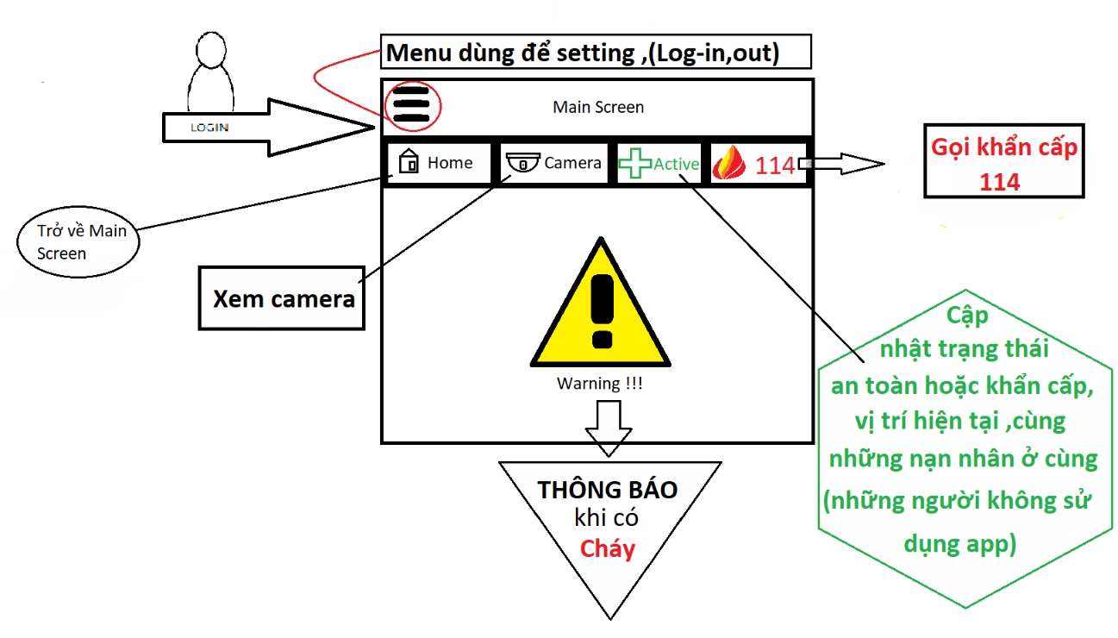

**Camera**

**Exit**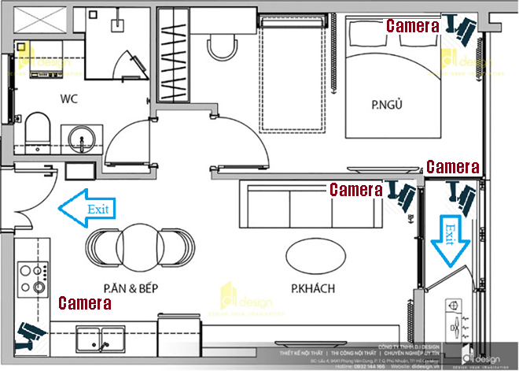

**Emergency Call**

**3.3 UML Diagram**

**3.4 Database Diagram**

1. **Features** 
   1. **Fire Detection and alarm**
      1. **Description**

**Manager:**

When fire appears in the scope of surveillance cameras, the system will pick up images and analyze them. If the predicted result is a fire, the system will send an image of the location, location and time of the fire to the manager.

**User:**

After the manager has confirmed that a fire has occurred and needs a warning, the system will send a notice to all customers around the building that are burning, and require everyone to update the safety status, Current position of each individual.

* 1. **Fire Detection**

Basically, the Computer camera is connected, as soon as any flame is fire detected it prints message as "Fire Detected". This message is than fed to Node-red which is running on Git-Bash and reply back with a audio message "Fire Detected".

**Use camera of computer to detect**

**Fire detected it and prints message on screen**

