1. **Scenario:** A retail company wants to design a data model to track product inventory, sales transactions, and customer information for their e-commerce platform. How would you approach designing the data model for this scenario?

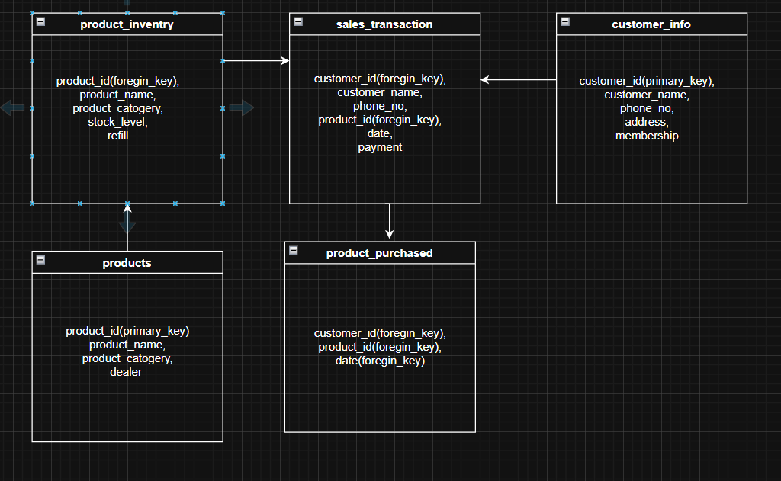***Hint:*** *Consider entities such as product, Inventory, Sales Transaction, Customer, and their relationships. Use normalization techniques to minimize data redundancy and ensure data integrity.*

2. **Scenario:** An online streaming service wants to improve its recommendation system by analyzing user behavior and preferences. How would you design a data model to capture user interactions, content metadata, and user profiles?

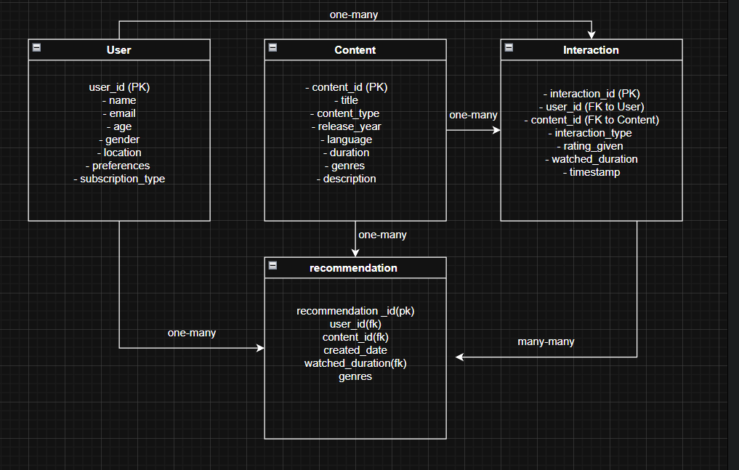***Hint:*** *Define entities such as User, Content, Interaction, and incorporate attributes such as user preferences, viewing history, and content metadata. Utilize techniques like collaborative filtering or content-based filtering for recommendation algorithms.*