

Callable bonds

Detailed explanation of the model and pricer



July 26, 2024

Deloitte Luxembourg

Author: Jiaqi Xia

Table of contents

Definition 2

Key Parameters: 2

Interest Rate Model 3

Choice of Instantaneous Interest Rate Model 3

Hidden Markov CIR model (HMCIR) 4

HMCIR Parameters 5

Model Calibration 5

Hyperparameters research 6

Interest rate paths simulation 8

Matching simulated Interest rate path with market swap curve 8

Pricing 9

Decision Agents 9

Callable Bond Pricer 10

Shocks and Repricing 11

Market Solvency Capital Requirement Calculation: 11

Interest Rate Shock 11

Spread Shock 12

Currency Shock 12

Performance 13

Accuracy 13

Computation speed 13

Literature review 13

## Definition

A callable bond, also known as a redeemable bond, is a bond that the issuer may redeem before it reaches the stated maturity date. A callable bond allows the issuing company to pay off its debt early. A business may choose to call its bond if market interest rates move lower, which allows them to re-borrow at a more advantageous rate. Callable bonds thus compensate investors for this potentiality by typically offering a more attractive interest rate or coupon rate due to their callable nature.

## Key Parameters:

1. **Market Value:** The current market value (price) of the bond in the portfolio.
2. **Face Value:** The face value or par value of the bond, which is the amount the issuer agrees to repay the bondholder at maturity.
3. **Redemption Rate:** The ratio of final pricinpal payment / Face value. Most of bonds have a remdemption rate of 1.
4. **Time to Maturity:** The time remaining until the bond matures, typically expressed in years.
5. **Coupon Rate:** The annual coupon rate of the bond, expressed as a percentage of the face value. This defines the periodic coupon payments made to bondholders.
6. **Coupon Frequency:** The frequency of coupon payments per year (e.g., semi-annual = 2, quarterly = 4).
7. **First Call Date:** The time until the bond can first be called (redeemed early) by the issuer.
8. **Notice Date:** The delay between when the bond issuer notifies the bondholder of the early redemption and the actual early redemption date. This is often set to 2 months.
9. **Call Price:** An array representing potential call premiums at different dates or conditions. This is the price at which the issuer can call the bond before maturity and is usually higher than 100. A call price of 103 at date means if the bond issuer wants to redeem at , they should pay .
10. **Implied Spread:** The spread over the risk-free rate that equates the present value of future cash flows (considering call options) to the current market value of the bond.
11. **Exercise Type:** The exercise type of the embedded call option. For simplicity here, we assume all bonds are Bermuda-type with exercise dates matching the coupon dates posterior to the first call date.
12. **currency:** The currency of the payments. This would indicate the exchange rate to use to convert bond value in instrument currency to portfolio currency. This also indicate which swap curve and historical interest rate dynamic to use. (See model calibration)

## Interest Rate Model

We aim to price a callable bond using Monte Carlo simulations of interest rate trajectories generated from a given instantaneous rate model. The issuer’s call decision is modeled by an agent making decisions based on interest rate levels and bond parameters. The final bond price is the empirical expectation of discounted future cash flows.

### Choice of Instantaneous Interest Rate Model

Upon analyzing online databases, it is observed that the classical Cox-Ingersoll-Ross (CIR) model does not accurately capture the evolution of long-term interest rates, as it assumes a fixed mean. This model underestimates the risks of paradigm shifts or interest rates deviating significantly from their initial mean values. In the short term, interest rates evolve as in the CIR model, but in the long term, multiple regimes with different means appear.

* United States Fed Funds Interest Rate (tradingeconomics.com)
* South Korea Interest Rate (tradingeconomics.com)
* ECB Data Portal for EURIBOR Rate (europa.eu)

I tested the three-factor model of Anderson & Lund (where both the volatility and the mean follow a mean-reverting stochastic process), which also allows modeling paradigm shifts but does not produce a discrete number of regimes. Therefore, we use the Hidden Markov CIR model (HMCIR), where each regime corresponds to a specific mean.

### Hidden Markov CIR model (HMCIR)

The Hidden Markov CIR (Cox-Ingersoll-Ross) model is a variation of the Cox-Ingersoll-Ross model, incorporating a hidden Markov chain to model regime switching. Here's a breakdown of the CIR model and how it can be extended to the Hidden Markov framework:

#### Cox-Ingersoll-Ross (CIR) Model

The CIR model is used to model interest rates or other mean-reverting processes. The standard stochastic differential equation (SDE) for the CIR model is:

Where:

* ​ is the process (e.g., interest rate, volatility),
* is the speed of mean reversion,
* is the long-term mean level,
* is the volatility parameter,
* ​ is a Wiener process (Brownian motion).

#### Hidden Markov CIR Model

In the Hidden Markov CIR model, the parameters of the CIR model () are assumed to change according to a hidden Markov chain. This allows the model to capture regime-switching behavior, where the process can transition between different states, each with its own set of parameters.

Let the hidden Markov chain be ​, with discrete states , and let each state correspond to a different set of parameters for the CIR process. The SDE in the Hidden Markov CIR model is:

Where:

* ​ is the Markov chain state at time ,
* ​​ are the parameters corresponding to the regime at time ,
* The transitions between different states are governed by a Markov transition matrix , with elements ​ representing the probability of switching from state to state .

#### Key Components

* 1. **CIR Parameters (Regime-Dependent)**: In each regime , the process follows a CIR model with parameters ​, and ​.
  2. **Hidden Markov Chain**: The chain ​ determines which set of parameters is active at any time, and the transitions between regimes are governed by the Markov chain transition probabilities .
  3. **Observation Process**: The process ​ is observed, but the state ​ is hidden.

### HMCIR Parameters

1. **:** Scalar, mean reversion speed assumed constant for all regimes for simplification.
2. **:** Vector representing the long-term means of each regime.
3. **:** Scalar, the volatility parameter of stochastic variations around the mean, assumed constant for all regimes.
4. **:** Transition probability matrix. (Expressed in probability / year)
5. **:** Initial rate.
6. **:** Initial hidden state.

### Model Calibration

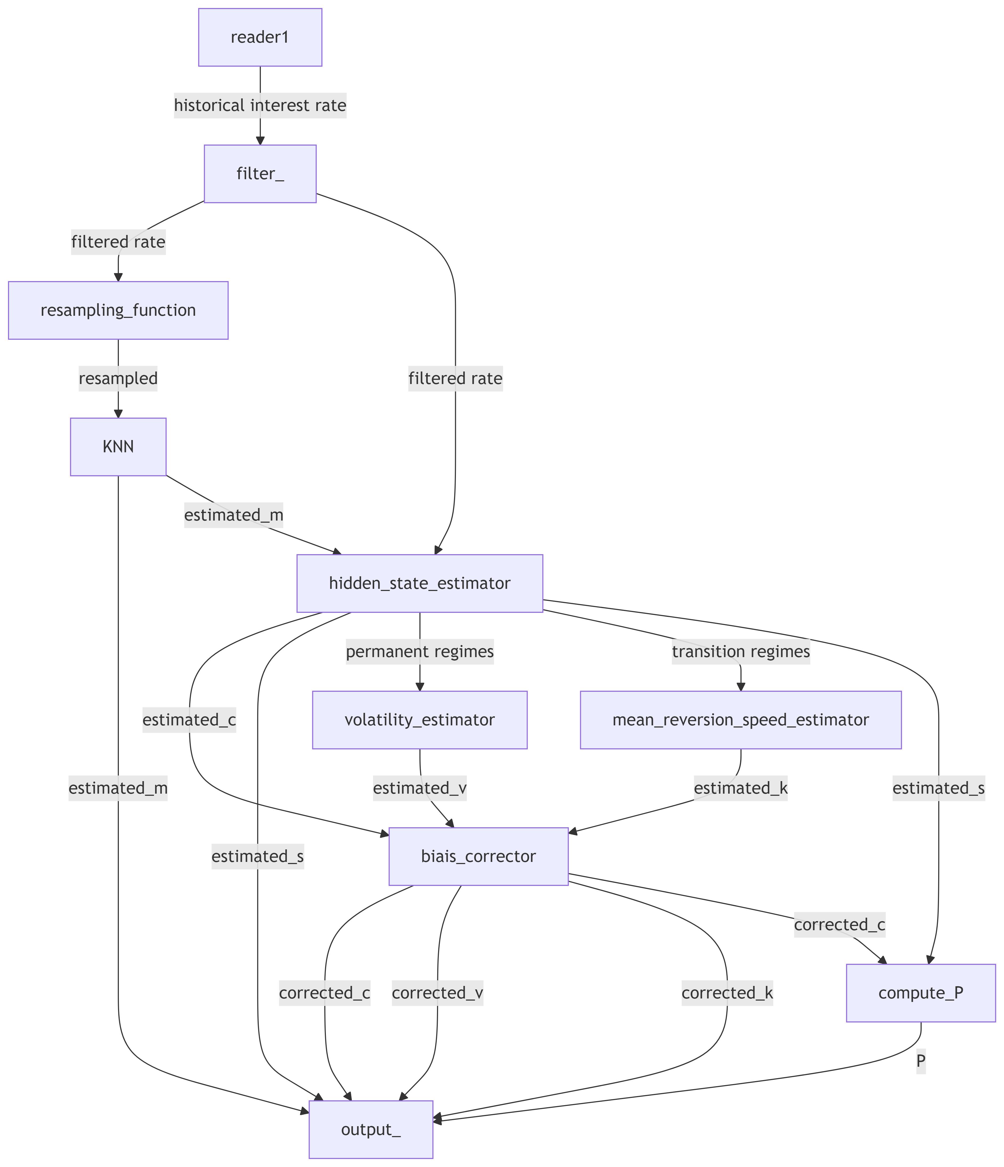

1. **Filter:**
   * The time series of instantaneous rates is filtered using a variable-size window that adapts to local volatility.
2. **Signal Resampling and KNN Estimation:**
   * The filtered signal is resampled, giving more weight to rare extreme points. This helps the KNN to estimate the mean levels of different regimes using K-Nearest Neighbors (KNN).
   * The number of neighbors, , is chosen as a compromise between minimizing distortion and ensuring significant level differences between regimes.
3. **Hidden State Estimator:**
   * The hidden state of each instant is estimated.
   * The parameter is estimated as the number of regime changes divided by the total duration.
   * The stationary probability is estimated as the frequency of visiting each regime.
   * The signal is divided into segments of transitional regimes and permanent regimes.
4. **Volatility parameter estimator:**
   * Volatility parameter is estimated in permanent regimes using linear regression.
5. **Mean reversion speed estimator:**
   * is estimated from the transition speed during transitional regimes using linear regression.
6. **Bias Corrector:**
   * The parameters undergo a linear transformation to correct biases.
   * This method ensures accurate estimation by adapting to local volatility, adequately weighing rare extreme points, and correctly dividing the signal into relevant segments for precise volatility and hidden state estimation.

### Hyperparameters research

The model estimator takes in argument several hyperparameters, such as window size for filtering, for resampling, maximum weight difference for resampling, penalization parameters in KNN, regime change detection threshold and bias correction coefficients. The hyperparameters are optimized by minimizing the pricing difference between using the paths of a true HMCIR model and the paths generated by a model estimated on the paths of the true model. This over many randomly generated models and callable bonds. The optimization can take more than 5 hours but is done once for all. For the moment the numerical values are hard coded in the implemented code.

#### Estimating the transition probability matrix

Estimating can be complicated as we have fewer identifiable jumps than parameters in the matrix. However, by imposing a certain stationary regime , defining an average number of jumps per year , and assuming a certain form for , it is possible to deduce .

|  |
| --- |
| How to compute |
| The constraints on are:   1. The sum of each row is 1: 2. is the stationary distribution of the Markov chain: 3. In the stationary regime, the probability of transition per step is :   These constraints are expressed mathematically as:  Let us assume has the following form:  is computed as follows:  With .  Thus, we have parameters for scalar equations. However, trying to solve this exactly could lead to numerical instability. Instead, we translate each constraint into a soft loss and solve this using numerical optimization. |

### 

### Interest rate paths simulation

By discretizing the HMCIR SDE, after fixing an initial rate and state, we simulate paths of steps over a time of years. ( )

The hidden state is not updated each step, but only a certain number per year with the matrix

The whole process is vectorialized to simulate paths in parallel.

### Matching simulated Interest rate path with market swap curve

When initializing the portfolio, we employ the HMCIR model to estimate the historical exchange rates for the most common currencies. For less frequently traded currencies, we use the USD model. We generate 200 trajectories for each currency.

In accordance with Solvency II regulations, interest rate instruments must be priced using market curves rather than historical data. Therefore, while historical rates provide the dynamic behavior, the market curve determines the average level of the trajectories.

To align the simulated paths with the market swap curves, we perform a normalization against three market scenarios: normal, shocked up, and shocked down.

Finally, each instrument is initialized with 200 paths of each type: unshocked, shocked up, and shocked down, according to its respective currency.

## Pricing

### Decision Agents

There is a list of decision agents sorted by increasing performance (ability to maximize bond issuer PnL):

1. **Random Agent:** This agent makes the decision to call the bond at each time step with a fixed probability (P).
2. **Excel Agent:** Replicates the method implemented in the Excel file (Test MC Callable Bond.xlsx). The bond is called when the coupon rate divided by the spot rate is less than the strike price divided by the nominal value.
3. **Short-term Fixed Rate Agent:** This agent buys back the bond if the discounted future cash flows at period (n), assuming buyback, are greater than those obtained in the case of buyback at period (n+1). This decision assumes that rates do not change in the interim.
4. **Short-term Rate Projection Agent:** Similar to the Short-term Fixed Rate Agent, but this agent makes a linear extrapolation of the rate evolution based on recent trends and uses this extrapolation to inform its call decision.
5. **Optimal Decision Agent:** A theoretical agent that maximizes the expected actualized value of future cash flows given all information till the present. Given all else equal, a pricer using this agent will provide the best approximation of the theoretical price. However, this does not eliminate other sources of error, such as model inaccuracies.
6. **Overpowered Agent:** This agent makes decisions knowing all the future interest rate trajectories until bond maturity, so it will always select the optimal time to call the bond. Thus, it would perform even better than the Optimal Decision Agent.

### Callable Bond Pricer

**Arguments**: *simulated interest paths, callable bond parameters, Decision Agent(function), hyper-parameters*

* 1. Calculate the time indexes corresponding to coupon dates and notice dates,
  2. For each path, initiate Bond value to 0.
     1. At each coupon date add the actualized coupon to the bond value. The actualization rate is the mean of the instantaneous rate from 0 to the coupon date + the implied spread.
     2. At each notice date the agent decides to call or not, if call, the cash flow (Coupon + principal) actualized at the next coupon date is added to the bond value. This bond value is retained as the bond price for the path.
  3. The final bond price is the average price of all paths.
  4. The pricer will also calculate the average call date, and if asked, plot the histogram of bond price of each path.

*Note:*

*In the test version where the Decision agent is an argument, it’s done with a loop. In the final version, when the agent to use is chosen, the whole process can also be vectorialized. This greatly increase time performance.*

## Shocks and Repricing

### Market Solvency Capital Requirement Calculation:

* Use the pricing algorithm backward (dichotomic research) to deduce the implied spread from the bond market price (provided by the client).
* Apply the different shocks listed in Solvency II (in this case, interest rate shock, spread shock, and currency shock).
* Use the algorithm forward with the shocked parameters to calculate the shocked price.

### Interest Rate Shock

Full repricing.

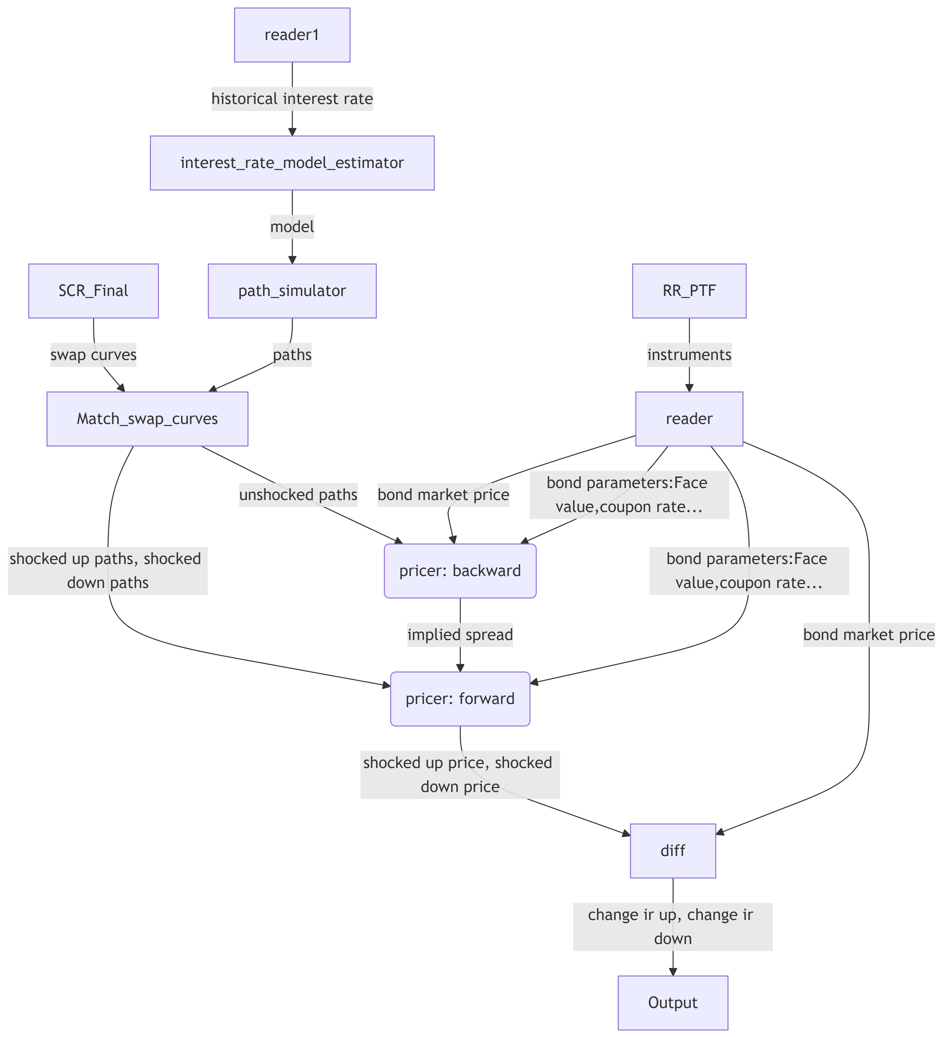

### Spread Shock

Full repricing.

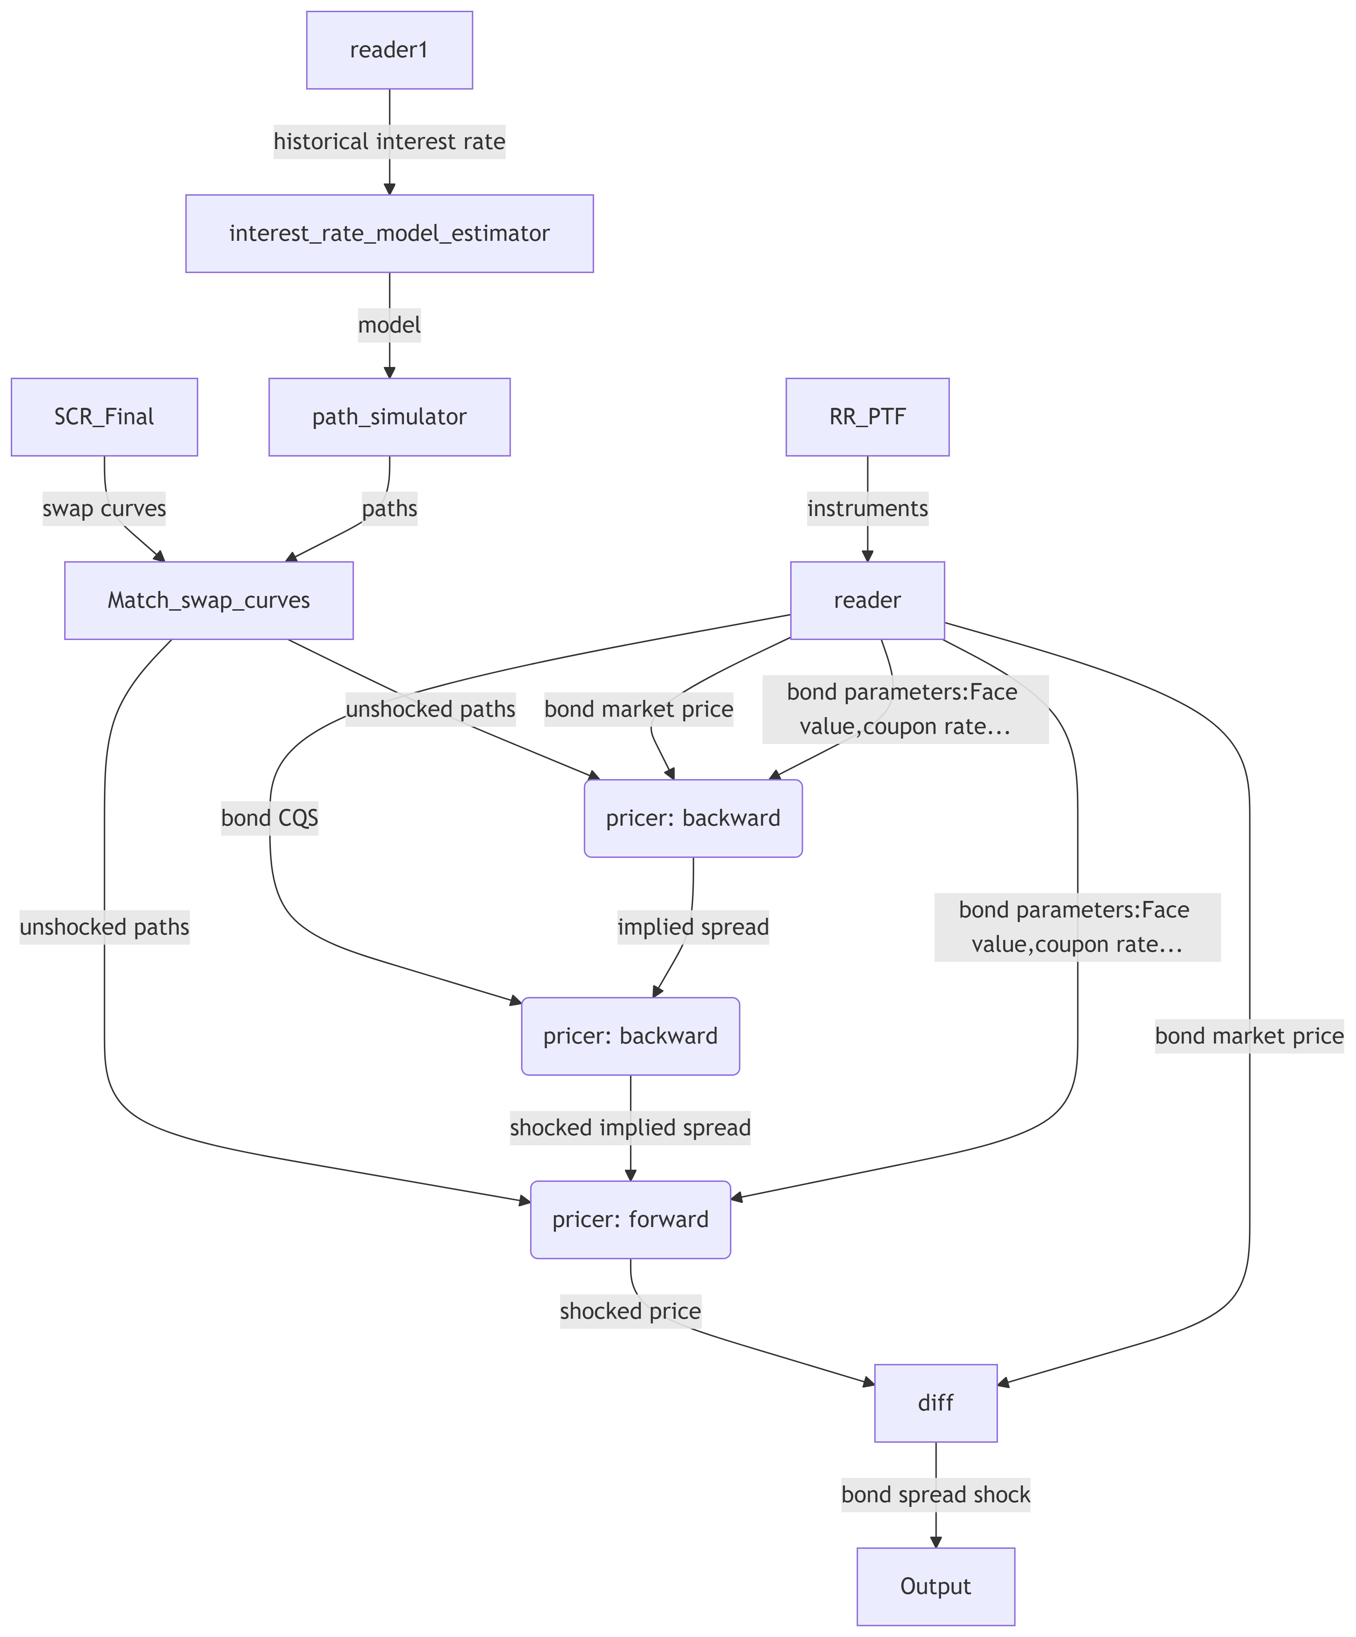

### Currency Shock

Linear repricing.

## Performance

### Accuracy

#### Errors due to Agent Choice

Tests with 1000 pairs of random bonds and random rate models show that the relative gap between the Short-term Rate Projection Agent and the Overpowered Agent is very small, and it seems to follow an exponential distribution with a mean of 1.4%. Since the optimal decision would yield a price between these two agents, both represent good approximations. For the following, we prefer to make a conservative choice by using the Overpowered Agent. This approach relies on fewer hypotheses and is more likely to underprice than overprice, which reduces the risk of overvaluation.

#### Errors due to Model Estimation

Tests with 1000 pairs of random bonds and random rate models show that the relative gap between pricing done with the historical interest path and paths generated by an HMCIR estimated on the historical path seems to follow an exponential distribution with a mean of 7%.

#### Variance Reduction

The result converges as we increase the number of paths used. In addition, we use the control variate technique to further reduce the variance. The control variate is chosen as the mean interest rate over time and over all paths. By default, we use only 20% of the given path for pricing; the rest is used to compute the control variate. This allows us to reduce the variance by 65% with nearly no additional computation.

### Computation speed

We tested on a portfolio of 53 callable bonds, and the whole process takes on average 1.2s per instrument. The simulation of interest rate paths for each currency takes a lot of time but is done once per run. For a larger input of around 20,000 instruments, the performance scales up and it takes 0.05s per instrument.

## Literature review

The CIR model: [Cox–Ingersoll–Ross model - Wikipedia](https://en.wikipedia.org/wiki/Cox%E2%80%93Ingersoll%E2%80%93Ross_model)

Using the Hidden Markov Model to Improve the Hull-White Model for Short Rate [588-FT0001.pdf (ijtef.org)](https://www.ijtef.org/vol9/588-FT0001.pdf)

Variance reduction [book_chap5.dvi (arizona.edu)](https://math.arizona.edu/~tgk/mc/book_chap5.pdf)

Annexe

**Focus sur l'Implied Spread et la Validation du Modèle**

1. **Introduction**

Considérons un modèle simple de valorisation obligataire, noté (m_0), où le prix est déterminé comme la somme des cashflows futurs actualisés. Le spread représente une compensation pour divers risques, incluant le risque de défaut, le coût d'opportunité, le risque de taux, etc. L'implied spread est la marge ajoutée au taux sans risque pour obtenir un taux d’actualisation qui donne le prix du marché. Une question se pose pour les callable bonds : doit-on inclure l'aspect callable dans l'implied spread ? À mon avis, non. Pour le calcul du SCR (Solvency Capital Requirement), des chocs de spread réglementés doivent être appliqués, ce qui requiert une cohérence dans la représentation du spread pour tous les instruments.

1. **Évolution et Implied Spread**

Pour les obligations classiques avec un taux de rédemption de 1 (le principal est payé à maturité et les coupons sont payés régulièrement), à l’émission, l'investisseur paie le prix du principal. À (T = 0), l'implied spread correspond au taux de coupon moins le taux sans risque selon le modèle (m_0). Au cours du temps, la valeur du bond peut évoluer de deux manières :

1. **Évolution intrinsèque liée au temps** : Due à l'accumulation des intérêts non encore payés. Si seule ce type d'évolution se produit, le spread reste constant.
2. **Évolution objective et subjective des risques** : Inclut un changement dans la probabilité de défaut, le coût d'opportunité, le risque de taux, ainsi que la valorisation subjective de ces risques. Ce type d'évolution peut entraîner des variations de l'implied spread au cours de la vie d'une obligation.
3. **Validation du Modèle**

La difficulté avec un modèle utilisant l'implied spread réside dans le fait que cette donnée n'est pas observable directement. Ainsi, tester la précision en comparant le prix du marché et celui calculé par le modèle est compliqué. De plus, ce modèle ne permet pas aux émetteurs ou acheteurs potentiels de calculer un prix "juste" sans une connaissance préalable de l'implied spread. Ces modèles permettent simplement de calculer l'implied spread à partir du prix du marché, sans garantir la véracité de cette correspondance.

1. **Modèle m1 et ses Limites**

Un modèle (m_1) utilisant l'implied spread en entrée calcule le prix à partir des données observables avec :

* Probabilité de défaut et trajectoire de taux comme variables aléatoires modélisant les risques de défaut et de taux.
* Modélisation du risque de défaut basée sur les notations de l'émetteur et les probabilités de défaut annuelles historiques.

Toutefois, ce modèle pose des problèmes :

* Difficile à modéliser le coût d'opportunité.
* On a de toute façon besoin d'un modèle intégrant l'implied spread pour le SCR.
* Approche basée sur la probabilité historique, tandis que le prix de marché reflète une évaluation subjective par des agents avers à risque.

Ces limitations entraînent un écart entre les résultats du modèle et les prix du marché.

1. **Analogies avec le Modèle de Black-Scholes (BS)**

Le modèle de Black-Scholes pour les options européennes n'utilise pas la volatilité historique pour tarifer les options, mais calibre plutôt une surface de volatilité implicite à partir des données de marché. L'écart entre volatilité historique et implicite montre les limites du modèle.

**Validité de BS :**

1. La dynamique historique des prix semble visuellement alignée avec un BS calibré.
2. La dynamique historique des prix est statistiquement proche de celle d'un BS calibré.
3. Hypothèses crédibles.
4. L'écart entre volatilité historique et implicite est acceptable car l'implied spread est mesuré sur le marché.
5. **Validation de Notre Modèle**

Pour valider notre modèle :

1. La dynamique historique des taux doit visuellement ressembler à un modèle HMCIR calibré.
2. La dynamique historique des prix doit statistiquement correspondre à un BS calibré (convergence de la moyenne à long terme vers l'espérance stationnaire du HM, etc.).
3. Hypothèses crédibles?
4. Est-il possible de calibrer une surface d'implied spread ?
5. **Calibration d'une Surface d'Implied Spread**

Contrairement à l'implied vol qui dépend de trois paramètres (strike, maturité, nature du sous-jacent), l'implied spread dépend de nombreux paramètres (taux de coupon, paramètres du HMCIR, strike, temps de protection, notation de crédit...).

Cependant, pour le calcul du SCR, il n'est pas nécessaire de calibrer toute la surface, mais seulement aux points correspondant aux produits à repricer. On calibre les points pour les instruments originaux et utilise le même implied spread après chocs pour le repricing. Cette approximation est prudente et cohérente avec la réglementation, qui exige une indépendance des chocs dans leur calcul avant l'agrégation par une matrice de corrélation.

En conclusion, cette approche permet une validation prudente et réglementaire du modèle basée sur la calibration et l'approximation prudente des spreads.

1. Nouvelle métrique : CB

Comment calculer la distance entre 2 modèles HMCIR ?

1. Une idée simple serai de calculer la distance entre des vecteurs paramètres normalisé. Sauf que chaque paramètre n’a pas forcément la même importance : Une erreur d’estimation de 10% pour la volatilité vaut elle la même chose qu’une erreur de 10% sur la probabilité de transition annuel de l’état 1 à 2 ou sur le niveau de l’état 2 ?
2. On peut simuler N trajectoires de chaque modèle, calculer une matrice M de distance avec par exemple Mij = MSE(simulation(i) model1, simulation(j) model2)/ (MSE(simulation(i) model1, 0) * MSE(simulation(j) model2, 0))**0.5 et calculer la moyenne de toute la matrice. Problème :

Non réflexivité même quand N => + inf

2 trajectoires générées par un même modèle peuvent avoir un MSE très grand à cause d’une différence de transition

1. A partir de la matrice de distances, matcher chaque courbe du model 1 avec une courbe du model 2, calculer la moyenne des MSE des courbes matchés. Le matching est fait de sorte à minimiser cette moyenne (ce genre de matching est un problème classique il existe des algorithmes tout fait). Converge vers 0 quand N tends vers infini.
2. CB distance : On price des bonds aléatoires avec N trajectoires de chaque modèle et on calcul la moyenne de l’erreur relative. Avantage :
   1. Réflexivité pour N tends vers l’infini
   2. Pondération automatique de chaque type d’erreur en fonction de l’application finale. Les erreurs sont d’autant plus pénalisées qu’ils ont d’influence sur le prix final.

Comment calculer la distance entre un modèle HMCIR et une courbe historique ?

Une idée simple serai de simuler n courbes (dans l’idéal une infinité) de courbes avec le modèle, calculer la norme avec la courbe historique et en faire la moyenne. Ce n’est pas bon car supposons que la courbe historique est vraiment un HMCIR et on en fait une estimation parfaite, la distance doit tendre vers 0 quand n tends vers + inf. Or ça ne sera jamais le cas car

1. Tests pour valider le modèle :
   1. Pour chaque modèle
2. Tester la performance de l’estimateur elle-même sur un vrai HMCIR
3. Tester la performance de fit : à quel point le choix du modèle est pertinent

Convergence de la moyenne à long terme vers l'espérance stationnaire du HM

CIR local : la volatilité locale est-elle proportionnelle à la racine du taux ?

Le temps de demi-vie est bien constant, et la vitesse de transition le respecte

1. Tester la performance de prédiction (backtesting, prendre des courbes historiques, fit sur la première partie, et calculer (pour tous les bonds de la base test) l’écart entre le pricing avec la 2nd partie de la courbe historique et les courbes simulés.
   1. Une fois le modèle choisi
2. Tester l’écart entre le pricing avec 2 modèles d’émetteur de bond différents
3. Tester la convergence après variance réduction : Montrer que sur un grand nombre de test, la variance/taille de l’intervalle de confiance est « faible » et décroit quand on augmente le nombre de trajectoires.
4. Majorer l’erreur total de tout le processus calcul de l’implied spread puis repricing
5. Utilisation de la base de données de bonds :

Train : Pour calibrer les hyper-paramètres des estimateurs

Val : Pour la validation des modèles

Test : Tester le modèle choisi

[CIR_Annexe_v2.0 EN.pdf (ressources-actuarielles.net)](https://www.ressources-actuarielles.net/EXT/ISFA/1226.nsf/0/07d144ee29ab0a4ac1258510005d261f/$FILE/CIR_Annexe_v2.0%20EN.pdf)

[FULLTEXT01.pdf (diva-portal.org)](https://www.diva-portal.org/smash/get/diva2:1761955/FULLTEXT01.pdf)

[lectures24_25.dvi (cmat.edu.uy)](https://www.cmat.edu.uy/~mordecki/hk2010/lectures24_25.pdf)

[588-FT0001.pdf (ijtef.org)](https://www.ijtef.org/vol9/588-FT0001.pdf)

[empiricalcomparison.pdf (ucla.edu)](https://www.anderson.ucla.edu/documents/areas/fac/finance/empiricalcomparison.pdf)

[OSTRUM_Research Paper_SOLVENCY II REAL ASSET DEBT_EN.pdf](https://www.ostrum.com/sites/default/files/2019-12/OSTRUM_Research%20Paper_SOLVENCY%20II%20REAL%20ASSET%20DEBT_EN.pdf)

[document (psu.edu)](https://citeseerx.ist.psu.edu/document?repid=rep1&type=pdf&doi=33886073841637fe79f8082a9e07bf369fa9aa56) AL3

[Dynamics of a mean-reverting stochastic volatility equation with regime switching - ScienceDirect](https://www.sciencedirect.com/science/article/abs/pii/S1007570419304290#:~:text=The%20general%20mean%2Dreverting%20stochastic,Bt%20is%20a%20Brownian)