Cypress Creek Pest Control of Texas

Po Box 690548

Houston, TX 77269

281-469-2679, Fax:281-469-4720

ADDRESSEE

Please check if address below is incorrect and indicate change on reverse side

Julie Rivers Office Condominiums

P.o. Box 90669

Houston, -rx 77298

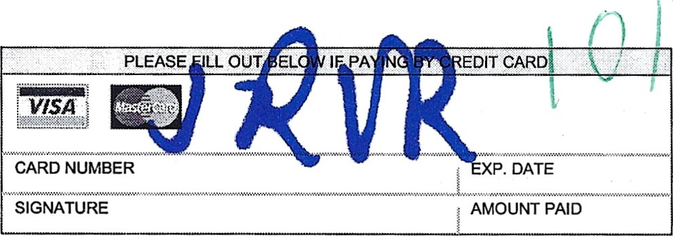VISA

CARD NUMBER

Invoice 1438324

Purchase order

|  |  |  |
| --- | --- | --- |
| ACCOUNT NUMBER | DATE | BALANCE |

212736 10/30/2024 $144.74

Cypress Creek Pest Control of Texas

Po Box 690548

Houston, TX 77269

Please Return this portion with your payment

SRSSBLU_110000000157627111000000103055611 Il IfalselPage 1 of 1 Ifalse12024103020543010

Invoice 1438324

|  |  |  |  |
| --- | --- | --- | --- |
| Date Descri tion Quantit | Amount | Tax | Total |
| Julie Rivers Office Condominiums | 12930 Dairy Ashford Sugarland, TX 77478  10/21/2024 Comm Pest Control - Quarterly | $133.71 | $11.03  Discount  Adjustment | $144.74  $0.00  $0.00 |
| Account # 212736 |  | Lic#: TPCL 2052 | AMOUNT DUE |
|  |  |  | $144.74 |

Page 1 of 1

281-469-2679 billing@cycreekpestcontrol.com

Cypress Creek Pest Control of Texas