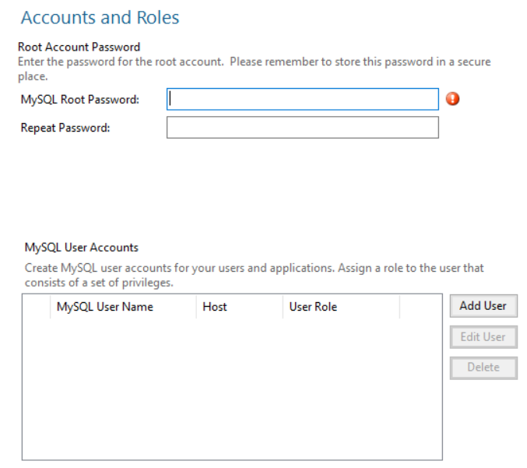
Password:
GFN2025sqlworkbench$

