Group 11 | Automated Aquaponic Garden PLC using a web-based interface
Major: | Team members:
CS | Chalmer M Frueauf
CS | Alexander John Gentry
CS | Derrick Kaliney
CS | Charles Witherspoon
Design Requirements
Objective 1: Device allows users to independently operate 8 different American style electrical sockets using a web app.
Objective 2: This device senses when the livestock tank water level is low and stops operations until water is added to the required level.
Objective 3: This device would host a webpage that allowed users to operate electric sockets on this device, run automated scheduling for lights, aeration, and water pumps set by the user.
Objective 4: This device would communicate with a database that would store growth data based on user input, log system modifications (i.e. when sockets were operational, water level notifications sent), and advises grow schedules based on plant types set by the user
Objective 5: This device would include a prototype aquaponic system. This aquaponic system is getting built as a component of this device to demonstrate functionality. The design uses a pipe system that would allow for up to 107 plants and would measure, allowing for up to 2” of variance, the following:
Grow bed structure:
Size: 48” * 72” * 36” ( up to 2” of variation on this )
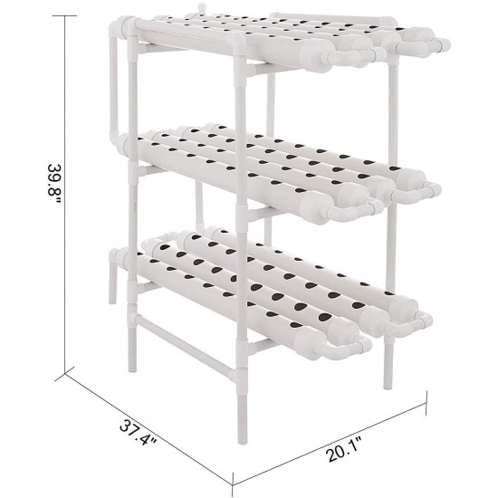
Illustrated in a single grow bed format below:
48””
36”
72”

Req No. | Obj No. | Requirement
10 | 1,2,3,4 | Device shall modify current flow independently on 8 electrical sockets via webpage interface. This operation is superseded by safety mechanisms to prevent unsafe operations, i.e. safety features could interrupt signals until safety measurements are met.
50 | 5 | Prototype system shall consist of multiple pipes grow beds with the measurements shown above. Variants of aquaponic system types such as ebb & flow and floating shall get demonstrated on this prototype system. Variance is allowable on up to 2” as long as system is watertight, other than water loss from evaporation, plant usage, and other “normal” aquaponic operations.
51 | 5 | ⁞Prototype system shall use multiple water-pumps, aeration devices, and lights to demonstrate the operation capabilities of the automated aquaponic plc device.
52 | 5 | Prototype system shall operate as a growth medium / environment for various fruit bearing and other types of vegetation, as well as different species of fish/shrimp depending on nitrogen load dependencies.

⁞

Definitions:
Flush- The user activated surge of water into the toilet bowl intended to clear the contents.
Bowl- The waste containing receptacle of the toilet.
⁞
Objective 1: Objective statement…
Objective 2: Objective statement…
Objective 3: Objective statement…
⁞
Req No. | Obj No. | Requirement

Definitions:
⁞

