Extensible Battle Platform - System Design & Specification

# 1. System Architecture Diagram

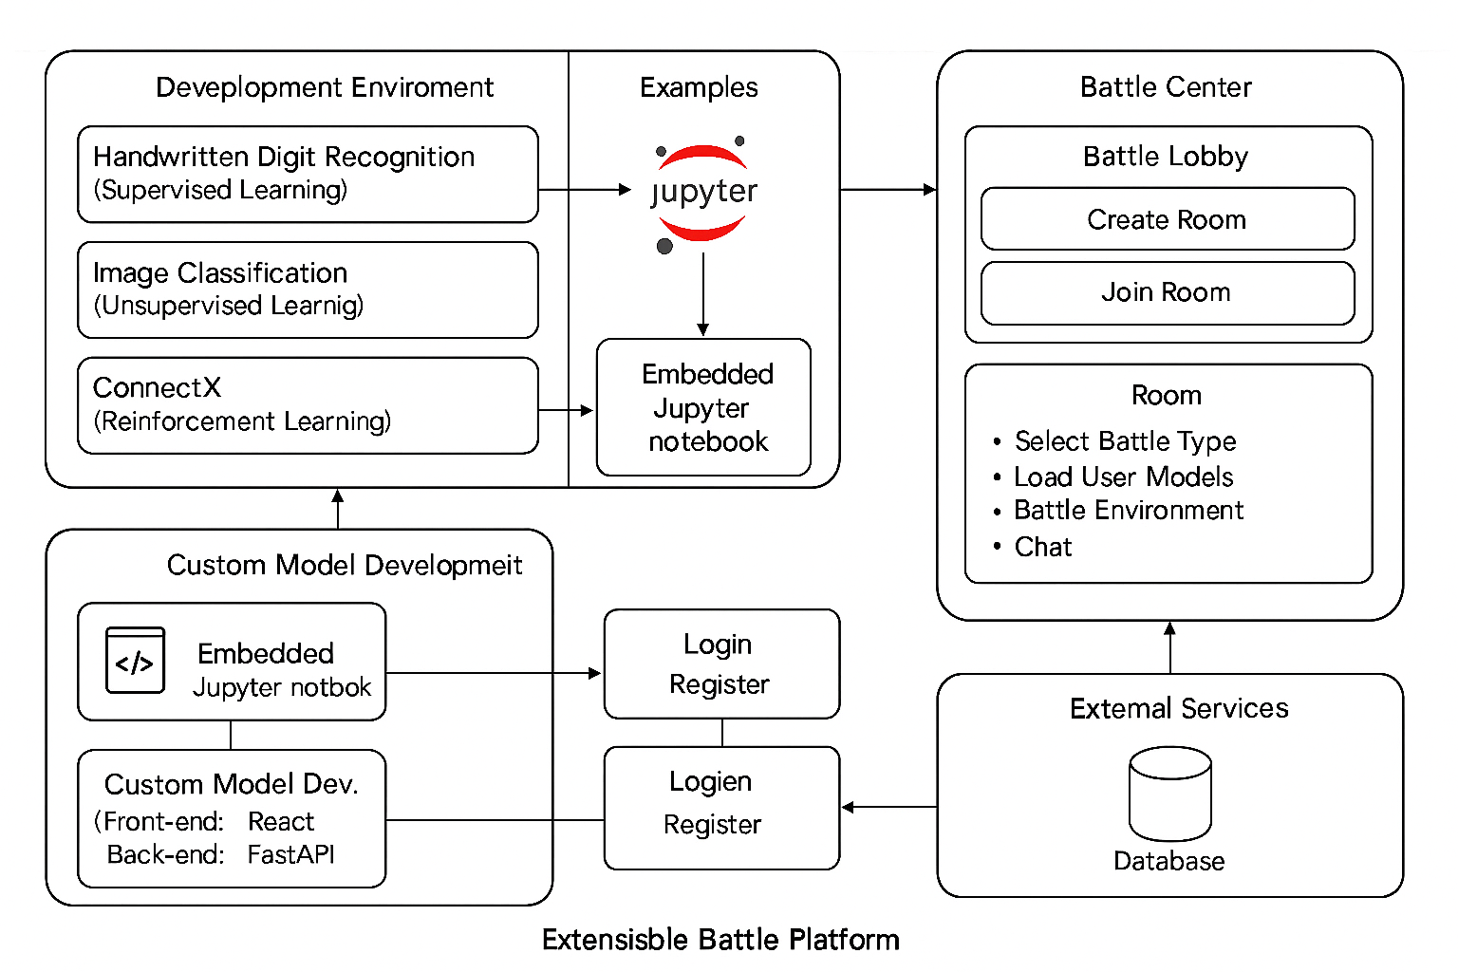

# 2. Complete Specification

Project Overview:  
This platform is an interactive battle system designed for high school students, supporting multiple modes including machine learning (supervised, unsupervised, reinforcement) and exam-based competitions (e.g. SAT). It features tutorials, embedded development, real-time battles, and a modular game engine for extensibility.  
  
Modules Overview:  
- User System: Registration, Login, JWT-based Auth, Profile, Model Library  
- Tutorials: Embedded Jupyter Notebooks with ML Examples (MNIST, CIFAR-10, ConnectX)  
- Custom Development: Jupyter-based local training and testing  
- Battle Center: Lobby, Room-based synchronous battle, Chat, Model upload and evaluation  
- SAT Duel: Exam-based real-time speed/accuracy competition  
  
Backend Architecture:  
- Framework: FastAPI (ASGI-native for WebSockets)  
- Database: PostgreSQL  
- Cache: Redis (for chat, score update, and socket session)  
- Notebook Service: JupyterHub or Voila  
- Execution Environment: Docker + gVisor/firejail (sandboxed)  
  
WebSocket Protocol:  
- Events: join_room, leave_room, submit_model, start_battle, submit_answer, update_score, send_chat, end_game, broadcast_result  
- JSON structure standardizes data payloads  
  
Database Schema (Simplified):  
- Users: id, username, rating, level  
- Models: id, user_id, accuracy, model_path  
- Questions: id, section, text, options, correct_answer  
- Rooms: id, room_type, host_user_id, config, status  
- Battles: id, room_id, result, timestamp  
  
Extensibility:  
- Each game/battle mode as module (backend logic + frontend component)  
- Modular route registration for dynamic loading  
- New types easily integrated: logic puzzles, math duels, AI bots, etc.  
  
Security:  
- Model validation and sandbox execution  
- Auth checks, input validation, and real-time error handling  
  
Gamification:  
- ELO-style rating, badge system, user level tiers (Bronze → Diamond)  
- Battle logs and performance dashboard  
  
Future Development:  
- Teacher rooms with classroom management  
- ChatGPT-based AI opponents  
- Plugin SDK for community-developed game modules