# CHAPTER ONE

# INTRODUCTION

Human beings have come through two major revolutions over the last few centuries. The Industrial revolution which transformed our society from being agriculturally based and the Electronic revolution which transformed our society from being mechanically based to electronically base. In the 21st century, a lot of manual techniques are now being implemented electronically and payroll is not an exemption. The switch from manual to electronic has expressly affected the payroll process in today’s world. [1] Payroll system is as old as 5000 years old as proven by a French archaeologist Denise Schmandt-Besserat through her discovery of cuneiform. Cuneiform is an ancient writing system distinguished by wedge-shaped marks made into clay. Denise pointed that the tablets had been used to record the back-and-forth of tokens, which themselves were recording the back-and-forth of the sheep, the grain, and the jars of honey.

Payroll is a list of employees who receive salary or wages together with the amounts due to each. Computerized payroll system is a software package to record, organize, and maintain employee data, such as names, addresses and pay rates, electronically. During each pay period, it calculates payroll deductions (e.g., EPF, SOCSO), salaries and wages, allowances (e.g., meal, transportation) and taxes; produces pay slips and keep all data up to-date. Manual system of payroll always put pressure on personnel to be correct in all aspect of their work. It is too easy to accidentally switch details and end up with inconsistency in data entry or in hand written orders. It could be time consuming and boring.

The invocation of computerize payroll system would help keep track of employees in order to reduce frauds like ghost worker manipulation to receive payment, etc. A computerized payroll system performs the same basic functions as those performed manually by payroll clerks; the important differences are the computer’s speed, accuracy, reliability, and ability to easily generate reports.

* 1. **Statement of the Problem**

1. **Inconsistency data entry, prone to error information**; Manual payroll in a private school involving more than 30 employees doesn't advice the use of pen and paper to record information of all the employees. Basic deductions, bonuses and difference in levels/ranks would make some employees not to have the same pay amount with other. If care is not taken, this may bring about errors like switching of data by the staff recording the information.
2. **Difficulty in handling personnel records and inaccessibility of information when needed:** Manual payroll has its information documented into papers, thereby making it very difficult in searching through lists of great number of employees to obtain one or two needed employee's data.
3. **Time consumption:** Writing and calculating each employee’s payment information can be tedious.
4. **Data insecurity:** Information written on paper requires no password from anyone in possession of it. Anyone can sneak in to where those papers are kept to manipulate letters or figures written on them.
   1. **Aim of the Project**

The aim of this study is to develop a payroll program that will automate paychecks for private school staff.

* 1. **Specific Objectives**

The Objectives of this project include;

1. To develop a web application that record teachers attendance as well compute pay for staff of the school.
2. To generate an efficient employee database.
3. To monitor attendance of staff to duties.
4. To generate various reports about attendance and payment of employees
5. To allow administrator to search employee's detail using employee's ID and fetch employee's payment information for payment management and pay slip printing.

# Significance of the Research

This project will benefit the totality of personnel most especially the finance staff as calculation errors calculation errors will be subdued and increased speed in fetching employee information to execute payroll processes is assured.

* 1. **Scope Of The Project**

The developed program is for New Era nursery and primary school. The project will specifically address the problems stated in the problem statements and specific objectives.

# CHAPTER TWO: LITERATUREREVIEW

# INTRODUCTION

This chapter covers review of related works, explanation of concepts and technologies involved in developing the project application.

**2.1. Theoretical Background**

Payroll has evolved greatly, rapidly adopting computerization in every business all around the world. The general idea of computerized payroll system is to make payment calculation automatic. The program was built upon an integrated development environment (IDE) Visual studio code using the following technologies HTML5, CSS3, JAVASCRIPT, MYSQL and PHP.

**HYPER TEXT MARK-UP LANGUAGE (HTML)**

HTML5 is the most widely used format to write Web Pages. HTML was originally developed with the intent of defining the structure of documents like headings, paragraphs, lists, and so forth to facilitate the sharing of scientific information between researchers. Now, HTML is being widely used to format web pages with the help of different tags available in HTML language.

**Cascading Style Sheet (CSS)**

CSS3 was used for creation of rules that specify how the content of an HTML element should appear. For example, the CSS was used to specify the background color of the system.

**Hypertext Preprocessor (PHP)**

PHP (recursive acronym for PHP: Hypertext Preprocessor) is a widely used open source general-purpose scripting language that is especially suited for web development and it is embedded in HTML codes of this project.

**MySQL**

MySQL is an open-source relational database managements system (RDBMS). PHP has lots of functions that perfectly fit into the MySQL database system. Hence PHP was used in conjunction with MySQL. Image below shows the database structure of admin table of the program

**JavaScript and JQuery**

JQuery is a JavaScript framework which aids for better development using JavaScript. JavaScript is a text-based programming language used to make the system pages interactive both on the client side and server side.

**2.2. Review of Related Literature**

The importance of this review is to make known of some other researches made in relevance to the project topic. Many researchers have made some findings on how this problem can be solved and the objective of the topic achieved. Nowadays, many computerized payroll system are implemented in different Institutions here in Nigeria because payroll system is one of the most important things in establishing a business firm. Business firms must operate within the boundaries of laws and government regulations, Laws have been developed not only to protect consumers but also to promote competition among businesses and industries. Over Half a century on, it’s fair to say that payroll is now one of the most commonly automated business operations and certainly the most frequently used.

The author [2] stated the importance of choosing a suitable payroll system. In-house payroll requires expert in the company to handle all payroll processing for the company. Outsourced payroll work with third party to handle all payroll processing, direct deposit, printing of checks, tax payment etc.

In creating the new payroll system, the authors [3] carried out an observation in the company internal system. From the internal data, then the company will be able to design the new payroll system that can be customized based on the needs of the company through a more structured DFD, ERD, and tables. However, the new system is the integration of payroll and administration module. Parts of the payroll system are basic salary, munch money, bonuses, taxation, Jamsostek, THR and cash bon. The administration process comprises the workers’ personal data, absenteeism, permission and leave, violation of rules and firing.

The author [4] useda biometrics with online data analytics dashboard to give krizalen enterprises an efficient payroll system that can automatically monitor the attendance and trip tickets of the employees, drivers and helpers with the biometrics technology and data analytics that would help them in the securityand accuracy of the company payroll and information. Summing up the past situation of payroll inside krizalen enterprises, there was need for a system that could help them with employee information management attendance, monitoring, payroll processes, and assistance for the manager decision making.

The author [5] defined payroll management as an essential tedious process that requires a high level of timelines, accuracy and efficient financial controls. The system proposes a cloud payroll management system, a software as a service (SaaS) which means "On-demand" software. The software is made available on the internet to enable clients install it in their computer system. As service to end user, the cloud service provider takes care both in firewall to achieve security of the software. The system's full access control gives the client the privilege to select and create menus, designs and layout of choice for each page. Also, the system provides an interactive interface that makes it easy for the user of the organization to enter, edit and update data relevant details to the current task they are set with.

According to [6] stated the importance and effectiveness of computer base transaction processing, thereof defining payroll system as transaction processing subsystem used to produce paychecks, data for tax purposes, as well as keep track of social security payments, union dues and group insurance deduction for employees.

The payroll system implemented by [7] is a desktop based system, which is developed in VB.net as frontend and Microsoft Access 2007 SQL server 2008 as backend. The base of the planned system is a database, which stores all information pertinent to personnel allowances, deductions, taxes and net pay. Features of the planned system are: Importing attendance from Biometric machine, Sending details regarding salary and attendance before finalizing salary, Faculty Management, Overtime Calculation, through mail sending salary slips, HRD programs like offer letter, appointment letter, promotion letter etc. Faculty Birthday notification, generate annual profit-loss of college by using graphs.

The author [8] described the functionality and specifications of the design of web application for managing employees and their payroll. Every organization has different employee and payroll management needs. This system helps to automate payment process and maintain computerized records without getting redundant entries so as to overcome the problems faced in the practice of manual system.

According to [9], the impression of handling employees pay calculations are quite tedious if done manually thus it requires more effort and time especially for big organizations. So therefore, if this process is automated, it would be of great benefit as it would require less time to calculate the salary of the employees. The program for payroll system service on the cloud is provided as a solution by the author

According to [10] Payroll Processing software module is a comprehensive payroll processing system for USA and Canadian payroll requirements. Whether running a single or a multi-site, multi-state operation with multiple user-defined deductions, the **Enterprise IQ Payroll Software** module can meet your processing and reporting needs. Automatic import of employee hours with the optional Time & Attendance module or other third party time clock systems.

**CHAPTER 3: SYSTEM ANALYSIS AND DESIGN**

1. **INTRODUCTION**

This chapter talks about System development. System development entails two major components: System Analysis and System Design. System Analysis and design are used as guide in software development; they provide structure in the development of quality software solutions. There are several methodologies for system analysis which include Structured System Analysis and Design Methodology (SSADM), Object-Oriented Analysis and Design Methodology (OOADM), Entity-Relationship Model (ER Model) etc. Object-Oriented Analysis and Design Methodology were used for this project.

OOADM is an approach to application or system development design which is based on object-oriented paradigm. It uses a set of diagrams or models called Unified Modeling Language (UML) diagrams to represent various views and functionalities of the system. The aim of OOADM is to transform the use cases into model which can be used to realize the associated goals of the system.

**3.1.DESCRIPTION OF EXISTING SYSTEM.**

Existing payroll systems are mostly semi-automated or manually based which involves manual calculation of paycheck, manual documentation of employees record and other details which may be time consuming and prone to error. Their processes include the following:

* Attendance is obtained by the process of employees filling out their time sheets with their names, ID numbers, date and Time in/Time out.
* Attendance is monitored and recorded on paper. .
* Payroll is prepared based on the entries of employees payroll information.

**3.2. ANALYSIS OF THE PROPOSED SYSTEM**

After careful analysis, the following problems were identified in the system:

* Time consumption; the time consumption is removed by automating the attendance sign in/sign out.
* Financial calculations done manually are prone to errors. Calculation error are removed by automating calculations of staff of the school.
* Data switch: the system generates unique employee ID for all the school to avoid redundancy.
* Data insecurity: The proposed system provided security to the payroll data and employee information through password and employee ID.

System data modeling tools used to analyze the system was modeled using Unified Modeling Language. The Unified Modeling Language tools are the Use Case Diagram and Packaged Diagram.

**Use Case Diagram:**

Use case diagram discusses the functionality of the system using actors and use cases. The actor represents the role of the user of the system. An actor interacts with the system, but has no control over the use cases. Use case can be described as a specific way of using the system from a user’s (actor’s) perspective. Use cases provide a means of capturing system requirements, communicate with the end users, and test the system

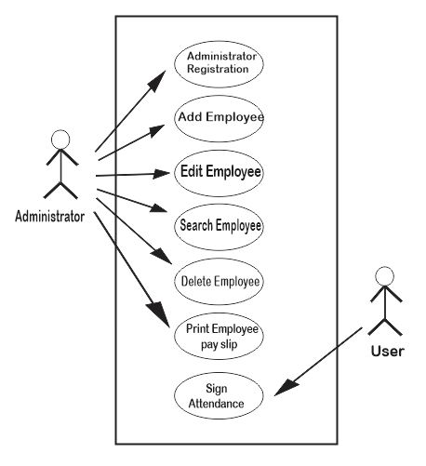

***Fig 3.1 Use Case Diagram of the payroll system***

**Packaged Diagram:**

Package diagram is a structure diagram which shows packages and how they depend on each other. It shows different views of a system, for example as multi-layered or multi-tiered application. Package, packaged element, dependency, element import, package import and package merge are nodes and edges drawn in a package diagram. Package is a name space used in grouping elements that are semantically related together. Packaged element is a named element that is owned directly by a package.

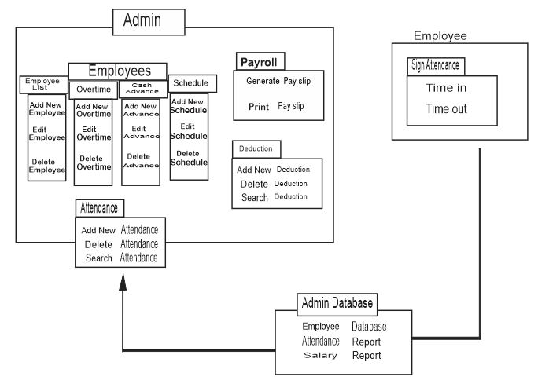

***Fig 3.2 Package Diagram of the payroll system***

**3.3. Design of the proposed system**

System design describes how the system will operate. The system design here includes Database Design, System Architecture, Input Design and Algorithm Design.

**Database Design:**

The database management used in this system is MySQL. MySQL is a fast, robust, relational database management system. The design shows how data are efficiently stored, searched, sorted and retrieved. The database design also involves identifying the various fields attribute used in the tables of database, the data types and size of the fields.

## *Table 3.1: Admin*

|  |  |  |  |
| --- | --- | --- | --- |
| Field(s) | Data Type | Emptiness | Size |
| Employee ID  (Primary key) | INT | NULL | 11 |
| First Name | VARCHAR | NULL | 50 |
| Last Name | VARCHAR | NULL | 50 |
| Username | VARCHAR | NULL | 30 |
| Password | VARCHAR | NULL | 30 |
| Photo | VARCHAR | NULL | 200 |

## *Table3.2: Employee*

|  |  |  |  |
| --- | --- | --- | --- |
| Field(s) | Data Type | Emptiness | Size |
| Employee ID  (Foreign key) | INT | NULL | 11 |
| last Name | VARCHAR | NULL | 50 |
| First Name | VARCHAR | NULL | 50 |

|  |  |  |  |
| --- | --- | --- | --- |
| Birth date | DATE | NULL |  |
| Address | Text | NULL |  |
| Contact Information | VARCHAR | NULL | 100 |
| Gender | VARCHAR | NULL | 10 |
| Position | VARCHAR | NULL | 11 |
| Schedule | VARCHAR | NULL | 11 |
| Photo | VARCHAR | NULL | 200 |
| Created_On | DATE | NULL |  |

## *Table 3.3: Attendance*

|  |  |  |  |
| --- | --- | --- | --- |
| Field(s) | Data Type | Emptiness | Size |
| Employee ID  (Foreign key) | INT | NULL | 30 |
| ID | INT | NULL | 11 |
| Date | DATE | NULL |  |
| Time_in | TIME | NULL |  |
| Status | INT(1) | NULL |  |
| Time_out | TIME | NULL |  |
| Nun_hr | DOUBLE | NULL |  |

**System Architecture:**

The system was designed in a 3tier architecture as shown in figure 3.16. The 3-tier architecture comprises of:

**The Presentation Tier:** This software level presents the user with the interface. It was designed with a HTML.

**The Middle Tier:** This level serves as an intermediary between the interface and the database. It picks data entered by the user through the interface and either inserts it into the database or compares with the already existing data in the database

**The Data tier:** This is the third tier of the software architecture. It is the database that allows the insertion, storage and retrieval of any information.

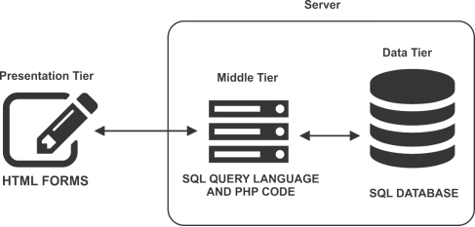

***fig 3.3: System Architecture***

**Input and Output Images of the Computerized Payroll System with Sample Data**

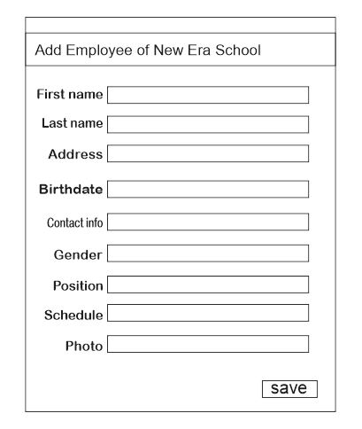

***fig 3.4:Add Employee***

Figure 3.4 shows the input design for registrating employee of the school

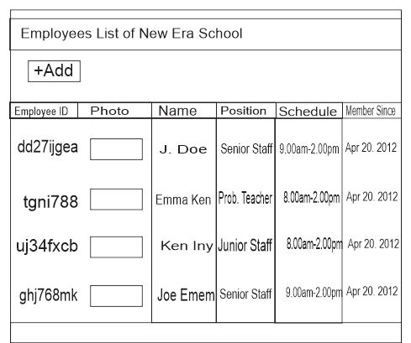

***fig 3.5: Employees List***

Figure 3.5 displays list of added employees of the school

**Chapter 4: System Implementation**

**4.0. Introduction.**

This chapter discusses the necessary implementation and development requirements for actualizing the proposed system. System Implementation is the actual development of the proposed system. In this stage, the plans, ideas, models, design and specifications discussed in the previous chapter are executed to realize the proposed system. It also briefly describes the choice of development environment and numerous software tests that was undergone during the development phase.

**4.1. Choice of Development**

The integrated development environment used in developing this system is Visual Studio Code. Visual Studio code is a highly sophisticated text editor, primarily intended for developing websites and web applications. It supports virtually all web programming languages and technologies.

The languages and technologies used for this project comprises of HTML5,CSS3, JAVASCRIPT, PHP AND MYSQL. The listed packages was used because of their features, accessibility and effectiveness.

**4.2. IMPLEMENTATION ARCHITECTURE**

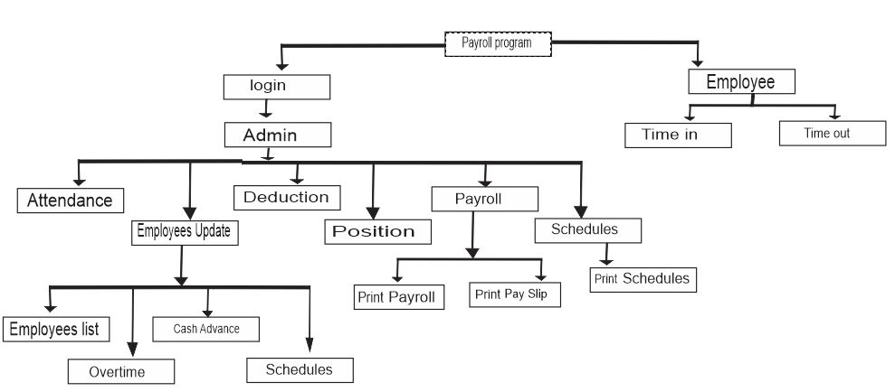

***fig 4.1:Implementation Architecture***

**4.3. SOFTWARE TESTING**

The system was tested at every stage of its development in other to detect and remove errors. The purpose is to ensure that the software satisfies the specific requirements and objectives of the project. This testing includes

* Syntax error testing: this method of testing is used to used to check all the syntax errors during the software development
* Compatibility testing: the testing is used to determine whether all the languages used during the programming were well integrated with each other.
* Logically testing: this is the argument involved during the programming. This will check whether the argument is accepted by the system or not.

Secondly, testing them by running the software on realistic form. This testing includes

* Running the application in its fullness using a local server each as wamp server, Xamp server, lamp server and so on that have local host which is using Apache as engine and MYSQL as the database
* Browser testing: this testing is used to test the appearance and shape of the software on the browser. This testing also replaces system testing in desktop application.

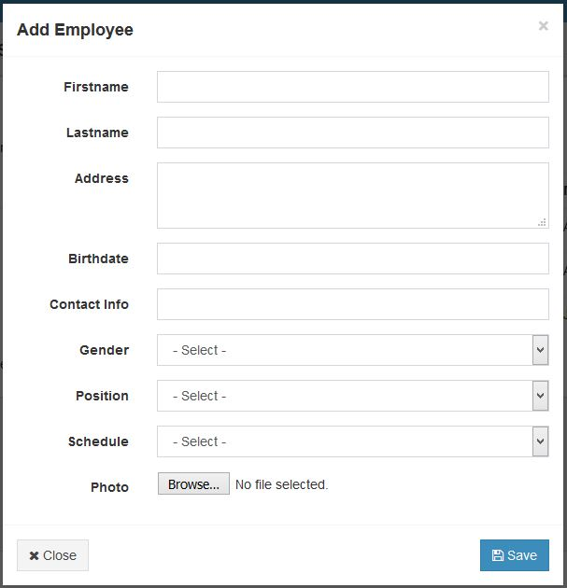

***fig 4.2: Screenshot of employee input page showing Add employee***

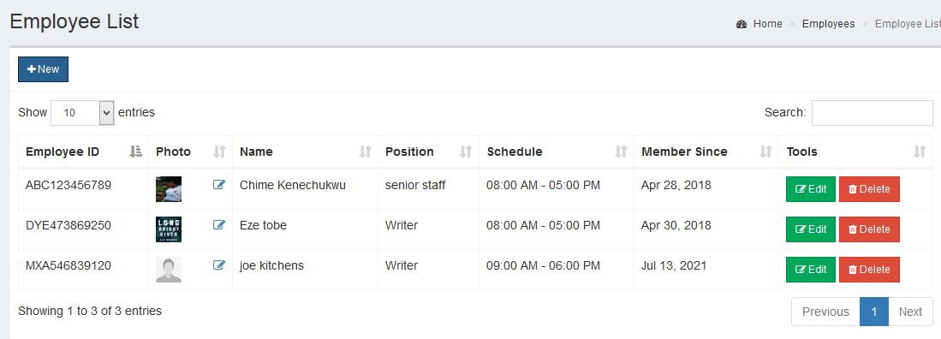

***fig 4.3: Screenshot of employee output page showing list of employees of the school.***

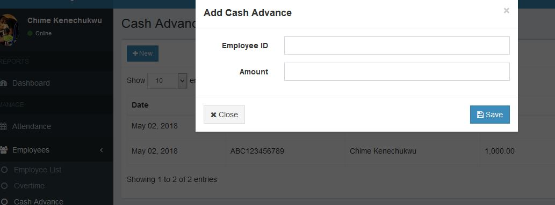

***fig 4.4: Screenshot of cash advance input page***

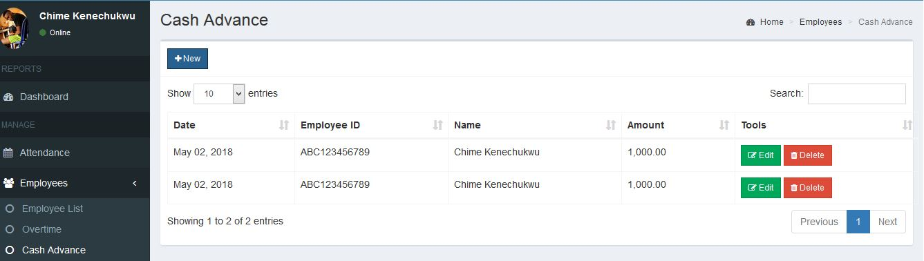

***fig 4.5: Screenshot of cash advance output page showing list of employees and added advance***

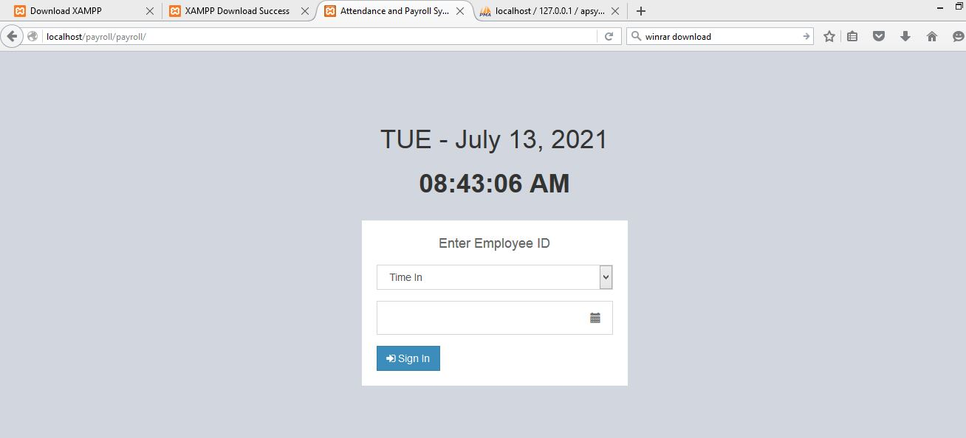

***fig 4.6: Screenshot of staff attendance page, here employee sign in/out***

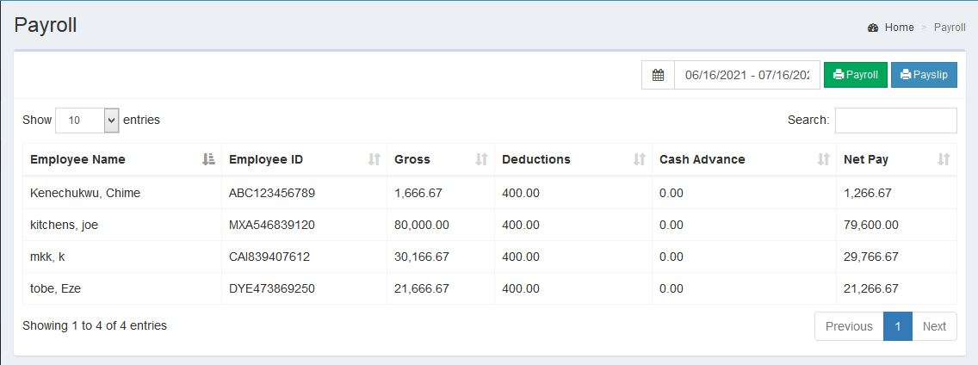

***Fig 4.7: Screenshot of the staff pay calculation***

**4.4. DOCUMENTATION**

**4.4.1. USER MANUAL:**

The user manual provides guide to the system users. The system has 2 basic levels of users; The Admin User Manual and The Employee User Manual.

**Admin User Manual.**

Startup the system.

* Launch a local server (xampp recommended)
* Start Apache and MySQL on the local server
* Open a web browser (Boodle chrome recommended) and enter the URL "http//localhost/payroll/payroll/admin/ which will display the system home page.

1. Login: The admin logs in with the default username and password given as chyme and admin respectively.
2. Admin profile update: By clicking on this page, profile of the admin like the username, password, first name, photo can be changed
3. Add employee: Navigate "employee list" on the left hand size, click on "New", fill the necessary details of the new employee and click "save". The new employee will be added to the employees list bearing with it randomly generated unique employee ID.
4. Cash Advance: to add cash advance for an employee, navigate "Employee list" click on "cash advance". Click on "New". Input employee ID and the amount, then save.
5. Deductions: To add deduction for an employee, click on "Deduction" on the left had side, click on "New", add description of the deduction and amount, the click save.
6. Payroll: To generate and print employee's payment details, click on "payroll" on the left hand side. The page displays detail of employees. On the top right hand side, click in "pay slip" to generate the PDF format for printing
7. Schedule: To create schedule, click on "Employees" on the left hand side click on "schedules", click on "new" and input the schedule time frame. To edit time of work for an employee, after adding the employee to the employee's list, click on "schedule" at the bottom left hand side, navigate the desired employee. Click on "edit" and set

**Employee User Manual**

Start up the system

* Launch a local server (xamp recommended)
* Start Apache and MySQL on the local server
* Open a web browser (Boodle chrome recommended) and enter the URL "http//http://localhost/payroll/payroll/ which will display the system attendance page.

To Sign In attendance

1. Select "Time In"
2. Input Employee ID and click sign in

To Sign Out attendance

1. Select "Time out"
2. Input Employee ID and Click "Sign In"

4.4 2. Source Code Listing

See Appendix A

**CHAPTER 5: SUMMARY AND CONCLUSION**

1. **SUMMARY**

Computer based payroll system enables you to store unlimited data while managing the data as well. Accounting software processes data and creates reports much faster than manual systems. Web based payroll Minimum errors as automatic or computerized calculations are done. Expenses associated with accounting software include training and program maintenance. Expenses can add up fast with costs for printers, pa per, ink and other supplies Productivity is higher than manual payroll as employees get their salary early as calculations are done on regular basis. No paper work is required as data is stored in the database. So, it is less bulky. It is more efficient than the manual payroll.

* 1. **CONCLUSION**

This Application will help to automate payroll system of an organization. Multiple authorized users will be able to login and logout from a web browser. Login checks (username, password) are controlled by administrator. Administrator will have total web based control to completely customize the payroll system. HR of the company will be able to authenticate new employees,

Update existing employees pay, view reports. The system is user friendly. Whenever there is an error in entering data, it immediately shows an error. The application is equipped with tools for updating salary records, deductions, net pay, add new allowances, leave appraisal or request deduction and savings and many other features that are easy to be operated by users. The system has also provision for full salary history including all payroll elements and changes that have been implemented. The prototype web based payroll system is complete in it self and ready to be implemented but changes and growth in requirements will be a reality on every software project so there is need to timely update them. The same applies to this payroll system

.

* 1. **RECOMMENDATIONS**

Based on the previous chapter discussions, there are some weaknesses in the web based payroll system and some recommendations are needed to be able to overcome the weaknesses. Hopefully, these recommendations can be useful.

1. Segregation of duties: The segregation of duties in most companies is not appropriate, the thing that can be seen through some organizational structure is that most of the employees do multi jobs, and in other to overcome this general weakness, which is related with the segregation of duties, a new organizational structure is needed.

2. Before you do business with a payroll service provider or an employee leasing company, check the company’s credentials and ensure it meets federal and state regulations. Obtain a clear, written agreement from the company, outlining the company’s responsibilities, including penalties that may arise from payroll errors it makes.

3. Finally, I recommend that companies that use a web based payroll system should have a good HR management and also a good Admin that will manage and update the system always and accurately.

**REFERENCES**

# [1] “How the world's first accountants counted on cuneiform”

Available at; https://www.bbc.com/news/business-39870485

[2] Steven M. Bragg "ESSENTIALS of Payroll: Management and Accounting" 2003

[3] AgustinusNoertjahyana, Felix Montana, Arlinah Imam Rahardjo, "DESIGN AND IMPLEMENTATION OF PAYROLL INFORMATION SYSTEM IN PT. KARYA TAMA RIMBA CEMERLANG" Informatics Department, Faculty of Industrial Technology, Petra Christian University, Surabaya

[4]Dokas M (2005) "Developing Web Sites For Web Based Expert Systems": A Web Engineering Approach.Proceedings of the Information Technologies in Environmental Engineering (ITEE): 202-217.

[5] DhanammaJagli, Ramesh Solanki, ParthChandarana, "Payroll Management System as SaaS" Proceedings of National Conference on New Horizons in IT - NCNHIT 2013

[6] Engr.FaizullahMahar , 2003. Role of Information Technology in Transaction Processing System. Information Technology Journal, 2: 128-134.

[7] Arjun V. Singh, Y S Sawant (2016) "Automated Payroll System " University of Mumbai, Department of Computer Science

[8] Marcus Atish D Rozario. "Project on Employee Database and Payroll MANAGEMENT SYSTEM" May 2018

[9]Poonamdeep Kaur, Dr. D. Grover,CSEDeptt., G. N. DevEngg. College, Ludhiana, "Computer Based Payroll System Implementation For E-Governance at Punjab Agricultural University" International Journal of Engineering Research and Developmente-ISSN: 2278-067X, p-ISSN : 2278-800X, www.ijerd.comVolume 5, Issue 3 (December 2012), PP. 55-[10] Cloud Computing – Issues,Research and Implementations Mladen A. VoukDepartment of Computer Science, North Carolina State University, Raleigh, North Carolina, USA Journal of Computing and Information Technology-CIT16, 2008, 4, 235246doi:10.2498/cit.1001391