Insurance AI Assistant Fine-Tuning Project
Contents
1. Project Title 2
2. Domain Selected 2
3. Business Problem 2
4. Architecture 3
5. Dataset Details 6
6. Model Used 7
7. Non-Instruction Fine-Tuning Approach 8
8. Instruction Fine-Tuning Approach 8
9. DPO Alignment Approach 9
10. LoRA / QLoRA Configuration 9
11. Training Screenshots or Logs 9
12. Before vs After Output Comparison 10
13. Final Observations 10
14. Challenges Faced 10
15. Future Improvements 10
16. Important Links 11
Conclusion 11

1. Project Title
Insurance AI Assistant Using QLoRA, Instruction Fine-Tuning, and DPO Alignment.

2. Domain Selected
Commercial Insurance & Underwriting
This project focuses on building an AI-powered insurance assistant capable of answering underwriting, risk assessment, policy evaluation, and insurance-related business questions.
The objective was to adapt a foundation Large Language Model (LLM) to understand insurance-specific terminology, underwriting guidelines, risk management concepts, and respond professionally to users.

3. Business Problem
Insurance professionals spend significant time reviewing submissions, analyzing risks, interpreting policy requirements, and answering repetitive underwriting questions.
Challenges include:
- Manual review of insurance submissions
- Inconsistent underwriting responses
- Slow turnaround time
- Knowledge dependency on experienced underwriters
- Limited accessibility to insurance expertise
The goal of this project is to develop an Insurance AI Assistant capable of:
- Understanding insurance terminology
- Providing underwriting guidance
- Assisting with risk evaluation
- Answering insurance-related questions
- Producing professional and consistent responses

4. Architecture
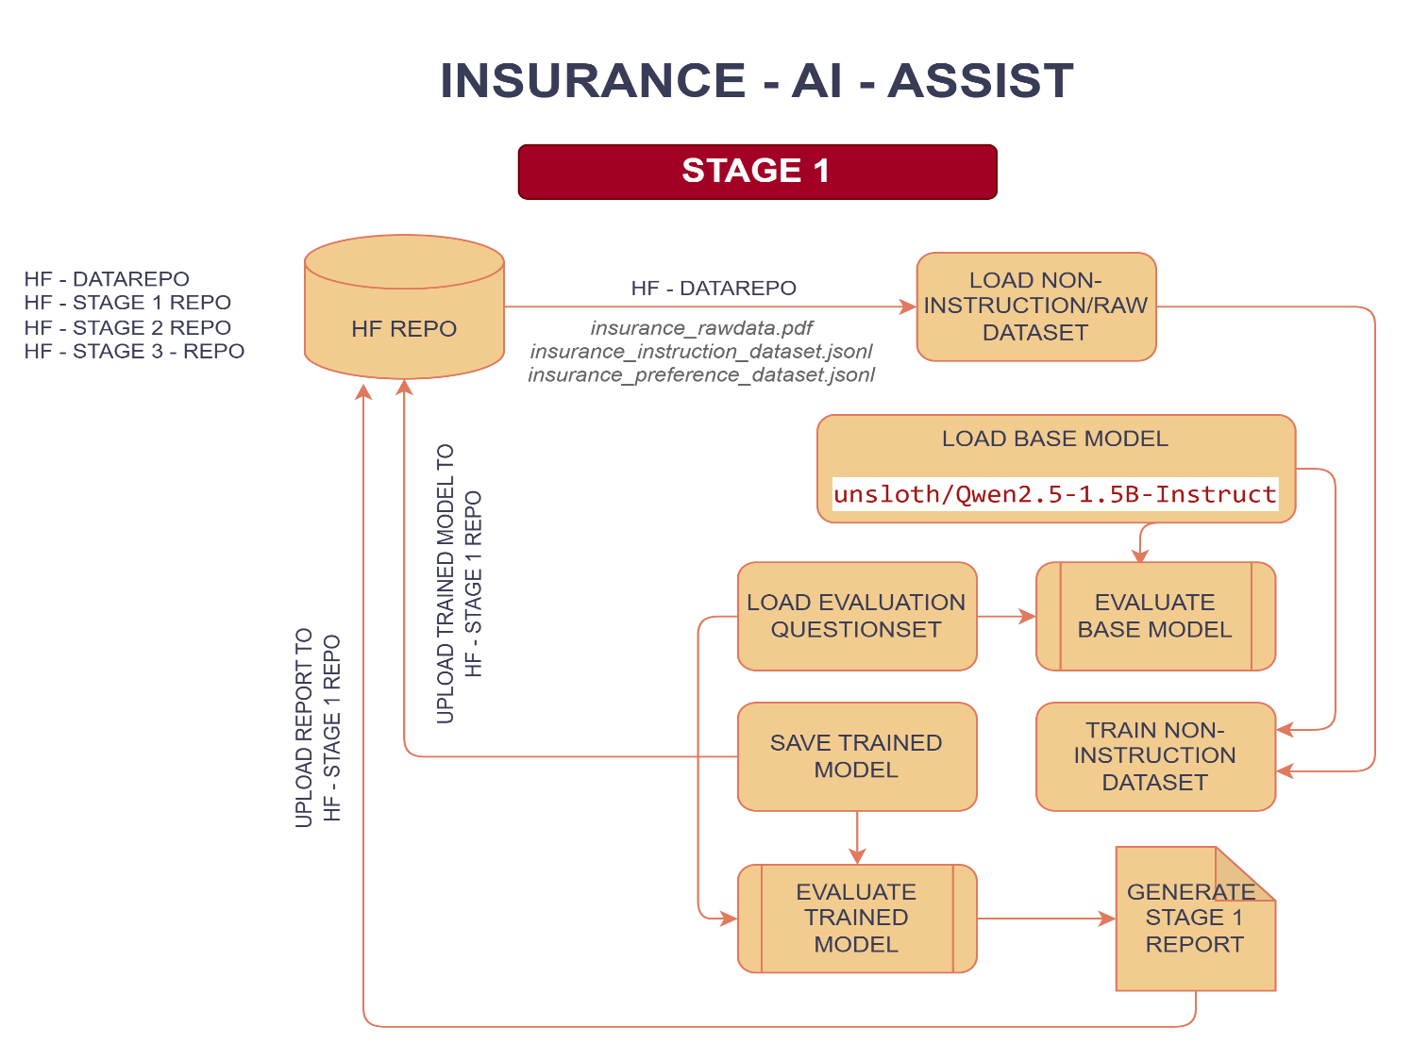
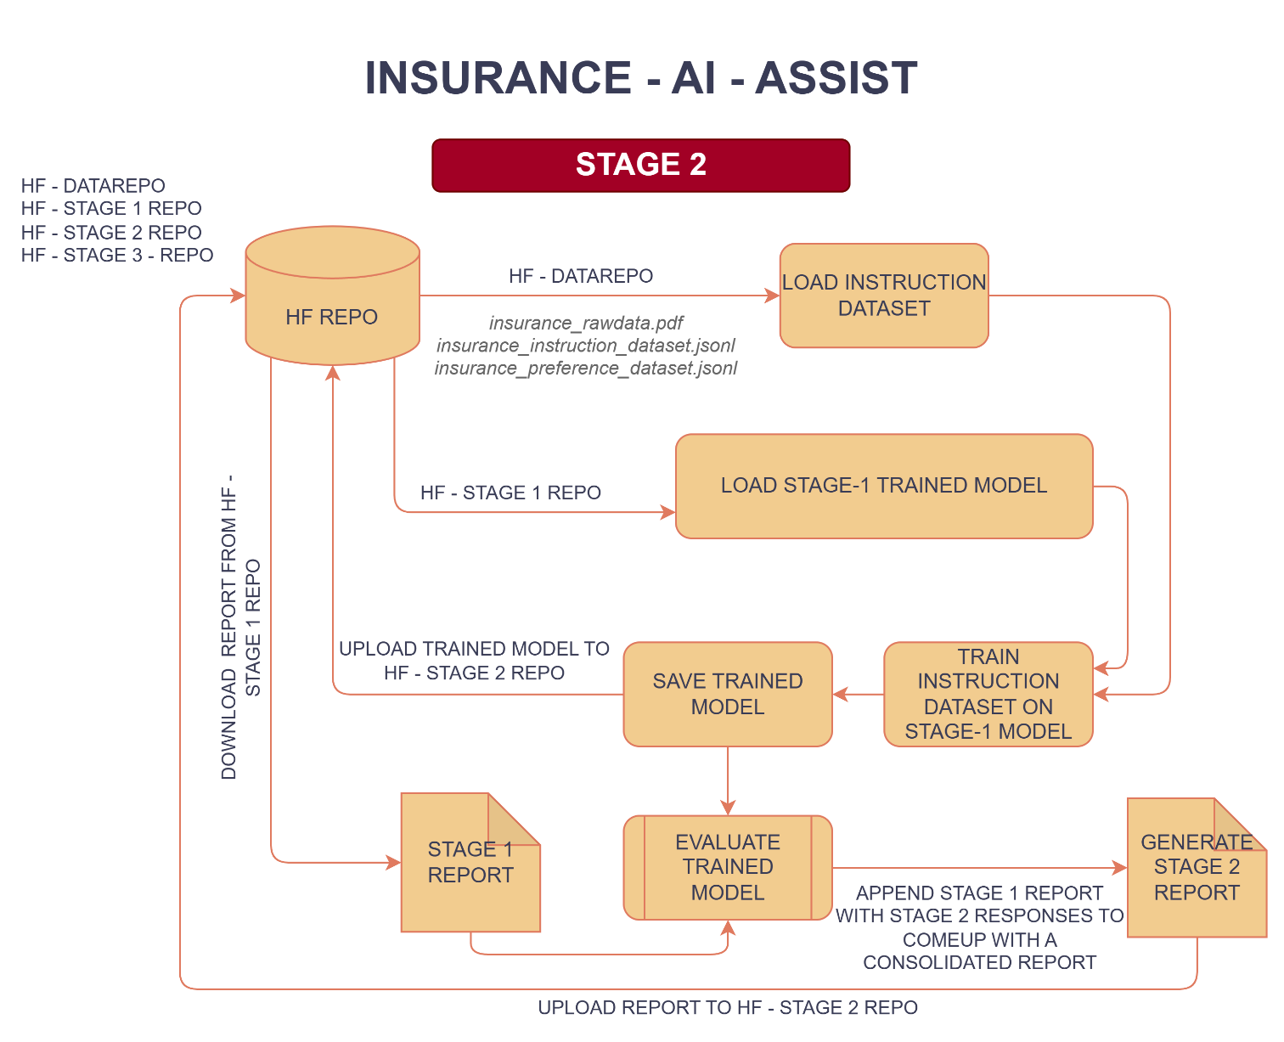
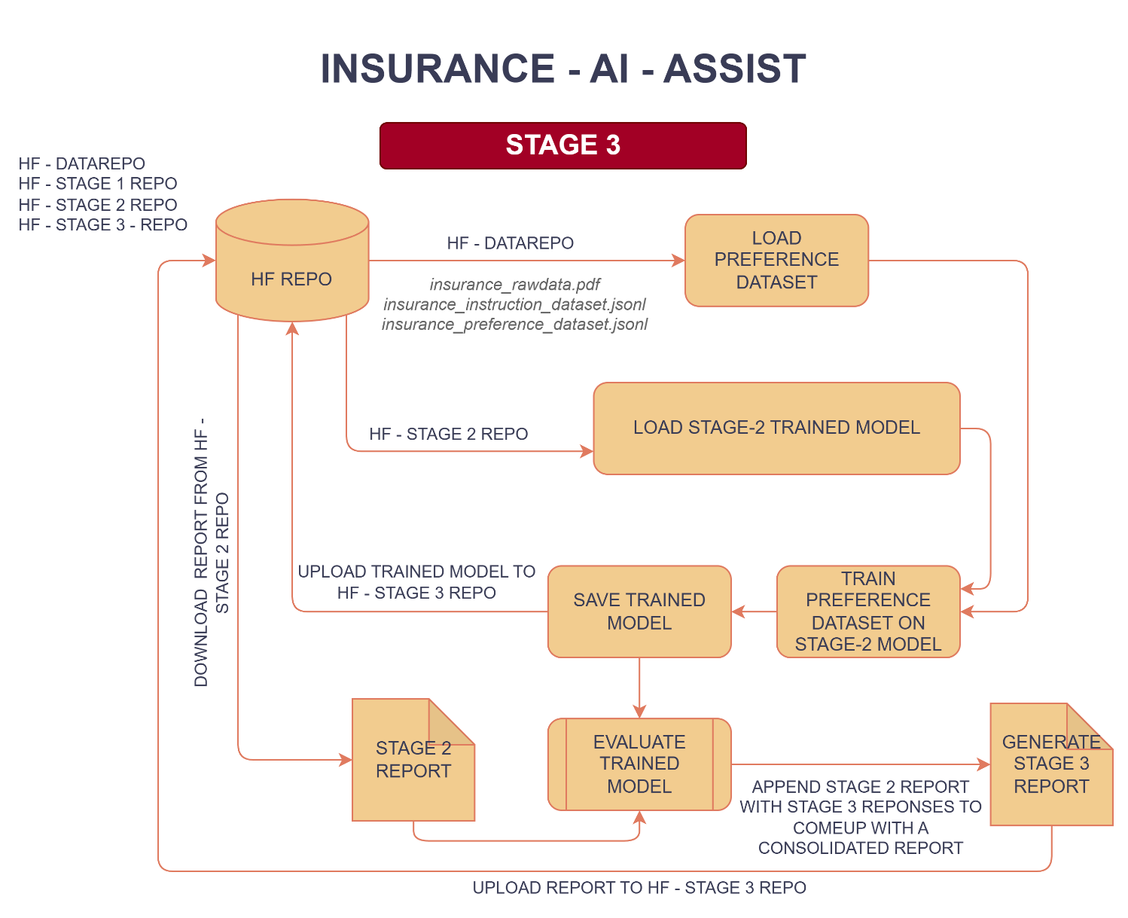
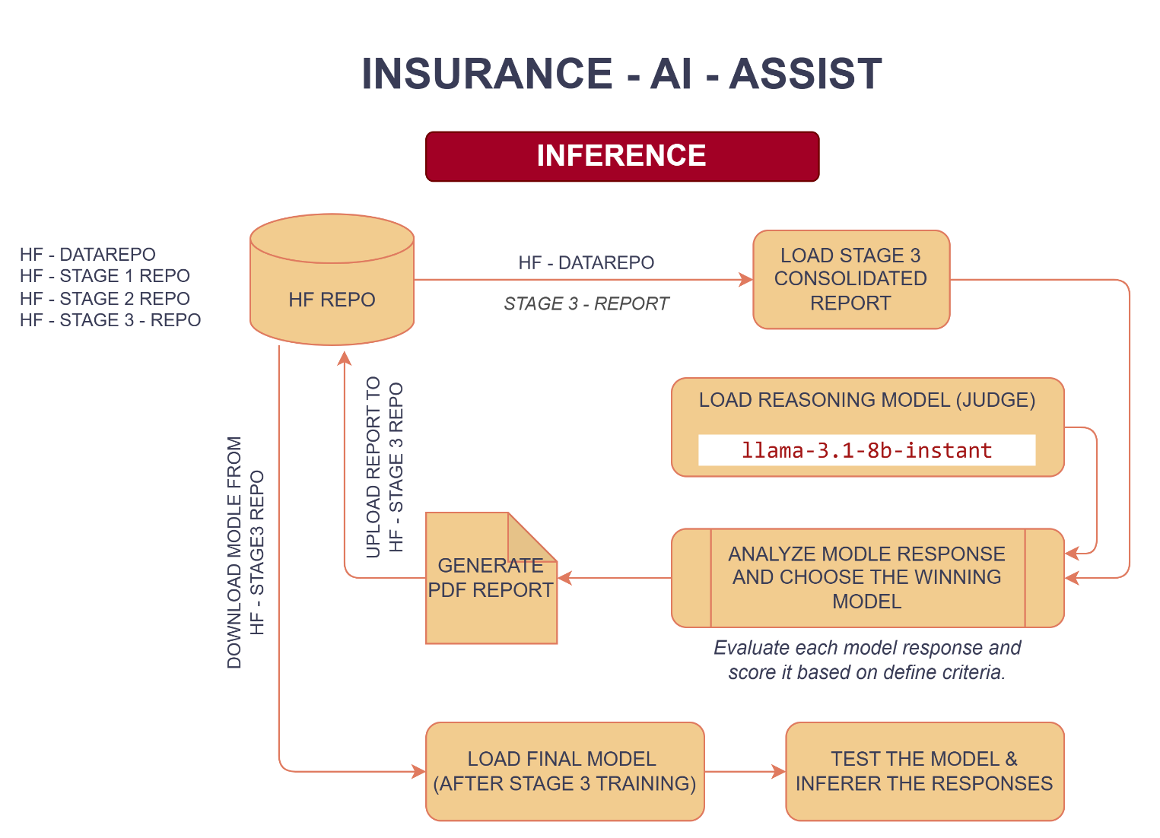

5. Dataset Details
Dataset Type
Custom Commercial Insurance Dataset (PDF & JSNOL)
Data Sources
The dataset was created using domain-specific insurance and underwriting content covering:
- Commercial insurance
- Risk assessment
- Workers compensation
- Property insurance
- Liability coverage
- Middle market underwriting
- Submission requirements
- Risk mitigation practices
- Insurance operations

Dataset Transformation Stages
Stage 1 Dataset – Non-instruction insurance knowledge dataset.
Format:
- Question
- Answer
Stage 2 Dataset – Instruction-following dataset.
Format:
- Instruction
- Input
- Response
Stage 3 Dataset – Preference dataset for DPO training.
Format:
- Prompt
- Chosen Response
- Rejected Response

6. Model Used
Base Model – Qwen2.5-1.5B-Instruct
The model was selected because:
- Lightweight and efficient for fine-tuning
- Strong instruction-following capabilities
- Suitable for QLoRA-based training
- Works effectively within Google Colab GPU limitations
- Provides a good balance between performance and computational cost
Judge Model – Llama-3.1-8B-Instant
The judge model was used during the evaluation phase to compare responses from:
- Base Model
- Non-Instruction Fine-Tuned Model
- Instruction Fine-Tuned Model
- DPO Fine-Tuned Model
The judge model assigned scores and identified the best response based on:
- Correctness
- Completeness
- Domain Accuracy
- Professional Quality
- Helpfulness

7. Non-Instruction Fine-Tuning Approach
Objective
Teach the model insurance domain knowledge.
Method
The model was trained on insurance-related question and answer pairs without explicit instruction formatting.
Outcome
The model learned:
- Insurance terminology
- Underwriting concepts
- Risk assessment language
- Commercial insurance knowledge
However, response structure and instruction-following capability remained limited.

8. Instruction Fine-Tuning Approach
Objective
Improve the model's ability to follow user instructions and provide structured responses.
Method
Training examples were converted into instruction-response format.
Outcome
The model became better at:
- Understanding user intent
- Providing structured answers
- Maintaining conversational format
- Producing professional responses

9. DPO Alignment Approach
DPO
Direct Preference Optimization
Objective
Improve answer quality by learning user preferences.
Approach
The model learns which response is preferred and adjusts its behavior accordingly.
Outcome
The model generated:
- More helpful answers
- Better clarity
- Better professionalism
- Reduced hallucinations
- Improved alignment with expected insurance responses

10. LoRA / QLoRA Configuration

QLoRA was selected because it enables efficient fine-tuning on limited GPU resources by loading the model in 4-bit precision while training LoRA adapters.

11. Training Screenshots or Logs
Refer below for training logs –
https://github.com/Pzazz55/insurance-ai-assistant-finetuning/tree/main/reports

12. Before vs After Output Comparison
Refer the below final evaluation report –
https://github.com/Pzazz55/insurance-ai-assistant-finetuning/blob/main/reports/final_evaluation_20260710_025732.pdf

13. Final Observations
Key Findings
- Domain adaptation significantly improved insurance knowledge.
- Instruction tuning improved response structure.
- DPO alignment improved response quality and professionalism.
- QLoRA enabled efficient training on limited hardware.
- Preference optimization produced the most consistent and useful outputs.

14. Challenges Faced
Technical Challenges
- Limited GPU memory in Google Colab
- Token length limitations
- Parsing large evaluation reports
- Managing multiple training stages
- DPO dataset creation and validation
- Consistent evaluation across model checkpoints
Solutions
- Used QLoRA for memory efficiency
- Applied truncation strategies
- Built automated evaluation pipelines
- Implemented model comparison frameworks

15. Future Improvements
Planned Enhancements
- Retrieval Augmented Generation (RAG)
Integrate:
- Underwriting manuals
- Policy documents
- Regulatory references

- Insurance Knowledge Base
Create a searchable repository of insurance documents.
- Vector Database Integration
Implement a Vector Database like – FAISS, ChromaDB, Pinecone, etc.
- Multi-Agent Architecture
Develop specialized agents:
- Underwriting Agent
- Claims Agent
- Risk Assessment Agent
- Compliance Agent

- Web Application
Convert the solution into an interactive application using:
- Continuous Preference Learning
Expand DPO datasets using production feedback and user interactions.

16. Important Links
- GitHub – https://github.com/Pzazz55/insurance-ai-assistant-finetuning/tree/main
- HuggingFace – https://huggingface.co/Pzazz55

Conclusion
This project successfully developed a domain-adapted Insurance AI Assistant through a three-stage fine-tuning pipeline consisting of:
- Non-Instruction Fine-Tuning
- Instruction Fine-Tuning
- DPO Preference Alignment

Using QLoRA enabled efficient training on limited GPU resources while achieving strong performance in commercial insurance and underwriting tasks. The final DPO-aligned model demonstrated the highest quality, professionalism, and user alignment among all evaluated model versions.

