Methodology:
In this assignment, different methods for solving differential equations are discussed. The differential equation used in this assignment is:
$$m\dot{v}=P-kv^{2}$$
In above equation, ‘m’ is mass of both cycle and cyclist, ‘v’ is speed, ‘P’ is driving force and ‘kv²’ is resistive force acting.
The values of parameters are known and differential equation is solved for v(t). For solving differential equation two methods are used:
- Explicit (Forward) Euler Method
- Implicit (Backward) Euler Method
The method used for comparison of results is ‘ode45’.
For implementation of Euler methods, separate function files are made named:
[t,y] = euler_exp (f,a,b,y0,h)
[t,y] = euler_imp (f,a,b,y0,h)
These files take ‘function f’, ‘starting time a’, ‘ending time b’, ‘step size h’ and ‘initial output y0’ as input and returns time and speed as output.
Results and Discussion:
The following figure shows the output of these methods.
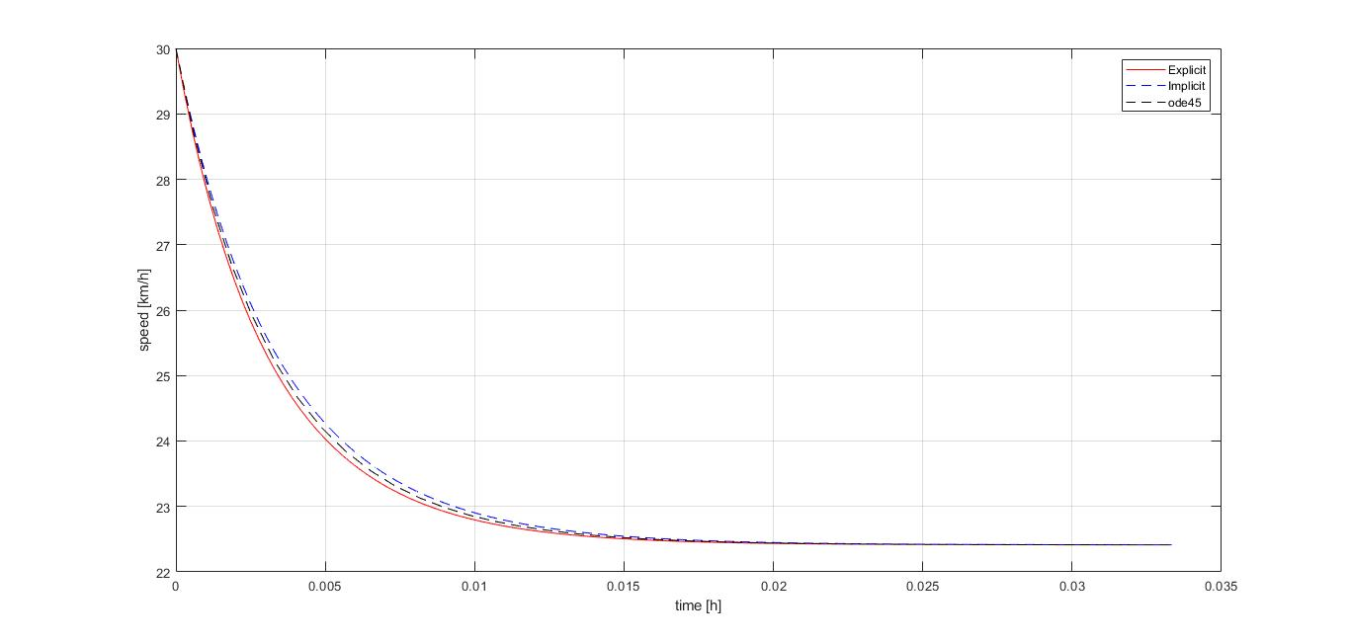
Figure 1: Output Speed
The steady state values using three methods are given as follow:
The steady speed value for Explicit Euler method is 22.41318km/h at 119.00000sec.
The steady speed value for Implicit Euler method is 22.41381km/h at 119.00000sec.
The steady speed value for ode45 method is 22.41343km/h at 119.09696sec.
It can be seen that steady state values for all three methods are approx. same. Similarly, steady speed time values are also same.

