Let’s play “More Or Less”.

[logo]

It’s a quiz game where you don’t need to know the answer; you just need to know the answer... more or less.

[strapline]

Each question has a definite numerical answer:



and an initial range in which the answer lies:



You can then set a range which you’re confident that the true answer lies in.

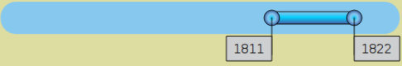

You can change the bounds of the range to make the range broader or narrower. The narrower the range the more points you will get if the actual answer lies in that range.



You can use your phone to change the range and send your answer.

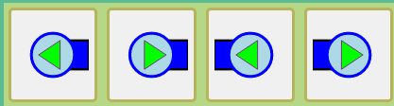

[screenshot of positive result]

[compound screenshot of phone UI superimposed on Pi ui]

## Disclaimers

**Does it cost?**

No! It’s free! Totally, 100% free.

**Will you take my email address and spam me endlessly?**

Nope. I hate that as much as you do.

**Am I downloading anything?**

Nope. When you scan the QR code you are just visiting a web site; just like you do when you browse the net on your phone.

**Why do I have to key in a code?**

**“What’s in it for you??!?”**

This machine has been sponsored by the owner of the shop. If you want to show your support and buy something from the shop, no one will stand in your way.