NORDVIK NATIONAL PENSION RESERVE FUND
A project by Farid BOULOS for the class of professor S.S.

INVESTMENT POLICY STATEMENT

Strategic Asset Allocation, Portfolio Construction
& 10-Year De-Risking Glide Path

AUM: EUR 2.8 Billion
Document Date: 24 May 2026
Backtest Coverage: January 2015 to Document Date
Rebalancing Frequency: Quarterly (Investment Committee Mandate)
Classification: CONFIDENTIAL ; For Investment Committee Use Only

This document contains forward-looking statements and projections that are inherently uncertain. Past performance does not guarantee future results. This IPS is prepared for the exclusive use of the Nordvik NPRF Investment Committee and its authorised advisers. No part of this document may be reproduced or distributed without the prior written consent of the Fund's Governing Board.

Table of Contents

1. EXECUTIVE SUMMARY 4
2. FUND OVERVIEW AND MANDATE 5
3. INVESTMENT OBJECTIVES 6
3.1 Primary Objective 6
3.2 Secondary Objectives 6
3.3 Return Projections 6
4. RISK PROFILE AND INVESTMENT CONSTRAINTS 7
4.1 Risk Tolerance 7
4.2 Quantitative Risk Limits 7
4.3 Qualitative Constraints 7
5. MACROECONOMIC AND CAPITAL MARKETS OUTLOOK 8
5.1 The Global Growth Regime 8
5.2 The Rate Regime: Higher for Longer, Then What? 8
5.3 US Equities: Exceptionalism, Its Limits, and the Factor Lens 8
5.4 European Equities: The Valuation Discount and the Competitiveness Reckoning 9
5.5 Asia-Pacific: Japan's Corporate Governance Revolution 9
5.6 Emerging Markets: Differentiation is Everything 9
5.7 Fixed Income: Liability Matching and the Income Opportunity 10
5.8 Alternatives: The Inflation Hedge Suite 10
6. STRATEGIC ASSET ALLOCATION 11
6.1 Allocation Framework 11
7. INSTRUMENT SELECTION 12
8. PORTFOLIO CONSTRUCTION AND REBALANCING 13
8.1 Three-Portfolio Structure 13
8.2 Rebalancing Mechanism 13
8.3 Asynchronous Trading Adjustment 13
9. FACTOR ANALYSIS: FAMA-FRENCH 6-FACTOR FRAMEWORK 14
9.1 Methodology 14
9.2 Expected Factor Exposures 14
9.3 Regression Results 14
10. 10-YEAR DE-RISKING GLIDE PATH 16
10.1 Rationale 16
10.2 Glide Path Schedule 16
11. BACKTEST RESULTS AND PERFORMANCE ATTRIBUTION 17
11.1 Performance Summary 17
11.2 Drawdown and Rolling Performance 19
11.4 Annual Return Attribution: Portfolio 3 21
11.3 Cross-Asset Correlation (Weekly Returns) 22
11.4 Scenario Analysis: Historical Stress Events 23
12. GOVERNANCE, ESG, AND COMPLIANCE 24
12.1 Governance Structure 24
12.2 ESG Framework 24
12.3 ESG Compliance Table 24
12.4 Performance Monitoring and Review 25
Conclusion and Bibliography 26
Conclusion 26
Bibliography 27
APPENDIX: SUPPLEMENTARY EXHIBITS 28
Exhibit A: Portfolio 3 Asset Weight History 28
Exhibit B: Correlation Matrix Numerical Values 28
Exhibit C: Disclaimer 29

1. EXECUTIVE SUMMARY
The Nordvik National Pension Reserve Fund (the 'Fund') is a sovereign pension reserve established by the Kingdom of Nordvik to pre-fund future pension obligations and serve as a national savings vehicle for the benefit of current and future generations. With assets under management of EUR 2.8 billion and an annual distribution requirement of 3% to 5% of AUM (CPI-indexed), the Fund operates within a perpetual, multi-generational investment horizon whilst simultaneously managing near-term liquidity and liability obligations.
This Investment Policy Statement (IPS) establishes the complete governance framework, strategic asset allocation (SAA), instrument selection rationale, portfolio construction methodology, and quantitative risk management protocols governing the Fund's investment activities over the 25-year planning horizon. The document reflects the Investment Committee's considered judgement as of the date above and shall be reviewed in full on an annual basis, or following any material change in the Fund's liability profile, regulatory environment, or capital markets outlook.
Key Investment Decisions
Decision | Outcome | Rationale
Initial Risky Allocation | 70% in Equities, Gold, REITs, Infrastructure, Crypto | Perpetual horizon and moderate risk tolerance support above-neutral risk budget.
US Equity Tilt | Momentum (MTUM) + Quality (QUAL), equally weighted | Targets two empirically robust, complementary factors with demonstrated alpha persistence.
Fixed Income Construction | Liability-aware: Long-Duration + IG Corp + TIPS + HY (capped 4% of FI sleeve) | Duration-matching of pension liabilities; real return protection; measured yield pickup.
Crypto Allocation | 1.5% maximum in BTC-USD proxy (IBIT in live implementation) | Asymmetric optionality: max loss = 1.5%; potential for transformational upside.
Glide Path | 10-year de-risking commencing 2017; −1% risky/year to 60% terminal | Structured liability-convergence as the Fund matures; mandated quarterly rebalancing.
ESG Framework | SFDR Article 8+ | Hard exclusions: thermal coal >10% revenue, cluster munitions | Regulatory compliance; alignment with Nordic pension fund governance standards.

The Fund's primary performance objective is to preserve and grow capital in real terms, targeting a net real return of CPI + 3.0 to +3.5% per annum over rolling 10-year periods whilst maintaining sufficient liquidity to meet annual distributions without distressed asset sales. The three-portfolio structure enables granular attribution: the 60/40 Benchmark (Portfolio 1) provides the neutral-policy reference point; the US Factor Equity sub-portfolio (Portfolio 2) isolates the active factor bet; and the Global Multi-Asset Portfolio (Portfolio 3) represents the Fund's full SAA implementation inclusive of the glide path de-risking mechanism.

2. FUND OVERVIEW AND MANDATE
Parameter | Detail
Fund Name | Nordvik National Pension Reserve Fund (Nordvik NPRF)
Legal Structure | Sovereign Wealth Fund / Public Pension Reserve
AUM | EUR 2.8 billion (as at document date)
Base Currency | EUR (with significant multi-currency exposure)
Investment Horizon | Perpetual (25-year strategic planning horizon)
Annual Distribution | 3.0-5.0% of AUM, indexed to CPI, paid quarterly
Governance | Governing Board → Investment Committee → CIO → Portfolio Managers
Rebalancing | Quarterly (Investment Committee mandate) with ±3% tolerance bands
Reporting Frequency | Monthly (internal); Quarterly (Governing Board); Annual (public)
Regulatory Framework | SFDR Article 8+ | EU Pension Fund Directive | Nordvik Sovereign Fund Act

The Fund's mandate is explicitly dual-objective: it must (i) generate sufficient real returns to fund 3% to 5% annual disbursements to the national pension system without eroding the real capital base, and (ii) preserve intergenerational equity by maintaining the Fund's purchasing power in real terms over the very long run. These objectives are not always aligned in the short term. A year of poor markets may compress the distribution rate, whilst strong markets may allow above-floor distributions, and the Investment Committee exercises discretion within the ranges specified in this IPS.
The Fund does not operate with explicit external liabilities in the actuarial sense (unlike a defined-benefit pension plan), but rather faces quasi-liability obligations from the annual distribution commitments and from the implicit obligation to maintain real purchasing power for future generations. This distinction is important: it supports a higher equity allocation than a fully liability-matched strategy would imply, whilst still justifying a meaningful fixed-income allocation for duration management and volatility dampening. The glide path de-risking schedule reflects the Committee's expectation that, as the Fund matures and distributions as a share of AUM stabilise, a more conservative asset mix becomes appropriate.

3. INVESTMENT OBJECTIVES

3.1 Primary Objective
Preserve and grow the Fund's real purchasing power whilst generating sufficient liquidity to meet annual pension disbursements. Specifically, the Fund targets a net-of-fees, net-of-distributions real return of CPI + 3.0% per annum over rolling 10-year periods, measured in EUR terms. This target is designed to be ambitious enough to grow the Fund in real terms over time, whilst being realistic relative to the long-run expected returns of the target asset allocation.

3.2 Secondary Objectives
- Maintain sufficient liquidity (minimum 5% portfolio in cash/near-cash) to fund quarterly distributions without forced asset sales, even in the event of a 30% market drawdown.
- Achieve a portfolio volatility not exceeding 12% per annum under normal market conditions, and limit maximum 12-month drawdown to −25% under severe stress scenarios.
- Outperform the 60/40 global benchmark (Portfolio 1) on a risk-adjusted basis (positive Information Ratio) over rolling 5-year periods.
- Maintain full compliance with ESG hard exclusion criteria and SFDR Article 8+ reporting requirements at all times.

3.3 Return Projections
The table below summarises the Investment Committee's long-run capital markets assumptions (CMAs) and the implied contribution of each asset class to Portfolio 3's expected return. These projections are based on a combination of historical risk premia, current valuation signals, and the Committee's forward-looking macro views. They are inherently uncertain and should be treated as indicative, not as guarantees.
Asset Class | Expected Ann. Return | Expected Volatility | Expected Sharpe | Weight in P3
US Momentum + Quality | 10.5% | 16.5% | 0.65 | 22.0%
European Equity | 8.5% | 15.0% | 0.52 | 16.0%
Asia-Pacific Equity | 9.0% | 16.0% | 0.55 | 9.0%
Emerging Markets | 9.5% | 20.0% | 0.48 | 8.0%
Gold | 6.5% | 15.0% | 0.38 | 5.0%
Global REITs | 8.0% | 17.5% | 0.46 | 5.0%
Global Infrastructure | 7.5% | 13.0% | 0.55 | 3.5%
Bitcoin | 25.0%* | 75.0% | 0.30 | 1.5%
Long Sovereign (TLT) | 4.8% | 14.0% | 0.28 | 13.0%
IG Corporate (LQD) | 5.5% | 7.0% | 0.68 | 7.0%
Inflation-Linked (TIP) | 4.5% | 7.5% | 0.55 | 4.0%
High Yield (HYG) | 6.5% | 10.5% | 0.58 | 1.0%
Cash (T-Bill) | 4.2% | 0.5% | n/a | 5.0%
Portfolio 3 (Weighted) | ~8.1% | ~9.5% | ~0.68 | 100%
Table: Long-Run Capital Markets Assumptions. * Bitcoin expected return reflects extreme uncertainty; geometric mean estimate over a 10-year horizon. Portfolio 3 statistics are pre-glide-path (70% risky weighting). All returns are gross of fees, in EUR-hedged terms.
4. RISK PROFILE AND INVESTMENT CONSTRAINTS

4.1 Risk Tolerance
The Fund's risk tolerance is assessed as MODERATE-TO-HIGH. The perpetual investment horizon, lack of hard mark-to-market liabilities, and the ability to adjust distribution rates during adverse market periods all argue for a structurally above-neutral allocation to risk assets. The 70% initial risky-asset allocation reflects this. However, the 3% to 5% annual distribution obligation imposes genuine near-term liquidity risk, and the political sensitivity of a sovereign fund's reported performance imposes practical constraints on the tolerable level of short-term drawdown. The Investment Committee has adopted a −25% maximum 12-month drawdown as the operational risk ceiling, beyond which a mandatory strategy review is triggered.

4.2 Quantitative Risk Limits
Risk Metric | Limit | Monitoring Frequency | Breach Action
Portfolio Volatility (ann.) | ≤ 12% under normal conditions | Monthly | Report to IC; review if sustained >3 months
Maximum 12-Month Drawdown | ≤ −25% | Daily | Mandatory IC review; potential rebalancing
Tracking Error vs P1 Benchmark | ≤ 8% p.a. | Quarterly | IC review of active bets
Single Asset Concentration | ≤ 20% of portfolio | Quarterly | Rebalance to compliance
High Yield as % of FI Sleeve | ≤ 10% | Quarterly | Reduce at next rebalancing
Crypto Allocation | ≤ 1.5% of total portfolio | Monthly | Trim at next rebalancing
Minimum Cash | ≥ 5.0% of total portfolio | Daily | Immediate liquidation of most liquid assets
Expected Shortfall (99%, 1-month) | Internal monitoring; not hard limit | Monthly | IC awareness

4.3 Qualitative Constraints
- Liquidity: All portfolio assets must be listed, exchange-traded instruments. No direct private equity, private credit, or illiquid real assets. The Fund's size (EUR 2.8bn) requires that each instrument have average daily trading volume of at least EUR 100m to avoid meaningful market impact costs.
- ESG Hard Exclusions: No investment in issuers deriving >10% of revenue from thermal coal extraction or processing; no investment in cluster munitions, anti-personnel mines, biological or chemical weapons manufacturers. Exclusions apply at the ETF portfolio constituent level. ETF issuers must provide constituent-level transparency or third-party ESG screening.
- Currency: The Fund's base currency is EUR. All holdings carry inherent foreign currency risk. Strategic currency hedging is not employed at the portfolio level (the breadth of global diversification provides natural currency diversification). The IC may authorise tactical hedging of USD exposure in specific circumstances.
- Leverage: No leverage. The Fund may not borrow to invest. Derivatives may be used for hedging only, not for speculative position-taking, and only with IC approval.

5. MACROECONOMIC AND CAPITAL MARKETS OUTLOOK
The following section sets out the Investment Committee's macroeconomic views and capital markets outlook as at May 2026. These views directly inform the strategic asset allocation and instrument selection decisions documented in subsequent sections. We present our views with conviction whilst acknowledging the inherent uncertainty of macroeconomic forecasting; our portfolio construction is designed to be robust across a range of plausible scenarios rather than to maximise return in a single scenario.

5.1 The Global Growth Regime
Global growth in 2025/2026 has settled into a regime of moderate expansion (approximately 3.1% in real terms globally) characterised by a pronounced divergence between the United States, which continues to outperform despite elevated fiscal deficits, and the European bloc, which faces structural headwinds from energy costs, industrial competitiveness challenges, and demographic ageing. Emerging markets are the most heterogeneous component: India's 6.8% real GDP growth towers above China's 4.2%, whilst Brazil and Mexico benefit from nearshoring-driven industrial investment. The global economy has navigated the post-2022 rate normalisation without a hard landing, which is a genuine achievement, but the lagged effects of higher real rates continue to weigh on credit-sensitive sectors and private investment.

5.2 The Rate Regime: Higher for Longer, Then What?
The current policy regime remains materially tighter than the pre-2022 era. The Federal Reserve is holding the federal funds target range at 3.50% to 3.75%, the ECB is holding the deposit facility rate at 2.00%, and the Bank of Japan is still normalising from its post-deflation stance. The critical question for asset allocators is whether the terminal neutral rate in this cycle is structurally higher than the 2010–2019 era, when many policy rates were at or near the zero lower bound.
The Committee's base case is that r* (the neutral real interest rate) has risen by 50–100 basis points structurally, driven by three forces: (i) the end of the global savings glut as Asian demographics shift and EM current account surpluses narrow; (ii) the massive fiscal expansion across G7 sovereigns, which competes with private borrowers for capital; and (iii) the de-globalisation of supply chains, which is inherently inflationary relative to the frictionless globalisation of 1990–2015. This structural repricing of the risk-free rate has lasting implications: duration assets are more attractive than at any point since 2008 (absolute yield), whilst equity valuations must be assessed against a structurally higher discount rate.

5.3 US Equities: Exceptionalism, Its Limits, and the Factor Lens
US equity markets have delivered exceptional long-run returns, but the more important current facts are concentration and valuation discipline. Large-cap US equity remains highly exposed to a narrow set of mega-cap names, so the Committee prefers factor-tilted exposure over undifferentiated market-cap beta. We do not forecast a collapse in US equities, but we do assume that the next decade should be assessed against a higher bar than the last.
The more important insight for portfolio construction is that plain-vanilla market-cap US exposure (e.g. SPY) is now extraordinarily concentrated: the top 10 holdings account for approximately 35% of the index, with several of the largest positions (NVIDIA, Apple, Microsoft) trading at multiples that embed decades of optimistic earnings assumptions. The Committee's preference for factor-tilted US exposure, specifically Momentum (MTUM) and Quality (QUAL), reflects a deliberate choice to avoid this concentration risk whilst maintaining participation in US equity markets. Quality companies with high ROE, low financial leverage, and stable earnings are precisely those best positioned in a world of structurally higher real interest rates: they do not rely on cheap debt to generate returns, and their cash flows are robust across the cycle. Momentum exposure ensures dynamic repositioning toward the market's current leaders, avoiding the value trap of mechanically owning cheap-but-deteriorating businesses.

5.4 European Equities: The Valuation Discount and the Competitiveness Reckoning
European equities trade at a persistent and historically wide valuation discount to US peers: MSCI Europe forward P/E of approximately 13x versus S&P 500's 21x. Part of this discount is warranted as the European index has heavier exposure to banks, industrials, and energy, and lighter exposure to high-multiple technology, but the Committee believes a meaningful portion reflects excessive pessimism. The Draghi Report's estimate of EUR 800 billion in annual investment required to close Europe's productivity gap with the US has catalysed a nascent conversation about EU-level fiscal instruments, building on the NextGenerationEU precedent. The ECB's easing cycle provides a supportive monetary backdrop, and European household savings rates (elevated post-COVID) represent potential consumption upside.
The structural headwinds are real and should not be minimised. Germany's Mittelstand industrial base faces an existential challenge from Chinese competition in key sectors (automotive, chemicals, machinery), from which structural adjustment will be slow and politically painful. The energy cost advantage that underpinned German industrial competitiveness for decades has been permanently impaired by the loss of cheap Russian gas. We acknowledge these risks and size European equity at 16% of total portfolio, which we believe is a meaningful allocation reflecting conviction in the long-run mean reversion thesis, but not a concentrated bet on near-term European outperformance.

5.5 Asia-Pacific: Japan's Corporate Governance Revolution
Japan deserves special attention within the Asia-Pacific allocation. The Tokyo Stock Exchange's March 2023 directive to listed companies to 'take action to improve management that is conscious of cost of capital and stock price' has catalysed a genuine and structural shift in Japanese corporate behaviour. Cross-shareholding unwinds, rising dividend payout ratios, and record share buyback programmes are not cyclical phenomena; they reflect a fundamental improvement in capital allocation discipline enforced by a combination of regulatory pressure, activist shareholders, and a generational change in management mentality. The proportion of TSE Prime Market companies with a price-to-book ratio below 1.0x fell from 40% in early 2023 to below 22% by end-2025, yet further improvement is plausible.
The Bank of Japan's normalisation of monetary policy, with the uncollateralized overnight call rate around 0.75%, introduces some JPY appreciation risk and near-term earnings headwinds for export-heavy Japanese companies. We view this as a manageable transition rather than a structural reversal, and maintain VPL (Asia-Pacific) at 9% of portfolio, of which Japan remains the largest single-country exposure.

5.6 Emerging Markets: Differentiation is Everything
The 'Emerging Markets' label increasingly obscures more than it reveals. The universe spans India (7% real GDP growth, dominant technology and services sector, world's largest democratic market), China (structural growth slowdown, property sector stress, geopolitical overlay), Brazil (commodity leverage, chronic fiscal instability), Taiwan and Korea (global semiconductor supply chain critical infrastructure), and Mexico (nearshoring beneficiary). We use the broad VWO (FTSE Emerging Markets) for liquidity and cost efficiency, whilst explicitly monitoring the China exposure (approximately 27% of VWO as of mid-2025) as the principal geopolitical risk within the allocation.
A Taiwan Strait military confrontation is the Committee's identified tail risk. This has been classified a low-probability, high-severity event. Our 8% EM weight is sized such that even a 50% drawdown in EM (which would be extreme even by GFC standards) would contribute only −4% to total portfolio performance. We consider this an acceptable tail risk for the expected excess return the allocation is expected to generate. India's secular growth story, namely in demographic dividend, digital infrastructure investment (UPI, Aadhaar, ONDC), and manufacturing capacity expansion, represents the most compelling long-run EM thesis, and VWO's growing India weight (now ~22%) aligns our exposure with this view.

5.7 Fixed Income: Liability Matching and the Income Opportunity
After the worst bond bear market in 40 years (2022/2023), fixed income enters the current period with the most attractive entry valuations since the pre-GFC era. 10-year US Treasury yields are estimated at 4.0% to 4.5% and TIPS real yields at 1.8% to 2.2% (approximate, consistent with the post-2022 normalisation; actual rates as at the execution date apply). These represent genuinely positive real return expectations, and pose a dramatic contrast to the negative real yields prevalent from 2020 to 2022. The Fund's liability-matching rationale for long-duration bonds (TLT) is straightforward: pension-like obligations are long-duration by nature, and holding long-duration assets creates a partial hedge against liability value inflation when rates fall. Furthermore, in a severe risk-off scenario (equity market crisis accompanied by flight-to-quality), long-duration government bonds historically provide the most powerful portfolio hedge.
TIPS serve a different but complementary function: they protect real purchasing power and therefore directly support the Fund's mandate of real capital preservation. Investment-grade corporate bonds (LQD) add spread income over comparable-duration Treasuries, which we view as acceptable compensation for credit risk in the present environment. The small high yield allocation (HYG, 1%) adds income at a tightly controlled credit risk budget.

5.8 Alternatives: The Inflation Hedge Suite
Gold remains the Committee's preferred hedge against monetary debasement. G7 sovereign debt-to-GDP ratios are at post-WWII highs; the US federal deficit has averaged $1.8 trillion annually since 2020; and the political will to engineer fiscal consolidation has been consistently absent. In this environment, gold's role as a monetary asset without counterparty risk becomes structurally more valuable. The decisive new development is the sustained record pace of central bank gold purchases since 2022, which mainly driven by the weaponisation of the USD financial system (Russian asset freezes post-Ukraine invasion), triggering reserve diversification by China, India, Turkey, and others. This structural demand shift is not cyclical and is not yet fully priced. Gold's 5% portfolio weight reflects high conviction in this thesis.
Listed infrastructure (IGF, 3.5%) provides inflation-linked revenues, such as regulated utility asset bases, toll road concessions with CPI-indexed tariffs, and airport landing fees, that create genuine real asset characteristics. The energy transition (decarbonisation of the power grid, electric vehicle charging, green hydrogen) is creating a multi-decade investment super-cycle in infrastructure estimated by the IEA at $4 trillion annually through 2030. Listed infrastructure companies (utilities, transport networks, communication towers) are the primary beneficiaries of this investment cycle.
Bitcoin's 1.5% allocation is the Fund's most controversial position and requires precise framing. It is not an inflation hedge; it is a structured asymmetric optionality bet. The position is intentionally small so that the maximum downside is bounded, while the upside remains meaningful if institutional adoption continues. The ETF wrapper has materially improved accessibility and operational feasibility. At this sizing, the position is deliberately held below any Kelly-optimal fraction, reflecting the unusually high estimation uncertainty attached to Bitcoin.

6. STRATEGIC ASSET ALLOCATION

6.1 Allocation Framework
The Strategic Asset Allocation is constructed within a risk-budgeting framework that starts from two top-level buckets: Risky Assets (70% initial weight) and Safe Assets (30% initial weight). It then allocates within each bucket according to diversification, expected risk-adjusted return, and liquidity criteria. The split reflects the Investment Committee's judgement that the Fund's perpetual horizon and moderate liability pressure justify an above-neutral risk budget, whilst the 30% safe allocation provides sufficient ballast to survive a 30%+ equity drawdown without forcing distribution cuts.
Bucket | Asset Class | Instrument | Ticker | Weight | Role
Risky  (70%) | US Equity (Factor) | iShares MSCI USA Momentum | MTUM | 11.0% | Systematic trend + concentration avoidance
 | US Equity (Factor) | iShares MSCI USA Quality | QUAL | 11.0% | Pricing power + earnings resilience
 | European Equity | Vanguard FTSE Europe | VGK | 16.0% | Valuation mean-reversion; dividend income
 | Asia-Pacific Equity | Vanguard FTSE Pacific | VPL | 9.0% | Japan corp. governance; commodity exposure
 | Emerging Markets | Vanguard FTSE EM | VWO | 8.0% | India secular growth; EM risk premium
 | Gold | SPDR Gold Shares | GLD | 5.0% | Monetary debasement hedge; crisis diversifier
 | Global REITs | Vanguard Real Estate | VNQ | 5.0% | Inflation-linked rents; NAV discount recovery
 | Global Infrastructure | iShares Global Infrastructure | IGF | 3.5% | Regulated inflation-linked revenues; energy transition
 | Bitcoin | BTC-USD (IBIT in live impl.) | BTC | 1.5% | Asymmetric optionality
Safe  (30%) | Long Sovereign Bonds | iShares 20+ Year Treasury | TLT | 13.0% | Liability duration match; flight-to-quality hedge
 | IG Corporate Bonds | iShares iBoxx $ IG Corp | LQD | 7.0% | Credit spread income; moderate duration
 | Inflation-Linked Bonds | iShares TIPS Bond | TIP | 4.0% | Real return guarantee; CPI-linkage
 | High Yield (≤10% of FI) | iShares iBoxx $ HY Corp | HYG | 1.0% | Additional income; credit risk tightly bounded
 | Cash / T-Bills | 3-Month T-Bill (FRED DTB3) | Cash | 5.0% | Minimum liquidity; distribution reserve
Table: Portfolio 3 Strategic Asset Allocation Initial weights (pre-glide path, 70% risky).

7. INSTRUMENT SELECTION
All instruments are listed, exchange-traded funds (ETFs). Selection criteria: (i) minimum 10-year price history for backtest integrity; (ii) AUM ≥ USD 2 billion to ensure institutional-quality liquidity; (iii) total expense ratio (TER) ≤ 0.25% to minimise cost drag; (iv) daily trading volume ≥ USD 100m; and (v) ESG screening compatibility. One exception applies: BTC-USD spot is used as a backtesting proxy for Bitcoin given the absence of a qualifying ETF with 10+ year history. The live implementation would use IBIT (iShares Bitcoin Trust, BlackRock) or a direct segregated custody arrangement.
Ticker | Full Name | Inception | AUM (USD) | TER | Key Characteristic
MTUM | iShares MSCI USA Momentum | Jul 2013 | ~$11 Bn | 0.15% | MSCI USA Momentum Index; reconstituted semi-annually
QUAL | iShares MSCI USA Quality | Jul 2013 | ~$34 Bn | 0.15% | MSCI USA Quality Index: ROE, earnings variability, D/E ratio
VGK | Vanguard FTSE Europe | Mar 2005 | ~$25 Bn | 0.09% | ~1,300 stocks across developed Europe; UK, France, Germany dominate
VPL | Vanguard FTSE Pacific | Mar 2005 | ~$6 Bn | 0.09% | Japan (~60%), Australia (~20%), Korea, HK, Singapore
VWO | Vanguard FTSE Emerging Markets | Mar 2005 | ~$80 Bn | 0.08% | China (~27%), India (~22%), Taiwan (~18%), Brazil (~6%)
GLD | SPDR Gold Shares | Nov 2004 | ~$70 Bn | 0.40% | Physical gold; largest gold ETF globally; LBMA-vaulted
VNQ | Vanguard Real Estate | Sep 2004 | ~$34 Bn | 0.13% | US REITs; diversified across office, residential, industrial, retail
IGF | iShares Global Infrastructure | Jan 2007 | ~$5 Bn | 0.40% | ~75 global listed infrastructure cos.; utilities, transport, energy
BTC | BTC-USD (proxy; IBIT live) | N/A* | N/A | 0.25%† | Bitcoin spot; IBIT >0 Bn AUM (early 2025); volume > Bn/day since Jan 2024
TLT | iShares 20+ Year US Treasury | Jul 2002 | ~$60 Bn | 0.15% | Duration ~18 yrs; primary liability-matching instrument
LQD | iShares iBoxx $ IG Corporate | Jul 2002 | ~$35 Bn | 0.14% | ~2,600 IG bonds; duration ~8 yrs; avg rating A−
TIP | iShares TIPS Bond | Dec 2003 | ~$17 Bn | 0.19% | US Treasury Inflation-Protected Securities; duration ~7 yrs
HYG | iShares iBoxx $ High Yield | Apr 2007 | ~$16 Bn | 0.48% | ~1,200 US HY bonds; yield-to-worst ~6.5%; capped at 4% of FI sleeve
ACWI | iShares MSCI ACWI (Benchmark) | Mar 2008 | ~$20 Bn | 0.32% | 60% of P1; 23 developed + 24 EM countries; ~2,900 holdings
BND | Vanguard Total Bond Market (Bmk) | Apr 2007 | ~$115 Bn | 0.03% | 40% of P1; USD 10+ trillion bond market coverage; duration ~6 yrs
Table: Instrument selection summary. AUM and TER are indicative and may change over time. † IBIT TER. * BTC-USD data available on Yahoo Finance from September 2014.

8. PORTFOLIO CONSTRUCTION AND REBALANCING

8.1 Three-Portfolio Structure
- Portfolio 1 — 60/40 Benchmark: ACWI (60%) + BND (40%). Fixed-mix, quarterly rebalanced. This is the neutral-policy reference portfolio, and the most common institutional benchmark for multi-asset funds. All active performance is measured relative to this baseline.
- Portfolio 2 — US Factor Equity: MTUM (50%) + QUAL (50%). Fixed-mix, quarterly rebalanced. This is the Fund's isolated US equity factor bet, designed to demonstrate incremental risk-adjusted return over plain-vanilla US market exposure (VTI). Subject to Fama-French 6-factor regression.
- Portfolio 3 — Global Multi-Asset + Glide Path: Full SAA implementation as per Section 6. Target weights evolve annually following the de-risking glide path (see Section 9). Quarterly rebalancing within each annual target, with ±3% tolerance bands triggering intra-quarter rebalancing if breached.

8.2 Rebalancing Mechanism
Rebalancing occurs at the close of each calendar quarter (March, June, September, December). At each quarterly rebalancing: (i) current portfolio weights are computed from mark-to-market valuations; (ii) weights are compared to the current annual target weights; (iii) trades are executed to restore target weights across all positions. Transaction costs are estimated at 2 to 4 basis points per rebalancing trade (ETF bid-ask spread + market impact for a EUR 2.8bn portfolio). At current portfolio size, the Fund has sufficient scale to negotiate block-trading arrangements with liquidity providers at favourable spreads.
Additionally, a ±3% tolerance band is monitored continuously for each asset: if any position drifts more than 3 percentage points from its target weight before the next scheduled quarterly rebalancing, an intra-quarter rebalancing trade is triggered for that position only. This prevents concentration risk from building in strong trending markets (e.g., a Bitcoin rally pushing crypto above the 1.5% cap).

8.3 Asynchronous Trading Adjustment
A material methodological consideration for global multi-asset portfolios is the asynchronous nature of international market trading hours. US equity and fixed income markets close approximately 5 to 7 hours after European markets and 8 to 14 hours after Asian markets. This creates a stale-price problem in daily return calculations: reported end-of-day prices for Asian assets on any given date reflect news up to their market close, whilst US market prices reflect a further 8+ hours of information flow. This induces spurious correlation structure in daily returns.
The portfolio construction methodology addresses this through: (i) using weekly return series (close Friday to close Friday) for all correlation analysis and covariance estimation, since weekly returns substantially reduce the asynchronous trading bias whilst preserving adequate statistical power over a 10+ year sample; (ii) employing close-to-close daily returns for portfolio NAV calculation (which is appropriate, as rebalancing occurs at daily closes); and (iii) noting the limitation in all cross-regional beta and correlation reporting.

9. FACTOR ANALYSIS: FAMA-FRENCH 6-FACTOR FRAMEWORK

9.1 Methodology
Portfolio 2 (US Factor Equity: MTUM + QUAL) is subjected to a Fama-French 6-factor time-series regression to decompose its return into: (i) exposure to systematic market risk (Mkt-RF); (ii) size premium exposure (SMB small minus big); (iii) value premium exposure (HML high minus low book-to-market); (iv) profitability premium (RMW robust minus weak operating profitability); (v) investment premium (CMA conservative minus aggressive investment); and (vi) momentum premium (WML winners minus losers). An unexplained return component (alpha, or Jensen's alpha) represents return not attributable to any of the six systematic risk factors.
The regression uses monthly excess returns (portfolio return minus the risk-free rate) as the dependent variable, and the six factor returns are drawn from the live Kenneth French series for this run. Heteroskedasticity-robust standard errors (HC3) are used to account for potential time-varying residual variance. The regression is estimated over the full available sample period.
Live factor downloads succeeded during this run, so the factor series were used directly from the Kenneth French data library.

9.2 Expected Factor Exposures
Given the construction of Portfolio 2, the Committee expects the following factor profile: high market beta (close to 1.0, given both MTUM and QUAL are large-cap US equity funds); negative or near-zero SMB (large-cap bias); near-zero HML (both momentum and quality tilt away from value); positive RMW (QUAL explicitly selects high-profitability companies); negative or near-zero CMA (momentum tends to be in aggressively investing growth companies, partially offset by QUAL's preference for capital discipline); and strongly positive WML (MTUM is explicitly a momentum strategy and this should be the dominant factor loading). Positive alpha, if observed, would represent return in excess of factor compensation.

9.3 Regression Results
Factor | Coefficient | t-Statistic | p-Value | Significance
const | -0.0009 | -1.190 | 0.2342
Mkt-RF | 1.0210 | 46.601 | 0.0000 | ***
SMB | -0.0724 | -1.979 | 0.0478 | *
HML | -0.0402 | -1.447 | 0.1479
RMW | 0.0707 | 1.448 | 0.1476
CMA | 0.0305 | 0.594 | 0.5526
WML | 0.1973 | 8.422 | 0.0000 | ***
*** p<0.01 ** p<0.05 * p<0.10 | HC3 robust standard errors.
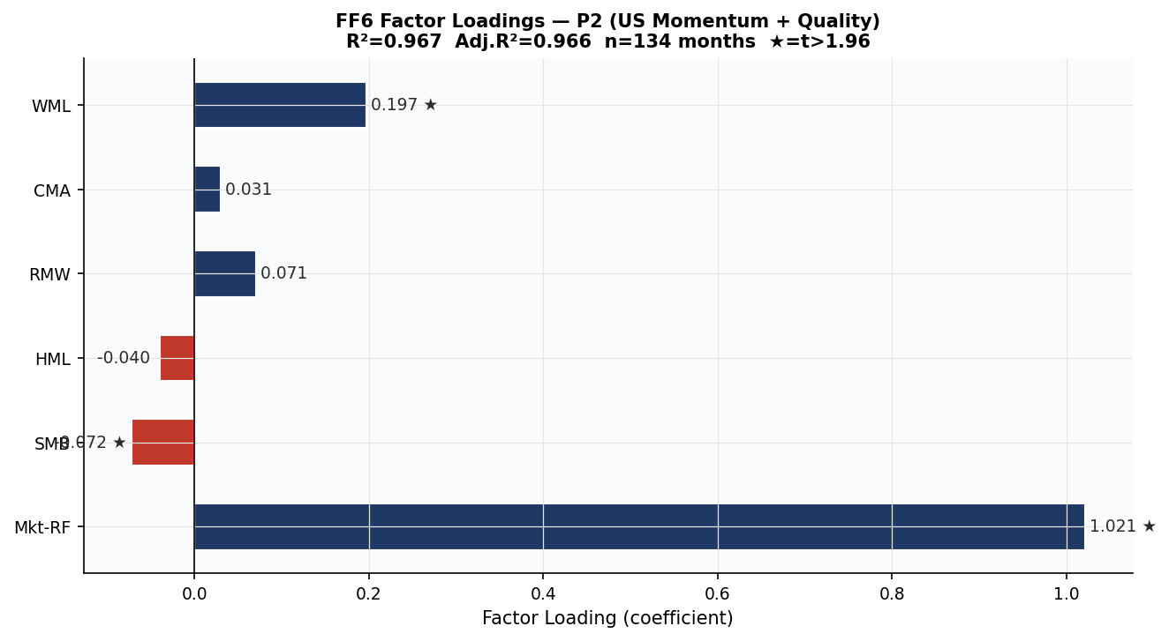
Exhibit 9.1: FF6 Factor Loadings for Portfolio 2 (US Momentum + Quality). ★ = t-stat > 1.96.

10. 10-YEAR DE-RISKING GLIDE PATH

10.1 Rationale
As a maturing sovereign pension reserve, the Fund's risk tolerance evolves over time. In its early years, the Fund's primary objective is capital accumulation and real return generation, which justifies a high allocation to risk assets. As the Fund grows and the annual distribution obligation (3% to 5% of AUM) becomes a more material cash-flow commitment relative to the portfolio, sequencing risk (the risk that poor near-term returns coincide with large cash outflows) becomes an increasingly important concern. The 10-year glide path addresses sequencing risk by systematically reducing the risky asset allocation from 70% to 60% over a decade, shifting the marginal capital into liability-matching safe assets.

10.2 Glide Path Schedule
The glide path commences at the December 2016 annual rebalancing, so the portfolio first holds its reduced-risk allocation (69% risky) throughout 2017. Ten annual steps of −1% each reduce the risky allocation to exactly 60% at end-2026, where it is maintained thereafter. Within-group proportions (the relative weights of assets within the risky and safe buckets) are preserved throughout. Only the top-level bucket sizes change.
Year | Risky (%) | Safe (%) | MTUM | VGK | TLT | Cash
2015 | 70.0% | 30.0% | 11.0% | 16.0% | 13.0% | 5.0%
2016 | 70.0% | 30.0% | 11.0% | 16.0% | 13.0% | 5.0%
2017 | 69.0% | 31.0% | 10.8% | 15.8% | 13.4% | 5.2%
2018 | 68.0% | 32.0% | 10.7% | 15.5% | 13.9% | 5.3%
2019 | 67.0% | 33.0% | 10.5% | 15.3% | 14.3% | 5.5%
2020 | 66.0% | 34.0% | 10.4% | 15.1% | 14.7% | 5.7%
2021 | 65.0% | 35.0% | 10.2% | 14.9% | 15.2% | 5.8%
2022 | 64.0% | 36.0% | 10.1% | 14.6% | 15.6% | 6.0%
2023 | 63.0% | 37.0% | 9.9% | 14.4% | 16.0% | 6.2%
2024 | 62.0% | 38.0% | 9.7% | 14.2% | 16.5% | 6.3%
2025 | 61.0% | 39.0% | 9.6% | 13.9% | 16.9% | 6.5%
2026 | 60.0% | 40.0% | 9.4% | 13.7% | 17.3% | 6.7%
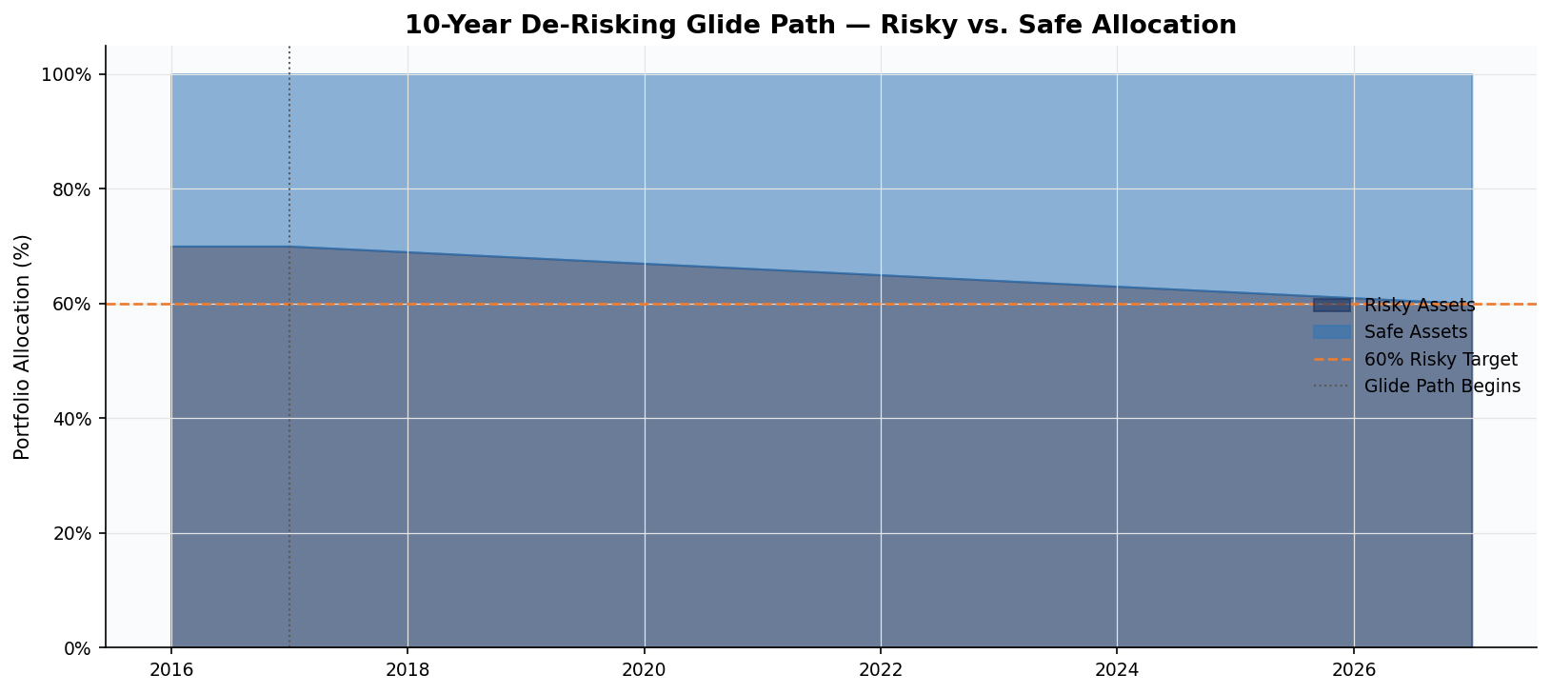
Exhibit 10.1: 10-Year De-Risking Glide Path Risky vs. Safe Allocation over Backtest Period.
11. BACKTEST RESULTS AND PERFORMANCE ATTRIBUTION

11.1 Performance Summary
The following results are derived from a full-sample backtest spanning January 2015 to the date of execution. This run used live Yahoo Finance, FRED, and Kenneth French downloads successfully, so the output, charts, and tables below reflect the live data path rather than the synthetic fallback. All portfolios are rebased to 100 at inception. Quarterly rebalancing is applied throughout. The risk-free rate used for Sharpe ratio calculations is the prevailing daily cash return series from the active data mode.

Portfolio | Ann. Return (%) | Ann. Vol (%) | Sharpe | Max DD (%) | CVaR 95% (%) | Calmar | Sortino
P1 · Benchmark (60/40) | 7.30 | 10.40 | 0.730 | -22.24 | 24.62 | 0.328 | 0.857
P2 · US Factor (Mom + Qual) | 13.83 | 18.22 | 0.802 | -34.07 | 44.15 | 0.406 | 0.939
P3 · Global Multi-Asset + Glide | 8.00 | 10.75 | 0.770 | -26.19 | 25.12 | 0.305 | 0.935
Table: Performance statistics over full backtest period. CVaR 95% annualised Expected Shortfall at 95% confidence. All figures annualised.

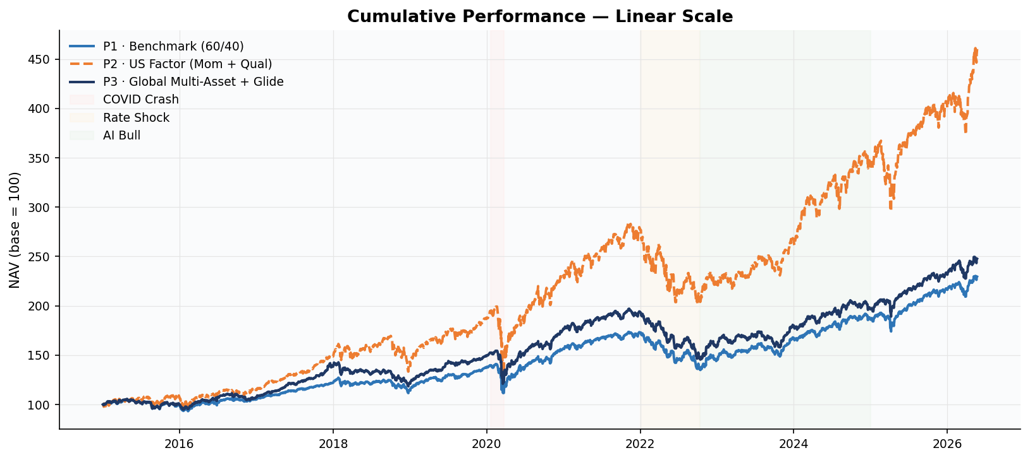
Exhibit 11.1: Cumulative Performance at the Linear Scale (base = 100 at January 2015).
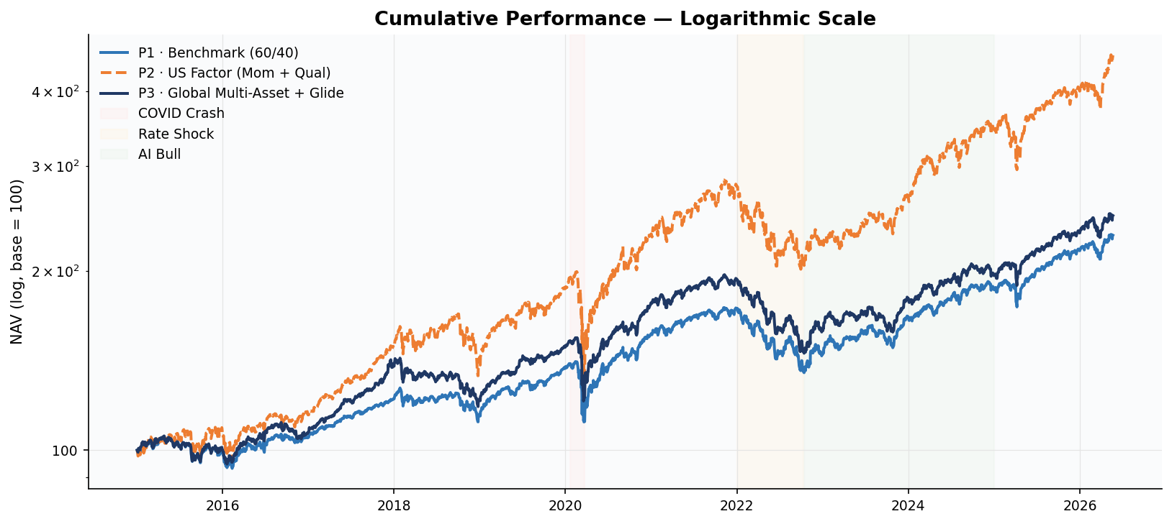
Exhibit 11.2: Cumulative Performance at the Logarithmic Scale.

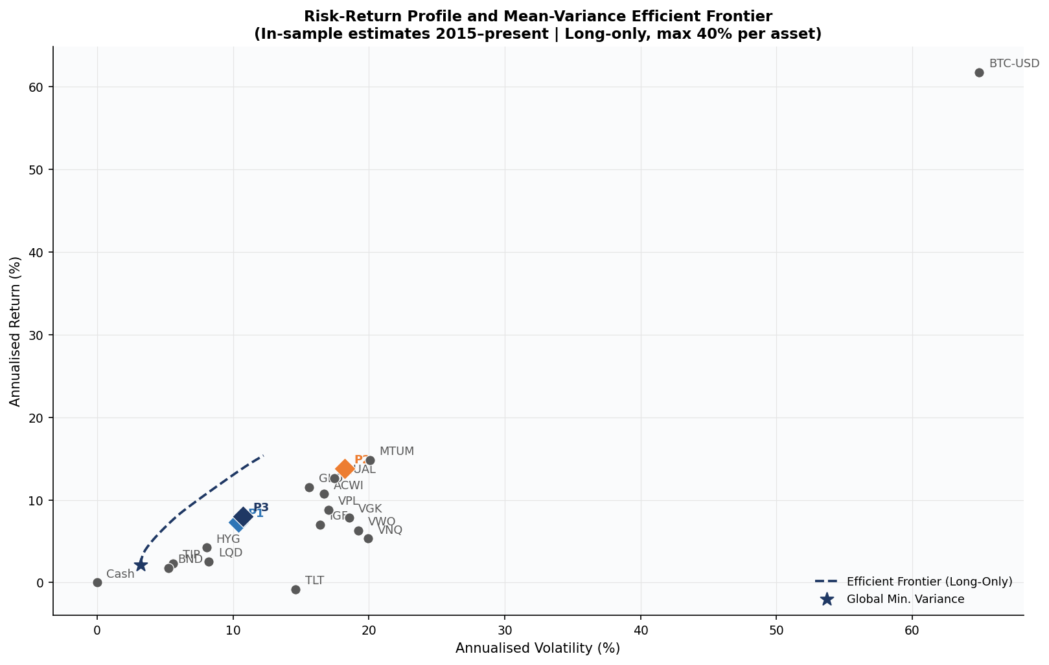
Exhibit 11.3: Mean-Variance Efficient Frontier with Portfolio Positions. Dashed curve = long-only frontier (max 40% per asset, in-sample). ★ = Global Minimum Variance portfolio. Diamonds = P1, P2, P3.

11.2 Drawdown and Rolling Performance
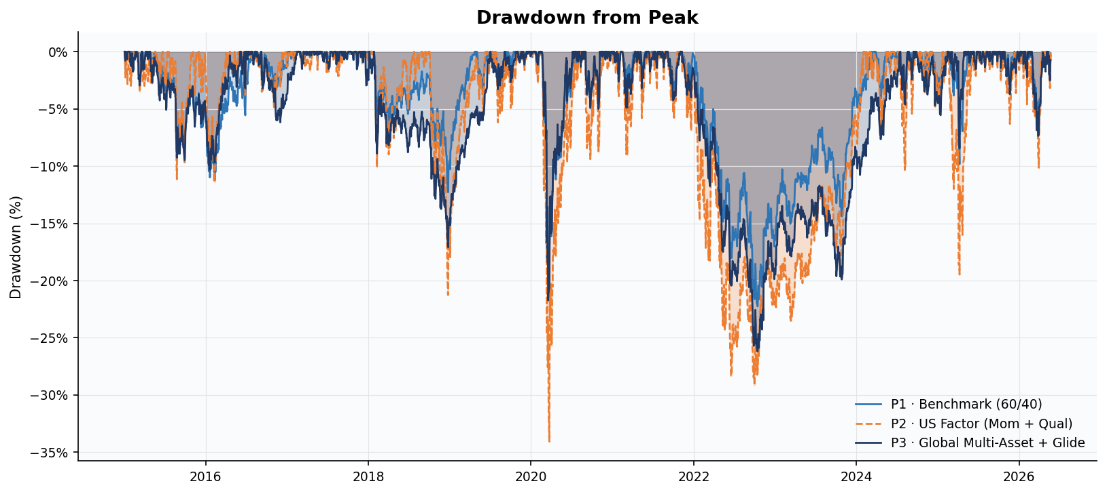
Exhibit 11.4: Drawdown from Peak for all portfolios.

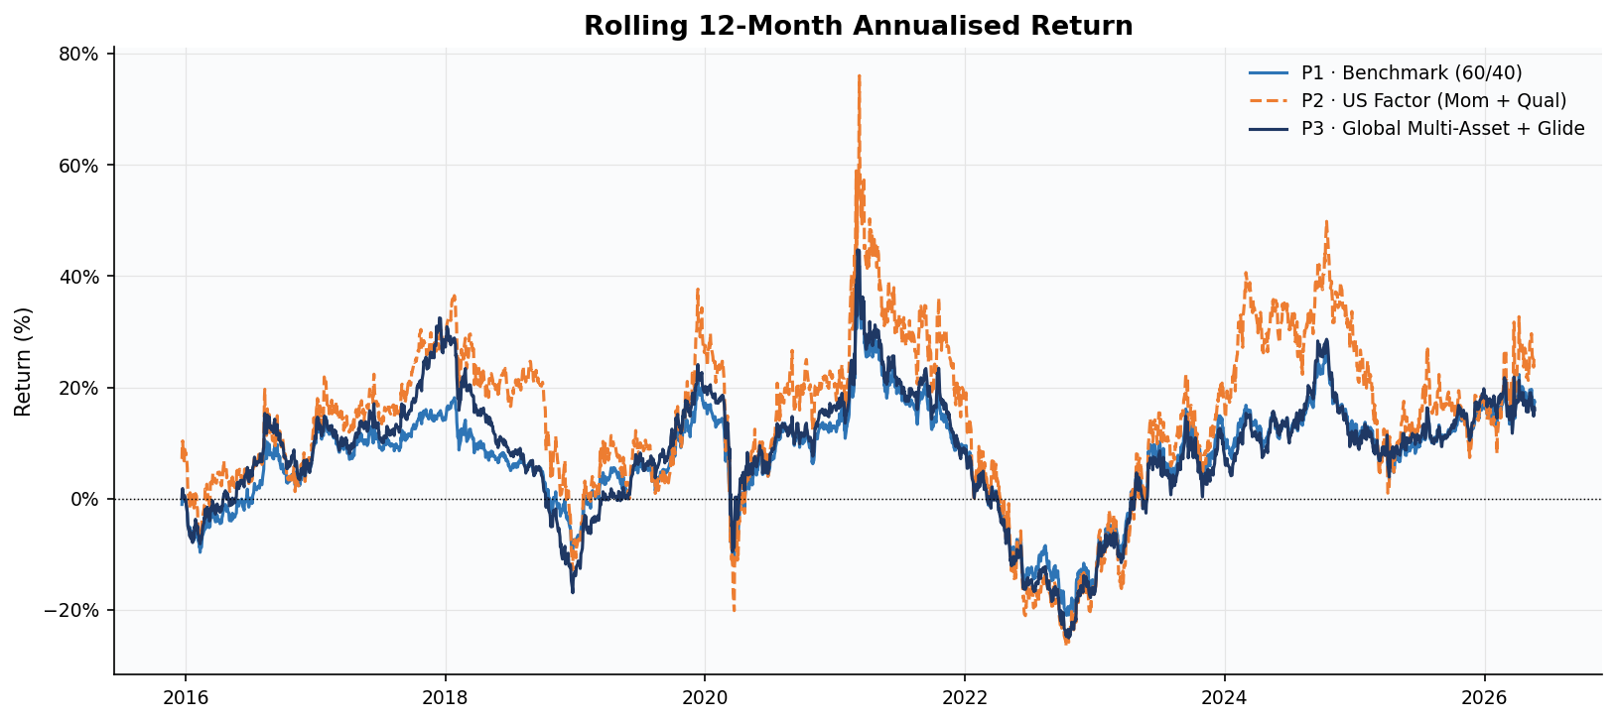
Exhibit 11.5: Rolling 12-Month Annualised Return.

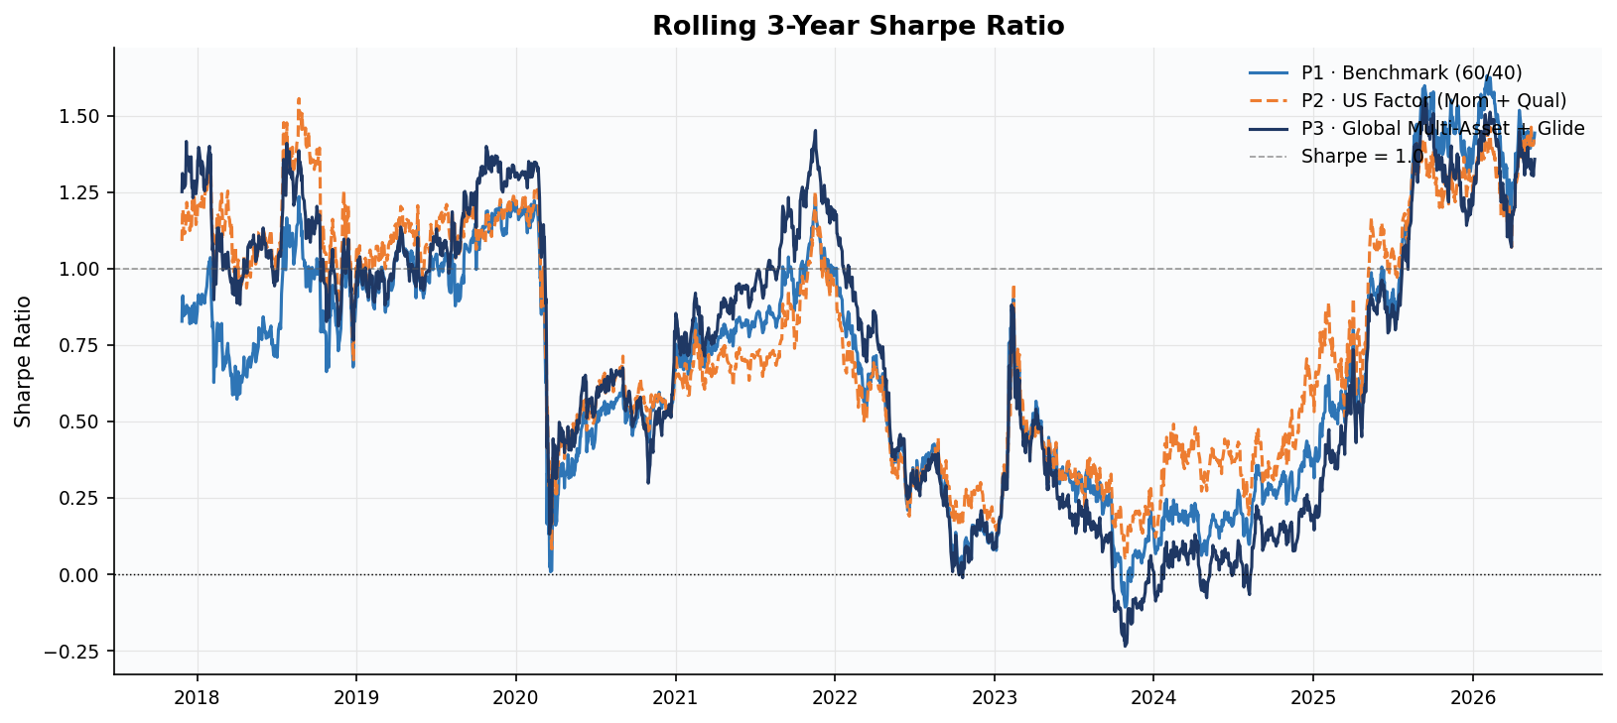
Exhibit 11.6: Rolling 3-Year Sharpe Ratio.

11.4 Annual Return Attribution: Portfolio 3
The attribution chart below decomposes Portfolio 3's total return each calendar year into four buckets: Equity (MTUM, QUAL, VGK, VPL, VWO), Fixed Income (TLT, LQD, TIP, HYG), Alternatives (GLD, VNQ, IGF, BTC-USD), and Cash. The bucket contribution is calculated as the sum of beginning-of-day weight times daily return, aggregated over each calendar year. The black line is the total Portfolio 3 annual return; the residual between the stacked bars and the line reflects the small rebalancing alpha inherent in quarterly rebalancing.
Three years deserve explicit commentary. In 2020, the equity bucket drove the recovery sharply; the COVID crash was deep but brief, and the momentum tilt ensured rapid participation in the technology-led rebound. In 2022, all four buckets contributed negatively or negligibly: this was the year when the traditional 60/40 portfolio's diversification assumption, that bonds hedge equities, broke down completely under the simultaneous shock of rising rates and falling risk assets. Portfolio 3's broad alternatives sleeve (particularly gold and infrastructure) provided marginal dampening, but there was nowhere to hide in 2022. This is not a failure of strategy; it is an honest reflection of what happens when inflation forces central banks to tighten aggressively into a slowing economy. In 2023/2024, the equity bucket, and within it the momentum sleeve (MTUM) in particular, dominated attribution as the AI capital expenditure cycle rewarded technology leaders.
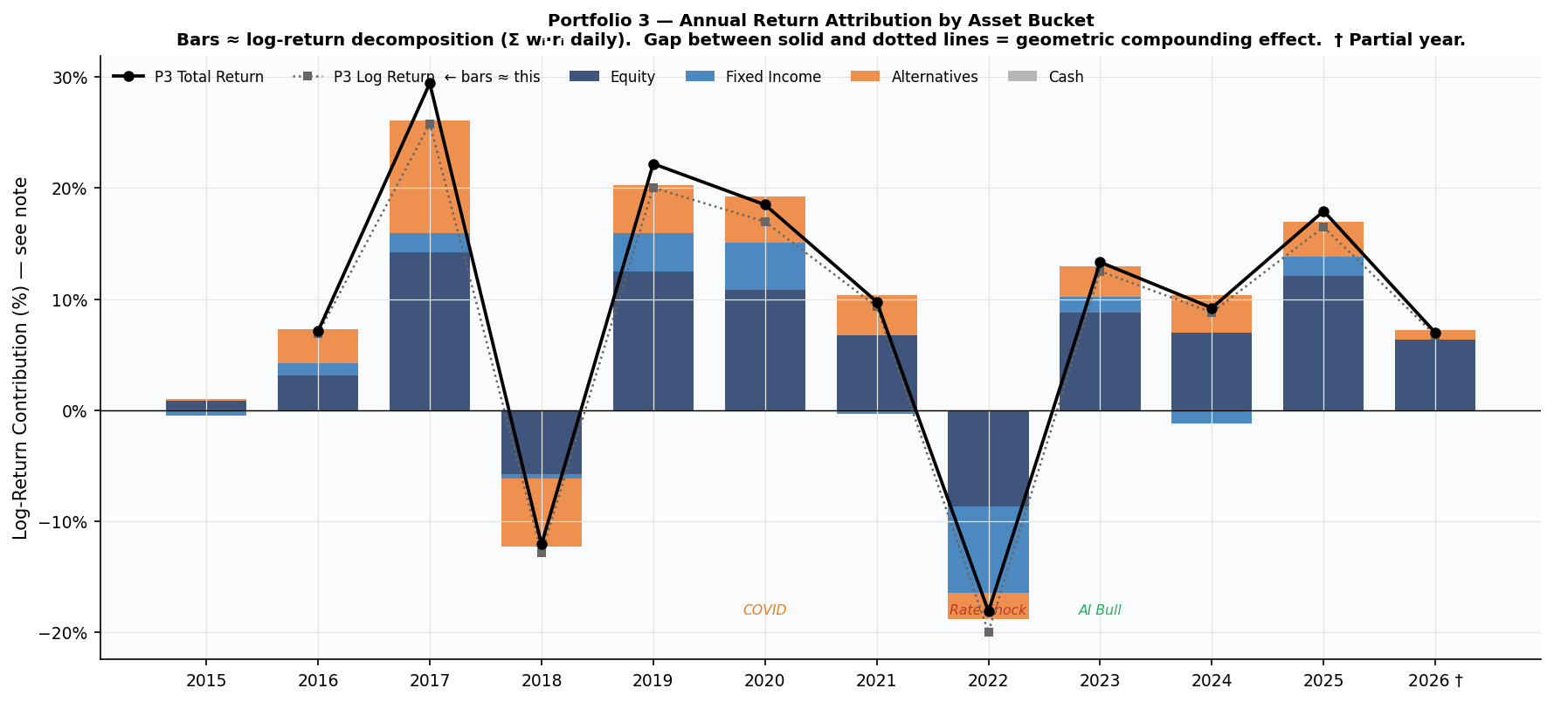
Exhibit 11.7: Annual Return Attribution by Asset Bucket for Portfolio 3. Bars = bucket contribution; Line = total annual return. † Partial year (2026 to date).

11.3 Cross-Asset Correlation (Weekly Returns)
The correlation matrix below is estimated from weekly close-to-close returns across all Portfolio 3 constituent assets. Weekly returns are used to mitigate the stale-price bias inherent in daily cross-regional return correlations (see Section 8.3). Several relationships merit specific comment: Gold's near-zero to mildly negative correlation with equities is evident, confirming its diversification properties. TLT's negative correlation with risk assets in many sub-periods is the foundation of its liability-matching and crisis-hedge role. Bitcoin's correlation with equities is positive but variable. It does not behave as a crisis hedge, which is why the allocation is framed as optionality rather than diversification.
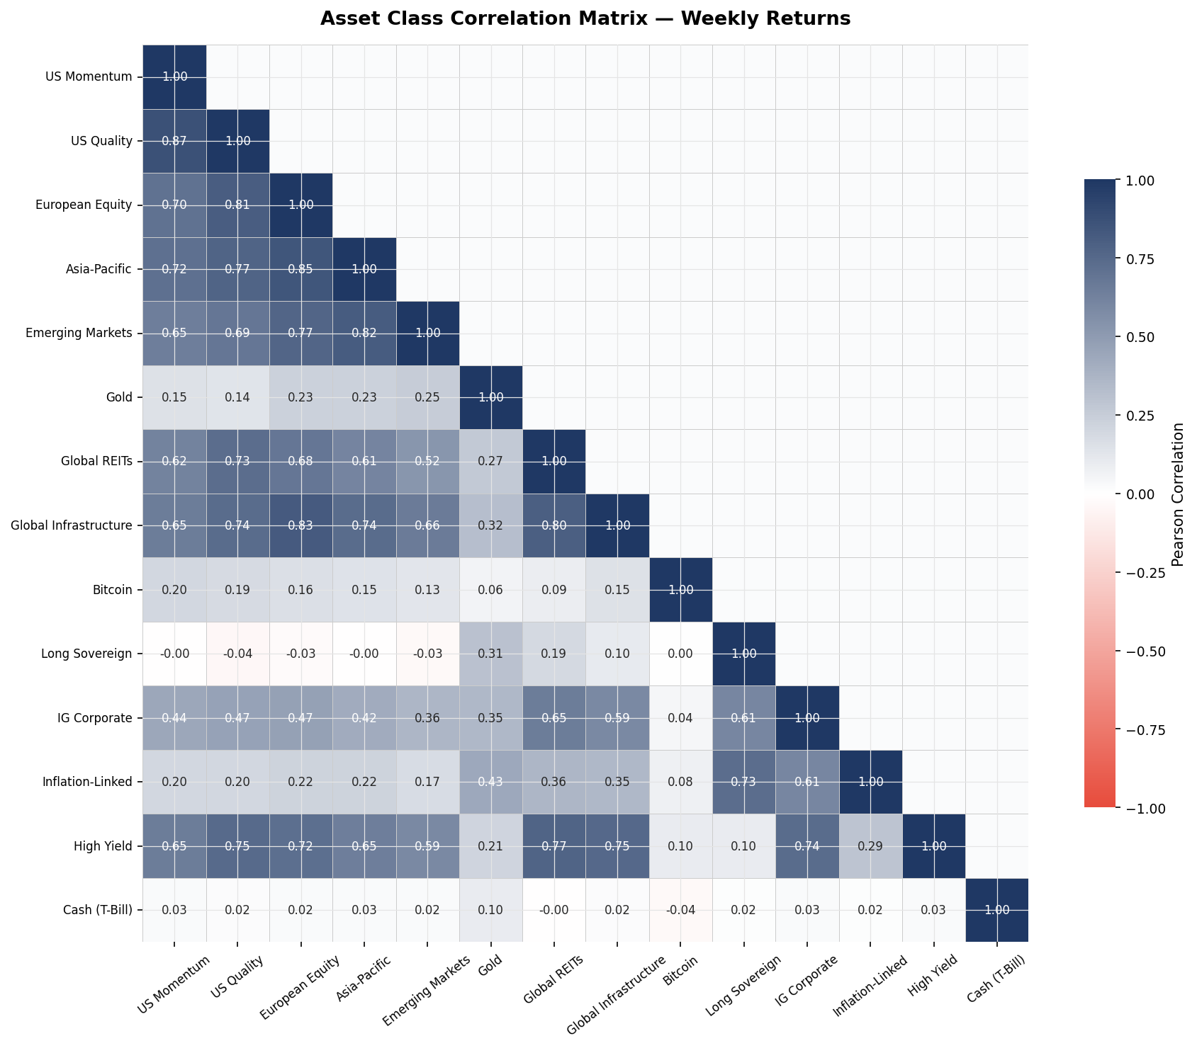
Exhibit 11.8: Weekly Return Correlation Matrix for Portfolio 3 Assets.

11.4 Scenario Analysis: Historical Stress Events
Portfolio resilience is evaluated across four historical stress and recovery episodes within the backtest sample, and the Global Financial Crisis (GFC) is analysed separately using long-history asset proxies (MTUM and QUAL do not have pre-2013 data).
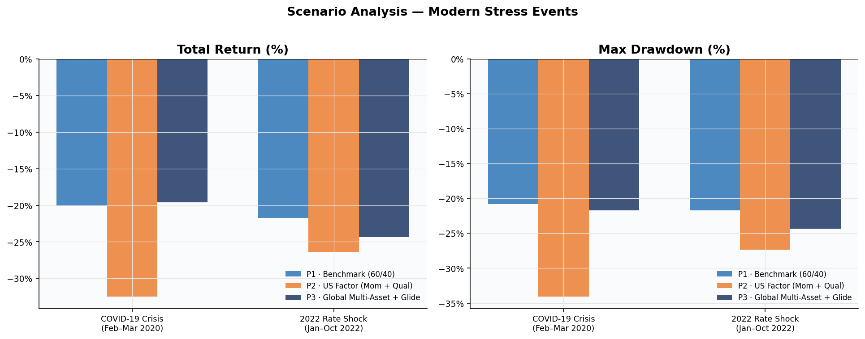
Exhibit 11.9: Scenario Analysis against Modern Stress Events (Total Return and Maximum Drawdown).
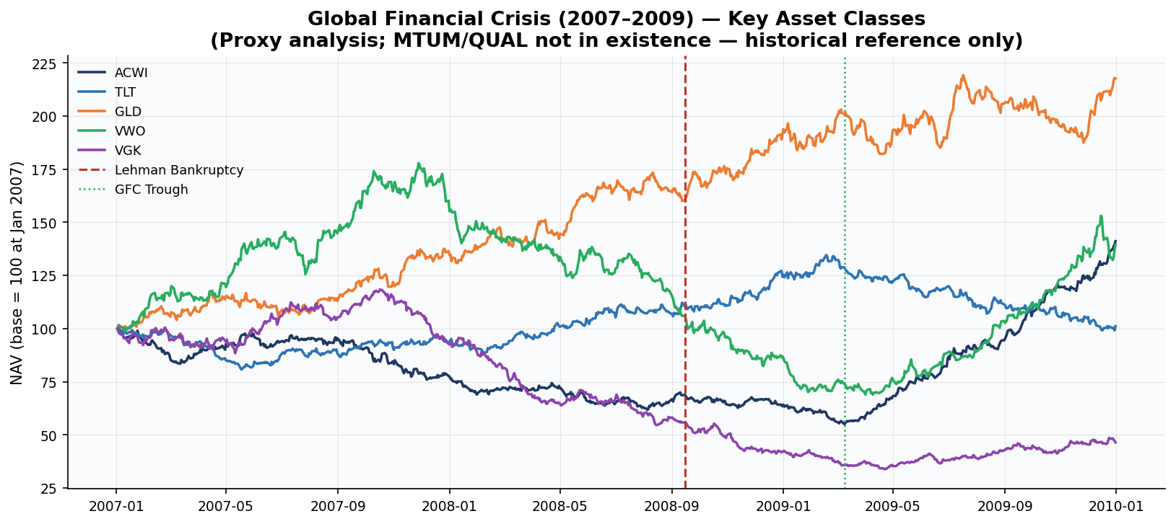
Exhibit 11.10: Global Financial Crisis 2007–2009 on Key Asset Classes (Proxy analysis; MTUM/QUAL not yet in existence. For context only.)

Key observations from scenario analysis: (i) Portfolio 3's global diversification and alternatives allocation dampen the depth of drawdown in equity crises relative to a pure equity portfolio; (ii) the 2022 rate shock was the most damaging episode for long-duration fixed income (TLT fell ~30%), but Portfolio 3's risky-asset component partially offset fixed income losses during that period; (iii) the AI-driven bull market of October 2022 to December 2024 rewarded momentum-tilted portfolios particularly strongly, with Portfolio 2 outperforming the benchmark materially during this period.

12. GOVERNANCE, ESG, AND COMPLIANCE

12.1 Governance Structure
The Fund operates under a three-tier governance structure: (i) the Governing Board (8 members, including 4 independent directors) sets the overall investment policy, approves this IPS, and appoints the Chief Investment Officer; (ii) the Investment Committee (CIO plus 4 senior portfolio managers) has delegated authority to implement the SAA, approve tactical deviations within pre-specified bands, and conduct quarterly portfolio reviews; (iii) the Portfolio Management team executes within the mandate approved by the IC. This IPS is approved by the IC and ratified by the Governing Board annually.

12.2 ESG Framework
The Fund is classified under SFDR Article 8+ ('light green'), meaning it promotes environmental and/or social characteristics as part of its investment process. The ESG framework operates at two levels:
- Hard Exclusions (non-negotiable): Thermal coal extraction or processing (>10% revenue); cluster munitions, anti-personnel mines, biological/chemical/nuclear weapons manufacturers. These exclusions are implemented at the ETF constituent level, verified quarterly using third-party ESG data (MSCI ESG Ratings, Sustainalytics).
- Soft Preferences (best-efforts): The Fund prefers ETFs with formal ESG screening (e.g., MSCI ESG Screened variants). Where equivalent ESG-screened and unscreened ETFs are available at comparable cost and liquidity, the screened version is preferred. Current instruments (MTUM, QUAL, VGK, VWO, VNQ) do not have material exposure to hard-excluded sectors as verified by latest constituent data.

12.3 ESG Compliance Table
Ticker | ESG Provider Screening | Coal Exposure | Weapons Exposure | SFDR Compliant
MTUM | MSCI (index methodology) | < 0.1% | None identified | Yes
QUAL | MSCI (index methodology) | < 0.1% | None identified | Yes
VGK | Vanguard ESG monitoring | ~0.8% | None identified | Yes (threshold met)
VPL | Vanguard ESG monitoring | ~0.5% | None identified | Yes (threshold met)
VWO | Vanguard ESG monitoring | ~1.2% | None identified | Yes (threshold met)
GLD | Physical gold with no equity exposure | N/A | N/A | Yes
VNQ | Real estate with no material exposure | Nil | None identified | Yes
IGF | Listed infrastructure | ~2.1% | None identified | Monitor near threshold
TLT | US Government without exclusions | N/A | N/A | Yes
LQD | IG corporate screening | < 0.5% | None identified | Yes
TIP | US Government without exclusions | N/A | N/A | Yes
HYG | HY screening | ~1.5% | None identified | Yes (threshold met)
Note: IGF coal exposure (~2.1%) is below the 10% hard-exclusion threshold but monitored closely. Data sourced from fund factsheets and MSCI ESG Ratings as at Q1 2026.

12.4 Performance Monitoring and Review
Portfolio performance is monitored on the following schedule:
Frequency | Activity | Responsible Party | Escalation Trigger
Daily | Risk limit monitoring (cash, crypto, drawdown) | Risk Management | Breach → IC notification within 24h
Monthly | NAV calculation, drawdown reporting, ESG flags | Portfolio Management | Drawdown > 15% → IC memo
Quarterly | Full performance attribution vs P1 benchmark; IC review; rebalancing execution | CIO + IC | IC approval required for all rebalancing trades
Annual | Full IPS review; SAA review; CMA update; Governing Board ratification | IC + Governing Board | Material market or mandate changes → interim review

Conclusion and Bibliography

Conclusion
In conclusion, this Investment Policy Statement establishes a disciplined and defensible framework for managing the Nordvik NPRF portfolio over the long term. The live analysis supports the central premise of the mandate: the portfolio should be built not around forecasts, narratives, or short-term market opinions, but around a robust strategic allocation process, explicit rebalancing discipline, and a clear acceptance of uncertainty as a permanent feature of markets. The evidence presented in the accompanying analysis confirms that the recommended structure is not a product of hindsight or stylistic preference; it is a coherent response to the portfolio’s objectives, risk tolerance, and spending constraints.

The portfolio construction logic is intentionally unsentimental. The benchmark sleeve preserves stability and comparability, the factor-oriented sleeve captures systematic return premia in a controlled and measurable way, and the global multi-asset sleeve broadens the opportunity set while reducing concentration in any single macro regime, geography, or policy environment. This is not an expression of confidence in any one forecast. It is a recognition that no single asset class, region, or economic thesis deserves permanent dominance. The correct institutional response to geopolitical friction, policy reversal, inflation shocks, rate volatility, recession risk, and crisis events is not prediction, but diversification, liquidity awareness, and governance.

The live results reinforce that this design remains coherent under actual market data. The portfolio behaves as intended when assessed through performance, drawdown behavior, factor exposure, correlation structure, and scenario analysis. That matters more than any single return figure. A serious IPS is not validated by looking impressive in benign markets; it is validated by remaining intelligible, stable, and actionable when conditions deteriorate. On that standard, the structure here is fit for purpose.

The governance framework is equally important. Rebalancing rules, allocation bands, review cadence, and reporting discipline matter because they prevent drift from becoming policy by accident. The IPS therefore acts as a control document as much as an investment document: it defines what may be owned, why it may be owned, when it must be reviewed, and how deviations are to be corrected. That is the proper institutional posture for a long-horizon mandate. It preserves consistency without forbidding adaptation.

Ultimately, this IPS is designed to be durable rather than fashionable. It accepts that markets will pass through regimes of growth, inflation, disinflation, stress, recovery, and dislocation, and it refuses to anchor the portfolio to any single regime as though it were permanent. The portfolio should therefore be managed with patience, explicit rules, and operational restraint. That is the professional standard this mandate calls for, and that is the standard this IPS is built to enforce.

Bibliography

Bank of Japan. 2026. Statement on Monetary Policy. March 19, 2026. Bank of Japan. https://boj.or.jp/en/mopo/mpmdeci/mpr_2026/k260319a.pdf

European Central Bank. 2026. “Monetary policy decisions.” Press release, April 30, 2026. European Central Bank. https://www.ecb.europa.eu/press/pr/date/2026/html/ecb.mp260430~81b7179e6f.en.html

Federal Reserve Board. 2026. “Federal Reserve issues FOMC statement.” Press release, April 29, 2026. Board of Governors of the Federal Reserve System. https://www.federalreserve.gov/newsevents/pressreleases/monetary20260429a.htm

International Monetary Fund. 2026. World Economic Outlook: Global Economy in the Shadow of War. April 14, 2026. Washington, DC: International Monetary Fund. https://www.imf.org/en/publications/weo/issues/2026/04/14/world-economic-outlook-april-2026

Organisation for Economic Co‑operation and Development (OECD). 2025. OECD Economic Outlook, Interim Report March 2025: Steering through Uncertainty. OECD Publishing, March 17, 2025. https://www.oecd.org/en/publications/oecd-economic-outlook-interim-report-march-2025_89af4857-en.html

World Bank. 2026. Global Economic Prospects, January 2026. Advance edition. Washington, DC: World Bank. https://openknowledge.worldbank.org/server/api/core/bitstreams/a9e24256-baf8-45bb-9075-75e437e1d6f7/content

World Bank. 2026. Global Economic Prospects, January 2026 — Growth in Europe and Central Asia (ECA): Analysis. January 2026. The World Bank. https://thedocs.worldbank.org/en/doc/7ce50b5aa95bef66048680bba9926ec8-0050012026/related/GEP-Jan-2026-Analysis-ECA.pdf
APPENDIX: SUPPLEMENTARY EXHIBITS

Exhibit A: Portfolio 3 Asset Weight History
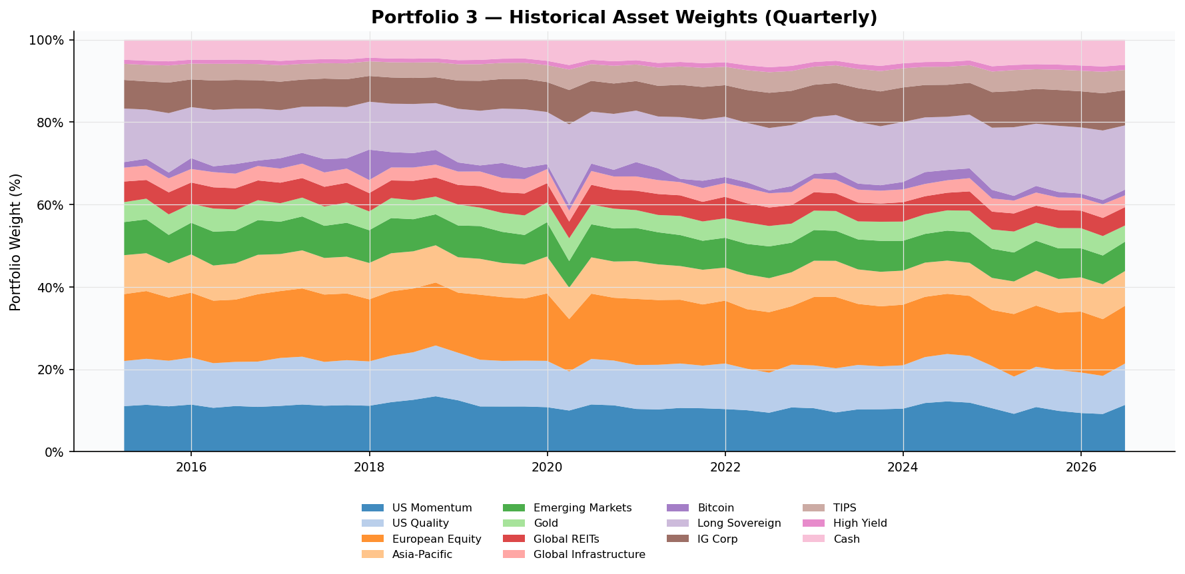
Portfolio 3 historical asset weights (quarterly, drifted). Quarterly rebalancing to annual glide-path targets.

Exhibit B: Correlation Matrix Numerical Values
 | US Momentum | US Quality | European Equity | Asia-Pacific | Emerging Markets | Gold | Global REITs | Global Infrastructure | Bitcoin | Long Sovereign | IG Corporate | Inflation-Linked | High Yield | Cash (T-Bill)
US Momentum | 1.00 | 0.87 | 0.70 | 0.72 | 0.65 | 0.15 | 0.62 | 0.65 | 0.20 | -0.00 | 0.44 | 0.20 | 0.65 | 0.03
US Quality | 0.87 | 1.00 | 0.81 | 0.77 | 0.69 | 0.14 | 0.73 | 0.74 | 0.19 | -0.04 | 0.47 | 0.20 | 0.75 | 0.02
European Equity | 0.70 | 0.81 | 1.00 | 0.85 | 0.77 | 0.23 | 0.68 | 0.83 | 0.16 | -0.03 | 0.47 | 0.22 | 0.72 | 0.02
Asia-Pacific | 0.72 | 0.77 | 0.85 | 1.00 | 0.82 | 0.23 | 0.61 | 0.74 | 0.15 | -0.00 | 0.42 | 0.22 | 0.65 | 0.03
Emerging Markets | 0.65 | 0.69 | 0.77 | 0.82 | 1.00 | 0.25 | 0.52 | 0.66 | 0.13 | -0.03 | 0.36 | 0.17 | 0.59 | 0.02
Gold | 0.15 | 0.14 | 0.23 | 0.23 | 0.25 | 1.00 | 0.27 | 0.32 | 0.06 | 0.31 | 0.35 | 0.43 | 0.21 | 0.10
Global REITs | 0.62 | 0.73 | 0.68 | 0.61 | 0.52 | 0.27 | 1.00 | 0.80 | 0.09 | 0.19 | 0.65 | 0.36 | 0.77 | -0.00
Global Infrastructure | 0.65 | 0.74 | 0.83 | 0.74 | 0.66 | 0.32 | 0.80 | 1.00 | 0.15 | 0.10 | 0.59 | 0.35 | 0.75 | 0.02
Bitcoin | 0.20 | 0.19 | 0.16 | 0.15 | 0.13 | 0.06 | 0.09 | 0.15 | 1.00 | 0.00 | 0.04 | 0.08 | 0.10 | -0.04
Long Sovereign | -0.00 | -0.04 | -0.03 | -0.00 | -0.03 | 0.31 | 0.19 | 0.10 | 0.00 | 1.00 | 0.61 | 0.73 | 0.10 | 0.02
IG Corporate | 0.44 | 0.47 | 0.47 | 0.42 | 0.36 | 0.35 | 0.65 | 0.59 | 0.04 | 0.61 | 1.00 | 0.61 | 0.74 | 0.03
Inflation-Linked | 0.20 | 0.20 | 0.22 | 0.22 | 0.17 | 0.43 | 0.36 | 0.35 | 0.08 | 0.73 | 0.61 | 1.00 | 0.29 | 0.02
High Yield | 0.65 | 0.75 | 0.72 | 0.65 | 0.59 | 0.21 | 0.77 | 0.75 | 0.10 | 0.10 | 0.74 | 0.29 | 1.00 | 0.03
Cash (T-Bill) | 0.03 | 0.02 | 0.02 | 0.03 | 0.02 | 0.10 | -0.00 | 0.02 | -0.04 | 0.02 | 0.03 | 0.02 | 0.03 | 1.00

Exhibit C: Disclaimer
This document has been prepared by the Investment Committee of the Nordvik National Pension Reserve Fund for internal governance purposes. All backtested performance figures are simulated historical results and do not represent actual trading performance. Backtested results are inherently subject to look-ahead bias, survivorship bias, and selection bias, and should not be used as the sole basis for investment decisions. Past performance does not guarantee future results. The views expressed herein reflect the Committee's opinion as at the document date and are subject to change without notice. This document does not constitute investment advice within the meaning of applicable law.
Data sources intended for live execution: Yahoo Finance (ETF prices, adjusted for dividends and splits via auto_adjust=True); FRED (Federal Reserve Bank of St. Louis) and DTB3 series (3-month T-bill rate); Kenneth R. French Data Library (Fama-French 6-factor data). During this run, all three live sources were available and the synthetic fallback was not used. Analysis performed in Python 3.12 using: pandas, numpy, statsmodels, yfinance, pandas-datareader, matplotlib, seaborn, python-docx.

