|  |  |  |  |  |  |  |  |  |  |
| --- | --- | --- | --- | --- | --- | --- | --- | --- | --- |
| Medicine A 100mg |  |  |  |  |  |  |  |  |  |
|  |  |  |  |  |  |  |  |  |  |

|  |  |  |  |  |  |  |  |  |  |
| --- | --- | --- | --- | --- | --- | --- | --- | --- | --- |
| Medicine B 200mg |  |  |  |  |  |  |  |  |  |
|  |  |  |  |  |  |  |  |  |  |

|  |  |  |  |  |  |  |  |  |  |
| --- | --- | --- | --- | --- | --- | --- | --- | --- | --- |
| Medicine C 300mg |  |  |  |  |  |  |  |  |  |
|  |  |  |  |  |  |  |  |  |  |

|  |  |  |  |  |  |  |  |  |  |
| --- | --- | --- | --- | --- | --- | --- | --- | --- | --- |
| Medicine D 400mg |  |  |  |  |  |  |  |  |  |
|  |  |  |  |  |  |  |  |  |  |

|  |  |  |  |  |  |  |  |  |  |
| --- | --- | --- | --- | --- | --- | --- | --- | --- | --- |
| Medicine E 500mg |  |  |  |  |  |  |  |  |  |
|  |  |  |  |  |  |  |  |  |  |

|  |  |  |  |  |  |  |  |  |  |
| --- | --- | --- | --- | --- | --- | --- | --- | --- | --- |
| Medicine F 10mg |  |  |  |  |  |  |  |  |  |
|  |  |  |  |  |  |  |  |  |  |

|  |  |  |  |  |  |  |  |  |  |
| --- | --- | --- | --- | --- | --- | --- | --- | --- | --- |
| Medicine G 20mg |  |  |  |  |  |  |  |  |  |
|  |  |  |  |  |  |  |  |  |  |

|  |  |  |  |  |  |  |  |  |  |
| --- | --- | --- | --- | --- | --- | --- | --- | --- | --- |
| Medicine H 30mg |  |  |  |  |  |  |  |  |  |
|  |  |  |  |  |  |  |  |  |  |

|  |  |  |  |  |  |  |  |  |  |
| --- | --- | --- | --- | --- | --- | --- | --- | --- | --- |
| Medicine I 40mg |  |  |  |  |  |  |  |  |  |
|  |  |  |  |  |  |  |  |  |  |

|  |  |  |  |  |  |  |  |  |  |
| --- | --- | --- | --- | --- | --- | --- | --- | --- | --- |
| Medicine J 50mg |  |  |  |  |  |  |  |  |  |
|  |  |  |  |  |  |  |  |  |  |

|  |  |  |  |  |  |  |  |  |  |
| --- | --- | --- | --- | --- | --- | --- | --- | --- | --- |
| Medicine K 60mg |  |  |  |  |  |  |  |  |  |
|  |  |  |  |  |  |  |  |  |  |

|  |  |  |  |  |  |  |  |  |  |
| --- | --- | --- | --- | --- | --- | --- | --- | --- | --- |
| Medicine L 70mg |  |  |  |  |  |  |  |  |  |
|  |  |  |  |  |  |  |  |  |  |

|  |  |  |  |  |  |  |  |  |  |
| --- | --- | --- | --- | --- | --- | --- | --- | --- | --- |
| Medicine M 80mg |  |  |  |  |  |  |  |  |  |
|  |  |  |  |  |  |  |  |  |  |

|  |  |  |  |  |  |  |  |  |  |
| --- | --- | --- | --- | --- | --- | --- | --- | --- | --- |
| Medicine N 90mg |  |  |  |  |  |  |  |  |  |
|  |  |  |  |  |  |  |  |  |  |

|  |  |  |  |  |  |  |  |  |  |
| --- | --- | --- | --- | --- | --- | --- | --- | --- | --- |
| Medicine O 100mg |  |  |  |  |  |  |  |  |  |
|  |  |  |  |  |  |  |  |  |  |

|  |  |  |  |  |  |  |  |  |  |
| --- | --- | --- | --- | --- | --- | --- | --- | --- | --- |
| Medicine P 110mg |  |  |  |  |  |  |  |  |  |
|  |  |  |  |  |  |  |  |  |  |

|  |  |  |  |  |  |  |  |  |  |
| --- | --- | --- | --- | --- | --- | --- | --- | --- | --- |
| Medicine Q 120mg |  |  |  |  |  |  |  |  |  |
|  |  |  |  |  |  |  |  |  |  |

Inventory Management

|  |  |  |  |  |
| --- | --- | --- | --- | --- |
|  |  |  |  |  |
|  |  |  |  |  |

Prescription ID: 0000-0000-0000-0001

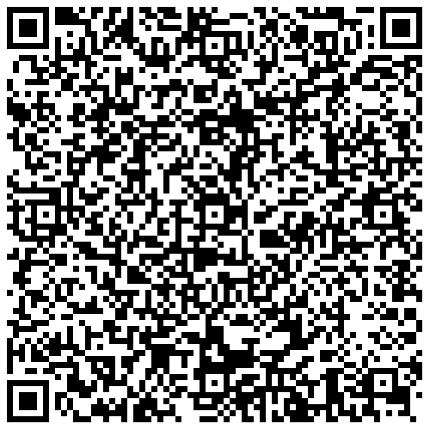

Prescription ID: 0000-0000-0000-0002

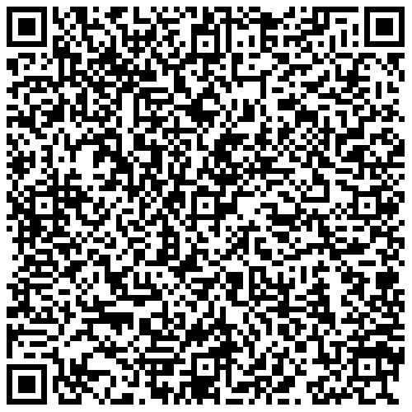

Prescription ID: 0000-0000-0000-0003

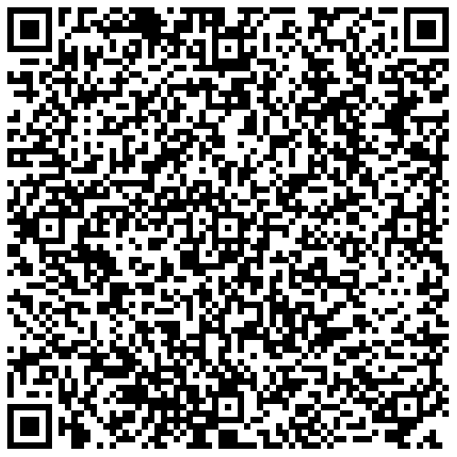

Prescription ID: 0000-0000-0000-0004

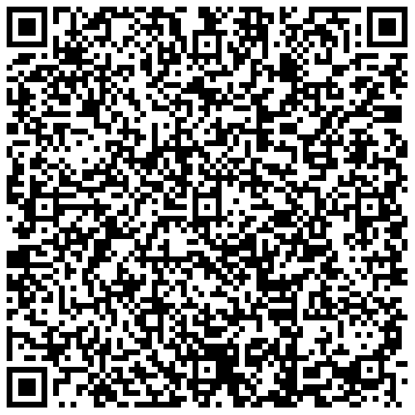

Prescription ID: 0000-0000-0000-0005

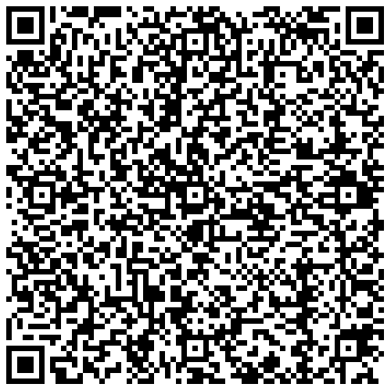

Prescription ID: 0000-0000-0000-0006

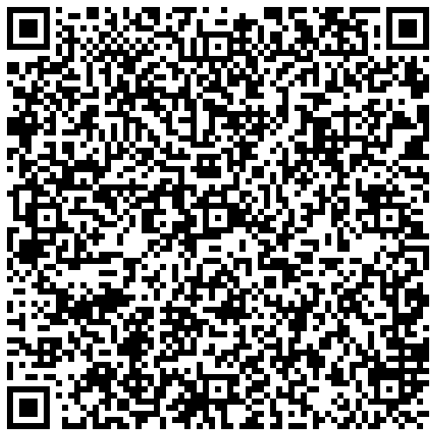

Prescription ID: 0000-0000-0000-0007

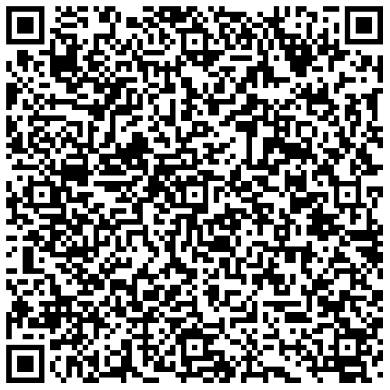

Prescription ID: 0000-0000-0000-0008

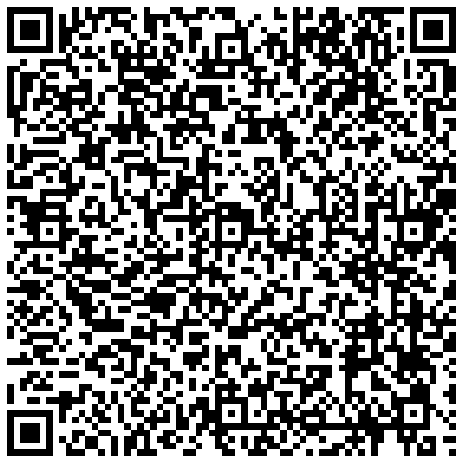

Prescription ID: 0000-0000-0000-0009

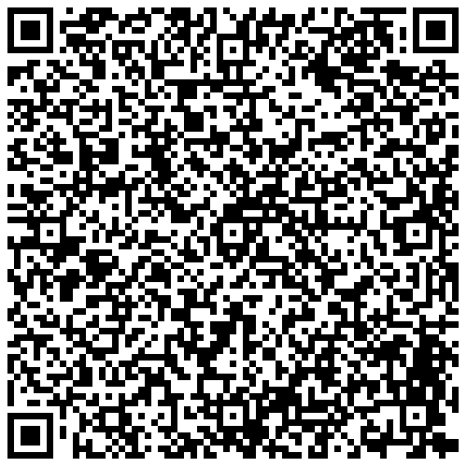

Prescription ID: 0000-0000-0000-0010

