

**FPT SMART SCHOOL**

**LOST & FOUND / FREELANCE JOB**

**Software Requirement Specification**

**Team SOS**

**Trịnh Ngọc Bảo - SE150650**

**Phạm Ngọc Long - SE150888**

**Tăng Quang Khải - SE150823**

**Nguyễn Văn Hải Nam - SE150925**

– HCM, May 2022 –

**Table of Contents**

I. Overview 3

1. Introduction 3

2. System Functions

1. Screen Flow
2. Screen Details
3. User Authorization
4. Non-Screen Functions

3. Common Requirements 5

II. Functional Requirements 6

1. <<Feature Name 1>> 6

a. <<Function Name 1>> 6

b. <<Function Name 2>> 6

2. <<Feature Name 2>> 6

# I. Overview

## 1. Introduction

Applying information technology in management and teaching and learning activities in general, and facilitating students in particular, is a popular development trend of universities in Vietnam in recent years. Industry 4.0 today. Grasping that trend, our SOS team has planned to research and develop on the basis of information technology applications, to launch an electronic application platform, serving a number of basic and convenient needs. profit. profit. Exclusively for FPT University students. Our application development is smart school system including:

1. Lost & Found: The situation of lost, dropped and forgotten items of students in school is increasing day by day but we still do not have a solution to improve this problem. Based on the increase and prevalence of student loss, our team came up with the idea to develop a website called “Lost & Found” in the hope of helping students who have lost their belongings. Lost items can be found on the site and can be easily returned to the lost person. "Lost & Found" will be the app that all Fpt students have access to. People can post a search when you drop your item or find the owner of the item you find. Our website also integrates the communication function between the finder and the lost, so students can find their items more easily. These are the functions we consider necessary at the moment.

2. Freelance jobs: Understanding the job search needs of students in the school, our team found that there are currently very few job search sites dedicated to FPT students and moreover looking for freelance jobs. , short on free time. Therefore, our team developed a job search website integrated with “Lost & Found” to create a smart school system that can help students in the school get more benefits. For this purpose, our website will offer students freelance, short-term jobs selected from companies or employers everywhere. Students can go to the website and choose jobs that suit their needs and majors. Employers and companies can post vacancies on the website with public salaries and job descriptions. Students can completely trust the safety of our website compared to other websites, we want to bring FPT students the best facilities and experience, and also a place to find a job. make it safe and reputable for students.

With a leading technology school like Fpt, this promises to be a useful system developed for the common goal of building a smart and modern school.

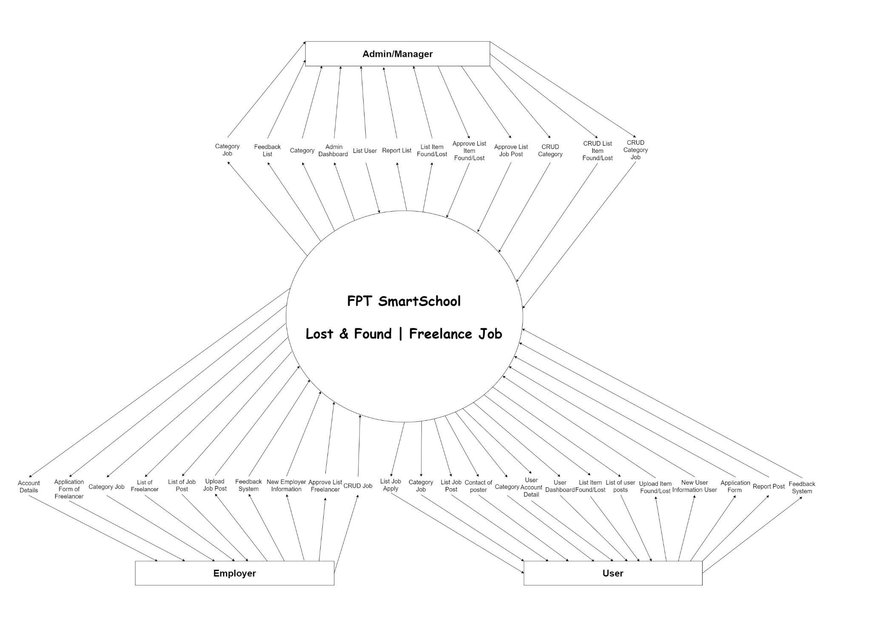

## 2. System Functions

#### a. Screen Flow

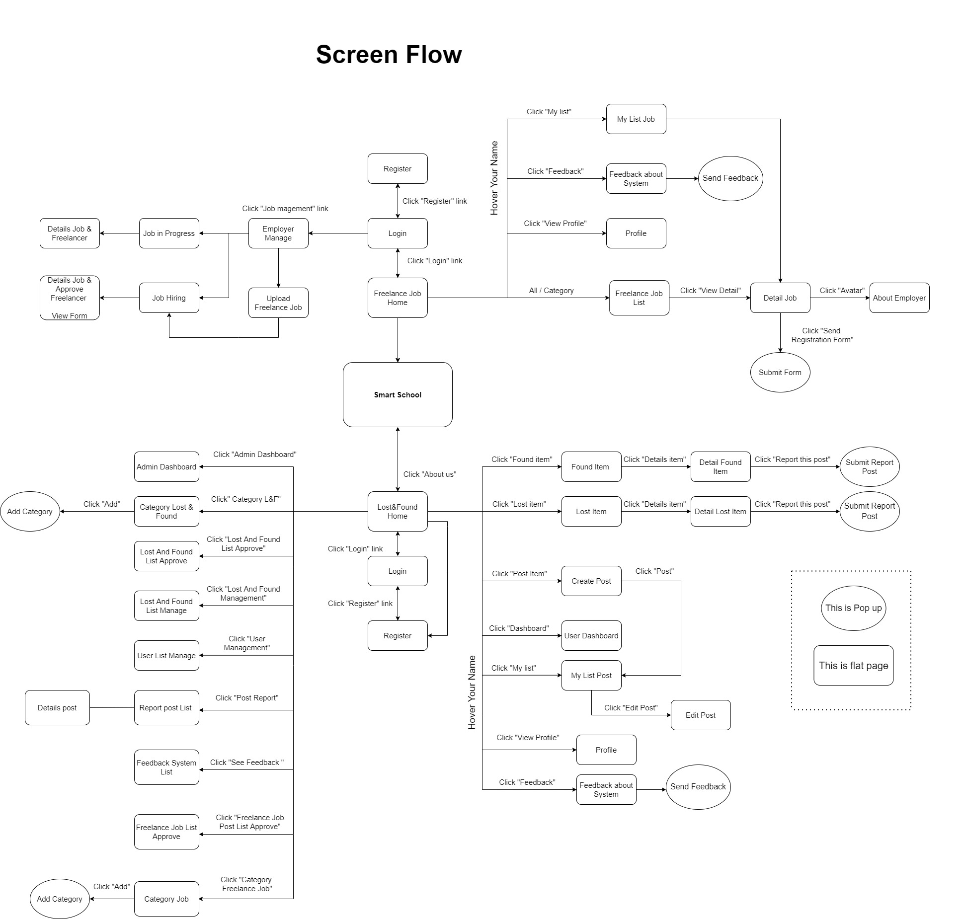

#### b. Screen Details

| **#** | **Feature** | **Screen** | **Description** |
| --- | --- | --- | --- |
| 1 | Post Management | L&F Home | Search post, view post, upload,.. |
| 2 | Post Management | Found Item | List post, view post, upload, show more, search… |
| 3 | Post Management | Lost Item | List post, view post, upload, show more, search,.. |
| 4 | Post Management | Detail Found | View details, upload, number view of this post, Delete reported post (Role Admin). |
| 5 | Post Management | Detail Lost | View details, upload, number view of this post,  Delete reported post (Role Admin). |
| 6 | Post Management | Create Post | Upload new post |
| 7 | Post Management | My list post | Show your post |
| 8 | Post Management | Edit post | Update post, delete post |
| 9 | Post Management | User Dashboard | View number list post, number of view post, pending post |
| 10 | Post Management | LostAndFound List Approve | Approve or Not, view, paging.. |
| 11 | Post Management | Admin Dashboard | View total number list of user post, number of pending post, number of lost post, number of found post |
| 12 | Post Management | LostAndFound Manage | List and view all posts of the user, delete, view details, paging,.. |
| 13 | Post Management | Report Post List | View details, paging,.. |
| 14 | User Management | View Profile | View profile, Edit profile (name, phone, email, address,..etc..) |
| 15 | User Management | Admin Dashboard | View total number of user |
| 16 | User Management | User List Manage | View information of user, view total number of user, remove user, paging |
| 17 | Account Management | Login | Authentication login name, password,… |
| 18 | Account Management | Register | Create new account |
| 19 | Category Management | Home | View category |
| 20 | Category Management | Found Item | View category |
| 21 | Category Management | Lost Item | View category |
| 22 | Category Management | Category manage | View all category, add category, edit category, remove category, paging |
| 23 | Report Management | Report Post List | View Report Post List, view total report, paging |
| 24 | Report Management | Detail Found | Send Report |
| 25 | Report Management | Detail Lost | Send Report |
| 26 | Send Feedback | Feedback about System | View your feedback about system, submit feedback |
| 27 | Send Feedback | Feedback System List | View user feedback about system, view total feedback, paging |
| 28 | Job Management | Employer Manage | Manage job |
| 29 | Job Management- | Job in progress | View job in progress |
| 30 | Job Management | Job Hiring | View Job Hiring |
| 31 | Job Management | Details Job & Freelancer | View details job and freelancer do this job |
| 32 | Job Management | Details Job & Approve  Freelancer | View details job and approve freelancer for this job |
| 33 | Job Management | Upload Freelance Job | Upload new Freelance Job, create question for freelancer when apply job |
| 34 | Job Management | Freelance Job Home | View all/by category, search job |
| 35 | Job Registration | Detail Job | View details this job, submit form registration, view information employer |
| 36 | Account Management | Profile | Account details of freelancer, edit info. |
| 37 | Send Feedback | Feedback about System | View your feedback about system, submit feedback |
| 38 | Job Management | My list job | Job applying, details job |
| 39 | Job Management | Freelance Job List Approve | Approve freelancer for this job |
| 40 | Category Management | Category Job | Create new category job, remove category job, edit category job |
| 41 | Job Registration | Submit form | Show question list of employer for freelancer |
| 42 | User Management | Employer Profile | Edit profile, Profile details of Employer |
| 43 |  |  |  |
| 44 |  |  |  |
| 45 |  |  |  |

#### c. User Authorization

| **Screen** | **Admin** | **User** | **Employer** |
| --- | --- | --- | --- |
| <<Welcome Page>> | X | X | X |
| <<Lost & Found Home>> |  | X |  |
| View post |  | X |  |
| Search post |  | X |  |
| Upload post |  | X |  |
| Login |  | X |  |
| Register |  | X |  |
| View category |  | X |  |
| <<Create post>> |  | X |  |
| Upload new post |  | X |  |
| <<Edit Post>> |  | X |  |
| Update/Edit Post |  | X |  |
| Delete Post |  | X |  |
| <<Found/Lost Item>> |  | X |  |
| Upload Post |  | X |  |
| Update/Edit Post |  | X |  |
| Search item |  | X |  |
| View category |  | X |  |
| <<Login>> | x |  |  |
| Authentication loginname, password | X | X |  |
| <<Register>> |  |  |  |
| Create new account |  | X |  |
| <<Detail Found/Lost>> |  | X |  |
| View details |  | X |  |
| Upload post |  | X |  |
| Delete reported post |  |  |  |
| Send Report |  | X |  |
| << My list post>> |  | X |  |
| Show your post |  | X |  |
| <<User Dashboard>> |  | X |  |
| View number of list post |  | X |  |
| Number of view post |  | X |  |
| Your Pending post |  | X |  |
| <<Admin Dashboard>> | X |  |  |
| View total number list of user post | X |  |  |
| View total number of pending post | X |  |  |
| View total number of lost post | X |  |  |
| View total number of found post | X |  |  |
| View total number of user | X |  |  |
| <<Lost and Found List Approve >> | X |  |  |
| Approve or Not | X |  |  |
| View list pending | X |  |  |
| Paging | X |  |  |
| <<Lost and Found Management >> | X |  |  |
| List and view all post of user | X |  |  |
| Delete post | X |  |  |
| View details post | X |  |  |
| Paging | X |  |  |
| <<Report Post List>> | X |  |  |
| View Report Post List, | X |  |  |
| View Total report | X |  |  |
| Paging Report | X |  |  |
| <<Account Details>> | X | X |  |
| View detail account | X | X |  |
| Edit information | X | X |  |
| <<User List Manager >> | X |  |  |
| View information of user | X |  |  |
| View total number of user | X |  |  |
| Remove user | X |  |  |
| Paging list user | X |  |  |
| <<Feedback about System>> |  | X |  |
| Send your Feedback |  | X |  |
| View your Feedback |  | X |  |
| <<Feedback System List>> | X |  |  |
| View user feedback about system | X |  |  |
| View total feedback | X |  |  |
| Paging Feedback system | X |  |  |
| <<Category Management>> | X |  |  |
| View all category | X |  |  |
| Add category | X |  |  |
| Edit category | X |  |  |
| Remove category | X |  |  |
| <<About us>> | X | X | X |
| <<Freelance Job Home>> |  | X |  |
| View list job |  | X |  |
| View category |  | X |  |
| Delete job post |  |  |  |
| <<My list job>> |  | X |  |
| View list job apply |  | X |  |
| View Detail |  | X |  |
| <<Detail job >> |  | X |  |
| View detail job and information of employer |  | X |  |
| <<Employer Profile>> |  |  | X |
| View profile of employer |  |  | X |
| Edit profile of employer |  |  | X |
| <<Employer Manager>> |  |  | X |
| View Job Hiring/ Job in Progress |  |  | X |
| <<Upload Freelance Job>> |  |  | X |
| Upload Job |  |  | X |
| <<Job Hiring>> |  |  | X |
| List Job Hiring |  |  | X |
| <<Details Job & Freelancer>> |  |  | X |
| View Details Job, List Freelancer apply this Job |  |  | X |
| <<Details Job & Approve Freelancer >> |  |  | X |
| View Details Job, List of freelancers applied for this job |  |  | X |
|  |  |  | X |

**In which:**

* **Admin:** Manage the system, manage user posts on the website, receive user feedback about the system and fix.
* **User:** Perform functions and operations on the website, have the right to post articles looking for items. Report, send feedback to the administrator.
* **Employer:** Post jobs and review applicants for jobs

#### d. Non-Screen Functions

| **#** | **Feature** | **System Function** | **Description** |
| --- | --- | --- | --- |
| 1 | Post Management | Show more |  |
| 2 | Post Management | Number view of post | show the number of people viewing the post |
| 3 | Post Management | Delete Reported post | Posts reported by users will be deleted |
| 4 | Post Management | user delete post | Users can directly delete their own posts |
| 5 | Post Management | Delete post (admin) | directly delete the post |
| 6 | User Management | Edit Profile | Users are allowed to directly edit their profile |
| 7 | User Management | Remove user | admin can delete users |
| 8 | Category Management | View category | Admins and users can view categories |
| 9 | Category Management | Edit category | Admin and Users can directly edit category |
| 10 | Category Management | Remove category | Admin can delete category when not needed |
| 11 | Report Management | Sent report | Submit a report of the offending post to the admin |
| 12 | Feedback Management | Send feedback | Submit a feedback of the offending post to the admin |

## 3. Common Requirements

* Web Server Apache Tomcat 8.0
* Web Browser: Chrome, Microsoft Edge
* SQL Server: 2019
* Security: Password encryption with SHA

# II. Functional Requirements

## 1. Welcome Page

This is the first page you see when you visit our website

* Function trigger: In this page we will divide into 2 different paths:

1. If you click on the "Lost & Found" section the site will take you to the app to find lost items.

2. If you click on the "Freelance Job" section, the site will take you to the freelance job search application.

* Function description: The purpose of this function is to help users easily choose the needs they want.

+ When clicking "Lost & Found" the interface will display lost or found items posted by other users.

+ When clicking on "Freelance Job", the interface will display the jobs that are currently being posted by companies and employers.

* Screen layout:

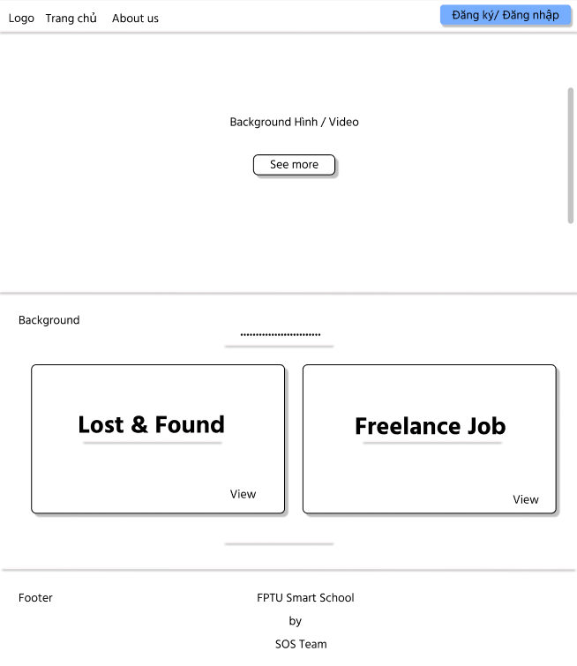

**2. Login**

On the welcome page, there is a registration or account login section. After clicking that button you will be able to login to the page with your account

* Function trigger: When you click the "Đăng Ký/Đăng nhập" button, you will be able to login to the page with your account
* Function description:

+Button "Đăng nhập" when you already have an account at our website. Once you're logged in, you can go to the site and post or find lost items and job searches with your. account.

+ "Đăng ký" button when you do not have an account at our website. And if you want to perform the functions in the website, you need to register your own account.

* Screen layout:

**

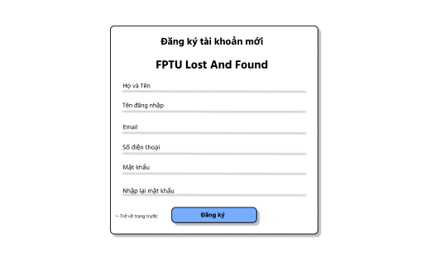

**3. Change Password Page**

At this page, you can change your password if you want or because you forgot your password and want to update it again.

* Function trigger:
* Function description:

+You need to enter all the information that the website requires to be able to change your current password

+

* Screen layout:

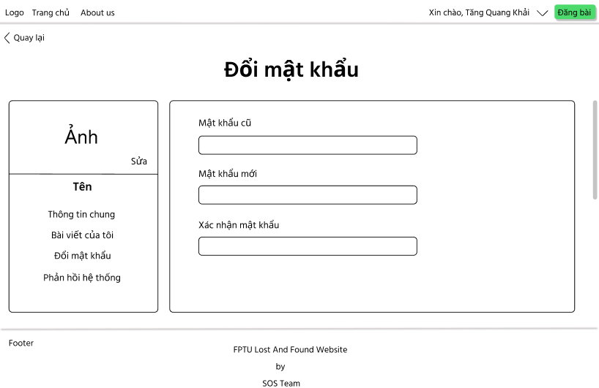

**3. Account Detail Page**

At this page, you can update your information such as name, job, email,...

* Function trigger: This function is activated when you want to change your personal information.
* Function description:

+After updating your information, you can click the "Lưu" button to save the newly entered information.

* Screen layout:

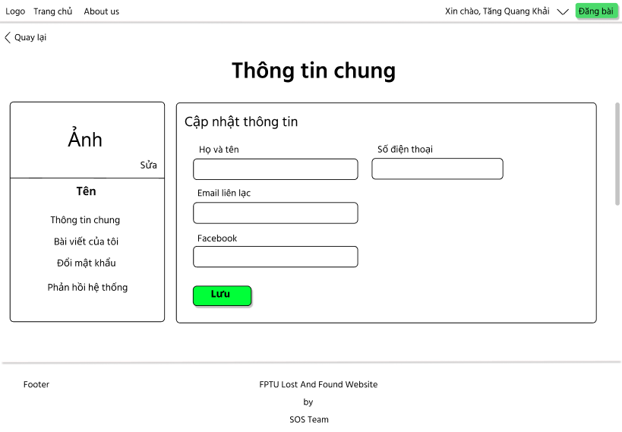

**4. Home Page**

This page displays posts about lost and found items.

* Function trigger:

1. “Tìm kiếm”: Search for objects by entering their names in the search box.
2. “Đồ nhặt được/ Đồ thất lạc” : The posts selected by the user will be displayed.

+If you select "Đồ nhặt được" the site will lead to posts according to the item picked up.

+ "Đồ thất lạc" the site will lead to posts under the lost item category.

1. “Đăng bài”: You can post articles about your lost or found items here.

* Function description:

+

* Screen layout:

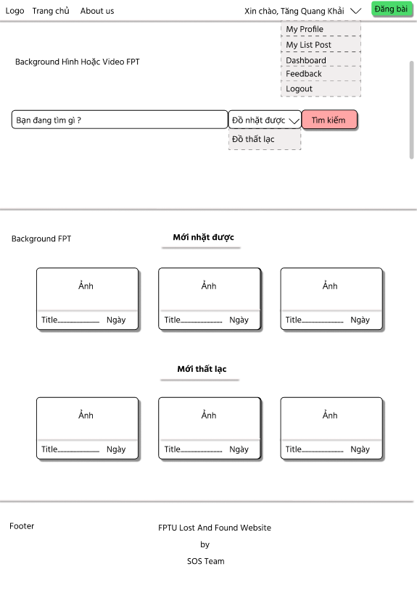

**5. Lost/Found Page**

This page displays posts about lost or found items.

* Function trigger:

1. “Tìm kiếm”: Search for objects by entering their names in the search box.
2. “Đồ nhặt được/ Đồ thất lạc” : The posts selected by the user will be displayed.

+If you select "Đồ nhặt được" the site will lead to posts according to the item picked up.

+ "Đồ thất lạc" the site will lead to posts under the lost item category.

1. “Danh mục”: you can select items such as "Điện thoại", "Laptop", "Thẻ sinh viên",... corresponding to the item you want to find.

* Function description:

+

* Screen layout:

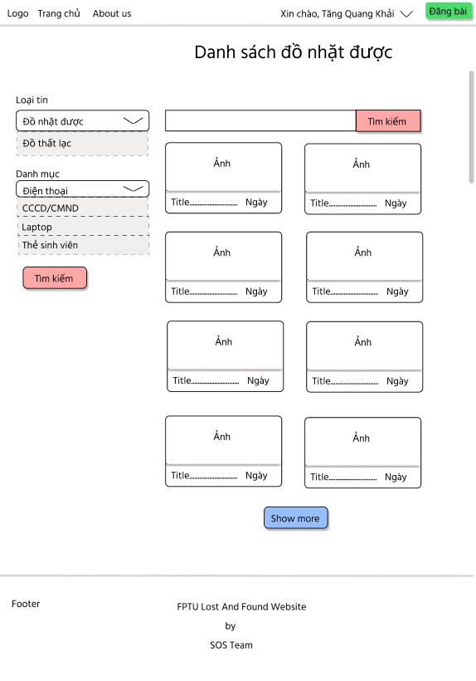

**6. Lost/Found Detail Item Page**

This page shows all details about the post: poster account, phone number and contact information, details of lost/found items

* Function trigger:

1. “Báo cáo vi phạm”: This button is used to report to the administrator if this post contains inappropriate content or provides false information.
2. “Call/Messenger/Mail” : These functions will provide the user with contact information for the person who posted the article

* Function description:

+ “Báo cáo vi phạm”: After clicking this button, the website will provide you with a form where you can fill in the offending content of the article, and send it to the administrator.

* Screen layout:

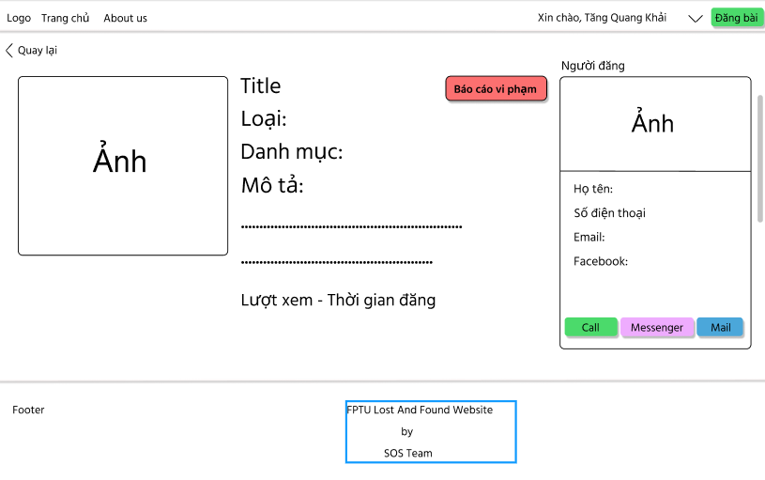

**7. Upload Post Page**

At this page you can fill in information and add images to post your own articles on the website.

* Function trigger:

1. “Tiêu đề”: Here you need to enter a title for your post.
2. “Loại tin / Danh mục” : You need to add categories and post type based on suggestions from the site so that articles can be categorized easily and clearly.
3. “Ảnh”: You can upload the necessary images for your post content here.
4. “Đăng tin”: After filling in the necessary information, click this button to complete the posting

* Function description:

+ “Đăng tin”: Clicking this button will send the user's post directly to the admin's browsing list. Admin can review the information and decide to approve the post to the site.

* Screen layout:

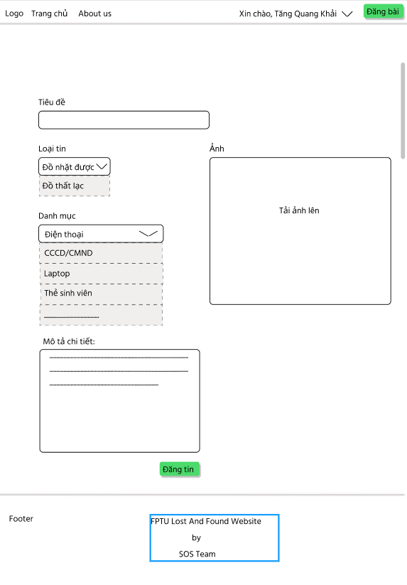

**8. My List Post Page**

This page will display all the published posts of each user account.

* Function trigger:

1. “Xem chi tiết”: Click on this link will take you to the Lost/Found Detail Item Page

* Function description:

+ When you clicking "Xem chi tiết" the site will take you to the details page of your post, showing all the information of the post.

* Screen layout:

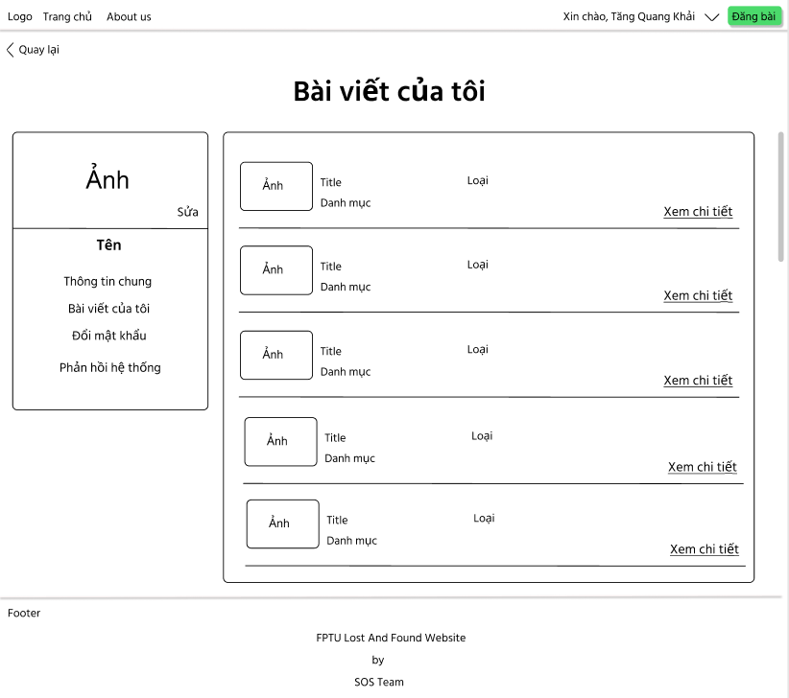

**9. Feedback System Page**

This page will allow you to create a feedback form to send to the system.

* Function trigger:

1. “Gửi”: Clicking this button will take your entire feedback form to the system.

* Function description:

+ The "Gửi" function makes it possible for users to submit their feedback form to the admin, from which the admin can review the feedback to better improve the site experience

* Screen layout:

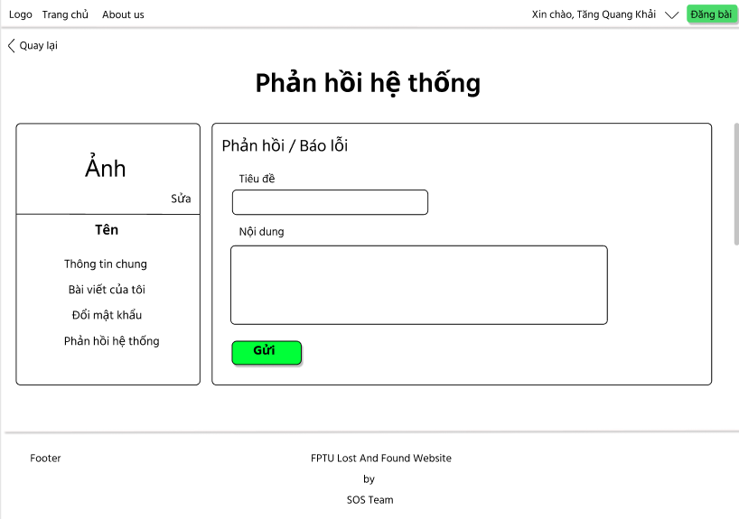

**10. Detail Post and Report Post Page**

This page will allow you to view the post details and if the post has inappropriate content you can create a report form about the post sent to the admin.

* Function trigger:

1. Choose inappropriate behavior to report
2. “Gửi”: Clicking this button will take your entire report form to the system.

* Function description:

+ The "Submit" function makes it possible for users to submit their report form to the admin, from which the admin can review the report to decide to delete the post.

* Screen layout:

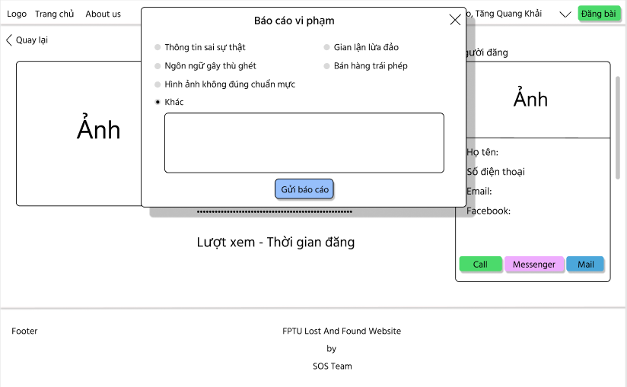

**11. Freelance Job Home Page**

This page is the first page when you enter the "Freelance Job Page". Here you can search for the job you need.

* Function trigger:

1. “Tìm kiếm”: When entering the job you are looking for in the search box, click the "Tìm kiếm" button, the website will display a list of the jobs you are looking for.
2. “Đăng ký/ Đăng nhập”: Click this button, the website will take you to the login page.
3. “Đăng bài”: This button has the function of creating a job posting form for you

* Function description:

+ The "Tìm kiếm" function makes it easier for users to find jobs according to their needs. Create a convenient and convenient experience when using the website

* Screen layout:

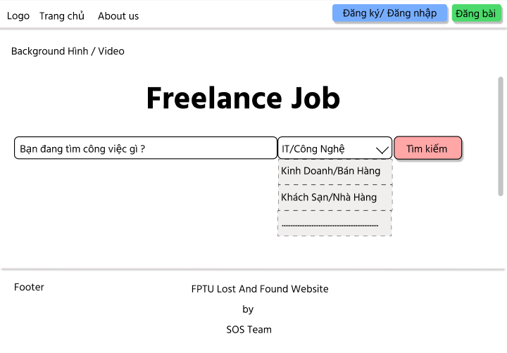

**12. Login Freelance Page**

On this page, you can log in or register your own account.

* Function trigger:

1. “Đăng ký”: Click this button if you don't have an account yet
2. “Đăng nhập”: After filling in your account and password, clicking this button will take you to the "Freelance Job Home Page"

* Function description:

+ Both "Đăng nhập" and "Đăng ký" functions help users access the website with their own account and can use the functions on the website.

* Screen layout:

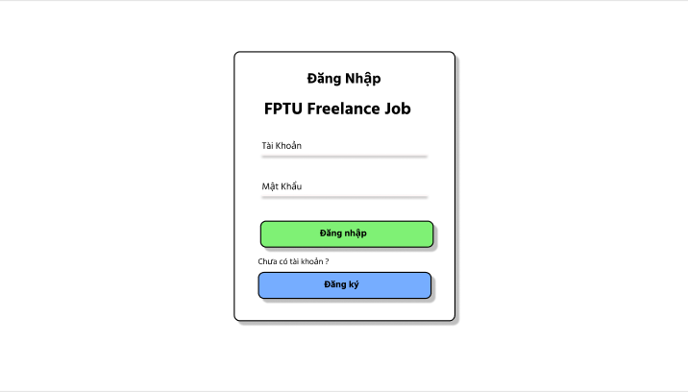

**13. Register Freelance Page**

On this page, you register your own account.

* Function trigger:

1. “Tuyển dụng”: Click this button will take you to an employer-specific account registration form.
2. “Tìm việc”: Click this button will take you to an account registration form for job seekers.

* Function description:

+ Both "Tuyển dụng" and "Tìm việc" functions help users to register their accounts but will differ in roles and functions on the website

* Screen layout:

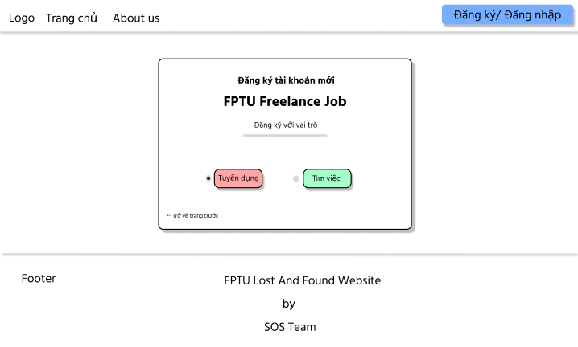

**14. Register Employer Page**

On this page, only for employers to create an account

* Function trigger:

1. “Đăng ký”: Click this button if you don't have an account yet

* Function description:

+ The "Đăng ký" function helps users create an account to access the website so that they can use the functions on the website for employers.

* Screen layout:

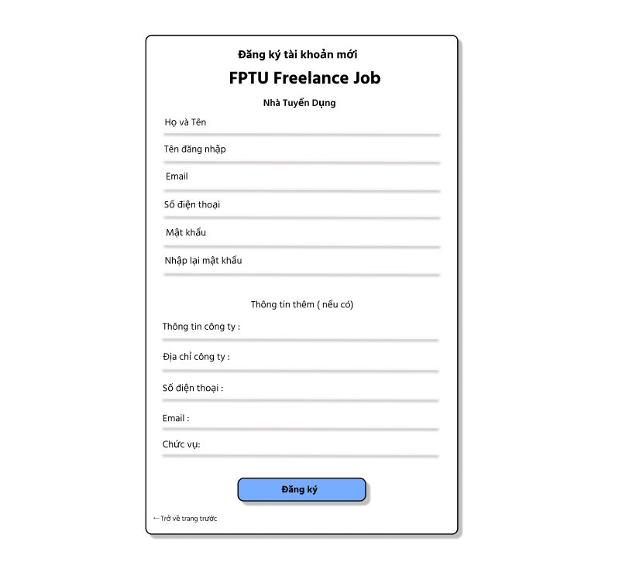

**15. Register Freelance Page**

On this page, only for job seekers to create an account

* Function trigger:

1. “Đăng ký”: Click this button if you don't have an account yet

* Function description:

+ The "Đăng ký" function helps users create an account to access the website so that they can use the functions on the website for employers.

* Screen layout:

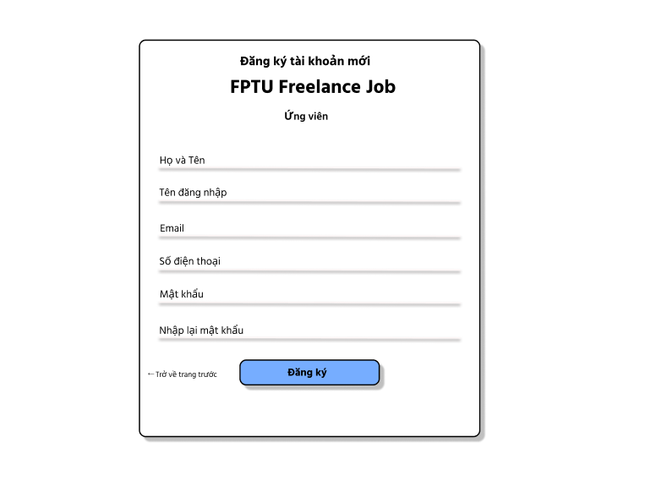

**16. Freelance Job List Page**

On this page you will see list of open jobs.

* Function trigger:

1. “Tìm kiếm”: When entering the job you are looking for in the search box, click the "Tìm kiếm" button, the website will display a list of the jobs you are looking for.

* Function description:

+ The "Tìm kiếm" function makes it easier for users to find jobs according to their needs. Create a convenient and convenient experience when using the website

* Screen layout:

