Customer Segmentation with Clustering Report
D. J. McCann, BSc
The 6th February 2026

Table of Contents
Problem Statement 3
Methods 3
Domain Context 3
The Dataset 3
Feature Engineering 3
Distribution Analysis 4
Feature Transformation and Scaling 5
Optimising Cluster Number k 5
Elbow Method 5
Silhouette Score 6
Hierarchical Clustering 6
K-Means Clustering 6
Results 7
Cluster Boxplots 7
Principal Component Analysis (PCA) 8
t-Distributed Stochastic Neighbour Embedding (t-SNE) 8
Uniform Manifold Approximation and Projection (UMAP) 9
Next Steps 9

Problem Statement
The company operates a bespoke packaging business across the UK and requires customer segmentation to enable more targeted and efficient marketing. The objective is to group customers into meaningful segments based on purchasing behaviour and value characteristics, supporting improved customer lifetime value and early assignment of new customers to appropriate segments.

Methods

Domain Context
Domain guidance suggests a focus on aggregated features within themes of cadence, value and order complexity, as the most efficient first step in producing meaningful segmentation.

The Dataset
The dataset was generated from 8,076 legacy Excel estimation documents. Various details were extracted including: Company Name, Estimate Date, Order total and Profit (when available). Further details for each company was gained from Companys House government website.

Feature Engineering
Data were aggregated by customer ID to produce one record per customer. Five engineered features were derived in line with the domain expert’s brief and used as inputs to the clustering models (Table 1).
Feature | Description
Frequency | Number of orders made by customer over the period of the dataset.
Tenure | Time between first and most recent order of the customer.
Estimates per Year | The sum of all estimates for the customer.
Average Days | Average days between consecutive orders for the customer.
Recency | Time since customer’s most recent order.
Recent 1 Year Revenue | Total revenue of estimates generated within 12 months for the customer.
Monetary Total | Total Revenue Estimated for the Customer.
Monetary Mean | Average Revenue Estimated for the Customer
Product Type Diversity | Diversity in factory operations and product types for the customer.
Table 1 - Engineered Features

Distribution Analysis
Most engineered features exhibit right-skewed distributions, particularly those involving recency. Recency shows structured tail behaviour, while monetary features are approximately symmetric. Outliers were retained, as they may represent high-value or atypical customers relevant to segmentation.
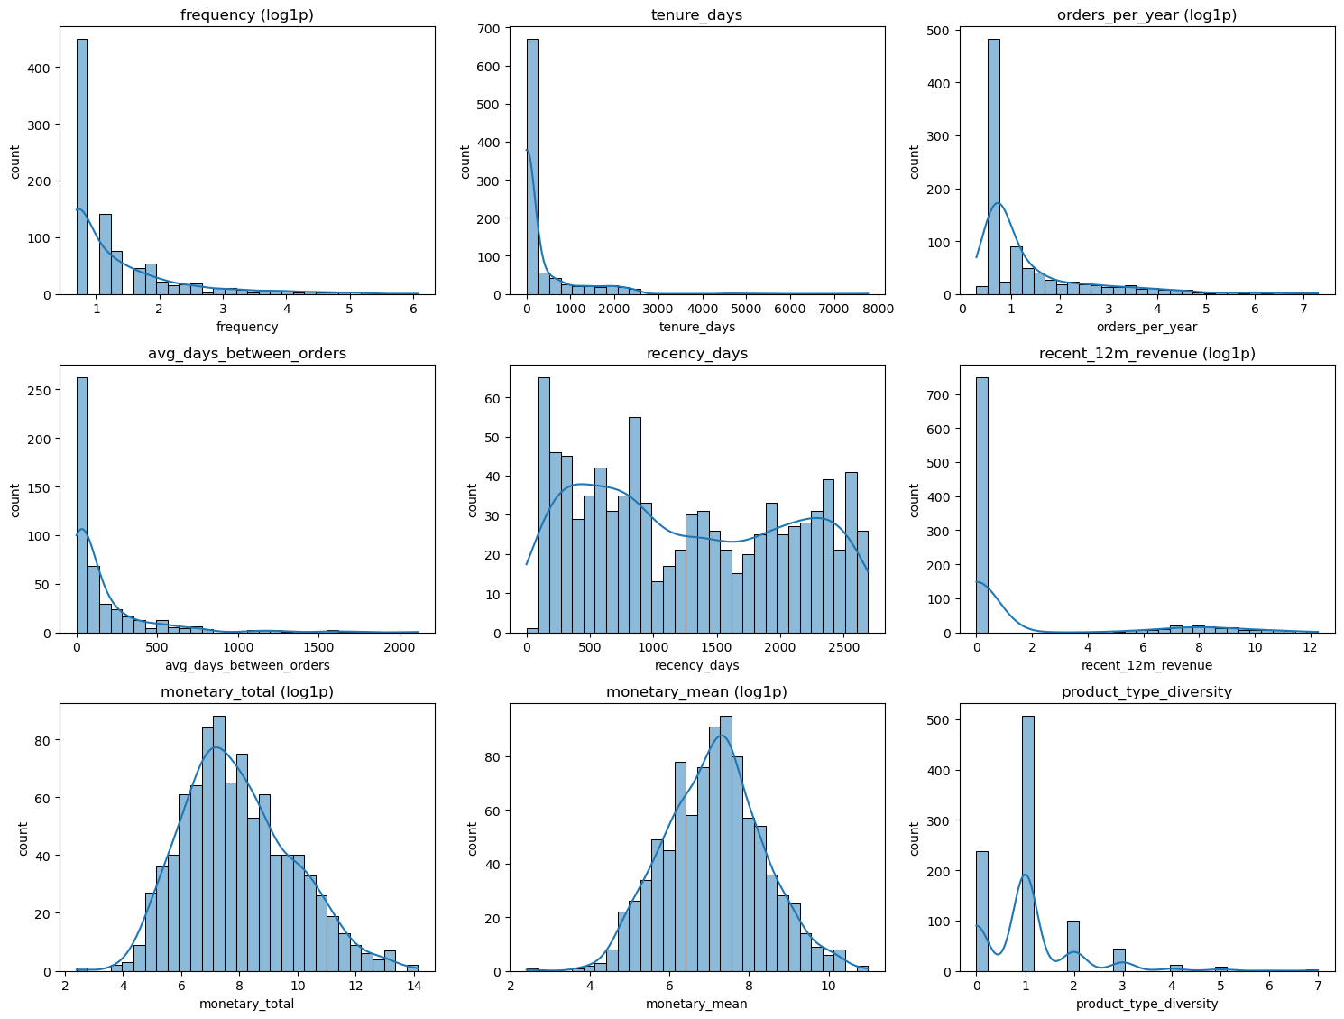
Figure 1 – Boxplot Analysis of Engineered Features

Feature Transformation and Scaling
A Log(1 + x) transformation was applied to right-skewed features to reduce the influence of extreme values on Euclidean distance calculations. All features were standardised using StandardScaler or RobustScalar (Table 2).
Features | Transform | Scaling | Rationale
Frequency,  Monetary Mean, Monetary Total, Estimates per Year, Recent year Revenue | log1p(x) | Standard Scaler(median) | Heavy-tailed / multiplicative scale (money, counts). log1p compresses extremes; StandardScaler makes dimensions comparable.
Average Days, Recency,  Tenure | None | RobustScaler (median/IQR) | RobustScaler (median/IQR) Spiky / outlier-prone numeric features (often time deltas). RobustScaler reduces outlier leverage vs StandardScaler.
Table 2 – Transformation and Scaling of the Engineered Features

Optimising Cluster Number k
The optimal number of clusters (k) was determined using converging evidence from the Elbow method, Silhouette score, and Hierarchical clustering applied to the transformed and scaled feature set.

Elbow Method
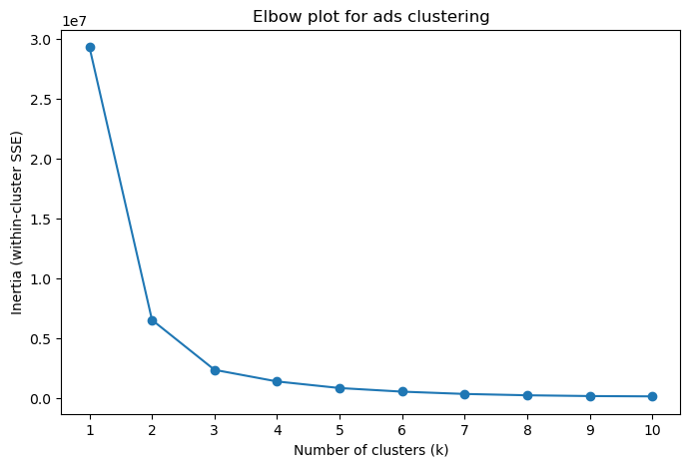
The elbow plot shows a steep reduction in inertia up to k=3, followed by diminishing returns and a near-linear tail beyond k=8. This suggests a small number of clusters (k=3-5) is optimum.

Figure 2 - Elbow Method

Silhouette Score
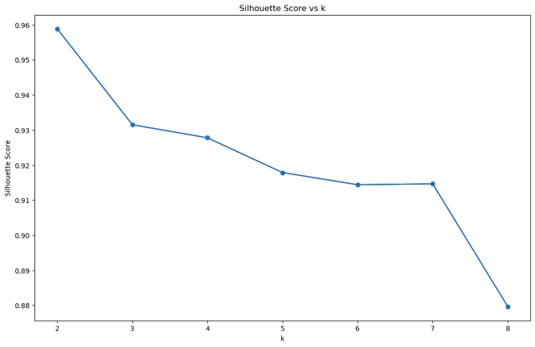
The silhouette score was highest at k = 2. Followed by k = 3 and k = 4, after which scores declined steadily. Although k = 2 provides the strongest geometric separation, a four-cluster solution was selected to balance cluster quality with interpretability and marketing relevance.

Figure 3 - Silhouette Method

Hierarchical Clustering
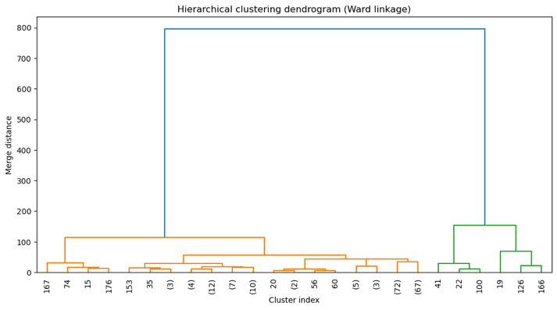
Hierarchical clustering using Ward linkage revealed a small number of dominant branches with clear separation at higher linkage distances, followed by moderate-distance secondary splits. This structure supports two broad customer groups with an additional subdivision, consistent with a three-cluster solution.
Figure 4 - Hierarchical Clustering Dendrogram

K-Means Clustering
K-means clustering was applied to the transformed and standardised feature set using Euclidean distance. The model was implemented using a scikit-learn pipeline with k = 4, random_state = 42, and n_init = “50" to ensure reproducibility and robust centroid initialisation.
The k-means clustering model with k = 3 assigned customers into three segments (Table 3).
Cluster 0 Customers | Cluster 1 Customers | Cluster 2 Customers | Cluster 2 Customers
855 (94%) | 38 (4.1%) | 10 (1.1%) | 5 (0.55%)
Table 3 - Cluster Apportionment
The initial clustering identified four distinct behavioural segments (Table 3), but with a highly imbalanced distribution, where Cluster 0 contains ~94% of customers. This indicates that Cluster 0 represents a broad core customer base rather than a single homogeneous behaviour, motivating further sub-clustering.

Principal Component Analysis (PCA)
PCA reveals four broad customer groups with partial separation primarily along the first principal component, alongside overlap at cluster boundaries between cluster 0 and 1, indicating linear variance alone is insufficient in separating customer behaviour, motivating the use of nonlinear techniques.
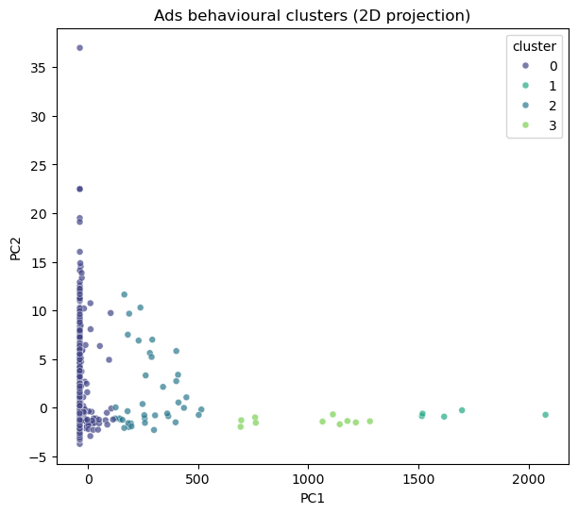
Figure 6 – PCA Projection of the K-Means Cluster Segments

Uniform Manifold Approximation and Projection (UMAP)
The UMAP projection reinforces the t-SNE findings while additionally revealing clear large-scale separation between customer segments, supporting the decision for further segmentation of cluster 0. The presence of internal sub-grouping indicates meaningful behavioural heterogeneity within cluster 0.
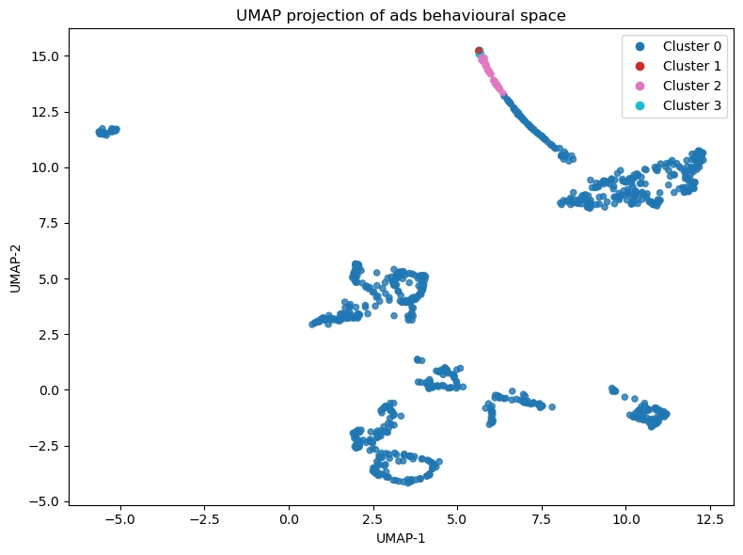
Figure 7 – UMAP Projection of the K-Means Cluster Segments

Optimising Cluster Number k for Core
The optimal number of clusters (k) was determined using converging evidence from the Elbow method, Silhouette score, and Hierarchical clustering applied to the transformed and scaled feature set.

Elbow Method
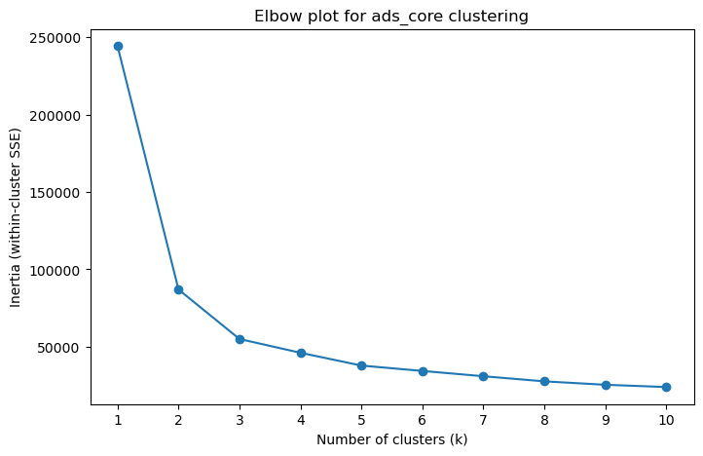
The elbow plot shows a steep reduction in inertia up to k=3, followed by diminishing returns and a near-linear tail beyond k=7. This suggests a small number of clusters (k=3-5) is optimum.

Figure 2 - Elbow Method

Silhouette Score
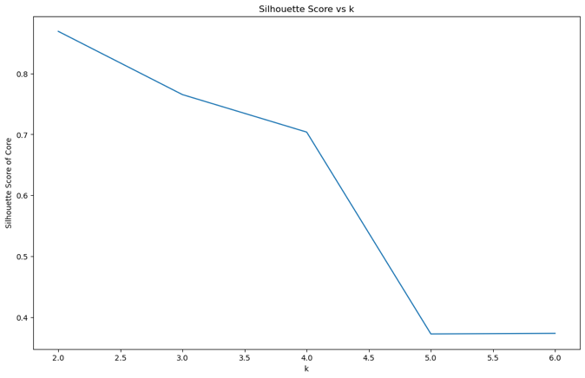
The silhouette score was highest at k = 2. Followed by k = 3 and k = 4, after which scores declined sharply.
Figure 3 - Silhouette Method

Hierarchical Clustering
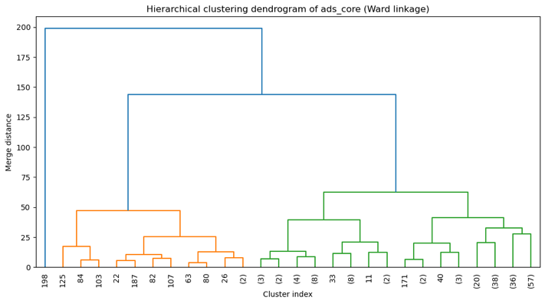
Hierarchical clustering using Ward linkage revealed a number of dominant branches with clear separation at higher linkage distances, followed by moderate-distance tertiary splits. This structure supports three broad customer groups with an additional subdivision, consistent with a five-cluster solution.
Figure 4 - Hierarchical Clustering Dendrogram

K-Means Clustering
K-means clustering was applied to the transformed and standardised feature set using Euclidean distance. The model was implemented using a scikit-learn pipeline with k = 5, random_state = 42, and n_init = “50" to ensure reproducibility and robust centroid initialisation.
The k-means clustering model with k = 4 assigned customers into three segments (Table 3).
Cluster 0 Customers | Cluster 4 Customers | Cluster 2 Customers | Cluster 3 Customers | Cluster 1 Customers
686 (80.2%) | 117 (13.7%) | 31 (3.6%) | 14 (1.6%) | 7 (0.81%)
Table 3 - Cluster Apportionment
The initial clustering identified four distinct behavioural segments (Table 3), but with a highly imbalanced distribution, where Cluster 0 contains ~94% of customers. This indicates that Cluster 0 represents a broad core customer base rather than a single homogeneous behaviour, motivating further sub-clustering.

Results

Cluster Boxplots

Cluster | Catagory | Description
Cluster 0 | Core Customers | The majority group with moderate purchase frequency, regular ordering cadence, and mid-range monetary value. Product diversity is limited, suggesting focused usage.
Cluster 1 | Infrequent/lapsed customers. | Characterised by long ordering gaps, low annual activity, and lower total value, indicating weak ongoing engagement.
Cluster 2 | Engaged regulars. | Smaller segment with higher engagement, shorter gaps between orders, and higher overall value, consistent with stable, repeat usage.
Cluster 3 | Low-revenue occasional customers. | Displays low frequency, low spend, and minimal product diversity, consistent with sporadic or one-off usage.
Table 4 - Summary of Cluster Characteristics
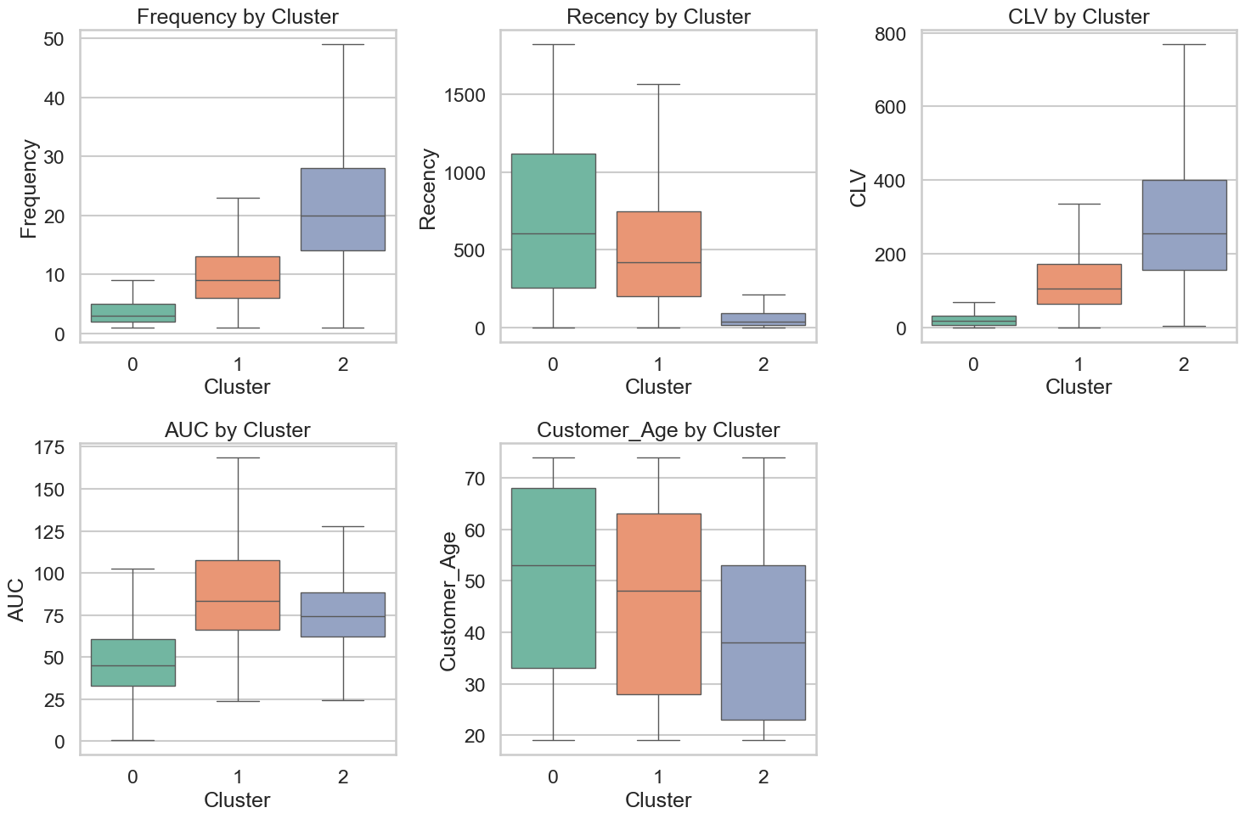
Figure 5 - Boxplot of the Unscaled Data Coloured by Cluster Number

Principal Component Analysis (PCA)
PCA reveals four broad customer groups with partial separation primarily along the first principal component, alongside overlap at cluster boundaries between cluster 0 and 1, indicating linear variance alone is insufficient in separating customer behaviour, motivating the use of nonlinear techniques.

Figure 6 – PCA Projection of the K-Means Cluster Segments

Uniform Manifold Approximation and Projection (UMAP)
The UMAP projection reinforces the t-SNE findings while additionally revealing clear large-scale separation between customer segments, supporting the decision for further segmentation of cluster 0. The presence of internal sub-grouping indicates meaningful behavioural heterogeneity within cluster 0.

Figure 7 – UMAP Projection of the K-Means Cluster Segments

Next Steps
- Assess cluster stability under alternative initialisations and subsampling
- Evaluate the temporal stability of segments across time periods
- Formulate testable, domain-validated marketing hypotheses based on identified segments

