CÁC BƯỚC THỰC HIỆN
Tên SV: Châu Thị Ngọc Quyên
Mssv: 1150080113
Lớp: 11_ĐH_CNPM2
Bài làm
- Tạo CSDL và kết nối DB
*Code SQL

CREATE DATABASE OrganizationDB
USE OrganizationDB

CREATE TABLE ORGANIZATION (
OrgID INT IDENTITY(1,1) PRIMARY KEY,
OrgName VARCHAR(255) NOT NULL,
Address VARCHAR(255),
Phone VARCHAR(20),
Email VARCHAR(100),
CreatedDate DATETIME NOT NULL DEFAULT GETDATE()
);
CREATE TABLE DIRECTOR (
DirectorID INT IDENTITY PRIMARY KEY,
DirectorName NVARCHAR(255) NOT NULL,
Phone VARCHAR(20),
OrgID INT NOT NULL,
FOREIGN KEY (OrgID) REFERENCES ORGANIZATION(OrgID)
);

select * from ORGANIZATION
select * from DIRECTOR

- Kết nối SQl với VS
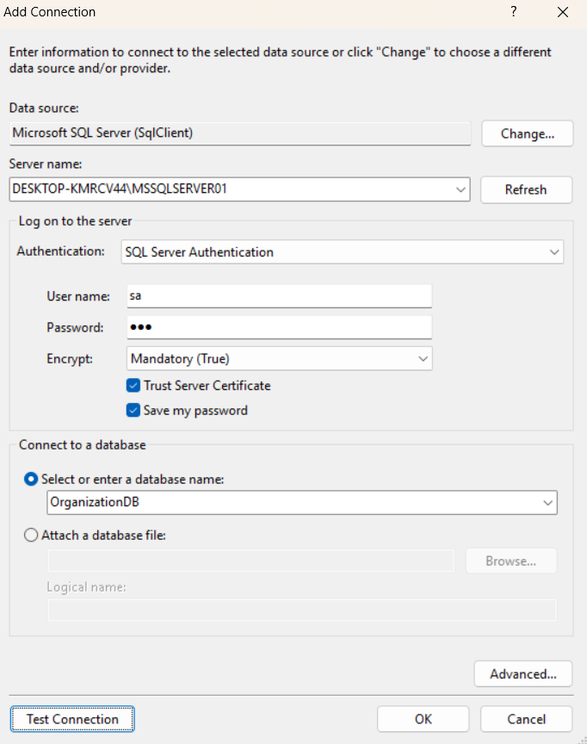

- Code
*OrganizationForm.cs

using System;
using System.Data.SqlClient;
using System.Linq;
using System.Net.Mail;
using System.Windows.Forms;

namespace BTTulamBuoi4
{
public partial class OrganizationForm : Form
{
// ===== KẾT NỐI SQL SERVER (SỬA CHO ĐÚNG MÁY EM) =====
string connectionString =
"Data Source=DESKTOP-KMRCV44\\MSSQLSERVER01;Initial Catalog=OrganizationDB;User ID=sa;Password=456";

int savedOrgId = -1;

public OrganizationForm()
{
InitializeComponent();
}

// ===== NÚT SAVE =====
private void btnSave_Click(object sender, EventArgs e)
{
string error;

if (!ValidateInput(out error))
{
MessageBox.Show(error, "Validation Error");
return;
}

if (CheckOrgNameExists(txtOrgName.Text.Trim()))
{
MessageBox.Show("Organization Name already exists");
return;
}

try
{
using (SqlConnection conn = new SqlConnection(connectionString))
{
conn.Open();

string sql = @"INSERT INTO ORGANIZATION (OrgName, Address, Phone, Email)
VALUES (@OrgName, @Address, @Phone, @Email);
SELECT SCOPE_IDENTITY();";

SqlCommand cmd = new SqlCommand(sql, conn);
cmd.Parameters.AddWithValue("@OrgName", txtOrgName.Text.Trim());
cmd.Parameters.AddWithValue("@Address", txtAddress.Text.Trim());
cmd.Parameters.AddWithValue("@Phone", txtPhone.Text.Trim());
cmd.Parameters.AddWithValue("@Email", txtEmail.Text.Trim());

savedOrgId = Convert.ToInt32(cmd.ExecuteScalar());
}

MessageBox.Show("Save successfully");
btnDirector.Enabled = true;
}
catch (Exception ex)
{
MessageBox.Show("Error when saving: " + ex.Message);
}
}

// ===== VALIDATE DỮ LIỆU =====
private bool ValidateInput(out string errorMessage)
{
errorMessage = "";

string orgName = txtOrgName.Text.Trim();
string phone = txtPhone.Text.Trim();
string email = txtEmail.Text.Trim();

if (string.IsNullOrEmpty(orgName))
{
errorMessage = "Organization Name is required";
return false;
}

if (orgName.Length < 3 || orgName.Length > 255)
{
errorMessage = "Organization Name must be from 3 to 255 characters";
return false;
}

if (!string.IsNullOrEmpty(phone))
{
if (!phone.All(char.IsDigit))
{
errorMessage = "Phone must contain only digits";
return false;
}

if (phone.Length < 9 || phone.Length > 12)
{
errorMessage = "Phone length must be from 9 to 12 digits";
return false;
}
}

if (!string.IsNullOrEmpty(email))
{
try { new MailAddress(email); }
catch
{
errorMessage = "Invalid email format";
return false;
}
}

return true;
}

// ===== CHECK TRÙNG TÊN ORGANIZATION =====
private bool CheckOrgNameExists(string orgName)
{
using (SqlConnection conn = new SqlConnection(connectionString))
{
conn.Open();
string sql = "SELECT COUNT(*) FROM ORGANIZATION WHERE LOWER(OrgName) = LOWER(@name)";
SqlCommand cmd = new SqlCommand(sql, conn);
cmd.Parameters.AddWithValue("@name", orgName);

int count = (int)cmd.ExecuteScalar();
return count > 0;
}
}

// ===== NÚT DIRECTOR =====
private void btnDirector_Click(object sender, EventArgs e)
{
if (savedOrgId <= 0)
{
MessageBox.Show("Please save Organization first");
return;
}

// Mở form Director và truyền dữ liệu sang
DirectorForm f = new DirectorForm(savedOrgId, txtOrgName.Text);
f.ShowDialog();
}

// ===== NÚT BACK =====
private void btnBack_Click(object sender, EventArgs e)
{
this.Close();
}
}
}

*DirectorForm.cs

using System;
using System.Data.SqlClient;
using System.Linq;
using System.Windows.Forms;

namespace BTTulamBuoi4
{
public partial class DirectorForm : Form
{
// KẾT NỐI DB (GIỐNG OrganizationForm)
string connectionString =
"Data Source=DESKTOP-KMRCV44\\MSSQLSERVER01;Initial Catalog=OrganizationDB;User ID=sa;Password=456";

int orgId;
string orgName;

// Constructor nhận dữ liệu từ OrganizationForm
public DirectorForm(int orgId, string orgName)
{
InitializeComponent();

this.orgId = orgId;
this.orgName = orgName;

// Hiển thị Organization đang làm Director cho nó
lblOrg.Text = "Organization: " + orgName + " (ID = " + orgId + ")";
}

// ===== SAVE DIRECTOR =====
private void btnSave_Click(object sender, EventArgs e)
{
string name = txtDirectorName.Text.Trim();
string phone = txtDirectorPhone.Text.Trim();

if (string.IsNullOrEmpty(name))
{
MessageBox.Show("Director name is required");
return;
}

if (!string.IsNullOrEmpty(phone) && !phone.All(char.IsDigit))
{
MessageBox.Show("Phone must be digits only");
return;
}

try
{
using (SqlConnection conn = new SqlConnection(connectionString))
{
conn.Open();

string sql = @"INSERT INTO DIRECTOR (DirectorName, Phone, OrgID)
VALUES (@name, @phone, @orgId)";

SqlCommand cmd = new SqlCommand(sql, conn);
cmd.Parameters.AddWithValue("@name", name);
cmd.Parameters.AddWithValue("@phone", phone);
cmd.Parameters.AddWithValue("@orgId", orgId);

cmd.ExecuteNonQuery();
}

MessageBox.Show("Director saved successfully");
this.Close();
}
catch (Exception ex)
{
MessageBox.Show("Error: " + ex.Message);
}
}

// ===== CLOSE =====
private void btnClose_Click(object sender, EventArgs e)
{
this.Close();
}
}
}

- Viết Unit test
* Cài đặt thư viện
Ở Solution Explorer
- Chuột phải vào project UnitTestBuoi4
- Chọn Add → Reference…
Cửa sổ hiện ra => bên trái chọn Assemblies => Framework
Tick chọn:
- System.Windows.Forms
- System.Drawing
Nhấn OK
* Code
using BTTulamBuoi4;
using Microsoft.VisualStudio.TestTools.UnitTesting;
using System.Threading;
using System.Windows.Forms;
using static System.Net.Mime.MediaTypeNames;

namespace BTTulamBuoi4.Tests
{
[TestClass]
public class OrganizationFormTests
{
OrganizationForm form;

// Khởi tạo Form trong STA Thread (bắt buộc với WinForms)
[TestInitialize]
public void Setup()
{
var thread = new Thread(() =>
{
form = new OrganizationForm();
System.Windows.Forms.Application.DoEvents();
;
});

thread.SetApartmentState(ApartmentState.STA);
thread.Start();
thread.Join();
}

// ===== TEST 1: OrgName rỗng =====
[TestMethod]
public void ValidateInput_OrgNameEmpty_ReturnFalse()
{
form.txtOrgName.Text = "";
form.txtPhone.Text = "0123456789";
form.txtEmail.Text = "test@gmail.com";

string error;
bool result = form.ValidateInput(out error);

Assert.IsFalse(result);
Assert.AreEqual("Organization Name is required", error);
}

// ===== TEST 2: OrgName quá ngắn =====
[TestMethod]
public void ValidateInput_OrgNameTooShort_ReturnFalse()
{
form.txtOrgName.Text = "AB";
form.txtPhone.Text = "0123456789";
form.txtEmail.Text = "test@gmail.com";

string error;
bool result = form.ValidateInput(out error);

Assert.IsFalse(result);
Assert.AreEqual("Organization Name must be from 3 to 255 characters", error);
}

// ===== TEST 3: Phone chứa ký tự chữ =====
[TestMethod]
public void ValidateInput_PhoneHasLetter_ReturnFalse()
{
form.txtOrgName.Text = "ABC Company";
form.txtPhone.Text = "01234abc89";
form.txtEmail.Text = "test@gmail.com";

string error;
bool result = form.ValidateInput(out error);

Assert.IsFalse(result);
Assert.AreEqual("Phone must contain only digits", error);
}

// ===== TEST 4: Phone quá ngắn =====
[TestMethod]
public void ValidateInput_PhoneTooShort_ReturnFalse()
{
form.txtOrgName.Text = "ABC Company";
form.txtPhone.Text = "12345";
form.txtEmail.Text = "test@gmail.com";

string error;
bool result = form.ValidateInput(out error);

Assert.IsFalse(result);
Assert.AreEqual("Phone length must be from 9 to 12 digits", error);
}

// ===== TEST 5: Email sai định dạng =====
[TestMethod]
public void ValidateInput_InvalidEmail_ReturnFalse()
{
form.txtOrgName.Text = "ABC Company";
form.txtPhone.Text = "0123456789";
form.txtEmail.Text = "abc@@gmail";

string error;
bool result = form.ValidateInput(out error);

Assert.IsFalse(result);
Assert.AreEqual("Invalid email format", error);
}

// ===== TEST 6: Dữ liệu hợp lệ =====
[TestMethod]
public void ValidateInput_AllValid_ReturnTrue()
{
form.txtOrgName.Text = "ABC Company";
form.txtPhone.Text = "0123456789";
form.txtEmail.Text = "test@gmail.com";

string error;
bool result = form.ValidateInput(out error);

Assert.IsTrue(result);
Assert.AreEqual("", error);
}
}
}

*Kết quả test
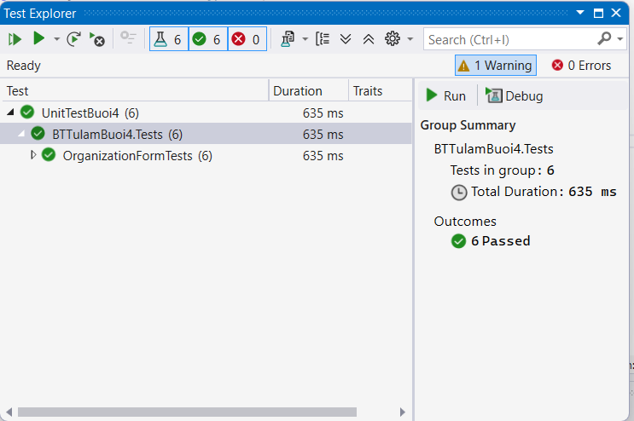

- Viết Testcase
Excel : “Buoi4_ChauThiNgocQuyen_1150080113_11DHCNPM2”
- Tổng hợp hình ảnh các trường hợp kiểm thử
TC01:
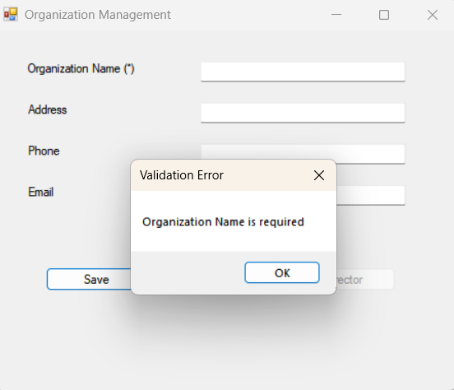

TC02:
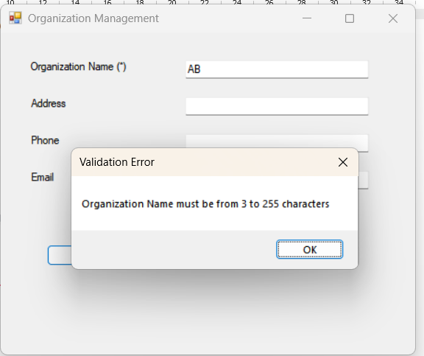
TC03:
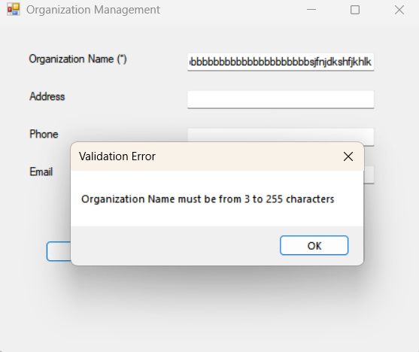
TC04:
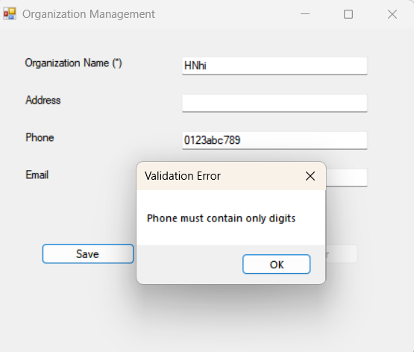

TC05:
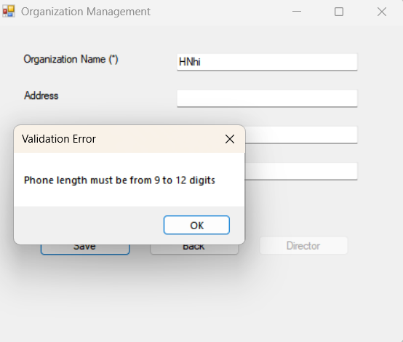
TC06:
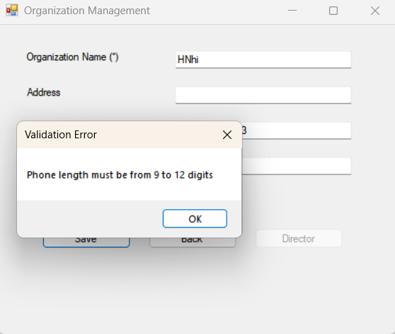
TC07:
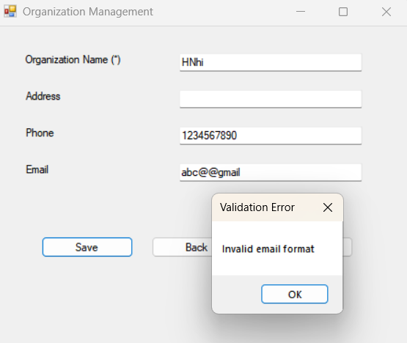

TC08:
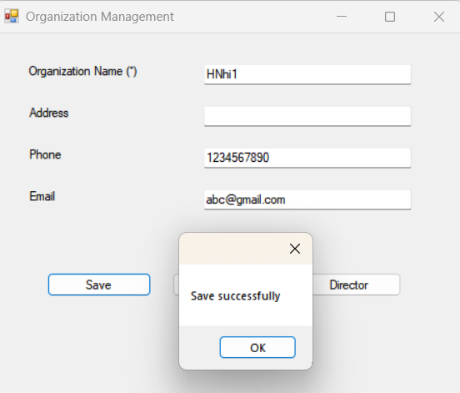
TC09:
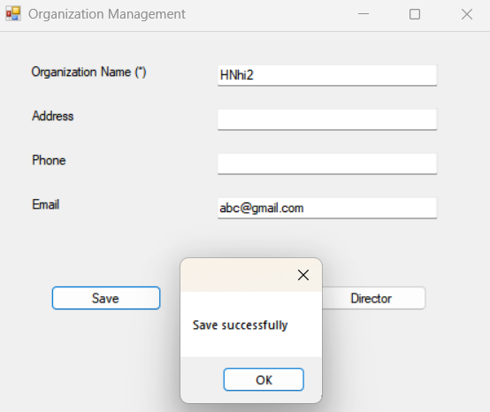
TC10:
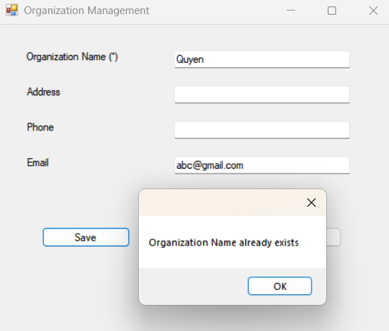

TC11:
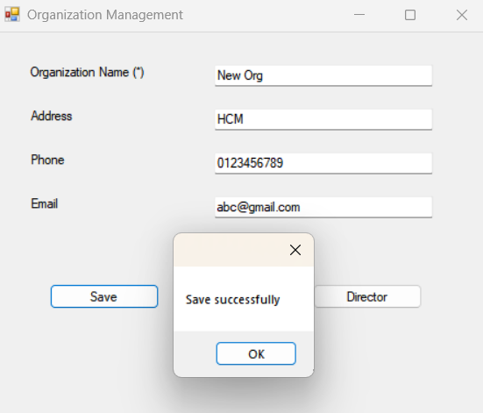
TC12:
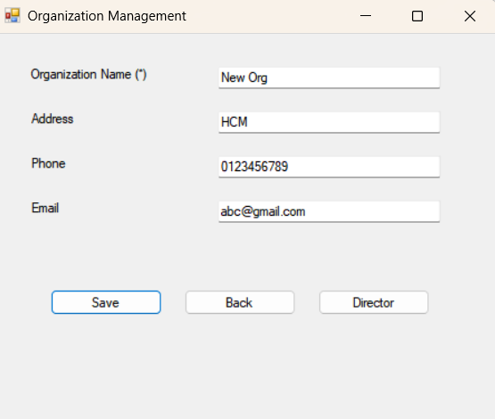
TC13:
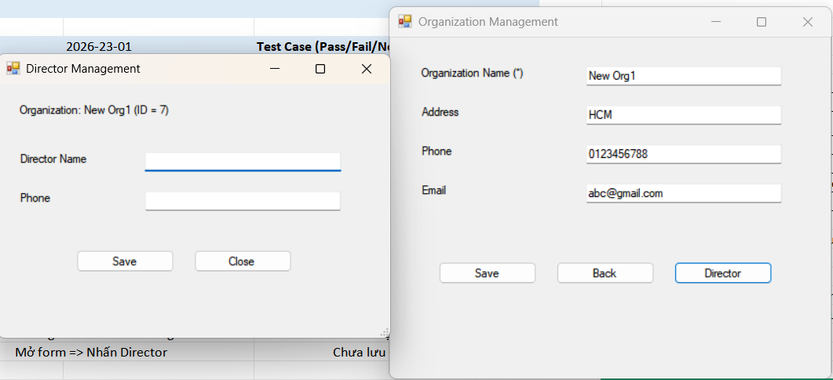

TC15:
