QBS-MANUFACTURING
STANDARD OPERATING PROCEDURE MANUAL

Item Master | Warehouse | Workstation | Operation | Routing | BOM | Production Plan | Work Order | Job Card | Material Transfer | Manufacture | Quality | Scrap | Rework | Closure
Version 1.0 | September 2026

Prepared for QBS-ERPNext Manufacturing implementations
Internal controlled working document

Document Control
Document Title | QBS-Manufacturing SOP Manual Version 1.0
Document Owner | Manufacturing / ERPNext Process Owner
Prepared By | Q10 Analytics Pvt. Ltd.
Approved By | ________________
Effective Date / Review Cycle | ________________ / Annual / major release

How to Use this Manual
This manual defines recommended operating procedures and control checklists for an ERPNext Manufacturing implementation. Exact field names, permissions and screen labels can vary by client configuration. Where a client-specific workflow differs, the approved configuration and role matrix shall prevail. Screenshots can be inserted later as implementation-specific work instructions without changing the underlying SOP controls.
Manufacturing Control Philosophy
- Maintain one authoritative Item and BOM structure for production.
- Material movement should be traceable from source warehouse through Work In Progress to finished goods and scrap.
- Production approvals and stock transactions should follow the configured authority matrix.
- Consumption, output, scrap and rejected material should be recorded against the appropriate production transaction.
- Production costing and stock balances should be reconciled before period closure.
SOP Index
SOP Module / Process | Primary Owner
01 Manufacturing Master Data & Item Management | Manufacturing / ERPNext Administrator
02 Warehouse & Stock Setup | Manufacturing / ERPNext Administrator
03 Workstation, Operation & Routing | Manufacturing / ERPNext Administrator
04 Bill of Materials (BOM) Management | Manufacturing / ERPNext Administrator
05 Manufacturing Settings & Controls | Manufacturing / ERPNext Administrator
06 Opening Stock & Material Availability | Stores / Manufacturing
07 Production Planning | Production Planner
08 Work Order Management | Production Planner / Supervisor
09 Material Transfer to WIP | Stores / Manufacturing
10 Job Card & Operation Processing | Production Supervisor
11 Material Consumption & Production Entry | Production Supervisor / Stores
12 Quality Inspection in Manufacturing | Quality / Production
13 Finished Goods, Scrap & Rejected Production | Production / Stores
14 Rework & Partial Production | Production Supervisor
15 Batch / Serial Number Manufacturing | Production / Stores
16 Manufacturing Cost & Stock Verification | Manufacturing / Accounts
17 Manufacturing Reports & Closure | Manufacturing / ERPNext Administrator
18 Manufacturing Exception & Troubleshooting | Manufacturing / ERPNext Administrator

SOP 01: Manufacturing Master Data & Item Management
Document | QBS Manufacturing SOP Manual | Version | 1.0
SOP Code | QBS-MFG-01 | Process Owner | Manufacturing / ERPNext Administrator
Effective Date | To be approved | Review Cycle | Annual / on major system change
Frequency | As required | Classification | Internal Use

Purpose
Ensure every raw material, packing material, semi-finished item and finished product has a complete and correctly configured Item master before manufacturing transactions begin.
Scope
Item creation, classification, stock settings, units of measure, inventory attributes and production eligibility.
Roles and Responsibilities
Role | Responsibility
Manufacturing / Stores | Provides approved item information and validates material classification.
ERPNext Administrator | Creates and maintains Item masters and system mappings.
Production | Validates production-related item attributes.
Quality | Confirms quality-related requirements where applicable.
Prerequisites
- Approved item list and naming convention are available.
- Item Groups and Units of Measure required by the implementation exist.
- Warehouse and stock configuration are available.
Procedure
- Search Item records to ensure the item does not already exist.
- Create the Item using the approved item code/name and Item Group.
- Set the item as a stock item where it is physically stored and consumed.
- Maintain the approved stock UOM and required alternate UOMs.
- Configure batch or serial tracking where required.
- Review default warehouse and valuation-related settings where applicable.
- Verify item status and production eligibility before using the item in a BOM.
- Save and independently review critical item attributes.
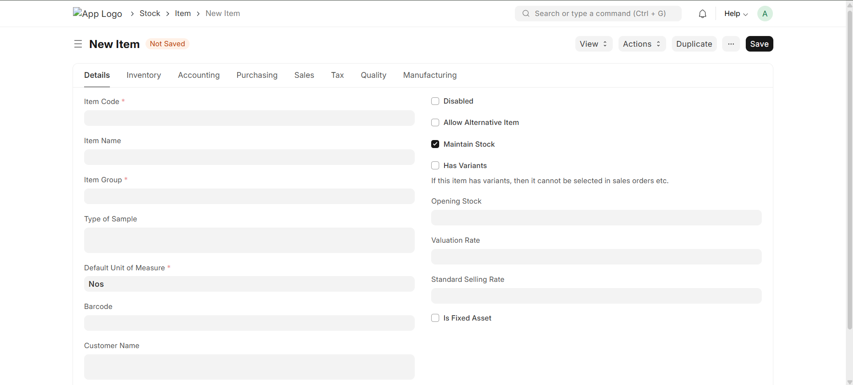
Controls and Exceptions
- Do not create duplicate items to correct naming or mapping problems.
- Do not change UOM or stock-tracking rules after transactions exist without impact assessment.
- Inactive items should not be used for new production transactions.
Checklist
✓ Check Point | Status | Remarks
☐ Unique Item Code/name verified
☐ Correct Item Group
☐ Stock Item setting verified
☐ UOM verified
☐ Batch/Serial settings verified where applicable
☐ Warehouse defaults reviewed
☐ Production eligibility verified
☐ Independent review completed

SOP 02: Warehouse & Stock Setup
Document | QBS Manufacturing SOP Manual | Version | 1.0
SOP Code | QBS-MFG-02 | Process Owner | Manufacturing / ERPNext Administrator
Effective Date | To be approved | Review Cycle | Annual / on major system change
Frequency | As required | Classification | Internal Use

Purpose
Ensure manufacturing warehouses are correctly structured so raw materials, work-in-progress, finished goods and scrap are physically and systemically traceable.
Scope
Warehouse creation, hierarchy, account mapping where applicable, and manufacturing stock movement.
Roles and Responsibilities
Role | Responsibility
Stores | Defines physical warehouse structure and material locations.
ERPNext Administrator | Creates and maintains warehouse masters.
Accounts | Validates accounting mappings where applicable.
Production | Confirms WIP and finished-goods flow.

Prerequisites
- Approved warehouse structure is available.
- Company and stock configuration are established.
- Required warehouse permissions are assigned.
Procedure
- Create or validate the required warehouses and warehouse groups.
- Maintain separate logical locations for raw material, WIP, finished goods and scrap where the process requires them.
- Verify company mapping and account settings where applicable.
- Review warehouse naming and hierarchy for consistency.
- Confirm users have access only to required warehouses.
- Validate stock movement between source, WIP and finished-goods warehouses.
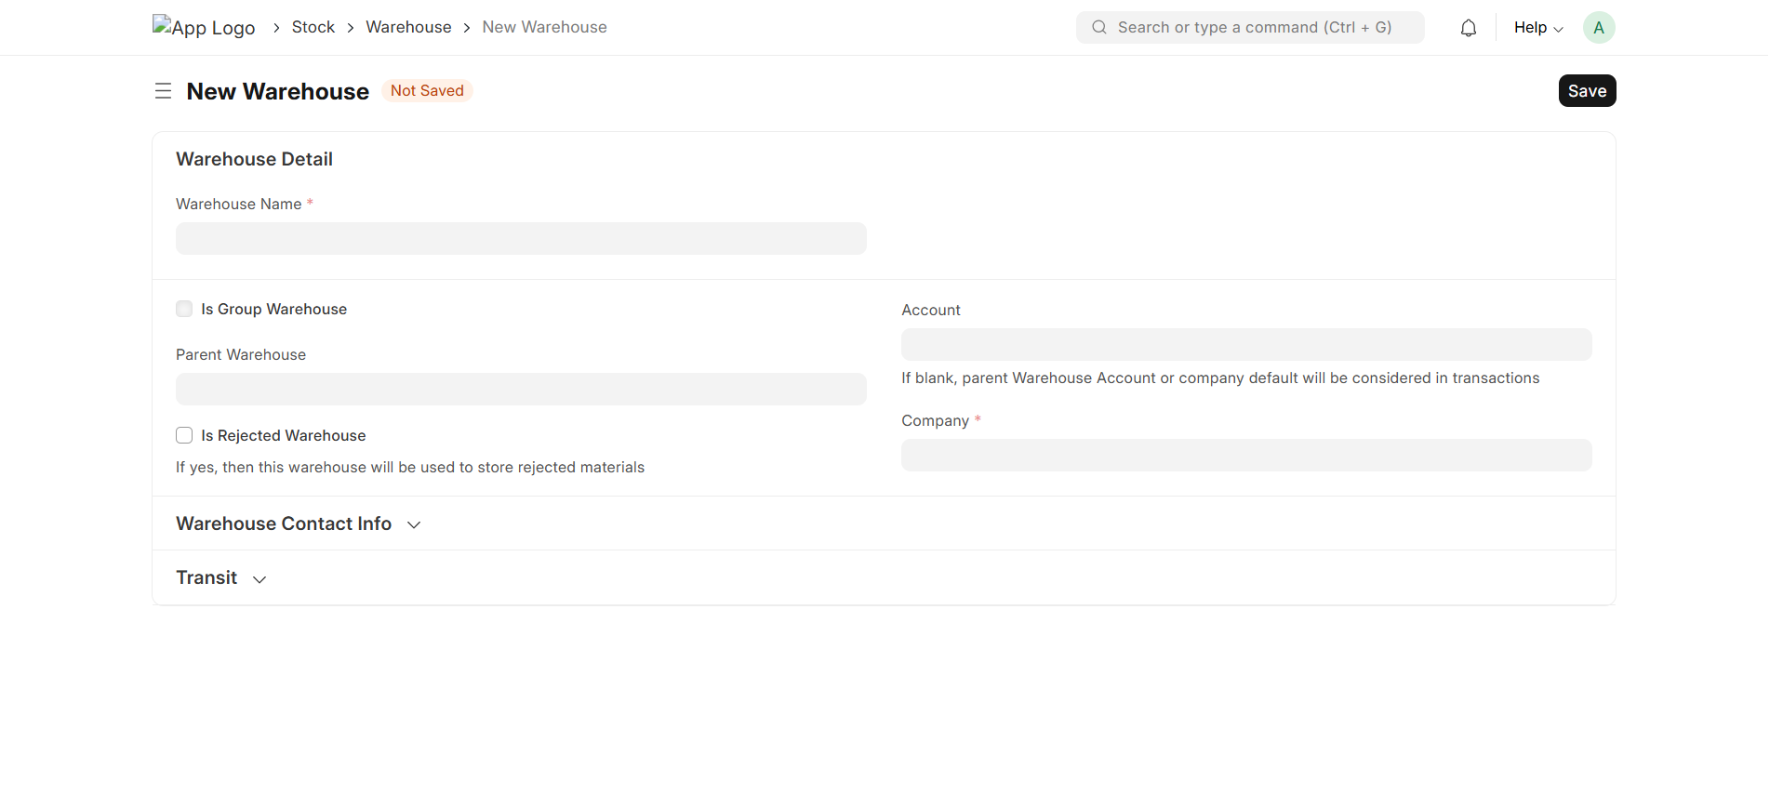
Controls and Exceptions
- Do not move stock directly to bypass the approved manufacturing flow.
- Do not delete warehouses containing historical transactions.
- Warehouse changes should be assessed for stock and accounting impact.
Checklist
✓ Check Point | Status | Remarks
☐ Warehouse hierarchy approved
☐ Raw material warehouse verified
☐ WIP warehouse verified
☐ Finished goods warehouse verified
☐ Scrap/rejection location verified where applicable
☐ Company/account mapping checked
☐ User access verified
☐ Stock movement tested

SOP 03: Workstation, Operation & Routing
Document | QBS Manufacturing SOP Manual | Version | 1.0
SOP Code | QBS-MFG-03 | Process Owner | Manufacturing / ERPNext Administrator
Effective Date | To be approved | Review Cycle | Annual / on major system change
Frequency | As required | Classification | Internal Use

Purpose
Define the production operations and resources required to execute manufacturing in a controlled sequence.
Scope
Workstations, operations, operation timings and routing sequence.
Roles and Responsibilities
Role | Responsibility
Production | Defines production sequence and resource requirements.
Production Supervisor | Validates practical operation steps and timings.
ERPNext Administrator | Configures Workstations, Operations and Routings.

Prerequisites
- Production process and operation sequence are approved.
- Required Workstations exist or are ready to be created.
- Standard operation timings are available where used.
Procedure
- Create or review Workstations used for production.
- Define Operations with clear operation names and instructions.
- Configure workstation assignment and standard timings where applicable.
- Create Routing in the required production sequence.
- Review operation dependencies and sequence.
- Validate that the Routing can be selected in the applicable BOM or Work Order flow.
- Test the routing before production use. 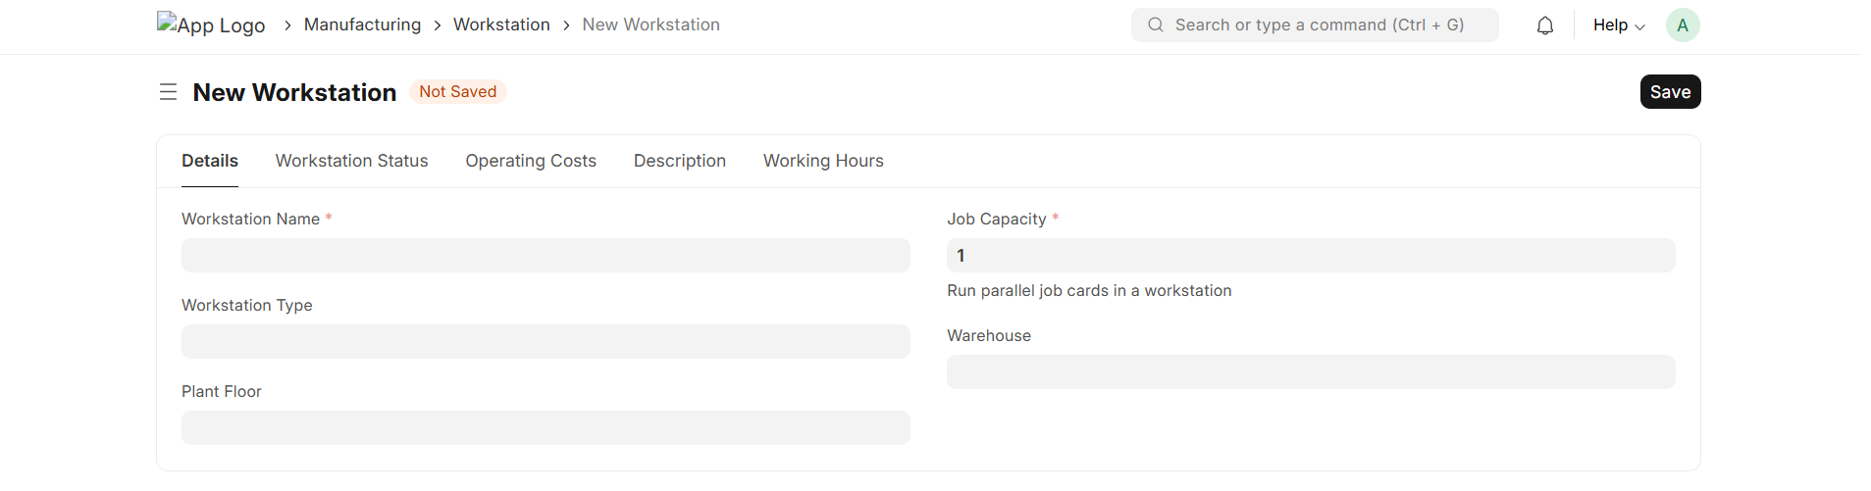
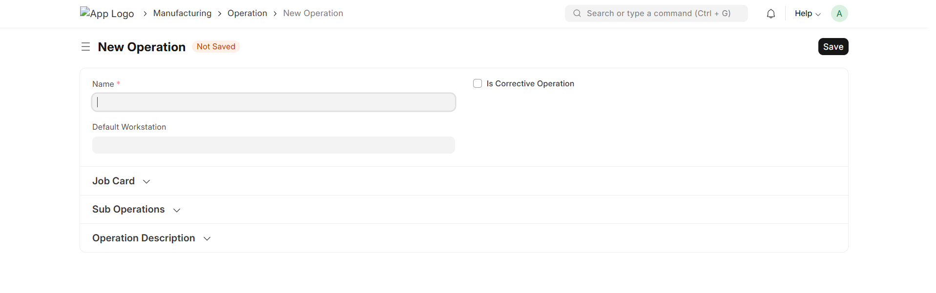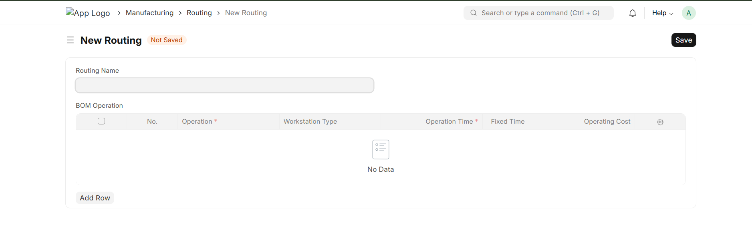

Controls and Exceptions
- Do not change operation sequence on active production without impact assessment.
- Standard timings should be reviewed when process changes occur.
- Duplicate or ambiguous operation names should be avoided.
Checklist
✓ Check Point | Status | Remarks
☐ Workstations created
☐ Operations defined
☐ Workstation assignment verified
☐ Operation timings reviewed
☐ Routing sequence approved
☐ Routing tested
☐ Production instructions available

SOP 04: Bill of Materials (BOM) Management
Document | QBS Manufacturing SOP Manual | Version | 1.0
SOP Code | QBS-MFG-04 | Process Owner | Manufacturing / ERPNext Administrator
Effective Date | To be approved | Review Cycle | Annual / on major system change
Frequency | As required | Classification | Internal Use

Purpose
Maintain an approved BOM that defines the materials, quantities and operations required to manufacture an item.
Scope
BOM creation, component quantities, UOM, operations, scrap and BOM version control.
Roles and Responsibilities
Role | Responsibility
Production Engineering | Defines and approves BOM structure.
Production | Validates manufacturing feasibility.
Stores | Validates material availability and UOM.
ERPNext Administrator | Maintains BOM records and permissions.
Prerequisites
- Finished item exists.
- Component items exist.
- Approved quantities and UOMs are available.
- Routing/operations are available where required.
Procedure
- Create the BOM for the finished item.
- Select the correct BOM items and quantities.
- Verify component UOM and stock UOM conversion where applicable.
- Add operations and operation timings when the process requires them.
- Configure scrap or process-loss quantities only from approved production rules.
- Review total component quantities and expected output.
- Submit and approve the BOM according to the configured process.
- Set the correct active/default BOM where multiple BOMs exist.
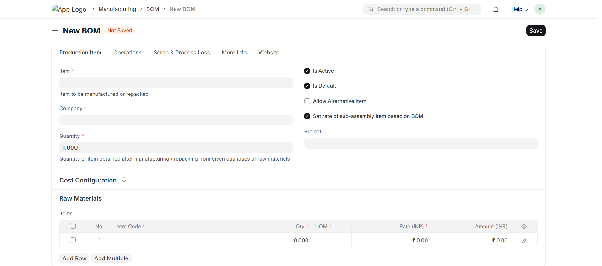
Controls and Exceptions
- Only approved BOMs should drive production.
- Do not modify a submitted BOM without considering existing Work Orders.
- Obsolete BOMs should be disabled or replaced through controlled revision.
Checklist
✓ Check Point | Status | Remarks
☐ Finished item verified
☐ Components verified
☐ Quantities verified
☐ UOM verified
☐ Operations linked where required
☐ Scrap/process loss reviewed
☐ BOM approved
☐ Active/default BOM verified

SOP 05: Manufacturing Settings & Controls
Document | QBS Manufacturing SOP Manual | Version | 1.0
SOP Code | QBS-MFG-05 | Process Owner | Manufacturing / ERPNext Administrator
Effective Date | To be approved | Review Cycle | Annual / on major system change
Frequency | As required | Classification | Internal Use

Purpose
Ensure Manufacturing settings, permissions and system controls are configured before production transactions begin.
Scope
Manufacturing Settings, stock settings, naming, permissions and production controls.
Roles and Responsibilities
Role | Responsibility
Process Owner | Approves manufacturing rules.
ERPNext Administrator | Configures system settings.
Stores / Production | Validates operational behavior.
Accounts | Validates accounting impact where applicable.

Prerequisites
- Manufacturing process is approved.
- Company, warehouse and stock settings are configured.
- Roles and permissions are defined.
Procedure
- Review Manufacturing Settings and related Stock Settings.
- Confirm default warehouses and required production controls.
- Review naming series for manufacturing documents.
- Configure permissions for Production Planner, Supervisor, Stores, Quality and Accounts roles as applicable.
- Validate cancellation/amendment permissions.
- Confirm stock and accounting settings required by the implementation.
- Perform a controlled end-to-end test before go-live.
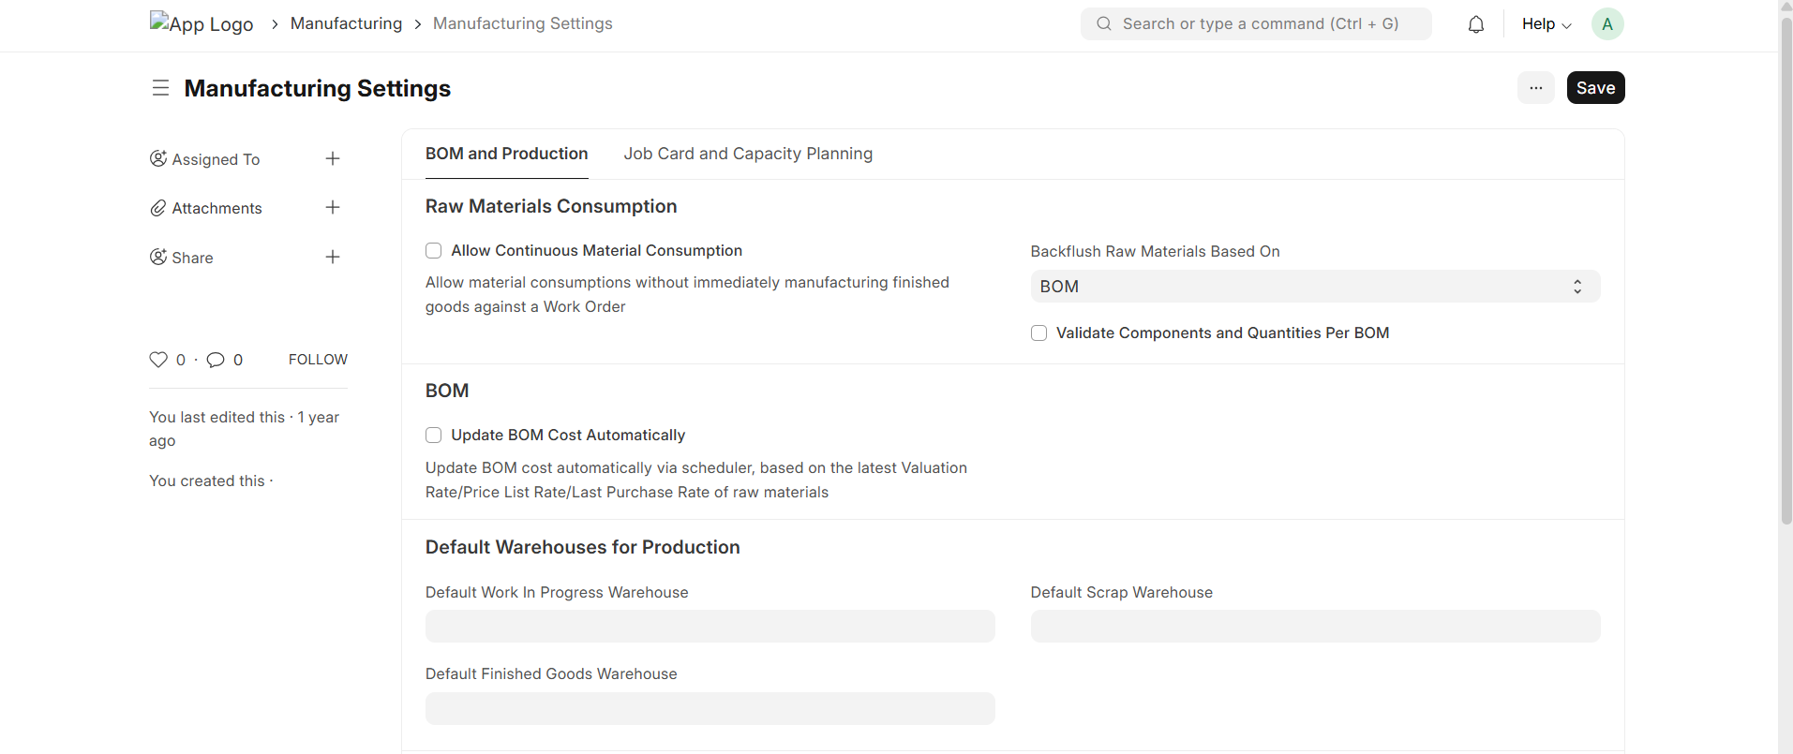
Controls and Exceptions
- Production users should not receive unnecessary administrator access.
- Settings affecting valuation or stock should be changed only through approved change control.
- Production configuration should be tested before use.
Checklist
✓ Check Point | Status | Remarks
☐ Manufacturing settings reviewed
☐ Default warehouses verified
☐ Naming series verified
☐ Roles/permissions reviewed
☐ Cancellation controls reviewed
☐ Stock/accounting settings validated
☐ End-to-end test completed

SOP 06: Opening Stock & Material Availability
Document | QBS Manufacturing SOP Manual | Version | 1.0
SOP Code | QBS-MFG-06 | Process Owner | Manufacturing / ERPNext Administrator
Effective Date | To be approved | Review Cycle | Annual / on major system change
Frequency | As required | Classification | Internal Use

Purpose
Ensure required raw materials and production inputs are available in the correct warehouses before production starts.
Scope
Opening stock, stock reconciliation and material availability.
Roles and Responsibilities
Role | Responsibility
Stores | Owns physical stock verification and stock entry.
Production | Confirms required materials.
Accounts | Validates valuation impact.
ERPNext Administrator | Supports configuration and correction.

Prerequisites
- Physical stock count is approved.
- Items and warehouses are configured.
- Opening stock process is approved.
Procedure
- Verify physical stock quantities.
- Record opening stock through the approved ERPNext stock process.
- Assign batch/serial details where applicable.
- Verify warehouse quantities after posting.
- Compare ERPNext stock with physical records.
- Resolve material discrepancies before production begins.
Controls and Exceptions
- Do not adjust stock merely to force production availability.
- Batch/serial quantities must remain traceable.
- Opening stock corrections require approved evidence.
Checklist
✓ Check Point | Status | Remarks
☐ Physical stock verified
☐ Correct warehouse used
☐ Batch/serial details verified
☐ Opening stock posted
☐ ERPNext balance reconciled
☐ Discrepancies resolved
SOP 07: Production Planning
Document | QBS Manufacturing SOP Manual | Version | 1.0
SOP Code | QBS-MFG-07 | Process Owner | Manufacturing / ERPNext Administrator
Effective Date | To be approved | Review Cycle | Annual / on major system change
Frequency | As required | Classification | Internal Use

Purpose
Convert approved production requirements into planned manufacturing demand and Work Orders.
Scope
Production Plan, demand, source documents, item selection and Work Order creation.
Roles and Responsibilities
Role | Responsibility
Production Planner | Creates and manages production plans.
Sales / Planning | Provides approved production demand.
Stores | Confirms material availability.
ERPNext Administrator | Supports configuration and exceptions.
Prerequisites
- Production demand is approved.
- Active BOM exists.
- Required items and warehouses are configured.
- Material availability can be reviewed.
Procedure
- Create the Production Plan according to the approved demand.
- Select the required production items and quantities.
- Fetch or select the applicable BOM.
- Review required raw materials and source warehouses.
- Check material availability and identify shortages.
- Generate Work Orders for the approved plan.
- Review the generated Work Orders before production release.
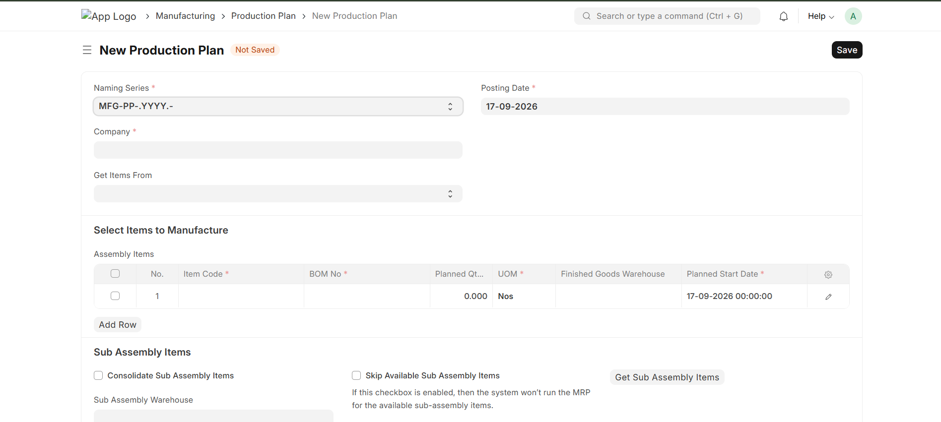
Controls and Exceptions
- Do not create production demand without approved requirement.
- Shortages should be resolved or formally accepted before release.
- Cancelled plans should not be treated as active production instructions.
Checklist
✓ Check Point | Status | Remarks
☐ Production demand approved
☐ Correct item/quantity
☐ BOM verified
☐ Material availability checked
☐ Shortages reviewed
☐ Work Orders generated
☐ Plan reviewed and released

SOP 08: Work Order Management
Document | QBS Manufacturing SOP Manual | Version | 1.0
SOP Code | QBS-MFG-08 | Process Owner | Manufacturing / ERPNext Administrator
Effective Date | To be approved | Review Cycle | Annual / on major system change
Frequency | As required | Classification | Internal Use

Purpose
Control production execution through approved Work Orders that define the item, quantity, BOM, operations and material requirements.
Scope
Work Order creation, release, material requirements, production quantity and completion.
Roles and Responsibilities
Role | Responsibility
Production Planner | Creates/releases Work Orders.
Production Supervisor | Executes production.
Stores | Provides material.
ERPNext Administrator | Supports system exceptions.
Prerequisites
- Approved Production Plan or production requirement exists.
- BOM is active.
- Required warehouses and operations are available.
Procedure
- Create or review the Work Order for the finished item.
- Verify quantity, BOM, source warehouse, WIP warehouse and target warehouse.
- Review required operations and materials.
- Check material availability.
- Release the Work Order according to production readiness.
- Transfer required materials to WIP where the process requires it.
- Monitor production progress and outstanding quantity.
- Close the Work Order after production is completed or formally stopped.
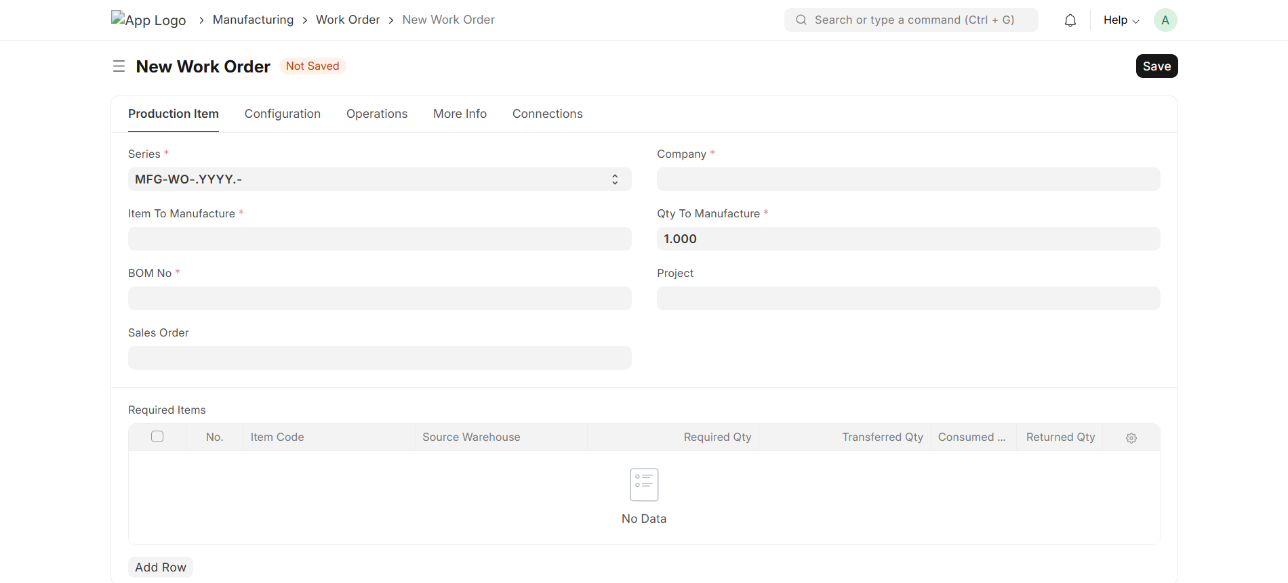
Controls and Exceptions
- Do not edit critical Work Order fields after dependent transactions without impact assessment.
- Work Order completion should match actual production.
- Unconsumed or excess materials should be reconciled.
Checklist
✓ Check Point | Status | Remarks
☐ Item and BOM verified
☐ Production quantity verified
☐ Warehouses verified
☐ Material availability checked
☐ Operations verified
☐ Work Order released
☐ Progress monitored
☐ Completion/closure verified

SOP 09: Material Transfer to WIP
Document | QBS Manufacturing SOP Manual | Version | 1.0
SOP Code | QBS-MFG-09 | Process Owner | Manufacturing / ERPNext Administrator
Effective Date | To be approved | Review Cycle | Annual / on major system change
Frequency | As required | Classification | Internal Use

Purpose
Move required production materials from stores to the approved Work In Progress location with full stock traceability.
Scope
Material transfer for manufacture, source and target warehouses, batch/serial tracking and reconciliation.
Roles and Responsibilities
Role | Responsibility
Stores | Transfers and records materials.
Production | Confirms material requirement.
Supervisor | Confirms receipt into WIP.
Prerequisites
- Released Work Order exists.
- Required material is available.
- Source and WIP warehouses are correct.
Procedure
- Open the material transfer transaction linked to the Work Order.
- Verify source warehouse and WIP warehouse.
- Transfer the required materials and quantities.
- Select correct batch/serial numbers where applicable.
- Submit the stock transaction.
- Verify source stock reduction and WIP stock increase.
- Reconcile transferred quantities with Work Order requirements.
Controls and Exceptions
- Do not transfer material to an unapproved WIP warehouse.
- Batch/serial selections must match physical material.
- Excess transfers should be corrected through controlled stock transactions.
Checklist
✓ Check Point | Status | Remarks
☐ Work Order linked
☐ Source warehouse verified
☐ WIP warehouse verified
☐ Quantities verified
☐ Batch/serial verified
☐ Stock transaction submitted
☐ WIP balance reconciled

SOP 10: Job Card & Operation Processing
Document | QBS Manufacturing SOP Manual | Version | 1.0
SOP Code | QBS-MFG-10 | Process Owner | Manufacturing / ERPNext Administrator
Effective Date | To be approved | Review Cycle | Annual / on major system change
Frequency | As required | Classification | Internal Use

Purpose
Record the execution of production operations, including work performed, time and operation status.
Scope
Job Cards, operation sequence, employees/resources, time logs and operation completion.
Roles and Responsibilities
Role | Responsibility
Production Supervisor | Assigns and monitors operations.
Operator | Records work performed.
ERPNext Administrator | Supports configuration.

Prerequisites
- Work Order and operations are available.
- Workstations are configured.
- Operators/users are authorised.
Procedure
- Create or review Job Cards generated from the Work Order.
- Verify the operation and workstation.
- Record employee/operator and actual work time where required.
- Update operation status as work progresses.
- Record completed quantity or relevant production information.
- Complete the Job Card after the operation is finished.
- Review incomplete Job Cards before Work Order closure.
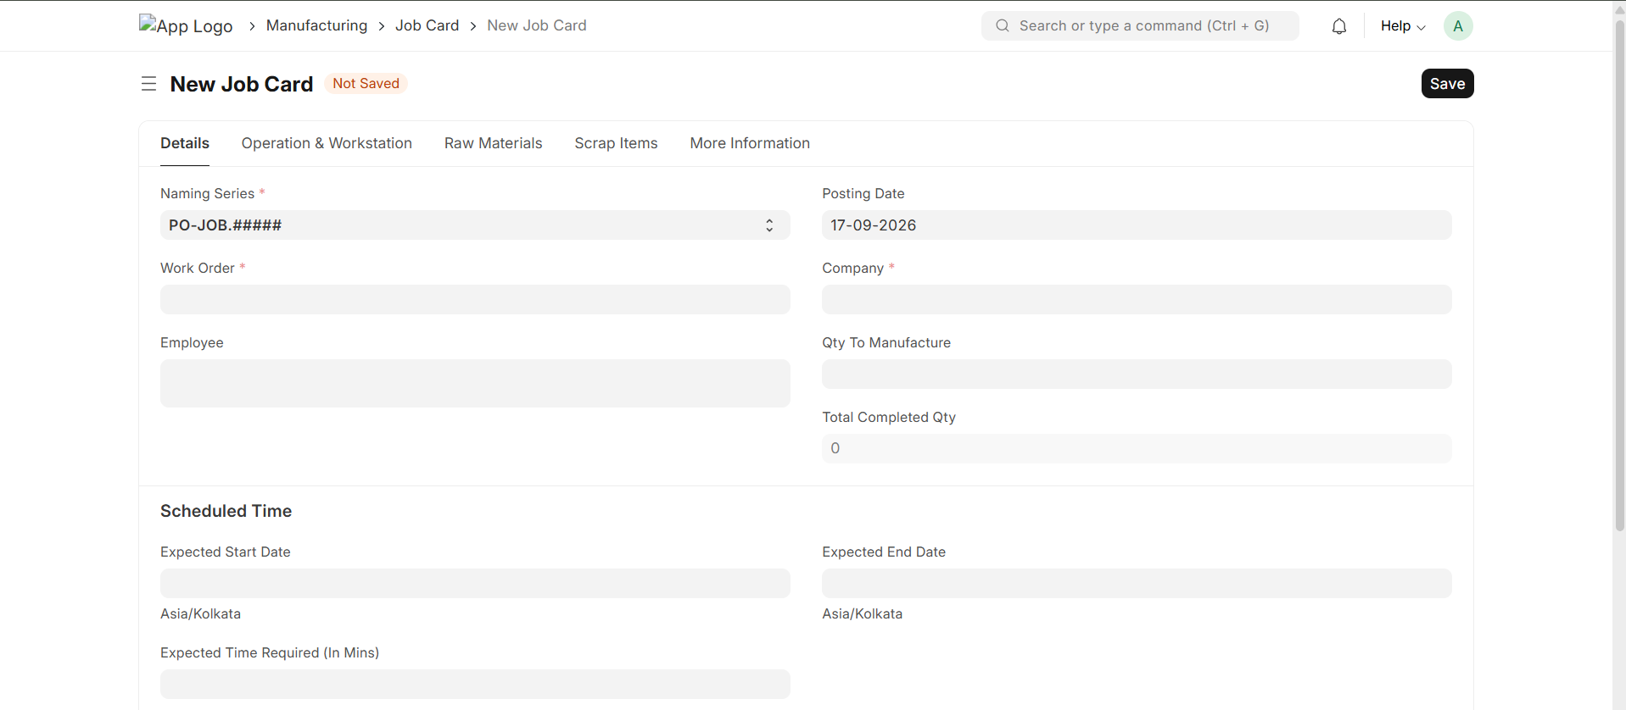
Controls and Exceptions
- Do not mark operations complete without production confirmation.
- Actual time should be recorded according to the approved process.
- Incomplete operations must be resolved before final closure.
Checklist
✓ Check Point | Status | Remarks
☐ Correct Work Order linked
☐ Operation verified
☐ Workstation verified
☐ Operator/time recorded
☐ Completed quantity verified
☐ Job Card completed
☐ Open operations reviewed

SOP 11: Material Consumption & Production Entry
Document | QBS Manufacturing SOP Manual | Version | 1.0
SOP Code | QBS-MFG-11 | Process Owner | Manufacturing / ERPNext Administrator
Effective Date | To be approved | Review Cycle | Annual / on major system change
Frequency | As required | Classification | Internal Use

Purpose
Record actual material consumption and finished production so stock and manufacturing records reflect the physical process.
Scope
Material consumption, manufacture entry, finished goods, source/WIP/target warehouses and actual quantities.
Roles and Responsibilities
Role | Responsibility
Production Supervisor | Confirms actual consumption and output.
Stores | Verifies stock movement.
Accounts | Reviews valuation impact where applicable.
ERPNext Administrator | Supports exceptions.

Prerequisites
- Work Order is active.
- Required materials are available or transferred to WIP.
- Finished goods warehouse is ready.
Procedure
- Open the production/manufacture transaction from the Work Order.
- Verify the finished item and actual production quantity.
- Review consumed materials against actual usage.
- Update actual quantities only where supported by production records.
- Select batch/serial numbers where required.
- Confirm source/WIP and finished-goods warehouses.
- Submit the manufacture entry.
- Verify stock balances and Work Order progress after posting.
Controls and Exceptions
- Do not record planned consumption as actual without confirmation.
- Avoid duplicate manufacture entries.
- Material and finished goods quantities must reconcile with the physical production.
Checklist
✓ Check Point | Status | Remarks
☐ Work Order linked
☐ Actual output verified
☐ Material consumption verified
☐ Batch/serial verified
☐ Warehouses verified
☐ Manufacture entry submitted
☐ Stock reconciled
☐ Work Order progress updated

SOP 12: Quality Inspection in Manufacturing
Document | QBS Manufacturing SOP Manual | Version | 1.0
SOP Code | QBS-MFG-12 | Process Owner | Manufacturing / ERPNext Administrator
Effective Date | To be approved | Review Cycle | Annual / on major system change
Frequency | As required | Classification | Internal Use

Purpose
Ensure required quality checks are completed and recorded before affected material is accepted for the next production or stock stage.
Scope
Quality inspection, acceptance/rejection, reference transactions and production release.
Roles and Responsibilities
Role | Responsibility
Quality | Performs and approves inspections.
Production | Provides samples/material and acts on results.
Stores | Maintains material segregation where required.

Prerequisites
- Quality parameters and inspection process are approved.
- Relevant items and transactions are available.
- Quality permissions are configured.
Procedure
- Identify the material or production transaction requiring inspection.
- Create the Quality Inspection against the applicable reference.
- Record the required test results and observations.
- Mark the inspection according to the approved acceptance criteria.
- Release accepted material to the next stage where applicable.
- Segregate rejected material and initiate the approved disposition process.
- Retain inspection records for traceability.
Controls and Exceptions
- Rejected material must not be released as accepted stock.
- Quality decisions should be recorded by authorised users.
- Inspection records should remain linked to the relevant material/production transaction.
Checklist
✓ Check Point | Status | Remarks
☐ Inspection required identified
☐ Reference transaction linked
☐ Tests recorded
☐ Acceptance criteria checked
☐ Result approved
☐ Rejected material segregated
☐ Record retained

SOP 13: Finished Goods, Scrap & Rejected Production
Document | QBS Manufacturing SOP Manual | Version | 1.0
SOP Code | QBS-MFG-13 | Process Owner | Manufacturing / ERPNext Administrator
Effective Date | To be approved | Review Cycle | Annual / on major system change
Frequency | As required | Classification | Internal Use

Purpose
Ensure finished goods, scrap and rejected output are recorded in the correct stock locations and remain traceable to production.
Scope
Finished goods receipt, scrap, rejected production and stock reconciliation.
Roles and Responsibilities
Role | Responsibility
Production | Confirms output and scrap quantities.
Stores | Receives and segregates stock.
Quality | Determines rejected disposition where applicable.

Prerequisites
- Production transaction is ready.
- Finished goods and scrap locations are defined.
- Quality disposition is available where required.
Procedure
- Confirm actual finished quantity.
- Record finished goods into the approved finished-goods warehouse.
- Record scrap quantity and destination according to the approved process.
- Record rejected production separately where required.
- Apply batch/serial tracking where applicable.
- Verify total quantities against the production transaction.
- Investigate unexplained quantity differences before closure.
Controls and Exceptions
- Scrap must not be hidden inside finished goods.
- Rejected stock must remain segregated until disposition.
- Quantity differences require investigation and documented correction.
Checklist
✓ Check Point | Status | Remarks
☐ Finished quantity verified
☐ Finished goods warehouse correct
☐ Scrap recorded
☐ Rejected output recorded where applicable
☐ Batch/serial verified
☐ Total quantity reconciled
☐ Disposition recorded

SOP 14: Rework & Partial Production
Document | QBS Manufacturing SOP Manual | Version | 1.0
SOP Code | QBS-MFG-14 | Process Owner | Manufacturing / ERPNext Administrator
Effective Date | To be approved | Review Cycle | Annual / on major system change
Frequency | As required | Classification | Internal Use

Purpose
Control production that is completed partially or requires additional processing without losing material and production traceability.
Scope
Partial Work Order completion, rework, additional operations and quantity reconciliation.
Roles and Responsibilities
Role | Responsibility
Production Supervisor | Controls rework and partial completion.
Quality | Approves rework/disposition where required.
Stores | Tracks material movement.

Prerequisites
- Reason for partial production or rework is documented.
- Affected Work Order is identified.
- Required approval is available.
Procedure
- Identify the affected Work Order.
- Record the quantity actually completed.
- Keep the remaining quantity open where further production is required.
- For rework, record the approved additional operation or production action.
- Move or consume materials through controlled stock transactions.
- Perform required quality inspection after rework.
- Close the Work Order only after final quantity and exceptions are reconciled.
Controls and Exceptions
- Do not close a Work Order merely to remove it from pending lists.
- Rework should not create duplicate finished goods.
- Additional material consumption must be traceable.
Checklist
✓ Check Point | Status | Remarks
☐ Reason documented
☐ Completed quantity verified
☐ Remaining quantity tracked
☐ Rework action approved
☐ Additional material tracked
☐ Quality recheck completed
☐ Final reconciliation completed

SOP 15: Batch / Serial Number Manufacturing
Document | QBS Manufacturing SOP Manual | Version | 1.0
SOP Code | QBS-MFG-15 | Process Owner | Manufacturing / ERPNext Administrator
Effective Date | To be approved | Review Cycle | Annual / on major system change
Frequency | As required | Classification | Internal Use

Purpose
Maintain batch and serial traceability throughout manufacturing where item tracking is required.
Scope
Batch/serial assignment, consumption, production output and traceability.
Roles and Responsibilities
Role | Responsibility
Stores | Maintains batch/serial stock.
Production | Records actual material/output identifiers.
Quality | Uses traceability during inspection.
ERPNext Administrator | Maintains tracking configuration.

Prerequisites
- Batch/serial tracking is enabled for applicable items.
- Numbering rules are approved.
- Stock locations are configured.
Procedure
- Verify tracking requirements for each relevant item.
- Select the correct batch/serial numbers during material consumption.
- Assign or create batch/serial numbers for finished production as configured.
- Confirm identifiers are recorded in stock transactions.
- Trace finished output back to consumed material where required.
- Review batch/serial balances after production.
Controls and Exceptions
- Never reuse a serial number.
- Do not select an incorrect batch to complete a transaction.
- Traceability gaps must be investigated before release.
Checklist
✓ Check Point | Status | Remarks
☐ Tracking configuration verified
☐ Correct batch/serial selected
☐ Finished batch/serial created
☐ Identifiers recorded
☐ Traceability checked
☐ Balances reconciled
SOP 16: Manufacturing Cost & Stock Verification
Document | QBS Manufacturing SOP Manual | Version | 1.0
SOP Code | QBS-MFG-16 | Process Owner | Manufacturing / ERPNext Administrator
Effective Date | To be approved | Review Cycle | Annual / on major system change
Frequency | As required | Classification | Internal Use

Purpose
Verify that manufacturing transactions produce consistent stock quantities and appropriate manufacturing cost information.
Scope
Stock valuation, material consumption, finished goods valuation, variance review and accounting impact.
Roles and Responsibilities
Role | Responsibility
Manufacturing | Reviews production quantities and variances.
Stores | Confirms physical stock.
Accounts | Reviews valuation and accounting entries.
ERPNext Administrator | Investigates system-level discrepancies.

Prerequisites
- Production transactions are posted.
- Stock ledger and relevant accounting reports are accessible.
- Physical reconciliation data is available.
Procedure
- Review material consumption against production output.
- Check finished goods and scrap quantities.
- Review stock ledger entries for the relevant warehouses.
- Review valuation or manufacturing cost information according to the configured costing method.
- Compare production records with physical stock.
- Investigate unexplained variances.
- Document approved adjustments and corrections.
Controls and Exceptions
- Do not change stock or valuation merely to hide a variance.
- Accounting corrections should follow approved financial controls.
- Large or recurring variances require root-cause analysis.
Checklist
✓ Check Point | Status | Remarks
☐ Consumption reconciled
☐ Finished goods reconciled
☐ Scrap reconciled
☐ Stock ledger reviewed
☐ Cost/valuation reviewed
☐ Variances investigated
☐ Corrections documented

SOP 17: Manufacturing Reports & Closure
Document | QBS Manufacturing SOP Manual | Version | 1.0
SOP Code | QBS-MFG-17 | Process Owner | Manufacturing / ERPNext Administrator
Effective Date | To be approved | Review Cycle | Annual / on major system change
Frequency | As required | Classification | Internal Use

Purpose
Ensure manufacturing activity is reviewed, reconciled and formally closed for the required period.
Scope
Production reports, Work Order status, stock reconciliation, pending operations and period closure.
Roles and Responsibilities
Role | Responsibility
Production Manager | Reviews production completion and exceptions.
Stores | Reconciles stock.
Accounts | Reviews financial impact.
ERPNext Administrator | Supports reports and system controls.

Prerequisites
- Period cut-off is communicated.
- Production transactions are posted or identified as pending.
- Required reports are available.
Procedure
- Review open Work Orders and pending Job Cards.
- Review production quantities and material consumption.
- Review finished goods, scrap and rejected quantities.
- Review stock balances and relevant stock ledger entries.
- Review manufacturing cost and accounting impact where applicable.
- Identify unresolved exceptions.
- Complete approved corrections before closure.
- Obtain responsible-owner sign-off for period closure.
Controls and Exceptions
- Do not close a period with material unresolved stock discrepancies.
- Retrospective changes after closure require approved exception handling.
- Retain closure evidence for audit.
Checklist
✓ Check Point | Status | Remarks
☐ Open Work Orders reviewed
☐ Pending Job Cards reviewed
☐ Production output reviewed
☐ Material consumption reviewed
☐ Scrap/rejection reviewed
☐ Stock reconciled
☐ Cost/accounting reviewed
☐ Closure sign-off obtained

SOP 18: Manufacturing Exception & Troubleshooting
Document | QBS Manufacturing SOP Manual | Version | 1.0
SOP Code | QBS-MFG-18 | Process Owner | Manufacturing / ERPNext Administrator
Effective Date | To be approved | Review Cycle | Annual / on major system change
Frequency | As required | Classification | Internal Use

Purpose
Provide a structured diagnostic path so manufacturing issues are corrected at the correct layer without creating secondary stock or production errors.
Scope
Common issues involving item/BOM setup, material availability, Work Orders, stock movement, Job Cards, production entries, quality and traceability.
Roles and Responsibilities
Role | Responsibility
Operator/User | Reports exact issue and transaction details.
Production/Stores | Validates physical and process conditions.
ERPNext Administrator | Diagnoses configuration and application issues.
IT/Developer | Fixes approved infrastructure or code defects where required.

Prerequisites
- Issue ID, transaction number, item and date/time are captured.
- Recent configuration or code changes are known.
Procedure
- Classify the issue as master data, configuration, permission, stock, production, quality, integration or application error.
- Check the source transaction and linked Work Order.
- Verify Item, BOM, warehouse and operation configuration.
- Trace stock movement from source warehouse through WIP to finished goods.
- Check batch/serial details where applicable.
- Review error messages before attempting corrections.
- Correct the root cause through the approved process.
- Retest the original transaction scenario.
- Reconcile stock and production quantities after correction.
- Document root cause and preventive action for recurring issues.
Controls and Exceptions
- Do not directly edit database records when the root cause is unknown.
- Do not cancel or repost stock blindly.
- Bulk corrections require backup, controlled testing and reconciliation.
Checklist
✓ Check Point | Status | Remarks
☐ Issue/transaction captured
☐ Item/BOM verified
☐ Warehouse flow checked
☐ Work Order checked
☐ Stock movement traced
☐ Batch/serial checked
☐ Root cause identified
☐ Fix tested
☐ Stock reconciled
☐ RCA/preventive action documented

Master QBS-Manufacturing Go-Live / Periodic Control Checklist
Area | Control Check | Status | Remarks / Owner
Masters | Item naming, groups and UOMs validated | ☐
Masters | Batch/Serial configuration validated where applicable | ☐
Masters | Workstations and Operations configured | ☐
Masters | Routing validated | ☐
Masters | Active/default BOMs validated | ☐
Warehouse | Raw material, WIP, finished goods and scrap warehouses validated | ☐
Security | Roles and permissions reviewed | ☐
Settings | Manufacturing and stock settings documented | ☐
Planning | Production Plan process tested | ☐
Planning | Work Order creation and release tested | ☐
Stores | Material transfer to WIP tested | ☐
Production | Job Card process tested | ☐
Production | Material consumption tested | ☐
Production | Manufacture entry tested | ☐
Quality | Quality Inspection process tested where applicable | ☐
Output | Finished goods receipt tested | ☐
Output | Scrap/rejected production process tested | ☐
Traceability | Batch/Serial traceability tested where applicable | ☐
Reconciliation | Stock ledger and physical stock reconciliation tested | ☐
Finance | Manufacturing cost/valuation impact reviewed | ☐
Closure | Open Work Orders and pending operations reviewed | ☐
Support | Exception and troubleshooting process documented | ☐
Governance | SOP training completed for relevant users | ☐

Monthly Manufacturing Control Sign-off
Control | Control Owner | Status | Remarks
Production and material transactions reconciled | Production / Stores | ☐
Pending Work Orders reviewed | Production | ☐
Stock discrepancies cleared | Stores | ☐
Quality exceptions cleared | Quality | ☐
Manufacturing cost/valuation reviewed | Accounts | ☐
Period closure completed | Production Manager | ☐
Recurring manufacturing incidents reviewed for RCA/CAPA | Production / ERPNext Admin | ☐
Revision History
Version | Date | Change | Prepared By / Approved By
1.0 | September 2026 | Initial QBS-Manufacturing SOP Manual | Q10 Analytics Pvt. Ltd. / __________

