**ASSIGNMENT COVER SHEET**

For use with online submission of assignments

Please complete all of the following details and then make this sheet the **first page of each file of your assignment – do not send it as a separate document.**

Your assignments must be submitted as either **Word documents, text documents with .rtf extension or as .pdf documents**. If you wish tosubmit in any other file format please discuss this with your lecturer well before theassignment submission date.

|  |  |
| --- | --- |
| Student Name: | Jiamu Rao |
| Student ID No.: | 202100408055 |
| Unit Name: | ISYS3001 Managing Software Development |
| Unit Code: | ISYS3001 |
| Tutor’s name: | Zhenjing Huang |
| Assignment No.: | Assessment 2 |
| Assignment Title: | Practical Skills |
| Due date: | 18 September 2022 11:59 PM (AEST) |
| Date submitted: | 24 September 2023 |

Declaration:

*I have read and understand the Rules Relating to Awards ([Rule 3 Section 18 – Academic Misconduct Including Plagiarism](http://policies.scu.edu.au/view.current.php?id=00140" \l "s18)) as contained in the SCU Policy Library.   
I understand the penalties that apply for plagiarism and agree to be bound by these rules. The work I am submitting electronically is entirely my own work.*

|  |  |
| --- | --- |
| Signed: | Jiamu Rao |
| (please type your name) |  |
| Date: | 2023.9.24 |

**GitHub Screenshot:**

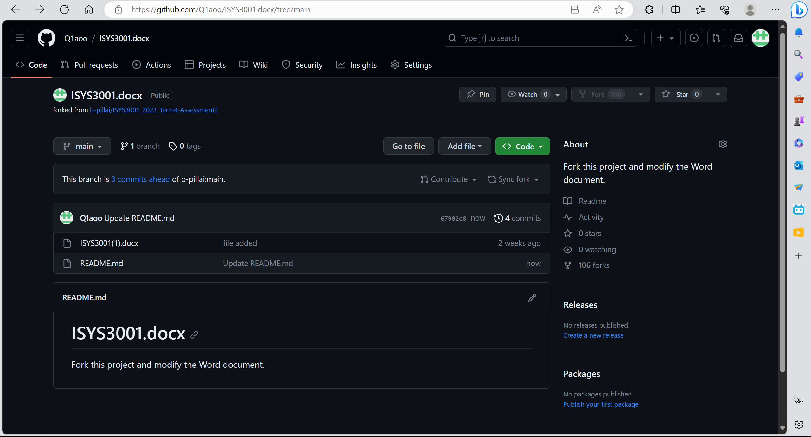

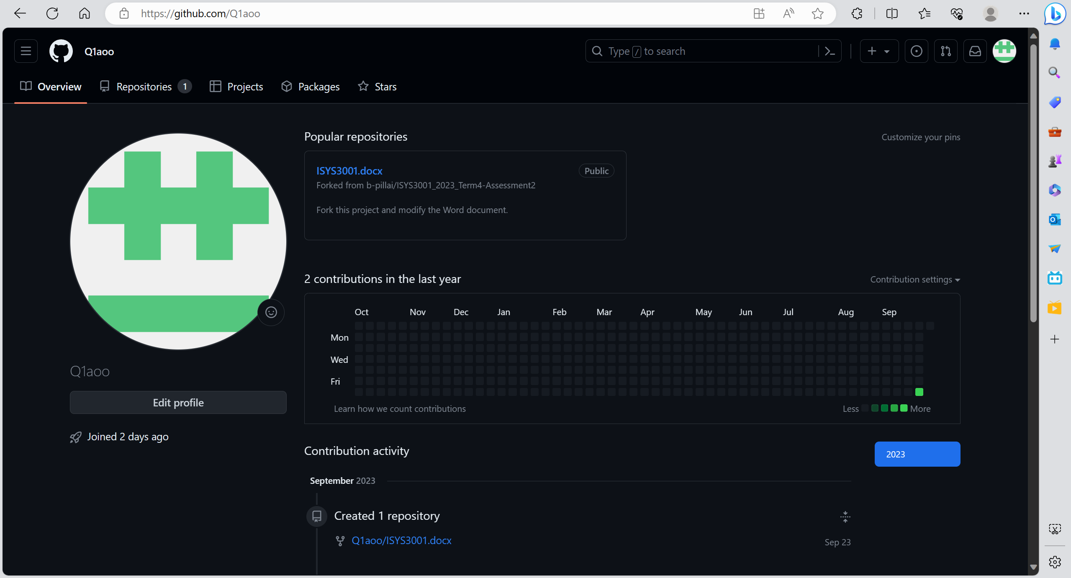

**Configuration Management**

1. Change Management:

Create a sense of urgency, take a hard look at market and competitive realities, identify and discuss crises, including potential or major crises, and form a strong leadership coalition. Develop a vision plan, establish a vision plan to guide reform measures, and form strategies to achieve the goals of the vision plan. Empower others to act in accordance with the vision and remove obstacles to reforms that seriously undermine the mechanisms and structures of such vision and encourage risk-taking and unconventional ideas, activities and behaviours. Institutionalize new approaches, identify the relationship between new behaviors and business success, and establish methods and systems that ensure the smooth development and transition of leadership.

1. Vision management:

If the company has a configuration administrator, it is recommended that the bin file generated by the project compilation (that is, the project result, such as exe, DLL, or *.so) be compiled and submitted by the configuration administrator. In the case of no configuration manager, we recommend a cross-compile commit approach for major projects, where developers commit only their own code, and then compile each other's code and upload others' bin files. This type of management can sometimes prevent many non-technical disputes in advance.

1. System Building:

For the system whose internal structure and characteristics have been clear, that is, the "white box" system, the system model can be obtained by using known laws and theorems and after certain analysis and reasoning. The corresponding model is also called the mechanism model. For those systems whose internal structure and characteristics are not very clear, that is, "gray box" systems, computer simulation models can be built to simulate the behavior of the actual system, and the system model can be confirmed and evaluated by simulating the input and output results. The corresponding model is also called semi-mechanism model.

1. Release Management:

Release management protects the existing IT operating environment and IT services from impact by implementing formal work procedures and strict monitoring, and is responsible for planning, designing, generating, configuring, and testing software/hardware releases that may affect the existing IT environment, customers, and branches of the organization.

**Request for Proposal (RFP)**

###### Title: Integrated System for Aussie Business Buzz (ABB)

Background：

Aussie Business Buzz (ABB), which sells technology products and provides after-sales services such as repairs and mobile device accessories, has opened four stores. The problem now is that they need an integrated system to support four stores, and they want to support more stores in the future over time. Because of this difficulty, I hope to find a solution through the Request for Proposal (RFP) to enhance competitiveness.

**System description:**

According to the requirements of the ABB enterprise, they needed an integrated system to support the branches, and also required persistence.

The system consists of the following three parts:

1. Establish a customer relationship database to understand customer needs and handle the most basic information of customers, including but not limited to the most basic information of purchased products and equipment to be repaired. This is the most basic part of this system, because the service group of the entire enterprise is these customers, and the maintenance of the entire enterprise is also determined by this type of people, so this part must be done well, can ensure the stable and long-term development of the enterprise. I can provide some ideas, in this database, in addition to the information mentioned above, it can also provide customers' personal information, purchase preferences, purchase history, feedback on problems and other information. I hope that through this database, I can achieve a comprehensive and three-dimensional understanding of customers, so as to provide a better service experience, so that not only do not lose customers but also attract more customers.

2. Create an inventory management system, if the first part is for customers, then this system is for the enterprise itself. In order to serve each customer very well, enterprises must have a very clear understanding of the inventory content they own, so that they can have a clear plan. This includes three types of inventory, two of which are for different needs of customers, respectively, products for sale and parts for repair, and the other is for enterprises, automatic orders for wholesalers. These three categories are indispensable, which constitute a virtuous circle of supply and demand and is a complete supply chain. In addition to this, the system is required to be able to be used in individual locations in order to find other products and parts. This is an important guarantee for the long-term development of enterprises themselves.

3. After analyzing the two important parts of the customer and the enterprise, there is also an indispensable part that is the management personnel. Most of the above mentioned contents are closely related to the management personnel, without whom the above work cannot be completed. So, report this to managers so they can understand what to do to help the business grow, down to ordering inventory, hiring staff, and other decision-making issues. Only managers can accurately do a good job of connection work, all the above situations can happen, otherwise it is empty talk.

The above three parts are aimed at three major directions: customers, enterprises and managers. This covers almost all the people and basic needs involved. Each part is the most basic and the most important, in order to do a good system, it must be around these three parts. This is the most important part of the system description in the RFP.

**Proposal:**

As for the subsequent proposals received, I don't think I can make a comprehensive assessment alone, there will always be some missing parts. Therefore, if I have the ability, I would like to set up a proposal evaluation team, including managers, as mentioned above, because they play a bridging role and need to understand very detailed content, and they can put forward ideas and discuss with different ideas in the proposal to find the best solution. I believe that having managers directly involved will go a long way in assessing progress. Due to lack of experience, in addition to the management staff, I also require an experienced consultant to be added to the team. The consultant can solve the problems we do not understand, and can also correct mistakes in time to prevent the team from developing in the wrong direction.

Besides, I have other ideas. In the evaluation process, we may consider involving the end user, the customer mentioned above, where appropriate. In this way, we can directly understand their feelings, make the most accurate adjustment and change, and even the customer can directly put forward their ideas, and then summarize, and finally make a satisfactory reply to the customer. I think this is an intuitive way, customers are not only consumers of enterprise products, but also partners of enterprises, so as to narrow the distance with customers, so that customers have a good impression on the enterprise, is a win-win idea, relatively innovative.

Finally, during this proposal evaluation process, a range of stakeholders will be consulted to achieve a comprehensive understanding, which will not only help ensure the fairness of the evaluation process, but also make it more likely that the solution that best meets the needs of the business will be selected. Also will not take any cheating, loopholes and other violations of the law, I will definitely notice these problems. I hope we can finally find a solution that satisfies both the company and the customer.

**Budget frame:**

The budget for the first phase is around $100,000, with an average of $25,000 per store, and progress will depend on the proposal. But we will try our best to control the budget, the less the better, to achieve the highest cost performance.

At last, I believe that if it can proceed smoothly as usual, it will be in our favor. The mature system of the enterprise has laid a good foundation for our progress, what we need to do is to learn from the past successful cases and proceed according to the plan.