应用篇

效率

1. 使用多线程充分利用 CPU

1) 环境搭建
基准测试工具选择，使用了比较靠谱的 JMH ，它会执行程序预热，执行多次测试并平均
cpu 核数限制，有两种思路
1. 使用虚拟机，分配合适的核
2. 使用 msconﬁg ，分配合适的核，需要重启比较麻烦
并行计算方式的选择
1. 最初想直接使用 parallel stream ，后来发现它有自己的问题
2. 改为了自己手动控制 thread ，实现简单的并行计算
测试代码如下
mvn archetype:generate -DinteractiveMode=false -DarchetypeGroupId=org.openjdk.jmh -
DarchetypeArtifactId=jmh-java-benchmark-archetype -DgroupId=org.sample -DartifactId=test - Dversion=1.0
package org.sample;

import java.util.Arrays;
import java.util.concurrent.FutureTask;

import org.openjdk.jmh.annotations.Benchmark;
import org.openjdk.jmh.annotations.BenchmarkMode;
import org.openjdk.jmh.annotations.Fork;
import org.openjdk.jmh.annotations.Measurement;
import org.openjdk.jmh.annotations.Mode;
import org.openjdk.jmh.annotations.Warmup;

@Fork(1)
@BenchmarkMode(Mode.AverageTime)
@Warmup(iterations=3)
@Measurement(iterations=5) public class MyBenchmark {
static int[] ARRAY = new int[1000_000_00]; static {
Arrays.fill(ARRAY, 1); }
@Benchmark
public int c() throws Exception {
int[] array = ARRAY;

FutureTask<Integer> t1 = new FutureTask<>(()->{ int sum = 0;
for(int i = 0; i < 250_000_00;i++) { sum += array[0+i];
}
return sum; });
FutureTask<Integer> t2 = new FutureTask<>(()->{ int sum = 0;
for(int i = 0; i < 250_000_00;i++) {
sum += array[250_000_00+i];
}
return sum; });
FutureTask<Integer> t3 = new FutureTask<>(()->{ int sum = 0;
for(int i = 0; i < 250_000_00;i++) {
sum += array[500_000_00+i];
}
return sum; });
FutureTask<Integer> t4 = new FutureTask<>(()->{ int sum = 0;
for(int i = 0; i < 250_000_00;i++) {
sum += array[750_000_00+i];
}
return sum; });
new Thread(t1).start();
new Thread(t2).start();
new Thread(t3).start();
new Thread(t4).start();
return t1.get() + t2.get() + t3.get()+ t4.get(); }
@Benchmark
public int d() throws Exception { int[] array = ARRAY;
FutureTask<Integer> t1 = new FutureTask<>(()->{ int sum = 0;
for(int i = 0; i < 1000_000_00;i++) { sum += array[0+i];
}
return sum; });
new Thread(t1).start();
return t1.get(); }
}

2) 双核 CPU（4个逻辑CPU ）

C:\Users\lenovo\eclipse-workspace\test>java -jar target/benchmarks.jar
# VM invoker: C:\Program Files\Java\jdk-11\bin\java.exe
# VM options: <none>
# Warmup: 3 iterations, 1 s each
# Measurement: 5 iterations, 1 s each
# Threads: 1 thread, will synchronize iterations
# Benchmark mode: Average time, time/op
# Benchmark: org.sample.MyBenchmark.c

# Run progress: 0.00% complete, ETA 00:00:16
# Fork: 1 of 1
# Warmup Iteration 1: 0.022 s/op
# Warmup Iteration 2: 0.019 s/op
# Warmup Iteration 3: 0.020 s/op
Iteration 1: 0.020 s/op
Iteration 2: 0.020 s/op
Iteration 3: 0.020 s/op
Iteration 4: 0.020 s/op
Iteration 5: 0.020 s/op

Result: 0.020 ±(99.9%) 0.001 s/op [Average]
Statistics: (min, avg, max) = (0.020, 0.020, 0.020), stdev = 0.000 Confidence interval (99.9%): [0.019, 0 .021]

# VM invoker: C:\Program Files\Java\jdk-11\bin\java.exe
# VM options: <none>
# Warmup: 3 iterations, 1 s each
# Measurement: 5 iterations, 1 s each
# Threads: 1 thread, will synchronize iterations
# Benchmark mode: Average time, time/op
# Benchmark: org.sample.MyBenchmark.d

# Run progress: 50.00% complete, ETA 00:00:10
# Fork: 1 of 1
# Warmup Iteration 1: 0.042 s/op
# Warmup Iteration 2: 0.042 s/op
# Warmup Iteration 3: 0.041 s/op
Iteration 1: 0.043 s/op
Iteration 2: 0.042 s/op
Iteration 3: 0.042 s/op
Iteration 4: 0.044 s/op
Iteration 5: 0.042 s/op

Result: 0.043 ±(99.9%) 0.003 s/op [Average]
Statistics: (min, avg, max) = (0.042, 0.043, 0.044), stdev = 0.001 Confidence interval (99.9%): [0.040, 0 .045]

# Run complete. Total time: 00:00:20

Benchmark | Mode | Samples | Score | Score | error | Units
o.s.MyBenchmark.c | avgt | 5 | 0.020 |  | 0.001 | s/op
o.s.MyBenchmark.d | avgt | 5 | 0.043 |  | 0.003 | s/op

可以看到多核下，效率提升还是很明显的，快了一倍左右

3) 单核 CPU
C:\Users\lenovo\eclipse-workspace\test>java -jar target/benchmarks.jar
# VM invoker: C:\Program Files\Java\jdk-11\bin\java.exe
# VM options: <none>
# Warmup: 3 iterations, 1 s each
# Measurement: 5 iterations, 1 s each
# Threads: 1 thread, will synchronize iterations
# Benchmark mode: Average time, time/op
# Benchmark: org.sample.MyBenchmark.c

# Run progress: 0.00% complete, ETA 00:00:16
# Fork: 1 of 1
# Warmup Iteration 1: 0.064 s/op
# Warmup Iteration 2: 0.052 s/op
# Warmup Iteration 3: 1.127 s/op
Iteration 1: 0.053 s/op
Iteration 2: 0.052 s/op
Iteration 3: 0.053 s/op
Iteration 4: 0.057 s/op
Iteration 5: 0.088 s/op

Result: 0.061 ±(99.9%) 0.060 s/op [Average]
Statistics: (min, avg, max) = (0.052, 0.061, 0.088), stdev = 0.016 Confidence interval (99.9%): [0.001, 0 .121]

# VM invoker: C:\Program Files\Java\jdk-11\bin\java.exe
# VM options: <none>
# Warmup: 3 iterations, 1 s each
# Measurement: 5 iterations, 1 s each
# Threads: 1 thread, will synchronize iterations
# Benchmark mode: Average time, time/op
# Benchmark: org.sample.MyBenchmark.d

# Run progress: 50.00% complete, ETA 00:00:11
# Fork: 1 of 1
# Warmup Iteration 1: 0.054 s/op
# Warmup Iteration 2: 0.053 s/op
# Warmup Iteration 3: 0.051 s/op
Iteration 1: 0.096 s/op
Iteration 2: 0.054 s/op
Iteration 3: 0.065 s/op
Iteration 4: 0.050 s/op

Iteration 5: 0.055 s/op

Result: 0.064 ±(99.9%) 0.071 s/op [Average]
Statistics: (min, avg, max) = (0.050, 0.064, 0.096), stdev = 0.018 Confidence interval (99.9%): [-0.007, 0.135]

# Run complete. Total time: 00:00:22

Benchmark | Mode | Samples | Score | Score | error | Units
o.s.MyBenchmark.c | avgt | 5 | 0.061 |  | 0.060 | s/op
o.s.MyBenchmark.d | avgt | 5 | 0.064 |  | 0.071 | s/op

性能几乎是一样的

限制

1. 限制对 CPU 的使用

sleep 实现
在没有利用 cpu 来计算时，不要让 while(true) 空转浪费 cpu ，这时可以使用 yield 或 sleep 来让出 cpu 的使用权给其他程序
while(true) { try {
Thread.sleep(50);
} catch (InterruptedException e) {
e.printStackTrace();
}
}
可以用 wait 或 条件变量达到类似的效果
不同的是，后两种都需要加锁，并且需要相应的唤醒操作， 一般适用于要进行同步的场景
sleep 适用于无需锁同步的场景

wait 实现

synchronized(锁对象) { while(条件不满足) {
try {
锁对象 .wait();
} catch(InterruptedException e) { e.printStackTrace();
}
}
// do sth
}

条件变量实现
lock.lock(); try {
while(条件不满足) {
try {
条件变量 .await();
} catch (InterruptedException e) { e.printStackTrace();
}
}
// do sth
} finally {
lock.unlock();
}

2. 限制对共享资源的使用

semaphore 实现
使用 Semaphore 限流，在访问高峰期时，让请求线程阻塞，高峰期过去再释放许可，当然它只适合限制单机线程数量，并且仅是限制线程数，而不是限制资源数（例如连接数，请对比 Tomcat LimitLatch 的实现）
用 Semaphore 实现简单连接池，对比『享元模式』下的实现（用wait notify），性能和可读性显然更好，注意下面的实现中线程数和数据库连接数是相等的
@Slf4j(topic = "c.Pool") class Pool {
// 1. 连接池大小
private final int poolSize;
// 2. 连接对象数组
private Connection[] connections;
// 3. 连接状态数组 0 表示空闲， 1 表示繁忙
private AtomicIntegerArray states;

private Semaphore semaphore;

// 4. 构造方法初始化
public Pool(int poolSize) { this.poolSize = poolSize;
// 让许可数与资源数一致
this.semaphore = new Semaphore(poolSize);
this.connections = new Connection[poolSize];
this.states = new AtomicIntegerArray(new int[poolSize]); for (int i = 0; i < poolSize; i++) {
connections[i] = new MockConnection("连接 " + (i+1)); }
}
// 5. 借连接
public Connection borrow() {// t1, t2, t3 // 获取许可
try {
semaphore.acquire(); // 没有许可的线程，在此等待
} catch (InterruptedException e) {
e.printStackTrace();
}
for (int i = 0; i < poolSize; i++) {
// 获取空闲连接
if(states.get(i) == 0) {
if (states.compareAndSet(i, 0, 1)) {
log.debug("borrow {}", connections[i]);
return connections[i]; }
}
}
// 不会执行到这里
return null; }
// 6. 归还连接
public void free(Connection conn) {
for (int i = 0; i < poolSize; i++) {
if (connections[i] == conn) {
states.set(i, 0);
log.debug("free {}", conn);
semaphore.release();
break; }
}
}
}

3. 单位时间内限流
guava 实现

@RestController
public class TestController {

private RateLimiter limiter = RateLimiter.create(50);

@GetMapping("/test")
public String test() {
// limiter.acquire();
return "ok"; }
}
没有限流之前
ab -c 10 -t 10 http://localhost:8080/test
结果
This is ApacheBench, Version 2.3 <$Revision: 1843412 $>
Copyright 1996 Adam Twiss, Zeus Technology Ltd, http://www.zeustech.net/ Licensed to The Apache Software Foundation, http://www.apache.org/

Benchmarking localhost (be patient) Completed 5000 requests
Completed 10000 requests
Completed 15000 requests
Completed 20000 requests Finished 24706 requests

Server Software:
Server Hostname: localhost
Server Port: 8080

Document Path: /test
Document Length: 2 bytes

Concurrency Level: 10
Time taken for tests: 10.005 seconds
Complete requests: 24706
Failed requests: 0
Total transferred: 3311006 bytes
HTML transferred: 49418 bytes
Requests per second: 2469.42 [#/sec] (mean)
Time per request: 4.050 [ms] (mean)
Time per request: 0.405 [ms] (mean, across all concurrent requests)
Transfer rate: 323.19 [Kbytes/sec] received

Connection Times (ms)

 | min | mean[+/-sd] | median | max
Connect: | 0 | 0 1.4 | 0 | 16

Processing: | 0 | 4 | 7.6 | 0 | 323
Waiting: | 0 | 3 | 6.9 | 0 | 323
Total: | 0 | 4 | 7.6 | 0 | 323

Percentage of the requests served within a certain time (ms) 50% 0
66% 2
75% 8
80% 8
90% 10
95% 16
98% 16
99% 16
100% 323 (longest request)

限流之后

This is ApacheBench, Version 2.3 <$Revision: 1843412 $>
Copyright 1996 Adam Twiss, Zeus Technology Ltd, http://www.zeustech.net/ Licensed to The Apache Software Foundation, http://www.apache.org/

Benchmarking localhost (be patient) Finished 545 requests

Server Software:
Server Hostname: localhost
Server Port: 8080

Document Path: /test
Document Length: 2 bytes

Concurrency Level: 10
Time taken for tests: 10.007 seconds
Complete requests: 545
Failed requests: 0
Total transferred: 73030 bytes
HTML transferred: 1090 bytes
Requests per second: 54.46 [#/sec] (mean)
Time per request: 183.621 [ms] (mean)
Time per request: 18.362 [ms] (mean, across all concurrent requests)
Transfer rate: 7.13 [Kbytes/sec] received

Connection Times (ms)

 | min | mean[+/-sd] |  | median | max
Connect: | 0 | 0 | 1.1 | 0 | 16
Processing: | 0 | 179 | 57.0 | 199 | 211
Waiting: | 0 | 178 | 57.6 | 198 | 211
Total: | 0 | 179 | 56.9 | 199 | 211

Percentage of the requests served within a certain time (ms) 50% 199

66% 200
75% 200
80% 200
90% 201
95% 201
98% 202
99% 203
100% 211 (longest request)

互斥

1. 悲观互斥
互斥实际是悲观锁的思想例如，有下面取款的需求
interface Account {
// 获取余额
Integer getBalance();
// 取款
void withdraw(Integer amount);

/**
* 方法内会启动 1000 个线程，每个线程做 -10 元 的操作
* 如果初始余额为 10000 那么正确的结果应当是 0 */
static void demo(Account account) {
List<Thread> ts = new ArrayList<>();
for (int i = 0; i < 1000; i++) { ts.add(new Thread(() -> {
account.withdraw(10); }));
}
long start = System.nanoTime();
ts.forEach(Thread::start);
ts.forEach(t -> { try {
t.join();
} catch (InterruptedException e) {
e.printStackTrace();
}
});
long end = System.nanoTime();
System.out.println(account.getBalance()
+ " cost: " + (end-start)/1000_000 + " ms"); }
}

用互斥来保护
class AccountSync implements Account {

private Integer balance;

public AccountUnsafe(Integer balance) { this.balance = balance;
}

@Override
public Integer getBalance() { synchronized (this) {
return this.balance; }
}

@Override
public void withdraw(Integer amount) { synchronized (this) {
this.balance -= amount; }
}
}

2. 乐观重试
另外一种是乐观锁思想，它其实不是互斥
class AccountCas implements Account {
private AtomicInteger balance;

public AccountCas(int balance) {
this.balance = new AtomicInteger(balance); }

@Override
public Integer getBalance() { return balance.get();
}

@Override
public void withdraw(Integer amount) { while(true) {
// 获取余额的最新值
int prev = balance.get();
// 要修改的余额
int next = prev - amount;
// 真正修改
if(balance.compareAndSet(prev, next)) { break;

} }
} }

同步和异步

1. 需要等待结果
这时既可以使用同步处理，也可以使用异步来处理

1. join 实现（同步）
static int result = 0;

private static void test1() throws InterruptedException { log.debug("开始 ");
Thread t1 = new Thread(() -> {
log.debug("开始 ");
sleep(1);
log.debug("结束 ");
result = 10; }, "t1");
t1.start();
t1.join();
log.debug("结果为 :{}", result); }
输出
20:30:40.453 [main] c.TestJoin - 开始
20:30:40.541 [Thread-0] c.TestJoin - 开始
20:30:41.543 [Thread-0] c.TestJoin - 结束
20:30:41.551 [main] c.TestJoin - 结果为 :10
评价
需要外部共享变量，不符合面向对象封装的思想
必须等待线程结束，不能配合线程池使用

2. Future 实现（同步）

private static void test2() throws InterruptedException, ExecutionException { log.debug("开始 ");
FutureTask<Integer> result = new FutureTask<>(() -> { log.debug("开始 ");
sleep(1);
log.debug("结束 ");
return 10; });
new Thread(result, "t1").start();
log.debug("结果为 :{}", result.get()); }
输出
10:11:57.880 c.TestSync [main] - 开始
10:11:57.942 c.TestSync [t1] - 开始
10:11:58.943 c.TestSync [t1] - 结束
10:11:58.943 c.TestSync [main] - 结果为 :10
评价
规避了使用 join 之前的缺点
可以方便配合线程池使用
private static void test3() throws InterruptedException, ExecutionException { ExecutorService service = Executors.newFixedThreadPool(1);
log.debug("开始 ");
Future<Integer> result = service.submit(() -> { log.debug("开始 ");
sleep(1);
log.debug("结束 ");
return 10; });
log.debug("结果为 :{}, result 的类型:{}", result.get(), result.getClass()); service.shutdown();
}
输出
10:17:40.090 c.TestSync [main] - 开始
10:17:40.150 c.TestSync [pool-1-thread-1] - 开始
10:17:41.151 c.TestSync [pool-1-thread-1] - 结束
10:17:41.151 c.TestSync [main] - 结果为 :10, result 的类型 :class java.util.concurrent.FutureTask
评价
仍然是 main 线程接收结果
get 方法是让调用线程同步等待

3. 自定义实现（同步）
见模式篇：保护性暂停模式

4. CompletableFuture 实现（异步）
private static void test4() {
// 进行计算的线程池
ExecutorService computeService = Executors.newFixedThreadPool(1);
// 接收结果的线程池
ExecutorService resultService = Executors.newFixedThreadPool(1); log.debug("开始 ");
CompletableFuture.supplyAsync(() -> { log.debug("开始 ");
sleep(1);
log.debug("结束 ");
return 10;
}, computeService).thenAcceptAsync((result) -> { log.debug("结果为 :{}", result);
}, resultService); }
输出
10:36:28.114 c.TestSync [main] - 开始
10:36:28.164 c.TestSync [pool-1-thread-1] - 开始
10:36:29.165 c.TestSync [pool-1-thread-1] - 结束
10:36:29.165 c.TestSync [pool-2-thread-1] - 结果为 :10
评价
可以让调用线程异步处理结果，实际是其他线程去同步等待
可以方便地分离不同职责的线程池
以任务为中心，而不是以线程为中心

5. BlockingQueue 实现（异步）

private static void test6() {
ExecutorService consumer = Executors.newFixedThreadPool(1);
ExecutorService producer = Executors.newFixedThreadPool(1); BlockingQueue<Integer> queue = new SynchronousQueue<>();
log.debug("开始 ");
producer.submit(() -> { log.debug("开始 ");
sleep(1);
log.debug("结束 ");
try {
queue.put(10);

} catch (InterruptedException e) {
e.printStackTrace();
}
});
consumer.submit(() -> { try {
Integer result = queue.take(); log.debug("结果为 :{}", result); } catch (InterruptedException e) {
e.printStackTrace(); }
});
}

2. 不需等待结果
这时最好是使用异步来处理

1. 普通线程实现
@Slf4j(topic = "c.FileReader") public class FileReader {
public static void read(String filename) {
int idx = filename.lastIndexOf(File.separator);
String shortName = filename.substring(idx + 1);
try (FileInputStream in = new FileInputStream(filename)) { long start = System.currentTimeMillis();
log.debug("read [{}] start ...", shortName);
byte[] buf = new byte[1024];
int n = -1;
do {
n = in.read(buf); } while (n != -1);
long end = System.currentTimeMillis();
log.debug("read [{}] end ... cost: {} ms", shortName, end - start); } catch (IOException e) {
e.printStackTrace(); }
}
}
没有用线程时，方法的调用是同步的：

@Slf4j(topic = "c.Sync") public class Sync {

public static void main(String[] args) { String fullPath = "E:\\1.mp4";
FileReader.read(fullPath);
log.debug("do other things ..."); }

}
输出
18:39:15 [main] c.FileReader - read [1.mp4] start ...
18:39:19 [main] c.FileReader - read [1.mp4] end ... cost: 4090 ms
18:39:19 [main] c.Sync - do other things ...
使用了线程后，方法的调用时异步的：
private static void test1() {
new Thread(() -> FileReader.read(Constants.MP4_FULL_PATH)).start(); log.debug("do other things ...");
}
输出
18:41:53 [main] c.Async - do other things ...
18:41:53 [Thread-0] c.FileReader - read [1.mp4] start ...
18:41:57 [Thread-0] c.FileReader - read [1.mp4] end ... cost: 4197 ms

2. 线程池实现
private static void test2() {
ExecutorService service = Executors.newFixedThreadPool(1);
service.execute(() -> FileReader.read(Constants.MP4_FULL_PATH)); log.debug("do other things ...");
service.shutdown(); }
输出
11:03:31.245 c.TestAsyc [main] - do other things ...
11:03:31.245 c.FileReader [pool-1-thread-1] - read [1.mp4] start ...
11:03:33.479 c.FileReader [pool-1-thread-1] - read [1.mp4] end ... cost: 2235 ms

3. CompletableFuture 实现
private static void test3() throws IOException {
CompletableFuture.runAsync(() -> FileReader.read(Constants.MP4_FULL_PATH)); log.debug("do other things ...");
System.in.read(); }
输出
11:09:38.145 c.TestAsyc [main] - do other things ...
11:09:38.145 c.FileReader [ForkJoinPool.commonPool-worker-1] - read [1.mp4] start ...
11:09:40.514 c.FileReader [ForkJoinPool.commonPool-worker-1] - read [1.mp4] end ... cost: 2369 ms

缓存

1. 缓存更新策略
更新时，是先清缓存还是先更新数据库先清缓存

B
缓存
数据库

A
1) 清空缓存
2) 查询数据库(x=1)
3) 将查询结果放入缓存(x=1)
4) 将新数据存入库(x=2)
5) 后续查询将一直是旧值(x=1) ！！！

B

A
缓存

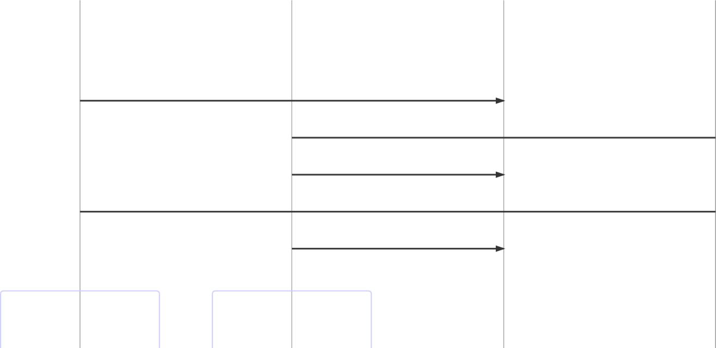
数据库

先更新数据库

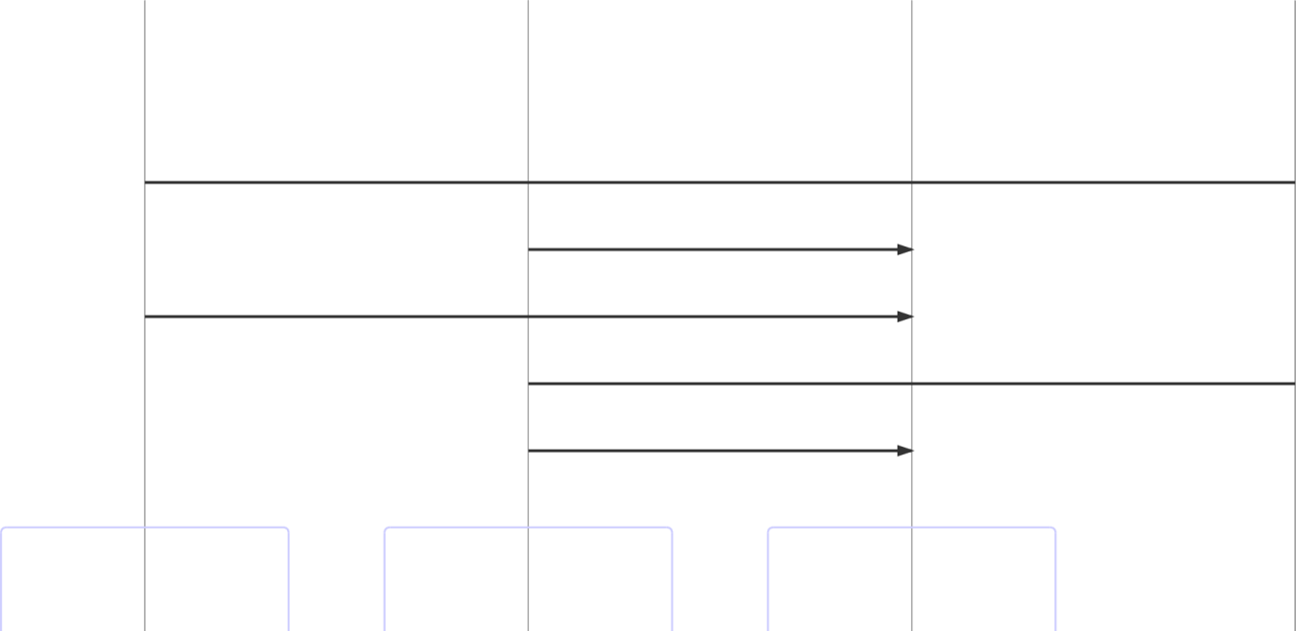

B
缓存
数据库

A
1) 将新数据存入库(x=2)
2) 查询缓存(x=1) ！！！
3) 清空缓存
4) 查询数据库(x=2)
5) 后续查询可以得到新值(x=2)

B

A
缓存

数据库

补充一种情况，假设查询线程 A 查询数据时恰好缓存数据由于时间到期失效，或是第一次查询

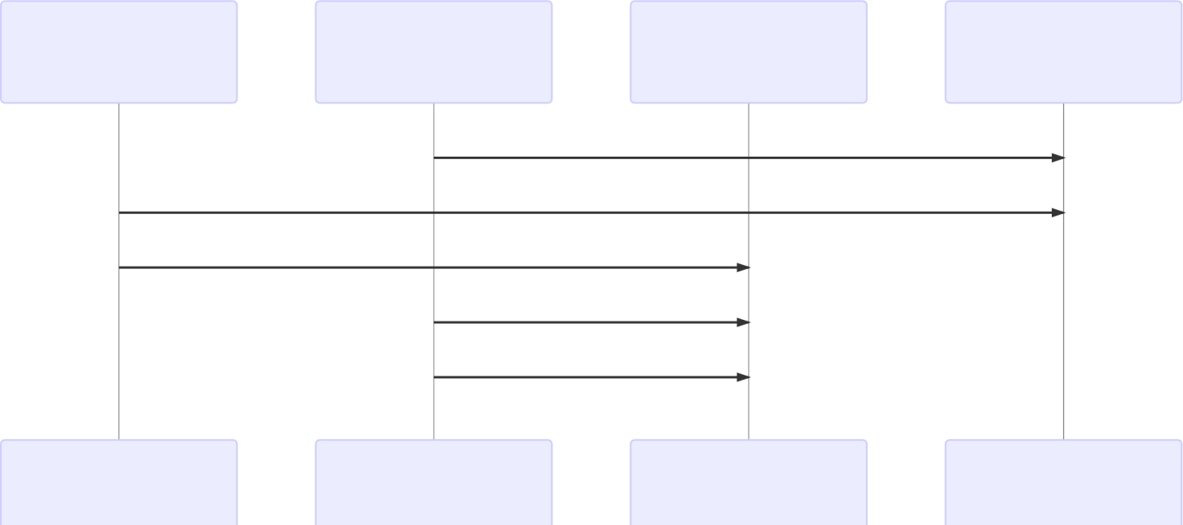
B A 缓存 数据库

1) 缓存没有 ，查询数据库 (x=1)
2) 将新数据存入库 (x=2)
3) 清空缓存
4) 将查询结果放入缓存 (x=1)
5) 后续查询将一直是旧值 (x=1) ！！！
B A 缓存 数据库

这种情况的出现几率非常小，见 facebook 论文

2. 读写锁实现一致性缓存
使用读写锁实现一个简单的按需加载缓存
class GenericCachedDao<T> {
// HashMap 作为缓存非线程安全 , 需要保护
HashMap<SqlPair, T> map = new HashMap<>();

ReentrantReadWriteLock lock = new ReentrantReadWriteLock(); GenericDao genericDao = new GenericDao();

public int update(String sql, Object... params) {
SqlPair key = new SqlPair(sql, params);
// 加写锁 , 防止其它线程对缓存读取和更改

lock.writeLock().lock();
try {
int rows = genericDao.update(sql, params);
map.clear();
return rows; } finally {
lock.writeLock().unlock(); }
}

public T queryOne(Class<T> beanClass, String sql, Object... params) { SqlPair key = new SqlPair(sql, params);
// 加读锁 , 防止其它线程对缓存更改
lock.readLock().lock();
try {
T value = map.get(key);
if (value != null) {
return value;
}
} finally {
lock.readLock().unlock(); }
// 加写锁 , 防止其它线程对缓存读取和更改
lock.writeLock().lock();
try {
// get 方法上面部分是可能多个线程进来的 , 可能已经向缓存填充了数据
// 为防止重复查询数据库 , 再次验证
T value = map.get(key);
if (value == null) {
// 如果没有 , 查询数据库
value = genericDao.queryOne(beanClass, sql, params);
map.put(key, value); }
return value; } finally {
lock.writeLock().unlock(); }
}
// 作为 key 保证其是不可变的
class SqlPair {
private String sql;
private Object[] params;

public SqlPair(String sql, Object[] params) { this.sql = sql;
this.params = params; }

@Override
public boolean equals(Object o) {

if (this == o) {

return true; }
if (o == null || getClass() != o.getClass()) { return false;
}
SqlPair sqlPair = (SqlPair) o;
return sql.equals(sqlPair.sql) &&
Arrays.equals(params, sqlPair.params); }

@Override
public int hashCode() {
int result = Objects.hash(sql);
result = 31 * result + Arrays.hashCode(params); return result;
}
}
}
注意
以上实现体现的是读写锁的应用，保证缓存和数据库的一致性，但有下面的问题没有考虑
适合读多写少，如果写操作比较频繁，以上实现性能低o 没有考虑缓存容量
o 没有考虑缓存过期
o 只适合单机
并发性还是低，目前只会用一把锁
更新方法太过简单粗暴，清空了所有 key（考虑按类型分区或重新设计 key）
乐观锁实现：用 CAS 去更新

分治

1. 案例 . 单词计数

private static <V> void demo(Supplier<Map<String, V>> supplier, BiConsumer<Map<String, V>, List<String>> consumer) {
Map<String, V> counterMap = supplier.get();
List<Thread> ts = new ArrayList<>();
for (int i = 1; i <= 26; i++) { int idx = i;
Thread thread = new Thread(() -> {
List<String> words = readFromFile(idx);
consumer.accept(counterMap, words); });
ts.add(thread); }

ts.forEach(t -> t.start());
ts.forEach(t -> {
try {

t.join();
} catch (InterruptedException e) {
e.printStackTrace();
}
});

System.out.println(counterMap); }

public static List<String> readFromFile(int i) { ArrayList<String> words = new ArrayList<>();
try (BufferedReader in = new BufferedReader(new InputStreamReader(new FileInputStream("tmp/" + i + ".txt")))) {
while (true) {
String word = in.readLine();
if (word == null) {
break;
}
words.add(word); }
return words;
} catch (IOException e) {
throw new RuntimeException(e); }
}
解法1 ：
demo(
() -> new ConcurrentHashMap<String, LongAdder>(),
(map, words) -> {
for (String word : words) {
map.computeIfAbsent(word, (key) -> new LongAdder()).increment(); }
}
);
解法2 ：
Map<String, Integer> collect = IntStream.range(1, 27).parallel()
.mapToObj(idx -> readFromFile(idx))
.flatMap(list -> list.stream())
.collect(Collectors.groupingBy(Function.identity(), Collectors.summingInt(w -> 1)));

2. 案例 . 求和
class AddTask3 extends RecursiveTask<Integer> { int begin;
int end;

public AddTask3(int begin, int end) { this.begin = begin;
this.end = end; }

@Override
public String toString() {
return "{" + begin + "," + end + '}'; }

@Override
protected Integer compute() {
// 5, 5
if (begin == end) {
log.debug("join() {}", begin);
return begin; }
// 4, 5
if (end - begin == 1) {
log.debug("join() {} + {} = {}", begin, end, end + begin); return end + begin;
}

// 1 5
int mid = (end + begin) / 2; // 3

AddTask3 t1 = new AddTask3(begin, mid); // 1,3
t1.fork();
AddTask3 t2 = new AddTask3(mid + 1, end); // 4,5
t2.fork();
log.debug("fork() {} + {} = ?", t1, t2);

int result = t1.join() + t2.join();
log.debug("join() {} + {} = {}", t1, t2, result);
return result; }
}
然后提交给 ForkJoinPool 来执行
public static void main(String[] args) {
ForkJoinPool pool = new ForkJoinPool(4);
System.out.println(pool.invoke(new AddTask3(1, 10))); }
结果

[ForkJoinPool-1-worker-0] - join() 1 + 2 = 3
[ForkJoinPool-1-worker-3] - join() 4 + 5 = 9
[ForkJoinPool-1-worker-0] - join() 3
[ForkJoinPool-1-worker-1] - fork() {1,3} + {4,5} = ?
[ForkJoinPool-1-worker-2] - fork() {1,2} + {3,3} = ?
[ForkJoinPool-1-worker-2] - join() {1,2} + {3,3} = 6
[ForkJoinPool-1-worker-1] - join() {1,3} + {4,5} = 15 15

统筹

案例 - 烧水泡茶

解法1 ：join
Thread t1 = new Thread(() -> {
log.debug("洗水壶 ");
sleep(1);
log.debug("烧开水 ");
sleep(15); }, "老王 ");
Thread t2 = new Thread(() -> {
log.debug("洗茶壶 ");
sleep(1);
log.debug("洗茶杯 ");
sleep(2);
log.debug("拿茶叶 ");
sleep(1);
try {
t1.join();
} catch (InterruptedException e) {
e.printStackTrace();
}
log.debug("泡茶 "); }, "小王 ");
t1.start();
t2.start();
输出
19:19:37.547 [小王] c.TestMakeTea - 洗茶壶
19:19:37.547 [老王] c.TestMakeTea - 洗水壶
19:19:38.552 [小王] c.TestMakeTea - 洗茶杯
19:19:38.552 [老王] c.TestMakeTea - 烧开水
19:19:40.553 [小王] c.TestMakeTea - 拿茶叶
19:19:53.553 [小王] c.TestMakeTea - 泡茶
解法1 的缺陷：

上面模拟的是小王等老王的水烧开了，小王泡茶，如果反过来要实现老王等小王的茶叶拿来了，老王泡茶呢？代码最好能适应两种情况
上面的两个线程其实是各执行各的，如果要模拟老王把水壶交给小王泡茶，或模拟小王把茶叶交给老王泡茶呢

解法2 ：wait/notify

class S2 {
static String kettle = "冷水 ";
static String tea = null;
static final Object lock = new Object();
static boolean maked = false;

public static void makeTea() {
new Thread(() -> {
log.debug("洗水壶 ");
sleep(1);
log.debug("烧开水 ");
sleep(5);
synchronized (lock) { kettle = "开水 ";
lock.notifyAll();
while (tea == null) { try {
lock.wait();
} catch (InterruptedException e) {
e.printStackTrace();
}
}
if (!maked) {
log.debug("拿({})泡({})", kettle, tea); maked = true;
}
}
}, "老王 ").start();
new Thread(() -> {
log.debug("洗茶壶 ");
sleep(1);
log.debug("洗茶杯 ");
sleep(2);
log.debug("拿茶叶 ");
sleep(1);
synchronized (lock) {
tea = "花茶 ";
lock.notifyAll();
while (kettle.equals("冷水 ")) { try {
lock.wait();
} catch (InterruptedException e) {
e.printStackTrace();

}
}
if (!maked) {
log.debug("拿({})泡({})", kettle, tea); maked = true;
}
}
}, "小王 ").start();
}
}
输出

20:04:48.179 | c.S2 [小王] - 洗茶壶
20:04:48.179 | c.S2 [老王] - 洗水壶
20:04:49.185 | c.S2 [老王] - 烧开水
20:04:49.185 | c.S2 [小王] - 洗茶杯
20:04:51.185 | c.S2 [小王] - 拿茶叶
20:04:54.185 | c.S2 [老王] - 拿 (开水)泡 (花茶)

解法2 解决了解法1 的问题，不过老王和小王需要相互等待，不如他们只负责各自的任务，泡茶交给第三人来做

解法3 ：第三者协调
class S3 {
static String kettle = "冷水 ";
static String tea = null;
static final Object lock = new Object();

public static void makeTea() { new Thread(() -> {
log.debug("洗水壶 ");
sleep(1);
log.debug("烧开水 ");
sleep(5);
synchronized (lock) { kettle = "开水 ";
lock.notifyAll();
}
}, "老王 ").start();
new Thread(() -> {
log.debug("洗茶壶 ");
sleep(1);
log.debug("洗茶杯 ");
sleep(2);
log.debug("拿茶叶 ");
sleep(1);
synchronized (lock) {
tea = "花茶 ";
lock.notifyAll(); }

}, "小王 ").start();
new Thread(() -> {
synchronized (lock) {
while (kettle.equals("冷水 ") || tea == null) { try {
lock.wait();
} catch (InterruptedException e) {
e.printStackTrace();
}
}
log.debug("拿({})泡({})", kettle, tea);
}
}, "王夫人 ").start();
}
}
输出

20:13:18.202 | c.S3 [小王] - 洗茶壶
20:13:18.202 | c.S3 [老王] - 洗水壶
20:13:19.206 | c.S3 [小王] - 洗茶杯
20:13:19.206 | c.S3 [老王] - 烧开水
20:13:21.206 | c.S3 [小王] - 拿茶叶
20:13:24.207 | c.S3 [王夫人] - 拿 (开水)泡 (花茶)

定时

1. 定期执行
如何让每周四 18:00:00 定时执行任务？
// 获得当前时间
LocalDateTime now = LocalDateTime.now(); // 获取本周四 18:00:00.000
LocalDateTime thursday =
now.with(DayOfWeek.THURSDAY).withHour(18).withMinute(0).withSecond(0).withNano(0); // 如果当前时间已经超过 本周四 18:00:00.000 ， 那么找下周四 18:00:00.000
if(now.compareTo(thursday) >= 0) {
thursday = thursday.plusWeeks(1);
}
// 计算时间差，即延时执行时间
long initialDelay = Duration.between(now, thursday).toMillis(); // 计算间隔时间，即 1 周的毫秒值
long oneWeek = 7 * 24 * 3600 * 1000;

ScheduledExecutorService executor = Executors.newScheduledThreadPool(2);

System.out.println("开始时间： " + new Date());
executor.scheduleAtFixedRate(() -> {
System.out.println("执行时间： " + new Date());
}, initialDelay, oneWeek, TimeUnit.MILLISECONDS);

