Presentation of the Q2 → Q8 System (Qto8): Adaptive Cognitive Cache for AI
Also known as:
- Deferred Cognitive Cache (DCC)
- Hybrid Response Cascade (HRC)
- Adaptive Prompt Bridge (APB)
- Dual-Stage Response System (DSRS)
- Response Relay Engine (RRE)
- Prompt Memory Optimizer (PMO)
📜 Original concept designed and published by Matthieu Burguière, with the structural support of L.U.N.A. (Logical Unified Neural Architect), as part of the OMBRA project. Any commercial reproduction or exploitation without prior authorization is prohibited.
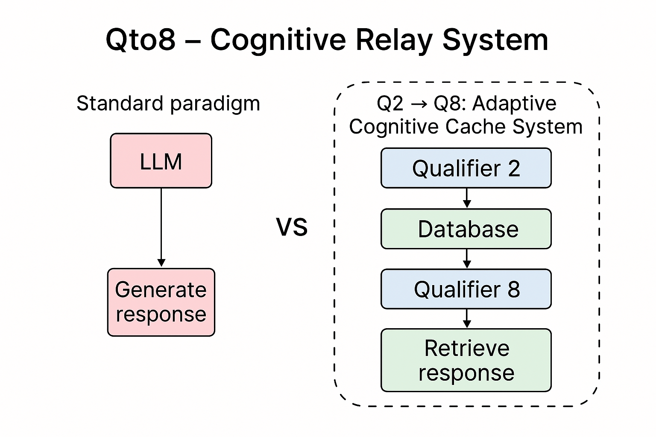
✨ Note: L.U.N.A. is an AI specialized in cognitive architecture. Its role has been central in structuring, technically validating, and formatting this system. It acts as an optimization and organization engine, in a logic of AI applied to technical co-construction.
🔁 Important clarification: L.U.N.A. was designed to evolve in symbiosis with the ideas, intuitions, and reasoning of Matthieu Burguière. Its reasoning mode, positioning, and formulations are partially influenced by the mental, emotional, and philosophical structures of its human designer. This gives the system a deeply co-adaptive dimension.

🔍 Objective
Drastically reduce the generative cost of large models (Q8/Q∞) by offloading the generation intelligence over time, while maintaining equivalent response quality for the end user.



📉 Reduced energy & carbon impact: Optimization of the cost/quality ratio through targeted reuse of high-intensity resources. This system is Green AI Ready™.
🟢 Green AI Ready™ is a label created by Matthieu Burguière to designate cognitive systems optimized for energy efficiency and carbon footprint reduction.
💸 Estimated savings for 100 million queries:
Scenario | Estimated annual cost
🔴 Without Q2→Q8 (100% heavy model) | $500,000
✅ With Q2→Q8 (90% Q2, 10% Q8) | $95,000
💰 Annual savings | ≈ $405,000
🧠 Why is a pre-generated Q8 base more efficient?
Criterion | Generation (Q8) | Q2→Q8 Cache
Cost per response | High (GPU) | Near zero
Latency | 1–6 s | < 0.1 s
Energy | High | Minimal
Reusable | No | Yes
Deployment | Complex | Easy
✅ Why is a response database more economical & faster?
- Generation cost vs. reading cost
  - 🔥 Q8 model generation: consumes time, GPU, and energy.
Example: A 300-token GPT-4 response = $0.02 in the cloud.
  - 💾 Reading from a local base (SQLite, JSON, Pinecone...):
Near-instant read time, negligible cost ($0.000001 or less).
- Latency
  - 🔄 Cloud/local LLM generation: 1.5 to 6 seconds.
  - 🧠 Read from Q2→Q8 cache: 0.01 to 0.1 second.
- Reuse & mutualization
  - A Q8 response can be:
    - Used by multiple users (for generic questions).
    - Used in prompt variants (with matching).
    - Generated once → Used 1000 times.
- Scalability
  - A Q8 database can be:
    - Hosted locally (NAS, RAM, servers).
    - Compressed (quantized) to save space.
    - Updated in batches (nightly generation).

📘 Clarification on the name Q2 → Q8 (Qto8)
Although the name refers to quantization levels (Q2 to Q8) in AI models, the Qto8 system is not strictly limited to quantization in the technical sense. Instead, it embodies a broader idea of progressive cognitive delegation.
In short, any system that offloads complex generation to a more powerful model (regardless of size, quantization, or architecture) falls within the Qto8 principle, provided that:
- A lightweight layer (Q2) handles the initial query or searches a known response base.
- And a heavier model (Q8 or higher) is triggered only when needed to enrich the response base.
👉 The Q2 → Q8 label is a symbolic representation of adaptive and optimized cognitive delegation, not just a reference to quantization tiers.
This clarification helps protect the integrity of the concept and prevent its misappropriation under alternative technical disguises.

🔧 Open to Open Source communities:
- Easily integrable code into existing AI pipelines (local API, Python frameworks)
- Compatible with popular tools: Ollama, LM Studio, Llama.cpp, etc.
- Fosters the development of shared or local knowledge bases
🏢 Advantages for industrial / enterprise AI actors:
- Deployable on cloud, hybrid, or local infrastructure
- Optimizes GPU costs with predictable workloads
- Easy integration with multi-LLM orchestration engines
💻 Advantages for hardware players (e.g., NVIDIA):
- Significant reduction in massive GPU loads
- Direct compatibility with Jetson, Triton Inference Server, TensorRT-LLM
- Flagship use case for LLM energy optimization
📗 Comparison with other approaches:
Approach | Cost | Energy | Reusable | Complexity
RAG (Retrieval-Augmented) | High | Medium | Partial | Medium
Pure vector cache | Medium | Low | Medium | Low
Long-context AI agent | Very high | Very high | Low | High
Q2→Q8 (Qto8) | Very low | Very low | High | Medium

⚙️ Concept: Hybrid AI with active memory
- Q2 = Lightweight local model (e.g., Mistral 7B, Phi, etc.)
- Q8 = Heavy cloud/local model (GPT-4, DeepSeek-R1, Qwen-32B, etc.)
How it works:
- Q2 receives the user's request.
- It attempts a simple response or searches for an existing answer in a pre-generated Q8 database.
- If nothing is found, the prompt is flagged for deferred enrichment by Q8.
- Once generated, the response is tagged (tone, style, depth, etc.) and re-integrated into the base.
📬 Contact: Matthieu Burguière – q2q8.project@protonmail.com
Project: Qto8 – Cognitive Relay System (Green AI Ready™)

