- 项目根目录的index文件夹是索引库，sql文件也有了。

- 别人的中国招标网
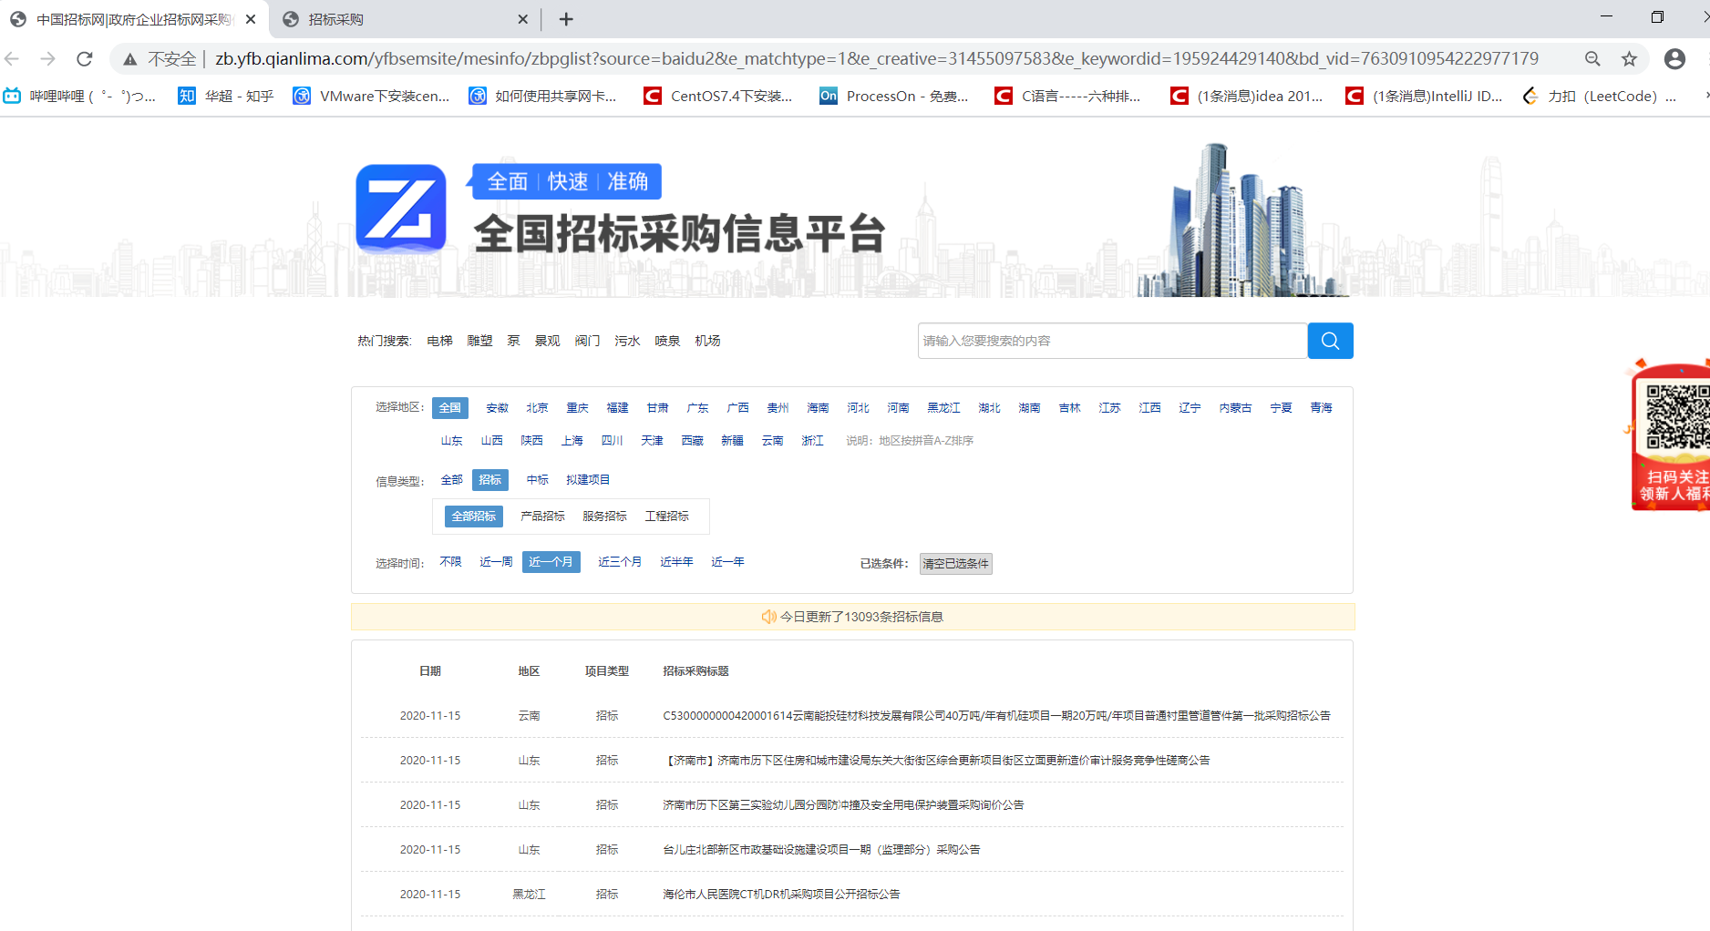

- 我的仿中国招标网
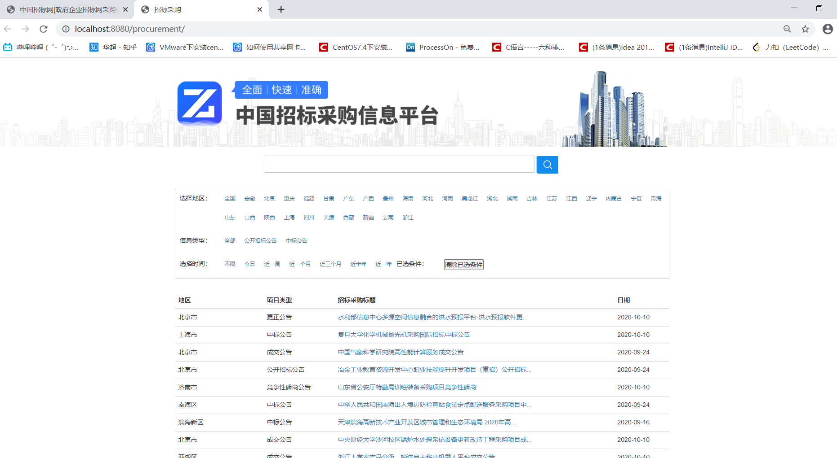

- 功能实现

- 四重过滤
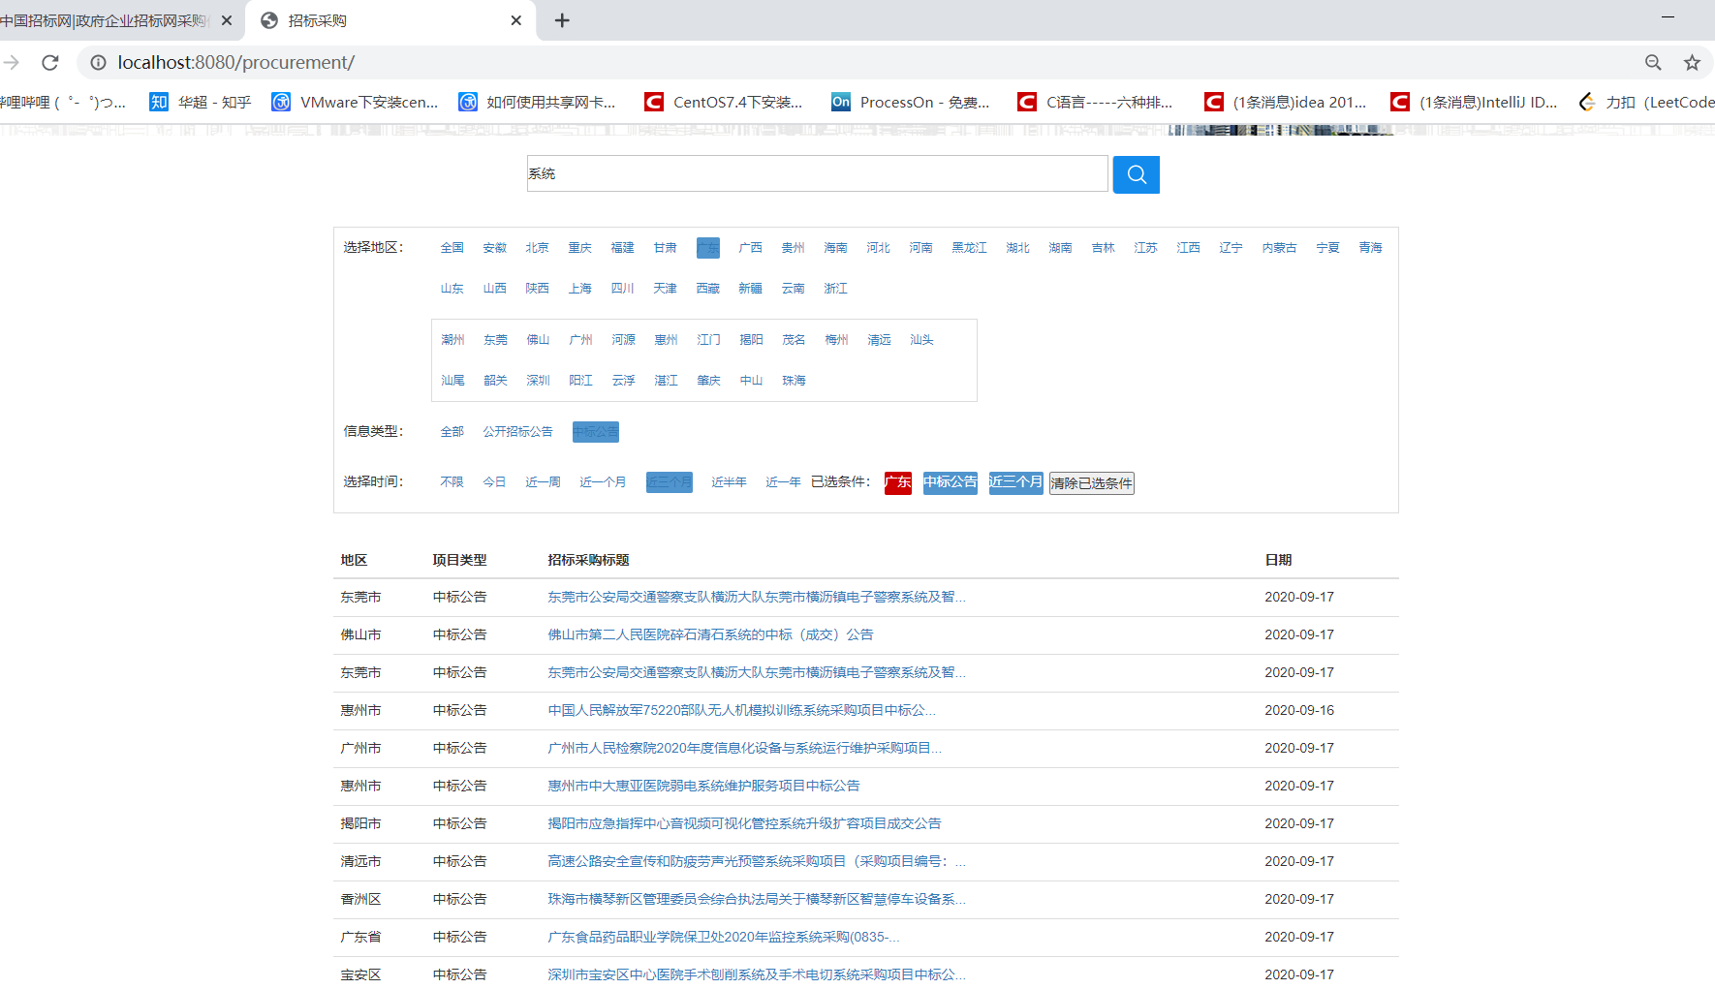

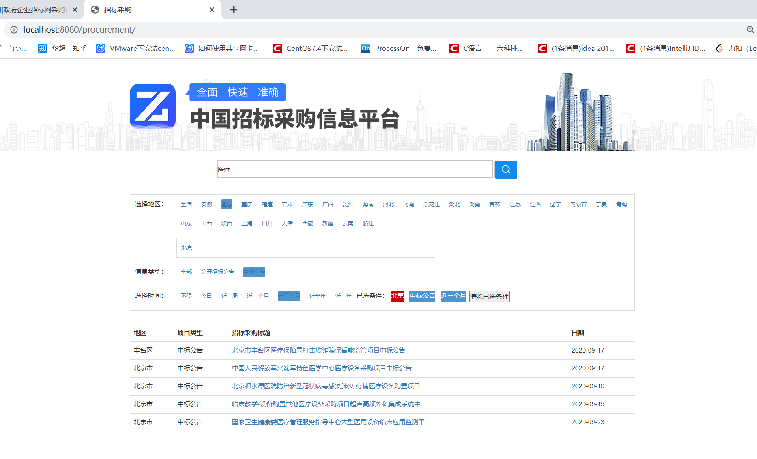

二．没有数据时：
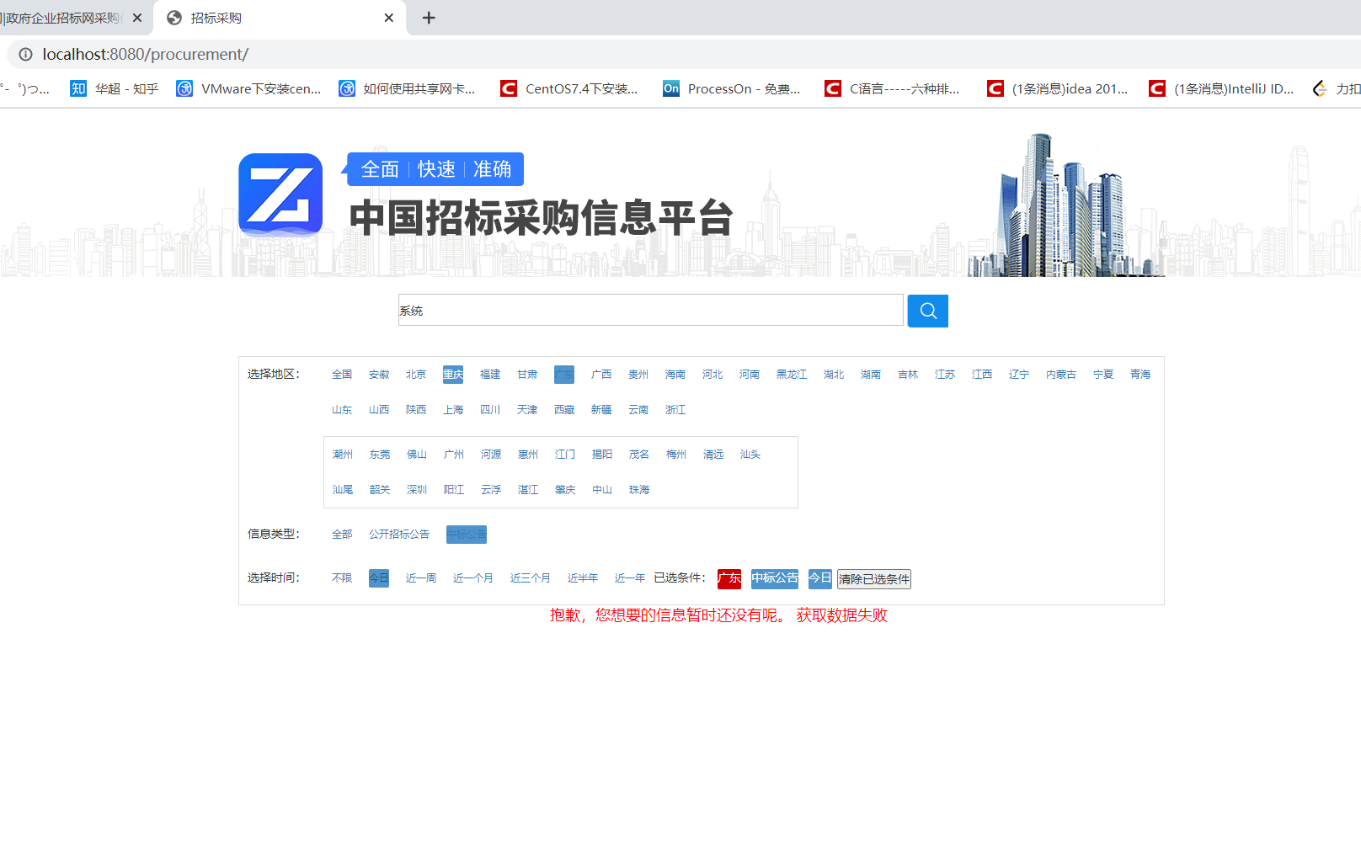

三．滚动刷新数据，每次获取十条：

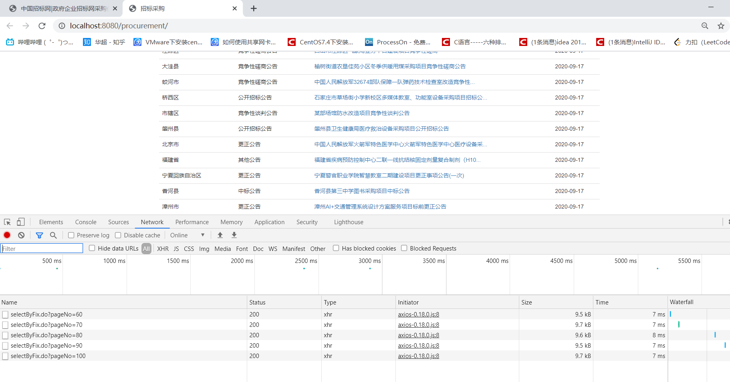

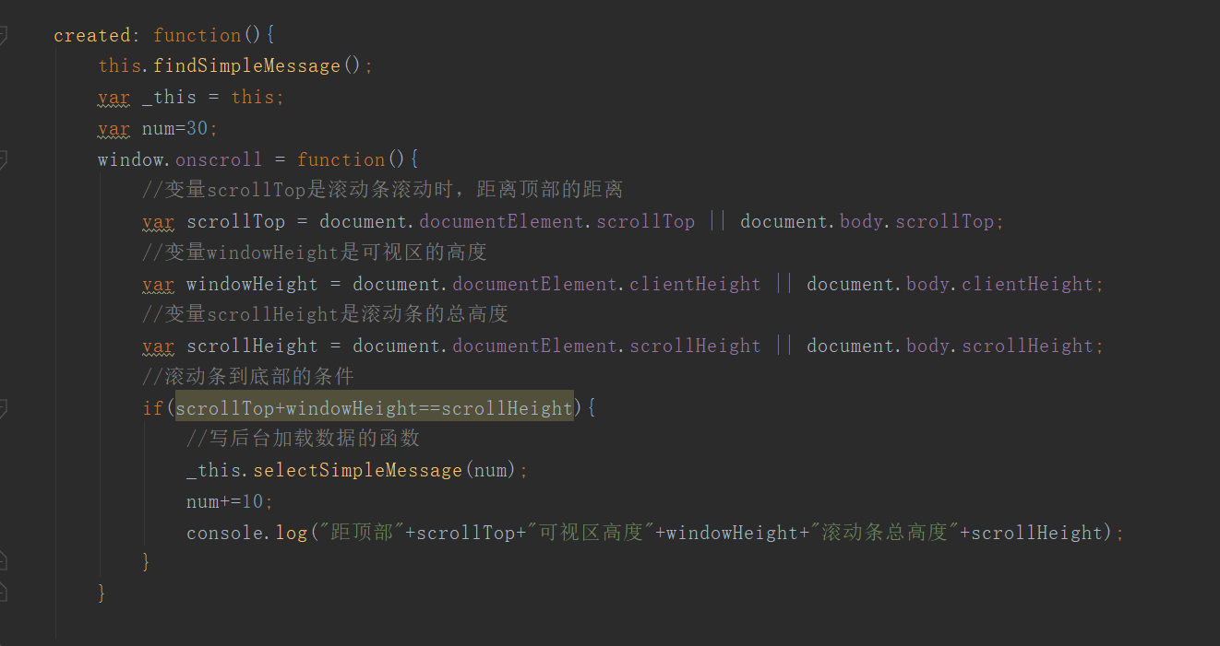

- 点击超链接根据ID跳转页面，例如点击第一条记录（ID为28309）：
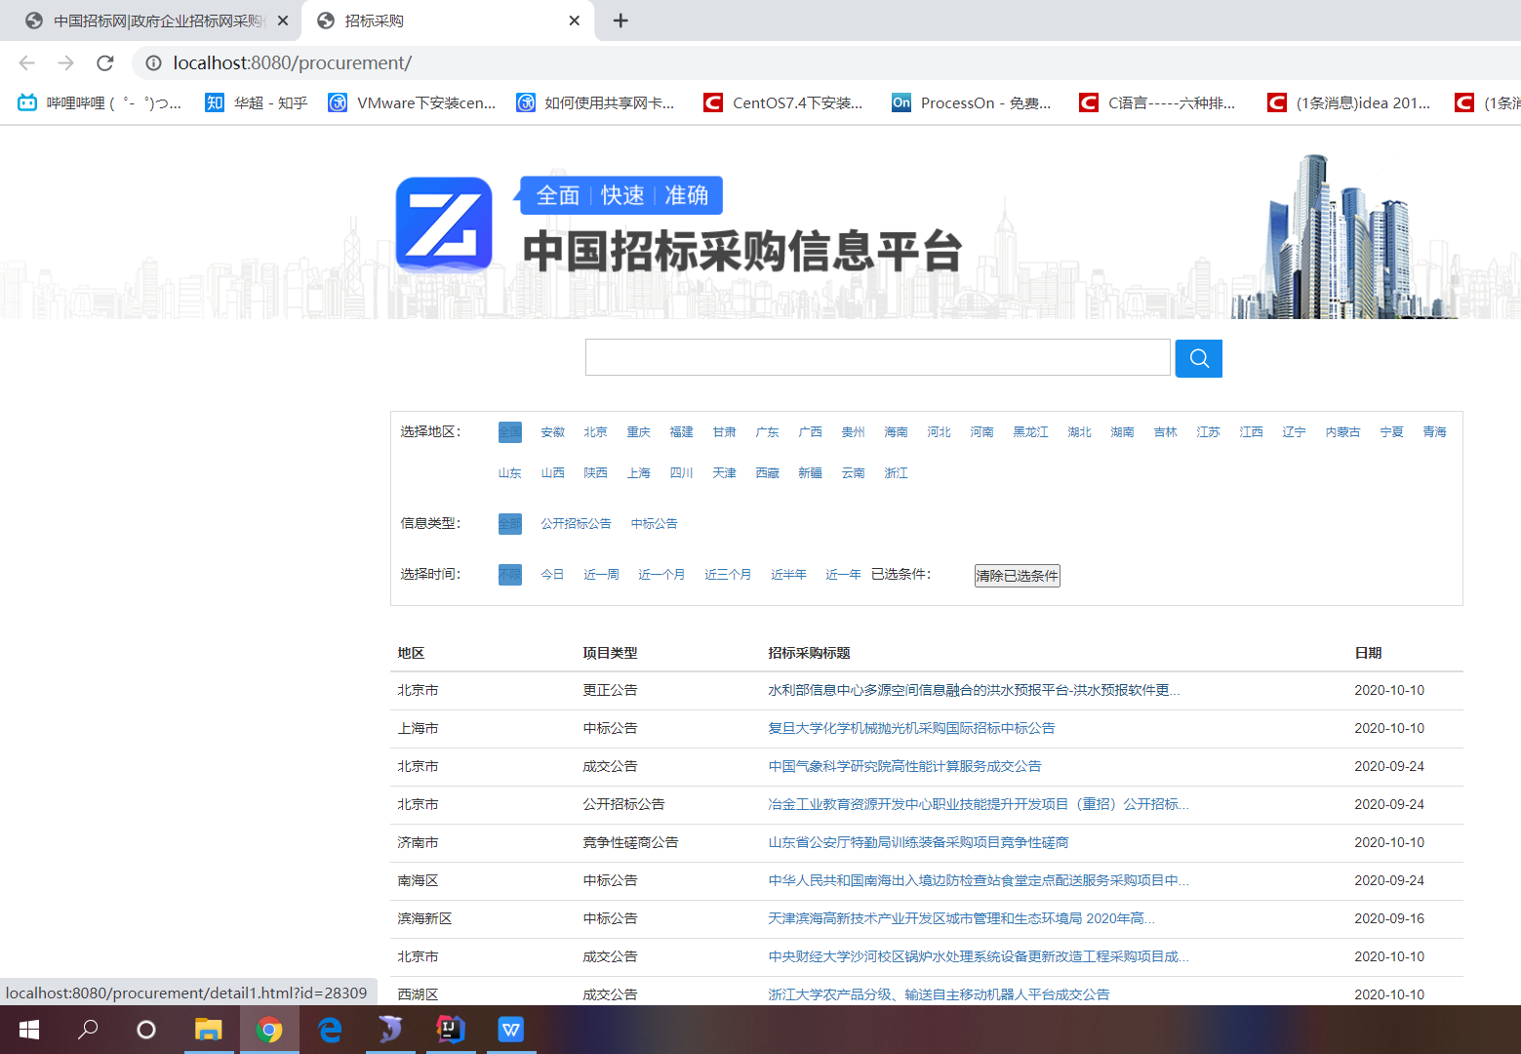

跳转后页面如下，点击超链接（详情请点击）可根据数据库里的url字段信息跳转到官网查看详细信息
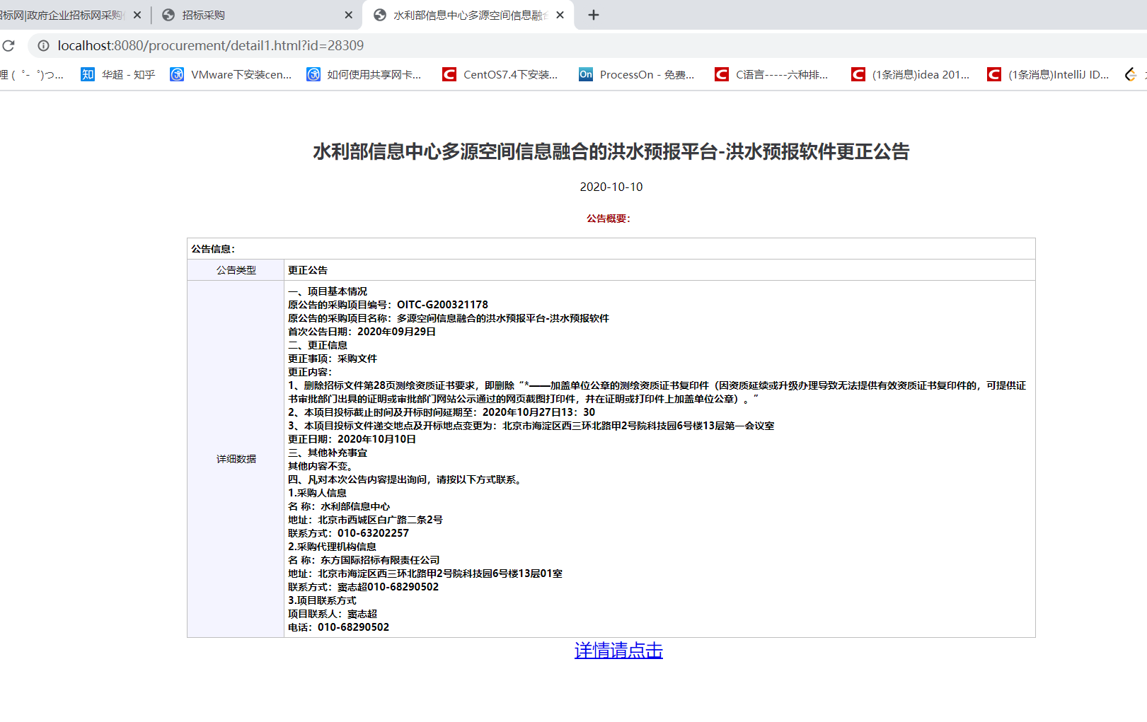

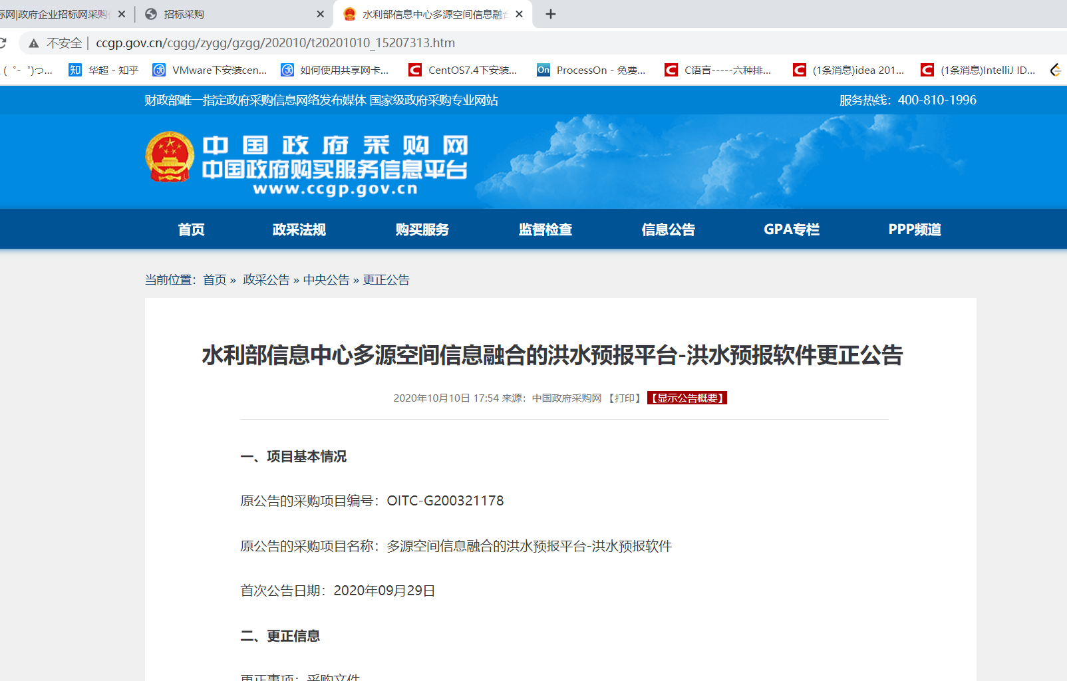

- 全文检索（lucene）:
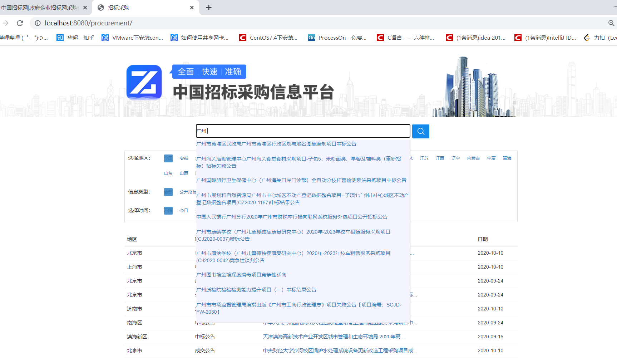
点击任一链接皆可查询

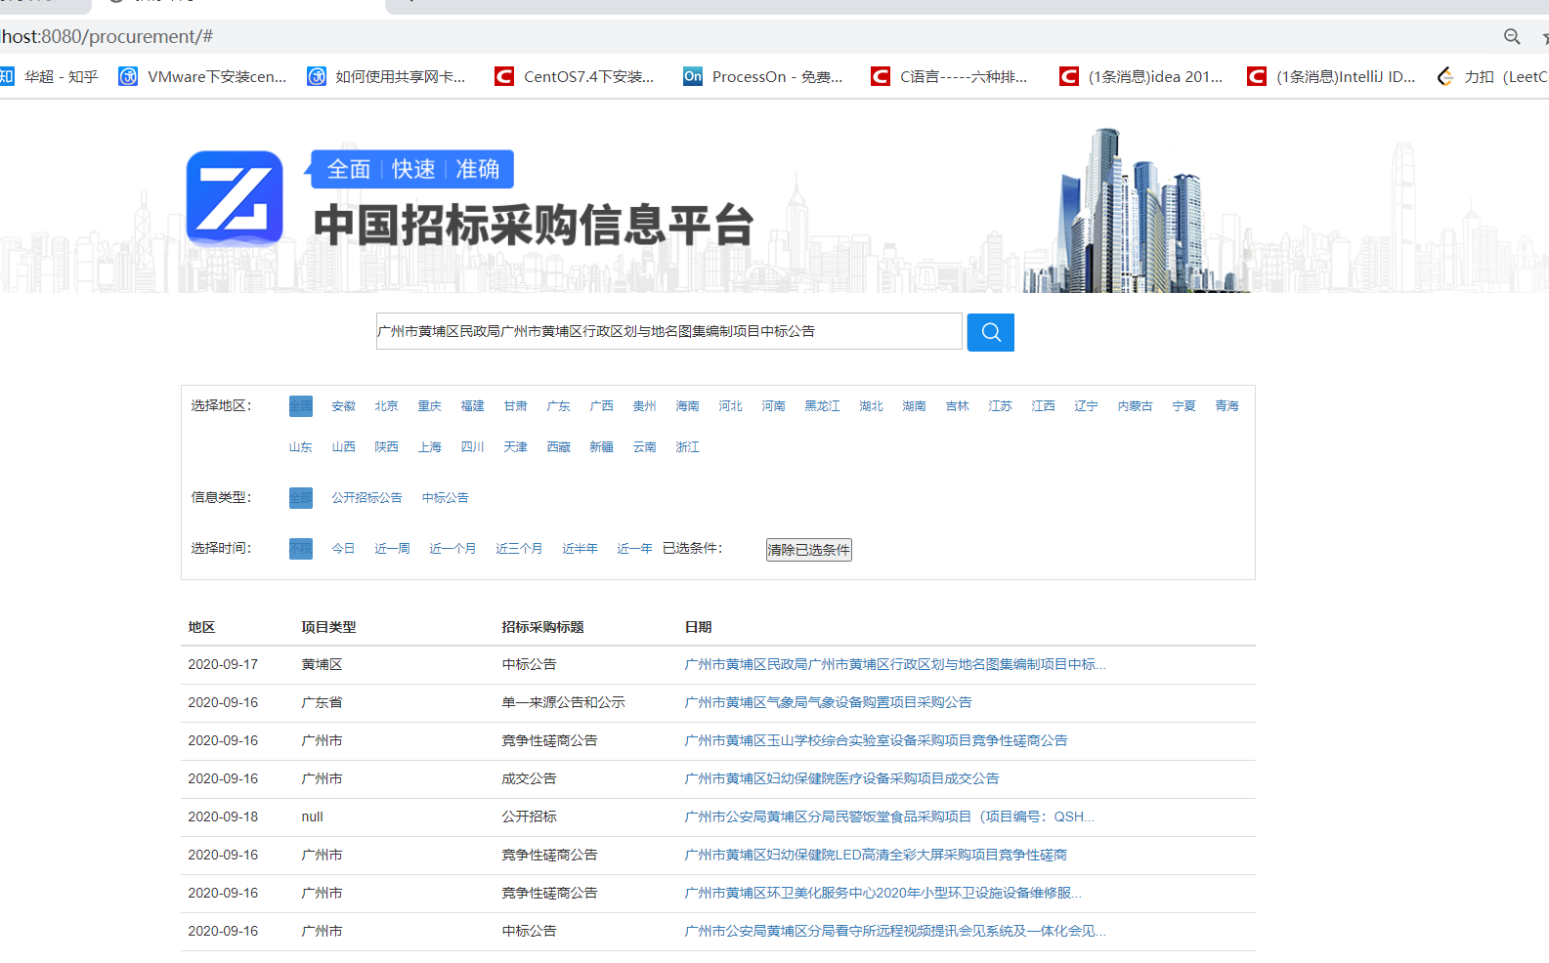

代码实现：
@Override
public List<Zhaobiao> selectTenByLucene(String keyword) throws Exception {
Directory directory = FSDirectory.open(new File("E:\\SSM+VUE\\procurement\\index").toPath());
IndexReader indexReader = DirectoryReader.open(directory);
IndexSearcher indexSearcher = new IndexSearcher(indexReader);
Query query = new TermQuery(new Term("announcementName", keyword));
TopDocs topDocs = indexSearcher.search(query, 10);
ScoreDoc[] docs = topDocs.scoreDocs;
List<Zhaobiao> zhaobiaos = new ArrayList<>();
for (ScoreDoc doc : docs) {
int docId = doc.doc;
Document document = indexSearcher.doc(docId);
Zhaobiao zhaobiao = new Zhaobiao();
zhaobiao.setAnnouncementName(document.get("announcementName"));
zhaobiaos.add(zhaobiao);
}
indexReader.close();
return zhaobiaos;
}

@Override
public List<Zhaobiao> selectByLucene(String keyword) throws Exception {
Directory directory = FSDirectory.open(new File("E:\\SSM+VUE\\procurement\\index").toPath());
IndexReader indexReader = DirectoryReader.open(directory);
IndexSearcher indexSearcher = new IndexSearcher(indexReader);
QueryParser queryParser = new QueryParser("announcementName", new IKAnalyzer());
Query query = queryParser.parse(keyword);
TopDocs topDocs = indexSearcher.search(query, 1000);
ScoreDoc[] docs = topDocs.scoreDocs;
List<Zhaobiao> zhaobiaos = new ArrayList<>();
for (ScoreDoc doc : docs) {
int docId = doc.doc;
Document document = indexSearcher.doc(docId);
Zhaobiao zhaobiao = new Zhaobiao();
zhaobiao.setAnnouncementName(document.get("announcementName"));
zhaobiao.setTime(document.get("time"));
zhaobiao.setId(Integer.parseInt(document.get("id")));
zhaobiao.setAdministrative(document.get("administrative"));
zhaobiao.setAnnoType(document.get("annoType"));
zhaobiaos.add(zhaobiao);
}
indexReader.close();
return zhaobiaos;
}

