Bug ID | Description | Severity | Test Case ID | Build Version | Environment
Bug 001 | Account is registered but 'Thank you for registering' email is not sent to the registered email address as a confirmation for registering the account | Minor | TC_RF_002
Bug 002 | Account is created with invalid phone number, and a warning message is not displayed | Minor | TC_RF_011
Bug 003 | Red colour * symbol is not displayed on the Privacy Policy field | Minor | TC_RF_014
Bug 004 | No warning message is displayed for not following password complexity and account was created | Major | TC_RF_016
Bug 005 | The leading and trailing spaces on the First name, Last name and Telephone are not trimmed and account was created | Minor | TC_RF_017
Bug 006 | User is not automatically getting logged out of the Application after 30 minutes of inactivity | Major | TC_LF_017
Bug 007 | User did not receive an email to the registered email address regarding resetting of the password | Major | TC_FP_001
Bug 008 | Proper warning message was not  displayed, rather success message was displayed | Major | TC_SC_010
Defects Report – TutorialsNinja

Bug ID | Bug 001

Brief Summary | Account is registered but 'Thank you for registering' email is not sent to the registered email address as a confirmation for registering the account.

Severity | Minor
Priority | Low

Steps to Reproduce

1. Open the Application URL

2. Click on 'My Account' Drop menu

3. Click on 'Register' option

4. Enter new Account Details into the Mandatory Fields (First Name, Last Name, E-Mail, Telephone, Password, Password Confirm and select Privacy Policy checkbox)

5. Click on 'Continue' button

6. Check the email address used for registering the account

7. Click on the Login page link from the Email body

Expected Result:

A confirmation email for registering the account should be sent to the registered email address.

Actual Result:

Account is registered but 'Thank you for registering' email is not sent to the registered email address as a confirmation for registering the account.

Screenshot

Not Applicable

Top
Bug ID | Bug 002

Brief Summary | Account is created with invalid phone number, and a warning message is not displayed.

Severity | Minor
Priority | Low

Steps to Reproduce

1. Open the Application URL
2. Click on 'My Account' Drop menu
3. Click on 'Register' option
4. Enter new Account Details into all the Fields (First Name, Last Name, E-Mail, Password,
Password Confirm, Newsletter and select Privacy Policy checkbox)
5. Enter invalid phone number into the Telephone Field. Test data = abcd
6. Click on 'Continue' button

Expected Result:

Account should not be created with invalid phone number, instead a proper warning message should be displayed.

Actual Result:

Account is created with invalid phone number, and a warning message is not displayed.

Screenshot

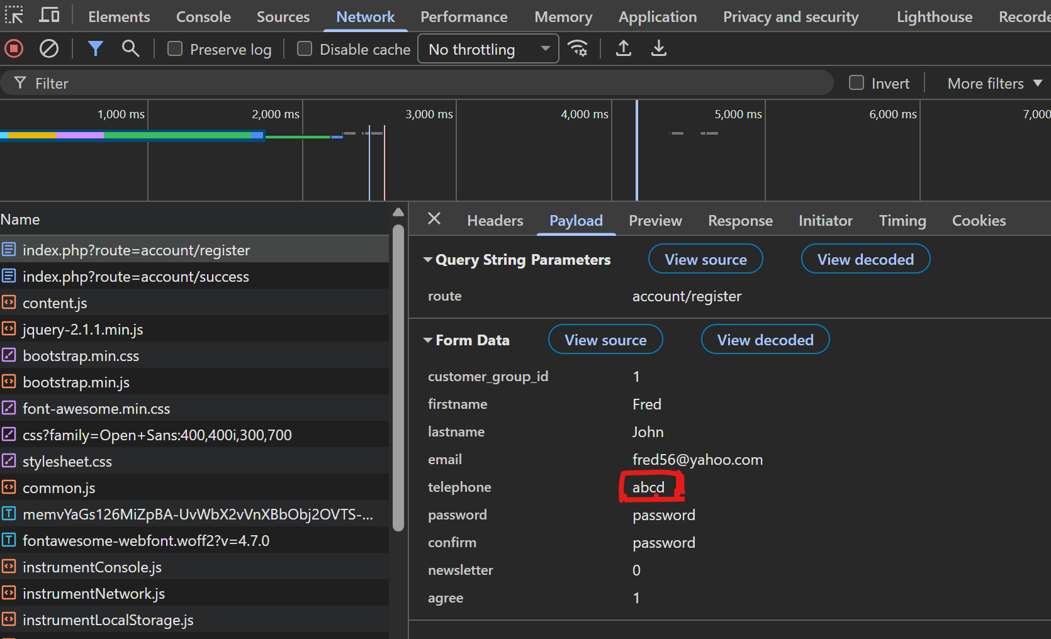

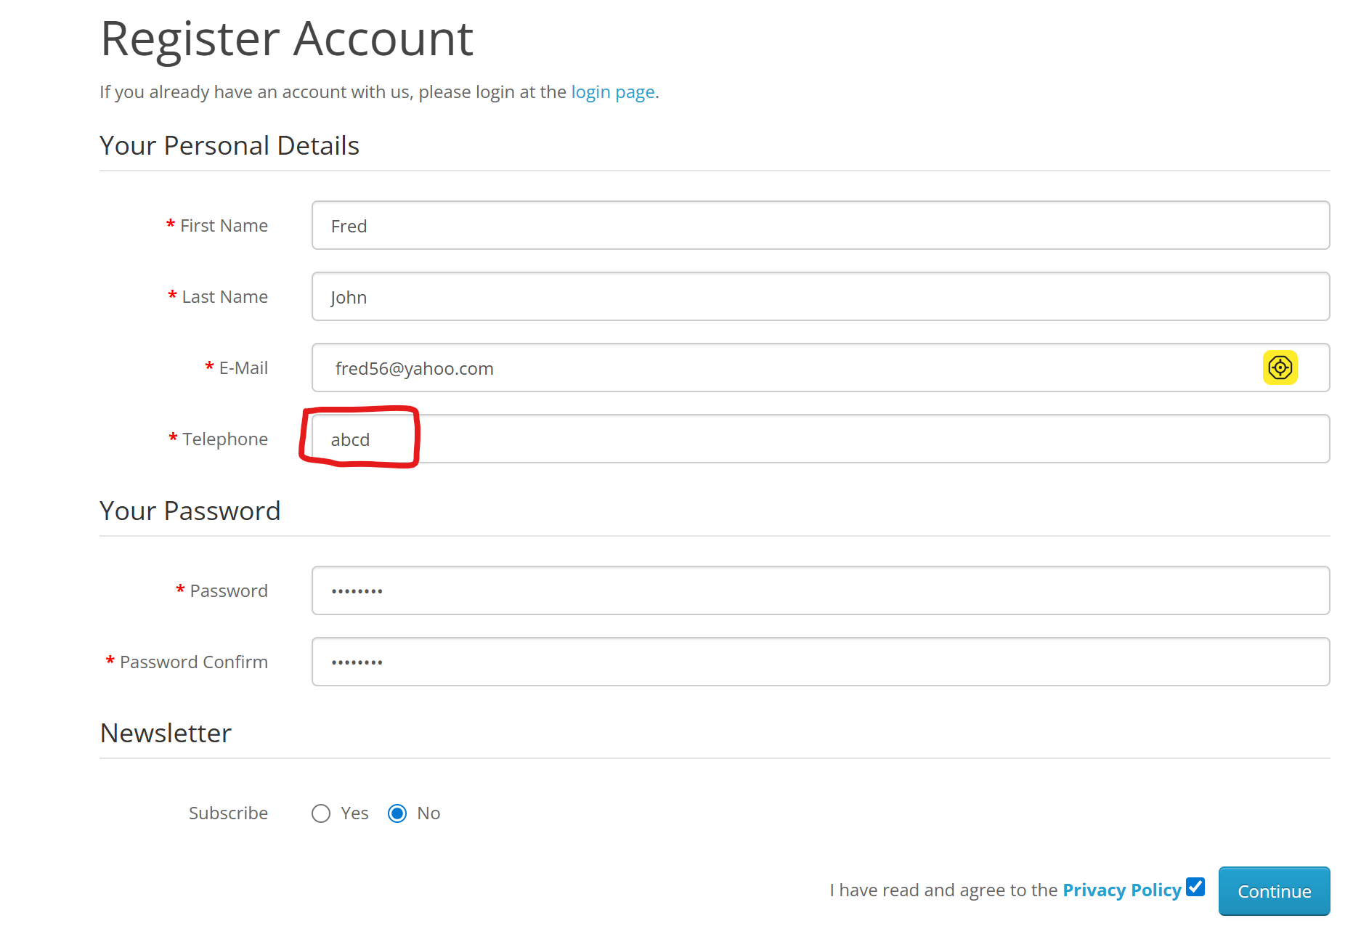

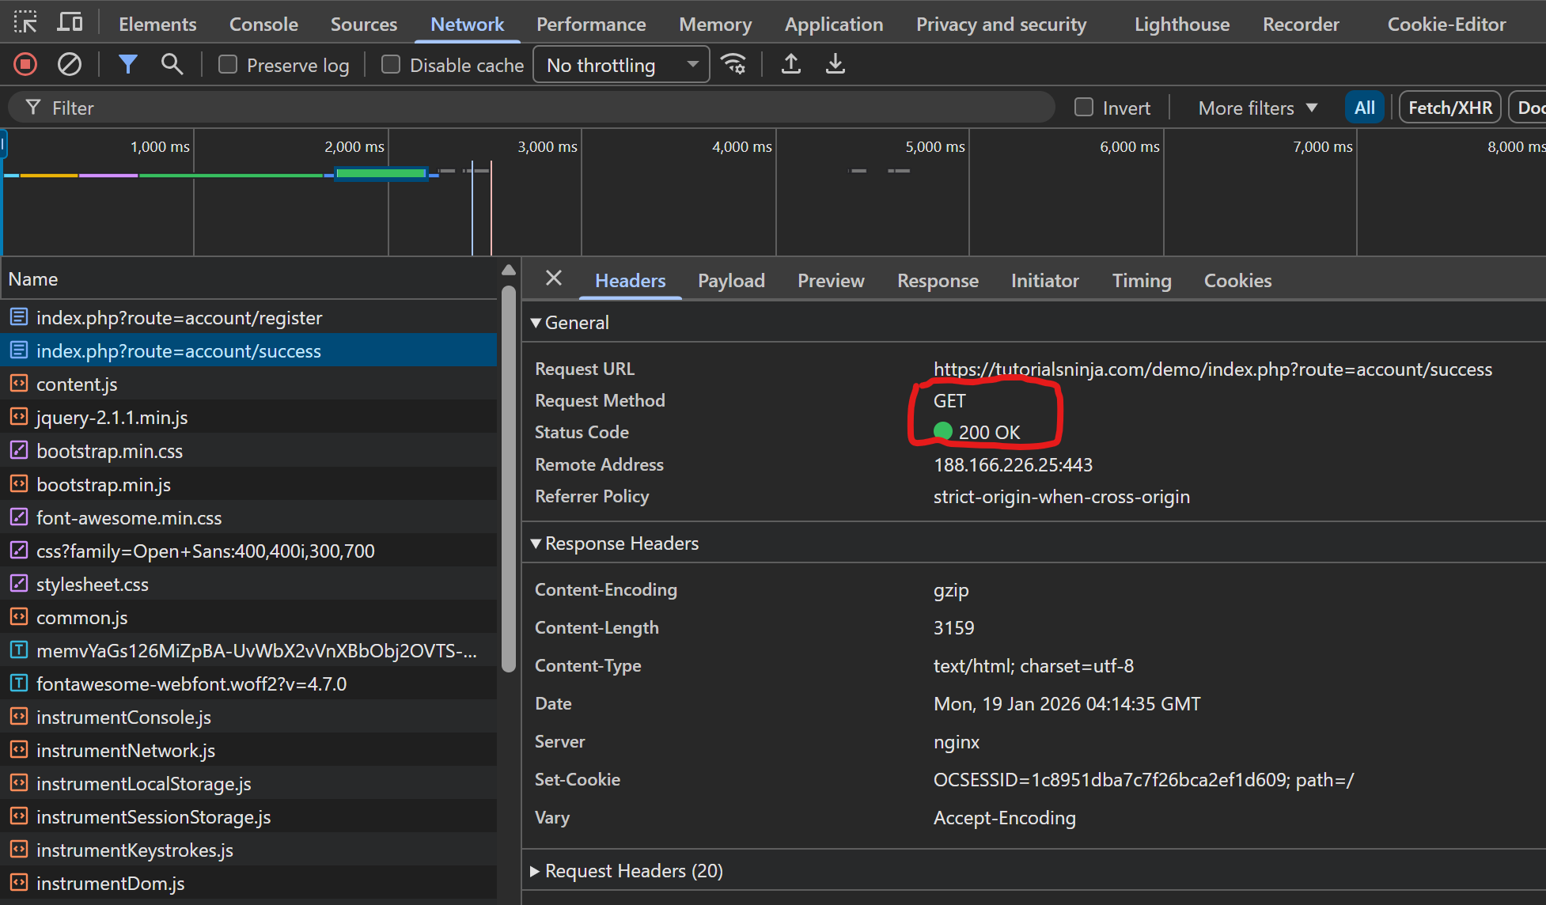
Top

Bug ID | Bug 003

Brief Summary | Red colour * symbol is not displayed on the Privacy Policy field

Severity | Minor
Priority | Low

Steps to Reproduce

1. Open the Application URL
2. Click on 'My Account' Drop menu
3. Click on 'Register' option
4. Check the Fields - First Name, Last Name, E-Mail, Telephone, Password, Password Confirm and Privacy Policy

Expected Result:

All the specified Fields in the Steps should be marked with red colour * symbol
Actual Result:

Red colour * symbol is not displayed on the Privacy Policy field

Screenshot

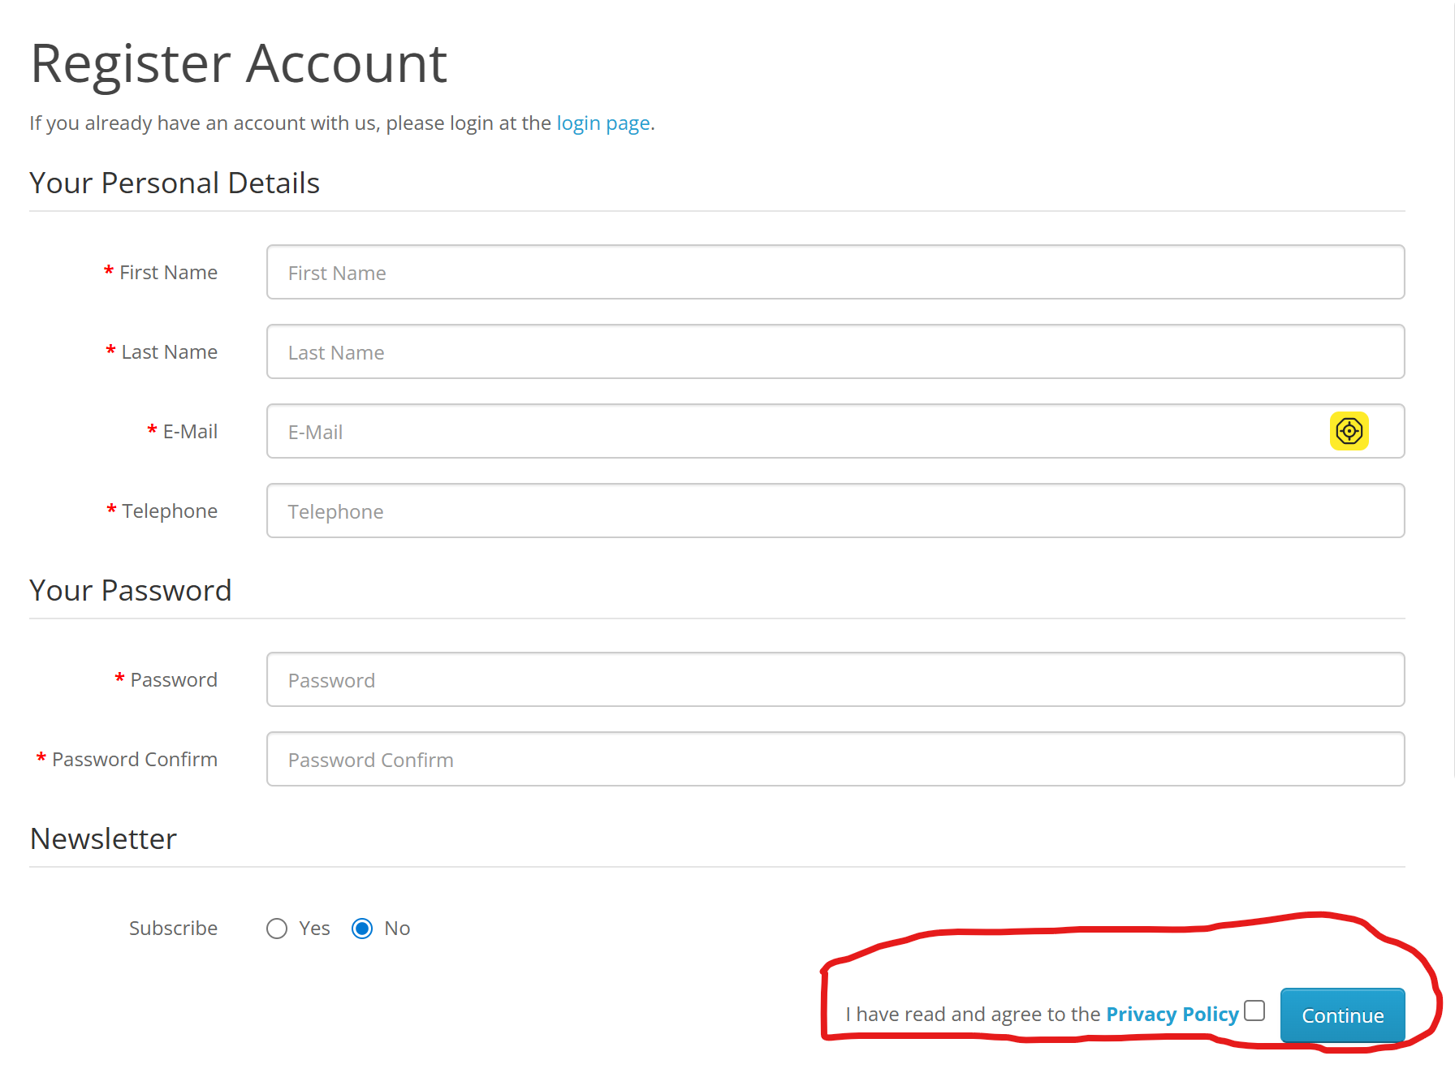
Top

Bug ID | Bug 004

Brief Summary | No warning message is displayed for not following password complexity and account was created

Severity | Major
Priority | High

Steps to Reproduce

1. Open the Application URL
2. Click on 'My Account' Drop menu
3. Click on 'Register' option
4. Enter new Account Details into all the Fields (First Name, Last Name, E-Mail, Telephone, Newsletter and select Privacy Policy checkbox)
5. Check entering simple passwords (Not following Password Complexity Standards i.e. Size of password as 8, password should contain at least one number, symbol, lowercase letter and uppercase letters) - Test Data = 123456
6. Click on 'Continue' button

Expected Result:

Warning message informing the User to enter a password matching the complexity standards should be displayed

Actual Result:

No warning message is displayed for not following password complexity and account was created
Screenshot

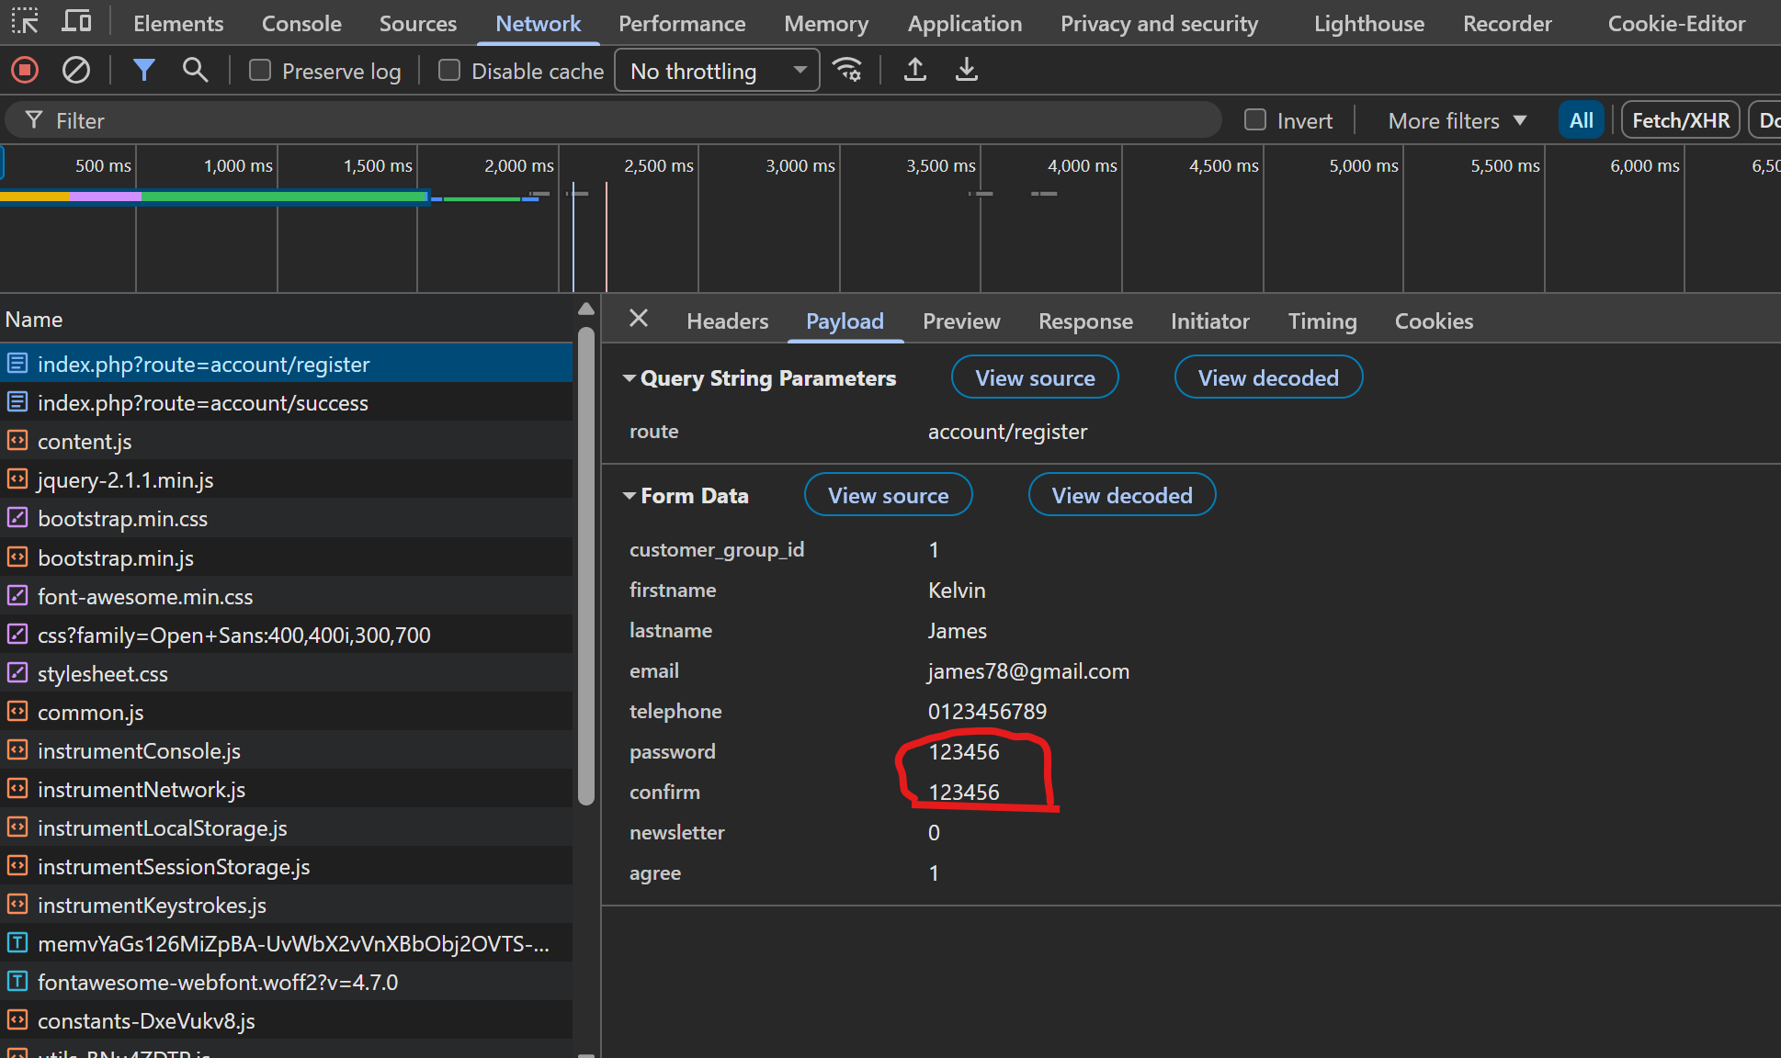

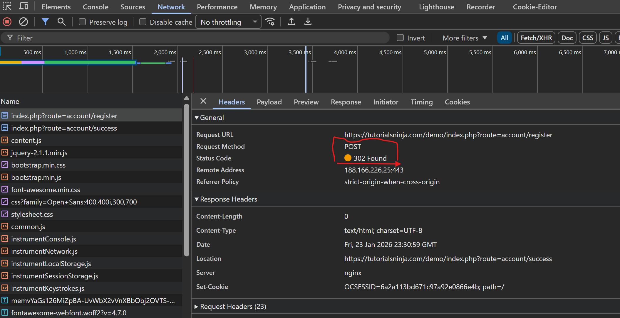

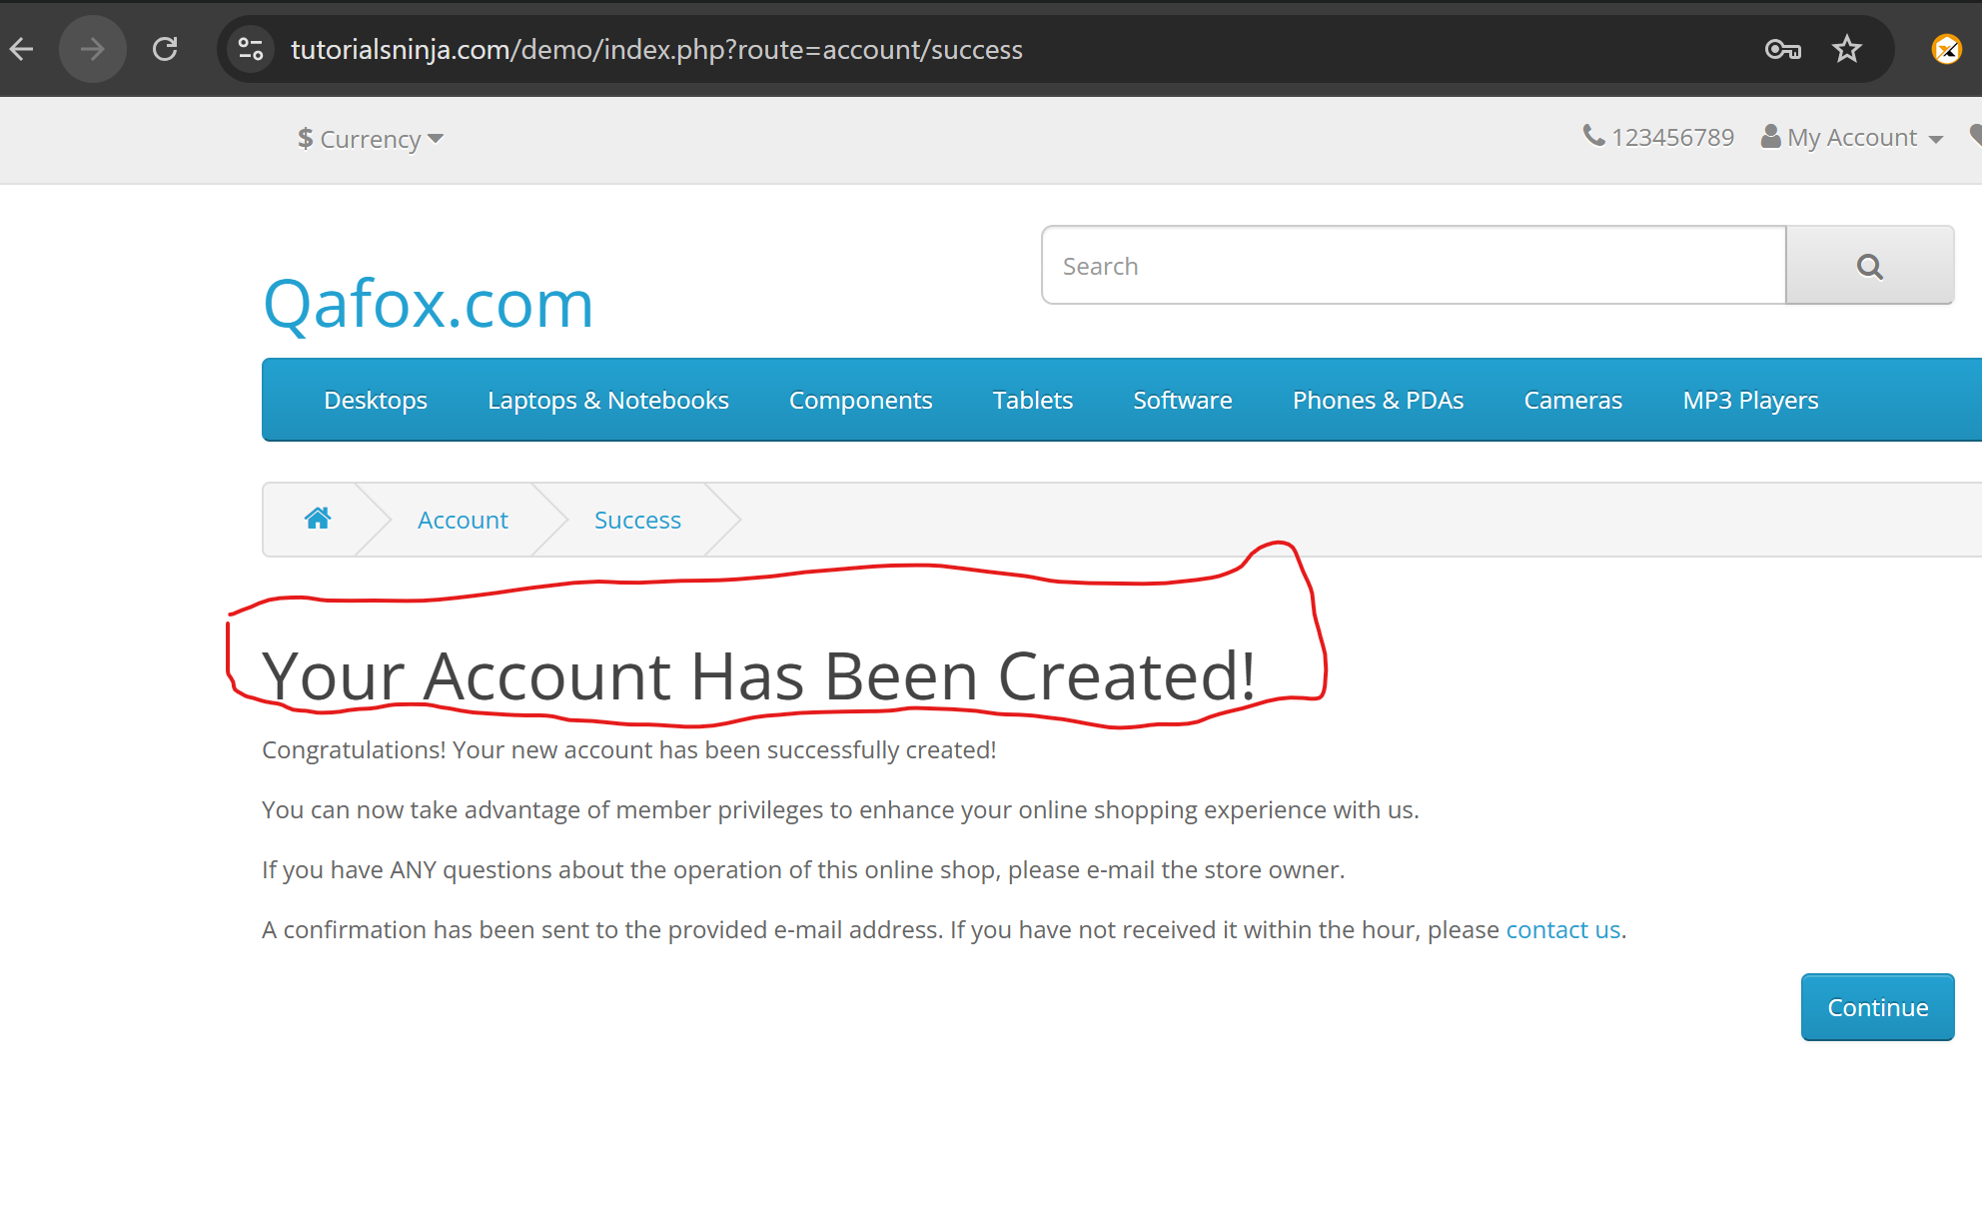

Top

Bug ID | Bug 005

Brief Summary | The leading and trailing spaces on the First name, Last name and Telephone are not trimmed and account was created

Severity | Minor
Priority | Low

Steps to Reproduce

1. Open the Application URL
2. Click on 'My Account' Drop menu
3. Click on 'Register' option
4. Enter new Account Details into all the Fields (First Name, Last Name, E-Mail, Telephone, Password, Password Confirm and add leading and trailing spaces to the First Name, Last Name, E-Mail, Telephone, select Newsletter and Privacy Policy Fields)
5. Click on 'Continue' button
6. Click on 'Continue' button again
7. Click on 'edit your account information'
8. Check if the spaces on the account details are trimmed

Expected Result:

The leading and trailing spaces entered into the fields should automatically get trimmed on successful account creation

Actual Result:

The leading and trailing spaces on the First name, Last name and Telephone
are not trimmed and account was created
Screenshot

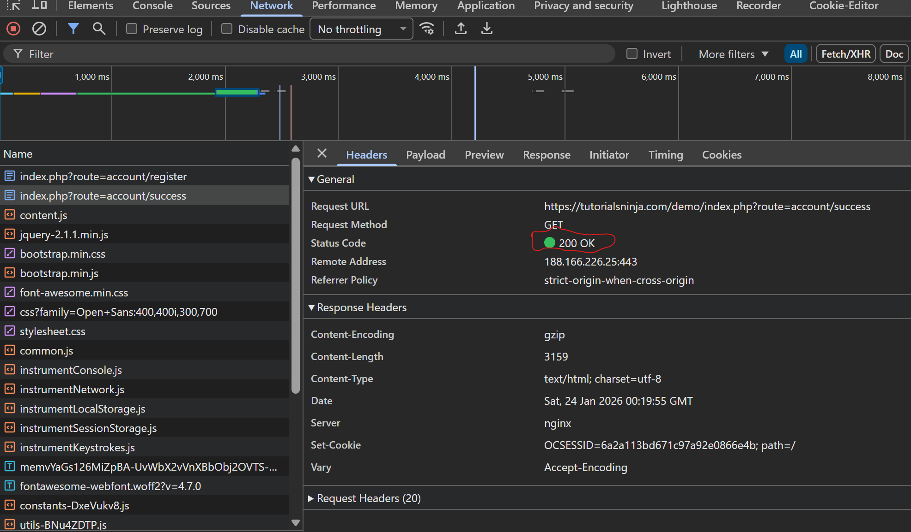

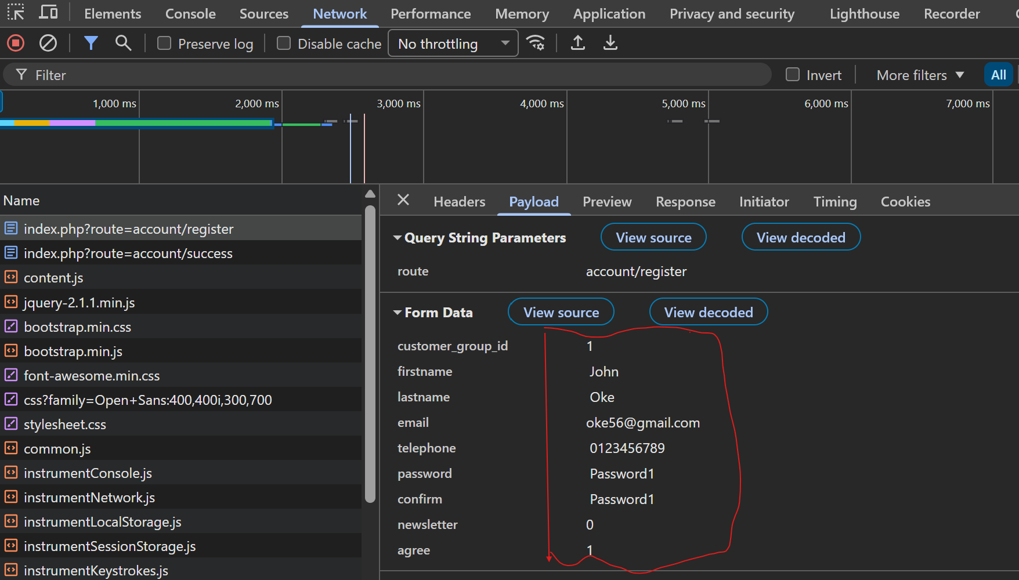

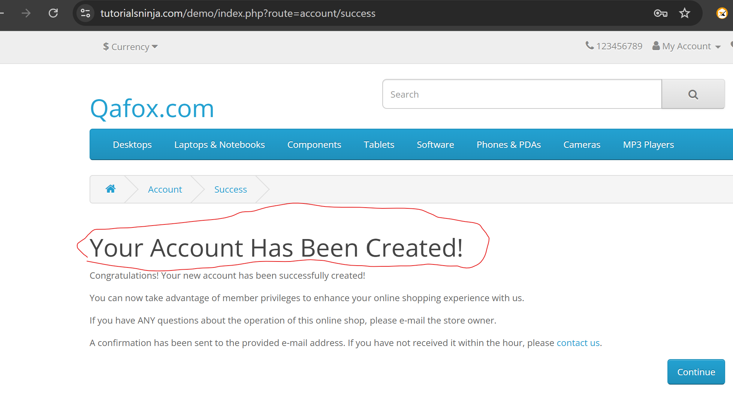

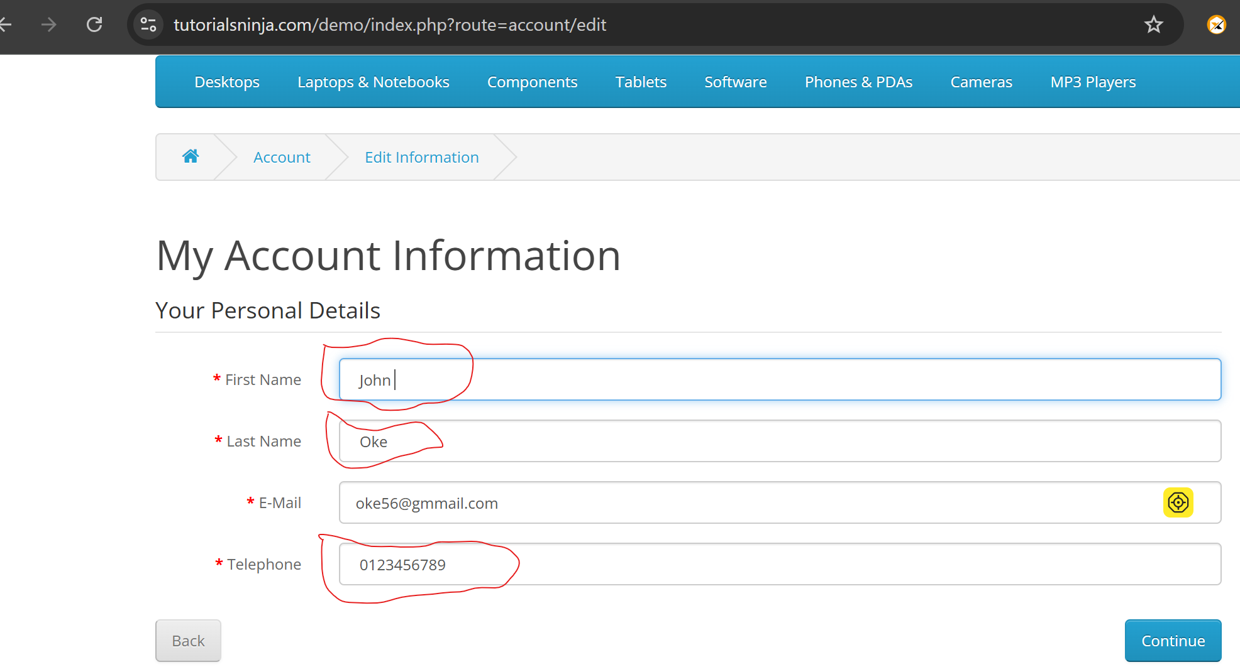

Top

Bug ID | Bug 006

Brief Summary | User is not automatically getting logged out of the Application after 30 minutes of inactivity

Severity | Major
Priority | High

Steps to Reproduce

1. Open Application URL
2. Click on 'My Account' Drop menu
3. Click on 'Login' option
4. Enter valid email address into the 'E-Mail Address' field
<Test Data = automationninja82@gmail.com>
5. Enter valid password into the 'Password' field
<Test Data = Password123>
6. Click on 'Login' button
7. Wait for at least 30 minutes without performing any activity on the Application
8. Perform any action on the Application
Expected Result:

User should get automatically logged out

Actual Result:

User is not getting logged out

Screenshot

Not Applicable
Top

Bug ID | Bug 007

Brief Summary | User did not receive an email to the registered email address regarding resetting of the password

Severity | Major
Priority | High

Steps to Reproduce

1. Open Application URL

2. Click on 'Forgotten Password' link from Login page (Verify ER-1)

3. Enter the email address of an existing account for which you have forgot the password

4. Click on 'Continue' button (Verify ER-2)

5. Check the registered email address for which the password got reset (Verify ER-3)

6. Click on the link for reseting the password from the received email body (Verify ER-4)

7. Enter new password into the 'Password' and 'Confirm' fields

8. Click on 'Continue' button (Verify ER-5)
9. Enter the email address into the E-Mail address field and the new resetted password into the 'Password' field

10. Click on 'Login' button (Verify ER-6)

Expected Result (ER):

1. User should be taken to 'Forgotten Password' page

2. Success message with text - 'An email with a confirmation link has been sent to your email address.' should be displayed in green color

3. Verify that an email is received regarding resseting of the password to the registered email address

4. User should be taken to 'Reset your Password' page

5. Success message with text - 'Success: Your password has been successfully updated.' should be displayed in green color and User should be navigated to 'Login' page

6. User should be able to login with the new password

Actual Result:

User did not receive an email to the registered email address regarding resetting of the password

Screenshot

Not Applicable
Top

Bug Id | Bug 008

Brief Summary | Proper warning message was not displayed, rather success message was displayed

Severity | Major
Priority | High

Steps to Reproduce

1. Open Application URL
2. Enter any existing Product name into the Search text box field - <Test Data = iphone>

3. Click on the button having search icon

4. Click on the Product displayed in the Search results

5. Enter negative value or non-numerical value into the 'Quantity' field of the Product or

leave the box blank

6. Click on 'Add to Cart' button in the displayed 'Product Display' page

Expected Result:

1. Proper warning message should be displayed informing the User to provide a positive numerical value

Actual Result:

Proper warning message was not displayed, rather success message was displayed

Screenshot

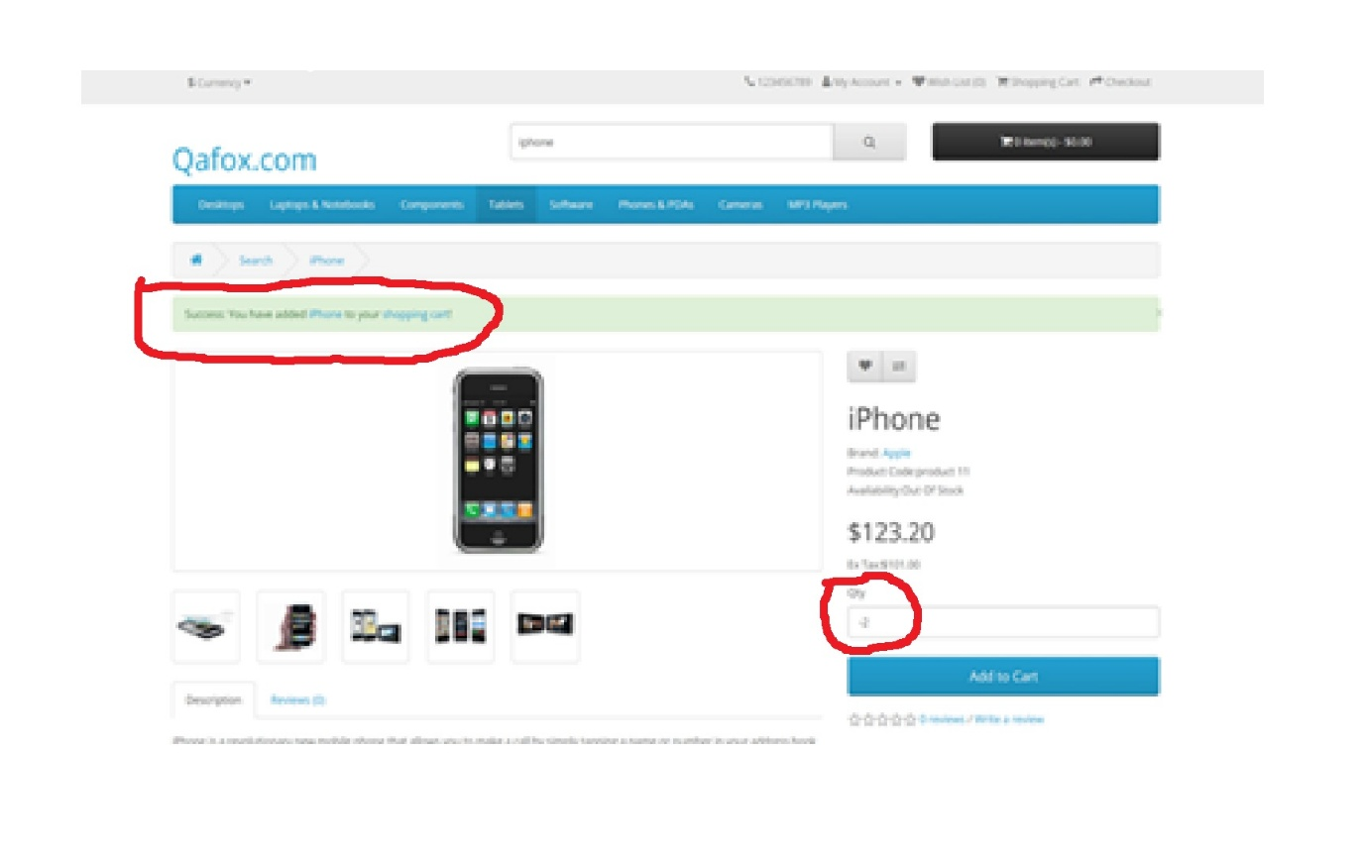

Top

