**1.0. Introduction**

***1.1. Purpose***  
The purpose of this document represents the description of Google Web mailing system called Gmail (hereinafter called **mailbox, Gmail** or simply **e-mail**). It will explain the purpose the system features, the interfaces of the web system, the process of sending an e-mail, if the system function correctly, the constraints under which it must operate and how the system will react to external stimuli.

***1.2. Scope of the project***  
The project will simulate the online mailing system thru the customer endpoint

***1.3. Overview of Document***  
The next chapter, the **Overall Description** section, of this document gives an overview of the functionality of the e-mail service. It describes the informal requirements and is used to establish a context for the technical requirements specification in the next chapter.  
The third chapter, **Requirements Specification** section, of this document is written primarily for the developers and describes in technical terms the details of the functionality of the product.  
Both sections of the document describe the same software product in its entirety, but are intended for different audiences and thus use different language.

**2.0. Overall description**

***2.1. System Environment***  
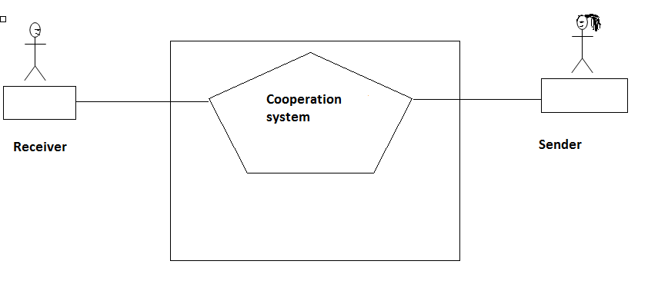

**Figure 1 - System Environment**

The online mailing system has one active actor and one cooperating system. The e-mail user access to the service thru the internet, he logs in and access his mailbox. The **cooperation system** get the request from the mail sender and forward it to the receiver.

***2.2. Functional requirement specification***

2.2.1 Expected Inputs

***2.2.1.1 Use Case 1 (Accessing the system - Log in)***   
The system can be accessed through the internet from its initial URL. It loads the log in mask with four predefined tabs for Register, Login and the additional tabs Help and “Remind me”.

To perform log in to the mailbox, first of all the user must create a registration providing some personal data (fist and last name, date of birth, backup account to other mailbox services, etc.), the obligatory fields are with red asterisk like choosing available username and safety password with minimum 8 ASCII symbols. After the registration the user can log in to the web mail service fulfilling the field username and password.

If the user has already account and he is logged in, these tabs are hidden and he access directly on his inbox.

***2.2.1.2 Use case 2 (Mailing)***  
The main option mailing permit to send and receive letters. When the customer click on “write” button there appear a new window that require to insert on the field “To” the e-mail address of the receiver, “subject” – resumption of the body of the letter, “CC” –send a copy of the letter to other e-mail addresses and field “Body” that permit to write the letter.

For already received letters there are intuitive options like:

- Reply

- Forward

- Delete

- Print

- Filter, etc.

***2.2.1.3. Use case 3 (Searching)***  
On Gmail is available a searching option, on the top of the page. The searching box permit fast searching for letters or contacts. When the customer type the name of the contact, part of the letter title or key word that is present on the internal of the letter, the system loading all letters that contain this data.

*2.2.2 Log In scenarios*

The user can log in to the his Gmail thru the official Gmail URL, from the appropriate link on the official Google searching page and Gmail mobile application.

***2.2.2.1 Log in thru Url***

There appear the log in page that require to insert valid e-mail address that stand for username and password. If one of the two fields is not populate correctly, appear the option for forgotten username or password and it gives the possibility to receive on already registered backup mailbox recovering link, or code number on the personal mobile phone. Clicking on the backup link or after typing the received code the system permit to change the password.

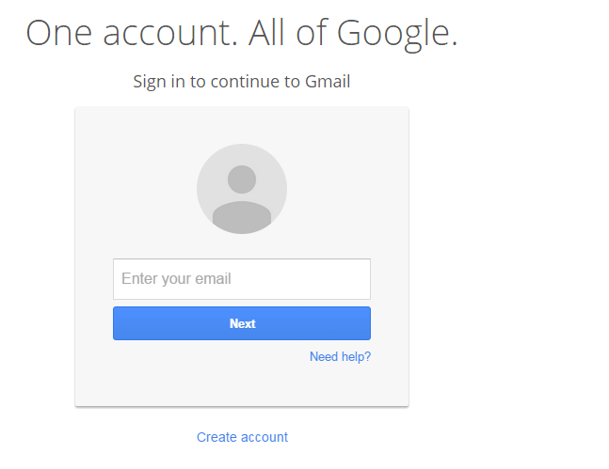

***2.2.2.2 Log in thru Google searching page***

On the official Google searching page on the upper right corner there is the Gmail icon (as shown on the screenshot below), when the user click on it, it open the standard Gmail log in page and the procedure is as described on **2.3.1**

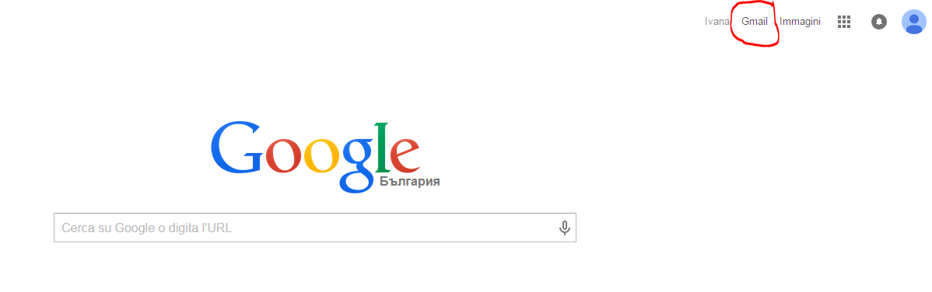

***2.2.2.3. Log In thru Mobile device***

First of all the customer should download the application for the Gmail service. When the installation is performed, should click on the Gmail icon (shown on the screenshot) and insert his username/e-mail address and password. After the first access the application remember the credentials. If the user do not perform “log out” option he will receive popup/alert for any currently received e-mail.



*2.2.3 Unwanted Input Scenarios*

Refers to scenarios where unwanted input is submitted. In these cases Gmail automatically resolves (“escapes”) the input or it throws an explanation error message.

***2.2.3.1 User Case 1 - Log In with wrong or missing credentials***

***2.2.3.1.1. Log in with non-existing e-mail address*** – the user receive alert message “unfortunately, Google do not recognize this e-mail address ” – as on the screenshot below.

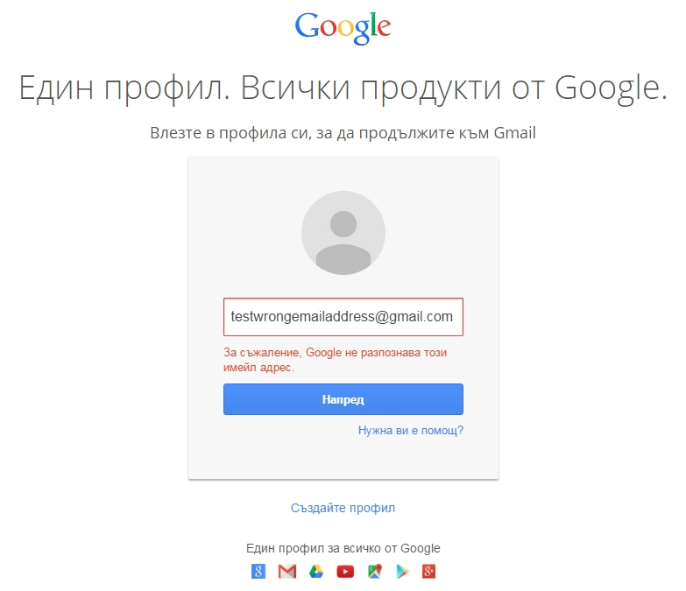

***2.2.3.1.2 Log in with script or typing casual symbols*** – Error message: Please, insert valid e-mail address (as on the screenshot)

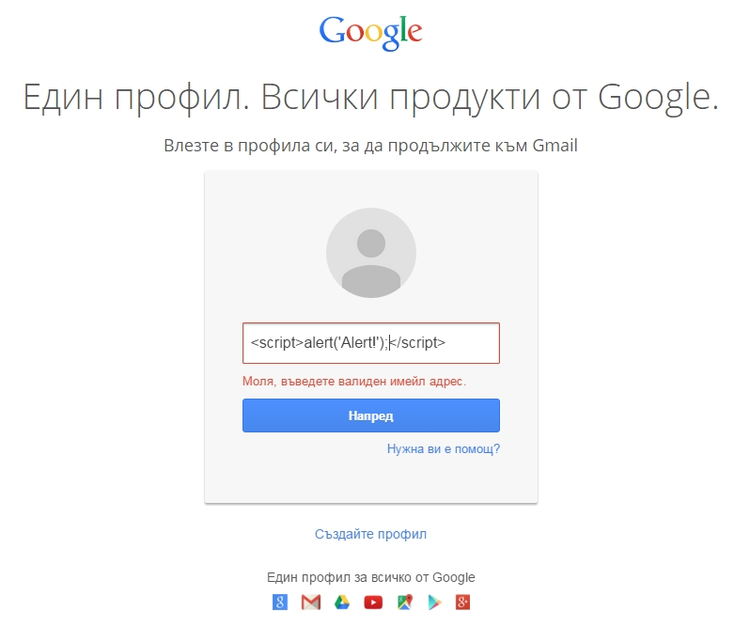

***2.2.3.1.3 Log in without typing a password*-** it return intuitive error message: “Please, type your password. “

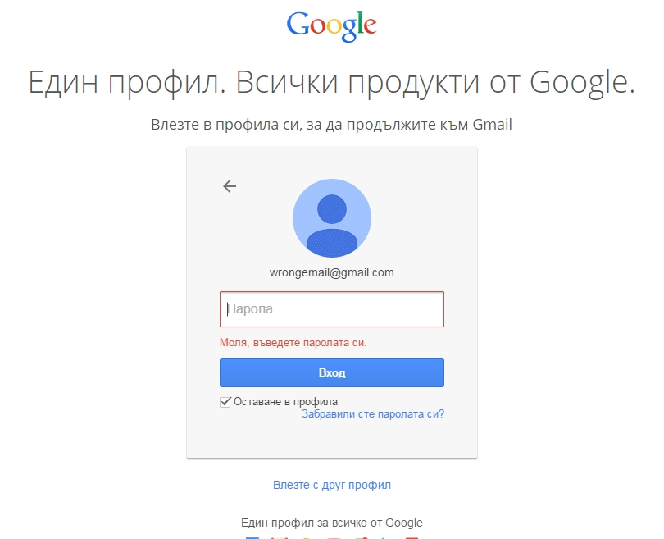

***2.2.3.1.4. Log in with not corresponding password*** – when the user type password that do not correspond on the specified e-mail address, it returns error message : “The e-mail and password that you type, do not match” and the user should type the password again.

