Resume

**TETIANA KOVALSKA**

**Phone number: +80504266645 email adress:** [**barnaulskay9@gmail.com**](mailto:barnaulskay9@gmail.com)

**Profile**

**Results-oriented and knowledgeable Quality Assurance Assstant with 2 months successfully graduated from advanced training QA courses on modern testing methods**

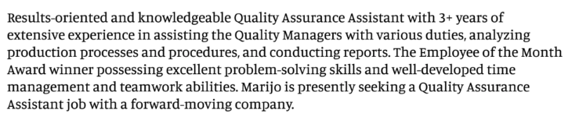

**Work experience**

**Education**

**Skills**