DataBase

* Filling the table
* 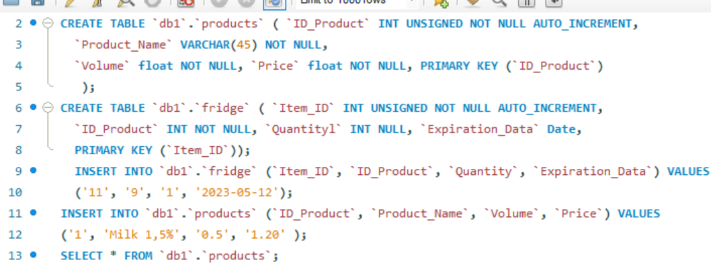
* Linking tables by key.
* 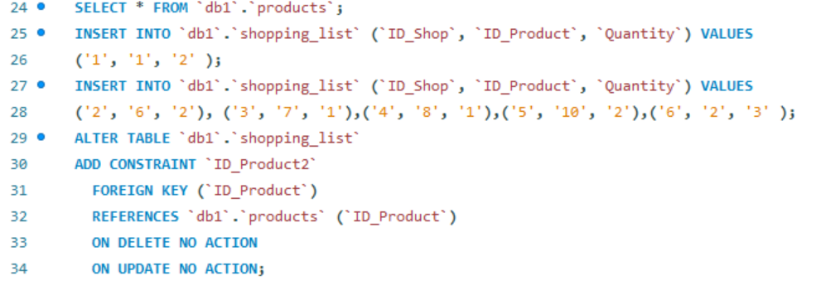
* Theinformation from the Shopping_List table (created earlier) about the most expensive and cheapest product.
* 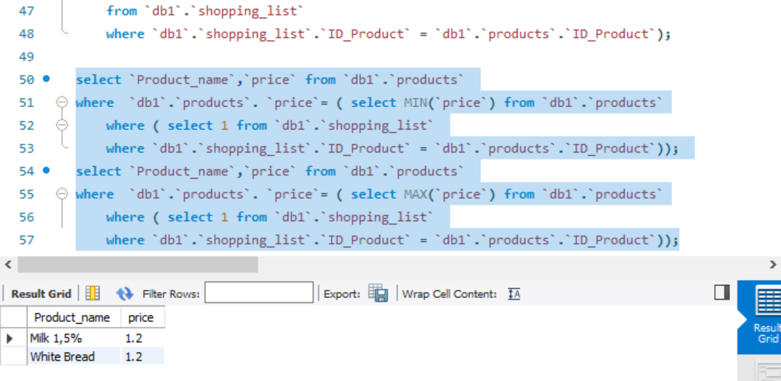
* 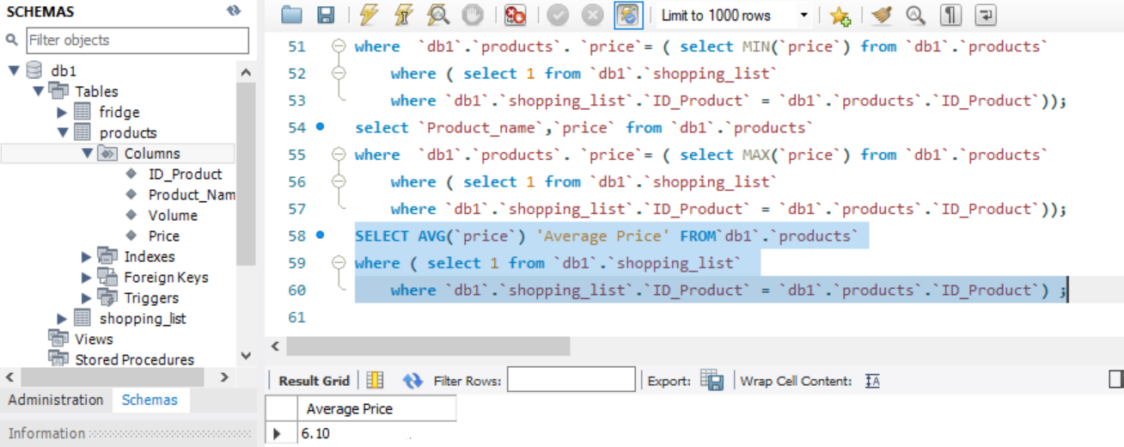
* Calculation of the average cost of products
* 
* Calculation of the number of products in the refrigerator
* 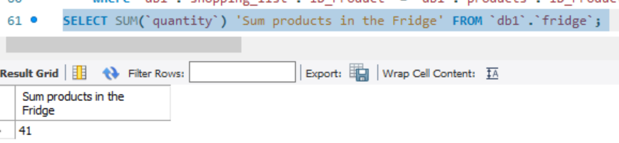
* Calculation of the number of products in the shopping list (from the Shopping_List table)
* 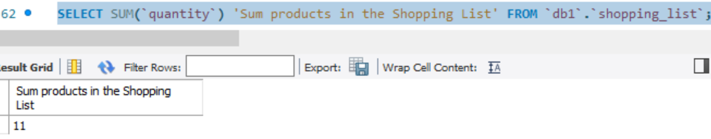
* There are all products starting with the letter A from the Shopping_List table
* 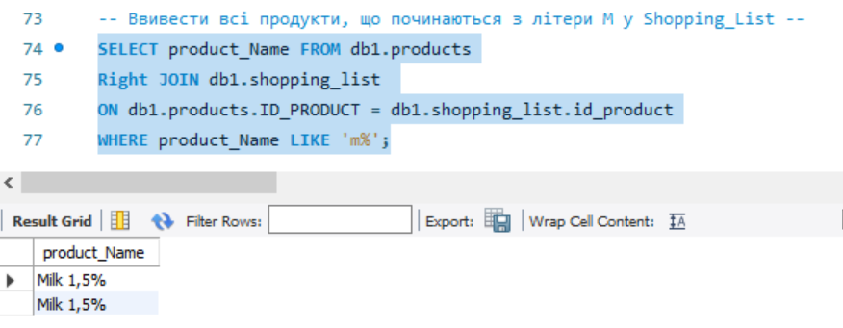
* Find products from the shopping list that are already in the refrigerator
* 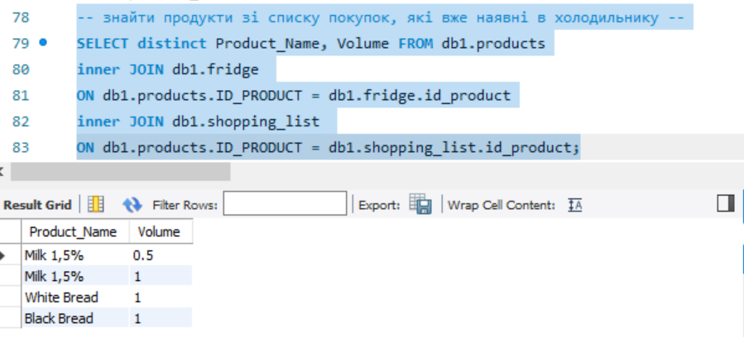
* Products that are not in the refrigerator and need to be bought (from the Shopping_List and Fridge tables)
* 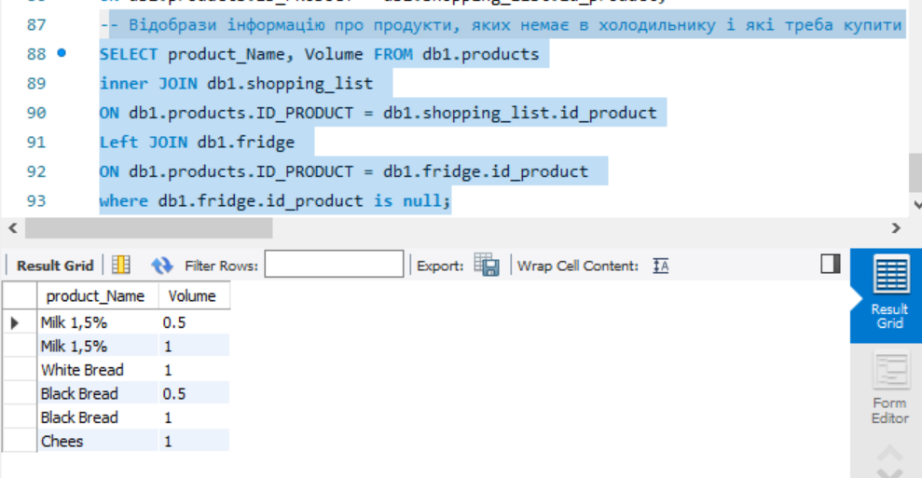
* There are all products from the Order table that are in the Shopping_List table and have expired.
* 