**Scenario 1**

**Step 1) Account replenishment**

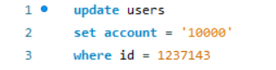

**Step 2) Purchase of 2 fundamental and 3 advanced courses**

**Fundamental**

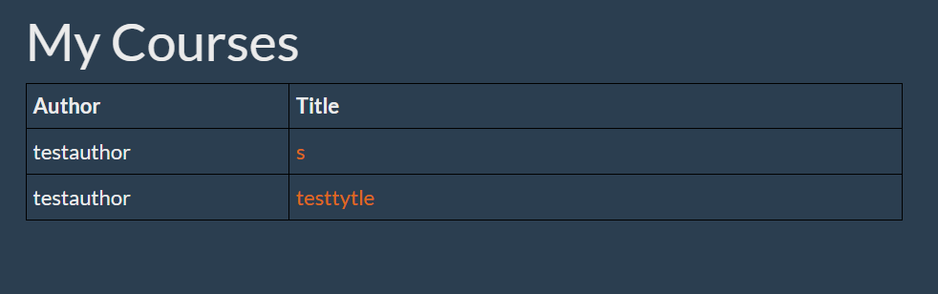

**Advanced**

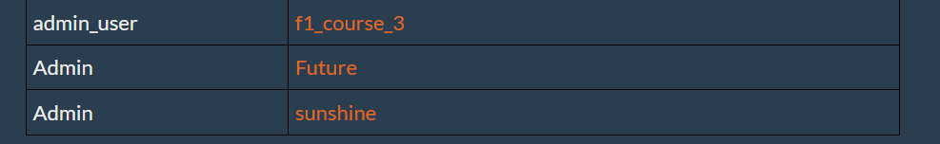

**Step 4) selection of the count of Fundamental and Advanced course**

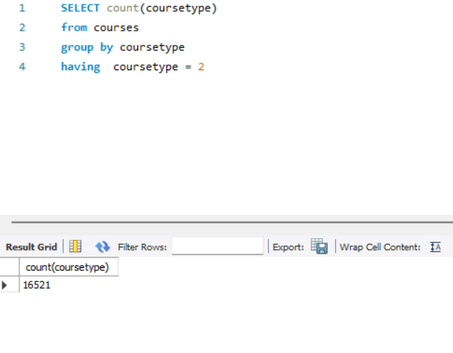**Fundamental**

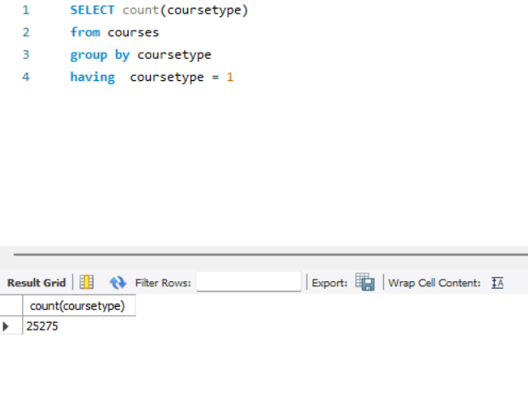**Advanced**

**6) update of one of the Advanced course prices ‘20’**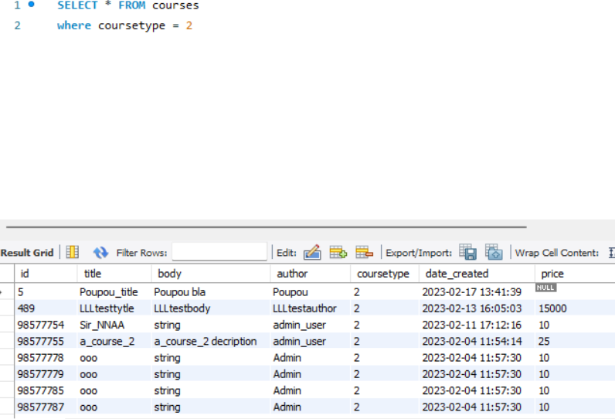

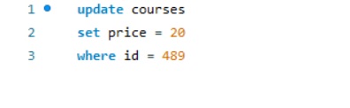

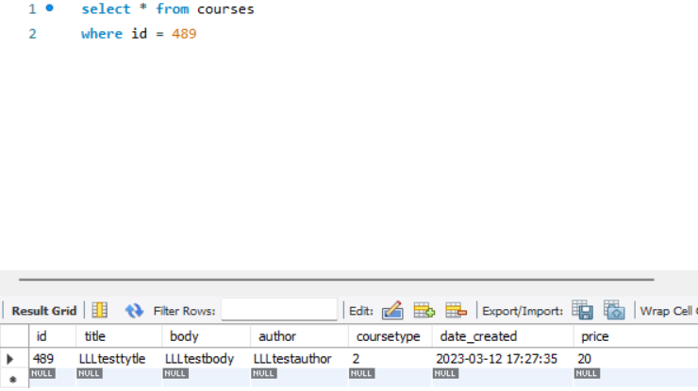

**Scenario 2**

**Step 1) selection of the non-admin and admin user counts**

**Non-admin**

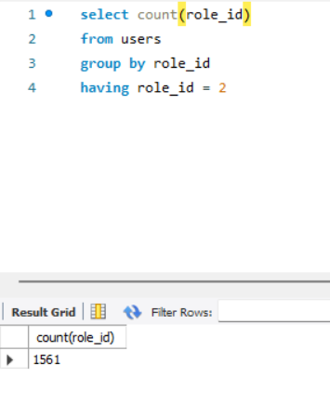

**Admin**

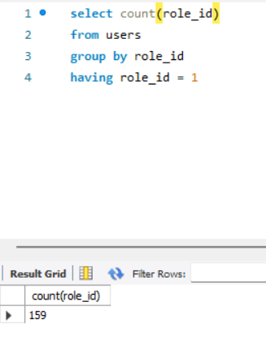

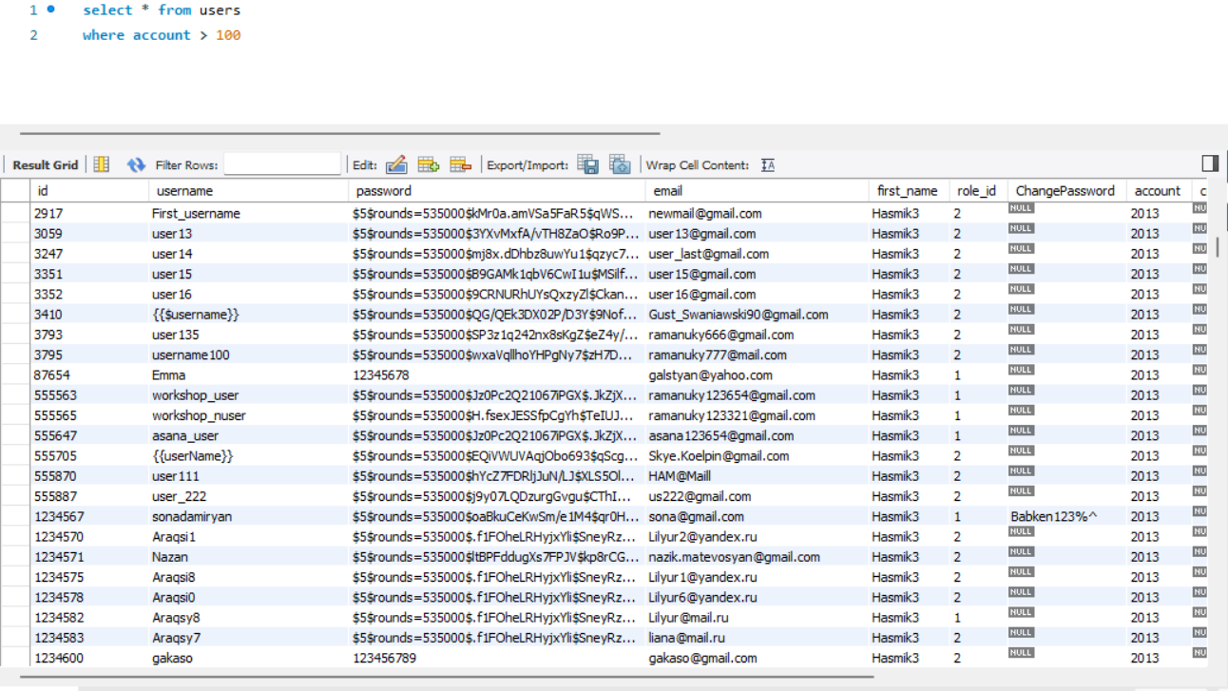**Step 2) selection of all users whose account is more than 100**

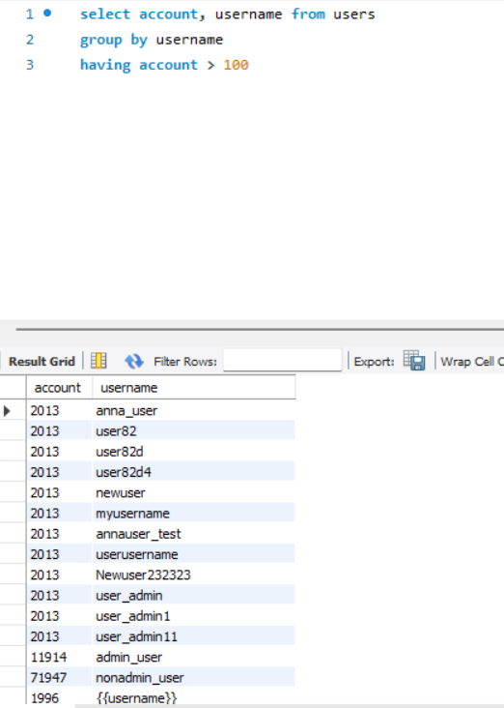**Step 3) group by username**

**Step 4) give all users whose names start with ‘Ann’**

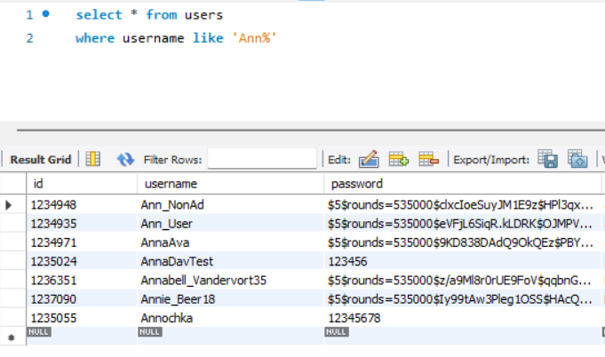

**Step 5) give all users whose names’ 2nd letter is ‘n’**

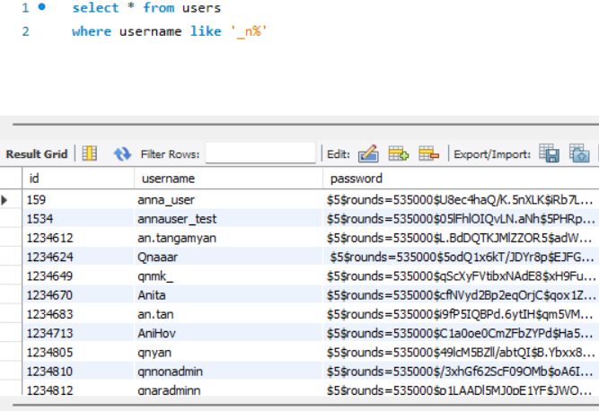

**Step 6) insert new user with all fields (encoded password should be used)**

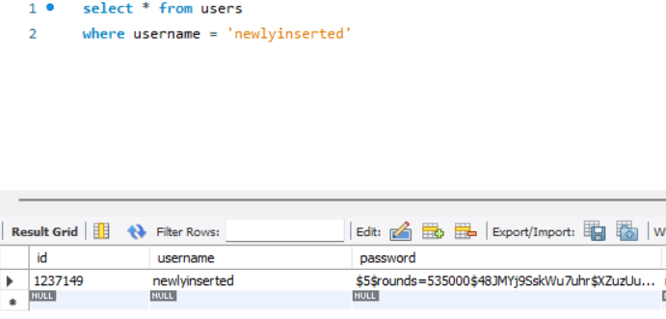

**Scenario 3**

**Step 1) add new non admin user (encoded password should be used)**

insert into users (username, password, email, first_name, role_id, ChangePassword, account, country, city, address, phone_number, gender, marital_status)

values ('Lidanonadminn', '$5$rounds=535000$48JMYj9SskWu7uhr$XZuzUuQdaIqeu6w1EiEEFV2kSgVCsaXI/71w/QbRR29', 'lidanonadminn@gmail.com', 'Lidanondmin', 2, 'lidanonadmin', 100000, 'Armenia', 'Yerevan', null, 011111111, 'female', null)

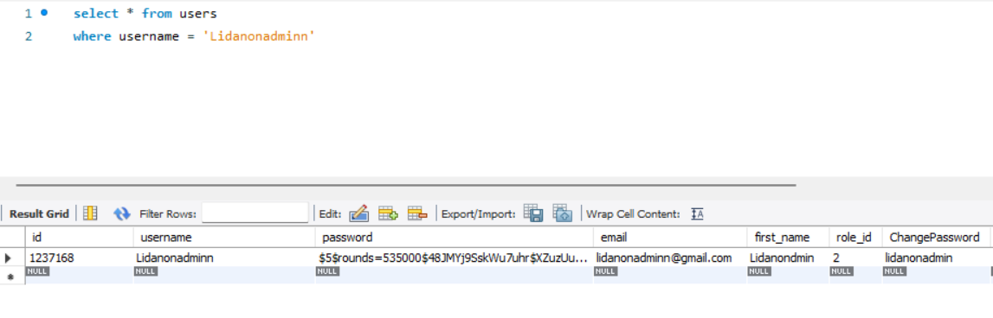

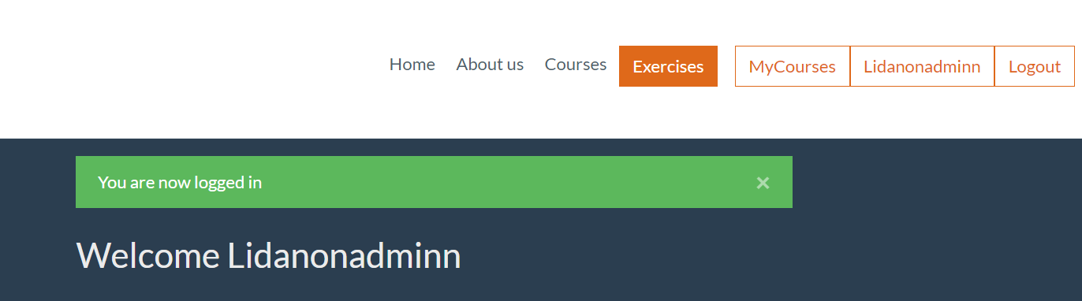**Step 2) Check that non admin can login to the system via application**

**Step 3) Update role as admin in DB**

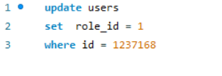

**Step 4) Login into system and check that you are admin**

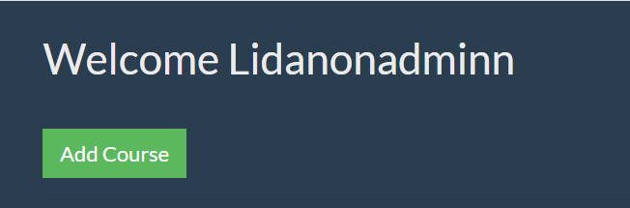

**Step 5) Change user pass in DB**

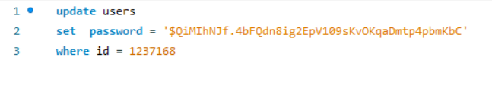

**Step 6) Try to login again in the system**

** Check that user is not able to login into the system**