**How to Set up Cypress and Typescript End-to-End Automation Testing Framework From Scratch**

This tutorial explains easy way to set up Cypress and Typescript Automation Framework with page object model. Cypress is new tool alternative to Protractor.

** by**

[**Ganesh Hegde**](https://dzone.com/users/4432636/ganeshsirsi.html)

**CORE ·**

**Jul. 01, 21 ·**[**Web Dev Zone**](https://dzone.com/web-development-programming-tutorials-tools-news)**· Tutorial**

**Like**[**(6)**](https://dzone.com/articles/cypress-typescript-end-to-end-automation-testing-from-scratch)

**Comment (4)**

**Save**

[**Tweet**](https://dzone.com/articles/cypress-typescript-end-to-end-automation-testing-from-scratch)

**57.91K Views**

Join the DZone community and get the full member experience.

[**JOIN FOR FREE**](https://dzone.com/static/registration.html)

This article explains creating or setting up a cypress.io end-to-end testing framework from scratch using Typescript. Unlike another tutorial, this explains setting up the [Cypress framework](https://dzone.com/refcardz/javascript-test-automation-frameworks) using Typescript in a simple and easy way. This article is helpful for whoever wants to set up the Cypress Typescript automation framework for the first time. Also, I know that there are many, migrating from different automation frameworks like Protractor, webdriver.io, etc. this will be helpful for them too.

This Tutorial shows page object model creation as well, however you can use it for any type of framework by skipping those steps.

**Prerequisites**

1. **Install NodeJS:**If you don't have NodeJS installed in your system navigate to <https://nodejs.org/en/download/> and choose LTS download and install.

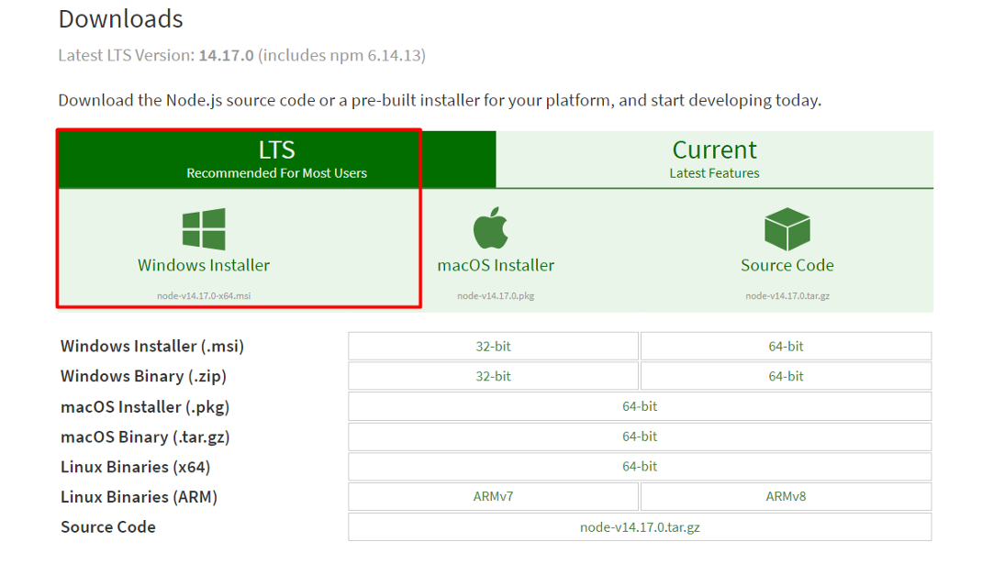2. **Install Visual Studio Code:** If you don’t have Visual Studio Code on your computer navigate to <https://code.visualstudio.com/download> download and install.

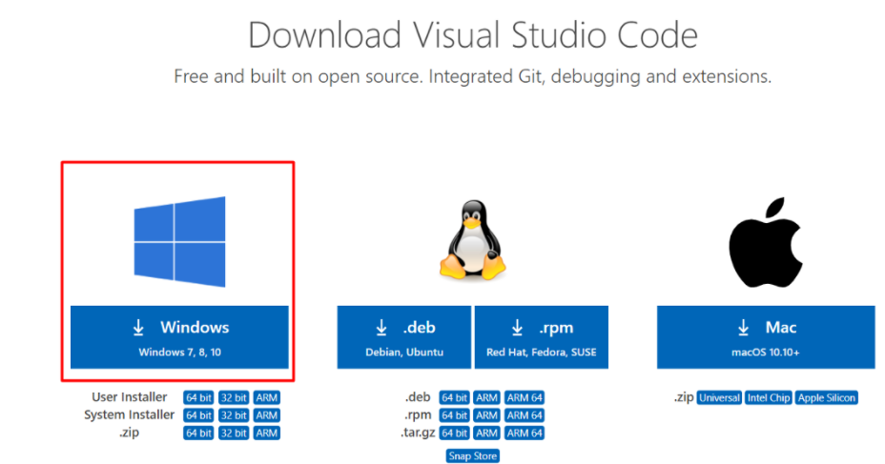

**Step by Step Guide to Configure/Setup Cypress Typescript Automation Framework**

**Step 1: Create a Project Folder**

The first step is to create a new folder on your computer on a desired location. Below I am creating **CypressTypescript** as the project folder.

**Step 2: Open Project Folder *CypressTypescript* in Visual Studio Code**

i. Open, **Visual Studio Code**, Click on ***File****>****Open Folder***

ii. Choose, ***CypressTypescript***Folder and Click on ***Select Folder*** at the bottom

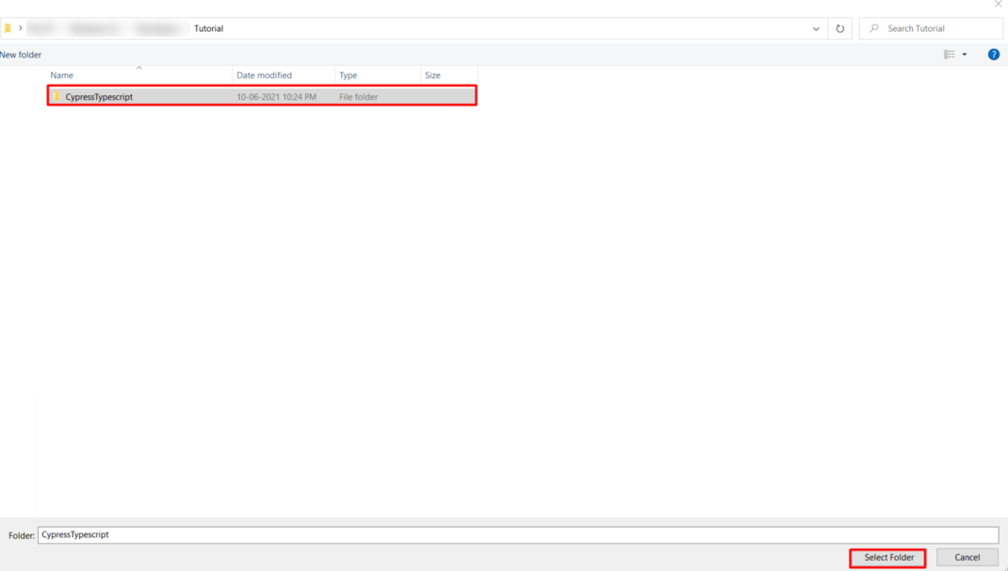

**Step 3: Create pacakge.json File**

Open Terminal, In Visual Studio Code by clicking on **Terminal Menu** > Choose **New Terminal.**

***Note:****Ensure****New Terminal****opened in the working directory as****CypressTypescript***.

i. ***New Terminal***window appears at the bottom of *Visual Studio Code*, In the new terminal type below command

**npm init**

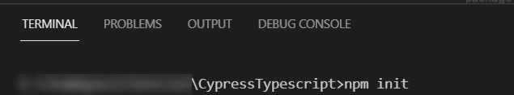

ii. It will ask you a set of questions if you want, you can type the desired text, else hit **[Enter]**key one by one until you get the message ***Is this Ok?***, then again hit enter it will create **package.json** for you.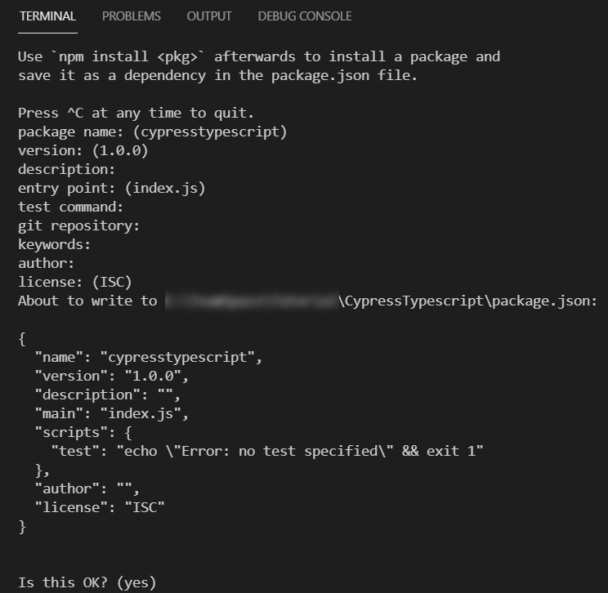

**Step 4: Install Cypress**

In the Visual Studio Code Terminal, you need to type below command:

**npm install cypress --save-dev**

The above command may take some time so please wait until it finishes.

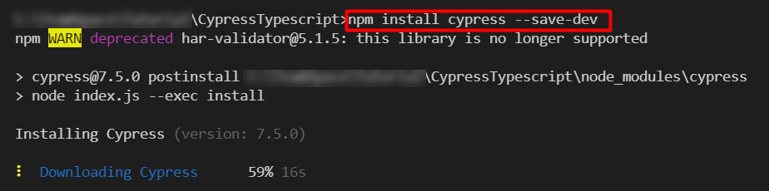

**Step 5: Open Cypress**

The first time when you enter the cypress open command it will create a default setup for you, which also includes directories like cypress, integration, fixtures, etc. To open cypress enter the below command in your *Visual Studio Code* **terminal window.**

**npx cypress open**

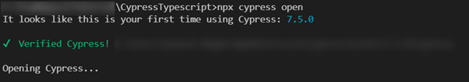

After the execution of the above command, it will create a default Cypress framework for you and also opens the Cypress window. At this point just **close**the Cypress window.

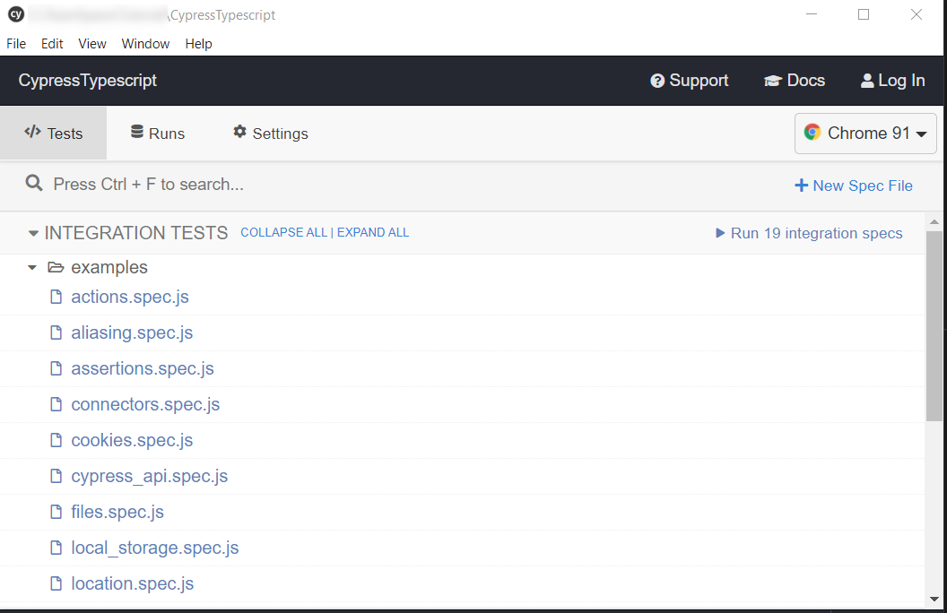

At this point, your **CypressTypescript** folder should look like below:

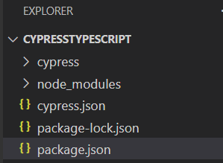

***Note:****Optionally, if you want you can play with a built-in example using the cypress window.*

**Step 6: Install Typescript Using the Below Command Typing in Terminal**

In the Visual Studio Code Terminal type the below command.

**npm i typescript**

**Step 7: Create Typescript Config File (tsconfig.json)**

In the Visual Studio Code Terminal type the below command to create **tsconfig.json** file.

**npx tsc --init**

The above command will create the ***default*tsconfig.json** file, let it be, for now, we will configure that later stages in this tutorial.

**Step 8: Create page-objects Folder**

Open **cypress**folder.

***Note: cypress the folder is located inside your root of the project in our case its CypressTypescript***

Create a folder inside **cypress** the folder, name it as **page-objects .**All your page object files should sit here.

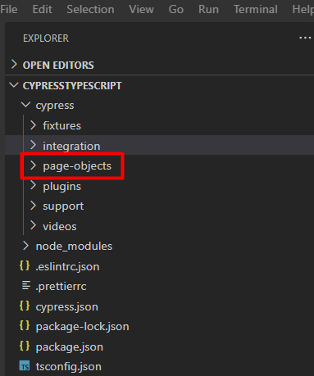

**Step 9: Create specs Folder Inside Integration Folder**

***Note:****The****integration****folder has already created by cypress, you don’t have to create your own. which is located inside****CypressTypescript/cypress****folder*

Inside your ***CypressTypescript***> Double Click on **c*ypress***Folder > Open **Integration**folder

The default **integration**folder looks like below.

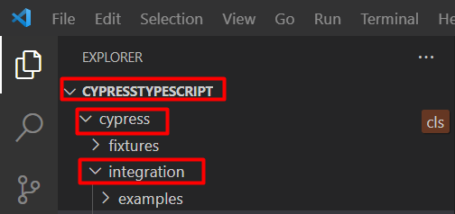

Now, Create a folder called **specs** inside the **integration**folder (Just reminding again integration folder is located inside the **cypress**folder

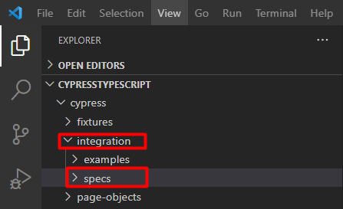

*Optionally you can****delete****the****examples****folder unless you want to keep it as a reference.*

**Note:** *1. example folder contains example tests, just to play around with some test cases, provided by cypress when you install the cypress package.  
2. Your tests should be always inside the integration folder. However, you can create subfolders to arrange your specs but they should be inside the integration folder.*

After the above step, we have created two folders namely **specs**and **page-objects**

1. **specs**folder inside integration folder

2. **page-objects** folder inside cypress folder

Below is the structure

CypressTypescript

-cypress

--integration

---specs

--page-objects

***Note:****Creating a separate folder for page objects and specs helps easy maintenance and managing the automation test. It is just a recommendation not mandatory.*

**Step 10: Create a First Page-Object File Inside the page-objects Folder**

Using *Visual Studio Code*, Create a file named **google-search.page.ts** . This file should be created inside **page-objects** folder created in **Step 8**. Copy and paste the below code inside **google-search.page.ts**  file.

TypeScript

1

//Inside your google-search.page.ts file. This is pageobject file.

2

/// <reference types="cypress" />

3

export class GoogleSearch{

4

googleSearch(){

5

return cy.get('input[name="q"]').first();

6

}

7

googleSearchBtn(){

8

return cy.get('input[name="btnK"]').first();

9

}

10

searchResults(){

11

return cy.get('h3').first();

12

}

13

 }

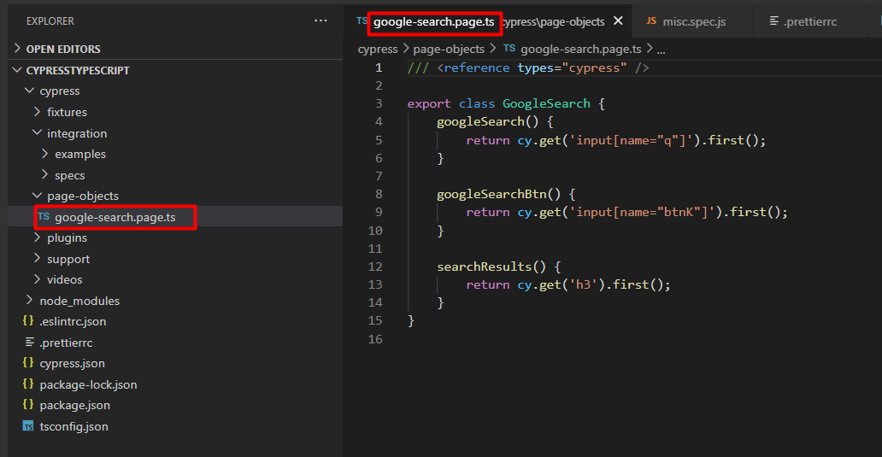

**Step 11: Create the First Spec Inside the Specs Folder**

Using *Visual Studio Code*, Create a file named **google-search.spec.ts** . This file should be created inside **spec** folder created in**Step 9**,Copy and paste the below code into the file google-search.spec.ts

TypeScript

1

//This is spec file, inside your google-search.spec.ts

2

import { GoogleSearch } from '../../page-objects/google-search.page';

3

const search = new GoogleSearch();

4

​

5

describe('Google Navigation', () => {

6

it('Google Search',() => {

7

cy.visit('https://www.google.com');

8

​

9

search.googleSearch().type('Something');

10

search.googleSearchBtn().click({ force: true });

11

search.searchResults().should('be.visible');

12

});

13

});

14

​

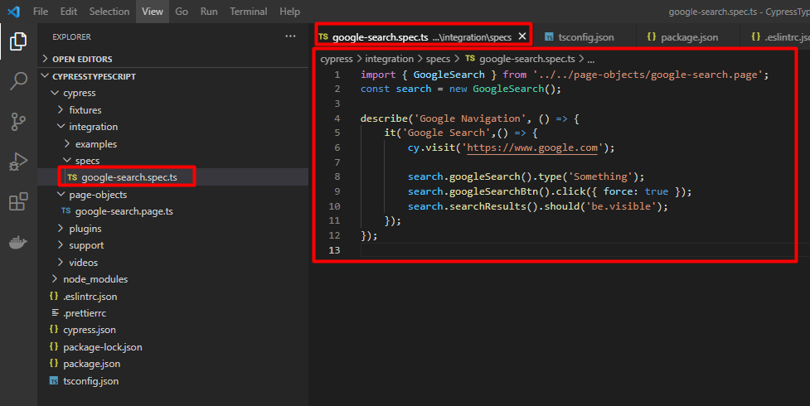

At this point, your framework should look like below.

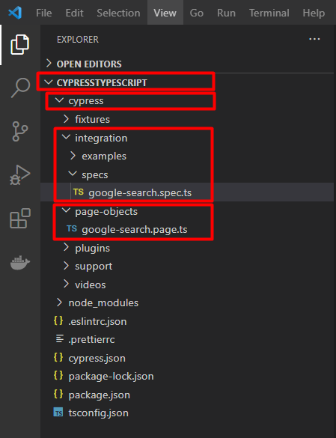

**Step 12: Configuring tsconfig.json File**

So, You have completed, page-object file, spec file. If you see those files you have created file with a **.ts** extension, that means we are using typescript in this project. In order for Cypress to understand typescript, we need to configure tsconfig.json file. The tsconfig.json file will be located in the root of the project folder that is inside folder CypressTypescript

i. In **Step 7** you have already created tsconfig.json file.  
ii. Navigate to tsconfig.json file  
iii. Remove all default settings inside it. (make it empty)  
iv. Copy and paste the below code

**{**

**"compilerOptions": {**

**"target": "es5",**

**"lib": ["es5", "dom"],**

**"types": ["cypress"]**

**},**

**"include": ["**/*.ts"]**

**}**

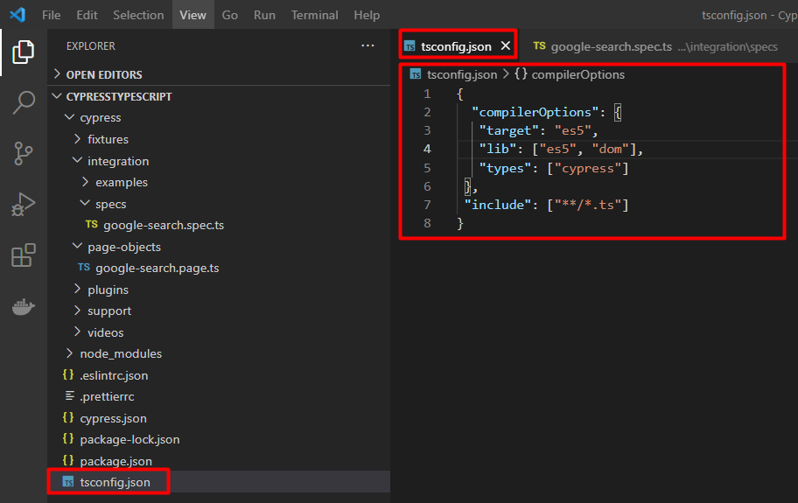

**Step 13: Execute Your First Test**

In the *VisualStudio Code*Terminal, Make sure the terminal present working directory is CypressTypescript**.**Type below command

**npx cypress open**

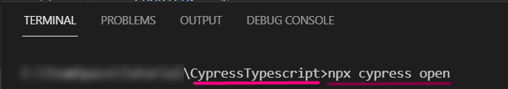

Wait for the Cypress window to open. The below window appears.

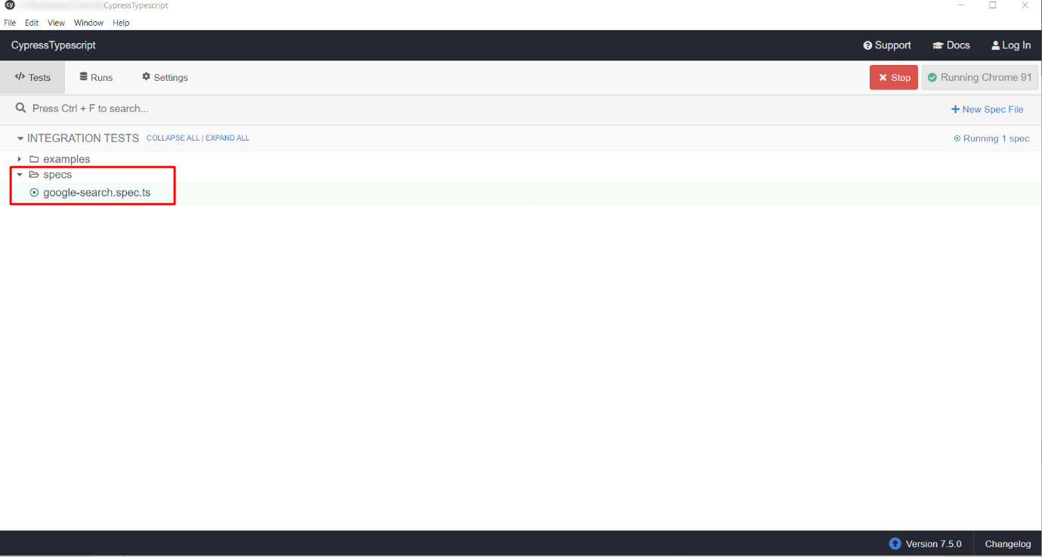

Now, click on the **google.search.spec.ts**file in the above window.

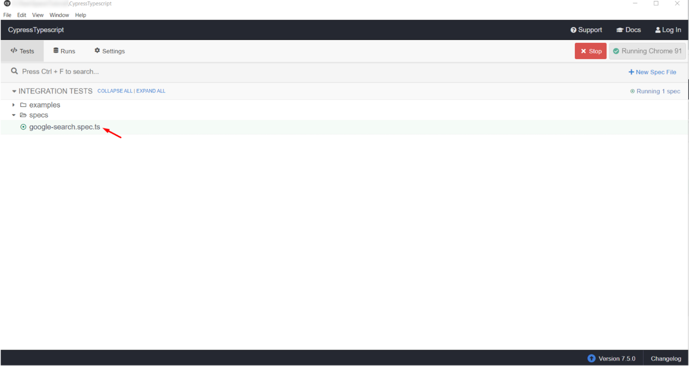

BOOM!!! Your test starts running in the browser.

Once it gets finished, you will see the result.

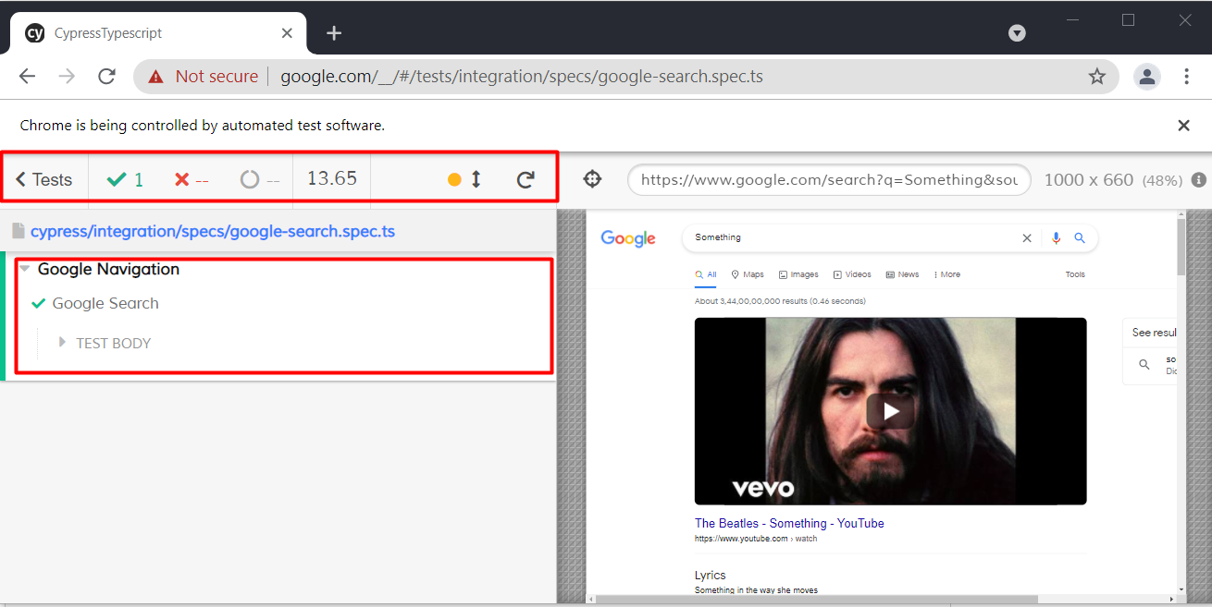

**How to Execute Cypress Tests Using the Command-Line Interface Cypress CLI?**

To execute cypress tests using the command line. Navigate to the **CypressTypescript** folder **using the command line** enter the below command:

**npx cypress run --spec="./cypress/integration/specs/google-search.spec.ts"**

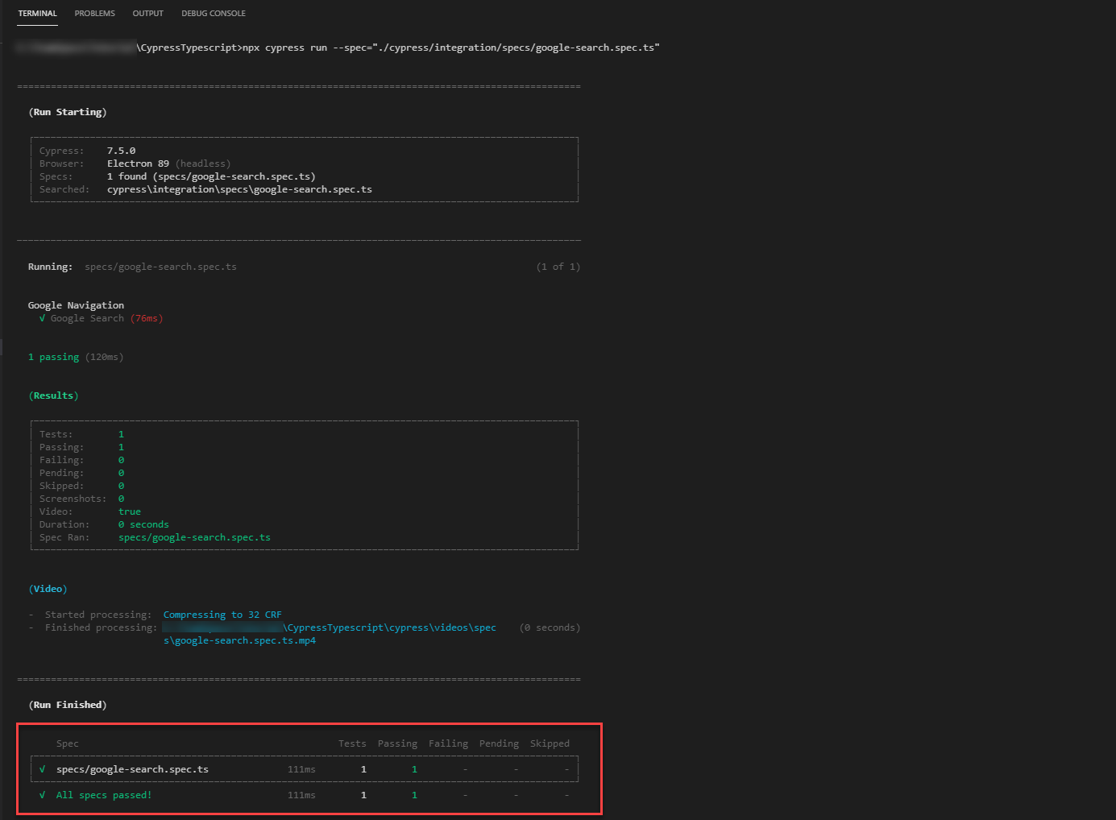

**Bonus:**

By default, Cypress doesn’t support XPath as a selector, if you need XPath support please install the [cypress-xpath](https://www.npmjs.com/package/cypress-xpath) npm package:

**npm i cypress-xpath**

To get support for the typescript uses the line **/// <reference types=”cypress-xpath” />** in your spec file. Below is the example:

**/// <reference types="cypress-xpath" />**

describe('Example', () => {

it('Example', () => {

//test something

});

});

Source: <https://dzone.com/articles/cypress-typescript-end-to-end-automation-testing-from-scratch>