Software Requirements Specification

for
Email system Yahoo

Version 1.0 approved
Prepared by Team “Azimir”:

Delyan Delev
Daniel Genchev
Atanas Subev
Ana Todorova
18 April 2016

1. Introduction

1.1 Purpose
This document provides an overview of the Yahoo Email System and more specific – the high-level function possibilities.

1.2 Scope
The scope of this project is to prove the functional stability of Yahoo Email System. Yahoo Email System is useful for both business and non – business users. It can be used to send/ receive important business transactions as communication between two or several companies, or any kind of organization. The information can be stored into the Inbox of the accounts for example. The same option can be used by regular users for daily communication.
This system is useful for users with basic skills in use of any other popular mailing systems.

1.3 Overview

The rest of this document contains the overall description of the Yahoo e-mail system and the specific requirements for the system in high-level use

2. Overall Description

2.1. Product Perspective
Yahoo Email System is free online software product. Users don’t need to pay anything for simple use of it. The system is already operational, users just need any conventional web browser or installed web application to use it. The interface is intuitive and requires minimal training. The Yahoo Email System is available 24/7 hosted by the software provider.
2.2. Product descriptions
The Email system application is developed and function with the help of Internet. This system is developed mainly for fast and secure transfer of information as large text messages and files between two or more users. The existing system contains various services such as composing, sending, storing and /or deleting mail.

Product Functions
2.3.1New Account Creation –users can create one or more accounts following these steps:

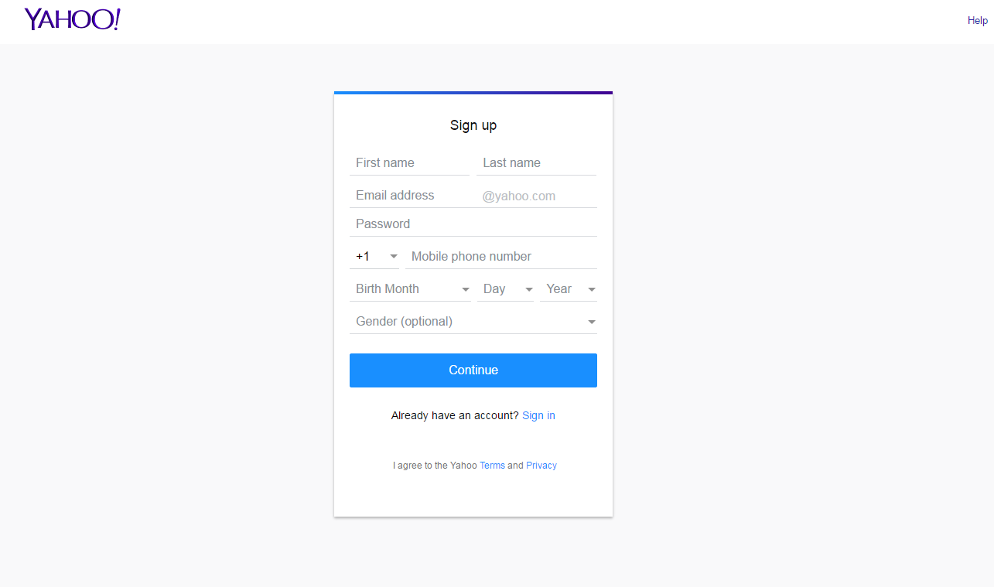
2.3.2. Log in – Log in with correct user name and password. If the password is forgotten or lost users can retrieve a new one.

2.3.3. Create a new e-mail – Users can create an e-mail, to write a text message and/or attach files. The e-mail can be send to one or more users with different e-mails than Yahoo.

2.3.4. Create a draft – Users can create drafts of e-mail, which can be sent or edited later.

2.3.5. Add / delete files – when users create a new e - mail or draft, they can attach file to it, or delete /edit already attached one.

2.3.6. Add /delete contacts – Users can change the recipients. They can delete previous or add additional recipients of the created e-mail/draft.

2.3.7. Receive e-mail – Users can received e-mails with or without attached files. The received e-mails can be read or deleted automatically. Also users can reply to received e-mail. The received e-mails can be moved to different folders.

2.3.8. Create folders – Users can create different folders then Inbox, Sent items, Delete items and Drafts. Also they can rename or delete the folders.

2.3.9. Create/delete contact – User can make an address book where they can store , edit or delete their contacts/e-mails,
2.3.10. Archive – all e-mails (received and sent) and folders can be archived.

2.3.11. Spam – spam folder include nearly identical messages sent to numerous recipients by email. The messages may contain disguised links that appear to be for familiar websites but in fact lead to phishing web sites or sites that are hosting malware. Spam e-mail may also include malware as scripts or other executable file attachments.

2.4 User Characteristics
Yahoo e-mail is suitable for users with basic skills in mailing applications, or none, but for using all its full potential, users need to have some mailing experience .

2.5. Minimum hardware and software requirements:

2.5.1. Hardware:
- Computer platform minimum P4
- 800 MHz of processor
- 128MB RAM
- Minimum 2 GB of Free Space
- Should be connected network (server)
- Keyboard & Mouse

2.5.2. Yahoo e-mail system requires operating system as:
- Windows 95 or higher
- MAC
- Linux
- IOS
- Android

2.5.3. Compatible with Browsers
- Microsoft Internet Explorer
- Mozilla Firefox
- Google Chrome
- Opera
- Safari

3. Flow Chart

Create user
Verify
Log in
Forgot pass

New e-mail

Drafts
Inbox /Folders
Settings
Profile
Contacts
Log out

Edit or Delete
Log out

4. Specific Requirements

4.1. Product Functions – Yahoo e-mail should support the following use cases:

CLASS OF USE CASES | № | USE CASES | DESCRIPTION OF USE CASES
Related to New Users |  | Create a user account | Create user name and password
Related to Login |  | Log in | Log in to the e-mail Yahoo
Related to Login |  | Change Password | Changes the log in password
Related to creation an  e-mail |  | Create an e-mail/message | Create a Message in Yahoo
Related to creation an  e-mail |  | Attach files in e-mail | Attach files in new open e-mail
Related to creation an  e-mail |  | Delete attached files from e-mail | Delete files from open/created e-mail
Related to creation an  e-mail |  | Add recipient in e-mail | Add users/recipient in open/created e-mail
Related to creation an  e-mail |  | Delete recipient from e-mail | delete users/recipient in open/created e-mail
Related to creation an  e-mail |  | Delete an e-mail/message | Delete Message from Yahoo Inbox
Related to drafts |  | Create a draft | Create a draft in Yahoo
Related to drafts |  | Change the draft | Edit the created draft
Related to drafts |  | Delete draft | Delete created draft
Related to address book |  | Add contacts in address book | Add new contact in address book of Yahoo
Related to address book |  | Edit contacts in address book | Edit the existing contact
Related to address book |  | Delete contacts from address book | Delete the creation of the new contact and delete the existing contacts
Related to receiving of e-mail |  | Receive e-mails | Receive e-mail in the Inbox in Yahoo
Related to receiving of e-mail |  | Open received e-mail | Open the received e-mails
Related to receiving of e-mail |  | Download the attachments | Download the attachments from the received e-mail
Related to receiving of e-mail |  | Delete the received e-mail | Delete the received e-mail before to be opened or after that
Related to receiving of e-mail |  | Reply to sender | Reply to the sender
Related to folders |  | Create folders | Create a new folders
Related to folders |  | Rename folders | Rename the existing folders
Related to folders |  | Delete folders | Delete the folders in Yahoo
Related to folders |  | Move the e-mails to different folders | Move the e-mails to different folders

4.2. Functional Requirements
We describe the functional requirements by giving various use cases. Considering that Yahoo is already functional product, we have chosen several main use options.

Use cases related to System Authentication:
Use Case №1: Login
Primary Actor: User
Pre Condition: Installed browser and active internet connection, created user account
Scenario:
- User initiates browser
- User specifies web address for accessing the Yahoo Email System
- There should be a username field and the cursor should mark writing area
- Write down username
- Write down password

Use Case №2: Retrieving forgotten/lost password/username
Primary Actor: User
Pre Condition: created user account
Scenario:
- Click on “Forgot password” link
- Confirm alternative E-mail address
- Open the alternative E-mail address
- Open received E-mail from Yahoo to retrieve new password.

Use Case №3: Change password
Primary Actor: User
Pre Condition: User logged in
Scenario:
- User goes to Edit Profile
- User initiates “Change Password” functionality
- User provides current password, new password and confirm new password
- System displays message for successful change

Use Case №4: Sending an e -mail
Primary Actor: User
Pre Condition: User logged in
Scenario:
1. Write a text massage
- Choose/write down recipient address
- Click “Send” button
- The recipient receives the e - mail

Use Case №5: Creating and sending Draft
Primary Actor: User
Pre Condition: User logged in
Scenario:
1. Type in email address, subject and message in the Compose box
- Click X on the top right corner
- The message is saved in “Drafts” sub-folder, ready for further actions
- When ready user go to “Drafts” sub-folder
- User edit (if needed) the massage and click “Send” button
- The massages is sent to chosen e-mail address and moved to the “Sent” sub-folder

Use Case №:6 Archiving a mail
Primary Actor: User
Pre Condition: User logged in
Scenario:
- User goes to the main text inbox and check the thick box of one of the message
- User click the “Archive” button
- The message is moved to “Archive”.

Use Case №:7 Deleting E-mail
Primary Actor: User
Pre Condition: User logged in
Scenario:
- User goes to the main text inbox and check the thick box of one of the message
- User click the “Delete” button
- The message is moved to “Trash”.

Use Case №:8 Adding contact to contact list
Primary Actor: User
Pre Condition: User logged in
Scenario:
- User click on the “contact ” icon
- User click on the “create new contact” button
- User enter the chosen information about the new contact
- User click on the “save” button
- Contact is saved in contact list

Use Case №:9 Deleting contact from the contact list
Primary Actor: User
Pre Condition: User logged in
Scenario:
- User click on the “contact ” icon
- User marks the chosen contact
- User click on the “delete” button
- User confirm the action in the pop-up window bay clicking “delete” button
- Contact is deleted from the contact list

Use Case №:10 Signing out from Yahoo e-mail
Primary Actor: User
Pre Condition: User logged in
Scenario:
- User hover the mouse over the Profile link in the top right corner
- User choose “sign out “ from the drop - down menu
- The user is redirected to www.yahoo.com.

4.3. User screens:
4.3.1. Login screen
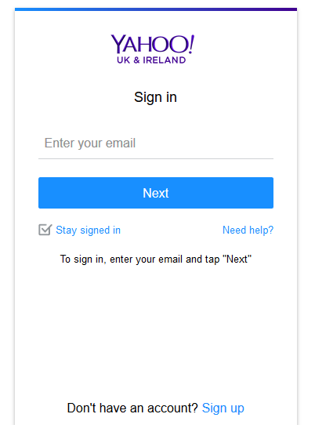

4.3.2. Retriveing forgoton/lost password
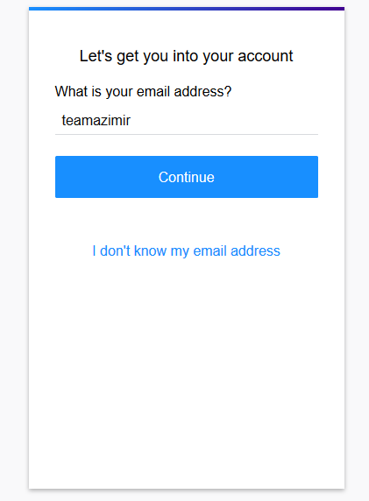
4.3.3. Writing,editing sending e-mail.

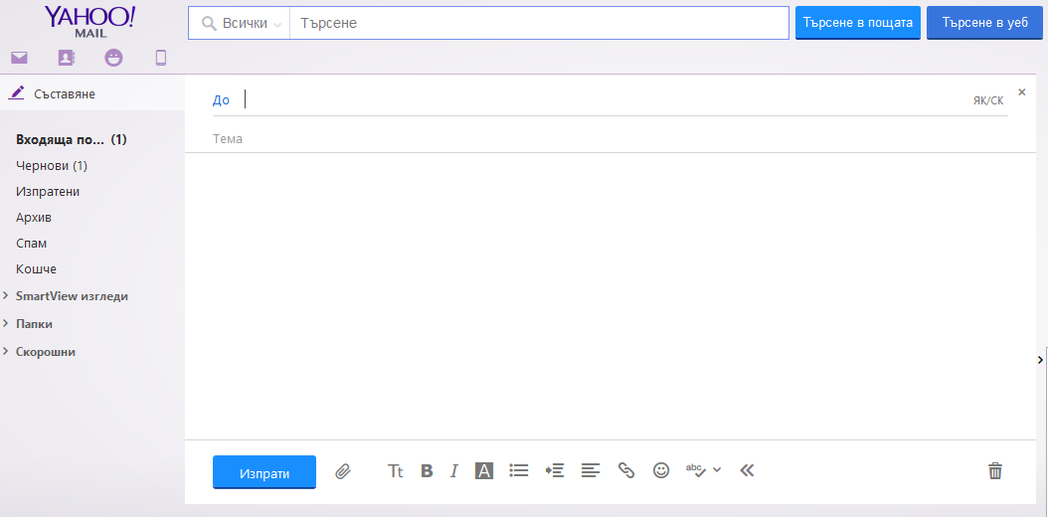

4.3.4.Creating a draft
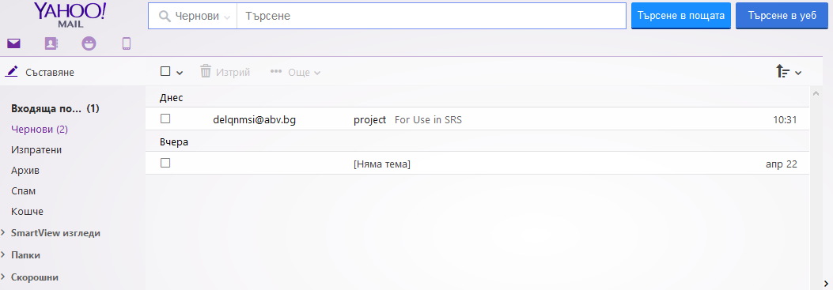

4.3.5. Deliting a masage

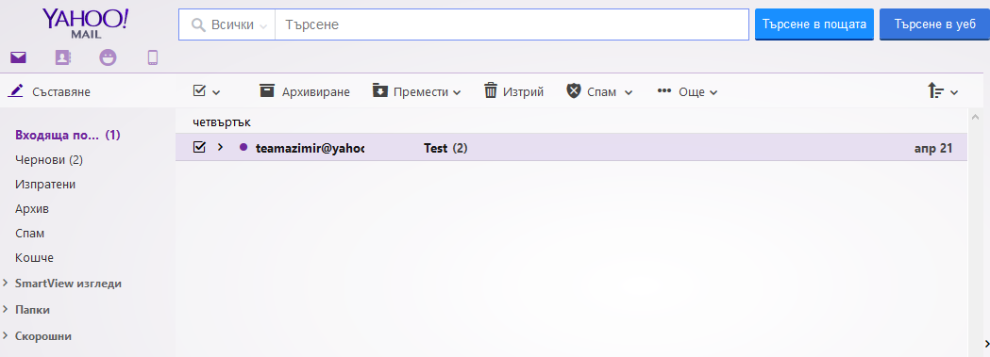

4.3.6. Adding/deleting contact

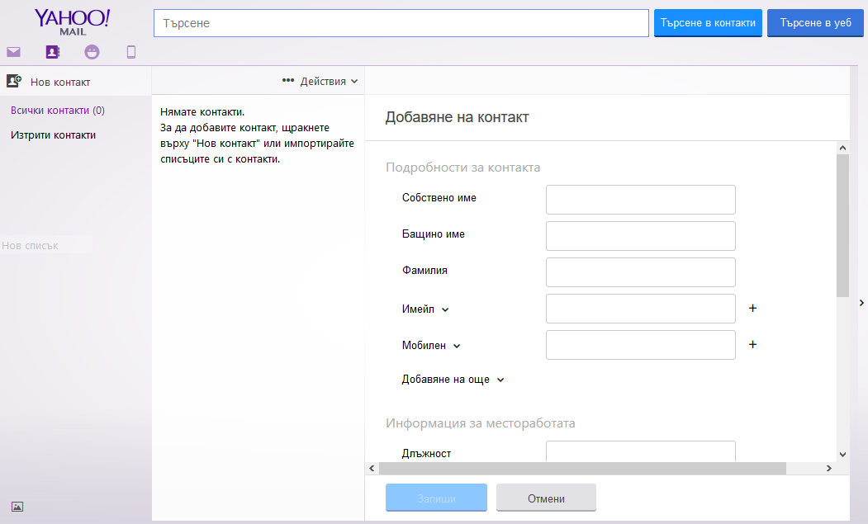

4.3.7. log out

