**SBL User Guide**

**SBL (Secondary Boot Loader)**

**User Guide**

# Table of Contents

1 Table of Contents 2

1. Introduction 5

2 SBL Supported Devices 5

3 Image Formats 6

3.1 SBL Bootloader Image 6

3.2 CH Image 7

3.3 Application Image 7

3.3.1 TDA3xx SBL 10

4 Building the SBL 11

5 Boot Modes of SBL 12

5.1 Flash Tools 13

5.1.1 QSPI Flash Writer 13

5.1.2 NOR Flash Writer 13

5.2 QSPI boot mode 13

5.3 NOR Boot Mode 14

5.4 MMCSD Boot Mode 15

5.4.1 Using PC tool 15

5.4.2 Option 2: Steps to prepare a bootable SD card using DISKPART 16

5.5 QSPI_SD Boot Mode 17

6 Board Modification 18

6.1 TDA2xx Board Modification for NOR BOOT Mode: 18

6.2 TDA2Px Board Modification for NOR BOOT Mode: 18

6.3 TDA2Ex Board Modification for NOR and QSPI BOOT Mode: 19

6.4 TDA2Ex_17x17 Board Modification for NOR BOOT Mode: 20

6.5 TDA3xx Board Modification for NOR BOOT Mode: 21

7 Build Mode 22

8 EMIFMODE 22

9 Multi OPP Support 22

10 SBL Optimization Level 24

11 PAD Configuration 24

12 WatchDog Timer2 (WD_TIMER2) 25

13 DSP Boot address alignment 25

14 AD PLL Clock Frequency 25

15 Boot-Up time 25

15.1 TDA2xx Device 25

15.1.1 QSPI Boot mode: 25

15.1.2 NOR Boot mode: 26

15.1.3 SD Boot mode: 26

15.2 TDA2Px Device 26

15.3 TDA2Ex Device 27

15.4 TDA2Ex_17x17 Device 27

15.5 TDA3xx Device 28

16 Component Folder 29

17 UART Console 29

18 Prebuilt Binaries 31

19 Multi core Image generation script 31

20 SBL Multicore Mailbox app 31

21 HS device support 32

21.1 Memory map 32

21.2 Boot authentication 32

21.2.1 Setting up MShield-DK/SECDEV for TDA2x 32

21.2.2 Boot-Image (PPA + SBL) generation 35

21.2.3 Signing AppImages 35

22 Flashing production binaries using – mflash 36

22.1.1 PC side setup 36

22.1.2 Build steps 36

22.1.3 Generating mflash SBL 36

23 Known Issues 36

24 Revision History 37

# Introduction

The Secondary Bootloader (SBL) initializes the execution environment for multi-core RTOS applications. It sets-up the AD PLL clock to values specified in TDA2xx, TDA2Px, TDA2Ex, TDA2Ex17x17 or TDA3xx datasheet, powers on the I/O Peripherals, initializes the DDR, loads the application image into DDR & brings the slave cores out of reset.

SBL supports three boot modes: QSPI, MMCSD & NOR for TDA2xx, TDA2Px,, TDA2Ex & TDA2Ex17x17 devices and QSPI, QSPI_SD & NOR for TDA3xx device. It copies the Multicore App Image from storage memory device, parses it & loads the executables into DDR.

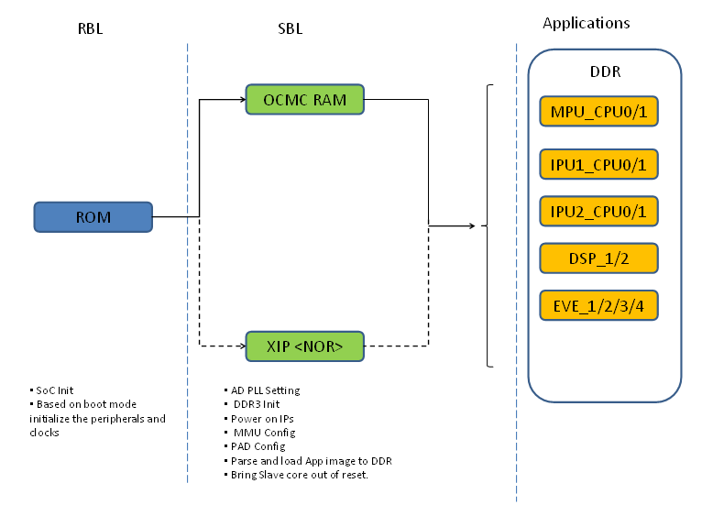

# SBL Supported Devices

This release of SBL supports the TDA2xx, TDA2Px, TDA2Ex, TDA2Ex17x17 and TDA3xx devices. The SBL also supports DRA7xx family of devices in the Processor SDK Automotive Audio. For the remainder of this document, the following mappings are interchangeable, unless otherwise specified:

* TDA2xx ⬄ DRA74x/DRA75x
* TDA2Ex ⬄ DRA72x
* TDA2Ex17x17 ⬄ DRA71x
* TDA3xx ⬄ DRA78x

# Image Formats

SBL Image Format:

In non-XIP boot mode, RBL expects the GP header to execute SBL and in XIP boot mode, it expects the SBL image in bin format. SBL image along with GP header is referred as tiimage. For more information on tiimage, refer to the section 3.1 of this user guide.

Application Image Format:

AppImage generation is two-step process: RPRC format conversion & Multicore Image file generation.

1. Firstly, application executable has to be converted from ELF/COFF format to custom TI RPRC image format. For more information on RPRC format, refer to the section 3.3.1 of this user guide.
2. AppImage is a Multicore image file that includes the RPRC image file of individual cores. It contains the CPU ID & boot-up sequence. For more information on Multicore Image format, refer to the section 3.3.2 of this user guide.

## SBL Bootloader Image

The Boot loader Image should be converted as given in this section:

1. **Convert the ELF image to binary.**

SBL should be changed into binary format using the following command:

***$ arm-none-eabi-objcopy.exe --gap-fill=0xff -O binary SBL.out SBL.bin***

arm-none-eabi-objcopy.exe is part of Linaro or Code-sourcery tool chain and is not provided as part of the PDK package.

1. **Convert the binary file to tiimage file.**

RBL expects the secondary bootloader with GP header only in non-XIP boot mode. The tiimage format is as given below:

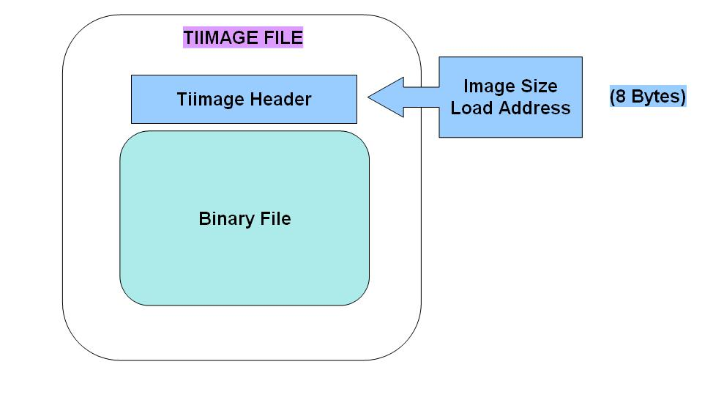

Using following command convert the generated bin file to tiimage:

***$tiimage.exe <Load Address> <ENDIAN> SBL.bin SBL.tiimage***

SBL sections should be mapped to OCMC region using the linker command file while building the SBL.

Load Address for SBL is 0x40300000 for TDA2xx/TDA2Px/TDA2Ex/ TDA2Ex17x17 whereas on TDA3xx this address is 0x00300000 as RBL already configures AMMU mapping of medium pages.

ENDIAN (BE/LE) specifies whether the TI header and the binary is in Big Endian/Little Endian.

For SPI/QSPI boot mode, the RBL expects the SBL in Big Endian.

For other boot modes (SD), the RBL expects the SBL in Little Endian.

tiimage.exe is provided as part of the PDK package under the folder packages/ti/boot/sbl_auto/tools/tiimage.

## CH Image

For fast boot on TDA3xx platform in QSPI and QSPI_SD boot mode, RBL can also boot another type of image called chimage (Configuration Header Image). RBL sets up QSPI speed as 48 MHz by default. On adding the CH header to tiimage we can change the QSPI speed. The configuration header is prepended to tiimage to create chimage. The size of header is 0x200 bytes.

Boot loader Image should be converted to chimage using below command:

***$chimage.exe CH.bin SBL.tiimage SBL.chimage***

Chimage.exe tool and the CH bin for TDA3xx (tda3x_chqspi_clock64mhz.bin) are present in folder packages/ti/boot/sbl_auto/tools/chimage.

## Application Image

The Application Image should be converted as given in this section. The Application Images of all the Cores should be built in ELF/Coff format and converted to a single file called Multi core Image file.

1. **Convert ELF to RPRC format**

RPRC Image Format is as shown below:

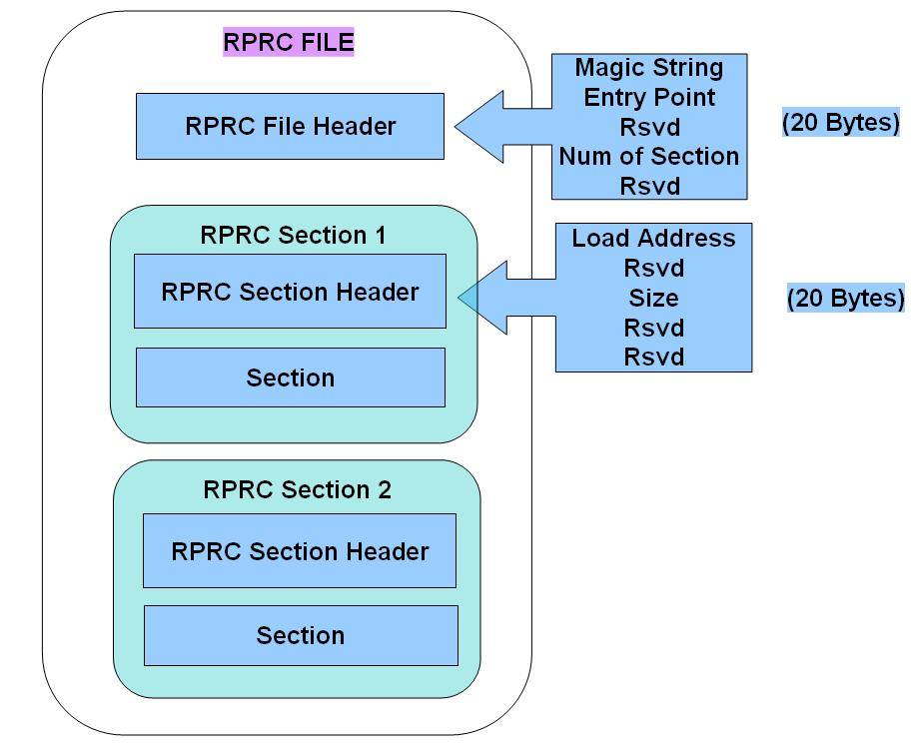

As shown in above diagram, RPRC file has one file header and multiple sections. File Header contains Magic string for sanity check of the image, Entry Point, Number of Sections and One reserved word.

File header is followed by multiple Sections. Each Section has section header and section data. The Section Header has five words: Load address, one reserved word, size and two reserved words. Address specifies the destination address of that section and size specifies section size in bytes of the Section Data that follows. The whole section has to be copied to the load address. RPRC sections are generated for each elf section as part of the elf executable.

Convert the different application image files (ELF/COFF) for various cores to RPRC image using the following command:

***$out2rprc.exe <App_In_name(elf or coff)> <App_out_name>***

out2rprc.exe is provided in tools as part of the PDK package under packages/ti/boot/sbl_auto/tools/out2rprc.

1. **Multi core Image generation from the application RPRC images.**

Multi core image format is as shown below:

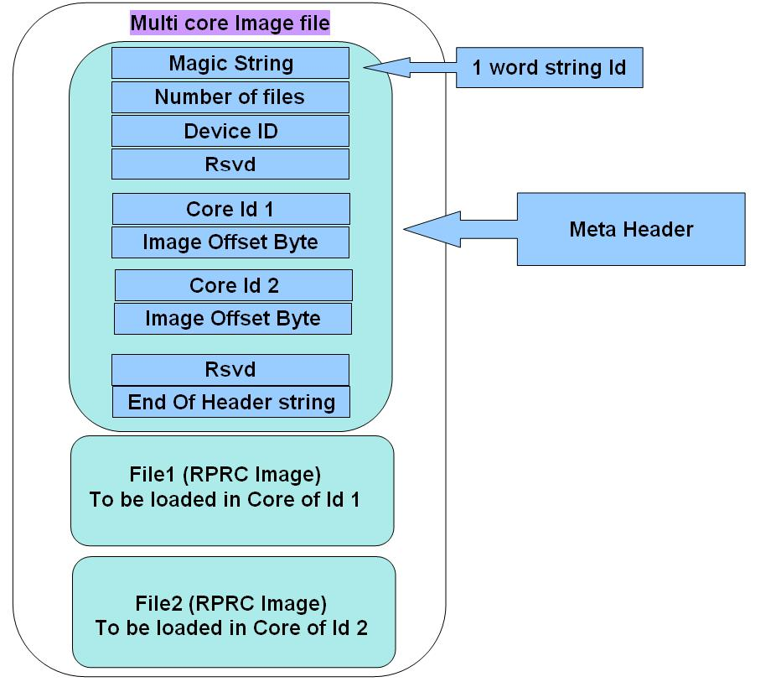

Meta Header is of variable length and depends on the number of files included. First word is a magic string for sanity check of the image. MSTR in ASCII will be used as the magic string. Second word is the number of RPRC image files included in the generated multi core image file. Third word is the Device Id followed by a reserved word. After this, follows the two word structure of Core Id and the offset for RPRC Image i.e. the starting byte of RPRC image. For a given structure, RPRC Image starting at the given offset will be loaded on the Core mentioned as Core Id.

Core IDs for TDA2xx device:

|  |  |
| --- | --- |
| MPU_CPU0_ID  (Master) | 0 |
| MPU_CPU1_ID | 1 |
| IPU1_CPU0_ID | 2 |
| IPU1_CPU1_ID | 3 |
| IPU1_CPU_SMP_ID | 4 |
| IPU2_CPU0_ID | 5 |
| IPU2_CPU1_ID | 6 |
| IPU2_CPU_SMP_ID | 7 |
| DSP1_ID | 8 |
| DSP2_ID | 9 |
| EVE1_ID | 10 |
| EVE2_ID | 11 |
| EVE3_ID | 12 |
| EVE4_ID | 13 |

Core IDs for TDA2Px device:

|  |  |
| --- | --- |
| MPU_CPU0_ID  (Master) | 0 |
| MPU_CPU1_ID | 1 |
| IPU1_CPU0_ID | 2 |
| IPU1_CPU1_ID | 3 |
| IPU1_CPU_SMP_ID | 4 |
| IPU2_CPU0_ID | 5 |
| IPU2_CPU1_ID | 6 |
| IPU2_CPU_SMP_ID | 7 |
| DSP1_ID | 8 |
| DSP2_ID | 9 |
| EVE1_ID | 10 |
| EVE2_ID | 11 |

Core IDs for TDA2Ex/TDA2Ex_17x17 device:

|  |  |
| --- | --- |
| MPU_CPU0_ID  (Master) | 0 |
| IPU1_CPU0_ID | 2 |
| IPU1_CPU1_ID | 3 |
| IPU1_CPU_SMP_ID | 4 |
| IPU2_CPU0_ID | 5 |
| IPU2_CPU1_ID | 6 |
| IPU2_CPU_SMP_ID | 7 |
| DSP1_ID | 8 |

Core Id for TDA3xx device:

|  |  |
| --- | --- |
| CORE_ID_IPU1_CPU0 | 2 |
| CORE_ID_IPU1_CPU1 | 3 |
| CORE_ID_DSP1 | 6 |
| CORE_ID_DSP2 | 7 |
| CORE_ID_EVE1 | 8 |
| CORE_ID_IPU1 | 14 |

There is a reserved word after the Core Id and the offset values, it should be used for calculating Meta header CRC to validate header before parsing the RPRC images. String MEND in ASCII is used as last word at the end of header string.

Create the Multicore Image from all the RPRC images using the following command.

***$ MulticoreImageGen.exe <ENDIAN> <Dev Id> <App out file> <Core Id 1> <RPRC in file for Core Id 1> [<Core Id n> <RPRC in file for Core Id n> ...]***

*ENDIAN (BE/LE):* specifies whether the out file is in Big Endian/Little Endian format. For QSPI/SPI boot mode application image should be in BE, for other boot modes application image should be in LE.

*Dev Id:* This is the device Id. Still the Device Ids of the supported devices are not populated & random values are chosen. In the present implementation of the SBL, only warning is printed on UART console if the device id doesn’t match and the boot is not aborted.

*App out file:* This is the name of the multicore image file to be created.

*Core Id*: This is the Id of the core as given in the table above to be followed by the *RPRC image file name* to be loaded in that core. The order of the core Id and RPRC file pair given while generating the file determines the order in which the slave cores are booted. If the image is SMP, please select the SMP core-id.

multicoreImageGen.exe is provided in tools as part of the PDK package under packages/ti/boot/sbl_auto/tools/multicore_image_generator.

There is a **batch file** provided under tools to generate application multicore Image from elf files. Refer to the section “Multi core Image generation script” of this user guide for batch file usage.

### TDA3xx SBL

TDA3xx bootloader supports CRC checks on application image and hence the multicore application image header has the golden CRC embedded in it. This golden CRC is calculated using offline tool and SBL computes CRC using the TDA3xx CRC hardware and checks for CRC match. In case the CRC does not match the boot is aborted.

Sample multi-core header for TDA3xx application image with one core’s application image is given below:

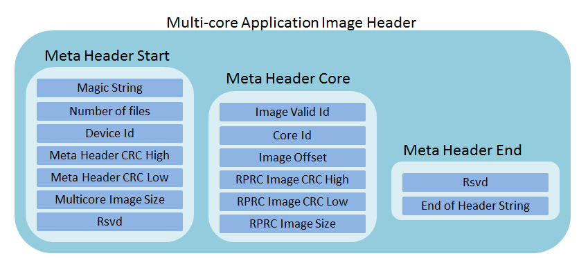

The multicore image can be generated using the tool present in TDA3xx folder in multicore tool directory. CRC is computed using the crc_multicore_image tool provided as part of the PDK package under packages/ti/boot/sbl_auto/tools/crc_multicore_image.

Command to run CRC tool is given below:

*"crc_multicore_image\crc_multicore_image.exe" %Out_Path%\AppImage_LE %Out_Path%\AppImage_BE*

**Note: User should make sure that he uses corresponding tools with TDA3xx SBL, otherwise SBL boot will fail.**

# Building the SBL

SBL is part of PDK package located under packages/ti/boot/sbl_auto sub-directory. Command to build the SBL is as follows:

***$gmake -C <pdk_dir>/packages/ti/build -s BOARD=<board> CORE=<core> BUILD_PROFILE=<profile> sbl <BOOTMODE=<bootmode>***

<board>: This parameter can be ‘tda2xx-evm’, ‘tda2ex-evm’, ‘tda3xx-evm’, ‘evmDRA72x, ‘evmDRA75x’, or ‘evmDRA78x’.

<core>: To build SBL for Cortex-A15, boot the parameter is ‘a15_0’ (valid only for TDA2xx/TDA2Px/TDA2Ex)

To build SBL for Cortex-M4, boot the parameter is ‘ipu1_0’ (valid only for TDA3xx)

<profile>: To build SBL in debug mode the parameter is ‘debug’

To build SBL in release mode the parameter is ‘release’

<bootmode>: To build sbl for SD boot mode the parameter is ‘sd’ (valid only for TDA2xx/TDA2PxTDA2Ex)

To build sbl for QSPI boot mode the parameter is ‘qspi’

To build sbl for NOR boot mode the parameter is ‘nor’

To build sbl for QSPI_SD boot mode the parameter is ‘qspi_sd” (valid only for TDA3xx)

Note: Command to build the SBL for all boot modes in release mode:

***$gmake -s -C <pdk_dir>/packages/ti/build sbl_all BOARD=<board>***

**Note: Build commands for TDA2Ex_17x17 are same as TDA2Ex. They are differentiated at run time.**

The SBL sections should be mapped into OCMC Region. This is specified in the Linker command file. The RBL loads the SBL into OCMC RAM for non-XIP memory devices. For NOR boot mode, the entry point has to be mapped to 0x08000000. This is specified in the NOR Linker command file.

The SBL executable can be located under the folder: packages/ti/binary/sbl/<bootmode>/<opp>/<board>/sbl_<bootmode>_<opp>_<core>_<profile>.<extension>

< extension> will be xa15g for A15 core and xem4 for M4 core.

To convert the elf image into bin & tiimage file refer to the section 3.1 “SBL Bootloader Image” of this user guide.

# Boot Modes of SBL

Supported boot modes on TDA2xx ES1.1 and ES2.0 device:

|  |  |  |  |  |
| --- | --- | --- | --- | --- |
| Boot Mode | EVM Switch SYSBOOT(SW2)[1:16] | EVM Switch SW5[1:10] | Execution Mode | Entry location |
| QSPI_1 | 01101100 10000001 | 1110100000 | Non-XIP | 0x40300000 |
| QSPI_4 | 11101100 10000001 | 1110100000 | Non-XIP | 0x40300000 |
| NOR | 10101100 10000101 | 0100100000 | XIP | 0x08000000 |
| SD | 00001100 10000001 | 0001100000 | Non-XIP | 0x40300000 |
| Debug | 00000000 10000001 | XXXXXXXX |  |  |

Supported boot modes on TDA2xx ES1.0 device:

|  |  |  |  |  |
| --- | --- | --- | --- | --- |
| Boot Mode | EVM Switch SYSBOOT(SW2)[1:16] | EVM Switch SW5[1:10] | Execution Mode | Entry location |
| QSPI | 01101100 10000001 | 1110100000 | Non-XIP | 0x40300000 |
| NOR | 10101100 10000101 | 0100100000 | XIP | 0x08000000 |
| SD | 11100000 10000001 | 0001100000 | Non-XIP | 0x40300000 |

Supported boot modes on TDA2Px/TDA2Ex/TDA2Ex_17x17 ES1.0 device:

|  |  |  |  |  |
| --- | --- | --- | --- | --- |
| Boot Mode | EVM Switch SYSBOOT(SW2)[1:16] | EVM Switch SW5[1:10] | Execution Mode | Entry location |
| QSPI_1 | 01101100 10000001 | 0001100000 | Non-XIP | 0x40300000 |
| QSPI_4 | 11101100 10000001 | 0001100000 | Non-XIP | 0x40300000 |
| NOR | 10101100 10000101 | 0100100000 | XIP | 0x08000000 |
| SD | 00001100 10000001 | 0001100000 | Non-XIP | 0x40300000 |
| Debug | 00000000 10000001 | XXXXXXXX |  |  |

Supported boot modes on TDA3xx 15X15 ES1.0 and ES2.0 device:

|  |  |  |  |  |
| --- | --- | --- | --- | --- |
| Boot Mode | EVM Switch SYSBOOT(SW2)[1:16] | EVM Switch SW8001[1:8] | Execution Mode | Entry location |
| QSPI_1 | 00011000 10000001 | 0100 0001 | Non-XIP | 0x00300000 |
| QSPI_4 | 10011000 10000001 | 0100 0001 | Non-XIP | 0x00300000 |
| NOR | 01011000 10000101 | 1100 0001 | XIP | 0x08000000 |
| Debug | 00111000 10000001 | XXXXXXXX |  |  |

## Flash Tools

### QSPI Flash Writer

In order to flash the SBL tiimage and multicore AppImage in QSPI flash, QSPI flash writer tool is required. This tool is present in the PDK directory packages/ti/boot/sbl_auto/qspiflash/examples.

Use the following command to build this tool in release mode:

**$gmake -s -C <pdk_dir>/packages/ti/build qspi_flash_writer BOARD=<board>**

The binary qspi_flash_writer_ipu1_0_ release.xem4 will be created in folder binary\qspiFlashWriter\bin\<board>.

### NOR Flash Writer

In order to flash the SBL bin file and multicore AppImage in NOR flash, NOR flash writer tool is required. This tool is present in the PDK directory packages/ti/boot/sbl_auto/norflash/examples.

Use the following command to build this tool in release mode:

**$gmake -s -C <pdk_dir>/packages/ti/build nor_flash_writer BOARD=<board>**

The binary nor_flash_writer_ipu1_0_release.xem4 will be created in folder binary\norFlashWriter\bin\<board>.

## QSPI boot mode

QSPI Memory Map:

In QSPI flash, flash SBL tiimage at offset 0x0 and the multicore Application Image file at offset 0x80000. QSPI flash part present on TI EVMs is of size 32/64 MB. Flash size can be different on custom board. For exact size please refer to the exact part number.

SBL

Application

Multicore Image

Offset

0x0

0x80000

0x2000000/0x4000000

Flashing the image into QSPI Flash:

Please follow the steps below to flash the image at a particular offset address in QSPI-Flash memory:

1. Open CCS & launch the target configuration.
2. Change the SYSBOOT Switch (SW2) to debug mode.
3. Set the relevant switches as given above to access QSPI FLASH.
4. Connect the UART terminal & launch Uart console.
5. Make sure both SBL & AppImage are in Big Endian format.
6. Connect Master CPU target. Load & run SBL ELF image (SD for TDA2xx/TDA2Px/TDA2Ex and QSPI_SD for TDA3xx).

Note: Refer to section 4 of this userguide to build SBL ELF image file.

1. Load the qspi_flash_writer_ipu1_0_release.xem4 on Cortex-M4 present at location packages\ti\binary\sbl\qspi_flash_writer\<board> & execute it from CCS.
2. Select if you want one bit write or 4 bit write.
3. Enter the image name to be flashed into QSPI.
4. Enter the offset value in hex.
5. Select the erase mode. In full erase mode, tool will erase the whole flash & terminates. Reset the target & start from step VI.
6. On selecting the Load option there will be two options: fread using RTS library or CCS scripting console. Fread using RTS could be slow for large images, so use the loadRaw command using the CCS scripting console.
7. Tool will first erase the flash & start writing the image.
8. “Verifying…Success” on the console signifies successful completion of the flashing.

## NOR Boot Mode

NOR Memory Map:

For NOR boot mode, make sure that the SBL is in bin format. Just convert the SBL.out file to binary and **don’t** convert to tiimage file.

SBL

Application

Multicore Image

Offset

0x0

0x80000

0x2000000

Flash the SBL binary image in the NOR Flash at 0x0 offset and the Application multicore Image file at offset 0x80000.

Flashing the image into NOR Flash:

Please follow the steps below to flash the image at a particular offset address in NOR-Flash memory:

1. Open CCS & launch the target configuration.
2. Change the SYSBOOT (SW2) switch to debug mode.
3. Set the relevant switches as given above to access NOR FLASH.
4. Connect the UART terminal & launch Uart console.
5. Make sure the AppImage is in Little Endian format.
6. Connect Master CPU target. Load & run SBL image (QSPI/SD ELF images) on OCMC RAM.

Note: Refer to section 4 of this userguide to build SBL ELF image file.

1. Load the nor_flash_writer_ipu1_0_release.xem4 into Cortex-M4 present at location packages\ti\binary\sbl\nor_flash_writer\<board> & execute it from CCS.
2. Enter the image name to be flashed into NOR.
3. Enter the offset value in Hex.
4. Select the erase mode. In full erase mode, tool will erase the whole flash & terminates. Reset the target & start from step VI.
5. Select the Load option. Fread using RTS library or CCS scripting console. Fread using RTS could be slow for large images, so use the loadRaw command using the CCS scripting console.
6. Tool will first erase the flash & start writing the image.
7. “Verifying…Success” on the console signifies successful completion of the flashing.

## MMCSD Boot Mode

Create a primary FAT partition on MMC/SD card (FAT32 format with sector size 512).

Rename the SBL tiimage as MLO and copy to the SD card.

Rename the Application multicore image file as “AppImage” and copy to SD card.

Steps to create bootable SD card are given below

### Using PC tool

* Ensure Empty SD card (at least 256MB, preferably 4GB SDHC) is available.
* Ensure SD memory card reader is available.
* Create a primary FAT partition on MMC/SD card (FAT32 format with sector size 512) and mark it as Active. A partition manager utility has to be used for the same.
* Format SD card from DOS command line as below.

“format <drive> /A:512 /FS:FAT32”

**Make SD card partition as active using below tool:**

<http://www.pcdisk.com/download.html>

IMPORTANT NOTE: Create a primary FAT partition on MMC/SD card (FAT32 format with sector size 512 bytes mark the partition as active.

### Option 2: Steps to prepare a bootable SD card using DISKPART

* Open windows 7 Command prompt and Run as Administrator mode
* Enter command "diskpart.exe"

C:\Windows\system32>diskpart.exe will take you DISKPART prompt

**Warning: Enter below command carefully w.r.t your computer/laptop SD card disk number. Choosing wrong disk number may delete data present in other drive**

To list all disk drive present on computer:

***DISKPART> list disk***

Select the SD card disk number, in my case it is disk 1:

***DISKPART> select disk 1***

Now all next command applicable only to disk 1(SD card)

Delete entire partition:

***DISKPART> clean***

To create Primary partition:

***DISKPART> create partition primary***

To list partition:

***DISKPART> list partition***

Select partition:

***DISKPART> select partition 1***

To list volume:

***DISKPART> list volume***

Select volume associated with SD card, in our case it is 3:

***DISKPART> select volume 3***

Format SD card, please wait this may take few seconds:

***DISKPART>format quick fs=fat32 unit=512 label=SD_BOOT***

Make disk active:

***DISKPART> active***

To exit utility:

***DISKPART> exit***

## QSPI_SD Boot Mode

In this boot mode, SBL is flashed on QSPI flash and AppImage is present on SD card.

Steps for how to flash the SBL on QSPI memory are present in section 5.2 of this userguide.

Create a primary FAT partition on MMC/SD card (FAT32 format with sector size 512).

Rename the Application multicore image file as “AppImage” and copy to SD card.

Note: Windows format disk not makes the SD card as bootable. Please format the card as bootable on Linux based PC.

**NOTE: Only SBL image should be flashed on QSPI.**

# Board Modification

## TDA2xx Board Modification for NOR BOOT Mode:

By default QSPI’s Zero ohm resistor are connected and GPMC lines are opened. To get NOR working, required to remove the QSPI Zero Ohm resistor & pop-up GPMC resistors as stated below.



* Remove the R735 resistor and popup at R736 resistor => C_GPMC_A13
* Remove the R737 resistor and popup at R738 resistor => C_GPMC_A14
* Remove the R739 resistor and popup at R740 resistor => C_GPMC_A15
* Remove the R741 resistor and popup at R742 resistor => C_GPMC_A16
* Remove the R743 resistor and popup at R744 resistor => C_GPMC_A17
* Remove the R745 resistor and popup at R746 resistor => C_GPMC_A18
* Remove the R747 resistor and popup at R748 resistor => C_GPMC_nCS2

QSPI will not work on Tda2xx Board which is modified for NOR BOOT Mode. For NOR, EVM switch setting SW5[1:10] – 0100100000

## TDA2Px Board Modification for NOR BOOT Mode:

By default QSPI’s Zero ohm resistor are connected and GPMC lines are opened. To get NOR working, required to remove the QSPI Zero Ohm resistor & pop-up GPMC resistors as stated below.

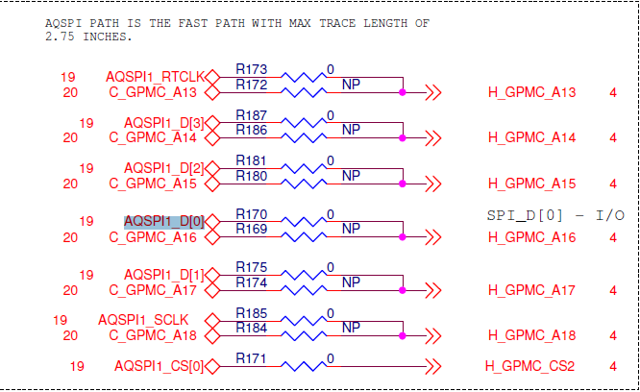

* Remove the R173 resistor and popup at R172 resistor => C_GPMC_A13
* Remove the R187 resistor and popup at R186 resistor => C_GPMC_A14
* Remove the R181 resistor and popup at R180 resistor => C_GPMC_A15
* Remove the R170 resistor and popup at R169 resistor => C_GPMC_A16
* Remove the R175 resistor and popup at R174 resistor => C_GPMC_A17
* Remove the R185 resistor and popup at R184 resistor => C_GPMC_A18

QSPI will not work on Tda2Px Board which is modified for NOR BOOT Mode. For NOR, EVM switch setting SW5[1:10] – 0100100000

## TDA2Ex Board Modification for NOR and QSPI BOOT Mode:

By default QSPI’s Zero ohm resistor are connected and GPMC lines are opened. To get NOR working, required to remove the QSPI Zero Ohm resistor & pop-up GPMC resistors as stated below.



* Remove the R735 resistor and popup at R736 resistor => C_GPMC_A13
* Remove the R737 resistor and popup at R738 resistor => C_GPMC_A14
* Remove the R739 resistor and popup at R740 resistor => C_GPMC_A15
* Remove the R741 resistor and popup at R742 resistor => C_GPMC_A16
* Remove the R743 resistor and popup at R744 resistor => C_GPMC_A17
* Remove the R745 resistor and popup at R746 resistor => C_GPMC_A18
* Remove the R747 resistor and popup at R748 resistor => C_GPMC_nCS2

For NOR, EVM switch setting SW5[1:10] – 0100100000. For SPI Flash, by default A-QSPI path resistor are connected and B-QSPI path resistor are opened. To get QSPI working on the TDA2EX Board which is modified for NOR, required to remove the A-QSPI path resistor & pop-up B-QSPI path resistor as stated below.



* Remove the R728 resistor and popup at R468 resistor => B_QSPI1_SCLK, QSPI1_RTCLK
* Remove the R731 resistor and popup at R732 resistor => QSPI1_CS[0]
* Remove the R729 resistor and popup at R444 resistor => QSPI1_D[0]
* Remove the R730 resistor and popup at R132 resistor => QSPI1_D[1]
* Remove the R733 resistor and popup at R443 resistor => QSPI1_D[2]
* Remove the R726 resistor and popup at R130 resistor => QSPI1_D[3]

For QSPI, EVM switch setting SW5[1:10] – 0001100000

## TDA2Ex_17x17 Board Modification for NOR BOOT Mode:

By default QSPI’s Zero ohm resistor are connected and GPMC lines are opened. To get NOR working, required to remove the QSPI Zero Ohm resistor & pop-up GPMC resistors as stated below.

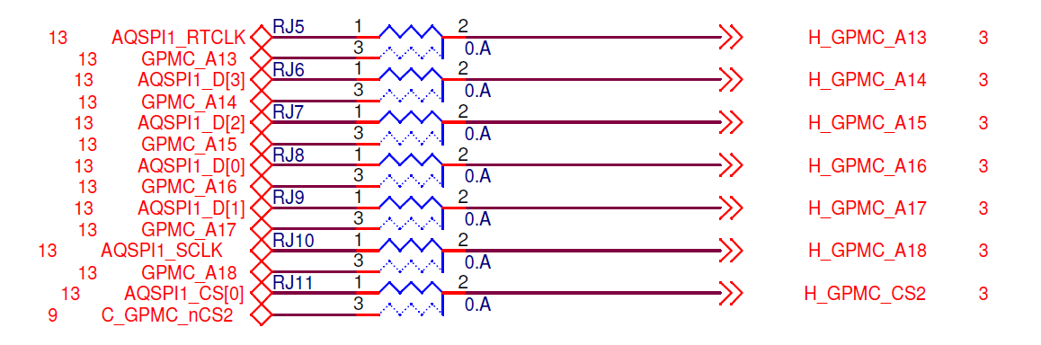

* Remove the register between pin 1 and 2 of RJ5 and pop between pin2 and 3 => GPMC_A13
* Remove the register between pin 1 and 2 of RJ6 and pop between pin2 and 3 => GPMC_A14
* Remove the register between pin 1 and 2 of RJ7 and pop between pin2 and 3 => GPMC_A15
* Remove the register between pin 1 and 2 of RJ8 and pop between pin2 and 3 => GPMC_A16
* Remove the register between pin 1 and 2 of RJ9 and pop between pin2 and 3 => GPMC_A17
* Remove the register between pin 1 and 2 of RJ10 and pop between pin2 and 3 => GPMC_A18
* Remove the register between pin 1 and 2 of RJ11 and pop between pin2 and 3 => GPMC_CS2

For NOR, EVM switch setting SW8[1:10] – 0100100000.

## TDA3xx Board Modification for NOR BOOT Mode:

By default QSPI’s Zero ohm resistor are connected and GPMC lines are opened. To get NOR working, required to remove the QSPI Zero Ohm resistor & pop-up GPMC resistors as stated below.



* Remove the register between pin 1 and 2 of RJ24 and pop between pin2 and 3 => GPMC_A17

# Build Mode

SBL supports two types of build modes: *production* and *development*.

In production build mode, if a valid app image for a given CPU core is not found, then the SBL puts the corresponding core to power down mode which helps save power in the device.

In development build mode, the CPU is not put to power down mode when valid app image is not there.

Production build mode is selected by default.

SBL can be built for different build modes using below command:

**gmake -s -C <pdk_dir>/packages/ti/build sbl BOOTMODE=<bootmode> CORE=<core> BOARD=<board> SBL_BUILD_MODE=<mode>**

mode: To build sbl for production boot mode the parameter is ‘prod’

To build sbl for development boot mode the parameter is ‘dev’

# EMIFMODE

SBL supports different LISA configurations for various devices. The following configurations are supported for TDA2xx device: SBLLIB_DUAL_EMIF_2X512MB, SBLLIB_DUAL_EMIF_1GB_512MB, SBLLIB_SINGLE_EMIF_256MB and SBLLIB_SINGLE_EMIF_512MB. The different modes can be set by modifying the macro TDA2XX_EMIF_MODE. This macro is defined in the file packages\ti\boot\sbl_auto\sbl_lib\src\tda2xx\sbl_lib_config_tda2xx.h. By default, SBLLIB_SINGLE_EMIF_512MB is selected. To build SBL for different EMIF Mode user can modify this macro definition and rebuild the SBL.

# Multi OPP Support

SBL supports three different OPPs for TDA2xx/TDA2Px/TDA2Ex/TDA2Ex17x17 and TDA3xx devices: opp_nom, opp_high and opp_od. For TDA2xx device, SBL only one more OPP: opp_low. The different OPPs can be set using the build option OPPMODE=<option>. By default, opp_nom is selected. The build command is given below:

**$ gmake -s -C <pdk_dir>/packages/ti/build sbl CORE=<core> BOARD=<board> BOOTMODE=<bootmode> OPPMODE=<option>**

You can build SBL for all OPPs in all supported bootmodes using the target sbl_all_opps:

**$gmake -s -C <pdk_dir>/packages/ti/build sbl_all_opps BOARD=<board>**

Multiple OPPs are supported across different voltage rails where every rail might not support all three OPPs. If any voltage rail does not support a particular OPP and SBL is built for that particular OPP then that voltage rail is configured for OPP NOM.

|  |  |  |  |  |
| --- | --- | --- | --- | --- |
| Voltage Rail | TDA2xx OPP SUPPORT | | | |
| OPP LOW | OPP NOM | OPP OD | OPP HIGH |
| VD_MPU | Supported | Supported | Supported | Supported |
| VD_DSPEVE | Not Supported | Supported | Supported | Supported |
| VD_IVA | Not Supported | Supported | Supported | Supported |
| VD_GPU | Not Supported | Supported | Supported | Supported |
| VD_CORE | Not Supported | Supported | Not Supported | Not Supported |

|  |  |  |  |  |
| --- | --- | --- | --- | --- |
| Voltage Rail | TDA2Px OPP Support | | | |
| OPP LOW | OPP NOM | OPP OD | OPP HIGH |
| VD_MPU | Supported | Supported | Supported | Supported |
| VD_DSPEVE | Not Supported | Supported | Supported | Supported |
| VD_IVA | Not Supported | Supported | Supported | Supported |
| VD_GPU | Not Supported | Supported | Supported | Supported |
| VD_CORE | Not Supported | Supported | Not Supported | Not Supported |

|  |  |  |  |
| --- | --- | --- | --- |
| Voltage Rail | TDA2Ex OPP SUPPORT | | |
| OPP NOM | OPP OD | OPP HIGH |
| VD_MPU | Supported | Supported | Supported |
| VD_DSPEVE | Supported | Supported | Supported |
| VD_IVA | Supported | Supported | Supported |
| VD_GPU | Supported | Supported | Supported |
| VD_CORE | Supported | Not Supported | Not Supported |

|  |  |  |  |
| --- | --- | --- | --- |
| Voltage Rail | TDA2Ex_17x17 OPP SUPPORT | | |
| OPP NOM | OPP OD | OPP HIGH |
| VD_MPU (Ganged with VD Core on EVM) | Supported | Not Supported | Not Supported |
| VD_DSPEVE | Supported | Not Supported | Supported |
| VD_IVA (Ganged with VD DSP on EVM) | Supported | Not Supported | Supported |
| VD_GPU (Ganged with VD Core on EVM) | Supported | Not Supported | Not Supported |
| VD_CORE | Supported | Not Supported | Not Supported |

|  |  |  |  |
| --- | --- | --- | --- |
| Voltage Rail | TDA3xx OPP SUPPORT | | |
| OPP NOM | OPP OD | OPP HIGH |
| VD_DSPEVE | Supported | Supported | Supported |
| VD_CORE | Supported | Not Supported | Not Supported |

# SBL Optimization Level

SBL supports different levels of optimization in order to achieve better performance. This feature needs platform specific modifications. There are three levels of optimization: ‘high’, ‘medium’ and ‘low’. The amount of prints given by SBL reduces as the optimization level increases. By default the optimization level is set as ‘low’. You can specify optimization level by using below build command:

**gmake -s sbl BOOTMODE=<bootmode> BOARD=<board> SBL_OPT_MODE=<mode>**

mode: To build sbl for high optimization level, the parameter is ‘high’

To build sbl for medium optimization level, the parameter is ‘medium’

To build sbl for low optimization level, the parameter is ‘low’

# PAD Configuration

PADs should be configured in isolation in case of TDA2xx, TDA2Ex and TDA2Ex17x17 device. This is done when SBL configures IO delay. Currently the SBL is doing IO delay calibration for a sample use case. User has to modify the pin mux configuration as per their use case. User needs to refer to device data sheet for adding IO delay configuration. User can refer to IO Delay Configuration application note for more information on IO recalibration and IO delay configuration (Link: <https://cdds.ext.ti.com/ematrix/common/emxNavigator.jsp?objectId=28670.42872.36762.42390>).

# WatchDog Timer2 (WD_TIMER2)

For TDA2xx/TDA2Ex/TDA2Ex17x17 device, ROM Bootloader enables the WD_TIMER2 & sets the value to three minutes. Second stage Bootloader and application need to handle the WD_TIMER2. SBL refreshes the WD_Timer2 but does not disable it.

For TDA3xx device, RTI DWWD is disabled by SBL.

# DSP Boot address alignment

Boot address for the DSP Core should be aligned to ‘0x400’ boundary. When the SBL brings DSP core out of reset it can load only the higher order 22 bits of the boot address and the lower order 10 bits are expected to be 0.

In the linker command file you can specify the following to align the boot address.

In case of non rtsc project the Entry point symbol _c_int00 for will be defined in rts*.lib file.

*SECTIONS*

*{*

*boot :*

*{*

*rts*.lib<boot.obj>(.text)*

*}load > MemorySectionName ALIGN(0x400)*

*}*

In case of the RTSC projects xdctools specify the Entry point symbol.

*Program.sectMap[".text:_c_int00"] = new Program.SectionSpec();*

*Program.sectMap[".text:_c_int00"].loadSegment = "DSP1_PROG";*

*Program.sectMap[".text:_c_int00"].loadAlign = 0x400;*

# AD PLL Clock Frequency

Device ADPLLJM & ADPLLM are clocked at respective frequencies depending on the OPP. Refer to the device datasheet for frequency values for respective OPP.

# Boot-Up time

## TDA2xx Device

This section summarizes the SBL boot-up cycles for TDA2xx device in all three boot modes & techniques used to improve the boot-up cycles. It provides the boot-up time taken by SBL to initialize the SOC & to launch the application from external storage memories. Report does not include the ROM code boot-up time & application boot-up time. ARM Cortex PMU cycle counter has been used to measure the elapsed CPU cycles

VISION SDK App Image has been used for the SBL boot-up time profiling.

### QSPI Boot mode:

QSPI driver throughput has improved with following settings:

1. Configure QSPI SCLK at 76.8MHz for ES1.1 and higher SR devices and 48 MHz for ES1.0 device.
2. Change the QSPI into memory mapped mode & quad read mode.
3. Use EDMA to copy the sections from serial flash to device memory.

### NOR Boot mode:

NOR Flash data through put has improved by making following changes:

1. Configured the GPMC timing parameter for 266 MHZ GPMC FCLK.
2. Changed to A-sync Page read mode.
3. Replaced the memcpy with EDMA channel copy.

### SD Boot mode:

SD card data through put has improved by making following changes in the SD driver:

1. EDMA Mode: Added the EDMA mode to read data from receive buffer.
2. BUSWIDTH: SD protocol supports 1-bit & 4-bit bus width. Changed the bus-width from 1-bit to 4-bit
3. Multi sector: Implemented multi-sector support in the MMC/SD driver

|  |  |  |  |  |
| --- | --- | --- | --- | --- |
|  | | **QSPI Boot mode** | **NOR Boot mode** | **SD Boot mode** |
| Sl.No | Break Up | Time in ms | Time in ms | Time in ms |
| 1 | SBL Initial Config Cycles | 12.34 | 5.98 | 12.30 |
| 2 | SOC Init Cycles | 14.59 | 14.89 | 14.56 |
| 3 | DDR Config Clock Cycles | 3.73 | 3.79 | 3.74 |
| 4 | App Image Load Cycles | 470.49  (App Image Size 10,768 KB) | 698.69  (App Image Size 28,524 KB) | 5713.98  (App Image Size 28,524 KB) |
| 5 | Slave Core Bootup Cycles | 17.76 | 17.84 | 17.75 |
| 6 | SBL Boot-up Cycles | 519.3 | 741.29 | 5762.45 |

## TDA2Px Device

This section summarizes the SBL boot-up cycles for TDA2Ex device in all three boot modes. It provides the boot-up time taken by SBL to initialize the SOC & to launch the application from external storage memories. Report does not include the ROM code boot-up time & application boot-up time. ARM Cortex PMU cycle counter has been used to measure the elapsed CPU cycles.

|  |  |  |  |  |
| --- | --- | --- | --- | --- |
|  | | **QSPI Boot mode** | **NOR Boot mode** | **SD Boot mode** |
| Sl.No | Break Up | Time in ms | Time in ms | Time in ms |
| 1 | SBL Initial Config Cycles | 8.91 | 5.88 | 8.91 |
| 2 | SOC Init Cycles | 14.57 | 14.91 | 14.56 |
| 3 | DDR Config Clock Cycles | 7.64 | 3.74 | 7.66 |
| 4 | App Image Load Cycles | 1778  (App Image Size 29,029 KB) | 886.27  (App Image Size 36,797 KB) | 3293.22  (App Image Size 29,029 KB) |
| 5 | Slave Core Bootup Cycles | 11.13 | 11.20 | 11.13 |
| 6 | SBL Boot-up Cycles | 1820.37 | 922.12 | 3335.58 |

## TDA2Ex Device

This section summarizes the SBL boot-up cycles for TDA2Ex device in all three boot modes. It provides the boot-up time taken by SBL to initialize the SOC & to launch the application from external storage memories. Report does not include the ROM code boot-up time & application boot-up time. ARM Cortex PMU cycle counter has been used to measure the elapsed CPU cycles.

|  |  |  |  |
| --- | --- | --- | --- |
|  | | **QSPI Boot mode** | **SD Boot mode** |
| Sl.No | Break Up | Time in ms | Time in ms |
| 1 | SBL Initial Config Cycles | 8.90 | 8.91 |
| 2 | SOC Init Cycles | 14.41 | 14.39 |
| 3 | DDR Config Clock Cycles | 3.68 | 3.67 |
| 4 | App Image Load Cycles | 975.73  (App Image Size 19,530 KB) | 25310.60  (App Image Size 19,530 KB) |
| 5 | Slave Core Bootup Cycles | 1.14 | 1.13 |
| 6 | SBL Boot-up Cycles | 1003.97 | 25338.80 |

## TDA2Ex_17x17 Device

This section summarizes the SBL boot-up cycles for TDA2Ex 17x17 device in all three boot modes. It provides the boot-up time taken by SBL to initialize the SOC & to launch the application from external storage memories. Report does not include the ROM code boot-up time & application boot-up time. ARM Cortex PMU cycle counter has been used to measure the elapsed CPU cycles.

|  |  |  |  |  |
| --- | --- | --- | --- | --- |
|  | | **QSPI Boot mode** | **NOR Boot mode** | **SD Boot mode** |
| Sl.No | Break Up | Time in ms | Time in ms | Time in ms |
| 1 | SBL Initial Config Cycles | 5.72 | 5.58 | 5.70 |
| 2 | SOC Init Cycles | 14.40 | 14.74 | 14.39 |
| 3 | DDR Config Clock Cycles | 3.64 | 3.72 | 3.63 |
| 4 | App Image Load Cycles | 975.72  (App Image Size 24,521 KB) | 473.90  (App Image Size 19,530 KB) | 3887.64  (App Image Size 19,530 KB) |
| 5 | Slave Core Bootup Cycles | 1.13 | 1.15 | 1.13 |
| 6 | SBL Boot-up Cycles | 1000.73 | 499.20 | 3912.60 |

## TDA3xx Device

This section summarizes the SBL boot-up cycles for TDA3xx device in all three boot modes. It provides the boot-up time taken by SBL to initialize the SOC & to launch the application from external storage memories. Report does not include the application boot-up time. 32K Timer has been used to measured elapsed time. By default, SBL instrumentation is enabled to measure the boot-up cycles.

|  |  |  |  |  |
| --- | --- | --- | --- | --- |
|  | | **QSPI Boot mode** | **QSPI_SD Boot mode** | **NOR Boot mode** |
| Sl.No | Break Up | Time in ms | Time in ms | Time in ms |
| 1 | Reset to SBL Init Cycles | 12.02 | 13.61 | 3.87 |
| 2 | SBL Initial Config Cycles Including IPU RAM ECC Cycles | 8.11 | 8.33 | 10.95 |
| 3 | IPU RAM ECC Cycles | 1.28 | 1.43 | 0.73 |
| 4 | SOC Init Cycles | 14.28 | 14.28 | 14.40 |
| 5 | DDR Config Clock Cycles | 7.01 | 7.01 | 7.04 |
| 6 | App Image Load Cycles (App Image size 27,338 KB) | 941.89 | 5147.79 | 681.57 |
| 7 | Slave Core Boot-up Cycles | 3.35 | 5.15 | 3.69 |
| 8 | SBL Boot-up Cycles | 974.76 | 5182.64 | 730.16 |

# Component Folder

The typical folder structure of the bootloader after installing the PDK package:

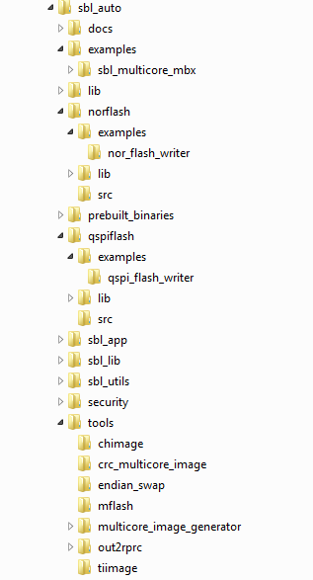

# UART Console

SBL sends the log messages to UART console. Messages displaying clock ticks are also sent to UART Console.

Connect to UART-1 terminal on the EVM for TDA2xx/TDA2Px/TDA2Ex device and UART-3 for TDA3xx device & configure the Serial Terminal at 115200 baud rate, 8 bit data, 1 stop bit, no parity and no flow control.

Following is the image of the UART console for mailbox multi core example bring up from SBL for TDA2xx device.

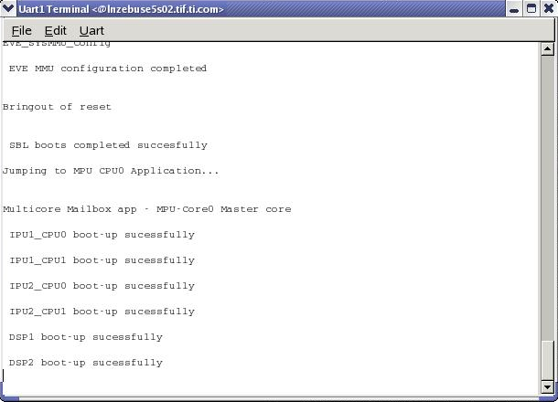

Following is the image of the UART console for mailbox multi core example bring up from SBL for TDA2Ex device

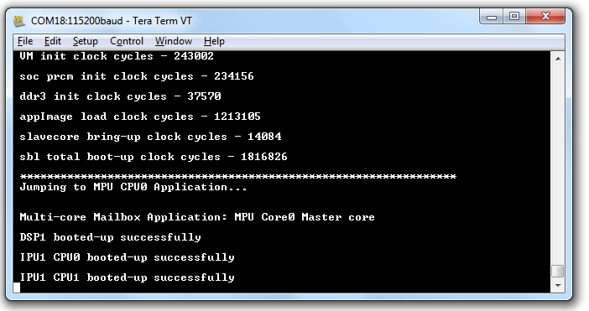

Following is the image of the UART console for mailbox multi core example bring up from SBL for TDA3xx device.

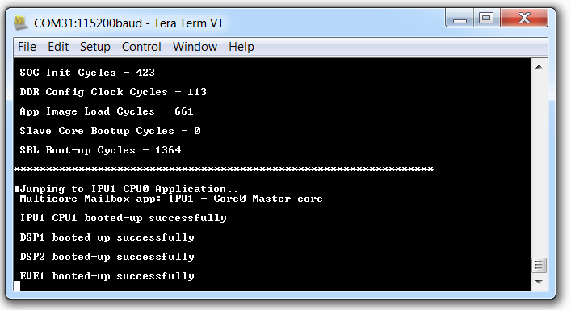

# Prebuilt Binaries

Prebuilt binaries are present in the folder: packages\ti\binary\sbl\<boot_mode>\<opp>\<board>. Multicore mailbox application images are present in the folder packages\ti\boot\sbl_auto\prebuilt_binaries\sbl_multicore_mbx\<soc>.

SBL images for all the boot modes are created used release mode binaries/ELF files.

# Multi core Image generation script

Under SBL tools, a batch file “MulticoreImageGen_<soc>.bat” is provided for generating the multi core Image from the elf files. User needs to edit the batch file to create multi-core application image.

Edit the batch variables to provide the elf files along with path. If it is not required to load a particular core then leave the corresponding variable blank.

Edit Out_Path with the location where the generated multi core image should be stored.

Paths to tools used out2rprc and MulticoreImageGen are the relative paths in the SBL.

Script creates two files AppImage_LE and AppImage_BE

AppImage_LE is a little endian file used in SD and NOR boot mode.

AppImage_BE is a big endian target used for QSPI boot mode.

# SBL Multicore Mailbox app

It is multicore sample application and uses mailbox for inter-processor communication. It is used to validate the multi-core boot-up use case. Master application sends wake-up message to all the slave cores & waits for acknowledgement message from the slave cores in an infinite loop. Each slave core waits for wake-up message from the master core & responds back with an acknowledgement message.

Multicore mailbox app is placed under packages\ti\boot\sbl_auto\examples\sbl_multicore_mbx. AppImage of this example is placed under prebuilt binaries.

# HS device support

## Memory map

SBL should not use OCMC_RAM1 from address 0x4030_000 to 0x4030_1350. The entry point will be set to 0x4030_1350. The GP-Header in SBL which indicates entry point and size of SBL is not needed when generating the boot-image using MShield-DK.

* If entry point is provided as 0xFFFFFFFF to the **tiimage** utility, the GP Header will not be appended at the top of the MLO.

## Boot authentication

SBL binary generated needs to be signed and merged with PPA using MShield-DK package.

### Setting up MShield-DK/SECDEV for TDA2x

* **MShield-DK/SECDEV package is supported only on Linux/Ubuntu machines**. This applies to building PPA, signing boot-images and application images.
* Extract the MShield-DK/SECDEV package into the VisionSDK installation directory. The “vision_sdk”, “ti_components” and “mshield-dk_std_x_x_x” folder should be at same level.
* GCC compiler installation details from MShield-DK/SECDEV documentation
* If you need to re-generate the PPA or PA using GCC, these are the compilers tested  
   DRA7xx/72x: GCC 4.8.2 arm-linux-gnueabihf-gcc cross compiler under Ubuntu 14.04 64-bit (arm-linux-gnueabihf-gcc (Ubuntu/Linaro 4.8.2-16ubuntu4) 4.8.2)  
   DRA7xx/72x: GCC 4.8 arm-eabi-gcc bare-metal cross compiler from TI Android SDK (arm-eabi-gcc (GCC) 4.8)
* The CROSS_COMPILE environment variable will be used, if it is defined, to prefix the gcc build calls. If it is not defined, the value 'arm-linux-gnueabihf-' will be used. The arm-linux-gnueabihf-gcc compiler can be installed under Ubuntu using the 'sudo apt-get gcc-arm-linux-gnueabihf' command.
* We will refer to the MShield-DK/SECDEV directory by the environment variable MSHIELD_DK_DIR.
* Setting up TDA2x configuration
  + Run the following commands:

cd $MSHIELD_DK_DIR/src

perl config.pl

* + Enter ‘n’ to select “[ DRA7XX ESx.x MSHIELD-DK Configuration ]”   
    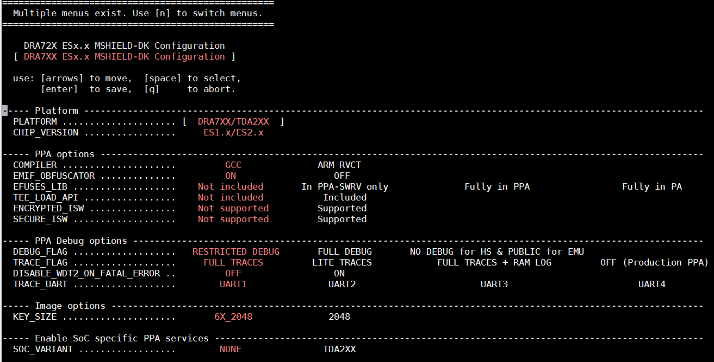
  + Different configurations can be selected using “Arrow” keys to move and “Space” to select. Hit “Enter” to save the configuration.

| **Option** | **Summary** |
| --- | --- |
| PLATFORM | Only one option. Sets up base configuration for DRA7x and TDA2x platforms for PPA generation. |
| CHIP_VERSION | Only one option. Currently all SR versions are supported in same configuration. |
| COMPILER | Select GCC compiler. ARM RVCT support is deprecated and present only for legacy users. |
| EMIF_OBFUSCATOR | Set this to “ON”. This enables obfuscation of EMIF signals using a 16bit key to prevent snooping or error injection using the EMIF interface. This has no effect of view of EMIF within the SoC or when using debugger interface. |
| EFUSES_LIB | Not verified for TDA2x. Refer to MShield-DK documentation for details. |
| TEE_LOAD_API | Not verified for TDA2x. Refer to MShield-DK documentation for details. |
| ENCRYPTED_ISW | Will assume the boot-image includes SBL in encrypted form. |
| SECURE_ISW | Keep as “Not supported”. This transfers control to SBL in while keeping the A15 in secure-mode. Refer to MShield-DK documentation for relevant use-cases. |
| DEBUG_FLAG | “RESTRICTED DEBUG” prevents any debugger connection via the JTAG interface.  “FULL DEBUG” allows users to connect to CCS for all software.  “NO DEBUG for HS & PUBLIC for EMU” prevents JTAG access when SECURE software is executing, but allow JTAG access for rest of the software. |
| TRACE_LOG | Select trace level as needed. |
| DISABLE_WDT2_ON_FATAL_ERROR | Disable/Enable watchdog timer after a fatal error. |
| TRACE_UART | Select which UART interface to use for ROM/PPA traces. TI EVM supports only UART1 interface. |
| KEY_SIZE | Keep as 6X_2048. Refer to MShield-DK documentation for details. |
| SOC_VARIANT | Select “TDA2XX” if you working with RTOS on A15. This enables some PPA services to enable firewall usage from RTOS environment. Caution: If you are using HLOS like Linux on a TDA2x device, select SOC_VARIANT = “NONE”. This is because the PPA services introduced by “TDA2XX” option should only be used when all software is authenticated. This may not be guaranteed in an HLOS environment. |

* If you enable ENCRYPTED_ISW, you need to modify   
  **reference/dra7xx/config/KEY_6X_2048/isw_m.cfg**

Uncomment the lines:

ISW_TYPE = "0x00000001"

ISW_ENC_IV = "000102030405060708090a0b0c0d0e0f"

ISW_ENC_KEY = "0828F4E5A4C5B20F119A631517C623CCA2752BBD639D150A12F26EC5923B3E86"

For TDA2x, only ISW_TYPE=1 is verified. This selects the key used for encryption ISW/SBL encryption. The key can be the device MEK, a key derived from the device MEK, the device CEK, or a key derived from the device CEK. Refer to MShield-DK documentation for details on these options. The default keys in this file are TI Dummy Keys.

### Boot-Image (PPA + SBL) generation

* Setup MShield-DK/SECDEV for TDA2XX

cd $MSHIELD_DK_DIR/src

perl config.pl

* Build PPA using the following command

cd $MSHIELD_DK_DIR/scripts

./ift-ppa-gen.sh dra7xx

* SD-BOOT: Create boot image using following commands:

(Input file: **unsigned_MLO**,Output file: **MLO** – Both are in little-endian format)

cd $MSHIELD_DK_DIR/scripts

./create-boot-image.sh MLO unsigned_MLO MLO

Note: Boot-Image for SD-BOOT must have the **MLO** as the first argument

* QSPI-BOOT Create boot image using following commands

(Input file: **unsigned_XLOADER**,Output file: **XLOADER** – Both are in little-endian format)

cd $MSHIELD_DK_DIR/scripts

./create-boot-image.sh X-LOADER unsigned_XLOADER XLOADER

Note: Boot-Image for QSPI-BOOT must have the **XLOADER** as the first argument

* In case of starterware, the **qspiFlashWriter** application expects input in big-endian format. This can be done in Linux using the following command

xxd -p -c 4 inp_LE | sed "s/\(..\)\(..\)\(..\)\(..\)/\4\3\2\1/" | xxd -r –p > out_BE

### Signing AppImages

* MShield-DK provides an image-signing tool to sign any binary image
* A signed image contains the original data padded with zero to reach a 4 byte aligned size, followed by a 280 byte of signature.
* This can be generated using the following command

cd $MSHIELD_DK_DIR/scripts

./ift-image-sign.sh dra7xx input_binary output_binary

* AppImage formats can be customized by users as needed. There are two formats of Multi-core application image: ‘V2 i.e. Version 2’ and ‘Version 1 i.e. V1’. The details of these formats are given in SBL Library header file. TI SBL support boot on HS devices that are built with newer i.e. “Version 2” format.

# Flashing production binaries using – mflash

It is a windows PC based a tool that allows users to flash binaries to production boards. PDK supports counter part of the mflash which is a special SBL that enables UART boot mode and transfer of production SBL and application image (AppImage) over UART.

### PC side setup

Kindly download mflash_0.1.zip from CDDS. Please refer mflash\doc\AppNote_mflash.pdf for PC side setup and build details.

### Build steps

SBL supports UART boot mode only for TDA3x.

make -s -j sbl BOARD=tda3xx-evm BOOTMODE=uart SBL_TYPE=mflash

### Generating mflash SBL

There are script files under <pdk>/packages/ti/boot/sbl_auto/tools/mflash

These will help you generate sbl_mflash

sbl_mflash_create_tda3xx.sh

sbl_mflash_create_tda3xx.bat

Sbl_mflash needs to be used along with PC side mflash tool to send it over UART.

For more information on hardware setup/switch settings please refer the AppNote mflash\doc\AppNote_mflash.pdf in mflash package.

# Known Issues

Please refer to the package release notes for the list of open issues & issues closed in the current release.

# Revision History

|  |  |  |  |  |
| --- | --- | --- | --- | --- |
| **Version** | **Date** | **Status** | **Author** | **Revision History** |
| 1.0 | 2-JULY-17 | Approved | Rishabh | SBL User guide for TDA2xx, TDA2Ex and TDA3xx with Performance numbers and details required to run/build/user SBL |
| 1.1 | 12-OCT-17 | Approved | Ankur | Added details for TDA2Px device |