RenoRisk — machine-learning results
Leave-one-dataset-out classification of diseased vs control kidney tissue: analysis of Results/ML_training, additional experiments, and medical interpretation
31 October 2026 · inputs: Data/ML_input/all.xlsx, all2.xlsx · outputs analysed: ML_training/RR, ALL/ALL, ALL/TOP_50_by_AUC, ALL/TOP_50_by_F1
1. Summary 2
2. Data, design and how to read the metrics 2
3. Folder RR — 5 RenoRisk genes + Compartment + Sex 4
3.1 Performance (ML_RR_perfs.xlsx) 4
3.2 ROC curves 4
3.3 Feature importances (FEAT_IMP_by_AUC / FEAT_IMP_by_F1) 5
4. Folder ALL/ALL — all 10,422 genes + Compartment + Sex 6
4.1 Performance (ML_ALL_perfs.xlsx) 6
4.2 ROC curves 6
4.3 Feature importances (identical in FEAT_IMP_by_AUC and FEAT_IMP_by_F1) 7
5. Folders ALL/TOP_50_by_AUC and ALL/TOP_50_by_F1 — top 50 genes + Compartment + Sex 9
5.1 Performance (identical in both folders) 9
5.2 ROC curves (four images, one curve) 9
5.3 Feature importances in the 50-gene model 10
6. Additional experiments 13
6.1 Exact sensitivity and specificity, per cohort 13
6.2 Which diseases are detected, which controls are recognised 14
6.3 What metadata and the panel contribute 15
6.4 Is the accuracy produced by surgery and stress? 15
6.5 The RenoRisk genes inside each series 16
7. Medical interpretation 18
7.1 How the tissue was obtained shapes the transcriptome 18
7.2 Genes that reflect real kidney disease 18
7.3 Why some diseases are missed 18
7.4 The RenoRisk panel in medical terms 19
7.5 What the numbers would mean in practice 19
8. Recommendations 19
9. Limitations 20

Contents: right-click → Update field in Word if page numbers are not shown.

1. Summary
- RenoRisk 5-gene panel: not a usable classifier of diseased tissue. Best ROC-AUC 0.628 (Logistic Regression). At the default threshold it calls 815 of 850 biopsies diseased: sensitivity 96%, specificity 5% (9 of 172 controls recognised). Compartment and Sex alone already give ROC-AUC 0.552; the five genes add little.
- All 10,422 genes: ROC-AUC 0.953, sensitivity 93%, specificity 63% (108 of 172 controls), PPV 91%, NPV 69%. Five of ten cohorts are separated perfectly (AUC 1.000); the weakest are GSE116626 (0.832) and GSE30122 (0.857). With a threshold calibrated per hospital, specificity at 90% sensitivity would reach 87%.
- The most influential genes are dominated by how the control tissue was obtained. Controls are mostly surgical specimens (living donors, tumour nephrectomies) taken under general anaesthesia with clamping and ischaemia; diseased samples are needle biopsies. Immediate-early stress genes (FOS, EGR1, DUSP1, ATF3, JUNB…) fill the top of the list; a stress score built from 17 of them is higher in controls in all 11 series and alone separates the groups with within-series AUC 0.65–0.95.
- But the disease signal is real, too. Removing the 222 genes that co-vary with the stress score still leaves ROC-AUC 0.934 (specificity falls from 63% to 57%). Fibrosis (FN1, LUM), loss of proximal-tubule metabolism (PCK1, G6PC1) and immune genes (HLA-DRB1) carry a genuine, cross-cohort disease signal. Stress genes inflate the importance ranking and part of the specificity, not the whole result.
- The top-50 run (ROC-AUC 0.970) is optimistic because its genes were selected on all cohorts; TOP_50_by_AUC and TOP_50_by_F1 are identical (the same model, Logistic Regression, is best by both criteria).
- Clinical reading: a whole-transcriptome classifier detects most diseases near-completely, except IgA nephropathy (62%) and hypertensive nephropathy (89%), whose biopsies are often near-normal; healthy tissue is the hard class. It could support, not replace, histology, and would need per-site calibration and validation on needle-biopsy controls.

2. Data, design and how to read the metrics
850 kidney tissue transcriptomes from 11 GEO series, analysed as 10 leave-one-dataset-out (LODO) groups (GSE104948 + GSE104954 = ERCB). 172 controls, 678 diseased: MN 116, FSGS 111, DKD 81, IgAN 78, other GN 68, ANCA vasculitis 58, CKD unspecified 53, MCD 52, lupus nephritis 30, hypertensive nephropathy 18, FSGS/MCD 10, thin membrane disease 3. Compartments: glomerular 614, tubulointerstitial 94, whole biopsy 142. Disease prevalence: 79.8% overall, 72.6% on average per cohort.
Each cohort is predicted by models trained on the other nine only, so every number measures transfer to an unseen hospital, platform and patient population. 17 PyCaret 3.3.2 classifiers with default settings; pre-processing inside the pipeline (mean imputation, one-hot encoding of Compartment and Sex, no scaling). Metrics are computed per left-out cohort and averaged without weighting.
Metric | Definition | Clinical meaning
ROC-AUC | Probability that a random diseased sample scores above a random control from the same cohort | Ranking ability independent of threshold; 0.5 = coin toss, 1.0 = perfect
Recall (sensitivity) | Diseased samples called diseased | How many sick kidneys are caught; misses = false reassurance
Specificity | Controls called control (not stored in result files; computed in Section 6) | How many healthy kidneys are cleared; failures = false alarms, unnecessary work-up
Precision (PPV) | Called diseased that are diseased | Trust in a positive result; falls sharply when disease is rare
NPV | Called control that are control | Trust in a negative result
F1 | Harmonic mean of precision and recall | Ignores true negatives; inflated when ~80% are diseased
Accuracy | All correct calls | Dominated by the majority (diseased) class
With 72.6–79.8% diseased samples, the dummy that calls every sample diseased reaches F1 0.818, precision 0.726, recall 1.000, accuracy 0.726 — every model must be compared with that row.

3. Folder RR — 5 RenoRisk genes + Compartment + Sex
Produced by Scripts/train_ML_RR.ipynb from Data/ML_input/all.xlsx. Files: ML_RR_perfs.xlsx (17 models), ML_RR_AUC_by_AUC.png and ML_RR_AUC_by_F1.png (mean ROC of the best model by each criterion), ML_RR_FEAT_IMP_by_AUC.xlsx and ML_RR_FEAT_IMP_by_F1.xlsx (10 rows each: 5 genes, 3 Compartment and 2 Sex one-hot columns), ML_RR_sessionInfo.txt (Python 3.11.9, scikit-learn 1.4.2, LightGBM 4.7.0, random_state 42, ERCB merged, 850 samples, 10 groups).

3.1 Performance (ML_RR_perfs.xlsx)
# | Model | Family | ROC-AUC | F1 | Precision | Recall | Accuracy
1 | Logistic Regression | linear | 0.628 | 0.808 | 0.727 | 0.973 | 0.711
2 | Ridge Classifier | linear | 0.627 | 0.810 | 0.731 | 0.972 | 0.721
3 | Linear Discriminant Analysis | linear | 0.626 | 0.800 | 0.730 | 0.954 | 0.709
4 | SVM - Radial Kernel | kernel | 0.604 | 0.767 | 0.741 | 0.904 | 0.675
5 | K Neighbors Classifier | instance-based | 0.595 | 0.719 | 0.737 | 0.831 | 0.631
6 | Gaussian Process Classifier | kernel | 0.586 | 0.722 | 0.742 | 0.842 | 0.638
7 | Extra Trees Classifier | tree ensemble | 0.581 | 0.731 | 0.718 | 0.821 | 0.654
8 | Naive Bayes | probabilistic | 0.553 | 0.677 | 0.640 | 0.810 | 0.590
9 | Light Gradient Boosting Machine | boosting | 0.550 | 0.710 | 0.731 | 0.773 | 0.623
10 | Random Forest Classifier | tree ensemble | 0.550 | 0.706 | 0.713 | 0.802 | 0.646
11 | MLP Classifier | neural net | 0.547 | 0.774 | 0.731 | 0.914 | 0.671
12 | SVM - Linear Kernel | linear | 0.530 | 0.646 | 0.590 | 0.760 | 0.643
13 | Decision Tree Classifier | tree | 0.516 | 0.672 | 0.728 | 0.707 | 0.622
14 | Dummy Classifier | baseline | 0.500 | 0.818 | 0.726 | 1.000 | 0.726
15 | Gradient Boosting Classifier | boosting | 0.496 | 0.688 | 0.700 | 0.765 | 0.604
16 | Ada Boost Classifier | boosting | 0.486 | 0.752 | 0.720 | 0.865 | 0.659
17 | Quadratic Discriminant Analysis | quadratic | 0.470 | 0.654 | 0.677 | 0.692 | 0.654
Green: best by ROC-AUC. Orange: dummy baseline.
- Ceiling 0.63: the three linear models (Logistic Regression 0.628, Ridge 0.627, LDA 0.626) lead; kernel, neighbour and tree methods fall to 0.47–0.60, three of them at or below chance (GBC 0.496, AdaBoost 0.486, QDA 0.470). More flexible models only overfit cohort-specific noise.
- No model beats the dummy on F1 (best 0.810 vs 0.818). Precision 0.727–0.742 equals the disease prevalence, i.e. a positive call carries no information beyond the base rate. Recall 0.97 with accuracy 0.71 means the linear models call almost everybody diseased.

3.2 ROC curves
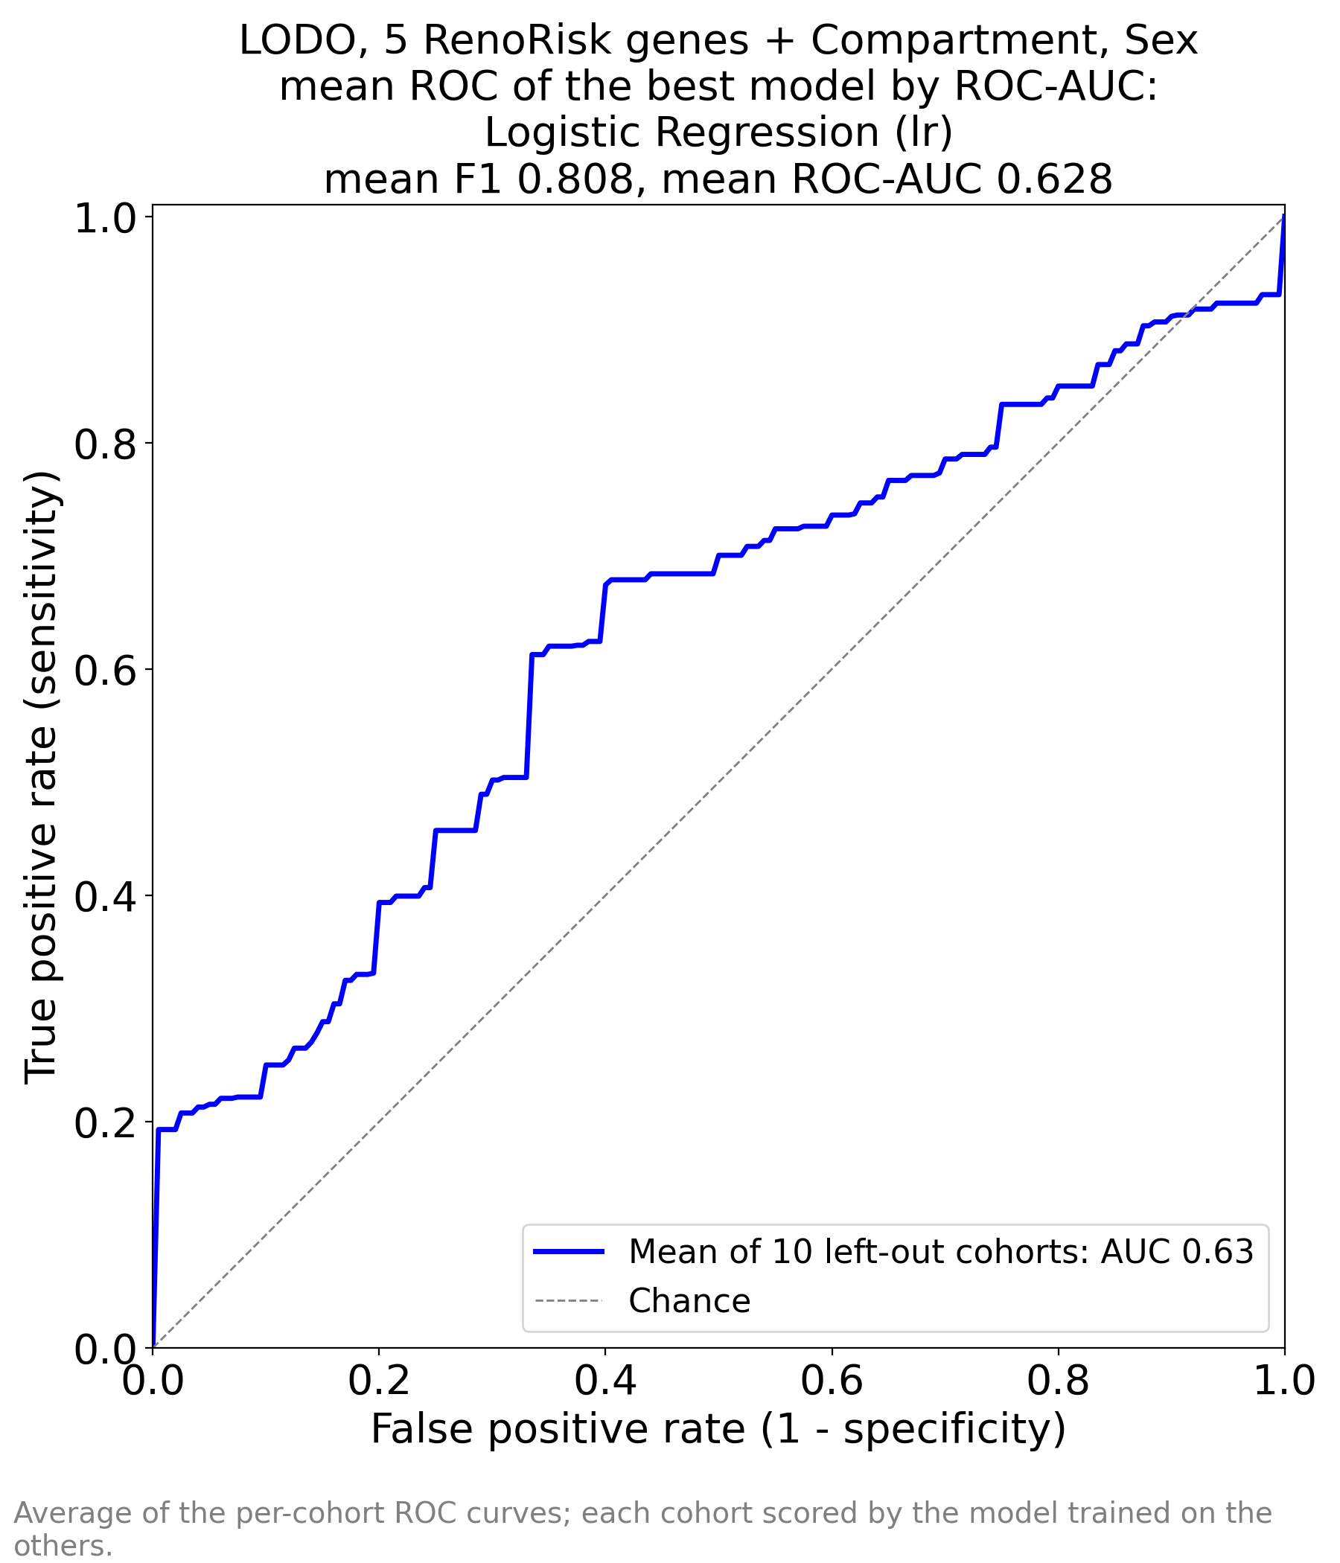  ML_RR_AUC_by_AUC.png | 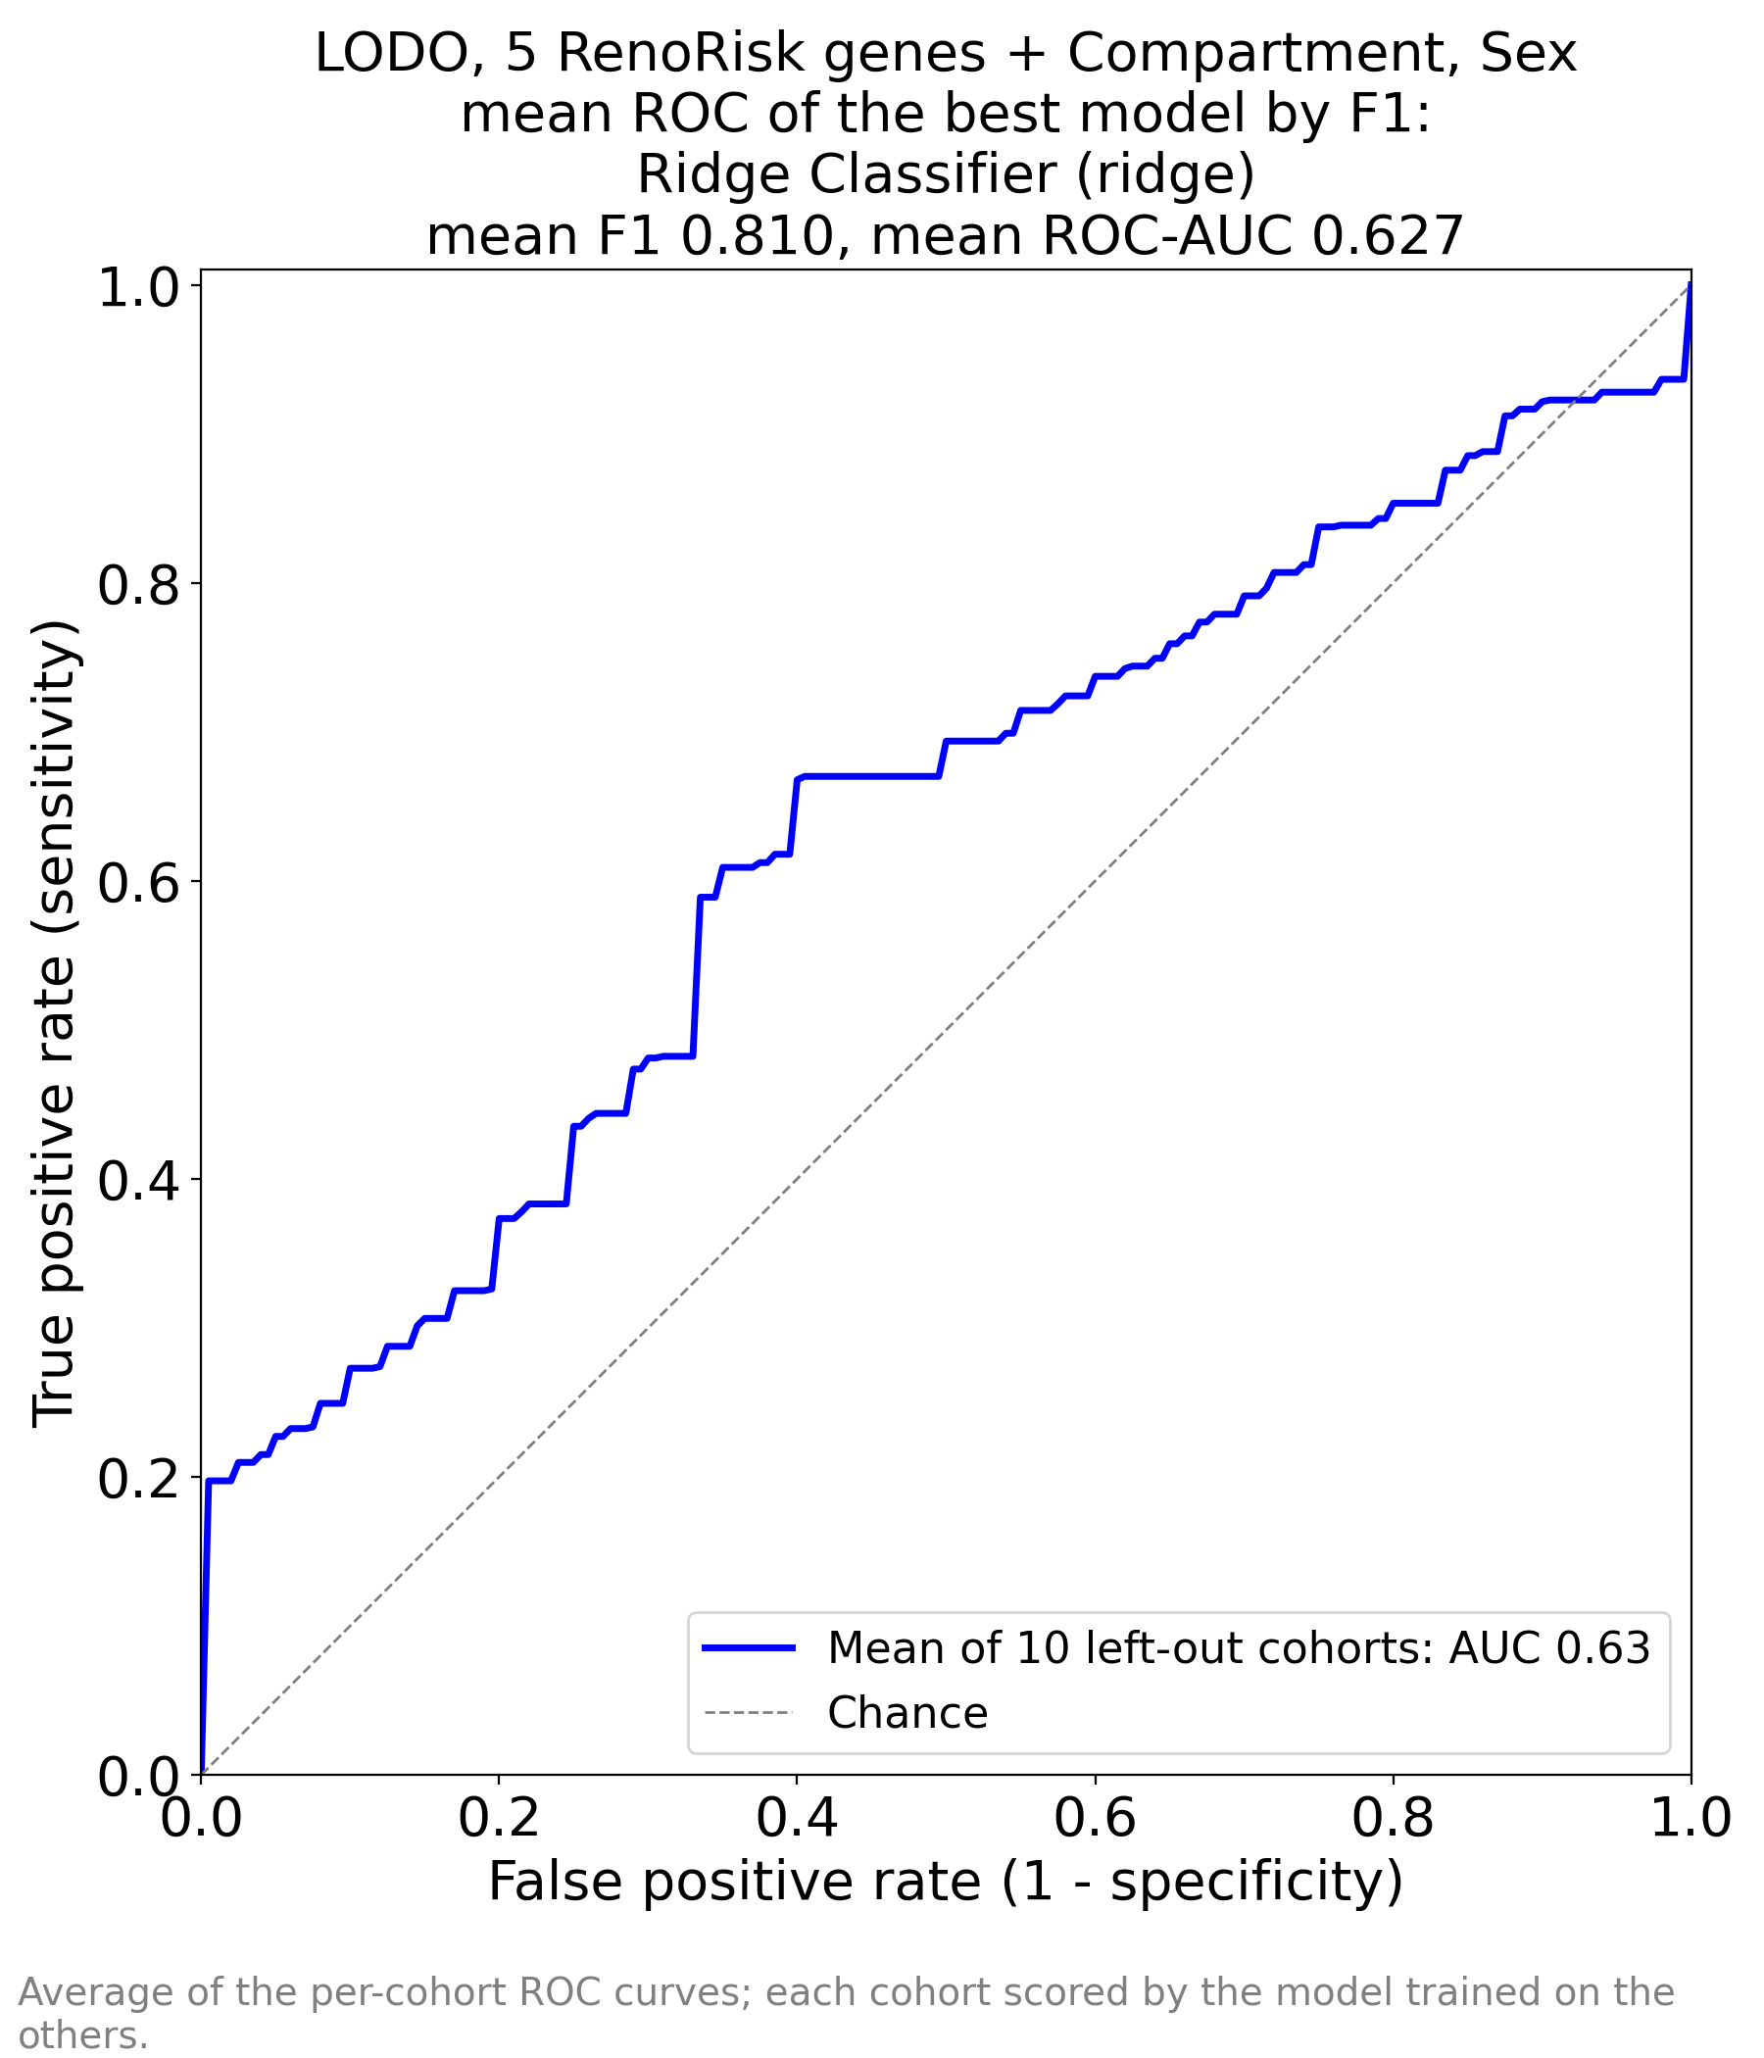  ML_RR_AUC_by_F1.png
Left: best by ROC-AUC, Logistic Regression (F1 0.808, AUC 0.628). Right: best by F1, Ridge (F1 0.810, AUC 0.627). The curves are nearly identical: both models are linear and use the same inputs. The initial vertical step to ~0.20 sensitivity means that in some cohorts a minority of diseased samples score above every control; afterwards the curve runs only slightly above the diagonal, and its last segment ends with a jump at false-positive rate 1.0 — some diseased samples score below all controls (opposite direction of effect in some cohorts).

3.3 Feature importances (FEAT_IMP_by_AUC / FEAT_IMP_by_F1)
Source | LR |coef| (by AUC) | LR coef | Ridge |coef| (by F1) | Ridge coef
Compartment | 1.748 | +1.75 | 0.600 | +0.60
Compartment | 0.902 | -0.90 | 0.344 | -0.34
Compartment | 0.842 | -0.84 | 0.256 | -0.26
HABP2 | 0.605 | +0.60 | 0.174 | +0.17
C4BPA | 0.447 | -0.45 | 0.127 | -0.13
CFI | 0.375 | -0.37 | 0.116 | +0.12
CFH | 0.342 | +0.34 | 0.111 | -0.11
Sex | 0.313 | +0.31 | 0.087 | +0.09
Sex | 0.308 | -0.31 | 0.087 | -0.09
COL13A1 | 0.147 | +0.15 | 0.047 | +0.05
Rows in order of importance; rows 6–7 differ between the two models (CFI/CFH swap places). The three Compartment rows are Whole biopsy (+), Tubulointerstitial (−), Glomerular (−); the two Sex rows are M (+) and F (−). Positive = pushes towards Disease.
- Compartment dominates both models (|coef| 0.84–1.75 in LR): whole-biopsy samples are 89% diseased, tubulointerstitial samples 52%. The model learns the case mix of the source studies rather than tissue biology.
- Among the genes, HABP2 (+0.60) and CFH (+0.34) push towards disease, C4BPA (−0.45) and CFI (−0.37) towards control, COL13A1 is weakest (+0.15). Male sex pushes towards disease (M is 83% diseased vs 75% for F). Ridge has the same ranking with ~3× smaller coefficients (stronger shrinkage).

4. Folder ALL/ALL — all 10,422 genes + Compartment + Sex
Produced by run 1 of Scripts/train_ML_ALL.ipynb from Data/ML_input/all2.xlsx (genes common to all 11 series). Files: ML_ALL_perfs.xlsx, ML_ALL_AUC_by_AUC.png, ML_ALL_AUC_by_F1.png, ML_ALL_FEAT_IMP_by_AUC.xlsx and ML_ALL_FEAT_IMP_by_F1.xlsx (10,427 rows each: 10,422 genes + 5 one-hot columns), ML_ALL_sessionInfo.txt (FAST=False: all 17 models; TOP_FEATURES_FOR_THE_SECOND_RUN = 50).

4.1 Performance (ML_ALL_perfs.xlsx)
# | Model | Family | ROC-AUC | F1 | Precision | Recall | Accuracy
1 | Logistic Regression | linear | 0.953 | 0.883 | 0.884 | 0.923 | 0.858
2 | SVM - Linear Kernel | linear | 0.953 | 0.880 | 0.890 | 0.903 | 0.861
3 | Ridge Classifier | linear | 0.939 | 0.836 | 0.885 | 0.890 | 0.801
4 | Linear Discriminant Analysis | linear | 0.917 | 0.813 | 0.878 | 0.876 | 0.777
5 | Gradient Boosting Classifier | boosting | 0.866 | 0.787 | 0.806 | 0.893 | 0.721
6 | Random Forest Classifier | tree ensemble | 0.858 | 0.743 | 0.754 | 0.880 | 0.671
7 | Light Gradient Boosting Machine | boosting | 0.857 | 0.802 | 0.812 | 0.913 | 0.750
8 | MLP Classifier | neural net | 0.851 | 0.697 | 0.759 | 0.803 | 0.635
9 | Extra Trees Classifier | tree ensemble | 0.826 | 0.793 | 0.751 | 0.942 | 0.703
10 | Ada Boost Classifier | boosting | 0.817 | 0.828 | 0.817 | 0.904 | 0.768
11 | SVM - Radial Kernel | kernel | 0.804 | 0.754 | 0.758 | 0.896 | 0.682
12 | K Neighbors Classifier | instance-based | 0.738 | 0.695 | 0.694 | 0.806 | 0.625
13 | Decision Tree Classifier | tree | 0.639 | 0.770 | 0.802 | 0.852 | 0.695
14 | Quadratic Discriminant Analysis | quadratic | 0.598 | 0.752 | 0.742 | 0.819 | 0.654
15 | Naive Bayes | probabilistic | 0.522 | 0.533 | 0.453 | 0.700 | 0.481
16 | Gaussian Process Classifier | kernel | 0.500 | 0.168 | 0.200 | 0.147 | 0.414
17 | Dummy Classifier | baseline | 0.500 | 0.818 | 0.726 | 1.000 | 0.726
- Linear models win clearly: Logistic Regression and linear SVM 0.953, Ridge 0.939, LDA 0.917. With 10,422 features and 850 samples, a regularised linear boundary is the most stable choice; tree ensembles reach only 0.83–0.87, distance- and density-based methods 0.52–0.80.
- Three technical failures, not data properties: Gaussian Process (F1 0.168, AUC 0.500 — kernel on 10,422 unscaled inputs collapses to a constant), Naive Bayes (0.522; independence assumption violated by thousands of correlated genes), QDA (0.598; covariance matrices not estimable).
- Clinically relevant gap: AUC 0.953 but accuracy 0.858 and F1 0.883 — scores rank well within each hospital but sit at different levels between hospitals, so the fixed 0.5 threshold misclassifies controls (Section 6.1).

4.2 ROC curves
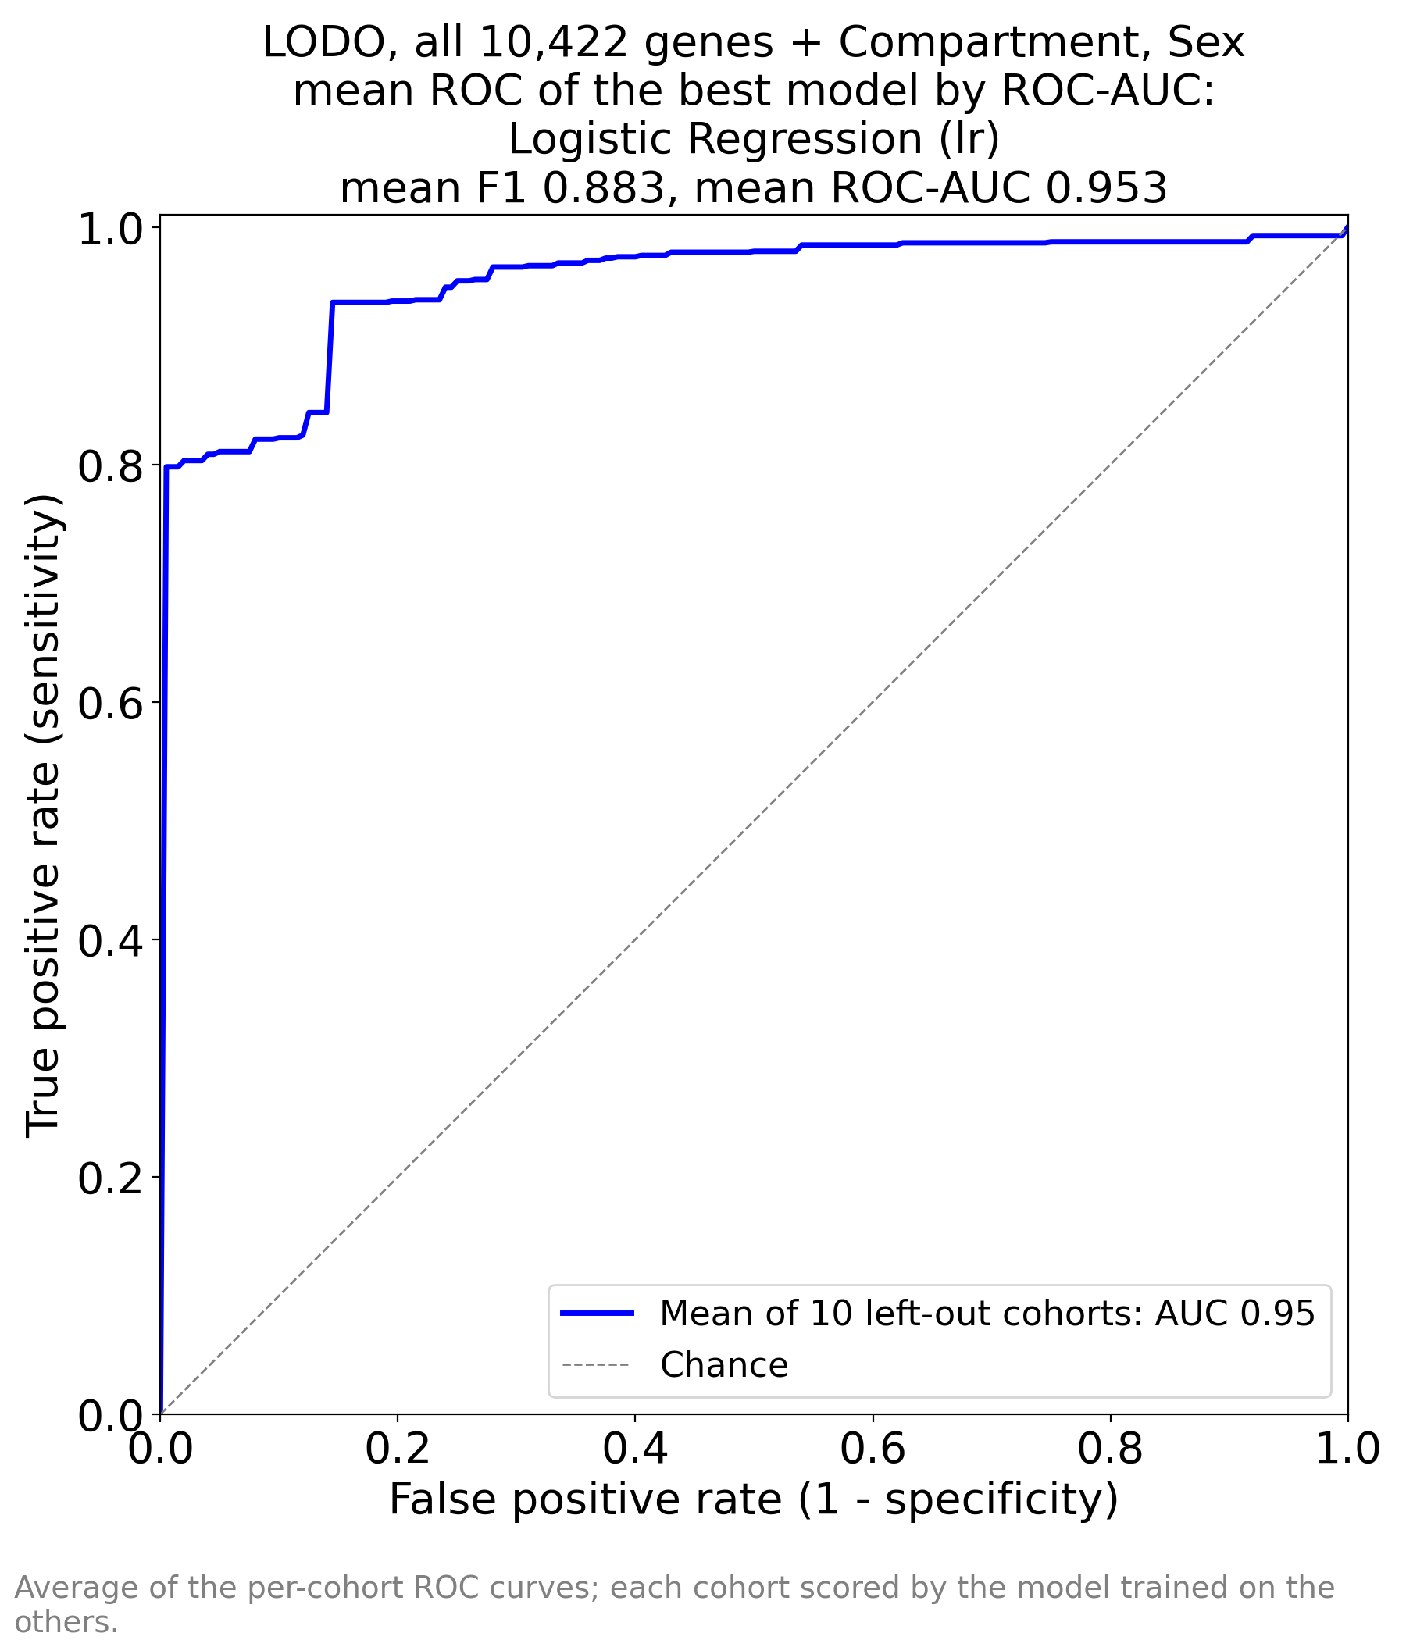  ML_ALL_AUC_by_AUC.png | 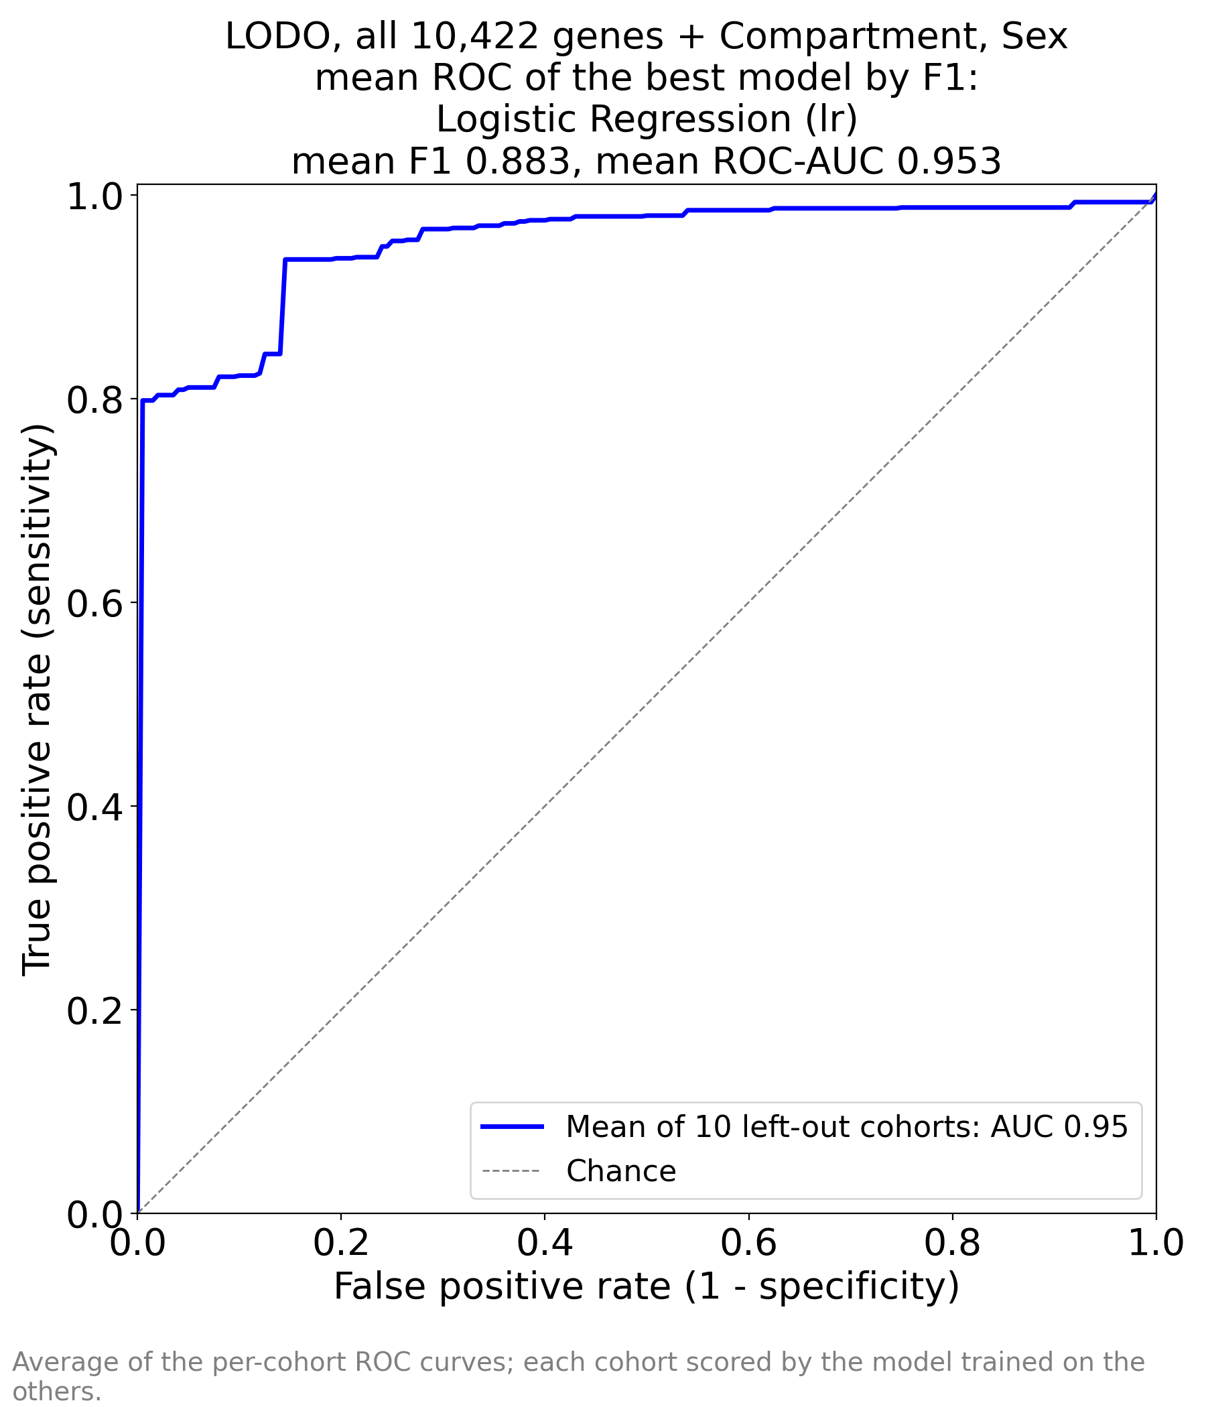  ML_ALL_AUC_by_F1.png
Logistic Regression is best by both criteria, so the two images show the same curve (F1 0.883, AUC 0.953). Shape: a vertical rise to 0.80 sensitivity at zero false positives (in most cohorts 80% of the diseased can be identified without a single false alarm), a step to 0.94 at false-positive rate ~0.15, then a plateau — the last ~5% of diseased samples look like controls (mostly IgAN in GSE116626, Section 6.2).

4.3 Feature importances (identical in FEAT_IMP_by_AUC and FEAT_IMP_by_F1)
Rank | Source | Importance | Coefficient | Biological group
1 | FOS | 0.239 | -0.24 | immediate-early / stress
2 | ALB | 0.213 | -0.21 | tubular metabolism / fasting
3 | EGR1 | 0.185 | -0.18 | immediate-early / stress
4 | DUSP1 | 0.152 | -0.15 | immediate-early / stress
5 | G6PC1 | 0.142 | -0.14 | tubular metabolism / fasting
6 | ATF3 | 0.140 | -0.14 | immediate-early / stress
7 | NR4A2 | 0.139 | -0.14 | immediate-early / stress
8 | JUNB | 0.138 | -0.14 | immediate-early / stress
9 | RGS2 | 0.137 | -0.14 | immediate-early / stress
10 | ZFP36 | 0.127 | -0.13 | immediate-early / stress
11 | PDK4 | 0.124 | -0.12 | tubular metabolism / fasting
12 | GDF15 | 0.122 | -0.12 | immediate-early / stress
13 | FN1 | 0.117 | +0.12 | fibrosis / injury / immune
14 | IGF1 | 0.112 | -0.11 | tubular metabolism / fasting
15 | MAFF | 0.110 | -0.11 | immediate-early / stress
16 | ANXA1 | 0.104 | +0.10 | fibrosis / injury / immune
17 | ESM1 | 0.104 | -0.10 | tubular / vascular differentiation
18 | S100A12 | 0.101 | -0.10 | blood / neutrophil
19 | LUM | 0.097 | +0.10 | fibrosis / injury / immune
20 | PCK1 | 0.097 | -0.10 | tubular metabolism / fasting
21 | CR2 | 0.096 | -0.10 | tubular / vascular differentiation
22 | NR4A1 | 0.095 | -0.10 | immediate-early / stress
23 | MAFB | 0.093 | +0.09 | fibrosis / injury / immune
24 | Compartment | 0.092 | +0.09 | metadata
25 | APOH | 0.090 | -0.09 | tubular metabolism / fasting
26 | HLA-DRB1 | 0.089 | +0.09 | fibrosis / injury / immune
27 | MNDA | 0.089 | -0.09 | blood / neutrophil
28 | SPINK1 | 0.088 | -0.09 | tubular / vascular differentiation
29 | NFIL3 | 0.088 | -0.09 | immediate-early / stress
30 | XYLT1 | 0.087 | -0.09 | tubular / vascular differentiation
31 | FOSB | 0.087 | -0.09 | immediate-early / stress
32 | CYP26B1 | 0.086 | -0.09 | tubular / vascular differentiation
33 | GSTA1 | 0.086 | -0.09 | tubular metabolism / fasting
34 | JUN | 0.086 | -0.09 | immediate-early / stress
35 | PTGS2 | 0.084 | -0.08 | immediate-early / stress
36 | SYNPO | 0.084 | +0.08 | fibrosis / injury / immune
37 | APOD | 0.084 | -0.08 | tubular / vascular differentiation
38 | FPR1 | 0.082 | -0.08 | blood / neutrophil
39 | RPS4Y1 | 0.081 | -0.08 | sex (Y chromosome)
40 | PPP1R3C | 0.081 | +0.08 | fibrosis / injury / immune
Green coefficient: higher expression → Control. Orange: higher expression → Disease. 9 of the top 50 genes point to disease, 41 to control. Compartment ranks 24th, Sex 93rd of 10,427 features. RenoRisk genes rank CFH 1,572, CFI 3,613, C4BPA 3,838, COL13A1 4,221, HABP2 8,982.
Reading the list: the model mostly recognises controls — by a burst of immediate-early gene transcription, high gluconeogenic/fasting genes and blood neutrophil transcripts — and recognises disease by fibrosis and immune genes. Section 7 explains each group medically; Section 6.4 tests how much of the accuracy each part carries.

5. Folders ALL/TOP_50_by_AUC and ALL/TOP_50_by_F1 — top 50 genes + Compartment + Sex
Run 2 of train_ML_ALL.ipynb repeats LODO on the 50 genes ranked highest by run 1’s best model by ROC-AUC (TOP_50_by_AUC) and by F1 (TOP_50_by_F1). Both criteria select Logistic Regression in run 1, so both folders use the same 50 genes; the perfs and both importance workbooks were verified to be cell-for-cell identical, and the four ROC images show the same curve. Each folder holds perfs.xlsx, two ROC images, two FEAT_IMP workbooks (55 rows: 50 genes + 5 one-hot columns) and a sessionInfo that records the selection and its optimism.

5.1 Performance (identical in both folders)
# | Model | Family | ROC-AUC | F1 | Precision | Recall | Accuracy
1 | Logistic Regression | linear | 0.970 | 0.896 | 0.896 | 0.942 | 0.861
2 | SVM - Linear Kernel | linear | 0.969 | 0.853 | 0.822 | 0.945 | 0.804
3 | Ridge Classifier | linear | 0.959 | 0.853 | 0.885 | 0.895 | 0.815
4 | Linear Discriminant Analysis | linear | 0.957 | 0.847 | 0.888 | 0.886 | 0.811
5 | MLP Classifier | neural net | 0.944 | 0.891 | 0.895 | 0.936 | 0.857
6 | Extra Trees Classifier | tree ensemble | 0.884 | 0.782 | 0.817 | 0.897 | 0.733
7 | SVM - Radial Kernel | kernel | 0.869 | 0.836 | 0.797 | 0.952 | 0.768
8 | Gradient Boosting Classifier | boosting | 0.869 | 0.780 | 0.803 | 0.901 | 0.724
9 | Light Gradient Boosting Machine | boosting | 0.861 | 0.824 | 0.822 | 0.923 | 0.770
10 | Ada Boost Classifier | boosting | 0.857 | 0.799 | 0.834 | 0.888 | 0.757
11 | Random Forest Classifier | tree ensemble | 0.840 | 0.767 | 0.811 | 0.887 | 0.721
12 | K Neighbors Classifier | instance-based | 0.796 | 0.838 | 0.823 | 0.924 | 0.776
13 | Quadratic Discriminant Analysis | quadratic | 0.757 | 0.774 | 0.812 | 0.824 | 0.763
14 | Decision Tree Classifier | tree | 0.751 | 0.810 | 0.849 | 0.886 | 0.760
15 | Gaussian Process Classifier | kernel | 0.747 | 0.845 | 0.835 | 0.927 | 0.787
16 | Naive Bayes | probabilistic | 0.736 | 0.617 | 0.643 | 0.724 | 0.534
17 | Dummy Classifier | baseline | 0.500 | 0.818 | 0.726 | 1.000 | 0.726
- Every model gains versus all genes, most strongly the ones that failed on 10,422 inputs: Gaussian Process 0.500 → 0.747, Naive Bayes 0.522 → 0.736, QDA 0.598 → 0.757, kNN 0.738 → 0.796, MLP 0.851 → 0.944. Logistic Regression 0.953 → 0.970.
- This gain is partly leakage: the 50 genes were ranked by a model fitted on all 850 samples, including each cohort that is later left out. The genuine benefit — fewer noisy inputs for unstable models — is real, but the size of the improvement cannot be trusted without selecting genes inside each fold.

5.2 ROC curves (four images, one curve)
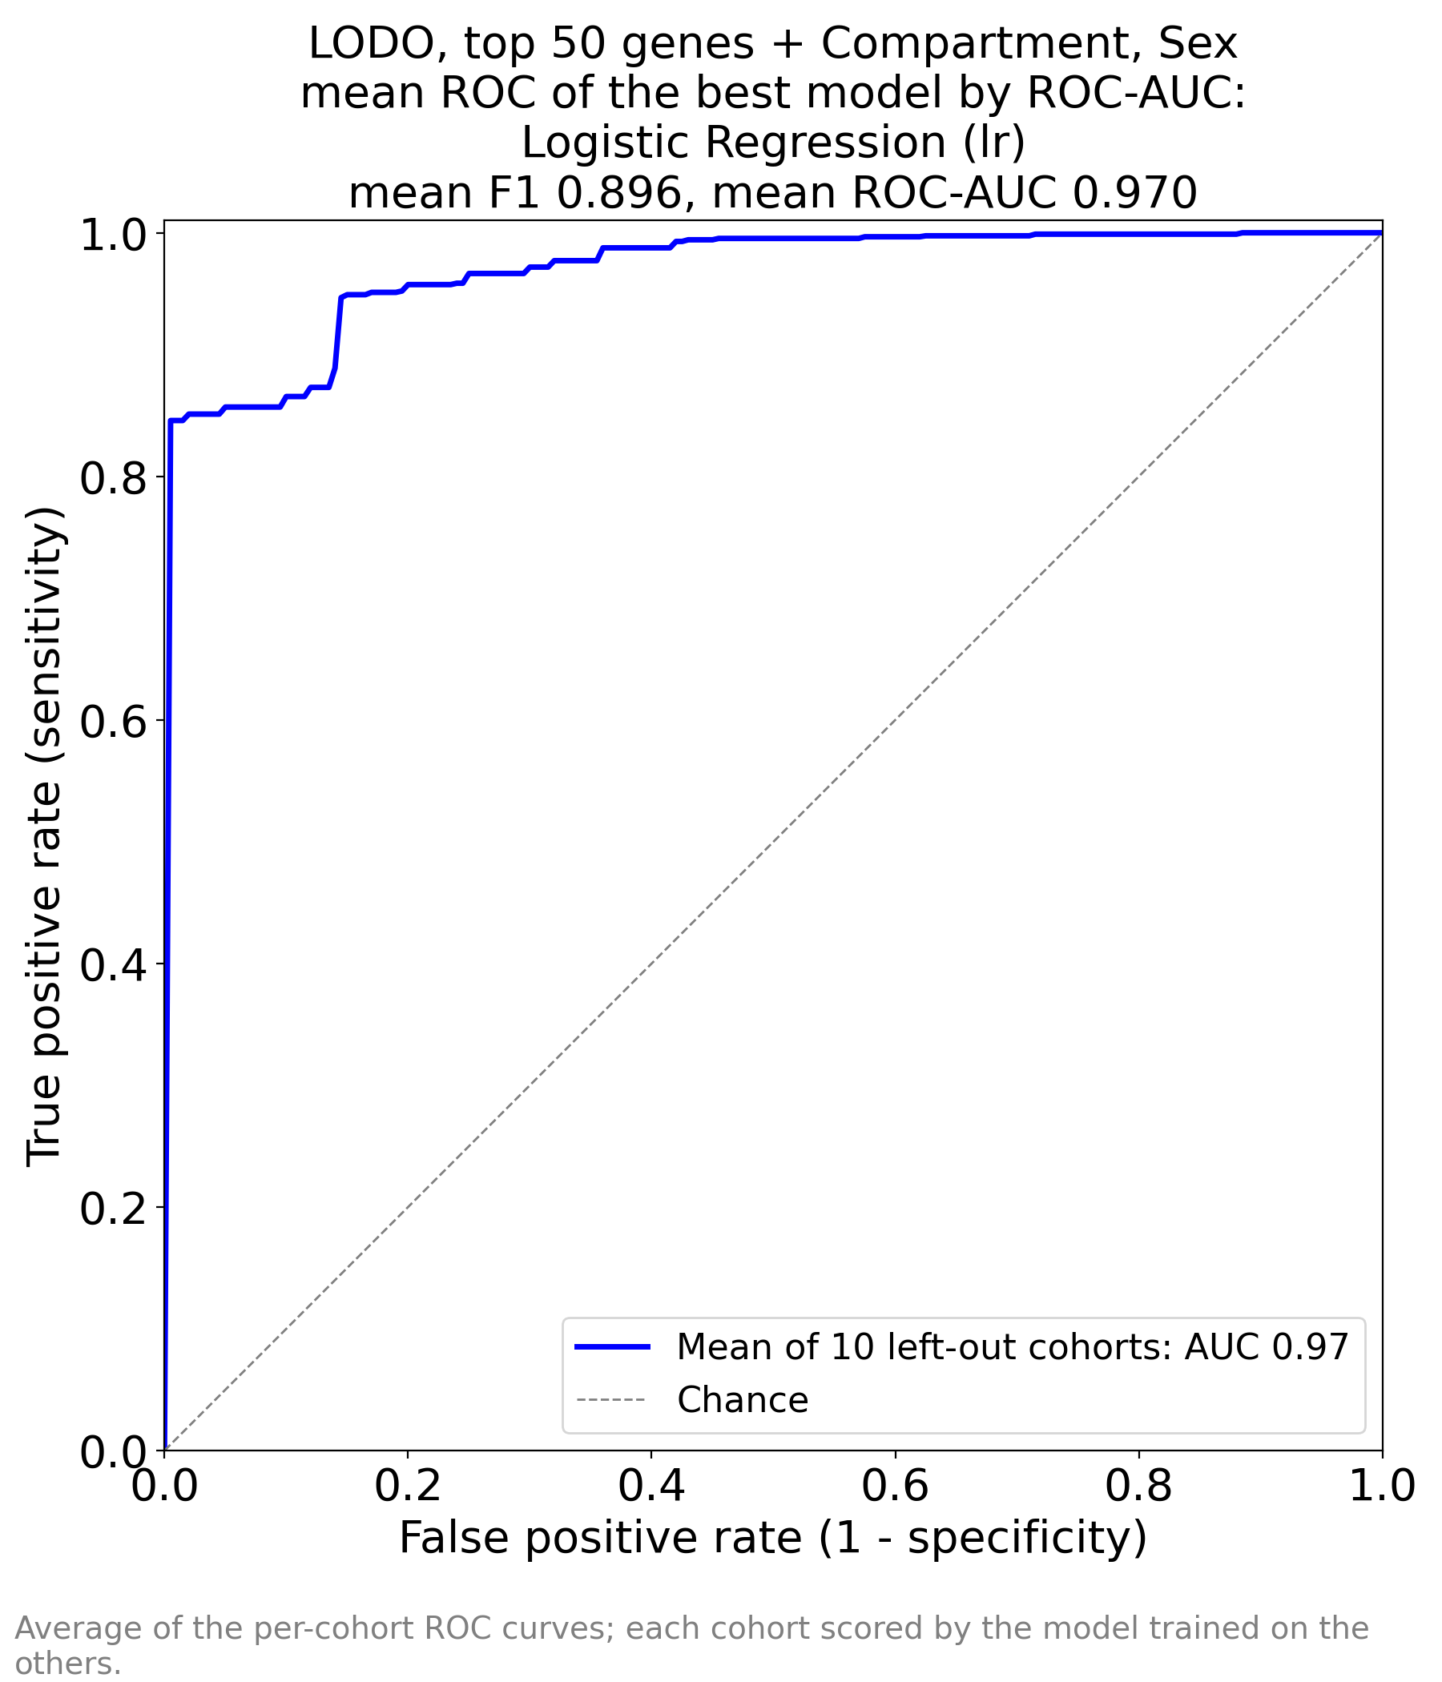  ML_TOP_50_by_AUC_AUC_by_AUC.png | 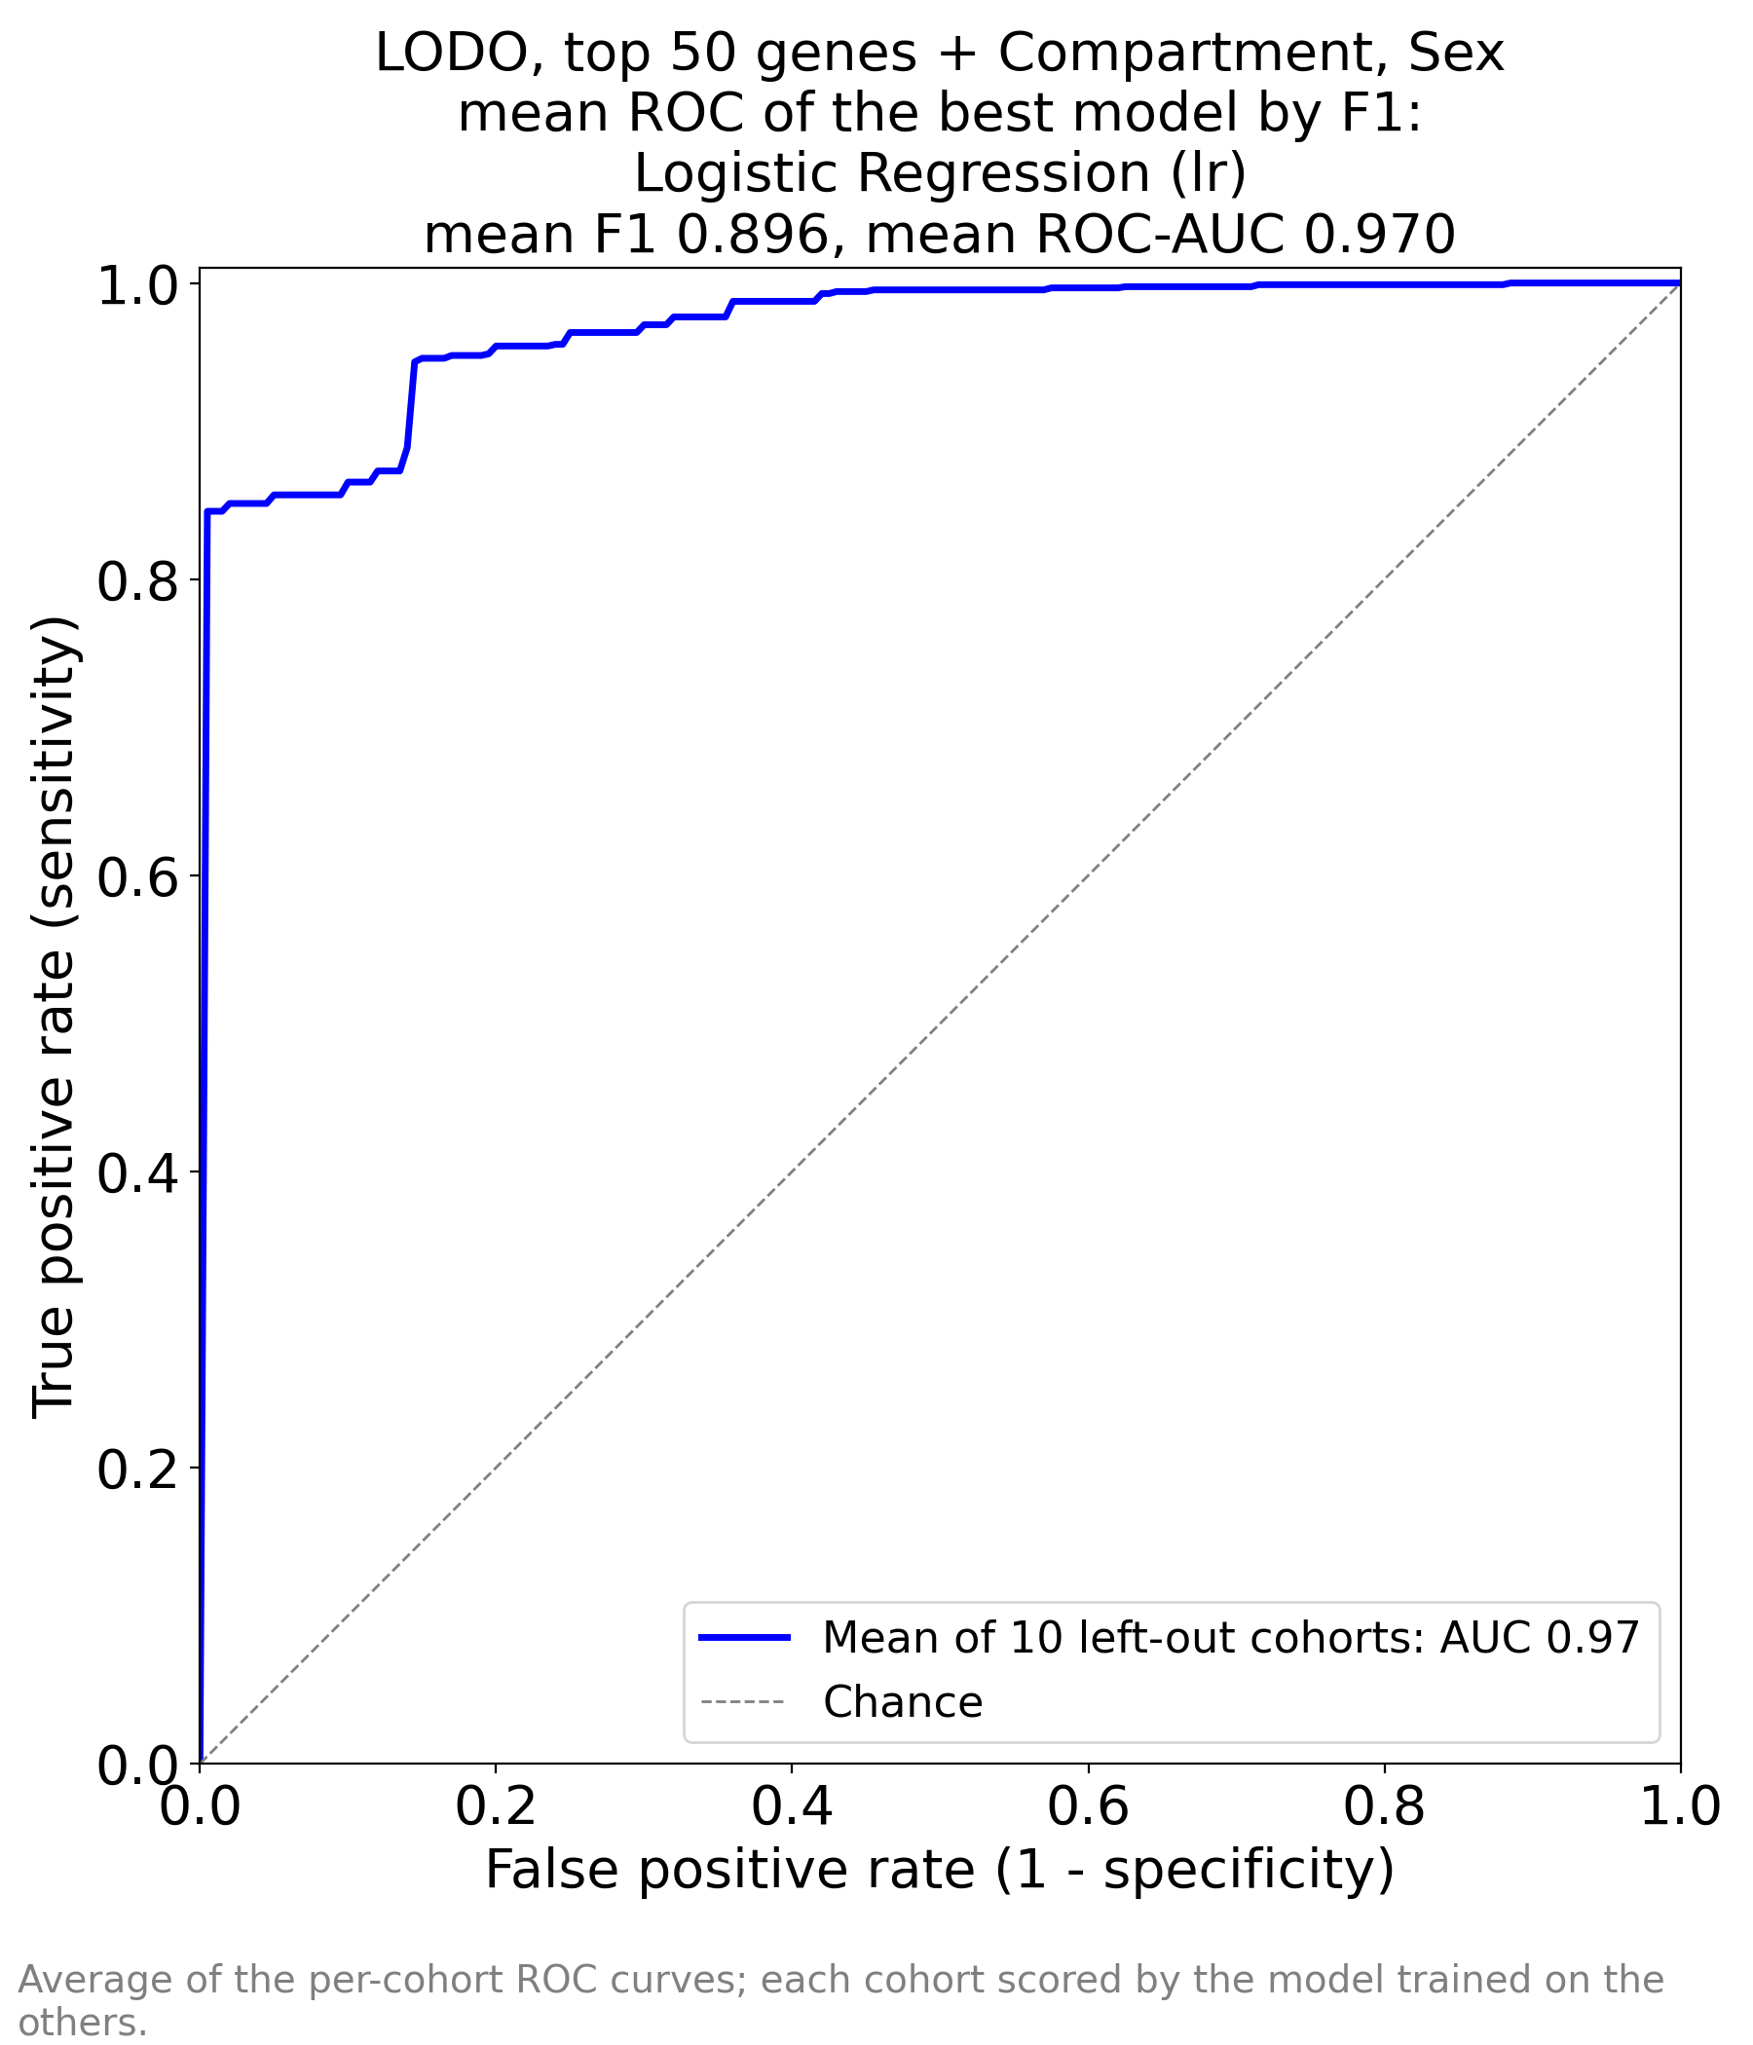  ML_TOP_50_by_AUC_AUC_by_F1.png
TOP_50_by_AUC: best by ROC-AUC (left) and by F1 (right), both Logistic Regression, F1 0.896, AUC 0.970. The vertical rise reaches 0.85 sensitivity at zero false positives (0.80 with all genes).
ML_TOP_50_by_F1_AUC_by_AUC.png | ML_TOP_50_by_F1_AUC_by_F1.png
TOP_50_by_F1: identical to the images above, as the gene set and the model are the same.

5.3 Feature importances in the 50-gene model
Rank | Source | Importance | Coefficient | Biological group
1 | FN1 | 2.012 | +2.01 | fibrosis / injury / immune
2 | DHRS2 | 1.725 | -1.73 | tubular / vascular differentiation
3 | PPP1R3C | 1.613 | +1.61 | fibrosis / injury / immune
4 | DUSP1 | 1.523 | -1.52 | immediate-early / stress
5 | Compartment | 1.493 | -1.49 | metadata
6 | ZFP36 | 1.128 | +1.13 | immediate-early / stress
7 | Compartment | 1.073 | +1.07 | metadata
8 | SYNPO | 1.010 | +1.01 | fibrosis / injury / immune
9 | NFIL3 | 0.980 | -0.98 | immediate-early / stress
10 | COL4A3 | 0.950 | -0.95 | tubular / vascular differentiation
11 | MNDA | 0.907 | -0.91 | blood / neutrophil
12 | Sex | 0.894 | +0.89 | metadata
13 | Sex | 0.881 | -0.88 | metadata
14 | F3 | 0.808 | +0.81 | fibrosis / injury / immune
15 | LYZ | 0.806 | +0.81 | fibrosis / injury / immune
16 | APOD | 0.787 | -0.79 | tubular / vascular differentiation
17 | RGS2 | 0.781 | -0.78 | immediate-early / stress
18 | JUNB | 0.739 | -0.74 | immediate-early / stress
19 | EGR1 | 0.727 | -0.73 | immediate-early / stress
20 | ESM1 | 0.711 | -0.71 | tubular / vascular differentiation
21 | ZNF331 | 0.671 | +0.67 | tubular / vascular differentiation
22 | XYLT1 | 0.660 | -0.66 | tubular / vascular differentiation
23 | ANXA1 | 0.611 | +0.61 | fibrosis / injury / immune
24 | ALB | 0.596 | -0.60 | tubular metabolism / fasting
25 | PTGS2 | 0.586 | -0.59 | immediate-early / stress
26 | S100A8 | 0.558 | +0.56 | blood / neutrophil
27 | GSTA1 | 0.545 | +0.54 | tubular metabolism / fasting
28 | S100A12 | 0.544 | -0.54 | blood / neutrophil
29 | JUN | 0.544 | +0.54 | immediate-early / stress
30 | FPR1 | 0.459 | +0.46 | blood / neutrophil
31 | NR4A1 | 0.447 | +0.45 | immediate-early / stress
32 | MAFB | 0.438 | +0.44 | fibrosis / injury / immune
33 | Compartment | 0.433 | +0.43 | metadata
34 | CALB1 | 0.431 | -0.43 | tubular / vascular differentiation
35 | HLA-DRB1 | 0.428 | +0.43 | fibrosis / injury / immune
36 | IGF1 | 0.411 | -0.41 | tubular metabolism / fasting
37 | PDK4 | 0.388 | -0.39 | tubular metabolism / fasting
38 | NR4A2 | 0.356 | -0.36 | immediate-early / stress
39 | LUM | 0.328 | +0.33 | fibrosis / injury / immune
40 | RAB20 | 0.314 | +0.31 | tubular / vascular differentiation
41 | CYP26B1 | 0.309 | -0.31 | tubular / vascular differentiation
42 | RPS4Y1 | 0.298 | -0.30 | sex (Y chromosome)
43 | CCN1 | 0.287 | +0.29 | immediate-early / stress
44 | GDF15 | 0.252 | +0.25 | immediate-early / stress
45 | ATF3 | 0.234 | -0.23 | immediate-early / stress
46 | PCK1 | 0.213 | -0.21 | tubular metabolism / fasting
47 | FOS | 0.195 | -0.19 | immediate-early / stress
48 | CHI3L1 | 0.141 | -0.14 | tubular / vascular differentiation
49 | HBEGF | 0.112 | +0.11 | immediate-early / stress
50 | SPINK1 | 0.110 | +0.11 | tubular / vascular differentiation
51 | G6PC1 | 0.104 | -0.10 | tubular metabolism / fasting
52 | MAFF | 0.093 | -0.09 | immediate-early / stress
53 | FOSB | 0.035 | -0.04 | immediate-early / stress
54 | APOH | 0.017 | +0.02 | tubular metabolism / fasting
55 | CR2 | 0.005 | +0.01 | tubular / vascular differentiation
Positive coefficient (orange) → Disease. Compartment and Sex appear as 3 and 2 one-hot rows.
- Coefficients change size and even sign relative to run 1: ZFP36, JUN, NR4A1, GDF15, GSTA1 and S100A8 now push towards disease, although each is higher in controls on its own. These are highly correlated genes (the immediate-early program moves as one block; its genes correlate with the stress score at up to r = 0.81, Section 6.4); once one of them carries the “stress” information, the others are used for small corrections in the opposite direction. Individual coefficients in this model should therefore not be interpreted as biological effects.
- Metadata gain weight: Compartment (|coef| 1.49 and 1.07) and Sex (0.89) are now among the top 12, because with 50 inputs every remaining source of variance is used.

6. Additional experiments
The result files hold only cohort-averaged scores. To answer the clinical questions, I re-ran the best model (Logistic Regression, identical settings and LODO groups) and stored every out-of-fold prediction. The reproduced mean ROC-AUCs match the notebooks exactly (0.628, 0.953, 0.970). Script: experiments.py (kept with the report sources).

6.1 Exact sensitivity and specificity, per cohort
Feature set | TP | FN | TN | FP | Sensitivity | Specificity | PPV | NPV | Spec at sens 0.90*
5 RenoRisk genes | 652 | 26 | 9 | 163 | 0.962 | 0.052 | 0.800 | 0.257 | 0.212
All genes | 629 | 49 | 108 | 64 | 0.928 | 0.628 | 0.908 | 0.688 | 0.873
Top 50 genes | 634 | 44 | 105 | 67 | 0.935 | 0.610 | 0.904 | 0.705 | 0.940
Pooled over all 850 out-of-fold predictions at the default threshold 0.5. * Mean over cohorts of the specificity achievable at 90% sensitivity if the threshold were set within each cohort (requires local calibration data).

All genes, per left-out cohort
Cohort | Controls | Ctrl / cases | AUC | Sens | Spec | PPV | NPV | Spec at sens 0.90
ERCB | LD + TN | 42 / 89 | 0.957 | 1.000 | 0.310 | 0.754 | 1.000 | 0.786
GSE108109 | LD | 6 / 105 | 1.000 | 1.000 | 1.000 | 1.000 | 1.000 | 1.000
GSE116626 | LD | 7 / 74 | 0.832 | 0.459 | 0.857 | 0.971 | 0.130 | 0.857
GSE121233 | TN | 5 / 5 | 1.000 | 1.000 | 0.800 | 0.833 | 1.000 | 1.000
GSE129973 | TN | 20 / 20 | 1.000 | 1.000 | 1.000 | 1.000 | 1.000 | 1.000
GSE200828 | LD | 6 / 147 | 1.000 | 1.000 | 1.000 | 1.000 | 1.000 | 1.000
GSE30122 | Not stated | 50 / 19 | 0.857 | 0.895 | 0.560 | 0.436 | 0.933 | 0.460
GSE66494 | Reference RNA | 8 / 53 | 0.929 | 1.000 | 0.000 | 0.869 | — | 0.750
GSE96804 | TN | 20 / 41 | 1.000 | 0.902 | 1.000 | 1.000 | 0.833 | 1.000
GSE99339 | TN | 8 / 125 | 0.959 | 0.976 | 0.625 | 0.976 | 0.625 | 0.875

5 RenoRisk genes, per left-out cohort
Cohort | Controls | Ctrl / cases | AUC | Sens | Spec | PPV | NPV | Spec at sens 0.90
ERCB | LD + TN | 42 / 89 | 0.610 | 0.865 | 0.190 | 0.694 | 0.400 | 0.143
GSE108109 | LD | 6 / 105 | 0.705 | 1.000 | 0.000 | 0.946 | — | 0.167
GSE116626 | LD | 7 / 74 | 0.797 | 1.000 | 0.000 | 0.914 | — | 0.286
GSE121233 | TN | 5 / 5 | 0.800 | 1.000 | 0.000 | 0.500 | — | 0.600
GSE129973 | TN | 20 / 20 | 0.610 | 1.000 | 0.000 | 0.500 | — | 0.250
GSE200828 | LD | 6 / 147 | 0.726 | 0.986 | 0.167 | 0.967 | 0.333 | 0.500
GSE30122 | Not stated | 50 / 19 | 0.514 | 1.000 | 0.000 | 0.275 | — | 0.020
GSE66494 | Reference RNA | 8 / 53 | 0.491 | 0.962 | 0.000 | 0.864 | 0.000 | 0.000
GSE96804 | TN | 20 / 41 | 0.573 | 1.000 | 0.000 | 0.672 | — | 0.150
GSE99339 | TN | 8 / 125 | 0.452 | 0.920 | 0.000 | 0.935 | 0.000 | 0.000
LD = living donor, TN = tumour nephrectomy. “—” = undefined (no sample called control). Top-50 per-cohort AUCs: ERCB 0.971, GSE108109 0.997, GSE116626 0.896, GSE121233 1.000, GSE129973 1.000, GSE200828 1.000, GSE30122 0.862, GSE66494 1.000, GSE96804 0.995, GSE99339 0.975.
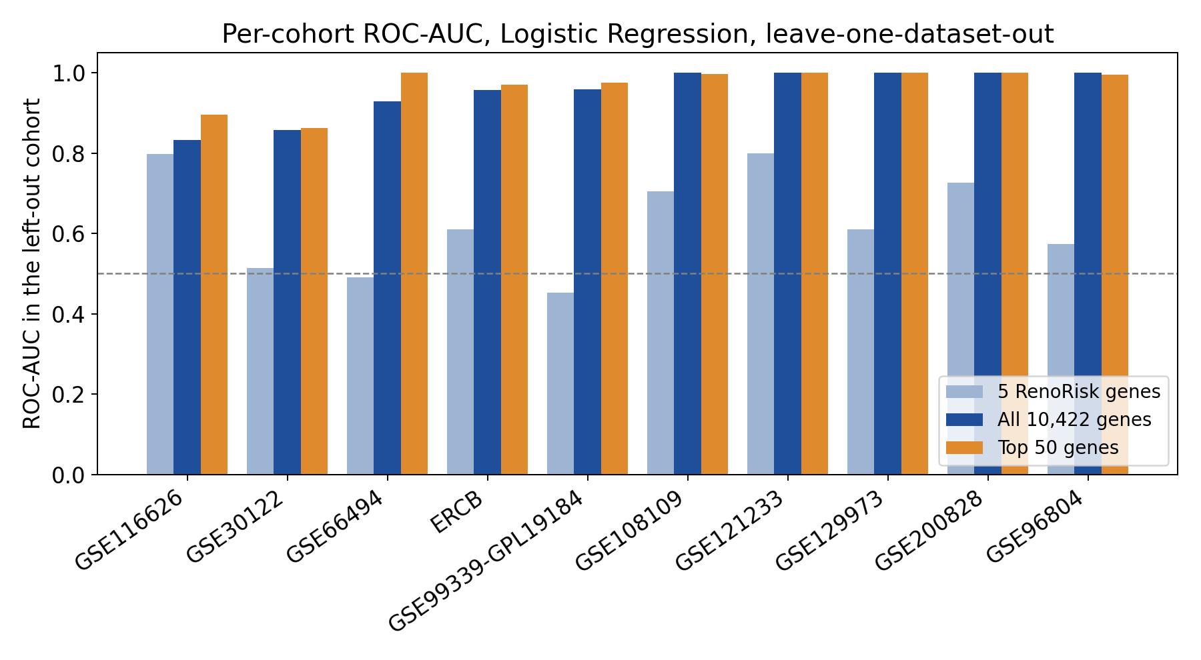
Figure 6.1. ROC-AUC in each left-out cohort for the three feature sets. Dashed line: chance.
- All genes: five cohorts perfectly separated (GSE108109, GSE121233, GSE129973, GSE200828, GSE96804 — all with surgical controls). The weakest are GSE30122 (0.857; control source not stated, smallest stress difference) and GSE116626 (0.832; Illumina WG-DASL, a platform built for degraded RNA, values per-gene centred): here the model catches only 46% of the diseased.
- Threshold transfer is the main practical failure: ERCB has AUC 0.957 but specificity 0.31 at threshold 0.5, while its achievable specificity at 90% sensitivity is 0.79. All 8 GSE66494 controls (reference RNA) are called diseased despite AUC 0.929. Scores are comparable within a centre, not between centres.
- RenoRisk: per-cohort AUC 0.45–0.80, below 0.5 in GSE99339 and GSE66494; only 9 controls in 850 samples are called control.

6.2 Which diseases are detected, which controls are recognised
Indication | n | Detected: RR | Detected: all genes | Detected: top 50
MN | 116 | 97% | 100% | 100%
FSGS | 111 | 98% | 100% | 97%
DKD | 81 | 99% | 93% | 98%
IgAN | 78 | 96% | 62% | 71%
Other GN | 68 | 99% | 85% | 87%
ANCA vasculitis | 58 | 93% | 100% | 98%
CKD (unspecified) | 53 | 96% | 100% | 100%
MCD | 52 | 94% | 100% | 96%
Lupus nephritis | 30 | 97% | 100% | 100%
Hypertensive nephropathy | 18 | 83% | 89% | 78%
FSGS/MCD | 10 | 80% | 100% | 100%
Thin membrane disease | 3 | 67% | 67% | 100%
Detected = called diseased at threshold 0.5 (sensitivity per indication).
Control source |  | Controls | Recognised: RR |  |  | Recognised: all genes |  |  | Recognised: top 50
Living donor + tumour nephrectomy |  | 42 | 19% |  |  | 31% |  |  | 74%
Living donor |  | 19 | 5% |  |  | 95% |  |  | 84%
Tumour nephrectomy |  | 53 | 0% |  |  | 93% |  |  | 91%
Not stated |  | 50 | 0% |  |  | 56% |  |  | 20%
Reference RNA |  | 8 | 0% |  |  | 0% |  |  | 0%
Compartment | Ctrl / cases | Sens RR |  | Sens all | Sens top 50 |  | Spec RR | Spec all |  | Spec top 50
Glomerular | 112 / 502 | 98% |  | 98% | 98% |  | 1% | 79% |  | 65%
Tubulointerstitial | 45 / 49 | 76% |  | 100% | 96% |  | 18% | 31% |  | 58%
Whole biopsy | 15 / 127 | 98% |  | 69% | 75% |  | 0% | 40% |  | 40%
- IgA nephropathy is the blind spot (62%). Its 78 cases come from GSE116626 (52), where only 46% of all cases are detected, and GSE99339 (26). Many IgAN biopsies show only mesangial changes with preserved tubulointerstitium; their transcriptome is close to normal tissue. Hypertensive nephropathy (89%), other GN (85%) and DKD (93%) follow; nephrotic and inflammatory diseases (MN, FSGS, MCD, lupus, ANCA vasculitis) are detected at 96–100%.
- Living-donor and tumour-nephrectomy controls are recognised well (95% and 93%) by the all-gene model — exactly the controls with the strongest surgical stress signature. Controls without a surgical signature (GSE30122, 56%) and reference RNA (0%) are not. ERCB controls (31%) are recognised poorly because of the score offset described in 6.1.

6.3 What metadata and the panel contribute
Features (Logistic Regression, LODO) | ROC-AUC | Sensitivity | Specificity
Compartment + Sex only (no genes) | 0.552 | 0.942 | 0.122
5 RenoRisk genes only | 0.624 | 0.867 | 0.087
5 RenoRisk genes + Compartment + Sex (RR notebook) | 0.628 | 0.962 | 0.052
All genes without Compartment, Sex | 0.952 | 0.928 | 0.657
- Compartment + Sex alone reach 0.552: within a cohort they are nearly constant, so they mainly shift the threshold. The five panel genes alone reach 0.624, and adding the metadata gives 0.628; the metadata add nothing on top of all genes (0.952 vs 0.953).

6.4 Is the accuracy produced by surgery and stress?
A per-sample stress score was built as the mean within-series z-score of the 17 immediate-early genes. For every gene, its correlation with this score was computed inside each series × label group, so the disease effect itself does not create correlation.
Series | Control source | Stress score, controls | Stress score, cases | AUC of stress score alone
GSE104948 | Living donor + tumour nephrectomy | +0.46 | -0.19 | 0.695
GSE104954 | Living donor + tumour nephrectomy | +0.79 | -0.43 | 0.937
GSE108109 | Living donor | +0.75 | -0.04 | 0.852
GSE116626 | Living donor | +1.36 | -0.13 | 0.946
GSE121233 | Tumour nephrectomy | +0.39 | -0.39 | 0.800
GSE129973 | Tumour nephrectomy | +0.43 | -0.43 | 0.825
GSE200828 | Living donor | +0.83 | -0.03 | 0.879
GSE30122 | Not stated | +0.10 | -0.25 | 0.645
GSE66494 | Reference RNA | +0.70 | -0.11 | 0.925
GSE96804 | Tumour nephrectomy | +0.82 | -0.40 | 0.945
GSE99339 | Tumour nephrectomy | +1.28 | -0.08 | 0.938
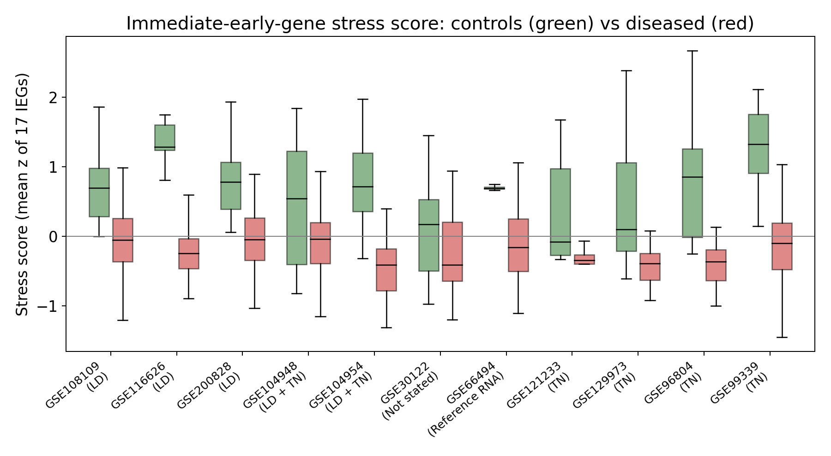
Figure 6.2. Stress score (mean z of 17 immediate-early genes) in controls (green) and diseased samples (red), per series. LD = living donor, TN = tumour nephrectomy.
- Controls have higher stress scores in all 11 series. The difference is largest in surgical series (stress-only AUC 0.94–0.95 in GSE96804, GSE116626, GSE99339, GSE104954) and smallest in GSE30122 (0.645), the only series without a stated surgical control source.
- The program is the classic immediate-early response: 18 genes correlate with the score at r > 0.5, 51 at r > 0.4, 222 at r > 0.3. Strongest: EGR1 0.81, FOS 0.74, JUNB 0.71, ZFP36 0.68, ATF3 0.67, CCN1 0.64, DUSP1 0.61, HBEGF 0.60, NR4A1 0.60, FOSB 0.59, EGR2 0.58, IER3 0.55, TNFRSF12A 0.54, JUN 0.54, EGR3 0.54, RGS2 0.53, MAFF 0.52, DUSP6 0.50, CXCL2 0.50, IER2 0.50.
Features (Logistic Regression, LODO) | Genes | ROC-AUC | Sensitivity | Specificity
All genes (reference) | 10,422 | 0.953 | 0.928 | 0.628
17 immediate-early genes only | 17 | 0.886 | 0.879 | 0.453
28 procurement genes only (IEG + fasting + blood) | 28 | 0.921 | 0.878 | 0.494
All genes minus 17 immediate-early genes | 10,405 | 0.940 | 0.914 | 0.576
All genes minus 28 procurement genes | 10,394 | 0.935 | 0.916 | 0.576
All genes minus 51 stress-co-varying genes (|r| > 0.4) | 10,371 | 0.941 | 0.913 | 0.576
All genes minus 222 stress-co-varying genes (|r| > 0.3) | 10,200 | 0.934 | 0.906 | 0.570
- Stress genes alone are strong predictors: 17 genes → AUC 0.886; adding 7 fasting/metabolic and 4 blood genes → 0.921.
- But removing them leaves AUC 0.93–0.94: the remaining genes still separate diseased from control tissue. What drops is specificity (0.628 → 0.570): without the stress genes, more controls look diseased. Conclusion: procurement explains why stress genes top the importance list and part of the control recognition; it does not explain the whole discrimination. The disease signal is real and redundant with the artefact — which is why the artefact can dominate the ranking.
- Caveat: genes that respond to surgery more slowly (hours rather than minutes) or that reflect fasting and anaesthetic drugs are not fully captured by an immediate-early score; the true procurement contribution is therefore probably somewhat larger than this experiment shows.

6.5 The RenoRisk genes inside each series
Series | Control source | C4BPA | COL13A1 | HABP2 | CFH | CFI | FN1 (ref.)
GSE104948 | LD + TN | +0.03 | +1.14 | +0.12 | +0.95 | +0.15 | +1.53
GSE104954 | LD + TN | -0.05 | +0.18 | +0.36 | +0.53 | +0.80 | +1.03
GSE108109 | LD | 0.00 | +0.73 | -0.03 | -0.73 | -1.37 | +1.18
GSE116626 | LD | -0.19 | +0.64 | +0.51 | +0.30 | +0.43 | +0.04
GSE121233 | TN | -0.44 | -0.17 | +1.02 | +0.79 | +1.01 | +2.24
GSE129973 | TN | +0.14 | +0.03 | -0.02 | +0.88 | +0.53 | +2.00
GSE200828 | LD | -0.09 | +0.63 | +0.06 | -0.76 | -1.28 | +0.87
GSE30122 | Not stated | +1.06 | +0.68 | +1.01 | +0.69 | +0.71 | +1.52
GSE66494 | Reference RNA | +0.25 | +0.58 | +0.94 | +0.65 | +1.03 | +0.64
GSE96804 | TN | -0.06 | +1.71 | -0.38 | +0.97 | +0.09 | +1.86
GSE99339 | TN | -0.07 | +0.05 | -0.90 | -0.12 | -0.43 | +0.79
Hedges-type g = standardised difference, diseased minus control, within each series. Orange ≥ +0.5 (higher in disease), green ≤ −0.5 (lower in disease).
- COL13A1 is the most consistent panel gene (higher in disease in 10 of 11 series, g up to +1.71) but small on average. CFH and CFI are higher in disease in most series but clearly lower in GSE108109 and GSE200828 (g −0.73 to −1.37) — the two large glomerular cohorts dominated by MN, FSGS and MCD. HABP2 runs in both directions (−0.90 to +1.02); C4BPA is flat everywhere except GSE30122 (+1.06, DKD).
- The panel is not affected by procurement: correlation with the stress score is C4BPA 0.01, COL13A1 0.12, HABP2 0.09, CFH 0.28, CFI 0.03. Its weak result is therefore a genuine biological limit, not an artefact — the panel’s 0.63 is the more honest number, but too low for diagnosis.

7. Medical interpretation

7.1 How the tissue was obtained shapes the transcriptome
Diseased samples are diagnostic percutaneous needle biopsies: local anaesthesia, a few seconds from needle to tissue, and immediate stabilisation (RNAlater or freezing). Most controls come from surgery: implantation or pre-donation biopsies from living donors and macroscopically normal tissue from tumour nephrectomies. These patients fasted overnight, received general anaesthesia (typically propofol or volatile agents with opioids), had a surgical stress response (catecholamine and cortisol surge), and the kidney underwent vascular clamping with warm ischaemia, then cold ischaemia and handling until the sample was preserved — often 15–60 minutes or more.
- Immediate-early genes (FOS, FOSB, JUN, JUNB, EGR1–3, ATF3, IER2/3, NR4A1–3, DUSP1, ZFP36, CCN1) are transcribed within 5–30 minutes of mechanical injury, hypoxia, cytokines or adrenergic stimulation, without new protein synthesis. Their mRNA rises many-fold in minutes and is well documented as a tissue-procurement artefact in surgical specimens. They describe the last hour of the tissue’s life, not the patient’s kidney disease.
- Fasting and stress hormones induce PDK4 (switch from glucose to fat oxidation), PCK1 and G6PC1 (renal gluconeogenesis, which rises during fasting) via glucocorticoids and glucagon. Their sign reverses in the two series without surgical controls (PDK4 g +0.69 and +0.74), consistent with a pre-operative fasting effect superimposed on biology.
- Blood content: S100A8/A12, MNDA and FPR1 are neutrophil transcripts. Surgical specimens contain more blood; S100A12 is clearly higher in controls in five series with surgical controls (three tumour-nephrectomy, two living-donor glomerular series; g −1.4 to −2.3) and not in the others.
- Tumour-bearing kidneys and donors are selected people: donors are healthy and screened; nephrectomy patients are older, may have hypertension or reduced function and receive the tumour’s systemic influence. “Control” therefore does not mean the same tissue state across cohorts.

7.2 Genes that reflect real kidney disease
- Fibrosis: FN1 (fibronectin) and LUM (lumican) are matrix proteins deposited in interstitial fibrosis and glomerulosclerosis — the common end-point of chronic kidney disease and the strongest histological predictor of progression. FN1 is higher in disease in all 11 series.
- Loss of tubular differentiation: PCK1, G6PC1, GSTA1, APOH and ALB (proximal tubule) and CALB1 (distal tubule) are markers of healthy tubular epithelium. Their reduction reflects tubular atrophy and dedifferentiation; in CKD, loss of tubular gluconeogenesis is linked to worse outcomes. This part of the “control” signal is biological.
- Inflammation and immunity: HLA-DRB1 (MHC class II on infiltrating antigen-presenting cells and activated tubular cells), LYZ, ANXA1 and F3 (tissue factor) mark immune infiltration and injury, prominent in GN, lupus nephritis and ANCA vasculitis — the diseases detected at 100%.
- Podocyte genes (MAFB, SYNPO) point to disease in the model, which seems paradoxical (podocyte loss lowers them). This reflects composition: glomerular extracts from diseased patients differ in cell mix between cohorts; individual coefficients in a model with 10,422 correlated inputs are not causal effects.

7.3 Why some diseases are missed
- IgA nephropathy (62% detected): most IgAN biopsies show mesangial hypercellularity with otherwise preserved parenchyma, and many patients have near-normal function at biopsy. A tissue-level classifier trained largely on stress and fibrosis signals cannot see a mild mesangial lesion; the 52 IgAN cases of GSE116626 (WG-DASL platform) add a technical penalty.
- Hypertensive nephropathy (89%) and DKD (93%): vascular and early diabetic changes are patchy and partly overlap with the age-related changes present in older nephrectomy controls.
- Nephrotic and inflammatory GN (96–100%): strong podocyte, immune and matrix changes produce a large transcriptomic shift that the model captures reliably.

7.4 The RenoRisk panel in medical terms
CFH (factor H) and CFI (factor I) are the main fluid-phase regulators of the alternative complement pathway; C4BPA (C4b-binding protein α) regulates the classical and lectin pathways; HABP2 encodes factor VII–activating protease (FSAP), a plasma serine protease linked to coagulation and inflammation; COL13A1 is a transmembrane collagen. The four plasma proteins are made mainly in the liver; kidney mRNA levels are low and change with local injury, infiltrating cells and complement activation. Complement dysregulation drives specific entities (C3 glomerulopathy, atypical HUS, part of IgAN, MN and lupus), so the panel’s genes plausibly carry prognostic or disease-specific information. As a general detector of diseased tissue, their effects are small and inconsistent in direction across series and diseases (Section 6.5), which explains the ceiling of 0.63. A fair test of the panel is its intended use — risk of progression or response to treatment — which requires outcome data not present in GEO.

7.5 What the numbers would mean in practice
With the all-gene model at its default threshold (sensitivity 93%, specificity 63%) and with a per-site calibrated threshold (sensitivity 90%, specificity 87%), the predictive values in populations with different disease frequency are:
Disease frequency in tested population | PPV default | NPV default | PPV calibrated | NPV calibrated
80% (biopsy cohorts as here) | 91% | 69% | 97% | 69%
50% | 71% | 90% | 88% | 90%
20% | 38% | 97% | 64% | 97%
5% (screening-like) | 12% | 99% | 27% | 99%
- In a biopsy clinic (most biopsied patients are ill) a positive call is right ~90% of the time, but a negative call only ~70% — it cannot rule out disease. In a low-prevalence setting, most positive calls would be false alarms.
- Real-world accuracy will be lower than measured here, because in practice both healthy and diseased tissue would be obtained by the same needle procedure, removing the stress contrast that currently helps to recognise controls. Experiment 6.4 suggests the ranking ability without that contrast is about 0.93 with specificity below 60% at a fixed threshold.
- Clinical role: histology with immunofluorescence and electron microscopy remains the reference. A transcriptomic classifier is useful as a quantitative adjunct (e.g. an objective fibrosis/injury score, or flagging molecular disease in a histologically borderline biopsy), not as a stand-alone detector. The RenoRisk panel, in this task, has no stand-alone diagnostic value.

8. Recommendations
- Validate on procedure-matched samples: needle-biopsy controls (zero-time/protocol biopsies, or normal-histology diagnostic biopsies), processed like the cases.
- Treat the immediate-early program as a covariate: report the stress score per sample, stratify or adjust for it, and show performance within stress-score strata.
- Calibrate per site before quoting sensitivity, specificity, PPV or NPV; report specificity explicitly, not F1.
- Select features inside each LODO fold to obtain an unbiased top-N result; use regularised linear models, which were consistently best.
- Test the RenoRisk panel on its intended endpoint (progression, eGFR decline, treatment response) and within disease entities where complement is implicated.

9. Limitations
- Expression values are as deposited by five processing pipelines on six platforms; three series are per-gene centred or relative. No cross-study correction was applied, by design.
- No clinical covariates (age, eGFR, proteinuria, histology scores, ischaemia time, anaesthetic) exist in the GEO records; procurement effects are inferred from the tissue source.
- Small control groups in several cohorts (5–8 controls) make per-cohort specificity unstable (one sample = 12–20 percentage points).
- Control source for ERCB mixes living donors and tumour nephrectomies; GSE30122 does not state it; GSE66494 controls are reference RNA.
- Feature importances come from models refitted on all cohorts; coefficients on unscaled, correlated inputs are not biological effect sizes.

