RenoRisk Biomarker Validation
Machine-learning detection of diseased kidney tissue: results, feature importance and clinical interpretation
Source: Results/ML_training___ (RR, ALL/ALL, ALL/TOP_50_by_AUC) · Report date: 31 October 2026

Contents
1. Executive summary 2
2. Data and experimental design 2
2.1 Data 2
2.2 Modelling 3
2.3 Files analysed 3
3. Results — data-science view 3
3.1 Headline performance 3
3.2 ROC figures 3
3.3 Full model comparison (all three performance workbooks) 5
3.4 Interpretation of the performance 6
4. Feature importance 7
4.1 RenoRisk panel (experiment A) 7
4.2 Genome-wide model (experiment B): the top 50 genes 8
4.3 Why these genes became the most important features 10
5. Medical interpretation 10
5.1 Module 1 — Immediate-early / acute stress response (higher in controls) 10
5.2 Module 2 — Loss of tubular differentiation and metabolic reprogramming (lower in disease) 10
5.3 Module 3 — Matrix expansion and fibrosis (higher in disease) 11
5.4 Module 4 — Immune and myeloid infiltrate 11
5.5 Module 5 — Glomerular structure and other genes 11
5.6 Overall clinical reading 11
6. Limitations 12
7. Conclusions and recommendations 12
Conclusions 12
Recommended next steps 12

1. Executive summary
- Three leave-one-dataset-out (LODO) experiments were run on 850 kidney-biopsy transcriptomes from 10 independent cohorts (678 disease, 172 control), comparing 16 classifiers plus a no-skill baseline.
- The 5-gene RenoRisk panel (C4BPA, COL13A1, HABP2, CFH, CFI) does not detect diseased tissue across cohorts: best mean ROC-AUC 0.628 (logistic regression). Its F1 of 0.808 is below the 0.818 of a classifier that labels every sample "Disease", and its largest model weight is the tissue compartment, not a gene.
- A genome-wide model (10,422 genes) generalises well to unseen cohorts: logistic regression, mean ROC-AUC 0.953, F1 0.883. This is the most trustworthy performance figure in the folder.
- The top-50-gene model reaches ROC-AUC 0.970, but this is optimistic: the 50 genes were chosen by a model that had already seen every test cohort. Its value is to show that ~50 genes carry almost all the signal, not to give a validated accuracy.
- What the model learned: the 50 most important genes form three biologically coherent programmes: (i) an acute immediate-early/stress programme (FOS, EGR1, JUNB, ATF3, DUSP1, NR4A1/2, ZFP36…) that is uniformly higher in control tissue, (ii) loss of tubular differentiation and gluconeogenic metabolism (PCK1, G6PC1, ALB, APOH, GSTA1, CALB1, PDK4) in disease, and (iii) gain of matrix and immune-infiltrate genes (FN1, LUM, ANXA1, LYZ, HLA-DRB1, MAFB) in disease.
- Key medical caveat: programme (i) is the strongest single signal and is most plausibly a tissue-procurement artefact. Controls are largely nephrectomy or living-donor specimens exposed to surgical warm/cold ischaemia, whereas disease samples are percutaneous needle biopsies fixed within seconds. Part of the reported discrimination is therefore "surgical specimen vs. needle biopsy", not "damaged vs. healthy kidney". Programmes (ii) and (iii) are genuine, well-documented hallmarks of chronic kidney injury.

2. Data and experimental design

2.1 Data
Input: Data/ML_input/all.xlsx (5-gene panel) and Data/ML_input/all2.xlsx (all 10,422 genes measured on every platform). Both contain the same 850 GSM samples from 11 GEO series after excluding the duplicate GSE30528/GSE30529 entries (their samples are represented through GSE30122). The two ERCB series (GSE104948, GSE104954) were merged into one LODO group, giving 10 test folds. Target: Disease_Label (Control = 0, any kidney disease = 1). Additional predictors: Compartment (glomerular / tubulointerstitial / whole biopsy) and Sex.
LODO cohort | Compartment(s) | Controls | Disease | Disease spectrum
ERCB (GSE104948 + GSE104954) | Glomerular, Tubulointerstitial | 42 | 89 | ANCA vasculitis, DKD, FSGS, FSGS/MCD, MCD
GSE108109 | Glomerular | 6 | 105 | MN, FSGS, MCD, ANCA vasculitis
GSE200828 | Glomerular | 6 | 147 | MN, FSGS, MCD, other GN
GSE99339 | Glomerular | 8 | 125 | LN, IgAN, MN, hypertensive nephropathy, FSGS, MCD, DKD, thin membrane disease
GSE96804 | Glomerular | 20 | 41 | DKD
GSE129973 | Glomerular | 20 | 20 | FSGS
GSE121233 | Glomerular | 5 | 5 | FSGS
GSE30122 | Glomerular, Tubulointerstitial | 50 | 19 | DKD
GSE116626 | Whole biopsy | 7 | 74 | IgAN, other GN
GSE66494 | Whole biopsy | 8 | 53 | CKD (unspecified)
Total |  | 172 | 678
Table 1. Cohorts used as LODO folds. Disease prevalence is 80% overall and exceeds 90% in four cohorts.

2.2 Modelling
- Validation: LeaveOneGroupOut by cohort. Every sample is predicted once by a model that never saw its cohort. Metrics are averaged over the 10 left-out cohorts.
- Models: the 17 PyCaret 3.3.2 default classifiers re-implemented in scikit-learn 1.4.2 / LightGBM 4.7.0, random_state = 42; mean/mode imputation, one-hot encoding, no feature scaling.
- Feature importance: from the best model by ROC-AUC (logistic regression in all three runs) refitted on all 850 samples; importance = |coefficient|, the signed coefficient > 0 pushes towards Disease. One-hot levels of Compartment and Sex appear as separate rows.
- Experiment C re-ran LODO on the top 50 genes of experiment B (plus Compartment and Sex).
To support the medical interpretation, this report adds one analysis not present in the folder: for each top-50 gene, the within-cohort standardised mean difference (Hedges-type g, disease minus control) was computed in each of the 12 study × compartment units, and the number of units in which the gene is higher (↑) or lower (↓) in disease was counted. This shows the direction of the gene independently of the multivariable model.

2.3 Files analysed
File (Results/ML_training___/) | Content | Discussed in
RR/ML_RR_perfs.xlsx | LODO metrics, 17 models, 5-gene panel | Tables 2, 3; §3.4
RR/ML_RR_FEAT_IMP_by_AUC.xlsx | Logistic-regression importances, panel model | Tables 6, 7; §4.1
RR/ML_RR_AUC_by_AUC.png | Mean LODO ROC, panel model | Figure 1
ALL/ALL/ML_ALL_perfs.xlsx | LODO metrics, 17 models, 10,422 genes | Tables 2, 4; §3.4
ALL/ALL/ML_ALL_FEAT_IMP_by_AUC.xlsx | Importances of all 10,427 features | Tables 7, 8; §4.2–5
ALL/ALL/ML_ALL_AUC_by_AUC.png | Mean LODO ROC, genome-wide model | Figure 2
ALL/TOP_50_by_AUC/ML_TOP_50_by_AUC_perfs.xlsx | LODO metrics, 17 models, top-50 genes | Tables 2, 5; §3.4
ALL/TOP_50_by_AUC/ML_TOP_50_by_AUC_FEAT_IMP_by_AUC.xlsx | Importances, 50-gene model | Table 8; §4.2–5
ALL/TOP_50_by_AUC/ML_TOP_50_by_AUC_AUC_by_AUC.png | Mean LODO ROC, top-50 model | Figure 3
*_sessionInfo.txt (3 files) | Software versions, settings, input | §2.2, Appendix
Table 1b. Every result file in the folder. ~$ML_TOP_50_by_AUC_FEAT_IMP_by_AUC.xlsx is an Excel lock file (165 bytes, no data) left by an open workbook and was ignored.

3. Results — data-science view

3.1 Headline performance
Experiment | Genes | Best model | ROC-AUC | F1 | Status
A. RenoRisk 5-gene panel (+ Compartment, Sex) | 5 | Logistic Regression | 0.628 | 0.808 | Unbiased LODO
B. All common genes (+ Compartment, Sex) | 10,422 | Logistic Regression | 0.953 | 0.883 | Unbiased LODO
C. Top-50 genes of run B (+ Compartment, Sex) | 50 | Logistic Regression | 0.970 | 0.896 | Optimistic (selection saw all cohorts)
Reference: Dummy (always "Disease") | – | Dummy Classifier | 0.500 | 0.818 | No-skill baseline
Table 2. Best model per experiment (mean over 10 left-out cohorts).

3.2 ROC figures
The folder contains three ROC figures, one per experiment. Each shows the mean of the 10 per-cohort ROC curves of the best model by ROC-AUC (each left-out cohort scored by a model trained on the other nine); curves are averaged vertically at fixed false-positive rates rather than pooling scores, because every fold has its own score scale.
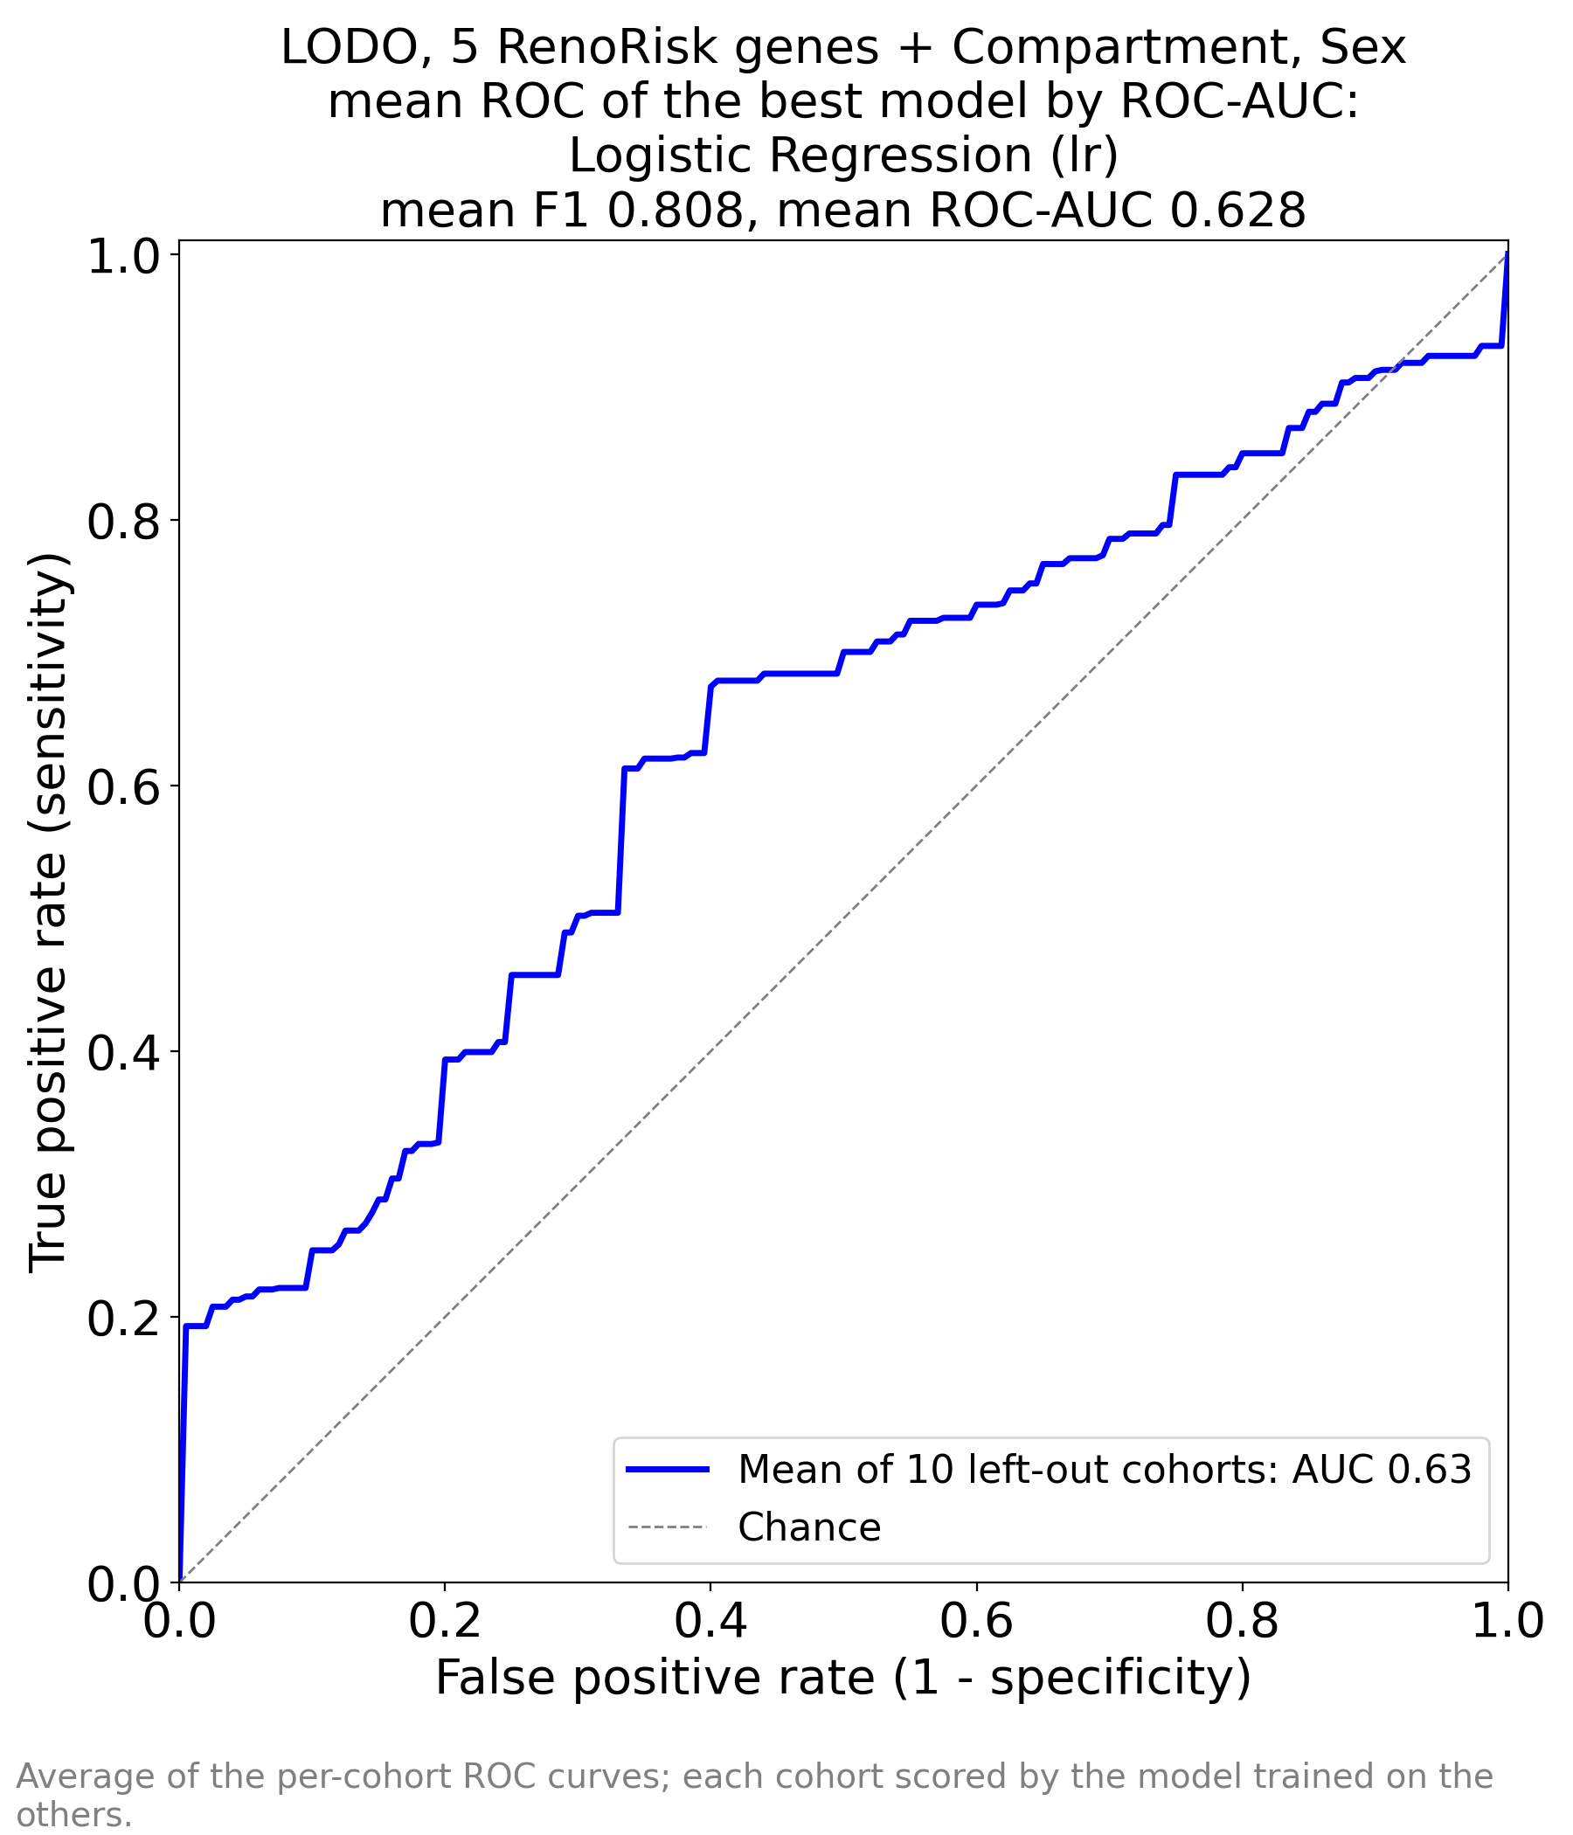
Figure 1. RR/ML_RR_AUC_by_AUC.png — RenoRisk 5 genes + Compartment, Sex; logistic regression, mean F1 0.808, mean ROC-AUC 0.628.
The curve stays close to the diagonal. A small initial step (sensitivity ≈ 0.2 at near-zero false-positive rate) shows that a minority of diseased samples have a distinctive panel profile, but beyond that the curve rises roughly in parallel with chance and falls below it at high false-positive rates. In clinical terms there is no useful operating point: at 80% sensitivity about 70% of controls would be called diseased.
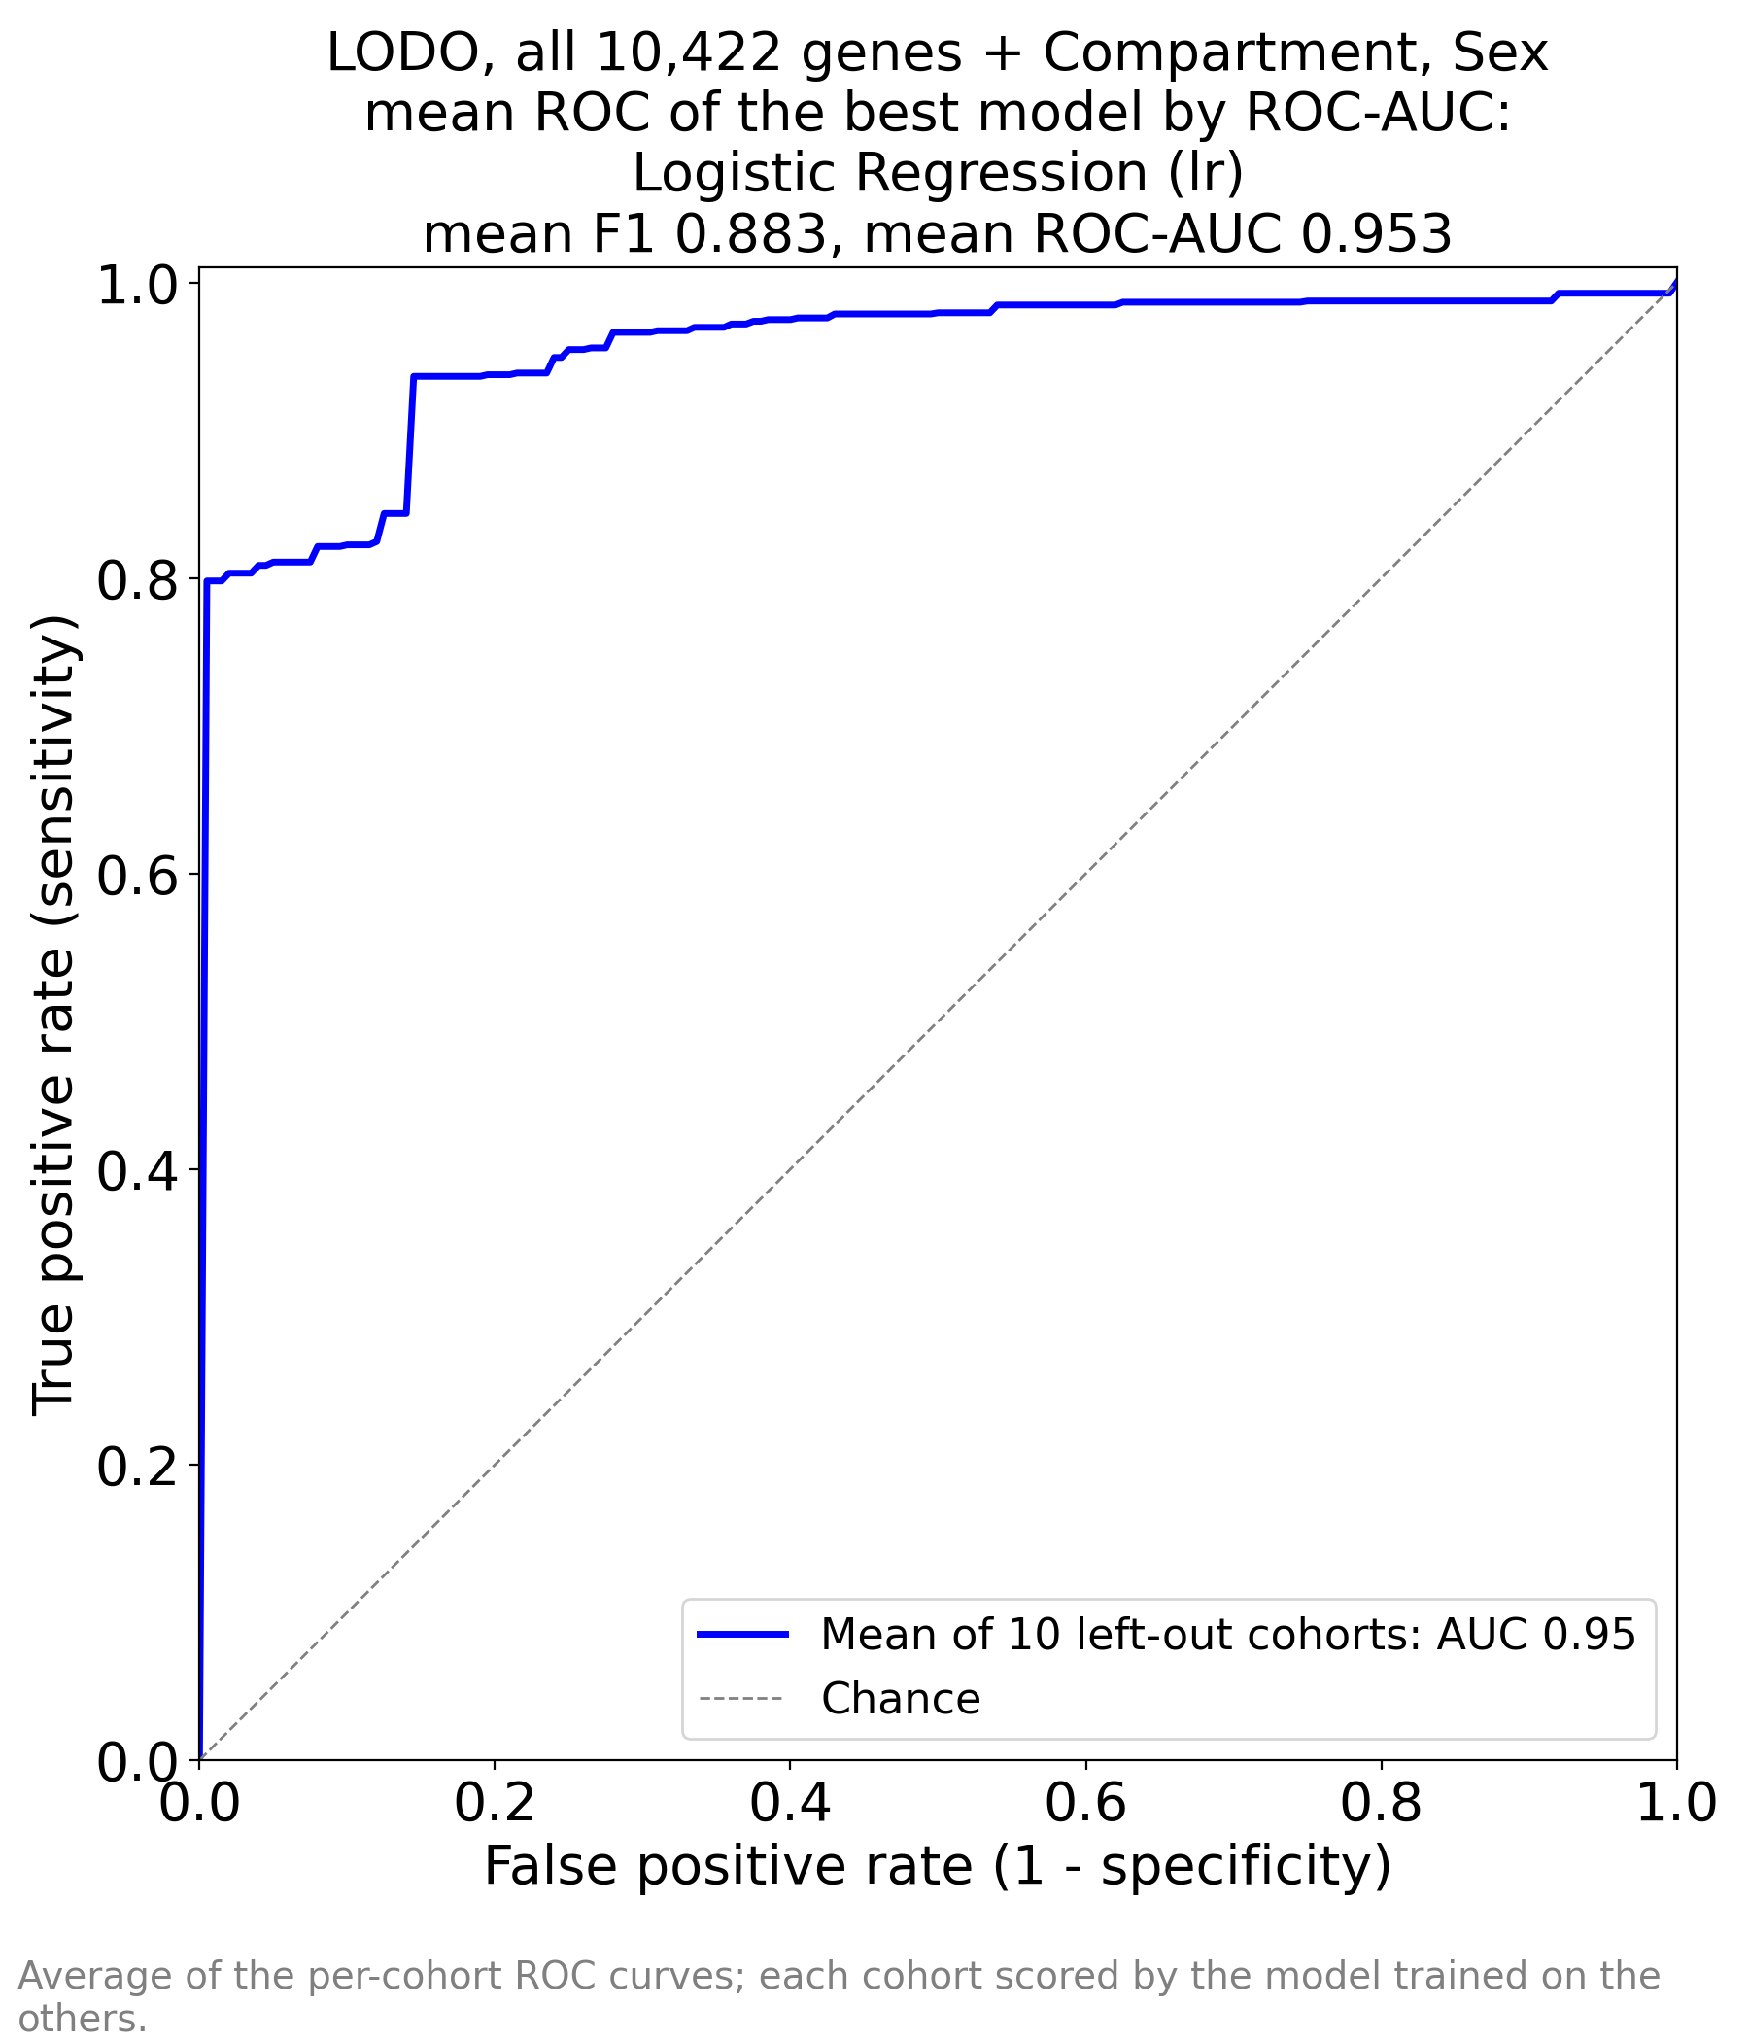
Figure 2. ALL/ALL/ML_ALL_AUC_by_AUC.png — all 10,422 genes + Compartment, Sex; logistic regression, mean F1 0.883, mean ROC-AUC 0.953.
The curve jumps immediately to a sensitivity of about 0.80 with essentially no false positives, then to about 0.94 at a false-positive rate of about 0.15. Thus four of five diseased biopsies in an unseen cohort score above every control of that cohort. The step near FPR 0.15 reflects the small number of controls per cohort: one misranked control in a 5–8-control fold moves that cohort’s curve by 12–20 percentage points. A plausible operating point is sensitivity ≈ 0.94 at specificity ≈ 0.85.
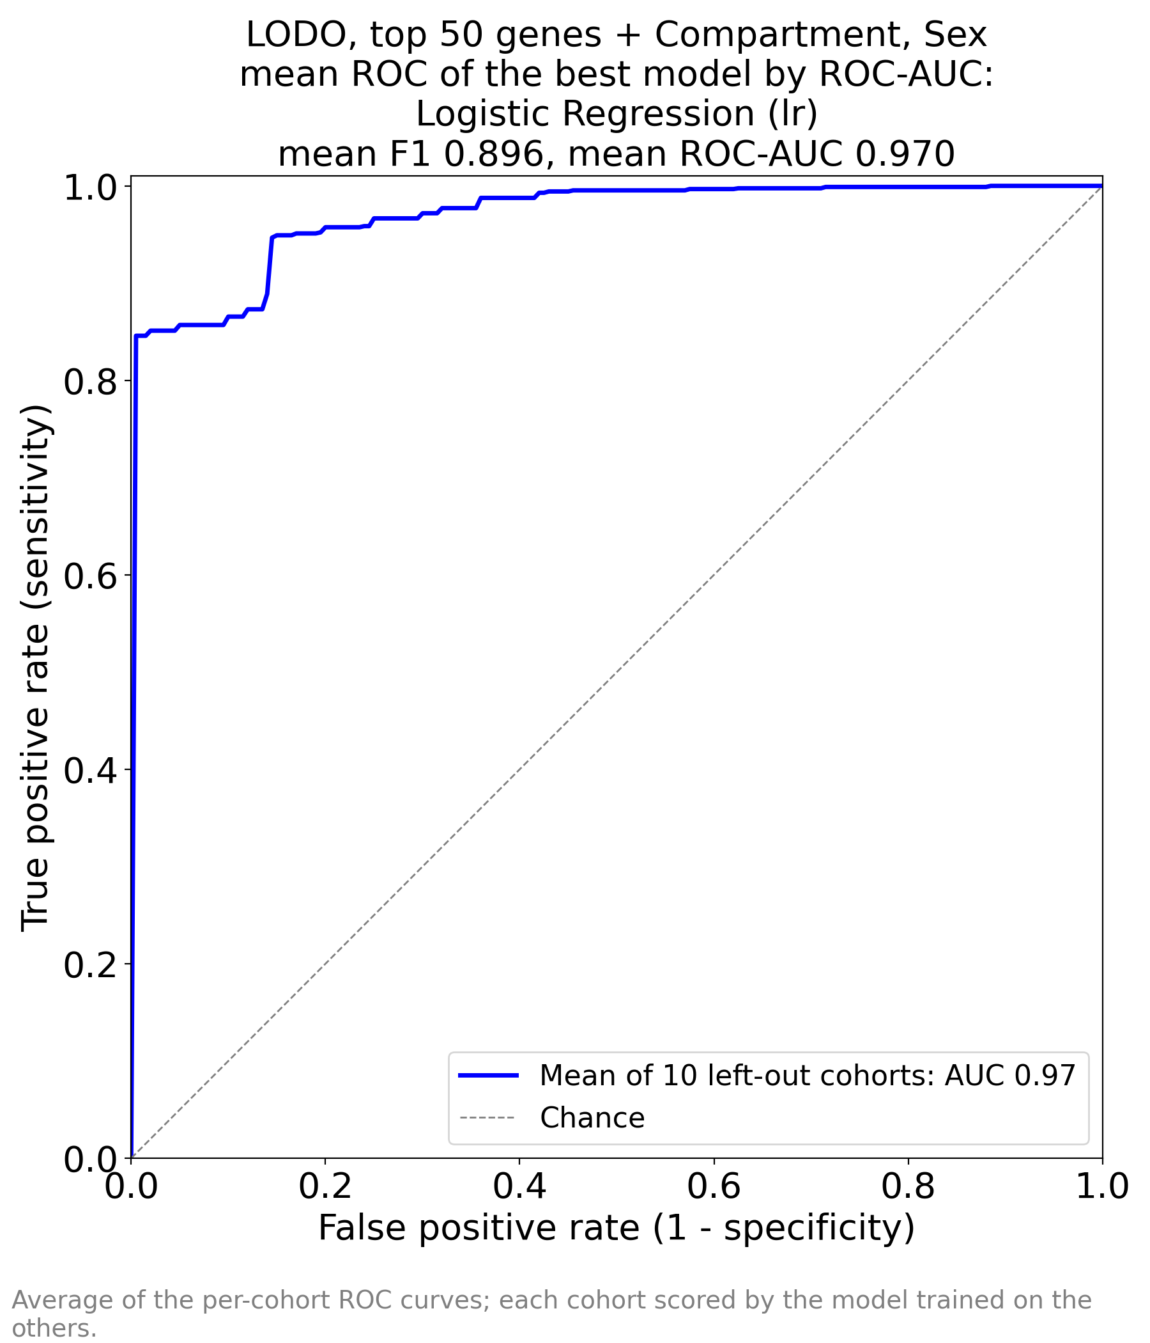
Figure 3. ALL/TOP_50_by_AUC/ML_TOP_50_by_AUC_AUC_by_AUC.png — top-50 genes + Compartment, Sex; logistic regression, mean F1 0.896, mean ROC-AUC 0.970 (optimistic).
Same shape as Figure 2 but slightly higher: about 0.85 sensitivity at zero false positives and about 0.95 at FPR 0.15. The gain over Figure 2 is modest and partly reflects the feature-selection leakage recorded in the session file; read it as an upper bound.

3.3 Full model comparison (all three performance workbooks)
Experiment A — RenoRisk 5-gene panel:
Model | ROC-AUC | F1 | Precision | Recall | Accuracy
Logistic Regression | 0.628 | 0.808 | 0.727 | 0.973 | 0.711
Ridge Classifier | 0.627 | 0.810 | 0.731 | 0.972 | 0.721
Linear Discriminant Analysis | 0.626 | 0.800 | 0.730 | 0.954 | 0.709
SVM - Radial Kernel | 0.604 | 0.767 | 0.741 | 0.904 | 0.675
K Neighbors Classifier | 0.595 | 0.719 | 0.737 | 0.831 | 0.631
Gaussian Process Classifier | 0.586 | 0.722 | 0.742 | 0.842 | 0.638
Extra Trees Classifier | 0.581 | 0.731 | 0.718 | 0.821 | 0.654
Naive Bayes | 0.553 | 0.677 | 0.640 | 0.810 | 0.590
Light Gradient Boosting Machine | 0.550 | 0.710 | 0.731 | 0.773 | 0.623
Random Forest Classifier | 0.550 | 0.706 | 0.713 | 0.802 | 0.646
MLP Classifier | 0.547 | 0.774 | 0.731 | 0.914 | 0.671
SVM - Linear Kernel | 0.530 | 0.646 | 0.590 | 0.760 | 0.643
Decision Tree Classifier | 0.516 | 0.672 | 0.728 | 0.707 | 0.622
Dummy Classifier | 0.500 | 0.818 | 0.726 | 1.000 | 0.726
Gradient Boosting Classifier | 0.496 | 0.688 | 0.700 | 0.765 | 0.604
Ada Boost Classifier | 0.486 | 0.752 | 0.720 | 0.865 | 0.659
Quadratic Discriminant Analysis | 0.470 | 0.654 | 0.677 | 0.692 | 0.654
Table 3. All 17 models, experiment A (file: RR/ML_RR_perfs.xlsx), sorted by mean ROC-AUC.

Experiment B — all 10,422 genes:
Model | ROC-AUC | F1 | Precision | Recall | Accuracy
Logistic Regression | 0.953 | 0.883 | 0.884 | 0.923 | 0.858
SVM - Linear Kernel | 0.953 | 0.880 | 0.890 | 0.903 | 0.861
Ridge Classifier | 0.939 | 0.836 | 0.885 | 0.890 | 0.801
Linear Discriminant Analysis | 0.917 | 0.813 | 0.878 | 0.876 | 0.777
Gradient Boosting Classifier | 0.866 | 0.787 | 0.806 | 0.893 | 0.721
Random Forest Classifier | 0.858 | 0.743 | 0.754 | 0.880 | 0.671
Light Gradient Boosting Machine | 0.857 | 0.802 | 0.812 | 0.913 | 0.750
MLP Classifier | 0.851 | 0.697 | 0.759 | 0.803 | 0.635
Extra Trees Classifier | 0.826 | 0.793 | 0.751 | 0.942 | 0.703
Ada Boost Classifier | 0.817 | 0.828 | 0.817 | 0.904 | 0.768
SVM - Radial Kernel | 0.804 | 0.754 | 0.758 | 0.896 | 0.682
K Neighbors Classifier | 0.738 | 0.695 | 0.694 | 0.806 | 0.625
Decision Tree Classifier | 0.639 | 0.770 | 0.802 | 0.852 | 0.695
Quadratic Discriminant Analysis | 0.598 | 0.752 | 0.742 | 0.819 | 0.654
Naive Bayes | 0.522 | 0.533 | 0.453 | 0.700 | 0.481
Gaussian Process Classifier | 0.500 | 0.168 | 0.200 | 0.147 | 0.414
Dummy Classifier | 0.500 | 0.818 | 0.726 | 1.000 | 0.726
Table 4. All 17 models, experiment B (file: ALL/ALL/ML_ALL_perfs.xlsx), sorted by mean ROC-AUC.
Experiment C — top-50 genes (optimistic):
Model | ROC-AUC | F1 | Precision | Recall | Accuracy
Logistic Regression | 0.970 | 0.896 | 0.896 | 0.942 | 0.861
SVM - Linear Kernel | 0.969 | 0.853 | 0.822 | 0.945 | 0.804
Ridge Classifier | 0.959 | 0.853 | 0.885 | 0.895 | 0.815
Linear Discriminant Analysis | 0.957 | 0.847 | 0.888 | 0.886 | 0.811
MLP Classifier | 0.944 | 0.891 | 0.895 | 0.936 | 0.857
Extra Trees Classifier | 0.884 | 0.782 | 0.817 | 0.897 | 0.733
SVM - Radial Kernel | 0.869 | 0.836 | 0.797 | 0.952 | 0.768
Gradient Boosting Classifier | 0.869 | 0.780 | 0.803 | 0.901 | 0.724
Light Gradient Boosting Machine | 0.861 | 0.824 | 0.822 | 0.923 | 0.770
Ada Boost Classifier | 0.857 | 0.799 | 0.834 | 0.888 | 0.757
Random Forest Classifier | 0.840 | 0.767 | 0.811 | 0.887 | 0.721
K Neighbors Classifier | 0.796 | 0.838 | 0.823 | 0.924 | 0.776
Quadratic Discriminant Analysis | 0.757 | 0.774 | 0.812 | 0.824 | 0.763
Decision Tree Classifier | 0.751 | 0.810 | 0.849 | 0.886 | 0.760
Gaussian Process Classifier | 0.747 | 0.845 | 0.835 | 0.927 | 0.787
Naive Bayes | 0.736 | 0.617 | 0.643 | 0.724 | 0.534
Dummy Classifier | 0.500 | 0.818 | 0.726 | 1.000 | 0.726
Table 5. All 17 models, experiment C (file: ALL/TOP_50_by_AUC/ML_TOP_50_by_AUC_perfs.xlsx), sorted by mean ROC-AUC.

3.4 Interpretation of the performance
- Use ROC-AUC, not F1 or accuracy. Disease prevalence is high, so the dummy classifier reaches F1 0.818 with recall 1.0. In experiment A the best model’s recall of 0.973 with precision 0.727 shows that it predicts almost every sample as diseased — effectively the dummy strategy.
- Linear models dominate. Logistic regression, linear SVM, ridge and LDA occupy the top four places in experiments B and C. The disease signal is broad and additive across many genes; trees and boosting (ROC-AUC 0.83–0.87) overfit cohort-specific splits, and kNN, Naive Bayes, QDA and Gaussian-process classifiers fail in p ≫ n with unscaled, platform-heterogeneous features.
- Generalisation across platforms is real. Each test cohort comes from a different laboratory, chip and processing pipeline (two cohorts are per-gene centred, one was linear and log-transformed). A mean LODO ROC-AUC of 0.95 under these conditions indicates a robust, cohort-independent transcriptional difference between case and control tissue.
- Feature reduction helps a little, with leakage. Going from 10,422 to 50 genes raised ROC-AUC from 0.953 to 0.970 and lifted non-linear models (MLP 0.851 → 0.944). Because selection used all cohorts, the gain cannot be claimed as validated; nested LODO (selection inside each training fold) is needed.
- Small control groups limit precision. Four folds contain 5–8 controls; per-cohort AUCs there rest on very few negatives. Per-cohort results should be reported with confidence intervals.
- Importance caveat. Features were not standardised, so |coefficient| also reflects each gene’s spread. Strongly collinear genes share weight unpredictably: 14 of the 50 genes change coefficient sign between experiments B and C (e.g., ZFP36, JUN, NR4A1, GDF15, GSTA1, CCN1, S100A8). Gene-level conclusions below therefore rely on the univariate within-cohort direction rather than on coefficient signs alone.

4. Feature importance

4.1 RenoRisk panel (experiment A)
Feature | Importance | Coefficient
Compartment | 1.748 | +1.75
Compartment | 0.902 | −0.90
Compartment | 0.842 | −0.84
HABP2 | 0.605 | +0.60
C4BPA | 0.447 | −0.45
CFI | 0.375 | −0.38
CFH | 0.342 | +0.34
Sex | 0.313 | +0.31
Sex | 0.308 | −0.31
COL13A1 | 0.147 | +0.15
Table 6. Logistic-regression importances, experiment A (three Compartment and two Sex one-hot rows).
The three Compartment rows carry the largest weights (1.75, 0.90, 0.84). The model mainly exploits case-mix: whole-biopsy cohorts are 89% disease, tubulointerstitial units only 52%. Among the genes, HABP2 (+0.60) and CFH (+0.34) push towards disease, C4BPA (−0.45) and CFI (−0.37) towards control, and COL13A1 contributes little. In the genome-wide model the five genes rank between 1,572 (CFH) and 8,982 (HABP2) of 10,427 features.
Gene | Rank in run B (of 10,427) | Units ↑ / ↓ in disease | Median g | Coef. run A
C4BPA | 3,838 | 6↑ / 6↓ | −0.02 | −0.45
COL13A1 | 4,221 | 10↑ / 2↓ | +0.61 | +0.15
HABP2 | 8,982 | 8↑ / 4↓ | +0.24 | +0.60
CFH | 1,572 | 8↑ / 4↓ | +0.59 | +0.34
CFI | 3,613 | 9↑ / 3↓ | +0.48 | −0.38
Table 7. Within-cohort direction of the RenoRisk genes across the 12 study × compartment units.
CFH, CFI and COL13A1 tend to be higher in diseased tissue (8–10 of 12 units, median g ≈ 0.5–0.6), consistent with local complement activation, but the effect is moderate and varies between cohorts. C4BPA has no consistent direction (6 vs 6). The panel therefore carries a weak, real complement signal that is too small and too heterogeneous for diagnostic discrimination. This does not rule out a prognostic role (progression, eGFR decline), which could not be tested because no cohort provides eGFR or fibrosis scores.

4.2 Genome-wide model (experiment B): the top 50 genes
Table 8 lists the 50 genes taken forward to experiment C, ordered by their importance in experiment B (Compartment occupies rank 24). Each gene is assigned to a biological module; the direction column shows how many of the 12 study × compartment units have the gene higher (↑) or lower (↓) in disease. Bold = consistent in at least 10 of 12 units.
Gene | Rank B | Coef. B | Coef. C | Within-cohort direction | Module | Biological note
FOS | 1 | −0.24 | −0.20 | ↓ Disease 1↑/11↓, g −1.58 | Immediate-early / stress | AP-1 transcription factor; induced within minutes by ischaemia, handling and mechanical stress.
ALB | 2 | −0.21 | −0.60 | ↓ Disease 0↑/12↓, g −1.64 | Tubular differentiation & metabolism | Albumin transcript; low-level renal signal, consistently lower in diseased tissue (12/12 units).
EGR1 | 3 | −0.18 | −0.73 | ↓ Disease 0↑/12↓, g −1.29 | Immediate-early / stress | Early growth response 1; canonical IEG, rises with warm/cold ischaemia time.
DUSP1 | 4 | −0.15 | −1.52 | ↓ Disease 0↑/12↓, g −1.95 | Immediate-early / stress | MAPK phosphatase (MKP-1); glucocorticoid- and stress-induced IEG.
G6PC1 | 5 | −0.14 | −0.10 | ↓ Disease 0↑/12↓, g −1.70 | Tubular differentiation & metabolism | Glucose-6-phosphatase; terminal step of proximal-tubule gluconeogenesis; lost in CKD.
ATF3 | 6 | −0.14 | −0.23 | ↓ Disease 0↑/12↓, g −1.17 | Immediate-early / stress | Stress transcription factor; also an injury marker in AKI, here higher in controls.
NR4A2 | 7 | −0.14 | −0.36 | ↓ Disease 0↑/12↓, g −1.20 | Immediate-early / stress | NURR1 orphan nuclear receptor; IEG.
JUNB | 8 | −0.14 | −0.74 | ↓ Disease 0↑/12↓, g −0.89 | Immediate-early / stress | AP-1 member; IEG.
RGS2 | 9 | −0.14 | −0.78 | ↓ Disease 1↑/11↓, g −0.80 | Immediate-early / stress | Regulator of G-protein signalling 2; rapidly induced, vascular tone.
ZFP36 | 10 | −0.13 | +1.13 | ↓ Disease 0↑/12↓, g −1.60 | Immediate-early / stress | Tristetraprolin; mRNA-decay factor, IEG. Sign flips between runs (collinearity).
PDK4 | 11 | −0.12 | −0.39 | ↓ Disease 3↑/9↓, g −2.19 | Tubular differentiation & metabolism | Pyruvate dehydrogenase kinase 4; fatty-acid oxidation switch; also fasting/stress-inducible.
GDF15 | 12 | −0.12 | +0.25 | ↓ Disease 1↑/11↓, g −0.49 | Immediate-early / stress | Stress-responsive cytokine; in this data set behaves as part of the acute-stress module.
FN1 | 13 | +0.12 | +2.01 | ↑ Disease 12↑/0↓, g +1.21 | Matrix / fibrosis | Fibronectin; mesangial and interstitial matrix expansion, glomerulosclerosis.
IGF1 | 14 | −0.11 | −0.41 | ↓ Disease 2↑/10↓, g −0.72 | Tubular differentiation & metabolism | Insulin-like growth factor 1; tubular growth/repair signalling.
MAFF | 15 | −0.11 | −0.09 | ↓ Disease 4↑/8↓, g −0.13 | Immediate-early / stress | Small MAF transcription factor; IEG.
ANXA1 | 16 | +0.10 | +0.61 | ↑ Disease 11↑/1↓, g +1.30 | Immune / myeloid | Annexin A1; inflammation-resolving, glucocorticoid-induced; up in injured glomeruli.
ESM1 | 17 | −0.10 | −0.71 | ↓ Disease 3↑/9↓, g −1.14 | Other | Endocan; endothelial activation marker, lower in disease in 9/12 units.
S100A12 | 18 | −0.10 | −0.54 | ↓ Disease 4↑/8↓, g −0.30 | Immune / myeloid | Neutrophil alarmin (EN-RAGE); direction inconsistent (4 up / 8 down).
LUM | 19 | +0.10 | +0.33 | ↑ Disease 10↑/2↓, g +0.99 | Matrix / fibrosis | Lumican; interstitial fibrosis proteoglycan.
PCK1 | 20 | −0.10 | −0.21 | ↓ Disease 0↑/12↓, g −1.44 | Tubular differentiation & metabolism | PEPCK-C; rate-limiting renal gluconeogenesis; a recognised hallmark lost in CKD.
CR2 | 21 | −0.10 | +0.01 | ↓ Disease 1↑/11↓, g −1.00 | Immune / myeloid | Complement receptor 2 (CD21); complement-pathway link to the RenoRisk panel.
NR4A1 | 22 | −0.10 | +0.45 | ↓ Disease 3↑/9↓, g −0.80 | Immediate-early / stress | NUR77 orphan nuclear receptor; IEG.
MAFB | 23 | +0.09 | +0.44 | ↑ Disease 10↑/2↓, g +0.51 | Glomerular / podocyte | Podocyte and macrophage transcription factor; up in 10/12 units.
APOH | 25 | −0.09 | +0.02 | ↓ Disease 1↑/11↓, g −1.35 | Tubular differentiation & metabolism | Beta-2-glycoprotein I; proximal-tubule (megalin-handled) protein.
HLA-DRB1 | 26 | +0.09 | +0.43 | ↑ Disease 10↑/2↓, g +0.92 | Immune / myeloid | MHC class II; antigen-presenting cell infiltrate / tubular MHC-II induction.
MNDA | 27 | −0.09 | −0.91 | ↑ Disease 6↑/6↓, g +0.29 | Immune / myeloid | Myeloid nuclear differentiation antigen; direction inconsistent (6/6).
SPINK1 | 28 | −0.09 | +0.11 | ↓ Disease 1↑/11↓, g −0.43 | Tubular differentiation & metabolism | Serine-protease inhibitor; tubular epithelial, lower in disease.
NFIL3 | 29 | −0.09 | −0.98 | ↓ Disease 1↑/11↓, g −1.75 | Immediate-early / stress | Stress/circadian transcription factor; IEG-like.
XYLT1 | 30 | −0.09 | −0.66 | ↓ Disease 4↑/8↓, g −0.58 | Matrix / fibrosis | Xylosyltransferase 1; proteoglycan synthesis.
FOSB | 31 | −0.09 | −0.04 | ↓ Disease 0↑/12↓, g −1.46 | Immediate-early / stress | AP-1 member; IEG.
CYP26B1 | 32 | −0.09 | −0.31 | ↓ Disease 5↑/7↓, g −0.19 | Other | Retinoic-acid catabolism; inconsistent direction.
GSTA1 | 33 | −0.09 | +0.55 | ↓ Disease 2↑/10↓, g −1.32 | Tubular differentiation & metabolism | Glutathione S-transferase A1; proximal-tubule differentiation/detox marker.
JUN | 34 | −0.09 | +0.54 | ↓ Disease 0↑/12↓, g −1.35 | Immediate-early / stress | c-Jun, AP-1; IEG.
PTGS2 | 35 | −0.08 | −0.59 | ↓ Disease 6↑/6↓, g −0.06 | Immediate-early / stress | COX-2; inducible prostanoid enzyme; inconsistent direction.
SYNPO | 36 | +0.08 | +1.01 | ↑ Disease 8↑/4↓, g +0.13 | Glomerular / podocyte | Synaptopodin; podocyte actin cytoskeleton; weak, inconsistent direction.
APOD | 37 | −0.08 | −0.79 | ↓ Disease 1↑/11↓, g −0.47 | Other | Apolipoprotein D; lower in disease (11/12).
FPR1 | 38 | −0.08 | +0.46 | ↑ Disease 7↑/5↓, g +0.27 | Immune / myeloid | Formyl-peptide receptor 1; neutrophil/monocyte; inconsistent.
RPS4Y1 | 39 | −0.08 | −0.30 | ↑ Disease 7↑/5↓, g +0.10 | Other | Y-chromosome ribosomal protein; a sex proxy, not a disease gene.
PPP1R3C | 40 | +0.08 | +1.61 | ↑ Disease 11↑/1↓, g +1.25 | Other | Glycogen-targeting PP1 subunit; up in disease (11/12).
F3 | 41 | +0.08 | +0.81 | ↓ Disease 5↑/7↓, g −0.49 | Immediate-early / stress | Tissue factor; inducible procoagulant; inconsistent direction.
CHI3L1 | 42 | −0.08 | −0.14 | ↓ Disease 1↑/11↓, g −0.81 | Immune / myeloid | YKL-40; macrophage/injury glycoprotein; lower in diseased tissue here (11/12).
COL4A3 | 43 | −0.08 | −0.95 | ↓ Disease 5↑/7↓, g −0.20 | Glomerular / podocyte | Type IV collagen α3 (GBM); inconsistent direction.
CCN1 | 44 | −0.08 | +0.29 | ↓ Disease 2↑/10↓, g −0.62 | Immediate-early / stress | CYR61; matricellular IEG.
DHRS2 | 45 | −0.08 | −1.73 | ↓ Disease 2↑/10↓, g −0.27 | Other | Short-chain dehydrogenase/reductase; weak univariate effect, large multivariate weight.
HBEGF | 46 | −0.08 | +0.11 | ↓ Disease 6↑/6↓, g −0.02 | Immediate-early / stress | Heparin-binding EGF; IEG; inconsistent direction.
CALB1 | 47 | −0.08 | −0.43 | ↓ Disease 0↑/12↓, g −0.89 | Tubular differentiation & metabolism | Calbindin-D28k; distal convoluted/connecting tubule; lower in disease (12/12).
S100A8 | 48 | −0.08 | +0.56 | ↓ Disease 4↑/8↓, g −0.44 | Immune / myeloid | Calprotectin subunit; neutrophil/blood content; inconsistent.
LYZ | 49 | +0.08 | +0.81 | ↑ Disease 11↑/1↓, g +1.04 | Immune / myeloid | Lysozyme; macrophage infiltrate; up in 11/12 units.
ZNF331 | 50 | −0.08 | +0.67 | ↓ Disease 1↑/11↓, g −1.09 | Immediate-early / stress | KRAB zinc-finger; co-varies with the stress module (11/12 lower in disease).
RAB20 | 51 | −0.08 | +0.31 | ↓ Disease 5↑/7↓, g −0.13 | Other | Endosomal GTPase; inconsistent.
Table 8. Top-50 genes. Coef. B is on the unscaled genome-wide model (all |coef| < 0.25); Coef. C is from the 50-gene model. Row colour = module.
Module composition of the 50 genes: Immediate-early / stress 19; Tubular differentiation & metabolism 9; Immune / myeloid 9; Other 7; Matrix / fibrosis 3; Glomerular / podocyte 3.

4.3 Why these genes became the most important features
Logistic regression on ten thousand correlated genes rewards genes whose case-control difference has the same direction and similar size in every cohort, because only such genes help in a cohort the model has never seen. Three properties explain the ranking:
- Consistency across cohorts. 14 of the top 20 genes have the same direction in at least 11 of 12 units (e.g., FOS, EGR1, DUSP1, JUNB, ATF3, NR4A2, G6PC1, PCK1, ALB all ↓ in 12/12 or 11/12). Disease-specific genes (e.g., interferon genes in lupus, or podocyte genes in FSGS) vary by indication and are down-weighted.
- Large effect size. The ten leading genes have median |g| of 0.8–2.0, i.e., one to two pooled standard deviations, which is exceptional for tissue transcriptomics.
- High expression and wide dynamic range. With unscaled features, genes with large variance (IEGs, ALB, FN1) receive larger coefficients for the same discriminative content.
Genes with weak univariate direction but high multivariable weight in experiment C (DHRS2, PPP1R3C, SYNPO, COL4A3, MNDA) act mainly as corrections of the dominant modules — for example, adjusting for glomerular purity or blood content — rather than as independent disease markers.

5. Medical interpretation
From a nephrologist’s and renal pathologist’s standpoint, the 50 genes read as a coherent picture of the tissue, which is reassuring, but they also contain a well-known pitfall.

5.1 Module 1 — Immediate-early / acute stress response (higher in controls)
Genes: FOS, FOSB, JUN, JUNB, EGR1, ATF3, DUSP1, NR4A1, NR4A2, ZFP36, RGS2, MAFF, NFIL3, CCN1, HBEGF, PTGS2, F3, GDF15, ZNF331.
These genes are transcribed within 15–60 minutes of any cellular stress — hypoxia, reperfusion, mechanical handling, cooling, or warm ischaemia during surgery. In this data set they are lower in diseased tissue in nearly every unit (e.g., FOS 11/12, EGR1 12/12, ATF3 12/12, DUSP1 12/12).
Clinically this is the opposite of what kidney injury would produce: ATF3, EGR1 and FOS are classic injury-induced genes in acute kidney injury and are elevated in damaged tubules. Their elevation in control tissue is best explained by how controls were obtained. In these cohorts, control tissue is predominantly tumour-nephrectomy specimens (GSE99339, GSE129973, GSE96804, GSE121233) or living-donor biopsies taken during transplantation (ERCB, GSE108109, GSE200828, GSE116626) — tissue that has undergone vascular clamping, warm ischaemia and delayed fixation. Patient biopsies are percutaneous needle cores dropped into RNA-stabiliser within seconds. The model has therefore partly learned the pre-analytical signature of surgically procured tissue.
Clinical consequence: the strongest feature family would not transfer to a real-world setting where both healthy and diseased kidneys are sampled by needle biopsy, and could produce false reassurance (a "control-like" IEG profile) or false alarm depending on handling time. This module should be regarded as a confounder until proven otherwise.

5.2 Module 2 — Loss of tubular differentiation and metabolic reprogramming (lower in disease)
Genes: PCK1, G6PC1, ALB, APOH, GSTA1, SPINK1, IGF1, PDK4, CALB1 (and APOD).
This is the most clinically meaningful signal. PCK1 and G6PC1 encode the rate-limiting and terminal enzymes of renal gluconeogenesis, a function of healthy proximal tubules. Reduced renal gluconeogenesis is an established hallmark of chronic kidney disease and correlates with tubular atrophy and progression. GSTA1 and APOH are mature proximal-tubule markers; CALB1 marks the distal convoluted and connecting tubule; PDK4 reflects the fatty-acid-oxidation programme that fails in injured tubular epithelium and drives fibrosis. Their coordinated loss (G6PC1, PCK1, CALB1, ALB: 12/12 units) describes tubular dedifferentiation and atrophy — the histological substrate of interstitial fibrosis/tubular atrophy (IF/TA), the strongest morphological predictor of eGFR decline in every glomerular disease.
Note that most cohorts are microdissected glomeruli. A tubular signal in glomerular samples partly reflects tubular carry-over during microdissection, which may itself differ between surgical and needle specimens. The direction is nevertheless consistent in the tubulointerstitial and whole-biopsy units, supporting a true biological effect.

5.3 Module 3 — Matrix expansion and fibrosis (higher in disease)
Genes: FN1, LUM, XYLT1 (and PPP1R3C).
Fibronectin (FN1; the top gene in experiment C, ↑ in 12/12 units, g ≈ +1.2) is a principal component of expanded mesangial matrix and of interstitial scar; it rises in diabetic nephropathy, FSGS, IgA nephropathy and lupus alike. Lumican (LUM) and xylosyltransferase-1 (proteoglycan synthesis) belong to the fibrotic extracellular-matrix programme. These are disease-agnostic markers of glomerulosclerosis and interstitial fibrosis, i.e., of chronic, potentially irreversible damage. From a clinical standpoint they are exactly what a "damaged tissue" detector should rely on.

5.4 Module 4 — Immune and myeloid infiltrate
Genes: LYZ, HLA-DRB1, ANXA1, MAFB (↑ in disease, consistent); S100A8, S100A12, MNDA, FPR1, CHI3L1 (inconsistent or ↓); CR2.
Lysozyme and MHC class II (HLA-DRB1) indicate macrophage and antigen-presenting-cell infiltration, present in proliferative GN, lupus nephritis, ANCA vasculitis and in progressive fibrosis. Annexin A1 is induced in injured glomeruli and by glucocorticoids, which many biopsied patients already receive. MAFB is both a podocyte transcription factor and a macrophage lineage factor; its increase most likely reflects macrophage influx. The neutrophil alarmins S100A8/S100A12, FPR1 and MNDA are inconsistent; in surgical specimens they reflect residual blood rather than tissue inflammation, which is why the model uses them only as corrections. CR2 (complement receptor 2) is notable because it links to the complement biology targeted by the RenoRisk panel; it is lower in disease (11/12).

5.5 Module 5 — Glomerular structure and other genes
SYNPO (synaptopodin, podocyte foot-process actin) and COL4A3 (glomerular basement membrane collagen) would be expected to fall with podocyte loss, but show no consistent direction. This is plausible: the disease mix (MN, MCD, IgAN, DKD, LN) includes many conditions without major podocyte depletion, and glomerular purity varies between studies. Their weight in experiment C mainly normalises for glomerular content. RPS4Y1 is a Y-chromosome gene and simply encodes sex; ESM1 (endocan) and APOD are lower in disease and may reflect endothelial and perivascular changes.

5.6 Overall clinical reading
A clinician reading Table 8 would recognise a credible biopsy-level portrait of chronic kidney damage: loss of tubular metabolic function, gain of matrix, and immune-cell influx — the transcriptional counterparts of IF/TA, glomerulosclerosis and interstitial inflammation scored in every renal biopsy report. These modules are shared across aetiologies, which is why a single classifier works for DKD, FSGS, IgAN, MN and lupus nephritis at the same time.
However, the most heavily weighted family — the immediate-early genes — is very likely a marker of tissue procurement rather than of disease. The AUC of 0.95 is therefore an upper bound on how well damaged tissue can be distinguished from healthy tissue sampled the same way. In practice the classifier is closest to answering "Is this a diagnostic biopsy from a patient with kidney disease, or surgically obtained reference tissue?"
The RenoRisk complement genes (CFH, CFI, COL13A1) are modestly higher in diseased tissue, a biologically plausible signal of local complement regulation in injured glomeruli, but they are not discriminative enough to serve as a stand-alone tissue-damage classifier. Their intended prognostic use remains untested in these data.

6. Limitations
- Pre-analytical confounding between control procurement (surgery) and disease sampling (needle biopsy), as discussed above.
- Submitter-processed values from five different pipelines; two cohorts are per-gene centred (absolute level lost) and features were not scaled before modelling.
- Binary label pools very different diseases and severities; no eGFR, proteinuria or %IF/TA is available to assess graded damage or prognosis.
- Feature importances come from a single model refitted on all data; they are not stability-tested (no bootstrap or per-fold importance).
- Experiment C feature selection used every test cohort (information leakage); its 0.970 is optimistic.
- Small control groups (5–8) in four cohorts; the label-imbalance makes F1 and accuracy uninformative.
- Microarray data only; the three RNA-seq series were not available for validation.

7. Conclusions and recommendations

Conclusions
- The RenoRisk 5-gene panel is not an adequate cross-cohort classifier of diseased kidney tissue (ROC-AUC 0.63, no better than the dummy on F1).
- A genome-wide linear model detects diseased biopsy tissue in unseen cohorts with ROC-AUC 0.95, and about 50 genes capture this signal.
- The top-50 genes describe recognised renal pathobiology (tubular dedifferentiation and lost gluconeogenesis, matrix expansion, immune infiltration), but the leading immediate-early stress genes most likely encode procurement artefact.

Recommended next steps
- Remove or adjust the procurement signal: re-run experiments B/C excluding a curated immediate-early gene set (or regressing out an IEG score) and report the change in ROC-AUC. A drop to, e.g., 0.85 would quantify how much of the performance is artefact.
- Restrict to like-for-like controls: sensitivity analysis using only living-donor biopsies as controls (the closest to needle sampling), using the control-type grouping already defined in pooling_strategy.R.
- Nested LODO feature selection for experiment C, and per-cohort ROC-AUC with bootstrap confidence intervals.
- Standardise genes within cohort (z-score per study) before training, so that coefficients become comparable importance measures and per-gene-centred cohorts are on the same footing.
- Stability of importances: bootstrap or per-fold coefficient ranking; report how often each gene enters the top 50.
- Pathway enrichment of the top 100–200 genes (with and without IEGs) to confirm the module assignment formally.
- Re-position the RenoRisk panel towards prognosis: test association with eGFR slope and IF/TA in cohorts that provide them (e.g., Nephroseq-linked ERCB data), rather than with the case/control label.

