Kidney tissue machine learning experiment results
  - RenoRisk panel and transcriptome models
Data science assessment and clinical interpretation
31 October 2026

Executive findings
The experiments identify a strong transcriptomic classification signal across the included studies, but do not yet establish a clinically usable test for damaged kidney tissue. The five-gene RenoRisk model has weak discrimination. The full-gene model is a substantially stronger research candidate. The reduced 50-gene model requires validation with feature selection repeated inside each training fold.
Experiment | Best reported ROC AUC | Interpretation
Five RenoRisk genes plus Compartment and Sex | 0.628 | Weak separation of disease and control tissue
10,422 genes plus Compartment and Sex | 0.953 | Strong study-held-out discrimination; clinical validity remains untested
Selected 50 genes plus Compartment and Sex | 0.970 | Exploratory score inflated by selection using held-out cohorts
All three feature-importance workbooks describe logistic regression fitted on all samples. Their importance scores are absolute coefficients, not statistical significance, causal effects, or the proportion of prediction explained. No scaling was applied. Tissue compartment and sex are also predictors, so these results do not isolate the contribution of genes alone.
The leading full-model genes include FOS, ALB, EGR1, DUSP1 and G6PC1. The selected set contains plausible matrix, immune and metabolic signals, including FN1, LUM, HLA-DRB1, LYZ, PCK1 and COL4A3. It also contains stress-responsive and sex-related features that could distinguish specimen sources. Fourteen of the 50 genes reverse coefficient sign after refitting, limiting directional biological interpretation.
A material specification issue needs resolution: the protocol names C4BPB, whereas the actual panel uses C4BPA. These are different genes. The reported experiment therefore evaluates the implemented C4BPA panel and cannot be presented as a direct validation of the exact protocol panel.
Clinical priority: verify specimen provenance and disease labels, test a locked signature in independent biopsies with blinded pathology, and establish calibration, specificity and decision benefit before using a score for patient care.

Contents
Executive findings 1
Study population and experimental scope 3
Methods and interpretation of the reported metrics 4
RenoRisk model performance 5
RenoRisk feature importance and medical meaning 6
Full transcriptome model performance 7
Full transcriptome biology and limitations 8
Selected 50 gene model performance 9
How the 50 genes were selected and how to read their scores 10
Gene atlas selection ranks 1 to 10 11
Gene atlas selection ranks 11 to 20 12
Gene atlas selection ranks 21 to 30 13
Gene atlas selection ranks 31 to 40 14
Gene atlas selection ranks 41 to 50 15
RenoRisk ROC figure 16
Full transcriptome ROC figure 17
Selected 50 gene ROC figure 18
Clinical interpretation and conclusions 19
Validation priorities and recommended next experiments 20
Source inventory and reproducibility checks 21
References for clinical and biological interpretation 22
Fixed table of contents with internal links. Entries and page numbers are stored as text; no table-of-contents update prompt is required.

Study population and experimental scope
The result archive contains three experiments, each with one performance workbook, one importance workbook, one ROC image and one session log. The experiments use 850 samples and 10 leave-one-dataset-out groups. Eleven GEO series become ten groups because the two ERCB compartment series are held out together. Samples in GSE30528 and GSE30529 remain represented through GSE30122, without adding the duplicate series entries.
The companion panel input workbook contains 678 disease and 172 control records: 79.8% disease overall. There are 614 glomerular, 94 tubulointerstitial and 142 whole-biopsy samples; 499 are labelled male and 351 female. All 850 GSM identifiers are distinct. Unique GSM identifiers do not prove that every record is a different patient. These population checks use Data/ML_input/all.xlsx as supporting input context.
LODO group | Disease | Control | Total
ERCB combined | 89 | 42 | 131
GSE108109 | 105 | 6 | 111
GSE116626 | 74 | 7 | 81
GSE121233 | 5 | 5 | 10
GSE129973 | 20 | 20 | 40
GSE200828 | 147 | 6 | 153
GSE30122 | 19 | 50 | 69
GSE66494 | 53 | 8 | 61
GSE96804 | 41 | 20 | 61
GSE99339 GPL19184 | 125 | 8 | 133
Total | 678 | 172 | 850
The endpoint is the assigned binary Disease_Label, not a measured histological damage score. Diagnoses and reference definitions differ between cohorts. A classifier that separates these labels has not thereby established severity, reversibility, chronicity, disease subtype or future kidney function decline.
The active inputs are deposited microarray expression values from Data/Raw_filtered. GSE66494 is log2 transformed; GSE30122 and GSE116626 are already per-gene centred. Absolute expression scales are therefore not interchangeable. Control sources include living donors and tumour-nephrectomy tissue; GSE66494 reference RNA replicates warrant particular caution as a clinical control comparator.

Methods and interpretation of the reported metrics
The notebooks implement 17 scikit-learn or LightGBM classifiers using settings described as PyCaret 3.3.2 defaults. They do not provide evidence that PyCaret itself ran the comparison. The session logs record Python 3.11.9, scikit-learn 1.4.2, LightGBM 4.7.0, pandas 2.1.4, numpy 1.26.4 and random state 42. The full and reduced runs record FAST=False and selection size 50.
Each outer fold trains on nine cohort groups and tests on the remaining group. Numeric mean imputation, categorical mode imputation and one-hot encoding are fitted inside the pipeline on training data. The listed metadata identifiers, Condition and Indication are excluded from predictors. Genes, Compartment and Sex are included. The classifiers receive no additional normalisation or StandardScaler transformation.
Performance values are arithmetic means of the per-cohort metrics, giving equal weight to a 10-sample and a 153-sample group. They are not pooled metrics over all 850 observations. All ten groups contain both classes. Cohort-average precision is not a patient-level positive predictive value in a new clinical setting. F1 is averaged directly, so it cannot be reconstructed from the displayed mean precision and mean recall.
ROC-AUC measures ranking across thresholds. Accuracy and F1 depend on the classifier prediction rule; logistic regression uses its default decision rule. The mean ROC figures average interpolated cohort curves at fixed false-positive rates. Each cohort is scored by a different fitted model. The mean curve is not an operating curve for one deployable model with one common threshold.
The workbooks round performance to three decimals. They provide no per-fold results, prediction records, confidence intervals, calibration curves, precision-recall curves or decision curves. Consequently, the report does not assign statistical significance to model differences or reconstruct specificity, negative predictive value or confusion matrices from macro averages.
The candidate model is chosen on the same LODO summaries used to report performance. This introduces model-selection optimism even in the full-gene experiment. Unlike the reduced experiment, the full-gene experiment does not select genes using all-cohort coefficient rankings. Model selection and independent external validation still need separation. TRIPOD+AI provides the relevant reporting framework. [6]
The protocol illustrates training-fold standardisation, whereas these notebooks omit it. The implementation also uses a broader classifier library and a mixed disease label. These differences should be documented alongside the C4BPA versus C4BPB discrepancy when making protocol-level claims.

RenoRisk model performance
Source: RR/ML_RR_perfs.xlsx, Sheet1, all 17 model rows. Disease is the positive class. Values are means over ten held-out cohorts.
Model | F1 | Precision | Recall | Accuracy | ROC AUC
Logistic Regression | 0.808 | 0.727 | 0.973 | 0.711 | 0.628
Ridge Classifier | 0.810 | 0.731 | 0.972 | 0.721 | 0.627
Linear Discriminant Analysis | 0.800 | 0.730 | 0.954 | 0.709 | 0.626
SVM - Radial Kernel | 0.767 | 0.741 | 0.904 | 0.675 | 0.604
K Neighbors Classifier | 0.719 | 0.737 | 0.831 | 0.631 | 0.595
Gaussian Process Classifier | 0.722 | 0.742 | 0.842 | 0.638 | 0.586
Extra Trees Classifier | 0.731 | 0.718 | 0.821 | 0.654 | 0.581
Naive Bayes | 0.677 | 0.640 | 0.810 | 0.590 | 0.553
Light Gradient Boosting Machine | 0.710 | 0.731 | 0.773 | 0.623 | 0.550
Random Forest Classifier | 0.706 | 0.713 | 0.802 | 0.646 | 0.550
MLP Classifier | 0.774 | 0.731 | 0.914 | 0.671 | 0.547
SVM - Linear Kernel | 0.646 | 0.590 | 0.760 | 0.643 | 0.530
Decision Tree Classifier | 0.672 | 0.728 | 0.707 | 0.622 | 0.516
Dummy Classifier | 0.818 | 0.726 | 1.000 | 0.726 | 0.500
Gradient Boosting Classifier | 0.688 | 0.700 | 0.765 | 0.604 | 0.496
Ada Boost Classifier | 0.752 | 0.720 | 0.865 | 0.659 | 0.486
Quadratic Discriminant Analysis | 0.654 | 0.677 | 0.692 | 0.654 | 0.470
Logistic regression ranks first by ROC-AUC at 0.628, narrowly ahead of ridge at 0.627 and LDA at 0.626. The three-decimal table does not support a meaningful distinction between them. Several flexible models are close to chance; gradient boosting, AdaBoost and QDA fall below 0.500.
The high logistic recall of 0.973 is accompanied by accuracy of 0.711 and F1 of 0.808. The dummy classifier, which always calls disease, obtains accuracy 0.726 and F1 0.818. Thus the logistic model improves ranking above chance but does not improve these default-threshold summary metrics over the trivial baseline. Ridge has the best non-dummy F1 at 0.810 and still remains below the dummy.
Medically, this pattern suggests a decision rule heavily favouring disease calls. It does not establish a useful screening or rule-out test because specificity, negative predictive value and a clinically selected threshold have not been demonstrated. The panel should not be used to label a biopsy as damaged on these results alone.

RenoRisk feature importance and medical meaning
Source: RR/ML_RR_FEAT_IMP_by_AUC.xlsx, Sheet1, all ten rows. Importance equals the absolute signed coefficient of the full-data logistic refit.
Source row | Importance | Coefficient
Compartment | 1.7482 | +1.7482
Compartment | 0.9017 | -0.9017
Compartment | 0.8419 | -0.8419
HABP2 | 0.6046 | +0.6046
C4BPA | 0.4473 | -0.4473
CFI | 0.3749 | -0.3749
CFH | 0.3423 | +0.3423
Sex | 0.3127 | +0.3127
Sex | 0.3081 | -0.3081
COL13A1 | 0.1473 | +0.1473
The three largest rows are Compartment indicators, with magnitudes 1.7482, 0.9017 and 0.8419. The export repeats the source name and omits the encoded category labels. These rows cannot be assigned to particular compartments from this workbook alone. Sex similarly appears twice. An indicator coefficient is not directly comparable with the coefficient of an unscaled continuous gene.
HABP2 has the largest gene coefficient, +0.6046. Its hyaluronan-binding extracellular protease biology makes vascular and matrix responses plausible hypotheses. It is not evidence of abnormal coagulation or a validated kidney injury mechanism in these samples. [13]
C4BPA is negative at -0.4473 and CFI at -0.3749; CFH is positive at +0.3423. These complement regulators could track inflammation, compensatory regulation or cell mixture. Transcript levels do not measure complement activation, protein function or pathogenic variants. Established complement biology supports clinical interest, but these models cannot identify complement-mediated nephropathy or select complement inhibition. [11,12]
COL13A1 is the weakest of the five gene terms at +0.1473. It encodes a transmembrane nonfibrillar collagen, so its name should not be treated as direct evidence of fibrillar scar burden. No fibrosis percentage was available as an outcome. [14]
C4BPA and C4BPB are separate alpha- and beta-chain genes. This analysis provides evidence about C4BPA only. Resolving the protocol identity requires an explicit specification decision; no gene substitution or retraining was performed for this report.

Full transcriptome model performance
Source: ALL/ALL/ML_ALL_perfs.xlsx, Sheet1, all 17 model rows. Predictors are 10,422 common genes plus Compartment and Sex.
Model | F1 | Precision | Recall | Accuracy | ROC AUC
Logistic Regression | 0.883 | 0.884 | 0.923 | 0.858 | 0.953
SVM - Linear Kernel | 0.880 | 0.890 | 0.903 | 0.861 | 0.953
Ridge Classifier | 0.836 | 0.885 | 0.890 | 0.801 | 0.939
Linear Discriminant Analysis | 0.813 | 0.878 | 0.876 | 0.777 | 0.917
Gradient Boosting Classifier | 0.787 | 0.806 | 0.893 | 0.721 | 0.866
Random Forest Classifier | 0.743 | 0.754 | 0.880 | 0.671 | 0.858
Light Gradient Boosting Machine | 0.802 | 0.812 | 0.913 | 0.750 | 0.857
MLP Classifier | 0.697 | 0.759 | 0.803 | 0.635 | 0.851
Extra Trees Classifier | 0.793 | 0.751 | 0.942 | 0.703 | 0.826
Ada Boost Classifier | 0.828 | 0.817 | 0.904 | 0.768 | 0.817
SVM - Radial Kernel | 0.754 | 0.758 | 0.896 | 0.682 | 0.804
K Neighbors Classifier | 0.695 | 0.694 | 0.806 | 0.625 | 0.738
Decision Tree Classifier | 0.770 | 0.802 | 0.852 | 0.695 | 0.639
Quadratic Discriminant Analysis | 0.752 | 0.742 | 0.819 | 0.654 | 0.598
Naive Bayes | 0.533 | 0.453 | 0.700 | 0.481 | 0.522
Gaussian Process Classifier | 0.168 | 0.200 | 0.147 | 0.414 | 0.500
Dummy Classifier | 0.818 | 0.726 | 1.000 | 0.726 | 0.500
Logistic regression and linear SVM both round to ROC-AUC 0.953. Logistic regression has F1 0.883, precision 0.884, recall 0.923 and accuracy 0.858. The linear SVM has slightly greater accuracy, 0.861, but lower recall, 0.903. Ridge and LDA follow at AUC 0.939 and 0.917. The ranking is compatible with a broad, approximately linearly separable transcriptomic signal.
Relative to RenoRisk logistic regression, the full model increases reported AUC by 0.325 and accuracy by 0.147, while recall decreases by 0.050. The better accuracy and precision suggest fewer indiscriminate disease calls, but macro averages cannot quantify how many control biopsies are correctly reclassified.
Tree ensembles remain below the leading linear models. Naive Bayes is close to chance at 0.522, and the Gaussian process classifier is at 0.500 with recall 0.147. High dimensionality, heterogeneous feature scales and default settings are plausible contributors; the archive cannot determine their causes. These results do not show that those model families are intrinsically unsuitable.

Full transcriptome biology and limitations
The complete importance workbook has 10,427 rows: 10,422 genes and five one-hot indicators. Every row contains a numeric coefficient, and each importance matches its absolute coefficient. There are 5,429 positive and 4,993 negative gene coefficients. The 50 selected genes include 9 positive and 41 negative coefficients. These are descriptive weights from one full-data fit, without gene-level hypothesis tests or uncertainty intervals.
FOS leads at |coefficient| 0.2393, followed by ALB 0.2132, EGR1 0.1849, DUSP1 0.1524 and G6PC1 0.1423. Many top genes form an immediate early stress programme. A recent kidney reference-tissue study found procurement-associated differences involving FOS, JUNB, JUN, ATF3 and DUSP1. This provides a concrete competing explanation for this signature, but does not prove that the present model is confounded. Test performance within matched reference types and collection conditions. [1]
The negative coefficients of G6PC1 and PCK1 are compatible with loss of differentiated tubular metabolic function. This has direct biological support from renal gluconeogenesis studies. FN1 and LUM provide a complementary matrix-remodelling hypothesis. HLA-DRB1 and LYZ can report immune-cell representation. A bulk-biopsy signature can combine altered cell proportions with altered transcription within cells; the present data do not separate them. [3,4,5]
ALB requires special scrutiny. A tissue-array ALB transcript coefficient cannot be interpreted as albuminuria, serum hypoalbuminaemia or tubular albumin uptake. Probe specificity and the cell source of the RNA need verification. Similarly, negative inflammatory-gene coefficients such as S100A12 do not establish that inflammation is protective. They are conditional on thousands of correlated inputs.
Panel gene | Rank among 10,422 genes | Full-model coefficient
CFH | 1569 | +0.02389
CFI | 3610 | +0.01492
C4BPA | 3835 | +0.01423
COL13A1 | 4218 | +0.01301
HABP2 | 8977 | +0.00253
None of the original five panel genes enters the selected 50. This suggests that they are not the strongest conditional discriminators in this particular full model; it does not refute their biological relevance. C4BPA and CFI also change sign relative to the five-gene model. Correlation, scale, regularisation and indication mix can redistribute coefficients.

Selected 50 gene model performance
Source: ALL/TOP_50_by_AUC/ML_TOP_50_by_AUC_perfs.xlsx, Sheet1, all 17 model rows. These are exploratory results after global feature selection.
Model | F1 | Precision | Recall | Accuracy | ROC AUC
Logistic Regression | 0.896 | 0.896 | 0.942 | 0.861 | 0.970
SVM - Linear Kernel | 0.853 | 0.822 | 0.945 | 0.804 | 0.969
Ridge Classifier | 0.853 | 0.885 | 0.895 | 0.815 | 0.959
Linear Discriminant Analysis | 0.847 | 0.888 | 0.886 | 0.811 | 0.957
MLP Classifier | 0.891 | 0.895 | 0.936 | 0.857 | 0.944
Extra Trees Classifier | 0.782 | 0.817 | 0.897 | 0.733 | 0.884
SVM - Radial Kernel | 0.836 | 0.797 | 0.952 | 0.768 | 0.869
Gradient Boosting Classifier | 0.780 | 0.803 | 0.901 | 0.724 | 0.869
Light Gradient Boosting Machine | 0.824 | 0.822 | 0.923 | 0.770 | 0.861
Ada Boost Classifier | 0.799 | 0.834 | 0.888 | 0.757 | 0.857
Random Forest Classifier | 0.767 | 0.811 | 0.887 | 0.721 | 0.840
K Neighbors Classifier | 0.838 | 0.823 | 0.924 | 0.776 | 0.796
Quadratic Discriminant Analysis | 0.774 | 0.812 | 0.824 | 0.763 | 0.757
Decision Tree Classifier | 0.810 | 0.849 | 0.886 | 0.760 | 0.751
Gaussian Process Classifier | 0.845 | 0.835 | 0.927 | 0.787 | 0.747
Naive Bayes | 0.617 | 0.643 | 0.724 | 0.534 | 0.736
Dummy Classifier | 0.818 | 0.726 | 1.000 | 0.726 | 0.500
Logistic regression leads with AUC 0.970, F1 0.896, precision 0.896, recall 0.942 and accuracy 0.861. Compared with the full logistic model, the increases are +0.017 AUC, +0.013 F1, +0.012 precision, +0.019 recall and +0.003 accuracy. These differences are descriptive and have no supplied confidence intervals.
The linear SVM reaches AUC 0.969 but has lower default-rule accuracy, 0.804, and precision, 0.822. MLP improves from full-model AUC 0.851 to 0.944. KNN, QDA and the Gaussian process classifier also improve markedly. Reducing dimensionality may help these methods, but all reduced-model comparisons share the selection leakage.
The session log explicitly states that selection saw the left-out cohorts. Therefore, neither the 0.970 AUC nor its improvement over 0.953 is an unbiased validation estimate. The reduced model is a candidate compact assay for further investigation, not a validated 50-gene diagnostic panel.

How the 50 genes were selected and how to read their scores
Run 1 ranks candidate classifiers by mean LODO ROC-AUC. Logistic regression is selected and refitted on all cohorts. Its gene coefficients are converted to absolute values and sorted. The 50 highest-ranking genes, excluding Compartment and Sex from the gene count, are passed to run 2; both categorical predictors are retained regardless of rank. Run 2 repeats LODO using this globally selected set.
The top 50 genes are not simply the first 50 workbook rows: a Compartment row is ranked 24th among all full-model features and must be skipped. The 50th selected gene is RAB20, which is feature row rank 51. The reduced importance workbook contains exactly those same 50 genes plus three Compartment and two Sex indicators, for 55 rows.
All importance scores are |beta| from logistic regression. A positive beta increases model disease log-odds when that predictor rises with the others held fixed; a negative beta decreases them. Because expression is not standardised, the coefficient depends on feature units and spread. It is not a comparable per-standard-deviation effect, a fold change, a p value, an attributable fraction or a causal estimate.
The gene atlas on the next five pages preserves the original gene-selection order and provides the full-model importance and signed coefficient, the reduced-model gene rank and signed coefficient, and a medical interpretation for every gene. Reduced-model importance is the absolute value of its displayed coefficient. Categorical indicators are discussed separately because the export omits their level names.
Example | Full beta | Reduced beta | Interpretive consequence
FOS | -0.2393 | -0.1946 | First selected gene becomes reduced gene rank 42
FN1 | +0.1172 | +2.0123 | Becomes reduced gene rank 1
ZFP36 | -0.1269 | +1.1278 | Sign reverses
GDF15 | -0.1219 | +0.2520 | Sign reverses
CR2 | -0.0962 | +0.0050 | Weight nearly disappears
Fourteen signs reverse: ZFP36, GDF15, CR2, NR4A1, APOH, SPINK1, GSTA1, JUN, FPR1, CCN1, HBEGF, S100A8, ZNF331 and RAB20. This is sensitivity to refitting, not a bootstrap stability analysis. Ranking stability and reproducible direction across held-out cohorts have not been established.
The reduced model also gives large coefficients to Compartment (-1.4927, +1.0730 and +0.4330) and Sex (+0.8942 and -0.8809). The two largest compartment rows rank 5th and 7th among all 55 inputs; the Sex rows rank 12th and 13th. These magnitudes emphasise the need for metadata-only and genes-only comparisons. The exported Source column does not identify which categorical level each row represents.

Gene atlas selection ranks 1 to 10
Sources: full and reduced feature-importance workbooks, Sheet1. Rank counts genes only. I = |beta|; signs refer to Disease = 1. Biological explanations are hypotheses, not validated clinical indications.
Select rank | Gene | Full I  Full beta | Refit rank  Refit beta | Biological interpretation and caution
1 | FOS | 0.2393  -0.2393 | 42  -0.1946 | AP1 immediate early transcription factor. The leading full-model feature may reflect rapid stress signalling or procurement conditions. A negative coefficient does not establish protection from kidney injury. [1]
2 | ALB | 0.2132  -0.2132 | 20  -0.5956 | Albumin transcript. Its high rank needs probe and tissue-source checks. This measurement is neither urinary albumin nor serum albumin; clinical albuminuria cannot be inferred from its negative coefficient.
3 | EGR1 | 0.1849  -0.1849 | 15  -0.7271 | Rapid-response transcription factor involved in stress and repair. A plausible state marker, but timing and handling can change expression. Its negative conditional weight is not evidence that EGR1 prevents fibrosis.
4 | DUSP1 | 0.1524  -0.1524 | 4  -1.5233 | MAP kinase phosphatase that restrains stress signalling. Reduced expression has been reported in human glomerulonephritis tubulointerstitium. Its negative weight is biologically plausible, while control procurement remains a competing explanation. [2]
5 | G6PC1 | 0.1423  -0.1423 | 46  -0.1043 | Glucose-6-phosphatase catalytic subunit in gluconeogenesis. A negative weight fits loss of differentiated tubular metabolism. It may also measure tubular representation rather than damage within a fixed cell population. [3]
6 | ATF3 | 0.1395  -0.1395 | 40  -0.2344 | Stress-inducible transcription factor with context-dependent adaptive effects. This is a candidate injury-state or handling marker. The coefficient alone cannot distinguish successful repair from maladaptive injury. [1]
7 | NR4A2 | 0.1388  -0.1388 | 33  -0.3565 | Inducible nuclear receptor and transcriptional regulator. It may capture immune or stress responses shared with the immediate early module. A disease-specific renal role is not established by this ranking.
8 | JUNB | 0.1382  -0.1382 | 14  -0.7392 | AP1 family transcription factor. Correlated stress-response expression can make it useful for classification. Shared regulation with FOS and JUN limits any claim of an independent diagnostic mechanism. [1]
9 | RGS2 | 0.1372  -0.1372 | 13  -0.7810 | Regulator of G protein signalling. Vascular and cellular stress responses are plausible contributors. The model cannot attribute its signal specifically to endothelium, blood pressure, or renal parenchymal injury.
10 | ZFP36 | 0.1269  -0.1269 | 5  +1.1278 | RNA-binding regulator of inflammatory transcript turnover. Its sign reverses after refitting, consistent with dependence on correlated predictors. It is a candidate regulatory-state marker, not a stable protective or harmful factor.
A molecular function can make a gene biologically plausible without establishing why this fitted model selected it. No formal pathway enrichment test was performed.

Gene atlas selection ranks 11 to 20
Sources: full and reduced feature-importance workbooks, Sheet1. Rank counts genes only. I = |beta|; signs refer to Disease = 1. Biological explanations are hypotheses, not validated clinical indications.
Select rank | Gene | Full I  Full beta | Refit rank  Refit beta | Biological interpretation and caution
11 | PDK4 | 0.1242  -0.1242 | 32  -0.3882 | Regulator of pyruvate dehydrogenase and fuel selection. It may reflect altered energy metabolism or systemic metabolic context. Diabetes, fasting and treatment effects should be assessed before assigning kidney specificity.
12 | GDF15 | 0.1219  -0.1219 | 39  +0.2520 | Stress-response cytokine. The negative full-model coefficient becomes positive after refitting. Tissue mRNA is not circulating GDF15; neither sign establishes a causal effect or a clinical protein threshold.
13 | FN1 | 0.1172  +0.1172 | 1  +2.0123 | Fibronectin extracellular matrix protein. Positive coefficients in both fits support a matrix-remodelling interpretation. The strongest reduced-model gene is a sensible fibrosis candidate, but fibrosis percentage was not the training target. [4]
14 | IGF1 | 0.1124  -0.1124 | 31  -0.4114 | Growth and repair signalling factor. A negative weight may reflect loss of a differentiated or trophic programme. Bulk expression cannot resolve the producing cell type or establish a therapeutic benefit.
15 | MAFF | 0.1103  -0.1103 | 47  -0.0934 | Small MAF transcriptional regulator linked to stress responses. It may report redox-related transcriptional state. Its contribution should be assessed with correlated genes and specimen handling rather than interpreted as renal-specific injury.
16 | ANXA1 | 0.1040  +0.1040 | 19  +0.6114 | Annexin involved in inflammatory regulation and membrane biology. Positive weights could capture infiltrating leukocytes or epithelial responses. The association does not imply that this often pro-resolving protein causes damage.
17 | ESM1 | 0.1038  -0.1038 | 16  -0.7114 | Endothelial cell-associated secreted proteoglycan endocan. It may capture vascular composition or activation. Negative weights in both models require cell-specific confirmation and cannot be translated into a serum endocan result.
18 | S100A12 | 0.1008  -0.1008 | 24  -0.5444 | Myeloid inflammatory alarmin. Its negative coefficient is not the expected simple inflammation story. Cell mixtures, disease spectrum and correlated inflammatory genes offer alternative explanations requiring direct expression checks.
19 | LUM | 0.0971  +0.0971 | 34  +0.3278 | Lumican extracellular matrix proteoglycan. Positive coefficients fit stromal expansion or matrix remodelling. It supports a scarring-related hypothesis but is neither kidney-specific nor a quantitative measure of irreversible fibrosis.
20 | PCK1 | 0.0968  -0.0968 | 41  -0.2133 | Gluconeogenesis and cataplerosis enzyme. Negative coefficients fit impaired tubular metabolic differentiation; experimental work supports renal metabolic relevance. Compartment composition must be separated from within-cell downregulation. [3]
A molecular function can make a gene biologically plausible without establishing why this fitted model selected it. No formal pathway enrichment test was performed.

Gene atlas selection ranks 21 to 30
Sources: full and reduced feature-importance workbooks, Sheet1. Rank counts genes only. I = |beta|; signs refer to Disease = 1. Biological explanations are hypotheses, not validated clinical indications.
Select rank | Gene | Full I  Full beta | Refit rank  Refit beta | Biological interpretation and caution
21 | CR2 | 0.0962  -0.0962 | 50  +0.0050 | Complement receptor 2 associated with B-cell biology. Its weight nearly disappears and changes sign in the reduced fit. This is weak evidence for an independent complement diagnostic signal.
22 | NR4A1 | 0.0952  -0.0952 | 27  +0.4471 | Inducible nuclear receptor involved in immune and stress regulation. A sign reversal after refitting shows conditional dependence. Cellular context and response timing are more defensible hypotheses than a fixed injury direction.
23 | MAFB | 0.0928  +0.0928 | 28  +0.4384 | Transcription factor with podocyte and myeloid roles. Positive coefficients could encode glomerular identity or immune composition. The ranking does not identify which cell population contributes to the signal.
24 | APOH | 0.0904  -0.0904 | 49  +0.0166 | Apolipoprotein H linked to lipid and coagulation biology. Its reduced coefficient is small and reverses sign. Tissue source and correlated vascular or metabolic signals need investigation before biomarker prioritisation.
25 | HLA-DRB1 | 0.0888  +0.0888 | 30  +0.4285 | MHC class II antigen presentation gene. Positive coefficients are compatible with immune activation or antigen-presenting cell abundance. It cannot establish a particular immune nephritis or justify immunosuppressive treatment.
26 | MNDA | 0.0887  -0.0887 | 9  -0.9071 | Myeloid-associated nuclear differentiation protein. Negative weights may track leukocyte composition or covariation rather than reduced inflammation. Cell deconvolution and within-cohort expression contrasts would clarify its contribution.
27 | SPINK1 | 0.0885  -0.0885 | 45  +0.1097 | Secreted protease inhibitor associated with epithelial stress and repair in several tissues. The sign changes after refitting. A renal repair hypothesis remains exploratory without spatial localisation and independent validation.
28 | NFIL3 | 0.0881  -0.0881 | 7  -0.9801 | Transcriptional regulator with immune and circadian functions. It may capture inflammatory or timing-related variation. Negative weights do not establish a kidney-specific protective programme or a clinically interpretable circadian effect.
29 | XYLT1 | 0.0872  -0.0872 | 18  -0.6605 | Enzyme initiating proteoglycan glycosaminoglycan synthesis. Matrix biology makes it a plausible remodelling marker. Its negative weight also shows why pathway relevance cannot substitute for direct cell-specific expression evidence.
30 | FOSB | 0.0869  -0.0869 | 48  -0.0354 | AP1 immediate early family member. It adds another correlated stress-response feature, with little weight after reduction. The shared module may report specimen context as well as renal biological state.
A molecular function can make a gene biologically plausible without establishing why this fitted model selected it. No formal pathway enrichment test was performed.

Gene atlas selection ranks 31 to 40
Sources: full and reduced feature-importance workbooks, Sheet1. Rank counts genes only. I = |beta|; signs refer to Disease = 1. Biological explanations are hypotheses, not validated clinical indications.
Select rank | Gene | Full I  Full beta | Refit rank  Refit beta | Biological interpretation and caution
31 | CYP26B1 | 0.0863  -0.0863 | 36  -0.3093 | Retinoic acid-metabolising enzyme. Retinoid handling and cell differentiation are plausible contributors. Its negative conditional association does not demonstrate retinoid deficiency or support treatment selection in individual patients.
32 | GSTA1 | 0.0857  -0.0857 | 23  +0.5447 | Glutathione transferase involved in detoxification. A tubular stress or metabolic explanation is plausible. The sign reversal argues against a simple expression-to-injury interpretation and calls for compartment-specific confirmation.
33 | JUN | 0.0857  -0.0857 | 25  +0.5436 | AP1 transcription factor. Its reversal from negative to positive on refitting is consistent with redistribution among correlated AP1 genes. It cannot independently identify a harmful or beneficial pathway direction.
34 | PTGS2 | 0.0843  -0.0843 | 21  -0.5864 | Cyclooxygenase 2 in prostaglandin synthesis. Expression varies with inflammatory and physiological context. Negative model weights do not imply that COX2 inhibition is beneficial or safe for these patients.
35 | SYNPO | 0.0837  +0.0837 | 6  +1.0097 | Synaptopodin, a podocyte cytoskeletal marker. Positive weights may reflect glomerular composition or conditional correlations. They should not be read as proof that more SYNPO means more podocyte injury.
36 | APOD | 0.0837  -0.0837 | 12  -0.7869 | Apolipoprotein D involved in lipid handling and stress responses. Negative weights may reflect cell identity or metabolic state. Direct renal-cell localisation is needed before proposing a specific protective mechanism.
37 | FPR1 | 0.0818  -0.0818 | 26  +0.4593 | Formyl peptide receptor involved in innate immune chemotaxis. A sign reversal highlights dependence on other inflammatory predictors. It is a plausible myeloid-state feature, not a validated kidney-damage-specific marker.
38 | RPS4Y1 | 0.0813  -0.0813 | 37  -0.2978 | Y-linked ribosomal protein transcript. It is primarily a sex-related signal and a confounding check. Its selection alongside Sex requires sex-stratified validation and review of expression-based sex inference.
39 | PPP1R3C | 0.0811  +0.0811 | 3  +1.6133 | Glycogen-targeting regulatory subunit of protein phosphatase 1. Its high reduced-model weight suggests a metabolic candidate. Renal injury specificity and an independent clinical association remain unproven. [8]
40 | F3 | 0.0809  +0.0809 | 10  +0.8076 | Tissue factor initiating coagulation. Positive weights are compatible with vascular injury or inflammatory remodelling. They do not establish systemic thrombosis or provide a reason to anticoagulate. Tissue localisation is needed.
A molecular function can make a gene biologically plausible without establishing why this fitted model selected it. No formal pathway enrichment test was performed.

Gene atlas selection ranks 41 to 50
Sources: full and reduced feature-importance workbooks, Sheet1. Rank counts genes only. I = |beta|; signs refer to Disease = 1. Biological explanations are hypotheses, not validated clinical indications.
Select rank | Gene | Full I  Full beta | Refit rank  Refit beta | Biological interpretation and caution
41 | CHI3L1 | 0.0802  -0.0802 | 43  -0.1409 | Secreted chitinase-like protein associated with inflammation and repair. Negative weights cannot classify repair as successful or maladaptive. Tissue transcript abundance is distinct from circulating or urinary protein concentration.
42 | COL4A3 | 0.0798  -0.0798 | 8  -0.9499 | Type IV collagen component of the glomerular basement membrane. Negative weights may reflect structural integrity or cell composition. Expression classification cannot diagnose an inherited COL4A3 disorder or replace variant assessment.
43 | CCN1 | 0.0792  -0.0792 | 38  +0.2867 | Matricellular signalling protein CYR61 involved in repair and vascular biology. Its sign reverses after reduction. The finding may reflect context-dependent remodelling rather than a stable directional fibrosis marker.
44 | DHRS2 | 0.0787  -0.0787 | 2  -1.7250 | Short-chain dehydrogenase/reductase. Its strong negative reduced weight prioritises an exploratory redox or metabolic signal. General biochemical function is documented; a clinically validated renal damage role is not established here. [7]
45 | HBEGF | 0.0787  -0.0787 | 44  +0.1122 | EGFR ligand involved in growth and injury responses. Its sign reverses in the reduced model. It is distinct from EGF; evidence for urinary EGF biomarkers cannot be transferred to HBEGF.
46 | CALB1 | 0.0786  -0.0786 | 29  -0.4314 | Calbindin calcium-binding protein associated with differentiated distal nephron cells. Negative weights may reflect epithelial loss or altered sampling of nephron segments. This is not evidence of systemic calcium deficiency.
47 | S100A8 | 0.0774  -0.0774 | 22  +0.5581 | Myeloid alarmin often coexpressed with S100A9. The negative-to-positive reversal cautions against a simple inflammatory interpretation. Cell abundance and correlation with other myeloid genes need separate assessment.
48 | LYZ | 0.0770  +0.0770 | 11  +0.8065 | Lysozyme, abundant in myeloid populations. Positive weights fit inflammatory cell representation, although other renal sources may contribute. A bulk-tissue signal cannot quantify infection or identify an infectious cause.
49 | ZNF331 | 0.0765  -0.0765 | 17  +0.6706 | Zinc finger transcriptional regulator. Its sign reversal makes a specific injury mechanism uncertain. It is a data-driven discovery candidate requiring replication, rather than an established renal diagnostic biomarker. [9]
50 | RAB20 | 0.0761  -0.0761 | 35  +0.3138 | Small GTPase involved in vesicle and phagosome biology. Its sign changes after reduction. Immune-cell trafficking is a plausible hypothesis, but a kidney-specific damage mechanism remains to be tested. [10]
A molecular function can make a gene biologically plausible without establishing why this fitted model selected it. No formal pathway enrichment test was performed.

RenoRisk ROC figure
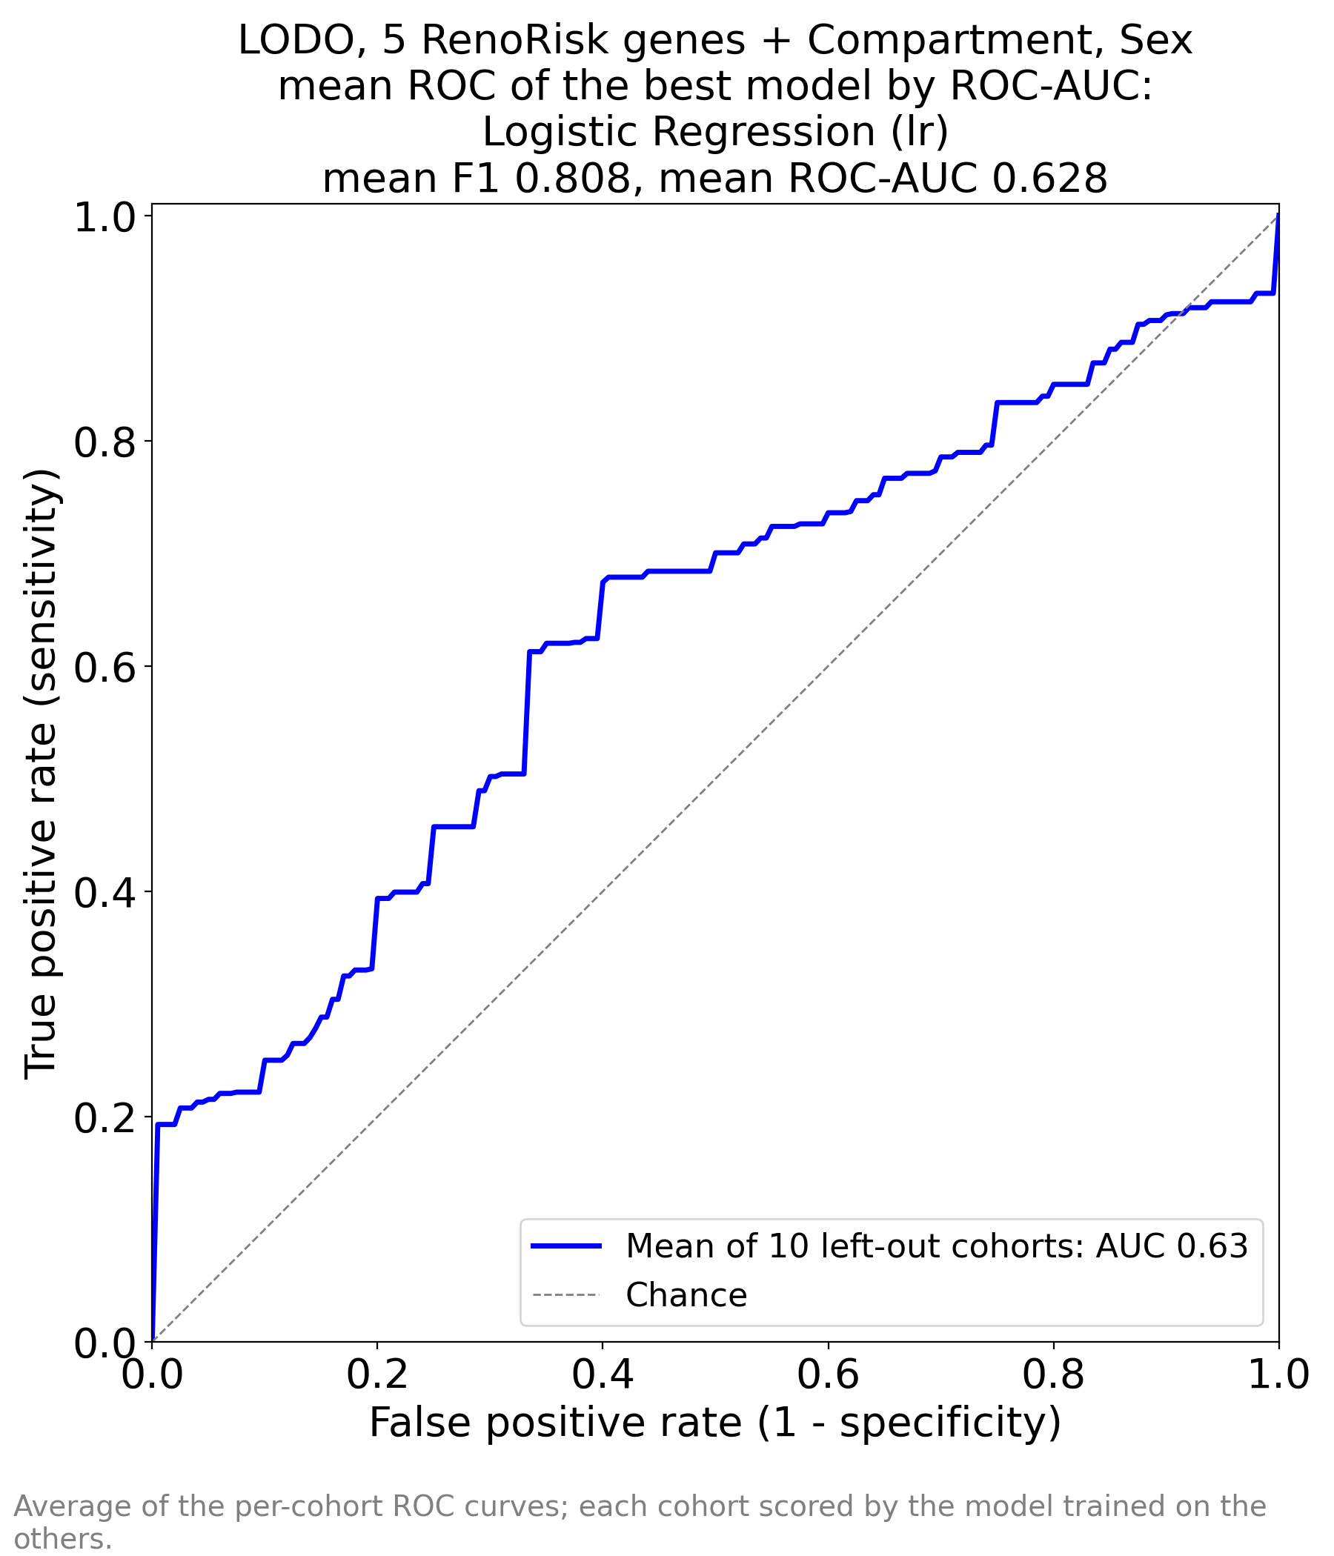
Figure 1. Original image embedded without alteration. Source: RR/ML_RR_AUC_by_AUC.png.
The mean curve lies only modestly above the chance diagonal. At visually estimated false-positive rates of about 0.10 and 0.20, sensitivity is only around 0.25 and 0.40 respectively. These are approximate readings of the image, not validated operating points. Achieving high sensitivity on this curve requires accepting many false-positive calls.
The figure reports mean AUC 0.63, rounded from workbook AUC 0.628, and mean F1 0.808. The curve and title agree with the performance workbook. Its shape reinforces the concern that recall 0.973 at the default prediction rule does not establish useful high-specificity detection.

Full transcriptome ROC figure
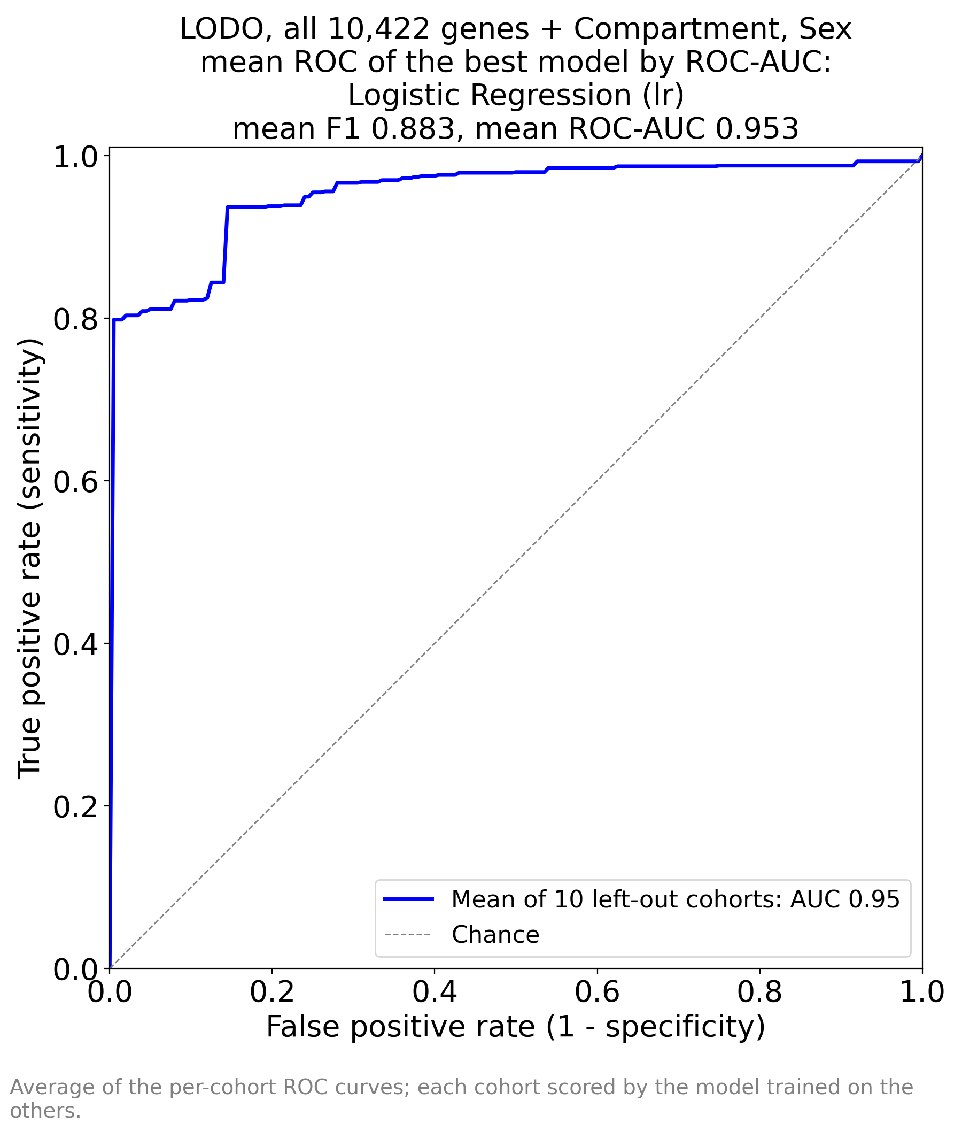
Figure 2. Original image embedded without alteration. Source: ALL/ALL/ML_ALL_AUC_by_AUC.png.
The curve rises sharply near the vertical axis and remains well above chance, consistent with the strong reported mean AUC. It visually suggests that useful discrimination may exist even at relatively low false-positive rates, but cannot supply a single threshold or establish how each cohort performs.
The title reports mean AUC 0.953 and F1 0.883; the legend rounds AUC to 0.95. There is no uncertainty band. Cohort averaging can conceal a poor-performing study, and cohorts with only six controls have coarse, uncertain specificity estimates. The plot therefore supports a research signal, not established clinical transportability.

Selected 50 gene ROC figure
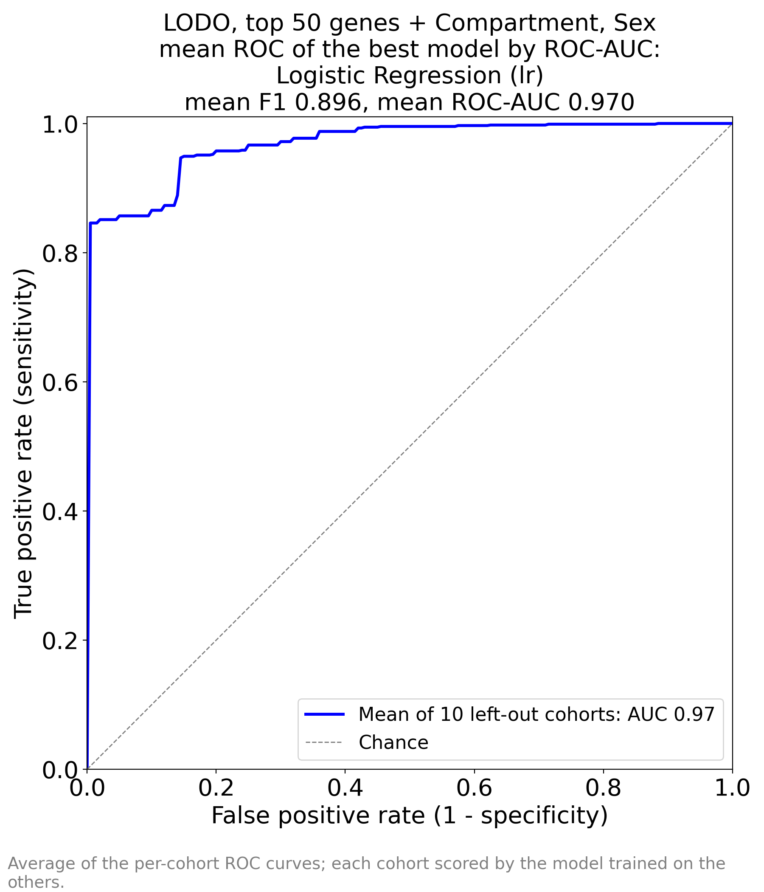
Figure 3. Original image embedded without alteration. Source: ALL/TOP_50_by_AUC/ML_TOP_50_by_AUC_AUC_by_AUC.png.
The curve is close to the upper left corner and looks slightly better than the full-gene curve, with title AUC 0.970 and F1 0.896 and legend AUC 0.97. The image is internally consistent with its workbook. It is an average of ten held-out cohort curves, rather than a ROC curve from a single independent validation cohort.
The image itself does not display the selection-leakage warning recorded in the session log. Its apparent improvement is exploratory because the left-out cohorts influenced which genes were selected. No statistical superiority or clinical threshold should be inferred from the visual gap.

Clinical interpretation and conclusions
The most defensible medical conclusion is that the broader tissue transcriptome distinguishes the study-defined disease and reference samples much better than the implemented RenoRisk panel. A plausible biological mixture includes reduced differentiated tubular metabolism, extracellular matrix remodelling, immune-cell representation and glomerular structural identity. This fits the heterogeneity of kidney disease, but does not identify the mechanism in an individual patient.
A nephropathology interpretation must separate active inflammation and potentially reversible epithelial injury from established interstitial fibrosis, tubular atrophy, glomerulosclerosis and vascular chronicity. The binary labels and summary workbooks do not support that distinction. FN1 and LUM suggest remodelling; SYNPO and COL4A3 suggest glomerular structure; none substitutes for a blinded pathological assessment with compartment-specific injury and chronicity scores.
A biopsy classified as disease is not a diagnosis of diabetic kidney disease, IgA nephropathy, FSGS or a complement-mediated disorder. Shared injury programmes can produce a high disease-versus-reference AUC while failing to distinguish aetiologies. No disease-specific sensitivity or specificity is supplied. No eGFR, measured fibrosis percentage, longitudinal progression or treatment response was evaluated in these outputs.
Control suitability is especially important. Surgically obtained reference tissue can have a different stress transcriptome from clinical needle biopsies, and reference RNA may differ from an actual control biopsy. A disease-associated classifier could partially recognise collection context. High rankings for immediate early genes make this an actionable concern. Tissue compartment is also a major panel predictor, and the selected set includes RPS4Y1 alongside Sex.
The five-gene results do not support standalone clinical deployment. Their limited performance does not exclude usefulness in a specific indication, tissue compartment, protein assay or combined clinical model; each would be a new validation question. The current task uses tissue mRNA and cannot establish performance of a urine or blood test. Any molecular test requiring biopsy would need to add value beyond routine histology and clinical assessment.
The full-gene model deserves independent investigation. The selected 50 genes offer an assay-development hypothesis, with FN1, DUSP1, PCK1, G6PC1, COL4A3, LUM, HLA-DRB1 and LYZ providing coherent biological priorities. DHRS2 and PPP1R3C are prominent reduced-model discovery candidates. Their prominence is not sufficient to designate validated biomarkers or drug targets.
Clinical decisions should continue to rely on the clinical presentation, kidney function, urine findings and appropriate pathological evaluation. These experiments do not justify changes to immunosuppression, complement blockade, anticoagulation or other treatment. Their present value is in selecting and testing research hypotheses.

Validation priorities and recommended next experiments
Priority | Experiment or analysis | What it resolves
1 | Resolve C4BPA versus C4BPB with the protocol owner and lock the intended panel | Defines which biomarker claim is being tested
2 | Repeat outer LODO with gene selection and model choice nested within training cohorts | Removes the known global feature-selection leakage
3 | Compare genes only, metadata only and genes plus metadata under identical folds | Measures incremental gene information and compartment or sex dependence
4 | Report every cohort AUC, calibration, sensitivity, specificity and class counts with uncertainty | Reveals failures hidden by the mean and unstable estimates in small control groups
5 | Evaluate within compartment, indication, platform, sex and matched control source | Tests transportability and alternative specimen-source explanations
6 | Validate a locked signature in an independent, prospectively defined biopsy cohort | Measures clinical validity without reuse of discovery samples
In the nested analysis, perform imputation, scaling if used, feature ranking, feature-count selection, hyperparameter tuning and classifier choice using training data only. Inner validation should preserve cohort or patient grouping. The final held-out cohort must not influence any choice. Evaluate scaling as a prespecified pipeline option rather than silently changing the current analysis.
For interpretability, export the actual one-hot feature names, training coefficients, convergence information and preprocessing parameters. Assess gene-selection frequency and coefficient stability across training folds or cohort-level resamples. Standardised coefficients and held-out permutation importance can complement the current raw weights; correlated genes should also be assessed in groups.
For biological confirmation, localise the leading signals with an orthogonal assay such as RNA in situ hybridisation or appropriately controlled protein staining. Confirm probe mapping for ALB and other unusual hits. Evaluate whether expression follows cell abundance, active injury or chronic scarring after accounting for tissue composition. These are proposed experiments, not results already obtained.
For clinical evaluation, prespecify the intended patient population and decision. Use blinded pathology and measured outcomes, collect procurement time and method, treatment, age, sex, eGFR and urine measurements, and resolve patient overlaps. Compare with a clinical and histology baseline. Evaluate calibration, prevalence-dependent predictive values and decision benefit at thresholds chosen without the external validation data. [6]

Source inventory and reproducibility checks
Every substantive file under Results/ML_training___ is covered below. Workbook values were read from every populated row, including the full 10,427-row importance table. No experiment was retrained and no source file was modified. Source paths below are relative to that archive.
File | Coverage
RR/ML_RR_perfs.xlsx | Sheet1; 17 models; all five performance metrics reproduced and discussed
RR/ML_RR_FEAT_IMP_by_AUC.xlsx | Sheet1; 10 feature rows; coefficient magnitude, ranking and completeness checked
RR/ML_RR_AUC_by_AUC.png | Original image embedded and discussed in its own figure section
RR/ML_RR_sessionInfo.txt | Versions, input, cohort grouping and selection notes reviewed
ALL/ALL/ML_ALL_perfs.xlsx | Sheet1; 17 models; all five performance metrics reproduced and discussed
ALL/ALL/ML_ALL_FEAT_IMP_by_AUC.xlsx | Sheet1; 10,427 feature rows; coefficient magnitude, ranking and completeness checked
ALL/ALL/ML_ALL_AUC_by_AUC.png | Original image embedded and discussed in its own figure section
ALL/ALL/ML_ALL_sessionInfo.txt | Versions, input, cohort grouping and selection notes reviewed
ALL/TOP_50_by_AUC/ML_TOP_50_by_AUC_perfs.xlsx | Sheet1; 17 models; all five performance metrics reproduced and discussed
ALL/TOP_50_by_AUC/ML_TOP_50_by_AUC_FEAT_IMP_by_AUC.xlsx | Sheet1; 55 feature rows; coefficient magnitude, ranking and completeness checked
ALL/TOP_50_by_AUC/ML_TOP_50_by_AUC_AUC_by_AUC.png | Original image embedded and discussed in its own figure section
ALL/TOP_50_by_AUC/ML_TOP_50_by_AUC_sessionInfo.txt | Versions, input, cohort grouping and selection notes reviewed
All three performance tables contain the same 17 model identifiers. All importance rows have complete numeric scores and satisfy Importance = |Coefficient|. The reduced workbook contains the exact 50 highest-ranked genes of the full logistic model after excluding categorical rows. All three ROC titles agree with the corresponding logistic performance rows. Reported differences use the rounded workbook values.
The folder also contains .DS_Store and a ~$ Excel owner file beside the selected-gene importance workbook. These are filesystem or editing metadata, not additional experimental results. They were inventoried but are not interpreted as data workbooks.
Supporting context was checked in Scripts/train_ML_RR.ipynb, Scripts/train_ML_ALL.ipynb, Scripts/all2.R, CLAUDE.md, the analysis protocol PDF and the panel input workbook. Repository notes describing LODO as unimplemented are superseded by the notebooks and dated result logs for this report. The archive does not contain fold predictions or an independently tested locked model.

References for clinical and biological interpretation
[1] Menon R et al. Not all reference samples are equal in single-cell transcriptomics of human kidney tissue. JCI Insight. 2026;11:e204385. Source
[2] Park S et al. RNA-seq profiling of tubulointerstitial tissue reveals a potential therapeutic role of dual anti-phosphatase 1 in glomerulonephritis. J Cell Mol Med. 2022;26:3364-3377. Source
[3] Verissimo T et al. Decreased renal gluconeogenesis is a hallmark of chronic kidney disease. J Am Soc Nephrol. 2022;33:810-827. Source
[4] Doke T et al. Transcriptome-wide association analysis identifies DACH1 as a kidney disease risk gene that contributes to fibrosis. J Clin Invest. 2021. Source
[5] Lake BB et al. An atlas of healthy and injured cell states and niches in the human kidney. Nature. 2023;619:585-594. Source
[6] Collins GS et al. TRIPOD+AI statement: updated guidance for reporting clinical prediction models that use regression or machine learning methods. BMJ. 2024;385:e078378. Source
[7] NCBI Gene. DHRS2, human Gene ID 10202. Biochemical function and annotation. Source
[8] NCBI Gene. PPP1R3C, human Gene ID 5507. Glycogen-targeting phosphatase subunit annotation. Source
[9] NCBI Gene. ZNF331, human Gene ID 55422. Transcriptional regulator annotation. Source
[10] NCBI Gene. RAB20, human Gene ID 55647. GTPase and phagosome biology annotation. Source
[11] MedlinePlus Genetics. CFH gene. Complement regulation and associated genetic disease. Source
[12] MedlinePlus Genetics. CFI gene. Complement factor I biology. Source
[13] Human Protein Atlas. HABP2 gene information. Protein class and gene annotation. Source
[14] NCBI Gene. COL13A1, human Gene ID 1305. Transmembrane collagen annotation. Source
Literature and authoritative gene resources accessed 31 October 2026. External studies support biological context; they do not independently validate this trained signature. Gene-specific mechanistic interpretations in the atlas are explicitly hypotheses.

