RenoRisk
Machine-Learning Validation Report
Leave-one-dataset-out classification on kidney-biopsy transcriptomes
Results of the experiments stored in Results/ML_training___
Source outputs: Results/ML_training___/{RR, ALL/ALL, ALL/TOP_50_by_AUC} | generated 2026-10-31
Analysis code: Scripts/train_ML_ALL.ipynb, Scripts/train_ML_RR.ipynb, Results/Report/experiments.py

This document reports the results stored in Results/ML_training___: three leave-one-dataset-out (LODO) classification runs of the RenoRisk kidney-biomarker programme - the five-gene panel alone (RR), the whole common transcriptome (ALL) and a 50-gene feature-selected model (TOP_50_by_AUC). Every number and figure quoted below comes from a file in that folder or from Results/Report/experiments.py, a companion script that re-runs the identical LODO design to expose the per-cohort and per-indication detail the stored workbooks do not carry; those extra outputs are labelled "derived for this report" wherever they appear.
Table of contents (fixed). Deliberately not a Word TOC field: the document contains no updatable table-of-contents field, so Word does not ask whether to update fields when the file is opened. The entries below are hyperlinks to the headings - click an entry to jump to that section. Page numbers are omitted because a page-numbered ToC would require exactly the field this document avoids.
1. Executive summary
2. What the folder contains
3. How the results were produced
3.1 Data
3.2 Validation design
3.3 Qualifications stated in the files themselves
4. Results: model performance
4.1 The five-gene panel (RR)
4.2 The whole common transcriptome (ALL)
4.3 The 50-gene model (TOP_50_by_AUC)
4.4 Cohort-by-cohort behaviour
4.5 Where the models fail: control source, indication, compartment
5. Results: feature importance
5.1 RR: what the panel model uses
5.2 ALL: what the whole-transcriptome model uses
5.3 TOP_50_by_AUC: the 55 rows of the importance file
5.4 The importance ranking is not identifiable
5.5 The provenance of the signal: procurement stress
6. The top-50 genes: what the model actually uses
6.1 The 50 genes, annotated
6.2 How these genes became the most important ones
7. Reading the results clinically
7.1 The five-gene panel as a test on biopsy tissue
7.2 What a 0.95-0.97 AUC means and does not mean at the bedside
7.3 The clinically coherent part of the signature
8. Data-science reading
9. Limitations and threats to validity
10. Conclusions
10.1 Recommended next steps

1. Executive summary
Design. Three LODO runs with identical machinery: 17 PyCaret-default classifiers, preprocessing (mean / most-frequent imputation, one-hot encoding, no scaling) fitted inside the pipeline of every fold, group = cohort, 10 folds, random_state = 42. Each sample is predicted exactly once by a model that never saw its cohort. Metrics are computed inside each left-out cohort and then averaged with equal weight over the ten cohorts. No model selection on these scores, no hyperparameter tuning.
Data. 850 samples - 678 disease and 172 control (79.8% positive) - in 11 series collapsed into 10 LODO groups (GSE104948 and GSE104954 merged into one ERCB group), with 10,422 genes common to all series plus Compartment and Sex as the only categorical inputs. Expression is as deposited and uncorrected: three value scales, and two cohorts (GSE30122, GSE116626) are per-gene centred, so their absolute level is unrecoverable.
Headline numbers. The best model is Logistic Regression in all three runs.
Run | Features | F1 | Recall | ROC-AUC | Sensitivity at 0.5* | Specificity at 0.5* | Mean specificity at 90% sensitivity*
RR | 5 RenoRisk genes | 0.808 | 0.973 | 0.628 | 0.962 | 0.052 | 0.212
ALL | 10,422 genes | 0.883 | 0.923 | 0.953 | 0.928 | 0.628 | 0.873
TOP_50_by_AUC | 50 genes | 0.896 | 0.942 | 0.970 | 0.935 | 0.610 | 0.940
Dummy (always Disease) | none | 0.818 | 1.000 | 0.500 | 1.000 | 0.000 | -

F1, recall and ROC-AUC are the per-cohort means stored in the three *_perfs.xlsx files. * The last three columns are derived for this report (experiments.py, same LODO design) from the out-of-fold scores pooled over all 850 samples: "specificity at 0.5" is the share of controls that receive a *not-disease* call at the 0.5 threshold, and "mean specificity at 90% sensitivity" is the sensitivity-matched operating point averaged over the ten cohorts. The constant-prediction dummy is the reference line.
- The five-gene RenoRisk panel does not separate disease from control in a cohort-independent way. Mean ROC-AUC 0.628; at the 0.5 threshold it calls 94.8% of all controls "disease" (specificity 0.052) while detecting 96.2% of cases, and at a sensitivity fixed to 90% its mean specificity is 0.212 - four out of five controls are still flagged. It is beaten by the constant "always Disease" rule on F1 (0.808 vs 0.818) and accuracy (0.711 vs 0.726), and ties it on precision (0.727 vs 0.726). Not one of its seventeen classifiers reaches ROC-AUC 0.63.
- The five-gene panel is also the least important part of its own model: with all five genes and no metadata the LODO AUC is 0.624; with Compartment and Sex alone (no genes at all) it is 0.552; with both it is 0.628. In the panel model's importance table (Section 5.1) the three Compartment levels are ranks 1-3, ahead of every gene.
- The transcriptome-wide model reaches ROC-AUC 0.953 and the 50-gene model 0.970. That signal is real and substantial - removing the entire immediate-early/procurement-stress axis (17 genes) still leaves 0.940, and removing the 222 stress-co-varying genes leaves 0.934 - but roughly a third of it is available from the stress axis alone (the 17 immediate-early genes by themselves give 0.886) and it is not evenly distributed. Thresholded performance differs sharply by tissue and by diagnosis: the all-gene model detects 98.2% of glomerular cases but 68.5% of whole-biopsy cases, and 100% of FSGS, MN, MCD, lupus-nephritis and ANCA cases but only 61.5% of IgAN cases. The five-gene panel, for comparison, sits at or below ROC-AUC 0.61 in six of the ten cohorts (Section 4.4).
- The control decision is cohort-specific. Specificity by control source in the ALL run: living-donor 0.947, tumour-nephrectomy 0.925, GSE30122 ("control type not stated") 0.560, GSE66494 (8 reference-RNA replicates, i.e. not patients at all) 0.000 - every one of those eight technical samples is called "disease" by all three runs.
- None of the five RenoRisk genes appears in the 50-gene list. Within the 10,422-gene model they rank 1,572 (CFH), 3,613 (CFI), 3,838 (C4BPA), 4,221 (COL13A1) and 8,982 (HABP2); when the model may choose, it does not choose the panel.
- The importance ranking is not a stable biomarker ranking. FOS is rank 1 of 10,427 in the full model and rank 47 of 55 in the 50-gene model; DHRS2 moves 45 -> 2. The immediate-early genes are a tightly co-expressed module, so an unregularised linear model distributes their shared coefficient almost arbitrarily. Only module-level statements survive.
- The TOP_50_by_AUC scores are optimistic by construction: the 50 genes were ranked by a model fitted on all cohorts, so each left-out cohort helped select the features it was then tested on. The ALL-run number is the only leak-free estimate in the folder and the one to quote.
- Clinically the folder supports one conclusion and one warning. The conclusion: in uncorrected biopsy expression the five-gene panel is not a stand-alone cross-cohort classifier. The warning: 0.95-0.97 AUC here means "separable given that the test cohort shares platform, compartment and specimen handling with the training cohorts" - it is not diagnostic accuracy for a new patient in a new hospital.

2. What the folder contains
Results/ML_training___ is a reduced copy of part of Results/ML_training: the by-ROC-AUC variants of the three runs, without the "by F1" twins. Verified by MD5, every .xlsx in ML_training___ (RR/, ALL/ALL/, ALL/TOP_50_by_AUC/) has the same digest as its counterpart in ML_training/; the by-F1 twins that exist only in ML_training are byte-identical to the by-AUC ones as well (experiments.py E6: perfs, FEAT_IMP_by_AUC and FEAT_IMP_by_F1 all compare equal), because both selection criteria chose the same model and therefore the same 50 genes.
File (relative to Results/ML_training___) | Rows x cols | Content
RR/ML_RR_perfs.xlsx | 17 x 7 | Performance of 17 classifiers; features = the 5 RenoRisk genes + Compartment + Sex
RR/ML_RR_FEAT_IMP_by_AUC.xlsx | 10 x 3 | Importance and signed coefficient of the 5 genes and 5 one-hot metadata columns (LR refit on all samples)
RR/ML_RR_AUC_by_AUC.png | image | Figure 1: mean ROC curve of the best model by ROC-AUC (LR) over the 10 left-out cohorts
RR/ML_RR_sessionInfo.txt | text | Provenance: versions, switches, model list, input (850 samples, 5 genes, 10 LODO groups)
ALL/ALL/ML_ALL_perfs.xlsx | 17 x 7 | Performance of 17 classifiers; features = all 10,422 genes + Compartment + Sex
ALL/ALL/ML_ALL_FEAT_IMP_by_AUC.xlsx | 10,427 x 3 | Importance and signed coefficient of every gene and one-hot column (LR refit on all samples)
ALL/ALL/ML_ALL_AUC_by_AUC.png | image | Figure 2: mean ROC curve of the best model by ROC-AUC (LR), 10 left-out cohorts
ALL/ALL/ML_ALL_sessionInfo.txt | text | Provenance: versions, switches, model list, input (850 samples, 10,422 genes, 10 LODO groups)
ALL/TOP_50_by_AUC/ML_TOP_50_by_AUC_perfs.xlsx | 17 x 7 | Performance of 17 classifiers on the selected 50 genes + metadata
ALL/TOP_50_by_AUC/ML_TOP_50_by_AUC_FEAT_IMP_by_AUC.xlsx | 55 x 3 | The 50 selected genes + 5 one-hot metadata columns, ranked by importance
ALL/TOP_50_by_AUC/ML_TOP_50_by_AUC_AUC_by_AUC.png | image | Figure 3: mean ROC curve of the best model by ROC-AUC (LR), 10 left-out cohorts
ALL/TOP_50_by_AUC/ML_TOP_50_by_AUC_sessionInfo.txt | text | As above plus the feature-selection warning (selection saw the left-out cohorts; scores are optimistic)

A thirteenth file in the tree, ALL/TOP_50_by_AUC/~$ML_TOP_50_by_AUC_FEAT_IMP_by_AUC.xlsx (165 bytes), is an Excel lock file for a workbook currently open on this machine. It holds no data and is not analysed. The three sessionInfo files are provenance only; their content is reproduced at the end of Section 3.
The three runs:
- RR - the five-gene panel (C4BPA, COL13A1, HABP2, CFH, CFI) plus Compartment and Sex. No feature selection. The direct test of the RenoRisk thesis.
- ALL - every gene common to all 11 series (10,422) plus Compartment and Sex. No feature selection; the ceiling of what this data set can separate.
- TOP_50_by_AUC - the 50 highest-importance genes of the ALL run's best model by ROC-AUC, plus all categorical columns (always kept, not counted in the 50). Run to test whether 50 genes carry the signal of 10,422.

3. How the results were produced

3.1 Data
Cohort (LODO group) | n | Ctrl | Cases | % disease | Control source | Compartments | Indications in the cases (n)
ERCB | 131 | 42 | 89 | 67.9 | Living donor + tumour nephrectomy | Glomerular, Tubulointerstitial | ANCA vasculitis (43), DKD (14), FSGS (13), FSGS/MCD (10), MCD (9)
GSE108109 | 111 | 6 | 105 | 94.6 | Living donor | Glomerular | ANCA vasculitis (15), FSGS (30), MCD (16), MN (44)
GSE116626 | 81 | 7 | 74 | 91.4 | Living donor | Whole biopsy | IgAN (52), Other GN (22)
GSE121233 | 10 | 5 | 5 | 50.0 | Tumour nephrectomy | Glomerular | FSGS (5)
GSE129973 | 40 | 20 | 20 | 50.0 | Tumour nephrectomy | Glomerular | FSGS (20)
GSE200828 | 153 | 6 | 147 | 96.1 | Living donor | Glomerular | FSGS (31), MCD (19), MN (51), Other GN (46)
GSE30122 | 69 | 50 | 19 | 27.5 | Not stated | Glomerular, Tubulointerstitial | DKD (19)
GSE66494 | 61 | 8 | 53 | 86.9 | Reference RNA | Whole biopsy | CKD (unspecified) (53)
GSE96804 | 61 | 20 | 41 | 67.2 | Tumour nephrectomy | Glomerular | DKD (41)
GSE99339-GPL19184 | 133 | 8 | 125 | 94.0 | Tumour nephrectomy | Glomerular | DKD (7), FSGS (12), Hypertensive nephropathy (18), IgAN (26), Lupus nephritis (30), MCD (8), MN (21), Thin membrane disease (3)

Composition of the 10 LODO folds (Data/ML_input/all2.xlsx). "% disease" is the per-cohort prevalence that a constant classifier gets right, and it ranges from 27.5% (GSE30122) to 96.1% (GSE200828): thresholded metrics cannot be compared across cohorts, ROC-AUC can. ERCB merges GSE104948 and GSE104954 (same bank, lab, platform and pipeline) and its cases pool several diagnoses.

3.2 Validation design
Leave-one-dataset-out (sklearn LeaveOneGroupOut) with group = cohort and ERCB merged. Ten folds; in each fold the model is fitted on nine cohorts and scored on the tenth, so every cohort is an unseen test set exactly once and there is no separate hold-out set. All preprocessing is refitted inside each fold, so the imputation statistics and the one-hot vocabulary come from training cohorts only.
Per-cohort metrics (F1, precision, recall, accuracy, ROC-AUC) are then averaged over the ten cohorts with equal weight, matching PyCaret's fold averaging. Predictions are deliberately not pooled for ROC-AUC: each fold's model has its own score scale, so a pooled ROC would mostly rank the fold-to-fold intercept shift (a prior-only dummy would appear to score 0.19 rather than 0.5).
Feature importance is computed after the run by refitting the winning model (Logistic Regression) on all 850 samples and reading |coefficient| per model input, one row per one-hot column. LODO validates the model, not this ranking. The column is also scale-bound: inputs are never scaled, so a coefficient mixes the gene's effect with its unit size - and the unit sizes differ across cohorts here (three deposited value scales; two cohorts per-gene centred).

3.3 Qualifications stated in the files themselves
- Run 2 selects features outside the folds. The 50 genes come from a model fitted on all cohorts, so each left-out cohort influenced the selection of the features it is tested on. The sessionInfo file says it: "selection saw the left-out cohorts, so these LODO scores are optimistic". A leak-free version would select inside each fold.
- No hyperparameter tuning, no regularisation sweep: every model runs at PyCaret defaults (Logistic Regression max_iter=1000, C=1.0). The performance tables are a model-family comparison, not a tuned benchmark.
- No scaling. That is PyCaret's default and it is what makes the |coefficient| ranking partly a scale ranking.
Provenance from the sessionInfo files (identical in all three runs except for the feature-selection note and the gene count): python 3.11.9, platform macOS-27.0.1-arm64, scikit-learn 1.4.2, lightgbm 4.7.0, pandas 2.1.4, numpy 1.26.4; RANDOM_STATE=42, MERGE_ERCB=True, FAST=False, TOP_FEATURES_FOR_THE_SECOND_RUN=50; 17 models at PyCaret 3.3.2 defaults (lr, knn, nb, dt, svm, rbfsvm, gpc, mlp, ridge, rf, qda, ada, gbc, lda, et, lightgbm, dummy).

4. Results: model performance

4.1 The five-gene panel (RR)
Model (PyCaret ID) | F1 | Precision | Recall | Accuracy | ROC-AUC
Logistic Regression | 0.808 | 0.727 | 0.973 | 0.711 | 0.628
Ridge Classifier | 0.810 | 0.731 | 0.972 | 0.721 | 0.627
Linear Discriminant Analysis | 0.800 | 0.730 | 0.954 | 0.709 | 0.626
SVM - Radial Kernel | 0.767 | 0.741 | 0.904 | 0.675 | 0.604
K Neighbors Classifier | 0.719 | 0.737 | 0.831 | 0.631 | 0.595
Gaussian Process Classifier | 0.722 | 0.742 | 0.842 | 0.638 | 0.586
Extra Trees Classifier | 0.731 | 0.718 | 0.821 | 0.654 | 0.581
Naive Bayes | 0.677 | 0.640 | 0.810 | 0.590 | 0.553
Light Gradient Boosting Machine | 0.710 | 0.731 | 0.773 | 0.623 | 0.550
Random Forest Classifier | 0.706 | 0.713 | 0.802 | 0.646 | 0.550
MLP Classifier | 0.774 | 0.731 | 0.914 | 0.671 | 0.547
SVM - Linear Kernel | 0.646 | 0.590 | 0.760 | 0.643 | 0.530
Decision Tree Classifier | 0.672 | 0.728 | 0.707 | 0.622 | 0.516
Dummy Classifier | 0.818 | 0.726 | 1.000 | 0.726 | 0.500
Gradient Boosting Classifier | 0.688 | 0.700 | 0.765 | 0.604 | 0.496
Ada Boost Classifier | 0.752 | 0.720 | 0.865 | 0.659 | 0.486
Quadratic Discriminant Analysis | 0.654 | 0.677 | 0.692 | 0.654 | 0.470

ML_RR_perfs.xlsx - all 17 classifiers, sorted by ROC-AUC as in the file. The reference row is the Dummy Classifier (constant "Disease"): F1 0.818, precision 0.726, recall 1.000, accuracy 0.726, ROC-AUC 0.500.
Reading. Logistic Regression is the best of seventeen classifiers at F1 0.808 and ROC-AUC 0.628, and it is worse than the constant baseline on F1 (0.808 vs 0.818), accuracy (0.711 vs 0.726) and recall (0.973 vs 1.000), tying it on precision (0.727 vs 0.726). Not one classifier reaches ROC-AUC 0.63, and three fall below 0.5 (Gradient Boosting 0.496, AdaBoost 0.486, QDA 0.470). Recall 0.973 with precision 0.727 is the profile of a model that calls almost everything diseased; the derived operating-point analysis confirms it - at the 0.5 threshold this model keeps a specificity of 0.052, i.e. it flags 94.8% of all controls, and even when its sensitivity is fixed at 90% its mean specificity is only 0.212. ROC-AUC 0.628 is the single number that shows any transferable signal at all, and it is 0.13 above chance for a test that would have to replace a clinical judgement.
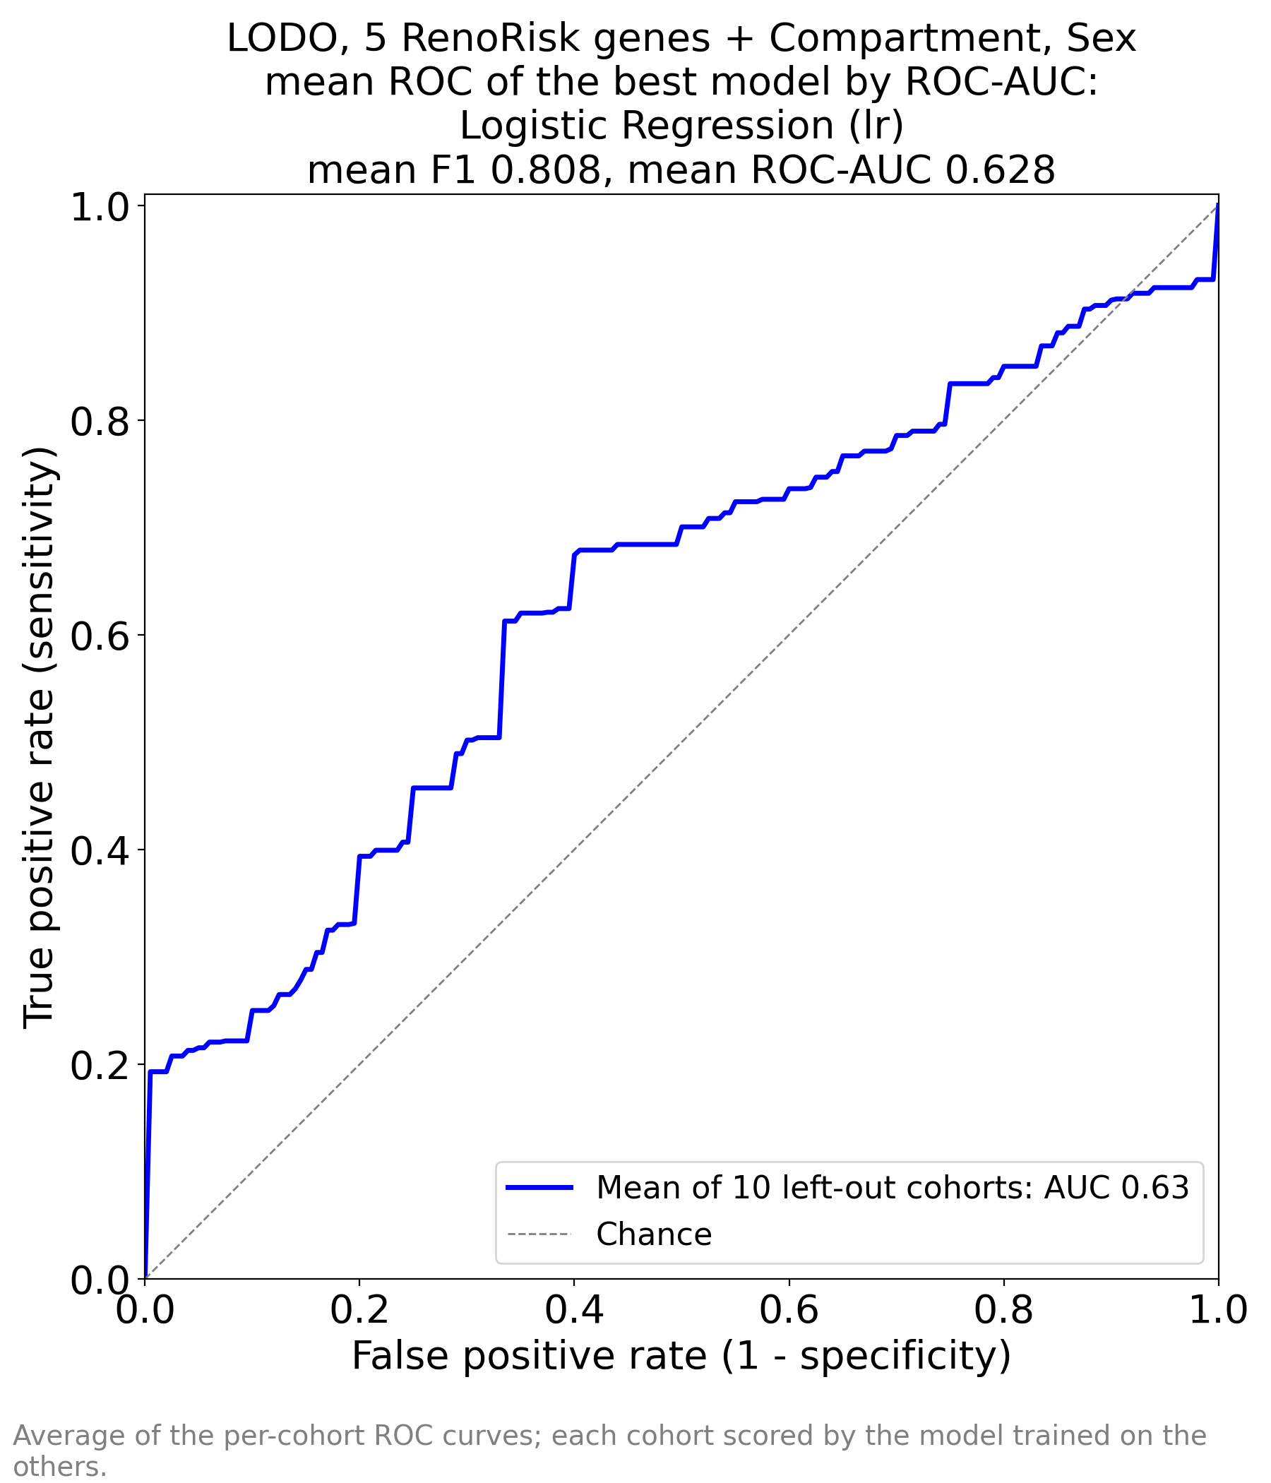
Figure 1 - RR run, stored file ML_RR_AUC_by_AUC.png. Mean ROC curve of the best model by ROC-AUC (Logistic Regression): the per-cohort ROC curves averaged vertically at fixed false-positive rates, each cohort scored by the model trained on the other nine. Mean AUC 0.63. The curve hugs the diagonal, with its largest deviation only below ~20% FPR and a first point at TPR 0.19 with FPR 0 - at its most conservative threshold the model still calls 19% of everything positive. This is the shape of a weak, prior-driven classifier, not of a test with a usable operating point.

4.2 The whole common transcriptome (ALL)
Model (PyCaret ID) | F1 | Precision | Recall | Accuracy | ROC-AUC
Logistic Regression | 0.883 | 0.884 | 0.923 | 0.858 | 0.953
SVM - Linear Kernel | 0.880 | 0.890 | 0.903 | 0.861 | 0.953
Ridge Classifier | 0.836 | 0.885 | 0.890 | 0.801 | 0.939
Linear Discriminant Analysis | 0.813 | 0.878 | 0.876 | 0.777 | 0.917
Gradient Boosting Classifier | 0.787 | 0.806 | 0.893 | 0.721 | 0.866
Random Forest Classifier | 0.743 | 0.754 | 0.880 | 0.671 | 0.858
Light Gradient Boosting Machine | 0.802 | 0.812 | 0.913 | 0.750 | 0.857
MLP Classifier | 0.697 | 0.759 | 0.803 | 0.635 | 0.851
Extra Trees Classifier | 0.793 | 0.751 | 0.942 | 0.703 | 0.826
Ada Boost Classifier | 0.828 | 0.817 | 0.904 | 0.768 | 0.817
SVM - Radial Kernel | 0.754 | 0.758 | 0.896 | 0.682 | 0.804
K Neighbors Classifier | 0.695 | 0.694 | 0.806 | 0.625 | 0.738
Decision Tree Classifier | 0.770 | 0.802 | 0.852 | 0.695 | 0.639
Quadratic Discriminant Analysis | 0.752 | 0.742 | 0.819 | 0.654 | 0.598
Naive Bayes | 0.533 | 0.453 | 0.700 | 0.481 | 0.522
Gaussian Process Classifier | 0.168 | 0.200 | 0.147 | 0.414 | 0.500
Dummy Classifier | 0.818 | 0.726 | 1.000 | 0.726 | 0.500

ML_ALL_perfs.xlsx - all 17 classifiers. Dummy Classifier = constant baseline (F1 0.818, accuracy 0.726, ROC-AUC 0.500).
Reading. With 10,422 genes the same classifier family jumps from AUC 0.628 to 0.953 and from F1 0.808 to 0.883, and the ordering of the seventeen models is informative in itself: linear and near-linear models fill the top (Logistic Regression 0.953, linear SVM 0.953, Ridge 0.939, LDA 0.917), every tree ensemble and the RBF SVM trails them (Gradient Boosting 0.866, Random Forest 0.858, LightGBM 0.857, Extra Trees 0.826), and three models collapse (QDA 0.598, Naive Bayes 0.522, Gaussian Process 0.500 with recall 0.147). A large, near-additive linear signal that trees cannot improve on is the classic signature of a level/offset difference between cohorts - the disease label tracks the cohort, and each cohort sits at a different expression level - rather than of a nonlinear biological signature that a tree would capture.
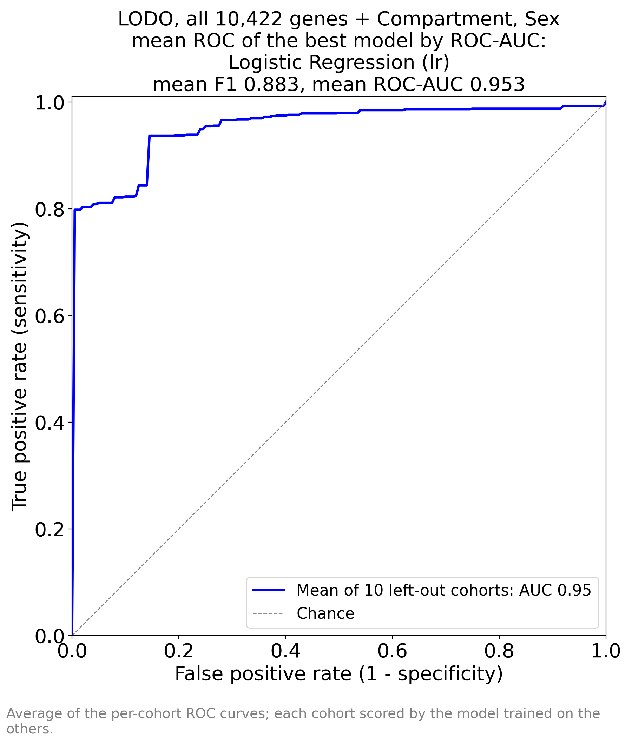
Figure 2 - ALL run, stored file ML_ALL_AUC_by_AUC.png. Mean ROC curve of Logistic Regression over the ten left-out cohorts; mean F1 0.883, mean ROC-AUC 0.953. The curve rises almost vertically to TPR ~0.80 at FPR 0 in the most separable cohorts and then climbs in steps to ~0.94 by 25% FPR. That shape - a mixture of cohorts that separate almost perfectly and cohorts that barely separate - is what pulls the mean up, and it is quantified cohort by cohort in Section 4.4.

4.3 The 50-gene model (TOP_50_by_AUC)
Model (PyCaret ID) | F1 | Precision | Recall | Accuracy | ROC-AUC
Logistic Regression | 0.896 | 0.896 | 0.942 | 0.861 | 0.970
SVM - Linear Kernel | 0.853 | 0.822 | 0.945 | 0.804 | 0.969
Ridge Classifier | 0.853 | 0.885 | 0.895 | 0.815 | 0.959
Linear Discriminant Analysis | 0.847 | 0.888 | 0.886 | 0.811 | 0.957
MLP Classifier | 0.891 | 0.895 | 0.936 | 0.857 | 0.944
Extra Trees Classifier | 0.782 | 0.817 | 0.897 | 0.733 | 0.884
SVM - Radial Kernel | 0.836 | 0.797 | 0.952 | 0.768 | 0.869
Gradient Boosting Classifier | 0.780 | 0.803 | 0.901 | 0.724 | 0.869
Light Gradient Boosting Machine | 0.824 | 0.822 | 0.923 | 0.770 | 0.861
Ada Boost Classifier | 0.799 | 0.834 | 0.888 | 0.757 | 0.857
Random Forest Classifier | 0.767 | 0.811 | 0.887 | 0.721 | 0.840
K Neighbors Classifier | 0.838 | 0.823 | 0.924 | 0.776 | 0.796
Quadratic Discriminant Analysis | 0.774 | 0.812 | 0.824 | 0.763 | 0.757
Decision Tree Classifier | 0.810 | 0.849 | 0.886 | 0.760 | 0.751
Gaussian Process Classifier | 0.845 | 0.835 | 0.927 | 0.787 | 0.747
Naive Bayes | 0.617 | 0.643 | 0.724 | 0.534 | 0.736
Dummy Classifier | 0.818 | 0.726 | 1.000 | 0.726 | 0.500

ML_TOP_50_by_AUC_perfs.xlsx - all 17 classifiers. Dummy Classifier = constant baseline. These scores are optimistic: the gene selection saw the left-out cohorts (Section 3.3).
Reading. Fifty genes reproduce and slightly exceed the whole-transcriptome result (Logistic Regression 0.970 vs 0.953; linear SVM 0.969; MLP 0.944) and give the best sensitivity-matched operating point in the folder (mean specificity 0.940 at 90% sensitivity, against 0.873 for ALL and 0.212 for the panel). Two conclusions follow. First, the 10,372 genes outside the selection are not merely uninformative to this linear model, they are mildly harmful - consistent with unregularised collinearity and with many of them being technical noise on uncorrected scales. Second, the gain cannot be claimed as evidence that "50 genes are enough": the selection is the leak. The defensible statement is that a 50-gene signature is a plausible compression of this data set whose out-of-cohort performance still has to be measured with selection inside the folds.
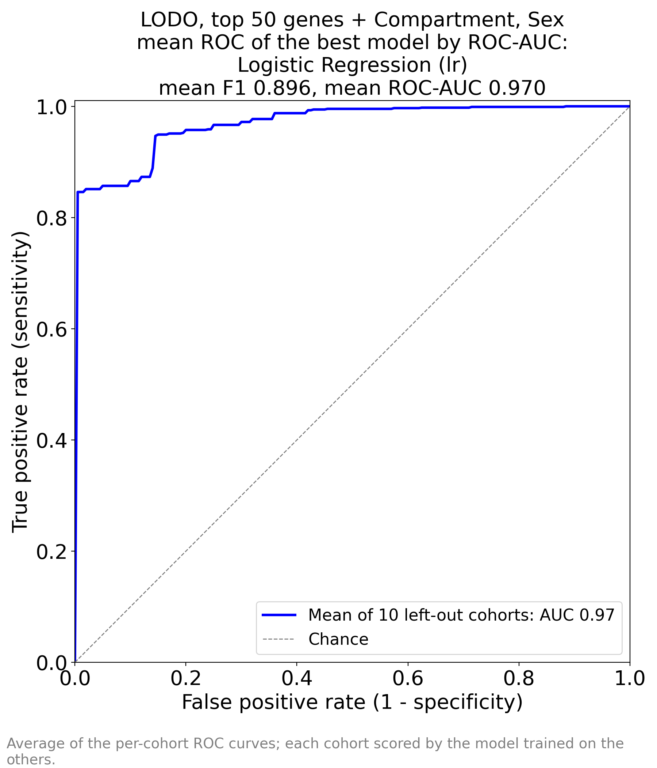
Figure 3 - TOP_50_by_AUC run, stored file ML_TOP_50_by_AUC_AUC_by_AUC.png. Mean ROC of Logistic Regression; mean F1 0.896, mean ROC-AUC 0.970. The curve is above Figure 2 at almost every false-positive rate and its first vertical step reaches TPR ~0.85 by FPR ~0.16. Some of that gain is the leaked selection and some is the removal of 10,372 noisy inputs; this experiment cannot separate the two.

4.4 Cohort-by-cohort behaviour
Cohort (worst ALL AUC first) | n | Ctrl | Cases | AUC 5 gene | AUC all | AUC top50 | Sens top50 | Spec top50 | Spec@Sens .90 top50
GSE116626 | 81 | 7 | 74 | 0.797 | 0.832 | 0.896 | 0.568 | 0.857 | 0.857
GSE30122 | 69 | 50 | 19 | 0.514 | 0.857 | 0.862 | 1.000 | 0.200 | 0.640
GSE66494 | 61 | 8 | 53 | 0.491 | 0.929 | 1.000 | 1.000 | 0.000 | 1.000
ERCB | 131 | 42 | 89 | 0.610 | 0.957 | 0.971 | 0.978 | 0.738 | 0.905
GSE99339-GPL19184 | 133 | 8 | 125 | 0.452 | 0.959 | 0.975 | 0.944 | 0.750 | 1.000
GSE108109 | 111 | 6 | 105 | 0.705 | 1.000 | 0.997 | 0.981 | 0.833 | 1.000
GSE121233 | 10 | 5 | 5 | 0.800 | 1.000 | 1.000 | 1.000 | 1.000 | 1.000
GSE129973 | 40 | 20 | 20 | 0.610 | 1.000 | 1.000 | 0.950 | 1.000 | 1.000
GSE200828 | 153 | 6 | 147 | 0.726 | 1.000 | 1.000 | 1.000 | 0.833 | 1.000
GSE96804 | 61 | 20 | 41 | 0.573 | 1.000 | 0.995 | 1.000 | 0.850 | 1.000

Derived for this report (experiments.py: identical LODO design, Logistic Regression only) so that the per-cohort detail behind Figures 1-3 can be read - the stored workbooks hold means only. Ctrl/Cases are the true class counts in the left-out cohort; Sens/Spec at the 0.5 threshold; Spec@Sens .90 is the specificity when sensitivity is fixed at 90% in that cohort. Cohorts sorted by the ALL-run AUC; the lower panels of Figure 4 show the same AUCs as bars.
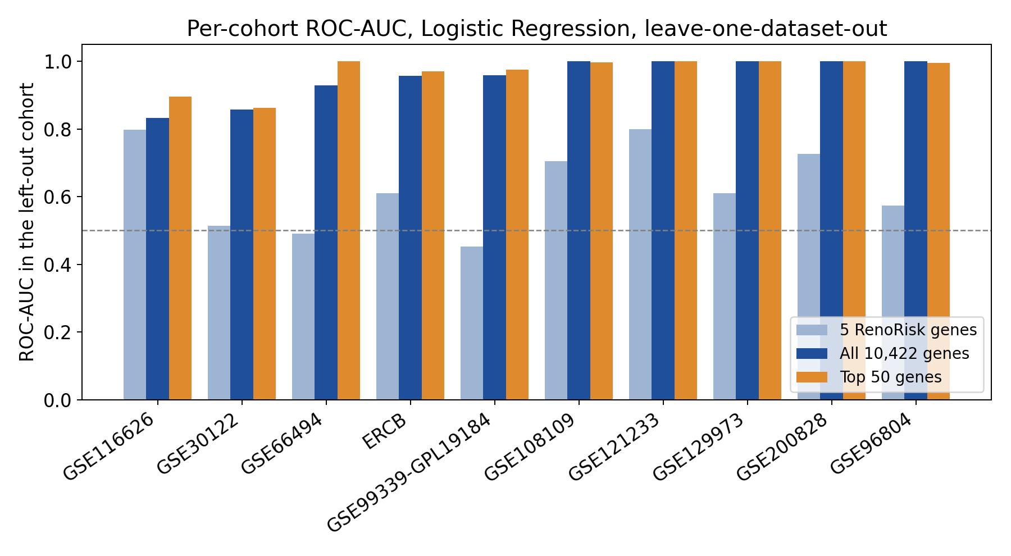
Figure 4 - per-cohort ROC-AUC of the three runs (derived for this report; not part of Results/ML_training___). Cohorts sorted by the all-gene AUC. The all-gene and top-50 bars stay above 0.83 everywhere and reach 1.00 in five cohorts; the five-gene panel (light blue) stays below 0.80 everywhere and below chance in the two cohorts whose controls it cannot recognise at all (GSE66494 reference RNA, GSE99339). The gap between the light-blue and dark-blue bars in every cohort is the panel-versus-transcriptome comparison; the scatter across cohorts is the single most important robustness fact in the folder.
The failure is the panel's, not the transcriptome model's. The all-gene AUC never falls below 0.83 (worst: GSE116626 0.832, the only whole-biopsy cohort, with 7 controls; then GSE30122 0.857 with 50 controls on a per-gene-centred scale) and reaches 1.000 in five cohorts - all of them with twenty or fewer controls, which is a further reminder of how thin the control arm of this data set is. The five-gene panel, in contrast, sits at or below 0.61 in six of the ten cohorts: 0.452 (GSE99339, 8 controls), 0.491 (GSE66494, 8 reference-RNA "controls"), 0.514 (GSE30122), 0.573 (GSE96804), 0.610 (ERCB) and 0.610 (GSE129973), and it never exceeds 0.800 anywhere. The same 850 samples produce both columns, so the gap between the panel column and the all-gene column is the panel-versus-transcriptome comparison - and it is wide in every cohort.

4.5 Where the models fail: control source, indication, compartment
The stored files do not contain this breakdown. It is derived for this report with the identical LODO design (experiments.py) and it is where the clinical meaning of the numbers becomes visible.
Control source (all controls of the cohort) | n | Specificity, 5-gene panel | Specificity, all genes | Specificity, top 50
Living donor + tumour nephrectomy | 42 | 0.190 | 0.310 | 0.738
Living donor | 19 | 0.053 | 0.947 | 0.842
Tumour nephrectomy | 53 | 0.000 | 0.925 | 0.906
Not stated | 50 | 0.000 | 0.560 | 0.200
Reference RNA | 8 | 0.000 | 0.000 | 0.000

Specificity = share of that cohort's controls correctly called "not disease" at the 0.5 threshold. The same model that reaches 0.947 on living-donor controls gets 0.560 on GSE30122 and 0.000 on GSE66494, whose eight "controls" are reference-RNA replicates rather than patients. The control decision is a property of the specimen type, not of health.
Indication (all cases of that diagnosis) | n | Detected by 5-gene panel | Detected by all genes | Detected by top 50
ANCA vasculitis | 58 | 0.931 | 1.000 | 0.983
CKD (unspecified) | 53 | 0.962 | 1.000 | 1.000
DKD | 81 | 0.988 | 0.926 | 0.975
FSGS | 111 | 0.982 | 1.000 | 0.973
FSGS/MCD | 10 | 0.800 | 1.000 | 1.000
Hypertensive nephropathy | 18 | 0.833 | 0.889 | 0.778
IgAN | 78 | 0.962 | 0.615 | 0.705
Lupus nephritis | 30 | 0.967 | 1.000 | 1.000
MCD | 52 | 0.942 | 1.000 | 0.962
MN | 116 | 0.974 | 1.000 | 1.000
Other GN | 68 | 0.985 | 0.853 | 0.868
Thin membrane disease | 3 | 0.667 | 0.667 | 1.000

Detection rate = share of that diagnosis's cases called "disease" at the 0.5 threshold, across all cohorts in which the diagnosis occurs. The all-gene model finds every case of FSGS, MN, MCD, lupus nephritis, ANCA vasculitis and unspecified CKD, but only 61.5% of IgAN cases (78 samples, from GSE116626 whole biopsies and GSE99339) and 88.9% of hypertensive nephropathy. A model whose detection rate depends on the diagnosis is not a generic damage detector.
Compartment | n | Ctrl | Cases | Sens RR | Spec RR | Sens all | Spec all | Sens top50 | Spec top50
Glomerular | 614 | 112 | 502 | 0.976 | 0.009 | 0.982 | 0.786 | 0.980 | 0.652
Tubulointerstitial | 94 | 45 | 49 | 0.755 | 0.178 | 1.000 | 0.311 | 0.959 | 0.578
Whole biopsy | 142 | 15 | 127 | 0.984 | 0.000 | 0.685 | 0.400 | 0.748 | 0.400

Thresholded sensitivity and specificity by tissue sampled. The all-gene model detects 98.2% of glomerular cases but only 68.5% of whole-biopsy cases - the compartment it trained on least is the compartment it fails on, even though Compartment is one of its inputs. The panel model's specificity is 0.009 / 0.178 / 0.000: it essentially never returns "not disease" in any compartment.
Feature set | LODO ROC-AUC | Sens | Spec
Compartment + Sex only (no genes) | 0.552 | 0.942 | 0.122
5 RenoRisk genes only | 0.624 | 0.867 | 0.087
5 RenoRisk genes + Compartment + Sex (RR notebook) | 0.628 | 0.962 | 0.052
All genes without Compartment, Sex | 0.952 | 0.928 | 0.657

Derived for this report: the same Logistic-Regression LODO design with features removed. Compartment and Sex carry a small amount on their own (0.552). The five genes alone give 0.624 and add almost nothing when the metadata are added back (0.628). Dropping Compartment and Sex from the 10,422-gene model costs 0.001 (0.953 -> 0.952), i.e. the transcriptome model does not need them - while the panel model does, and still fails.

5. Results: feature importance
Each *_FEAT_IMP_by_AUC.xlsx holds the |coefficient| and the signed coefficient of the winning model (Logistic Regression) refitted on all 850 samples. Coefficient > 0 pushes the prediction towards Disease, < 0 towards Control. Inputs are unscaled, so magnitude mixes the gene's effect with its unit size, and each categorical input becomes several one-hot rows that keep the same Source name (Compartment x 3, Sex x 2) - the files do not retain which level a row is, so the metadata rows are shown by their source column only.

5.1 RR: what the panel model uses
Rank | Source (model input) | Importance |coef| | Coefficient | Direction
1 | Compartment | 1.748 | 1.748 | towards Disease
2 | Compartment | 0.902 | -0.902 | towards Control
3 | Compartment | 0.842 | -0.842 | towards Control
4 | HABP2 | 0.605 | 0.605 | towards Disease
5 | C4BPA | 0.447 | -0.447 | towards Control
6 | CFI | 0.375 | -0.375 | towards Control
7 | CFH | 0.342 | 0.342 | towards Disease
8 | Sex | 0.313 | 0.313 | towards Disease
9 | Sex | 0.308 | -0.308 | towards Control
10 | COL13A1 | 0.147 | 0.147 | towards Disease

ML_RR_FEAT_IMP_by_AUC.xlsx - all 10 rows, in file order. Ranks 1-3 are the three one-hot levels of Compartment and ranks 8-9 the two of Sex; ranks 4-7 and 10 are the genes. Even inside a five-gene model the metadata outrank four of the five genes.
Reading. Compartment is the strongest input of the panel model (1.748, 0.902, 0.842 across its levels), ahead of HABP2 (0.605, positive), C4BPA (0.447, negative), CFI (0.375, negative), CFH (0.342, positive), Sex (0.313, 0.308) and finally COL13A1 (0.147, positive). In a model whose stated purpose is to detect damaged kidney tissue from five biomarkers, the largest single driver is which tissue the biopsy came from - a sampling variable, not a patient phenotype - and the second is patient sex. The gene coefficients also split in direction within one pathway: HABP2 and CFH rise with disease while C4BPA and CFI fall. That is not a coherent complement-activation signature; it is what fitting cohort offsets with five variables looks like. This table is the panel-model counterpart of ROC-AUC 0.628.

5.2 ALL: what the whole-transcriptome model uses
Rank | Gene | Importance |coef| | Coefficient | Direction | Position in the 50-gene list
1 | FOS | 0.239 | -0.239 | Control | #42 of 50
2 | ALB | 0.213 | -0.213 | Control | #20 of 50
3 | EGR1 | 0.185 | -0.185 | Control | #15 of 50
4 | DUSP1 | 0.152 | -0.152 | Control | #4 of 50
5 | G6PC1 | 0.142 | -0.142 | Control | #46 of 50
6 | ATF3 | 0.139 | -0.139 | Control | #40 of 50
7 | NR4A2 | 0.139 | -0.139 | Control | #33 of 50
8 | JUNB | 0.138 | -0.138 | Control | #14 of 50
9 | RGS2 | 0.137 | -0.137 | Control | #13 of 50
10 | ZFP36 | 0.127 | -0.127 | Control | #5 of 50
11 | PDK4 | 0.124 | -0.124 | Control | #32 of 50
12 | GDF15 | 0.122 | -0.122 | Control | #39 of 50
13 | FN1 | 0.117 | 0.117 | Disease | #1 of 50
14 | IGF1 | 0.112 | -0.112 | Control | #31 of 50
15 | MAFF | 0.110 | -0.110 | Control | #47 of 50
16 | ANXA1 | 0.104 | 0.104 | Disease | #19 of 50
17 | ESM1 | 0.104 | -0.104 | Control | #16 of 50
18 | S100A12 | 0.101 | -0.101 | Control | #24 of 50
19 | LUM | 0.097 | 0.097 | Disease | #34 of 50
20 | PCK1 | 0.097 | -0.097 | Control | #41 of 50
21 | CR2 | 0.096 | -0.096 | Control | #50 of 50
22 | NR4A1 | 0.095 | -0.095 | Control | #27 of 50
23 | MAFB | 0.093 | 0.093 | Disease | #28 of 50
24 | APOH | 0.090 | -0.090 | Control | #49 of 50
25 | HLA-DRB1 | 0.089 | 0.089 | Disease | #30 of 50
26 | MNDA | 0.089 | -0.089 | Control | #9 of 50
27 | SPINK1 | 0.088 | -0.088 | Control | #45 of 50
28 | NFIL3 | 0.088 | -0.088 | Control | #7 of 50
29 | XYLT1 | 0.087 | -0.087 | Control | #18 of 50
30 | FOSB | 0.087 | -0.087 | Control | #48 of 50

ML_ALL_FEAT_IMP_by_AUC.xlsx - the top 30 of 10,427 rows (10,422 genes + 5 one-hot metadata columns). The last column cross-references Section 5.3.
Reading. The top of the list is a module, not a set of independent markers. Twelve of these thirty genes are immediate-early / stress-response genes (FOS, EGR1, DUSP1, ATF3, NR4A2, JUNB, RGS2, ZFP36, MAFF, NR4A1, NFIL3, GDF15), and PTGS2, FOSB, JUN, CCN1 and HBEGF belong to the same module further down the list; ALB, G6PC1, PCK1, PDK4, IGF1, APOH and GSTA1 are the proximal-tubule fasting and metabolic programme; FN1 and LUM are extracellular-matrix genes; S100A12, S100A8, MNDA and FPR1 are myeloid. Seventeen of the top twenty coefficients are negative: the model's default move is "in disease these programmes are lower", which holds for the stress and tubular-metabolic modules and is exactly why a linear boundary is so easy to find. Section 5.5 measures how much of that is specimen procurement.
Where the five RenoRisk genes sit in the same ranking:
RenoRisk gene | Rank in the ALL run | Importance |coef| | Coefficient
CFH | 1,569 of 10,427 | 0.0239 | 0.0239
CFI | 3,610 of 10,427 | 0.0149 | 0.0149
C4BPA | 3,835 of 10,427 | 0.0142 | 0.0142
COL13A1 | 4,218 of 10,427 | 0.0130 | 0.0130
HABP2 | 8,977 of 10,427 | 0.0025 | 0.0025

Extracted from ML_ALL_FEAT_IMP_by_AUC.xlsx. None of the five enters the model's own top 1,500 genes; HABP2 sits in the bottom 14% of the transcriptome.

5.3 TOP_50_by_AUC: the 55 rows of the importance file
Rank | Source | Type | Importance |coef| | Coefficient | Direction | Rank in ALL run
1 | FN1 | gene | 2.012 | 2.012 | Disease | 13
2 | DHRS2 | gene | 1.725 | -1.725 | Control | 44
3 | PPP1R3C | gene | 1.613 | 1.613 | Disease | 39
4 | DUSP1 | gene | 1.523 | -1.523 | Control | 4
5 | Compartment | one-hot metadata column | 1.493 | -1.493 | Control | -
6 | ZFP36 | gene | 1.128 | 1.128 | Disease | 10
7 | Compartment | one-hot metadata column | 1.073 | 1.073 | Disease | -
8 | SYNPO | gene | 1.010 | 1.010 | Disease | 35
9 | NFIL3 | gene | 0.980 | -0.980 | Control | 28
10 | COL4A3 | gene | 0.950 | -0.950 | Control | 42
11 | MNDA | gene | 0.907 | -0.907 | Control | 26
12 | Sex | one-hot metadata column | 0.894 | 0.894 | Disease | -
13 | Sex | one-hot metadata column | 0.881 | -0.881 | Control | -
14 | F3 | gene | 0.808 | 0.808 | Disease | 40
15 | LYZ | gene | 0.807 | 0.807 | Disease | 48
16 | APOD | gene | 0.787 | -0.787 | Control | 36
17 | RGS2 | gene | 0.781 | -0.781 | Control | 9
18 | JUNB | gene | 0.739 | -0.739 | Control | 8
19 | EGR1 | gene | 0.727 | -0.727 | Control | 3
20 | ESM1 | gene | 0.711 | -0.711 | Control | 17
21 | ZNF331 | gene | 0.671 | 0.671 | Disease | 49
22 | XYLT1 | gene | 0.661 | -0.661 | Control | 29
23 | ANXA1 | gene | 0.611 | 0.611 | Disease | 16
24 | ALB | gene | 0.596 | -0.596 | Control | 2
25 | PTGS2 | gene | 0.586 | -0.586 | Control | 34
26 | S100A8 | gene | 0.558 | 0.558 | Disease | 47
27 | GSTA1 | gene | 0.545 | 0.545 | Disease | 32
28 | S100A12 | gene | 0.544 | -0.544 | Control | 18
29 | JUN | gene | 0.544 | 0.544 | Disease | 33
30 | FPR1 | gene | 0.459 | 0.459 | Disease | 37
31 | NR4A1 | gene | 0.447 | 0.447 | Disease | 22
32 | MAFB | gene | 0.438 | 0.438 | Disease | 23
33 | Compartment | one-hot metadata column | 0.433 | 0.433 | Disease | -
34 | CALB1 | gene | 0.431 | -0.431 | Control | 46
35 | HLA-DRB1 | gene | 0.429 | 0.429 | Disease | 25
36 | IGF1 | gene | 0.411 | -0.411 | Control | 14
37 | PDK4 | gene | 0.388 | -0.388 | Control | 11
38 | NR4A2 | gene | 0.357 | -0.357 | Control | 7
39 | LUM | gene | 0.328 | 0.328 | Disease | 19
40 | RAB20 | gene | 0.314 | 0.314 | Disease | 50
41 | CYP26B1 | gene | 0.309 | -0.309 | Control | 31
42 | RPS4Y1 | gene | 0.298 | -0.298 | Control | 38
43 | CCN1 | gene | 0.287 | 0.287 | Disease | 43
44 | GDF15 | gene | 0.252 | 0.252 | Disease | 12
45 | ATF3 | gene | 0.234 | -0.234 | Control | 6
46 | PCK1 | gene | 0.213 | -0.213 | Control | 20
47 | FOS | gene | 0.195 | -0.195 | Control | 1
48 | CHI3L1 | gene | 0.141 | -0.141 | Control | 41
49 | HBEGF | gene | 0.112 | 0.112 | Disease | 45
50 | SPINK1 | gene | 0.110 | 0.110 | Disease | 27
51 | G6PC1 | gene | 0.104 | -0.104 | Control | 5
52 | MAFF | gene | 0.093 | -0.093 | Control | 15
53 | FOSB | gene | 0.035 | -0.035 | Control | 30
54 | APOH | gene | 0.017 | 0.017 | Disease | 24
55 | CR2 | gene | 0.005 | 0.005 | Disease | 21

ML_TOP_50_by_AUC_FEAT_IMP_by_AUC.xlsx - all 55 rows in file order. Ranks 5 and 7 are two one-hot levels of Compartment, ranks 12 and 13 the two of Sex, and rank 33 a third Compartment level; the other 50 rows are the genes listed and interpreted in Section 6.

5.4 The importance ranking is not identifiable
The two runs rank the same genes in wildly different orders. The clearest case is FOS: rank 1 of 10,427 in the ALL run, rank 47 of 55 in the 50-gene run. EGR1 falls from 3 to 19, ALB from 2 to 24, GDF15 from 12 to 44, APOH from 25 to 54 and CR2 from 21 to 55, while FN1 rises from 13 to 1, DHRS2 from 45 to 2, PPP1R3C from 40 to 3, SYNPO from 36 to 8, COL4A3 from 43 to 10 and LYZ from 49 to 15.
Mechanically this is what unregularised collinearity does: the immediate-early genes share most of their variance, so a logistic regression that contains them all distributes the shared coefficient almost arbitrarily; remove all but a handful and one member absorbs the module. Two consequences matter here.
- Do not read the ranking as a biomarker league table. It is a property of the model and the feature set, not of the gene. Only module-level statements - IEG module, tubular-metabolic module, myeloid module, ECM module, podocyte module - survive the re-run, and those are what Section 6 is built on.
- The apparent superiority of the 50-gene run (0.970 vs 0.953) is partly an artefact of the same instability: those 50 genes were chosen because they had large coefficients in a model that contained all of them, which is precisely the configuration in which a correlated module hands its coefficient to the last remaining member.

5.5 The provenance of the signal: procurement stress
Feature set | n genes | LODO ROC-AUC | Sens | Spec
17 immediate-early genes only | 17 | 0.886 | 0.879 | 0.453
28 procurement genes only (IEG + fasting + blood) | 28 | 0.921 | 0.878 | 0.494
All genes minus 17 immediate-early genes | 10405 | 0.940 | 0.914 | 0.576
All genes minus 28 procurement genes | 10394 | 0.935 | 0.916 | 0.576
All genes minus 51 stress-co-varying genes (|r| > 0.4) | 10371 | 0.941 | 0.913 | 0.576
All genes minus 222 stress-co-varying genes (|r| > 0.3) | 10200 | 0.934 | 0.906 | 0.570

Derived for this report (experiments.py), identical LODO design and Logistic Regression. "All genes" is the ML_ALL configuration (0.953). Removing a module and re-measuring shows how much of the score that module alone accounts for.
Series | Control source | Stress score, controls | Stress score, cases | AUC of the stress score alone
GSE104948 | Living donor + tumour nephrectomy | 0.46 | -0.19 | 0.695
GSE104954 | Living donor + tumour nephrectomy | 0.79 | -0.43 | 0.937
GSE108109 | Living donor | 0.75 | -0.04 | 0.852
GSE116626 | Living donor | 1.36 | -0.13 | 0.946
GSE121233 | Tumour nephrectomy | 0.39 | -0.39 | 0.800
GSE129973 | Tumour nephrectomy | 0.43 | -0.43 | 0.825
GSE200828 | Living donor | 0.83 | -0.03 | 0.879
GSE30122 | Not stated | 0.10 | -0.25 | 0.645
GSE66494 | Reference RNA | 0.70 | -0.11 | 0.925
GSE96804 | Tumour nephrectomy | 0.82 | -0.40 | 0.945
GSE99339 | Tumour nephrectomy | 1.28 | -0.08 | 0.938

The "stress score" is the mean of the within-series z-scores of 17 immediate-early genes (FOS, EGR1, DUSP1, ATF3, NR4A2, JUNB, RGS2, ZFP36, MAFF, NR4A1, NFIL3, FOSB, JUN, PTGS2, CCN1, HBEGF, GDF15), computed per series. Higher = more ischemic/handling stress. The AUC column is oriented so that >0.5 means controls carry the higher score.
Reading. Seventeen immediate-early genes on their own reach LODO ROC-AUC 0.886, and the 28-gene procurement set (immediate-early + fasting + blood genes) reaches 0.921 - against 0.953 for all 10,422 genes. Conversely, deleting all 17 immediate-early genes from the full model costs only 0.013 (0.953 -> 0.940), and deleting the 222 genes that co-vary with the stress score leaves 0.934. The honest summary is therefore two-sided: the stress axis is a strong standalone predictor made of a 17-gene technical programme, and the transcriptome model retains a substantial signal without it. Both facts belong in any clinical reading.
Direction and size. The stress score is higher in controls than in cases in all ten cohorts, and the within-cohort Hedges' g of the individual genes is extreme: DUSP1 -3.91 in GSE104954 and -4.17 in GSE96804, FOS -4.22 in GSE96804, G6PC1 -8.52 in GSE121233. Effect sizes of that size are not what chronic kidney disease does to a tissue-wide transcriptional programme; they are what a systematic difference in how case and control specimens were obtained, handled and processed does. The decisive witness is GSE66494: its eight "controls" are reference-RNA replicates with no patient behind them, they carry one of the highest stress scores of any control group (0.70), and all three runs classify 100% of them as "disease". A module that behaves like a sample-type detector is a sample-type detector.
The 25 genes that co-vary most with the stress score inside series and label group are the immediate-early family and its neighbours: EGR1 r = 0.81, FOS 0.74, JUNB 0.71, ZFP36 0.68, ATF3 0.67, CCN1 0.64, DUSP1 0.61, HBEGF 0.60, NR4A1 0.60, FOSB 0.59, EGR2 0.58, IER3 0.55, TNFRSF12A 0.54, JUN 0.54, EGR3 0.54, RGS2 0.53, MAFF 0.52, DUSP6 / CXCL2 / IER2 0.50, NR4A2 / NR4A3 0.49, GDF15 / FOSL2 0.48, ZYX 0.47 (222 genes exceed |r| > 0.3, 51 exceed 0.4, 18 exceed 0.5). Two of the five RenoRisk genes move with that programme by themselves - CFH r = +0.28 and COL13A1 r = +0.12, the others near zero - which is the expected behaviour of a complement regulator and a stromal collagen measured in a tissue whose handling shapes its transcriptome.
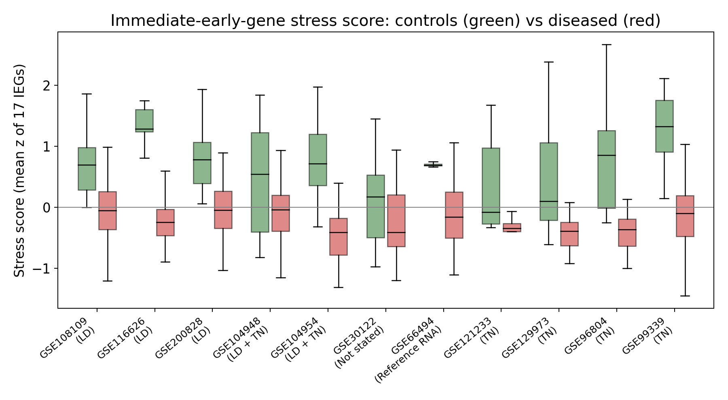
Figure 5 - immediate-early-gene stress score per series (derived for this report from experiments.py; not part of Results/ML_training___). Controls green, cases red, boxes are the interquartile ranges. In ten of ten cohorts the controls sit above the cases, including in the cohort whose "controls" are reference RNA. The module that dominates the ALL-run importance list is therefore partly a record of how the specimen was obtained, not of the patient's disease.

6. The top-50 genes: what the model actually uses
The 50 genes of ML_TOP_50_by_AUC_FEAT_IMP_by_AUC.xlsx, grouped by the biology they represent. This grouping is the interpretation layer; the file itself carries no annotation. Every gene is listed with its importance, its direction and its rank in the full 10,422-gene model, so the reader can see how much the subsetting reshuffles the order (Section 5.4).

6.1 The 50 genes, annotated
# | Gene | Product / role | Importance |coef| | Direction | Rank in ALL run
1 | FN1 | fibronectin 1, ECM glycoprotein, canonical fibrosis gene | 2.012 | higher in disease | 13
2 | DHRS2 | dehydrogenase/reductase SDR family 2 (Hep27), mitochondrial | 1.725 | lower in disease | 44
3 | PPP1R3C | protein phosphatase 1 regulatory subunit 3C (PTG), glycogen targeting, hypoxia-inducible | 1.613 | higher in disease | 39
4 | DUSP1 | dual-specificity phosphatase 1 (MKP-1), immediate-early stress phosphatase | 1.523 | lower in disease | 4
5 | ZFP36 | tristetraprolin, AU-rich-element mRNA decay factor, immediate-early | 1.128 | higher in disease | 10
6 | SYNPO | synaptopodin, podocyte foot-process protein | 1.010 | higher in disease | 35
7 | NFIL3 | E4BP4, immediate-early transcription factor | 0.980 | lower in disease | 28
8 | COL4A3 | collagen IV alpha-3, podocyte-derived GBM component (Alport) | 0.950 | lower in disease | 42
9 | MNDA | myeloid nuclear differentiation antigen | 0.907 | lower in disease | 26
10 | F3 | tissue factor, coagulation initiator | 0.808 | higher in disease | 40
11 | LYZ | lysozyme, myeloid/lysosomal | 0.807 | higher in disease | 48
12 | APOD | apolipoprotein D, lipid transport | 0.787 | lower in disease | 36
13 | RGS2 | regulator of G-protein signalling 2, immediate-early | 0.781 | lower in disease | 9
14 | JUNB | AP-1 component, immediate-early | 0.739 | lower in disease | 8
15 | EGR1 | early growth response 1, ischemia-induced immediate-early | 0.727 | lower in disease | 3
16 | ESM1 | endocan, endothelial activation | 0.711 | lower in disease | 17
17 | ZNF331 | KRAB zinc-finger protein 331 | 0.671 | higher in disease | 49
18 | XYLT1 | xylosyltransferase 1, proteoglycan glycosaminoglycan initiation | 0.661 | lower in disease | 29
19 | ANXA1 | annexin A1, glucocorticoid-induced anti-inflammatory mediator | 0.611 | higher in disease | 16
20 | ALB | albumin; proximal-tubule / permeability marker | 0.596 | lower in disease | 2
21 | PTGS2 | COX-2, prostaglandin synthesis, inflammatory | 0.586 | lower in disease | 34
22 | S100A8 | calprotectin subunit, neutrophil/monocyte | 0.558 | higher in disease | 47
23 | GSTA1 | glutathione S-transferase A1, proximal tubule | 0.545 | higher in disease | 32
24 | S100A12 | calgranulin C / EN-RAGE, neutrophil | 0.544 | lower in disease | 18
25 | JUN | AP-1 component, immediate-early | 0.544 | higher in disease | 33
26 | FPR1 | formyl peptide receptor 1, neutrophil chemotaxis | 0.459 | higher in disease | 37
27 | NR4A1 | nuclear receptor NR4A1, immediate-early | 0.447 | higher in disease | 22
28 | MAFB | macrophage and podocyte transcription factor | 0.438 | higher in disease | 23
29 | CALB1 | calbindin 1, distal-tubule calcium transport | 0.431 | lower in disease | 46
30 | HLA-DRB1 | MHC class II, antigen presentation | 0.429 | higher in disease | 25
31 | IGF1 | insulin-like growth factor 1, growth / metabolic | 0.411 | lower in disease | 14
32 | PDK4 | pyruvate dehydrogenase kinase 4, fasting / lipid oxidation | 0.388 | lower in disease | 11
33 | NR4A2 | NURR1, immediate-early nuclear receptor | 0.357 | lower in disease | 7
34 | LUM | lumican, interstitial proteoglycan, fibrosis | 0.328 | higher in disease | 19
35 | RAB20 | Ras-related GTPase, hypoxia / anoxia induced | 0.314 | higher in disease | 50
36 | CYP26B1 | retinoic-acid 4-hydroxylase | 0.309 | lower in disease | 31
37 | RPS4Y1 | ribosomal protein S4, Y-linked (sex-linked, not disease) | 0.298 | lower in disease | 38
38 | CCN1 | CYR61, immediate-early ECM / adhesion | 0.287 | higher in disease | 43
39 | GDF15 | GDF15, stress / metabolic cytokine | 0.252 | higher in disease | 12
40 | ATF3 | activating transcription factor 3, stress immediate-early | 0.234 | lower in disease | 6
41 | PCK1 | PEPCK-C, proximal-tubule gluconeogenesis | 0.213 | lower in disease | 20
42 | FOS | c-Fos, canonical immediate-early gene | 0.195 | lower in disease | 1
43 | CHI3L1 | YKL-40, inflammation and tissue remodelling | 0.141 | lower in disease | 41
44 | HBEGF | heparin-binding EGF-like growth factor, immediate-early | 0.112 | higher in disease | 45
45 | SPINK1 | serine peptidase inhibitor Kazal type 1, secreted | 0.110 | higher in disease | 27
46 | G6PC1 | glucose-6-phosphatase, proximal-tubule gluconeogenesis | 0.104 | lower in disease | 5
47 | MAFF | MAF bZIP transcription factor F, stress immediate-early | 0.093 | lower in disease | 15
48 | FOSB | FosB, immediate-early | 0.035 | lower in disease | 30
49 | APOH | apolipoprotein H / beta-2-glycoprotein I | 0.017 | higher in disease | 24
50 | CR2 | complement receptor 2 (CD21) | 0.005 | higher in disease | 21

All 50 selected genes, in the order of ML_TOP_50_by_AUC_FEAT_IMP_by_AUC.xlsx, with product/role added for this report and each gene's rank in the 10,422-gene model for comparison. Because the importance order is unstable (Section 5.4), the "Rank in ALL run" column is the more conservative ordering.

6.2 How these genes became the most important ones
A doctor asks a specific question of such a list: does it describe an injury signature, or does it describe the specimen? The answer here is "both, and they are entangled".
Immediate-early / stress-response module - 18 genes
Genes: FOS, FOSB, JUN, JUNB, EGR1, DUSP1, ATF3, ZFP36, NFIL3, RGS2, NR4A1, NR4A2, MAFF, PTGS2, CCN1, HBEGF, GDF15, PPP1R3C
The transcriptional response to any acute perturbation - in a kidney biopsy, above all to ischemia time and tissue handling. This module dominates the ALL-run ranking (15 of its top 30) and its coefficients are almost all negative, i.e. lower in disease, which is the direction a case-versus-control difference in handling produces (Figure 5). On its own it reaches LODO AUC 0.886.
Proximal-tubule / metabolic module - 7 genes
Genes: ALB, G6PC1, PCK1, PDK4, IGF1, GSTA1, CALB1
Gluconeogenesis, fatty-acid oxidation and transport functions of the proximal tubule (CALB1 is distal-tubule calcium handling). Negative coefficients mean loss of the differentiated tubular programme - one of the most reproducible findings in CKD biopsy transcriptomics and the transcriptomic correlate of tubular atrophy and interstitial fibrosis.
Podocyte / glomerular basement membrane module - 2 genes
Genes: SYNPO, COL4A3
Synaptopodin (podocyte foot processes) and collagen IV alpha-3 (the podocyte-synthesised GBM component, the Alport gene). Negative coefficients mean loss of podocyte-specific transcripts - the expected footprint of podocyte injury and of any disease that reduces the podocyte share of the biopsy.
Myeloid / immune-infiltration module - 7 genes
Genes: S100A8, S100A12, MNDA, FPR1, LYZ, MAFB, HLA-DRB1
Neutrophil/monocyte and antigen-presentation genes. The signs are mixed - HLA-DRB1, MNDA, FPR1, LYZ and MAFB positive, the calgranulins negative - but either way they track macrophage infiltration and interstitial inflammation: real disease biology and, at the same time, the most treatment- and timing-sensitive part of the signal.
Extracellular-matrix / fibrosis module - 4 genes
Genes: FN1, LUM, CHI3L1, XYLT1
Fibronectin, lumican, YKL-40 and xylosyltransferase 1 - matrix deposition and proteoglycan synthesis. The positive coefficients (FN1, LUM) point in the fibrotic direction. FN1 holds the single largest coefficient in this run yet is only rank 13 in the full model: the module is retained, the ordering is not.
Endothelial / coagulation module - 4 genes
Genes: ESM1, F3, ANXA1, RAB20
Endocan (endothelial activation), tissue factor (coagulation and injury), annexin A1 (anti-inflammatory, glucocorticoid-induced) and RAB20 (hypoxia-induced). Peritubular-capillary injury and local coagulation are established features of progressive nephropathy.
Secreted / plasma-derived genes - 4 genes
Genes: SPINK1, APOD, CYP26B1, APOH
Secreted or plasma-derived proteins (serine peptidase inhibitor, apolipoprotein D, retinoic-acid hydroxylase, apolipoprotein H / beta-2-glycoprotein I). Consistent with a changed tubular secretory and plasma-protein profile; none is a specific injury marker, and APOD and APOH are exactly the kind of transcript that follows plasma content rather than tissue state.
Transcriptional control / other - 3 genes
Genes: ZNF331, DHRS2, CR2
A KRAB zinc-finger, a mitochondrial short-chain dehydrogenase/reductase (Hep27) and complement receptor 2. DHRS2 rises from rank 45 in the full model to rank 2 here - the clearest single illustration that this list is a set, not a ranking.
Sex-linked - 1 gene: not disease biology
Genes: RPS4Y1
Y-chromosome ribosomal protein. It appears because the cohorts differ in sex composition and because Sex is itself an input; sex was inferred in most cohorts from XIST/Y markers, so a Y-chromosome gene inside the model is partly circular. Its presence is a warning, not a finding.
Why these particular genes, mechanically:
- The classifier is a linear model over expression values that differ by scale and by cohort. Any gene whose level differs systematically between the cohorts in which cases and controls live receives a large coefficient, whether or not it has anything to do with kidney injury. Because the label is not balanced within cohorts - and in some cohorts every sample is a case - cohort identity predicts the label almost perfectly, so a high AUC does not by itself imply a learned mechanism.
- The fibrosis module (FN1, LUM, CHI3L1), the podocyte module (SYNPO, COL4A3) and the myeloid set do carry coherent disease biology: matrix deposition, podocyte loss and macrophage infiltration are what a nephrologist expects in a damaged kidney, and their direction is correct. That is the part of the model a clinician would recognise as real.
- The immediate-early module is the part a clinician would recognise as an artefact. FOS, JUN, EGR1, DUSP1 and ATF3 respond within minutes to surgical ischemia and to the interval between clamping and freezing, and Figure 5 shows the controls carrying the higher stress score in every cohort - including GSE66494, whose controls are reference RNA. Eighteen of the fifty selected genes belong to this module: over a third of the signature.
- Compartment (ranks 5, 7, 33 of 55) and Sex (ranks 12, 13) are inside the top 55, and RPS4Y1 (rank 42) is a sex proxy. A model that needs to know which tissue was sampled and what sex the patient is, in order to separate disease from control, is modelling the cohort design as much as the disease.
- The five RenoRisk genes are absent. No member of the list is a complement regulator except CR2 at rank 55 (importance 0.005, i.e. indistinguishable from noise). When the model is free to choose, it does not choose the panel: it chooses a tissue-composition and procurement signature instead.

7. Reading the results clinically

7.1 The five-gene panel as a test on biopsy tissue
The RenoRisk panel is a set of complement regulators and matrix proteins: C4BPA, CFH and CFI are mainly liver-derived plasma complement-control proteins, COL13A1 is a stromal collagen and HABP2 is a secreted serine protease. None is a product of a kidney cell type whose loss defines tissue damage, and none is a kidney-restricted transcript. That biology is the most plausible explanation of the LODO result: across ten cohorts the panel alone reaches ROC-AUC 0.624 (0.628 with metadata) and is beaten by a constant "Disease" call on F1 and accuracy, with a threshold behaviour - 96.2% of cases and 94.8% of controls called diseased - that is clinically unusable.
Two caveats keep this from being a verdict on the panel as a biomarker. First, the abundance of a plasma protein in a kidney biopsy is a poor proxy for the plasma concentration a clinical assay would measure: the panel may still work as a urine or plasma immunoassay, and nothing in this folder tests that. Second, the within-cohort effects are real - they are simply not consistent in sign or size (table below). The failure demonstrated here is specifically failure to transport across cohorts in uncorrected biopsy expression, not absence of effect.
Gene (Hedges g, disease vs control, within cohort) | GSE104948 | GSE104954 | GSE108109 | GSE116626 | GSE121233 | GSE129973 | GSE200828 | GSE30122 | GSE66494 | GSE96804 | GSE99339
C4BPA | 0.03 | -0.05 | 0.00 | -0.19 | -0.44 | 0.14 | -0.09 | 1.06 | 0.25 | -0.06 | -0.07
COL13A1 | 1.14 | 0.18 | 0.73 | 0.64 | -0.17 | 0.03 | 0.63 | 0.68 | 0.58 | 1.71 | 0.05
HABP2 | 0.12 | 0.36 | -0.03 | 0.51 | 1.02 | -0.02 | 0.06 | 1.01 | 0.94 | -0.38 | -0.90
CFH | 0.95 | 0.53 | -0.73 | 0.30 | 0.79 | 0.88 | -0.76 | 0.69 | 0.65 | 0.97 | -0.12
CFI | 0.15 | 0.80 | -1.37 | 0.43 | 1.01 | 0.53 | -1.28 | 0.71 | 1.03 | 0.09 | -0.43
FN1 | 1.53 | 1.03 | 1.18 | 0.04 | 2.24 | 2.00 | 0.87 | 1.52 | 0.64 | 1.86 | 0.79
LUM | 0.42 | 0.83 | -0.53 | 1.14 | 1.88 | 2.39 | -0.65 | 1.56 | 0.39 | 1.55 | 0.26
S100A12 | 0.11 | 0.12 | -1.43 | -0.10 | -1.59 | -1.36 | -1.38 | -0.25 | 0.55 | -2.33 | -0.17
HLA-DRB1 | 0.97 | 1.38 | 0.88 | 1.08 | -2.45 | -1.43 | 1.12 | 0.90 | 0.36 | 0.35 | 1.84
FOS | -0.67 | -2.30 | -1.09 | -1.88 | -1.67 | -1.94 | -1.16 | -0.30 | -2.44 | -4.22 | -1.50
DUSP1 | -1.62 | -3.91 | -2.06 | -1.74 | -1.97 | -2.32 | -1.94 | -1.11 | -2.01 | -4.17 | -1.17

Derived for this report (experiments.py) from the uncorrected values in Data/ML_input/all2.xlsx; the eleven series are shown separately, not as merged ERCB. Positive g = higher in disease. The panel genes have real effects - COL13A1 is positive in nine of eleven series - but C4BPA, CFH and CFI change sign between series (CFI +1.03 in GSE66494 versus -1.37 in GSE108109 and -1.28 in GSE200828), which is why a classifier trained on nine cohorts fails on the tenth. Note also that GSE108109 and GSE200828 - the pair flagged as strongly overlapping in the expression audit - agree with each other and disagree with everything else, and that the proximal-tubule genes (ALB, PCK1, G6PC1) and FN1 are consistently negative and positive respectively in almost every series: the damage axis is the reproducible one, the panel is not.

7.2 What a 0.95-0.97 AUC means and does not mean at the bedside
- It means the biopsy profile can tell "this cohort is a disease cohort" from "this cohort is a control cohort" within the platform, compartment and handling structure of these eleven series. In a deployed test the patient arrives at one hospital with one protocol, and the model would have to transfer from ten protocols to that one - precisely what LODO already stress-tests. The panel fails that test; the transcriptome model passes it largely by learning cohort-level offsets and tissue composition, and it does not transfer between compartments (whole-biopsy sensitivity 0.685 vs 0.982 glomerular).
- It does not mean diagnostic accuracy for an individual patient. There is no patient-level covariate anywhere in this data set - no eGFR, no proteinuria, no percentage of interstitial fibrosis or tubular atrophy, no treatment - so the model cannot be calibrated against severity. The label is a binary "disease yes/no" taken from the submitters' diagnosis field.
- It does not correct for the class mix. 79.8% of samples are disease, and prevalence ranges from 27.5% to 96.1% across cohorts. At 90% sensitivity and 90% specificity, a positive predictive value of ~0.97 in this data set becomes ~0.32 at a 5% clinic prevalence. Precision is not a portable number here, which is why the folder's F1 and precision columns should never be quoted without the dummy row beside them.
- It does not survive the overlap. The expression audit flags GSE108109 / GSE200828 as strongly overlapping and GSE121233 / GSE129973 as further candidates; leave-one-cohort-out keeps overlapping or re-analysed series in the training set, so the 850 GSMs are not 850 independent patients and generalisation is overstated.

7.3 The clinically coherent part of the signature
Setting the technical modules aside, the surviving message is the one nephrology already states: damaged kidney tissue loses its differentiated tubular and podocyte programmes and gains matrix and myeloid infiltration. The groups with consistent, mechanistically sensible direction in this list are the proximal-tubule metabolic genes (ALB, PCK1, G6PC1, PDK4 - lower in disease in ten, ten, ten and eight of eleven series respectively, the transcriptomic correlate of tubular atrophy and dedifferentiation), the podocyte/GBM genes (SYNPO, COL4A3 - lower) and the fibrosis genes (FN1, LUM - higher in ten and nine of eleven series). A clinician would read these as a plausible composite "chronic damage" axis, and would immediately add the caveat that none of them is disease-specific: the same axis moves in any nephropathy, and most of it is already summarised in a routine biopsy report by the IFTA score, the glomerular-sclerosis count and the interstitial-inflammation grade. A transcriptomic classifier that reproduces the histology report is not yet adding information to it.

8. Data-science reading
- The baseline row is the most informative row in each table. It is not a formality: for the five-gene panel the constant rule wins on F1 and accuracy, and quoting F1 0.808 alone would describe a failing model as a working one.
- Mean-over-cohorts metrics weight a 10-sample cohort equally with a 153-sample cohort. GSE121233 has 10 samples (5 cases, 5 controls), so its AUC moves in 0.1 steps; GSE30122 has 50 of the 172 controls and values on a per-gene-centred scale. Report the spread, not only the mean: the per-cohort table and Figure 4 exist for that reason, and the fact that the stored workbooks contain means only is the largest gap in the folder.
- ROC-AUC is the right primary metric, and the notebooks say why; the pooled-AUC temptation must still be avoided, because each fold's score has a different scale. The honest summaries are the mean of the per-cohort AUCs (what the files store) and the mean of the per-cohort ROC curves (what the figures show).
- Ranking instability is the second-biggest finding after the panel failure. Importance from an unregularised linear model over a correlated transcriptome is a shared-attribution problem: FOS moves from rank 1 to rank 47, DHRS2 from 45 to 2. Any downstream use of the list - a targeted panel, a protein assay, a publication table - must be built on stability selection or on module scores, not on this ordering.
- |coefficient| on unscaled inputs is partly a scale statistic. With three deposited value scales and two per-gene-centred cohorts, the same biological effect can produce different coefficient magnitudes for different genes, and the metadata one-hots carry small integer/indicator scales that inflate their apparent importance relative to continuous expression. Standardising inside each fold, or z-scoring per cohort, would make the ranking comparable at the cost of discarding the absolute level that some cohorts still have. Both variants should be run; the current files cannot separate effect from units.
- The linear > tree pattern (Logistic Regression and linear SVM 0.953 against Random Forest 0.858, LightGBM 0.857, Extra Trees 0.826) says the usable signal is essentially additive and monotone in the raw value. Together with the immediate-early and compartment results, the most economical explanation is cohort-level level shifts plus tissue composition, on top of a genuine damage axis - not a nonlinear disease signature.
- Three models collapse against the same data (Gaussian Process recall 0.147, QDA 0.598, Naive Bayes 0.522) and in the RR run three sit below 0.5 (Gradient Boosting 0.496, AdaBoost 0.486, QDA 0.470), with Decision Tree (0.516) effectively tying chance. With one-hot columns plus thousands of correlated genes the covariance matrices these estimators need are singular or near-singular. An AUC below 0.5 here is estimator instability, not a biological finding in reverse.
- The 50-gene run's gain cannot be claimed as a validation result because of the selection leak, but it is worth recording as a hypothesis: a nested run with in-fold selection may well land near 0.95 with 50 genes. That is the next experiment, and it is cheap.
- Importance was computed from a model refitted on all samples, so it describes the everything-trained model, not the ten fold models. A fold-wise importance distribution (mean, and rank overlap across folds) would be the defensible version and would directly quantify Section 5.4.
- The threshold metrics and the rank metrics disagree in an informative way. By ROC-AUC the top-50 model is the best in the folder (0.970); at a fixed 90% sensitivity it is also the best (specificity 0.940); but by F1 it barely differs from the panel model's constant behaviour because F1 at 0.5 is dominated by prevalence. Report the sensitivity-matched specificity, or a decision curve, whenever the intended use is clinical.

9. Limitations and threats to validity
Limitation | Consequence for these results
Class imbalance: 678 disease / 172 control (79.8%) | Thresholded metrics are prior-driven; F1 and precision must always be read next to the dummy row. The panel model's recall 0.973 is the imbalance, not sensitivity.
Per-cohort prevalence 27.5%-96.1% | Precision and PPV are neither comparable across cohorts nor portable to a clinic.
Ten folds, some very small (GSE121233 n=10; GSE108109 has 6 controls) | The equal-weight mean of per-cohort AUC has high variance; one sample can swing a cohort's AUC.
Cohort = batch, and the label is nested in cohort for most series | LODO cannot separate "learning disease biology" from "learning this cohort's offsets". A 17-gene technical proxy alone reaches 0.886 (Section 5.5).
Uncorrected expression on three value scales; two cohorts per-gene centred | Absolute levels are not comparable across cohorts; coefficients and importances are partly scale-bound.
Submitter-processed series (five pipelines), no Stage 1 re-quantification | Gene-level values carry each submitter's normalisation choices and there is no uniform quantification to check them against.
Documented cross-study overlap (GSE108109/GSE200828 flagged; GSE121233/GSE129973 further candidates) | The effective number of independent patients is below 850, folds are not independent, and generalisation is overstated.
ERCB merges GSE104948 + GSE104954 and pools several diagnoses in its cases | One fold mixes two compartments and multiple diseases; its effect sizes are averages over a mixed group.
Compartment and Sex are model inputs, and Compartment is nested in cohort for most series | Part of the accuracy is attribution to a sampling variable. Compartment cannot be "predicted" for a new patient in any meaningful sense, yet it is model input.
Sex was inferred for most cohorts from XIST/Y markers | A Y-chromosome gene (RPS4Y1) in the top-50 list makes the Sex input partly circular.
No patient-level clinical variables (no eGFR, proteinuria, IFTA/%TIF, treatment) | No calibration to severity; no way to test whether the model ranks patients within one diagnosis.
Feature selection for the 50-gene run was done outside the folds | Those LODO scores are optimistic; only the ALL-run number is leak-free.
Importance computed by refitting on all samples, inputs unscaled | Rank order is unstable under collinearity and partly reflects units (Sections 5.4 and 8).
No hyperparameter tuning; PyCaret defaults throughout | The tables compare model families at defaults, not optimised performance; a tuned variant would need nested tuning to stay honest.
No RNA-seq series in scope | Conclusions apply to microarray biopsy profiles as deposited, not to RNA-seq or single-cell data.

10. Conclusions
1. The five-gene RenoRisk panel is not a stand-alone cross-cohort classifier in kidney-biopsy expression. Best LODO ROC-AUC 0.628; at the 0.5 threshold it calls 94.8% of controls diseased and, at 90% sensitivity, keeps a mean specificity of 0.212. It is beaten by the constant "Disease" rule on F1 and accuracy, and inside its own model Compartment and Sex outrank four of its five genes. Nothing in this folder supports using the panel as a tissue-expression diagnostic.
2. The transcriptome-wide result (ROC-AUC 0.953, the only leak-free estimate here) is part real biology and part specimen provenance, and the two can be separated to a useful degree. Seventeen immediate-early genes alone yield 0.886 and behave like a sample-type detector (higher in controls in ten of ten cohorts, including reference-RNA "controls"); removing them from the full model still leaves 0.940, so a genuine damage axis remains - tubular and podocyte gene loss, myeloid infiltration, matrix deposition.
3. The 50-gene model (ROC-AUC 0.970, mean specificity 0.940 at 90% sensitivity) is not evidence that 50 genes suffice. Its selection saw the test cohorts, and its gain over the full model is partly the same collinearity that makes its own ranking unstable. A nested, in-fold selection run is required before any "50-gene signature" claim.
4. Feature-importance orderings in these files are not biomarker rankings. FOS 1 -> 47 and DHRS2 45 -> 2 between two runs of the same data show that only module-level statements are stable. Follow-up panels must be built from stability selection or from module scores.
5. None of CFH, CFI, C4BPA, COL13A1 or HABP2 enters the top 1,500 of the 10,422-gene model (ranks 1,572 to 8,982). The model that best detects damaged kidney tissue in this data set does not use the panel; and the panel's own effects, real within cohorts, are inconsistent in sign between them.

10.1 Recommended next steps
- Re-run the 50-gene selection inside each fold (or nest it) and report that number; it is the honest version of Figure 3 and the first result anyone will ask for.
- Store a per-cohort results table with the outputs (cohort, n, controls, cases, AUC, sensitivity, specificity, specificity at 90% sensitivity). The folder currently stores means only, so the largest source of uncertainty is invisible in it.
- Standardise or per-cohort z-score the inputs inside the folds and re-report the importance ranking; compare it with the current unscaled one to separate effect from units.
- Quantify stability: 100 bootstrap or repeated-fold models, then report each gene's selection frequency in the top 50 instead of a single-run ordering.
- Model the technical axis explicitly - include the 17-gene procurement-stress score as a covariate or regress it out, and report the AUC of the residual model. The folder already shows the module to use.
- Drop Compartment and Sex from the final feature set, or stratify by them, and report the cost. They are not patient phenotypes, and their presence makes the model non-deployable.
- Never split overlapping or re-analysed series (GSE108109/GSE200828, GSE121233/GSE129973) across train and test; group them together for an honest generalisation estimate.
- For the clinical claim, move the panel to a matrix where it can be measured properly (plasma or urine) and validate against a severity outcome - eGFR slope, proteinuria, IFTA/%TIF - rather than a binary disease label whose definition varies by submitter.

