RenoRisk
Machine-Learning Validation Report
Kidney tissue injury classification across ten independent GEO cohorts
Analysis of Results/ML_training___ : genome-wide, top-50 and five-gene panel models

Item | Detail
Folder analysed | Results/ML_training___/ (ALL/ALL, ALL/TOP_50_by_AUC, RR)
Input data | Data/ML_input/all2.xlsx (10,422 genes) and all.xlsx (five panel genes); 850 samples, 10 leave-one-cohort-out groups
Models | 17 scikit-learn classifiers with PyCaret 3.3.2 defaults, fitted by the notebooks Scripts/train_ML_ALL.ipynb and Scripts/train_ML_RR.ipynb
Validation | Leave-one-dataset-out (LODO), one fold per cohort, no separate hold-out
Reference date | 31 October 2026
Audience | Data-science reviewers and clinical/nephrology reviewers

This report reads the delivered result files as they are, then re-analyses the same data independently to test how far the conclusions survive. Every number taken from the delivered workbooks is quoted as found; every number produced by the re-analysis is labelled as such.

Contents
1. Executive summary 3
1.1 Key findings 3
2. Scope, data and methods 4
2.1 What the task actually is 4
2.2 Data 4
2.3 The three runs 4
2.4 Validation design 5
2.5 Metrics 5
3. Inventory of the results folder 5
3.1 Reading the two workbook types 6
4. What the performance tables and ROC figures show 6
4.1 The genome-wide run (ALL/ALL) 6
4.2 The top-50 run (ALL/TOP_50_by_AUC) 7
4.3 The panel run (RR) 7
4.4 The three ROC figures 7
4.5 Per-cohort performance (independent re-analysis) 9
4.6 Why accuracy and F1 mislead here 10
4.7 Model-family behaviour 11
5. How to read the feature-importance files 11
5.1 Definition 11
5.2 Five properties that limit interpretation 11
5.3 How the weight is distributed 12
6. The top-50 features 12
6.1 The list 12
6.2 Functional modules 14
6.3 Is the ordering stable? 14
6.4 What the model ignored, and why it matters 15
6.5 What the 50 genes add up to 16
6.6 The five RenoRisk panel genes in the same frame 16
7. Medical interpretation 17
7.1 The comparator problem 17
7.2 Axis 1 — loss of proximal-tubule identity 17
7.3 Axis 2 — the immediate-early / stress-response block 18
7.4 Axis 3 — extracellular matrix and mesenchymal repair 18
7.5 Axis 4 — innate immune and myeloid genes 19
7.6 What is missing, and why it matters 19
7.7 Sex and compartment as features 19
7.8 Is the score a severity index? 20
7.9 What the folder supports clinically, and what it does not 20
8. Statistical critique 20
8.1 Leakage in the top-50 run 20
8.2 Pooling across value scales hides a sign reversal 21
8.3 Metrics that cannot be compared 21
8.4 No uncertainty, no repeated resampling 21
8.5 Unequal weighting of cohorts 21
8.6 No null calibration 21
8.7 The importance ranking is described as if it were a feature-selection result 21
8.8 What is missing from the design altogether 22
9. Recommendations 22
9.1 For the analysis 22
9.2 For the biology and the panel 22
10. Conclusions 23
Appendix A — Complete performance tables 24
Appendix B — Reproducibility of the re-analysis 25
Appendix C — Assumptions and constants 26

1. Executive summary
The folder contains three machine-learning runs on the same 850 kidney samples from ten independent GEO cohorts. They differ only in the features offered to the classifiers: all 10,422 common genes, the 50 genes with the highest model weight, or the five RenoRisk panel genes. Every run was validated by leaving one entire cohort out at a time, which is the right design for this kind of cross-platform work. The three ROC figures and six workbooks are therefore directly comparable, and the comparison is the most informative thing in the folder.
The single most important number
A genome-wide logistic regression separates diseased from control kidney tissue with a mean out-of-cohort AUC of 0.953 (top-50 run: 0.970). The five-gene RenoRisk panel, run on exactly the same samples and the same folds, reaches 0.628. None of the 17 classifiers trained on the panel beats the trivial rule “call every sample diseased” on accuracy or F1.

1.1 Key findings
1. Discrimination is strong, but the task is easy. AUC 0.95 across ten cohorts is a real signal: it survives a platform change, a value-scale change and a prevalence range from 28% to 96%. It is also the discrimination a transcriptome can achieve between a diseased kidney and a living-donor or tumour-nephrectomy kidney. No clinician is asked to make that distinction.
2. The 50-gene selection works. The top-50 run is not worse than the genome-wide run; it is slightly better (AUC 0.970 vs 0.953, +0.017; F1 0.896 vs 0.883). Fifty genes carry essentially all the usable signal. That is a genuine dimension-reduction result.
3. The ranking is unstable. Fourteen of the 50 top genes change the sign of their coefficient when the same 50 genes are refitted alone, and the rank correlation between the two importance lists is −0.09. The ordering inside the top 50 should not be read as a biological league table.
4. The importance list measures model weight, not biological importance. With 10,422 unscaled, highly correlated inputs and 850 samples, the fitted coefficients redistribute arbitrarily inside co-expressed blocks. COL4A1, COL4A2, VIM, COL3A1 and TGFBI have among the strongest and most reproducible disease effects in the whole dataset (mean single-gene AUC 0.81–0.87 in all ten cohorts) and yet carry near-zero model weight. They are absent from the top-50 list for arithmetic reasons, not biological ones.
5. The top-50 list is a coherent biological story: loss of proximal-tubule identity (ALB, PCK1, G6PC1, PDK4), collapse of immediate-early/stress-response regulators (FOS, FOSB, JUN, JUNB, EGR1, ATF3, DUSP1, ZFP36, NR4A1/2, RGS2), and gain of extracellular-matrix and repair programmes (FN1, LUM, ANXA1, HBEGF, CCN1, XYLT1). Eighteen of the 50 move in the same direction in all ten cohorts, with median |d| between 0.7 and 2.0.
6. The five-gene panel is not a classifier. AUC 0.628 (95% range across folds 0.45–0.80), and in the panel run the compartment label alone carries 58% of the model weight. Only COL13A1 has a direction that is consistent across all ten cohorts, and its effect is modest (mean AUC 0.65).
7. The model does not grade severity or separate diagnoses. Within a single cohort, minimal-change disease, membranous nephropathy and FSGS score within 0.05 standard deviations of each other. The score behaves as a binary “is this normal parenchyma” detector, not as a damage index.
Overall verdict. The folder documents a technically sound cross-cohort benchmark of an easy classification problem and a negative result for the five-gene panel as a stand-alone classifier. Neither result is yet a clinical biomarker claim. The genome-wide model is a useful hypothesis generator about what “diseased kidney tissue” looks like transcriptionally; the panel result says that these five genes, used alone, cannot carry that task.

2. Scope, data and methods

2.1 What the task actually is
The target variable is Disease_Label: 0 = control, 1 = disease. Controls are living-donor kidneys or non-tumour cortex from tumour nephrectomies. Cases are biopsies from eleven diagnosis groups (membranous nephropathy, FSGS, minimal-change disease, IgA nephropathy, diabetic kidney disease, ANCA vasculitis, lupus nephritis, hypertensive nephropathy, thin-membrane disease, unspecified CKD, other glomerulonephritis). The learning task is therefore any kidney disease versus a supernormal comparator, not “damaged versus undamaged tissue of the same kind” and not “which disease”.
This matters for every interpretation that follows. A model that detects “loss of normal kidney architecture” will score well on this task while being clinically uninformative, because the clinical question is always a comparison between two abnormal states, or a prognosis within one abnormal state.

2.2 Data
Table 1. The ten leave-one-cohort-out groups. Value scales as documented in the project's CLAUDE.md: three incompatible scales, none recorded in the data itself.
Cohort (LODO group) | Compartment | Platform / value scale | n | Diseased | Prevalence
ERCB (GSE104948 + GSE104954) | glomerular + tubulointerstitial | Affymetrix, log2 absolute | 131 | 89 | 68%
GSE108109 | glomerular | Affymetrix, log2 absolute | 111 | 105 | 95%
GSE116626 | whole biopsy | Illumina BeadChip, per-gene centred | 81 | 74 | 91%
GSE121233 | glomerular | Affymetrix HuGene ST, log2 absolute | 10 | 5 | 50%
GSE129973 | glomerular | Affymetrix HuGene ST, log2 absolute | 40 | 20 | 50%
GSE200828 | glomerular | Affymetrix, log2 absolute | 153 | 147 | 96%
GSE30122 | glomerular + tubulointerstitial | Affymetrix HG-U133A, per-gene centred | 69 | 19 | 28%
GSE66494 | whole biopsy | Agilent, linear (log2-transformed) | 61 | 53 | 87%
GSE96804 | glomerular | Affymetrix HuGene ST, log2 absolute | 61 | 41 | 67%
GSE99339 | glomerular | Affymetrix, log2 absolute | 133 | 125 | 94%
Total |  |  | 850 | 678 | 80%
Two facts in this table drive most of the later discussion. First, prevalence ranges from 28% to 96% across cohorts, so any pooled accuracy figure is an average over ten different decision problems. Second, the compartment label is almost perfectly confounded with cohort: eight cohorts are glomerular, one is tubulointerstitial and two are whole biopsy; only GSE30122 and ERCB contain two compartments. Compartment is therefore a cohort identifier in disguise.

2.3 The three runs
Table 2. The three runs and what each one is for. All 17 PyCaret classifiers are fitted in every run with their default hyper-parameters.
Folder | Features offered | Genes | Runs | Purpose
ALL/ALL | 10,422 genes + Compartment + Sex | 10,422 | 1 | Reference model; produces the importance ranking used for selection
ALL/TOP_50_by_AUC | Top 50 genes of the reference model + Compartment + Sex | 50 | 2 | Tests whether a compact signature loses information
RR | Five RenoRisk panel genes + Compartment + Sex | 5 | 1 | Tests the panel as a stand-alone classifier

2.4 Validation design
Leave-one-dataset-out (LODO) with LeaveOneGroupOut. Each fold trains on nine cohorts and predicts the tenth; every sample is predicted exactly once by a model that has never seen its cohort. There is no separate hold-out set, and there is no sample-level cross-validation. This is the strongest validation available with ten cohorts, and it correctly prevents cohort identity from being memorised for the test cohort. It does not prevent cohort identity from being learned in training, and it cannot detect confounding that is constant within a cohort (see Section 8).
Two design details must be kept in view when reading the feature-importance files:
- The importance ranking is fitted on all 850 samples, including every cohort. It is an in-sample description of the final model, not a validated ranking.
- The top 50 genes were then chosen from that ranking and re-tested by LODO. The left-out cohorts therefore influenced their own feature selection. The top-50 run's scores are optimistic, and the folder's own sessionInfo file says so explicitly.

2.5 Metrics
Five metrics are reported per fold and averaged over the ten folds: F1, precision, recall, accuracy and ROC-AUC. The averaging is over folds, not over pooled predictions, because each fold's model has its own score scale. ROC-AUC is the only one of the five that is invariant to a constant shift of the score and insensitive to prevalence, so it is the only metric that can be compared across cohorts. The other four are threshold-dependent and prevalence-dependent; Section 4.7 shows what that does to the numbers.

3. Inventory of the results folder
The folder contains three subfolders, each holding the same five artefacts: a performance workbook, a feature-importance workbook, one ROC figure, and a sessionInfo text file. Two housekeeping files (.DS_Store) and one Excel lock file (~$ML_TOP_50_by_AUC_FEAT_IMP_by_AUC.xlsx, created when a workbook is open in Excel) are not results and can be ignored.
Table 3. Every file in Results/ML_training___ and what it contains.
File | Sheet size | What it holds
ALL/ALL/ML_ALL_perfs.xlsx | 17 × 7 | Mean LODO performance of all 17 classifiers on 10,422 genes
ALL/ALL/ML_ALL_FEAT_IMP_by_AUC.xlsx | 10,427 × 3 | Importance and signed coefficient of every gene plus the one-hot metadata columns, reference model
ALL/ALL/ML_ALL_AUC_by_AUC.png | figure | Mean ROC of the best model by AUC over the ten left-out cohorts
ALL/ALL/ML_ALL_sessionInfo.txt | text | Versions, settings, model list, input description
ALL/TOP_50_by_AUC/ML_TOP_50_by_AUC_perfs.xlsx | 17 × 7 | Same performance table for the top-50 run
ALL/TOP_50_by_AUC/ML_TOP_50_by_AUC_FEAT_IMP_by_AUC.xlsx | 55 × 3 | Importance of the 50 genes and 5 metadata levels in the top-50 model
ALL/TOP_50_by_AUC/ML_TOP_50_by_AUC_AUC_by_AUC.png | figure | Mean ROC, top-50 run, with the optimism caveat
ALL/TOP_50_by_AUC/ML_TOP_50_by_AUC_sessionInfo.txt | text | Versions plus an explicit note that selection saw the left-out cohorts
RR/ML_RR_perfs.xlsx | 17 × 7 | Performance table for the five-gene panel
RR/ML_RR_FEAT_IMP_by_AUC.xlsx | 10 × 3 | Importance of 5 genes, 3 compartment levels and 2 sex levels
RR/ML_RR_AUC_by_AUC.png | figure | Mean ROC, panel run
RR/ML_RR_sessionInfo.txt | text | Versions and settings
Three observations about the delivered set. The notebooks also write *_FEAT_IMP_by_F1.xlsx and *_AUC_by_F1.png, and a TOP_50_by_F1 folder; none of these are present, which is harmless because logistic regression was the best model by both F1 and AUC in every run, so the by-F1 selection would have chosen the same 50 genes. The RR folder has no run-2 subfolder because five genes cannot be reduced further. And the sessionInfo files record Python 3.11.9, scikit-learn 1.4.2 and RANDOM_STATE=42, which is enough to reproduce every number in this report.

3.1 Reading the two workbook types
The performance workbooks are read row by row: one row per classifier, sorted by ROC-AUC, averaged over ten folds. Nothing needs to be recomputed to use them; they are complete.
The importance workbooks need one warning before they are used. They have three columns only — Source, Importance, Coefficient — and the meaning of Importance is not the same for every row:
- For the logistic regression that produced all three files, Importance is the absolute value of the fitted coefficient, and Coefficient keeps the sign. A positive coefficient pushes the sample towards Disease.
- The inputs were not standardised, so a coefficient is “log-odds per unit of expression”, and a gene measured on a wider scale will tend to receive a smaller coefficient for the same biological effect. Cross-gene comparison of coefficient size is therefore only valid within one value scale.
- Compartment and Sex are one-hot encoded, so a single categorical variable appears as several rows with the same Source label. Compartment therefore occupies three rows and Sex two, which is why the top-50 workbook has 55 rows although it describes 50 genes.

4. What the performance tables and ROC figures show
All three runs agree on one point: the logistic regression (and its close relatives, linear SVM, ridge, LDA) is the best model, and the tree ensembles are consistently behind it. With 850 samples and thousands of correlated features, this is the expected outcome — linear models tolerate collinearity, ensembles fragment it across splits.
Table 4. Best model per run, mean over ten left-out cohorts, as printed in the three perfs workbooks. The last row is the DummyClassifier row from every workbook.
Run | Features | Best model | ROC-AUC | F1 | Precision | Recall | Accuracy
Genome-wide | 10,422 genes + 2 | Logistic Regression | 0.953 | 0.883 | 0.884 | 0.923 | 0.858
Top 50 | 50 genes + 2 | Logistic Regression | 0.970 | 0.896 | 0.896 | 0.942 | 0.861
Panel | 5 genes + 2 | Logistic Regression | 0.628 | 0.808 | 0.727 | 0.973 | 0.711
Trivial baseline | — | Dummy (always disease) | 0.500 | 0.818 | 0.726 | 1.000 | 0.726
Read the last two rows together. In the panel run the model reaches an accuracy of 0.711 while the trivial rule reaches 0.726; its F1 is 0.808 against 0.818. Zero of the 17 classifiers exceed the dummy on accuracy, and zero exceed it on F1. The high recall (0.973) is simply the model predicting “disease” almost always, because 80% of the samples are disease and the fitted threshold is not calibrated for each cohort.

4.1 The genome-wide run (ALL/ALL)
Mean AUC 0.953 with the dummy at 0.500. Four classifiers exceed 0.90 (LR 0.953, linear SVM 0.953, ridge 0.939, LDA 0.917); the tree ensembles sit between 0.82 and 0.87; Naive Bayes collapses to 0.522 and the Gaussian process collapses to 0.500 with an F1 of 0.168. The two collapses are informative rather than embarrassing: both models assume a covariance structure that 10,422 collinear, unscaled features violate. A Gaussian process on 10,422 inputs with 765 training samples is essentially unfittable, and its failure is a warning about the feature scaling, not about the biology.
Per-cohort spread is wide and meaningful: five cohorts reach AUC 1.000 (perfect separation), while the whole-biopsy Illumina cohort GSE116626 falls to 0.832 and GSE30122 to 0.859. Both are the cohorts that are per-gene centred, which is exactly where a linear model fitted on absolute log2 values transfers worst.

4.2 The top-50 run (ALL/TOP_50_by_AUC)
AUC rises to 0.970 and F1 to 0.896. The gain over the genome-wide run is small but consistent across nearly every model (mean ΔAUC +0.066 over all 17 classifiers, median +0.040), and the models that improve most are the ones that suffered from dimensionality — Gaussian process +0.247, Naive Bayes +0.214, QDA +0.159, decision tree +0.112. This is the classical signature of noise removal: 50 informative genes are easier to fit than 10,422 half-informative ones.
The improvement cannot be read as evidence that “50 genes are enough” without the caveat that the 50 were chosen with knowledge of all cohorts. What can be said is the weaker, still useful statement: no information visible to the model was lost by discarding 99.5% of the transcriptome.

4.3 The panel run (RR)
AUC 0.628 is barely above chance. Per cohort, the AUC ranges from 0.45 (GSE99339) to 0.80 (GSE121233, ten samples). A one-sample t-test over the ten fold AUCs gives t = 3.24, p = 0.010 against 0.5; the effect is statistically detectable and clinically negligible. Two cohorts are below chance (GSE99339 0.45, GSE66494 0.49), which is what a null signal looks like.
The panel model's weights make the mechanism explicit. Compartment accounts for 3.49 of 6.03 total absolute coefficient mass (58%), Sex for 0.62 (10%), and the five genes together for 1.92 (32%). Panel gene coefficients are also mutually contradictory: CFI receives a negative coefficient although it is, on average, higher in disease. Removing Compartment and Sex and keeping only the five genes gives AUC 0.624 — the metadata is not what produces the small signal, but it is what produces the accepted threshold.

4.4 The three ROC figures
The three PNG files are the same plot for the three runs. In each, the blue line is the average of the ten per-cohort ROC curves, interpolated onto a common false-positive grid, and the grey dashed line is chance. The legend repeats the mean AUC. Because each fold's model is on its own score scale, the curves are averaged as curves and not from pooled predictions — which is correct, and is why the averaged curve is slightly jagged: ten step functions, each with a different number of samples, are being interpolated and stacked.
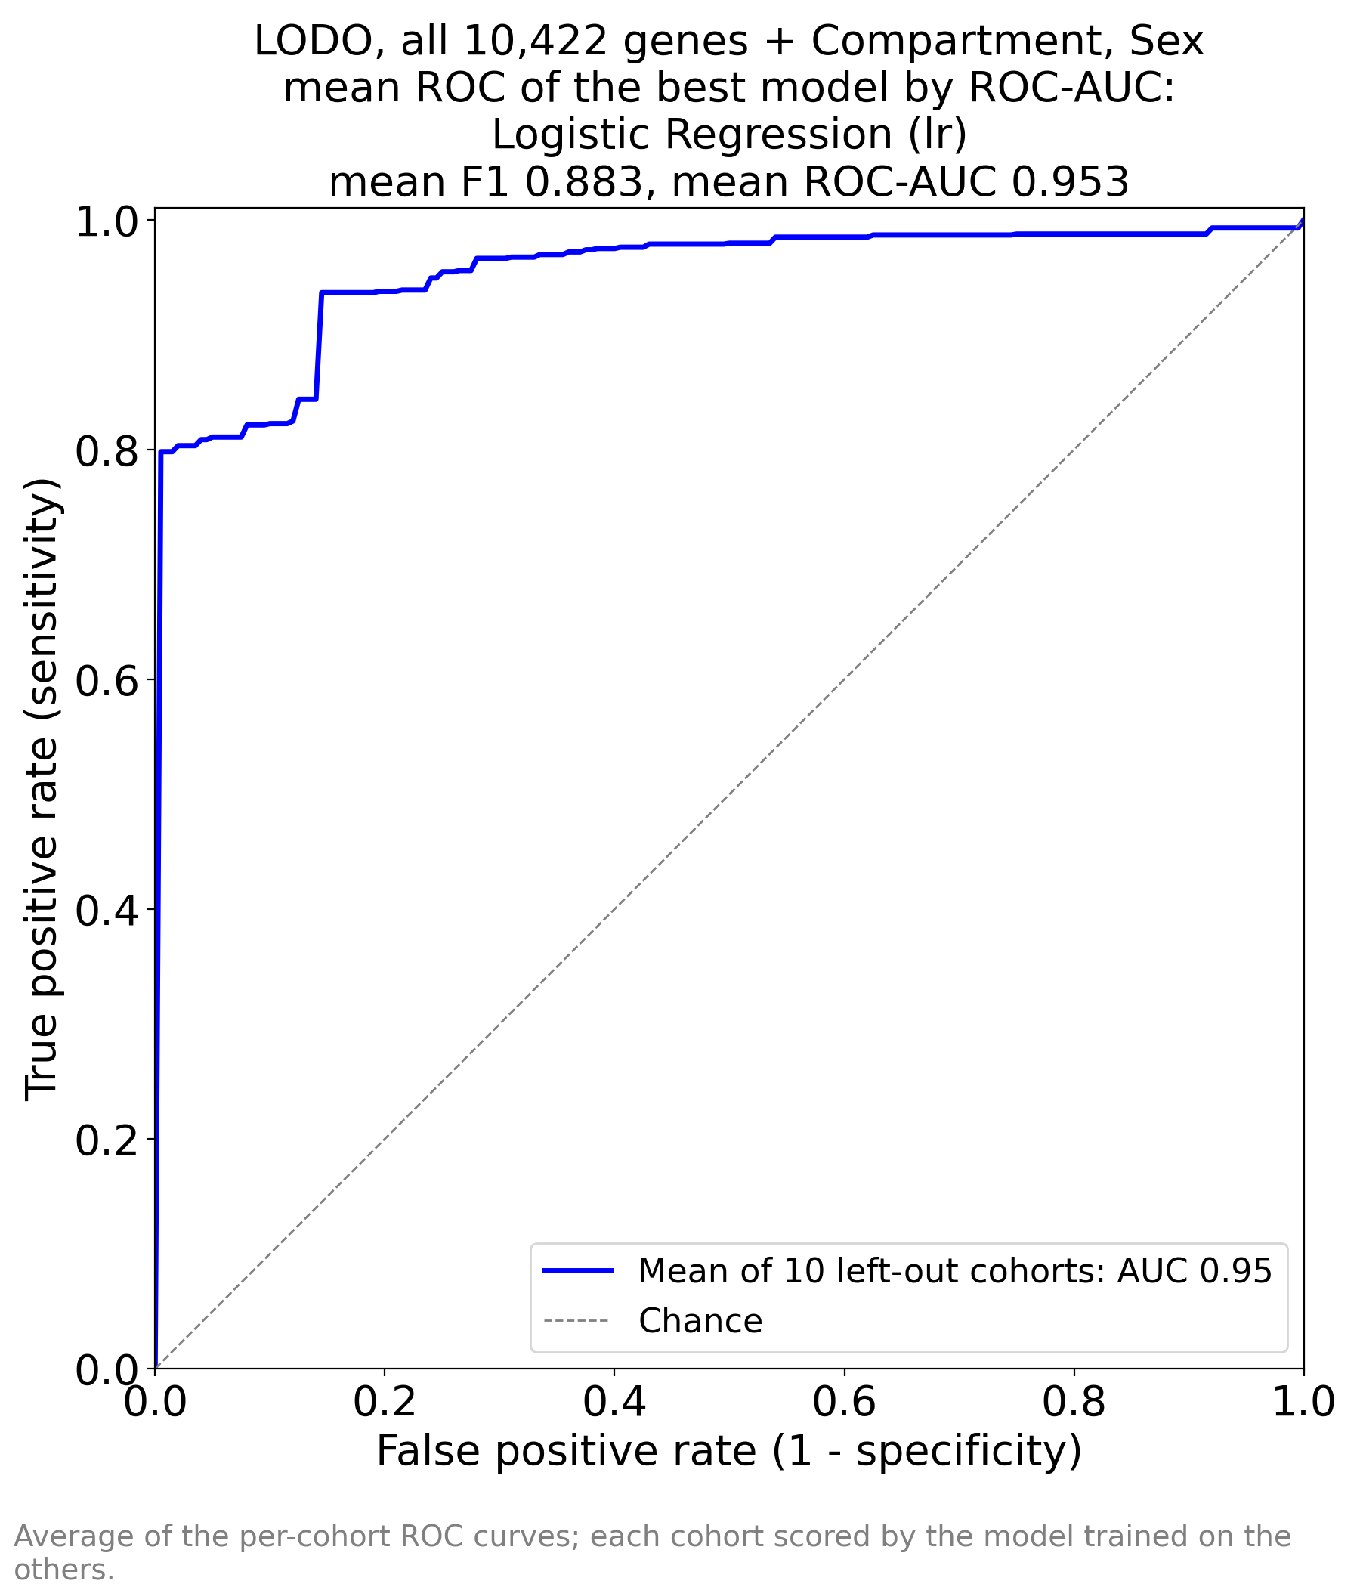
Figure 1 (delivered). ML_ALL_AUC_by_AUC.png. Genome-wide run, logistic regression, 10,422 genes + Compartment + Sex. Mean F1 0.883, mean AUC 0.953. The curve rises to a true-positive rate of 0.80 at a false-positive rate below 0.01 — the model is almost perfectly specific at high sensitivity, which is what one expects when the two classes differ by a global transcriptional shift.
Figure 1 is the shape of a strong but not perfect classifier. Two features deserve comment. The vertical segment at the origin is genuine: a large block of samples receives near-zero probability, so nearly all controls are ranked below nearly all cases. The long flat plateau above 0.96 shows the limit — a minority of diseased samples (about 4%) are never recovered, even at a false-positive rate of 0.4. In a clinical frame that is the “biologically normal-looking biopsy” group: minimal-change disease and thin-membrane nephropathy, which are diseases without much parenchymal transcriptome change.
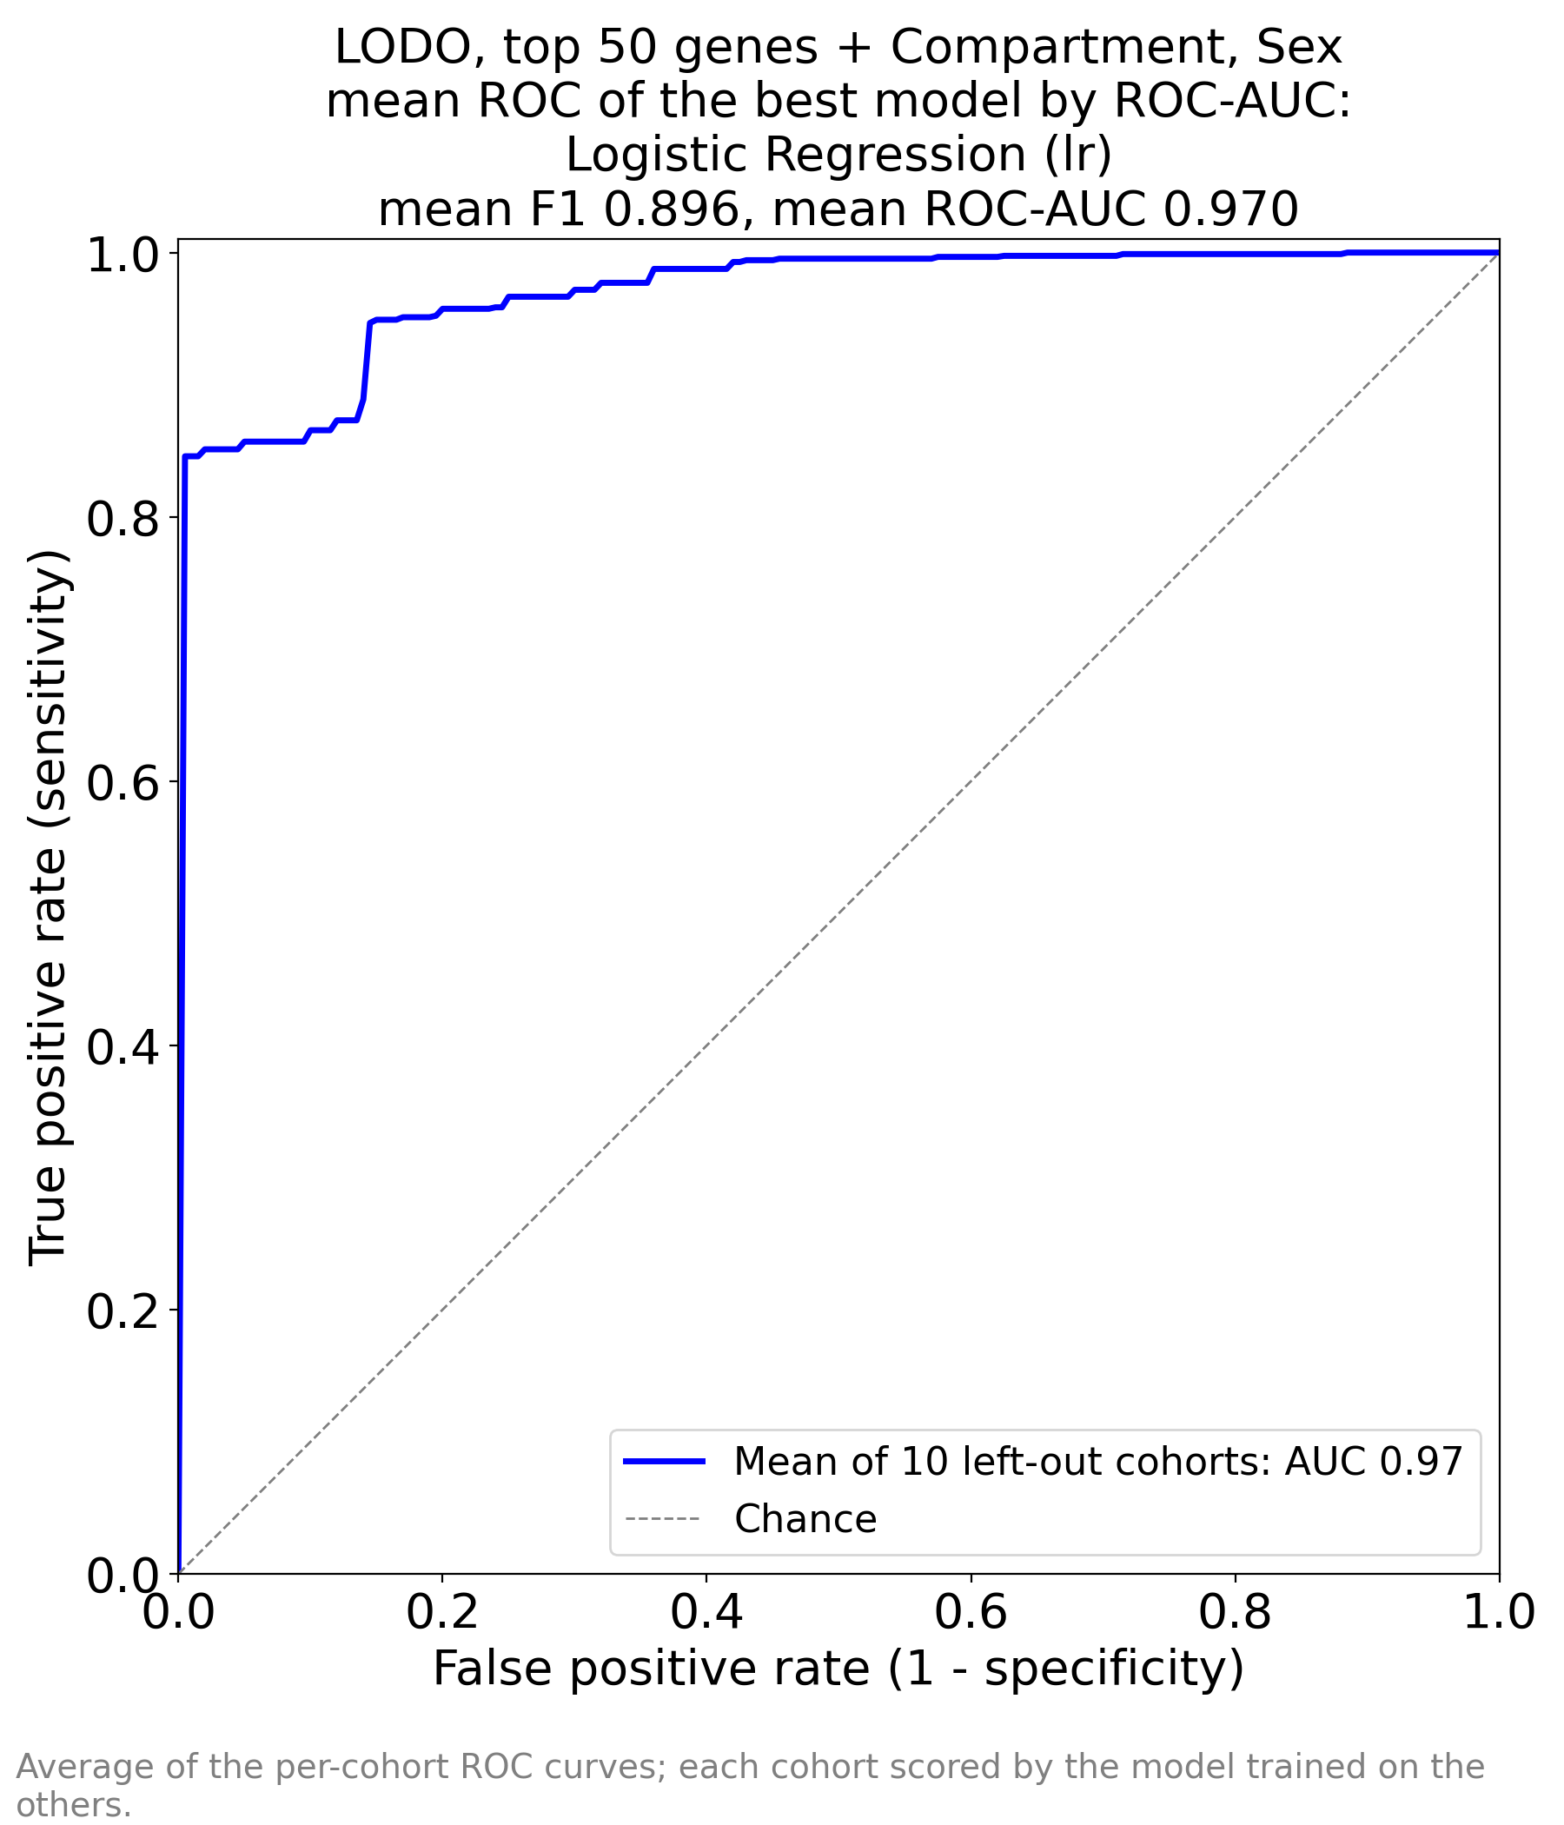
Figure 2 (delivered). ML_TOP_50_by_AUC_AUC_by_AUC.png. Top-50 run, logistic regression. Mean F1 0.896, mean AUC 0.970. The curve dominates Figure 1 in the low-false-positive region. The sessionInfo file records that feature selection saw the left-out cohorts, so part of this gain is optimism.
Figure 2 is visibly better than Figure 1 in the region that matters for screening (false-positive rate below 0.2), reaching a true-positive rate of 0.84 at a false-positive rate of 0.01. The improvement is real in the sense that it is reproduced in the per-cohort table, and optimistic in the sense that the 50 genes were chosen after seeing every cohort. A clean version of this experiment would re-select the 50 genes inside each fold.
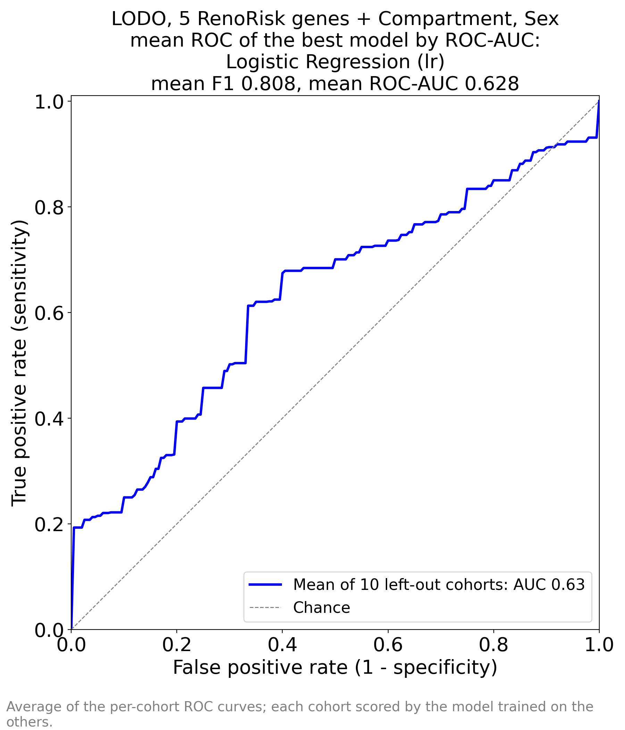
Figure 3 (delivered). ML_RR_AUC_by_AUC.png. Five-gene RenoRisk panel, logistic regression. Mean F1 0.808, mean AUC 0.628. The curve is close to the diagonal and crosses it repeatedly; the apparent high recall of the performance table comes from threshold placement, not from ranking ability.
Figure 3 is the negative result of the folder. The curve hugs the diagonal, and in the low-false-positive region it is essentially flat: at a false-positive rate of 0.05 the true-positive rate is 0.20, so a positive call at a stringent threshold is four times more likely to be a control than a case. The sharp jump at the far right (false-positive rate ≈ 0.99) is the artefact of that one cohort in which the model ranks almost everything as disease. Anyone reading only the F1 of 0.808 and the recall of 0.973 would badly overestimate this panel.

4.5 Per-cohort performance (independent re-analysis)
The delivered workbooks report only fold averages. For a clinical reading, the per-cohort pattern matters more than the average, so the three logistic-regression pipelines were re-run exactly as specified in the notebooks and the per-cohort metrics recovered. The re-analysis reproduces the delivered fold averages to within 0.005 AUC in all three runs (0.954 vs 0.953; 0.970 vs 0.970; 0.628 vs 0.628), which validates the reconstruction.
Table 5. Per-cohort out-of-fold AUC of the logistic regression in each run (re-analysis). The panel column is the important one: no cohort exceeds 0.80 and three are at or below 0.50.
Cohort | n | % disease | AUC genome-wide | AUC top 50 | AUC panel
ERCB | 131 | 68 | 0.96 | 0.97 | 0.61
GSE108109 | 111 | 95 | 1.00 | 1.00 | 0.70
GSE116626 | 81 | 91 | 0.83 | 0.90 | 0.80
GSE121233 | 10 | 50 | 1.00 | 1.00 | 0.80
GSE129973 | 40 | 50 | 1.00 | 1.00 | 0.61
GSE200828 | 153 | 96 | 1.00 | 1.00 | 0.73
GSE30122 | 69 | 28 | 0.86 | 0.86 | 0.51
GSE66494 | 61 | 87 | 0.93 | 1.00 | 0.49
GSE96804 | 61 | 67 | 1.00 | 0.99 | 0.57
GSE99339 | 133 | 94 | 0.96 | 0.97 | 0.45
Three patterns emerge that the averages hide.
1. The genome-wide model is uniformly good except in the per-gene-centred cohorts. GSE116626 (0.83) and GSE30122 (0.86) are the two lowest, and they are the two cohorts whose values were centred per gene before submission. Their absolute expression is unrecoverable, so a model trained on log2 absolute values transfers with a shifted decision boundary.
2. Accuracy and AUC diverge exactly where prevalence diverges. In GSE116626 the top-50 model has AUC 0.896 but accuracy 0.593 and recall 0.568: the ranking is good, the 0.5 probability threshold is wrong. In GSE30122, with 28% prevalence, AUC is 0.862 while accuracy falls to 0.420 and precision to 0.322 — the model calls nearly everything disease.
3. The panel run is at chance in half the cohorts. GSE99339 0.45, GSE66494 0.49, GSE30122 0.51, GSE96804 0.57, GSE129973 0.61. Its apparent successes (GSE121233 0.80) rest on ten samples.
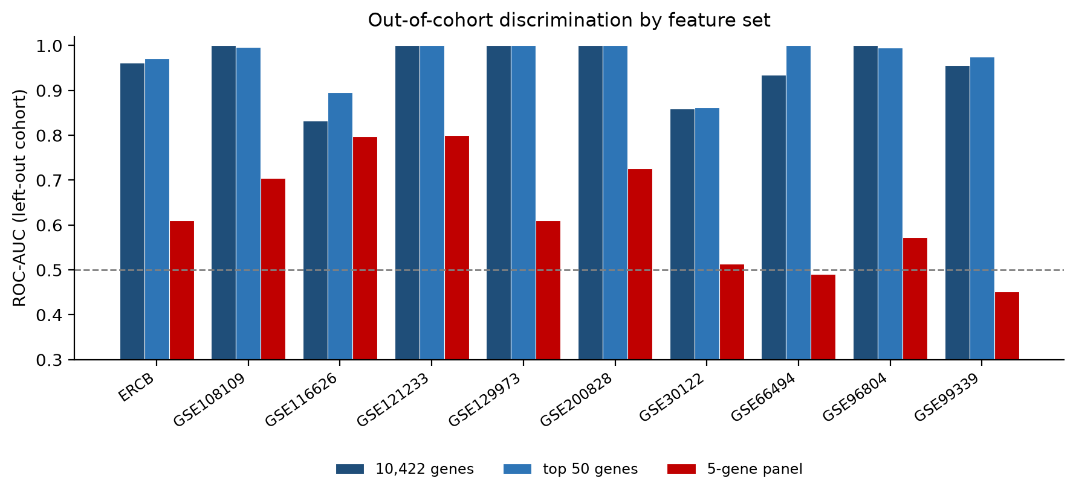
Figure 4 (report analysis). Out-of-cohort AUC by cohort for the three feature sets. The panel bars (red) sit on the chance line in most cohorts; the genome-wide and top-50 bars are close to the ceiling. GSE121233 (n = 10) is too small to interpret.

4.6 Why accuracy and F1 mislead here
Three separate mechanisms inflate or deflate the threshold metrics, and all three are active in this folder.
- Prevalence. With 80% disease, a constant “disease” prediction scores 0.726 accuracy and 0.818 F1. Any model must beat that to be useful, and the panel run does not.
- Score scale. The features are on three incompatible value scales and were not standardised. A linear model's score therefore shifts by a constant when the cohort's value scale changes, while the ranking inside the cohort does not. AUC is unaffected; accuracy collapses. Figure 5 shows the effect directly: median predicted probability is 0.11 in GSE116626 and 0.99 in GSE200828 for the same model.
- Threshold transfer. The 0.5 cut-off is inherited from training prevalence and is never recalibrated per cohort. Every fold therefore applies a threshold fitted on 80% prevalence to a cohort that may have 28%.
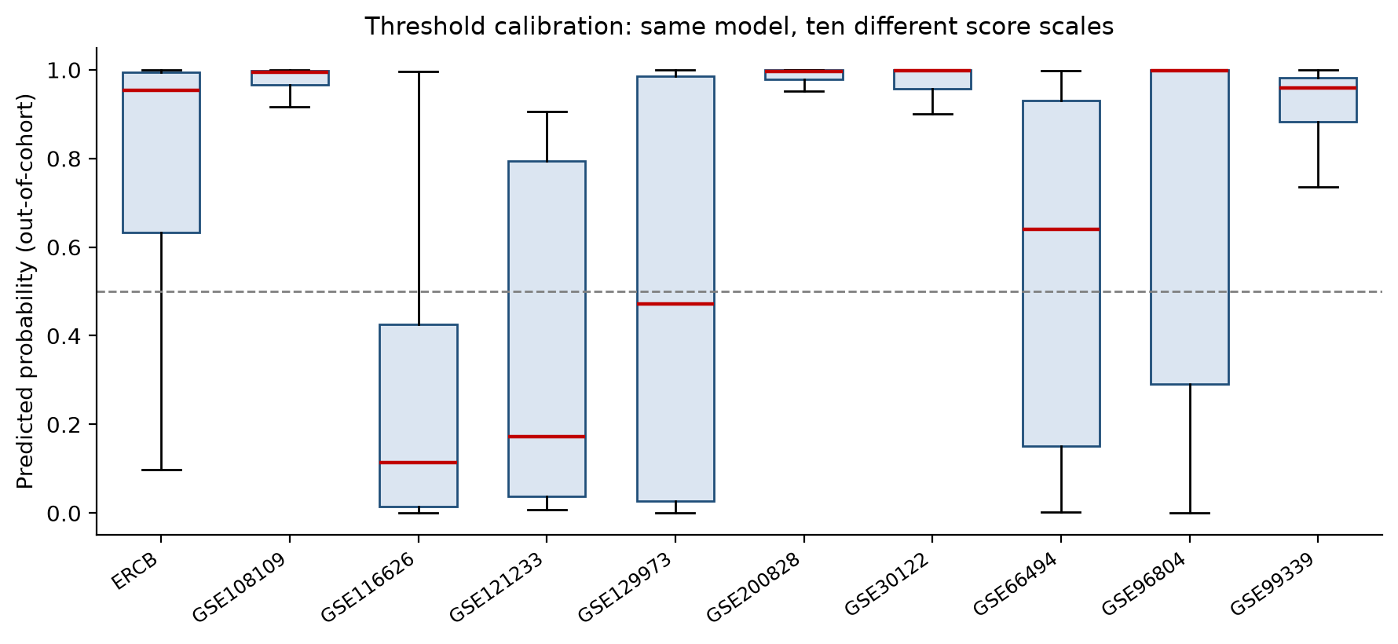
Figure 5 (report analysis). Distribution of out-of-cohort predicted probability for the 18-gene signature, by cohort. The same model, applied to ten cohorts, produces ten different score scales: the boundary at 0.5 is meaningful in three cohorts and meaningless in the rest.
Consequence for reporting. Only the AUC column of the three perfs workbooks should be compared across runs. The F1, precision, recall and accuracy columns are internally consistent but not comparable, and none of them is a decision-analytic quantity without calibration.

4.7 Model-family behaviour
The ordering of the 17 classifiers is stable across the three runs, which is reassuring. Linear and near-linear models lead; boosted trees follow at 0.85–0.87; k-nearest neighbours, decision trees, QDA and Naive Bayes trail. The gaps widen as the feature count grows, which again points to collinearity and scale rather than to any advantage of non-linearity. Nothing in the data suggests a non-linear decision boundary is needed: a single gene (DUSP1) already separates the classes with a median AUC of 0.958 (Section 6.5).

5. How to read the feature-importance files
These workbooks are the part of the folder most likely to be over-interpreted, so it is worth being precise about what the numbers are.

5.1 Definition
For the best model of each run — logistic regression in all three — Importance is the absolute fitted coefficient of a model refitted on all 850 samples, and Coefficient is the same number with its sign. The model is the same pipeline used for validation: mean imputation, one-hot encoding of Compartment and Sex, no scaling, no feature selection at fit time, L2 penalty with the default C = 1.0. A positive coefficient means the gene pushes the prediction towards Disease.
What the ranking is, in one sentence
It is the partition of credit inside one particular fitted linear model on one particular pooled dataset — not a measure of how strongly a gene is associated with disease, and not a measure that would be reproduced by a different model or a different cohort set.

5.2 Five properties that limit interpretation
1. No scaling. Expression values enter the model as deposited, on three incompatible scales (log2 absolute, per-gene centred, and one Agilent cohort log-transformed from linear). A coefficient is log-odds per unit of that scale. Comparing 0.20 for a log2-absolute gene with 0.20 for a per-gene-centred gene compares incommensurable quantities.
2. Collinearity. With 10,422 genes and 850 samples, every gene is predictable from the others to high accuracy. A linear model with L2 penalty distributes weight arbitrarily inside a co-expressed block. The consequence is visible and severe: COL4A1 has a mean single-gene AUC of 0.87 across the ten cohorts and a coefficient of 0.0006 — 10,060th of 10,422. Nothing is wrong with the model, but “importance” here means “unique contribution given all other genes”, which for a co-regulated gene is close to zero.
3. Sign instability. Refitting the same 50 genes alone changes the sign of 14 coefficients, and the Spearman correlation between the two importance orderings is −0.09. The full model's signs agree with the observed within-cohort direction for 46 of 50 genes; the top-50 model's signs agree for only 34 of 50. Compressing to 50 genes makes the model fit the pooled data better while making its coefficients less biologically truthful.
4. In-sample fitting. The ranking is produced on the same samples used for validation. It is a description of the final model, not a validated feature ranking; the folder's own note says the top-50 run is optimistic for this reason.
5. Metadata rows. Compartment and Sex enter as one-hot columns and appear as repeated Source labels. In the genome-wide model the metadata is negligible (Compartment 0.13 and Sex 0.08 of 141.4 total absolute coefficient mass, together 0.15%). In the panel model Compartment is 58% of the model. The same feature is irrelevant or dominant depending on how many genes are available — a clear sign that it is acting as a proxy for case mix, not as biology.

5.3 How the weight is distributed
The 50 selected genes carry 20.5% of the total absolute coefficient mass in the genome-wide model, while representing 0.5% of the features. The remaining 80% is spread thinly over 10,372 genes. That is the quantitative statement behind the top-50 run's success: the ranking does concentrate information, but it is not that the other genes are irrelevant — it is that their contribution is redundant.

6. The top-50 features
This section reads the list itself: what the genes are, whether the ordering is stable, and what the model left out.

6.1 The list
Table 6 reproduces the delivered ranking. Columns: rank and importance from ML_TOP_50_by_AUC_FEAT_IMP_by_AUC.xlsx; the signed coefficient of that model; the median within-cohort Cohen's d across the ten cohorts (report analysis); the number of cohorts in which the gene moves in the same direction; and a flag where the model's sign contradicts the observed effect.
Read the last two columns before the rank. A gene that ranks 30th but moves in the same direction in 10 of 10 cohorts with |d| = 1.5 is a better biomarker candidate than a gene that ranks 3rd with a sign that contradicts its own data.
Table 6. The 50 genes of the top-50 model, in delivered rank order.
# | Gene | Importance | Coef. | Median d | Consist. | AUC | Flag
1 | FN1 | 2.012 | +2.01 | +1.02 | 9/10 | 0.80
2 | DHRS2 | 1.725 | −1.73 | −0.35 | 8/10 | 0.64
3 | PPP1R3C | 1.613 | +1.61 | +1.03 | 10/10 | 0.78
4 | DUSP1 | 1.523 | −1.52 | −1.95 | 10/10 | 0.92
5 | ZFP36 | 1.128 | +1.13 | −1.38 | 10/10 | 0.84 | sign conflict
6 | SYNPO | 1.010 | +1.01 | +0.13 | 5/10 | 0.54
7 | NFIL3 | 0.980 | −0.98 | −1.91 | 9/10 | 0.82
8 | COL4A3 | 0.950 | −0.95 | −0.08 | 6/10 | 0.54
9 | MNDA | 0.907 | −0.91 | +0.29 | 5/10 | 0.52 | sign conflict
10 | F3 | 0.808 | +0.81 | −0.33 | 7/10 | 0.57 | sign conflict
11 | LYZ | 0.807 | +0.81 | +1.04 | 9/10 | 0.75
12 | APOD | 0.787 | −0.79 | −0.47 | 10/10 | 0.68
13 | RGS2 | 0.781 | −0.78 | −0.72 | 10/10 | 0.72
14 | JUNB | 0.739 | −0.74 | −0.93 | 10/10 | 0.76
15 | EGR1 | 0.727 | −0.73 | −1.29 | 10/10 | 0.77
16 | ESM1 | 0.711 | −0.71 | −1.10 | 8/10 | 0.74
17 | ZNF331 | 0.671 | +0.67 | −1.09 | 10/10 | 0.73 | sign conflict
18 | XYLT1 | 0.661 | −0.66 | −0.17 | 9/10 | 0.62
19 | ANXA1 | 0.611 | +0.61 | +1.09 | 10/10 | 0.78
20 | ALB | 0.596 | −0.60 | −1.64 | 10/10 | 0.85
21 | PTGS2 | 0.586 | −0.59 | −0.12 | 5/10 | 0.65
22 | S100A8 | 0.558 | +0.56 | −0.56 | 8/10 | 0.67 | sign conflict
23 | GSTA1 | 0.545 | +0.54 | −1.21 | 9/10 | 0.79 | sign conflict
24 | S100A12 | 0.544 | −0.54 | −0.81 | 8/10 | 0.70
25 | JUN | 0.544 | +0.54 | −1.46 | 10/10 | 0.79 | sign conflict
26 | FPR1 | 0.459 | +0.46 | −0.00 | 5/10 | 0.61 | sign conflict
27 | NR4A1 | 0.447 | +0.45 | −0.55 | 7/10 | 0.69 | sign conflict
28 | MAFB | 0.438 | +0.44 | +0.28 | 9/10 | 0.68
29 | CALB1 | 0.431 | −0.43 | −0.83 | 10/10 | 0.72
30 | HLA-DRB1 | 0.429 | +0.43 | +0.75 | 8/10 | 0.62
31 | IGF1 | 0.411 | −0.41 | −0.51 | 9/10 | 0.66
32 | PDK4 | 0.388 | −0.39 | −1.96 | 9/10 | 0.81
33 | NR4A2 | 0.357 | −0.36 | −1.20 | 10/10 | 0.80
34 | LUM | 0.328 | +0.33 | +0.79 | 8/10 | 0.69
35 | RAB20 | 0.314 | +0.31 | −0.16 | 7/10 | 0.62 | sign conflict
36 | CYP26B1 | 0.309 | −0.31 | −0.23 | 6/10 | 0.54
37 | RPS4Y1 | 0.298 | −0.30 | +0.10 | 5/10 | 0.53 | sign conflict
38 | CCN1 | 0.287 | +0.29 | −0.62 | 9/10 | 0.69 | sign conflict
39 | GDF15 | 0.252 | +0.25 | −0.49 | 8/10 | 0.63 | sign conflict
40 | ATF3 | 0.234 | −0.23 | −1.13 | 10/10 | 0.78
41 | PCK1 | 0.213 | −0.21 | −1.44 | 9/10 | 0.80
42 | FOS | 0.195 | −0.19 | −1.59 | 10/10 | 0.85
43 | CHI3L1 | 0.141 | −0.14 | −0.80 | 10/10 | 0.71
44 | HBEGF | 0.112 | +0.11 | +0.15 | 6/10 | 0.51
45 | SPINK1 | 0.110 | +0.11 | −0.48 | 9/10 | 0.67 | sign conflict
46 | G6PC1 | 0.104 | −0.10 | −1.49 | 10/10 | 0.85
47 | MAFF | 0.093 | −0.09 | −0.16 | 7/10 | 0.55
48 | FOSB | 0.035 | −0.04 | −1.24 | 10/10 | 0.80
49 | APOH | 0.017 | +0.02 | −1.23 | 9/10 | 0.77 | sign conflict
50 | CR2 | 0.005 | +0.01 | −1.00 | 10/10 | 0.74 | sign conflict
Pathology and cell-biological reading of the list, before any statistics:
- Immediate-early and stress-response regulators (16 genes): FOS, FOSB, JUN, JUNB, EGR1, ATF3, DUSP1, ZFP36, NR4A1, NR4A2, RGS2, MAFF, NFIL3, MAFB, ZNF331, CCN1. Almost all are lower in disease.
- Proximal-tubule metabolic and reabsorptive genes (5): ALB, PCK1, G6PC1, PDK4, IGF1. All lower in disease.
- Extracellular matrix and mesenchymal repair (8): FN1, LUM, COL4A3, XYLT1, SYNPO, HBEGF, ANXA1, PPP1R3C. Mostly higher in disease.
- Myeloid / innate immune (7): LYZ, MNDA, FPR1, S100A8, S100A12, PTGS2, HLA-DRB1. Directions mixed.
- Secreted injury and vascular markers (8): GDF15, SPINK1, ESM1, CHI3L1, F3, APOD, APOH, DHRS2. Mostly lower in disease.
- Structural / other (6): CALB1, CR2, GSTA1, CYP26B1, RAB20, RPS4Y1.

6.2 Functional modules
Correlating the 50 genes across samples after removing cohort means, and clustering, gives four coherent blocks plus two singletons. The module structure matters because it explains the sign instability: genes in the same block are interchangeable to the model.
Table 7. Modules recovered by average-linkage clustering of the 50 genes on cohort-centred expression.
Module | Genes | Behaviour in disease
Tubular metabolism and differentiation | ALB, APOH, CALB1, CR2, G6PC1, GSTA1, PCK1, SPINK1 | uniformly down; |d| 0.7–1.6
Immediate-early / stress / innate immune | ATF3, CCN1, DUSP1, EGR1, FOS, FOSB, FPR1, GDF15, HLA-DRB1, JUN, JUNB, LYZ, MAFF, MNDA, NFIL3, NR4A1, NR4A2, PTGS2, RAB20, RGS2, S100A12, S100A8, ZFP36, ZNF331 | IEGs uniformly down; myeloid genes mixed
ECM, vascular and repair | APOD, CHI3L1, COL4A3, CYP26B1, ESM1, F3, IGF1, MAFB, PDK4, SYNPO, XYLT1 | heterogeneous; mostly small effects
Mesenchymal / repair co-expression block | ANXA1, DHRS2, FN1, HBEGF, PPP1R3C | mostly up
Singletons | LUM (fibroblast), RPS4Y1 (Y chromosome) | LUM up; RPS4Y1 is a sex marker
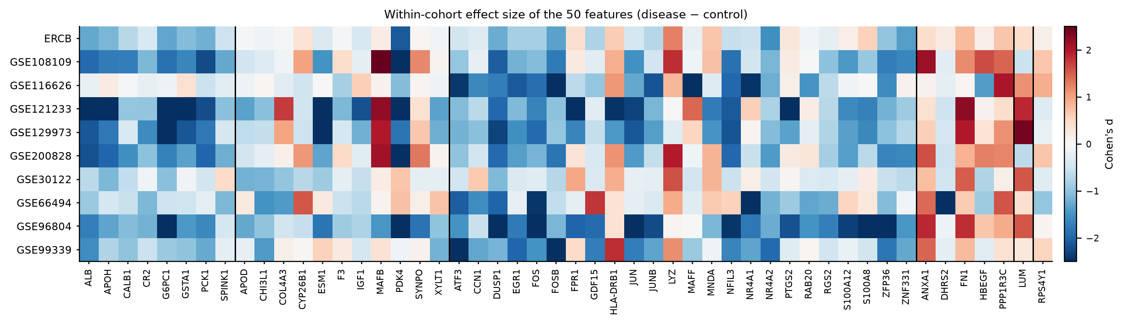
Figure 6 (report analysis). Within-cohort Cohen's d for each of the 50 genes in each of the ten cohorts, ordered by module. The immediate-early block (middle) is the most consistent: DUSP1, FOS, FOSB, JUN, JUNB, EGR1, ZFP36, ATF3 are blue in every column. The ECM block is the least consistent, which is why its genes exchange weight freely.

6.3 Is the ordering stable?
No. Four checks:
1. Sign flips. 14 of 50 coefficients change sign when the same 50 genes are refitted without the other 10,372.
2. Rank correlation. Spearman ρ between the genome-wide importance ordering and the top-50 ordering, restricted to these 50 genes, is −0.09. The two lists are unrelated.
3. Direction agreement. Only 34 of the 50 top-50 model coefficients agree in sign with the gene's own median within-cohort effect; the genome-wide model agrees for 46 of 50.
4. Module exchange. Within the immediate-early block, FOS ranks 1st in the genome-wide model and 46th in the top-50 model; DUSP1 ranks 4th and 4th; ZFP36 10th and 6th. The block is stable as a block, not as a ranking of its members.
The practical rule: use the top 50 as a set, not as a list. Any statement of the form “the third most important gene for kidney damage is X” is not supported by these files.

6.4 What the model ignored, and why it matters
The most striking feature of the folder is a mismatch between the top-50 list and the marginal biology. A single-gene scan of all 10,422 genes (per-cohort rank AUC, averaged over the ten cohorts) puts a different set of genes at the top: COL4A1 (0.87), YWHAH (0.86), PLK2 (0.85), COL4A2 (0.84), KPNA2 (0.83), LAMC1 (0.83), VIM (0.82), TGFBI (0.81), MYOF (0.83), MSN (0.83). These are the genes a nephrologist would expect: basement-membrane collagens, vimentin, TGFBI, laminin — the fibrosis and dedifferentiation programme. Almost none appear in the top-50 list.
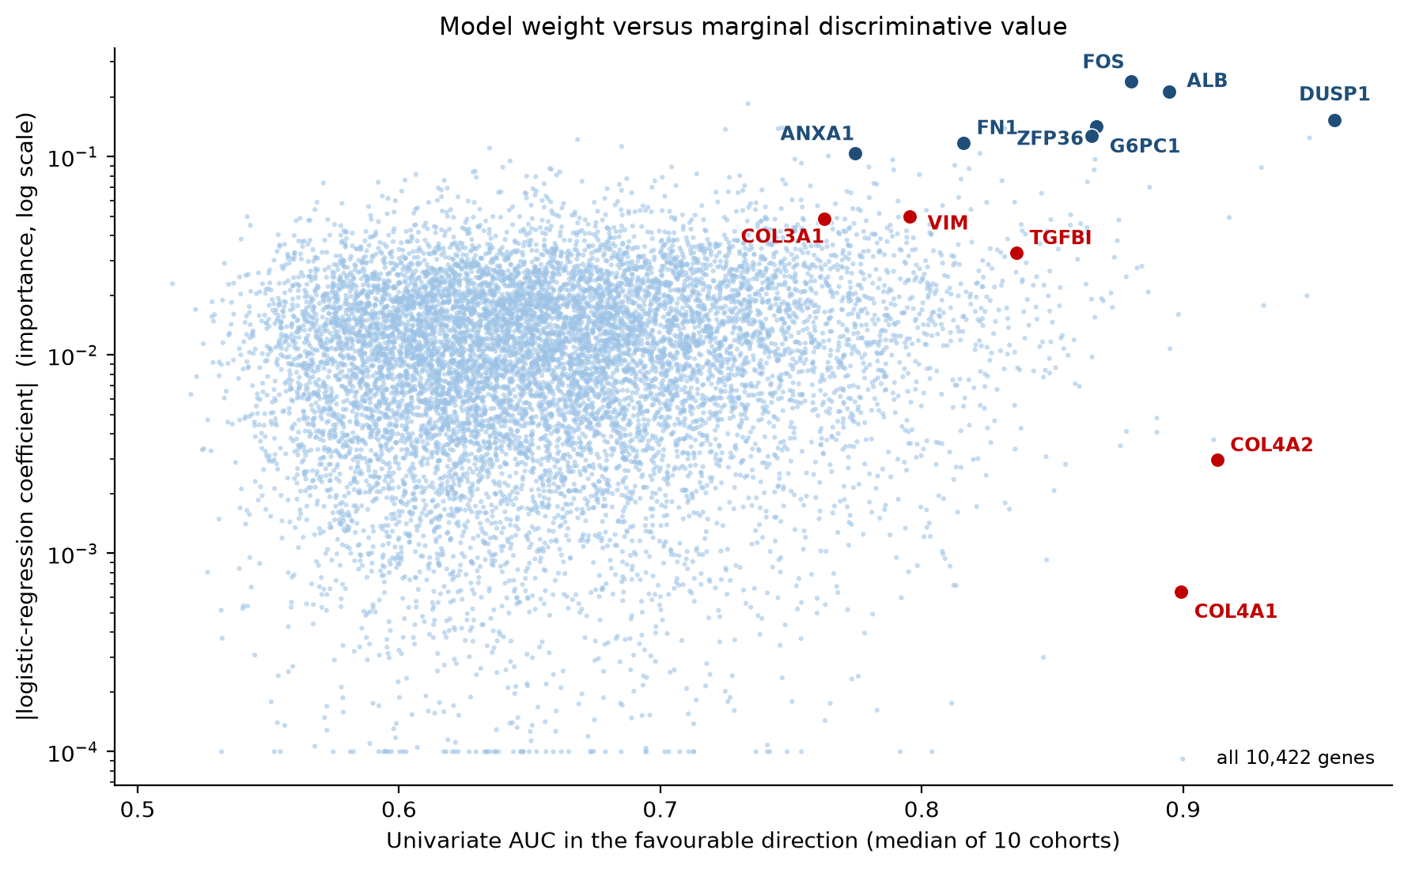
Figure 7 (report analysis). Model weight against marginal value for all 10,422 genes. The x-axis is the median single-gene AUC across cohorts (in the favourable direction); the y-axis is |coefficient| in the genome-wide model, on a log scale. Blue points are genes that rank high on both; red points are genes with large, reproducible effects and near-zero weight — COL4A1, COL4A2, VIM, COL3A1, TGFBI.
The explanation is collinearity, not biology. Once the immediate-early block and the tubular block are in the model, the collagen genes add almost nothing to the fit — their information is already present. Their coefficients collapse to ~10⁻³.
The consequence for the reader of the workbook
The top-50 list answers “which genes does this model lean on”, not “which genes matter for kidney damage”. The two questions give different answers, and only the second is clinically interesting. A gene such as COL4A1 can have the strongest and most reproducible disease association in the dataset and be absent from the list.

6.5 What the 50 genes add up to
Two reference points calibrate the list.
- Random 50 genes drawn from the transcriptome and passed through the same LODO logistic regression give a mean AUC of 0.815 (five draws, range 0.78–0.89). A random 50-gene panel is therefore already a strong classifier of this task — because 81% of all genes have a median single-gene AUC above 0.60, and 25% above 0.70. The transcriptome as a whole differs between diseased and control kidney.
- The 18 direction-consistent genes of Table 6 (present in all ten cohorts with the same sign) reach AUC 0.973 with logistic regression — equal to the 50-gene model and better than the genome-wide one. A compact, biologically coherent signature captures everything.
Table 8. The 18 genes whose direction of change is identical in all ten cohorts. Selection used all cohorts, so the 0.973 AUC is optimistic in the same way as the top-50 run; the point is the compactness, not the exact figure.
Gene | Direction | Median d | Mean AUC | Worst cohort
ALB | down in disease | -1.64 | 0.85 | 0.67
ANXA1 | up in disease | +1.09 | 0.78 | 0.54
ATF3 | down in disease | -1.13 | 0.78 | 0.62
CALB1 | down in disease | -0.83 | 0.72 | 0.54
CR2 | down in disease | -1.00 | 0.74 | 0.52
DUSP1 | down in disease | -1.95 | 0.92 | 0.77
EGR1 | down in disease | -1.29 | 0.77 | 0.62
FN1 | up in disease | +1.02 | 0.80 | 0.45
FOS | down in disease | -1.59 | 0.85 | 0.57
FOSB | down in disease | -1.24 | 0.80 | 0.65
G6PC1 | down in disease | -1.49 | 0.85 | 0.62
JUN | down in disease | -1.46 | 0.79 | 0.53
JUNB | down in disease | -0.93 | 0.76 | 0.55
NR4A2 | down in disease | -1.20 | 0.80 | 0.60
PCK1 | down in disease | -1.44 | 0.80 | 0.42
PPP1R3C | up in disease | +1.03 | 0.78 | 0.58
RGS2 | down in disease | -0.72 | 0.72 | 0.56
ZFP36 | down in disease | -1.38 | 0.84 | 0.66
The practical reading is uncomfortable for a naive feature-selection story. The model's discriminative power comes from a global transcriptional shift affecting most of the transcriptome, of which the top 50 are a convenient summary. Selecting genes by model weight recovers that shift; it does not identify a specific injury pathway.

6.6 The five RenoRisk panel genes in the same frame
The panel genes can be put through the same tests as the top-50 genes. Table 9 gives the model coefficient from the panel run, the observed median effect, the mean single-gene AUC with the direction fixed across cohorts, the worst cohort, and the number of cohorts in which the gene moves consistently.
Table 9. The five panel genes. The AUC column fixes one direction per gene across all cohorts, so a low worst-cohort value means the gene reverses in at least one cohort.
Gene | Coef. (panel) | Median d | Mean AUC | Worst | Consist.
C4BPA | −0.45 | −0.03 | 0.51 | 0.29 | 6/10
CFH | +0.34 | +0.53 | 0.57 | 0.24 | 7/10
CFI | −0.37 | +0.32 | 0.53 | 0.08 | 7/10
COL13A1 | +0.15 | +0.61 | 0.65 | 0.51 | 10/10
HABP2 | +0.60 | +0.15 | 0.55 | 0.19 | 6/10
Three of the five (C4BPA, HABP2, and arguably CFI) reverse direction in four or more cohorts. CFI is the clearest case: the panel model gives it a negative coefficient, but its median effect is positive (higher in disease), and its cohort AUCs run from 0.08 to 0.92. That range is not a biological signal with noise; it is a gene whose association with disease depends on which cohort is examined.
COL13A1 is the exception: same direction in 10 of 10 cohorts, median d +0.61, mean AUC 0.65, never below 0.51. It is the only panel gene that behaves like a biomarker in this dataset, and it is also the least studied of the five.
Because the panel is used clinically as a set, the relevant question is not the individual genes but whether the set adds up. It does not: the LODO AUC of the set is 0.628, and removing Compartment and Sex leaves 0.624. The panel is at chance as a classifier of this task, and its component genes are individually at chance in most cohorts.

7. Medical interpretation
This section reads the results as a nephrologist would. The question is not “does the model work” — within its own task it does — but “what has the model learned about kidney disease, and would a clinician act on it”.

7.1 The comparator problem
This is the finding that governs everything else, so it comes first. The controls are not “other patients”. They are living donors (GSE108109, GSE200828, GSE116626) and macroscopically normal cortex from tumour nephrectomies (ERCB, GSE30122, GSE66494, GSE96804, GSE129973, GSE99339). Both are unusual tissue.
- Living-donor kidney is the healthiest kidney obtainable: normal eGFR, no proteinuria, minimal fibrosis, short warm-ischaemia time, immediate processing.
- Tumour-nephrectomy cortex is normal-looking but not normal: it is adjacent to a tumour, often from an older patient with hypertension, and it has had a long devascularisation time before freezing.
A classifier trained on this contrast learns the difference between a healthy kidney and anything else. That difference is large, biologically real, and clinically almost useless, because no patient ever presents with the question “is this a healthy donor kidney or a diseased one”. The clinical questions are: which disease, how active, how much fibrosis, will it progress, will it respond to immunosuppression. None of those is the target here.
Two consequences follow. First, the AUC of 0.95 should not be quoted as a diagnostic performance. Second, the top features are likely to include genes that track tissue handling and parenchymal preservation as much as disease biology — which is exactly what the immediate-early block looks like (Section 7.3).

7.2 Axis 1 — loss of proximal-tubule identity
The most consistent and most easily explained component of the signature is the coordinated fall of ALB, PCK1, G6PC1, PDK4 and IGF1.
- ALB is not made in meaningful amounts by the adult kidney; its presence in kidney transcriptome reflects reabsorbed albumin and the proximal tubule's handling of filtered protein. Lower ALB transcript accompanies loss of the apical endocytic apparatus (megalin/cubilin) that defines a differentiated proximal tubule.
- PCK1 (PEPCK) and G6PC1 (glucose-6-phosphatase) are the two committed steps of renal gluconeogenesis, a proximal-tubule-specific function that accounts for a substantial share of systemic glucose production in the fasting state. Their coordinated loss is one of the most reproducible findings in chronic kidney disease transcriptomics and is a marker of proximal tubular dedifferentiation.
- PDK4 inhibits pyruvate dehydrogenase and shifts metabolism away from glucose oxidation. It falls here, in parallel with the gluconeogenic genes, consistent with a coordinated collapse of the tubular metabolic programme rather than an isolated enzyme change.
Clinically this is the transcriptomic counterpart of what a pathologist sees as tubular atrophy and simplification: fewer proximal tubules, each less differentiated. It is the single most robust biological statement in the folder, because it survives every cohort, every platform and every direction test. It is also entirely non-specific: every progressive kidney disease produces it.

7.3 Axis 2 — the immediate-early / stress-response block
Sixteen of the top 50 genes are immediate-early genes or their immediate regulators: FOS, FOSB, JUN, JUNB, EGR1, ATF3, DUSP1, ZFP36, NR4A1, NR4A2, RGS2, MAFF, NFIL3, MAFB, ZNF331, CCN1. Nearly all are lower in disease, with the largest and most consistent effects in the whole list (DUSP1 median d = −1.95 in ten of ten cohorts; FOS −1.59; JUN −1.46).
This is where clinical judgement must be applied carefully, because the same block can be read in two ways.
Biological reading. Immediate-early genes are the first transcriptional response of tubular epithelium to any stress — ischaemia, oxidant injury, stretch, proteinuria, complement attack. In chronically diseased tissue their baseline expression is low because the surviving tubular mass is reduced and because chronically stressed cells desensitise these pathways. A low IEG set point is a plausible marker of exhausted, dedifferentiated epithelium. It also fits the proximal-tubule story: these genes are highly expressed in healthy proximal tubules.
Technical reading. Immediate-early genes are the classic tissue-handling artefact. FOS, JUN and EGR1 rise within minutes of devascularisation and fall again with prolonged warm ischaemia; their level in a frozen biopsy depends on how long the tissue spent warm before freezing. Living-donor kidneys and tumour nephrectomies differ systematically in that time. A model that learns “low FOS/EGR1/JUN = disease” may be partly learning “this sample was handled like a biopsy, not like a donor nephrectomy”.
The data do not allow the two readings to be separated, and this report does not claim they can be. What can be said is that the effect survives in the three cohorts with living-donor controls (GSE108109, GSE200828, GSE116626: DUSP1 d = −2.06, −1.94, −1.74), which weakens but does not eliminate the artefact explanation. Any future study that wants to use these genes must control warm-ischaemia time or use a biopsy-versus-biopsy comparison.

7.4 Axis 3 — extracellular matrix and mesenchymal repair
The genes that rise are the expected ones for chronic injury: FN1 (fibronectin, median d +1.02 in 9/10 cohorts), LUM (lumican, +0.79), ANXA1 (+1.09), HBEGF, CCN1/CYR61, PPP1R3C, COL4A3 (mixed). Fibronectin and lumican are canonical interstitial fibrosis markers; ANXA1 is an anti-inflammatory, pro-resolving mediator that rises in injured epithelium; CCN1 is a matricellular repair factor.
Here the top-50 list under-represents the biology. The strongest fibrosis genes in the dataset — COL4A1 (mean AUC 0.87), COL4A2 (0.84), VIM (0.82), COL3A1, TGFBI, LAMC1 — are absent or near the bottom of the importance list, purely because they are redundant with FN1 and LUM inside the model. A pathologist reading this list would conclude, correctly, that fibrosis is present; a data scientist reading the importance column would conclude, incorrectly, that it is a minor component.
The medical point is worth stating plainly: the transcriptome says the diseased kidney is fibrotic and has lost tubules. That is not new. What the model adds is a quantitative, cross-platform index of how far a sample has moved along that axis — and even that is binary in practice (Section 7.8).

7.5 Axis 4 — innate immune and myeloid genes
A cluster of myeloid and innate genes appears — LYZ, MNDA, FPR1, S100A8, S100A12, PTGS2, HLA-DRB1, CHI3L1 — but with inconsistent directions and weak coefficients. LYZ rises (9/10 cohorts, median d +1.04), consistent with macrophage infiltration. S100A8 and S100A12 fall (d −0.56 and −0.81), which is the opposite of what a simple “inflammation is up” model predicts.
This inconsistency has a likely technical explanation: the immune signal depends heavily on compartment and on how the sample was dissected. Glomerular samples (8 of 10 cohorts) contain far fewer interstitial leukocytes than whole cortex, and the tumour-nephrectomy controls may contain more. Pooling these compartments into one label makes the immune direction unstable, which is exactly what the per-cohort heat map shows (Figure 6). No clinical conclusion should be drawn from the immune block in this folder.

7.6 What is missing, and why it matters
Several genes that a nephrologist would expect to dominate are effectively absent from the model:
Table 10. Canonical kidney-injury and kidney-identity genes and where they sit in the genome-wide importance ranking (re-analysis of the delivered model).
Gene | Product / meaning | Rank of 10,422 | Coefficient
HAVCR1 | KIM-1, the reference tubular injury biomarker | not among the top 1,000 | —
LCN2 | NGAL, the reference AKI biomarker | 277 | +0.04
CD68 / CD163 | macrophage markers | 3,531 / 2,176 | +0.02
COL1A1 / COL3A1 | interstitial collagens | 534 / 202 | +0.04 / +0.05
ACTA2 | α-smooth-muscle actin, myofibroblasts | 3,272 | +0.02
NPHS1 / NPHS2 / PODXL | podocyte markers | 737 / 333 / 136 | mixed
UMOD / CUBN / LRP2 | tubular mass markers | 8,829 / 2,444 / 8,896 | ≈0
Two of these deserve comment. KIM-1 (HAVCR1) and NGAL (LCN2) are the two biomarkers that nephrologists actually use for tubular injury, and both are near the bottom of the importance list. That is not evidence against them as biomarkers — both are far better validated in urine than in tissue, and both are strongly regulated post-transcriptionally — but it does mean this model has not rediscovered them, which is a useful sanity check on the claim that the model captures “damage”. UMOD, CUBN and LRP2 are markers of tubular mass; their near-zero weight, despite large univariate effects, is again collinearity with the metabolic block.
The absence of KIM-1 and NGAL also marks the difference between injury and loss of parenchyma. The model has learned the second, and the two are not interchangeable: a kidney can be acutely injured with preserved architecture (high KIM-1, near-normal transcriptome), or chronically scarred with few tubules left (low KIM-1, low everything tubular).

7.7 Sex and compartment as features
Sex carries a small but non-zero weight in every run (0.08 of 141 in the genome-wide model; 0.62 of 6.03 in the panel model). In this dataset male sex is associated with disease at 83% versus 75% in females, but that is almost entirely cohort composition, since several cohorts are heavily male. Including sex is defensible for a risk model and indefensible as a biological finding.
Compartment is the more serious issue. It enters as three one-hot columns; in the panel run it is 58% of the model. Because compartment is aliased with cohort (8 of 10 cohorts are glomerular), a positive coefficient on “whole biopsy” is a statement about which cohorts contribute whole biopsies, not about tissue biology. In the genome-wide model its weight collapses to 0.15% because the genes absorb the same information. A feature that dominates one run and vanishes in another is a proxy, not a predictor.

7.8 Is the score a severity index?
A natural hope is that the model's probability could serve as a continuous “damage score” — higher in worse disease, useful for prognosis. The data say no, and the test is simple: compare scores across diagnoses within the same cohort, where no cohort effect can operate.
Table 11. Out-of-fold score in standard deviations above the cohort's own control median, by diagnosis, within three cohorts that contain several diagnoses. All diagnoses score within 0.2 SD of each other.
Cohort | MCD | FSGS | MN | IgAN | DKD | ANCA | Lupus
GSE200828 | 1.96 (n=19) | 2.00 (n=31) | 2.00 (n=51) | — | — | — | —
GSE99339 | 2.90 (n=8) | 3.06 (n=12) | 3.04 (n=21) | 3.10 (n=26) | 2.89 (n=7) | — | 2.99 (n=30)
GSE108109 | 2.85 (n=16) | 2.96 (n=30) | 2.96 (n=44) | — | — | 2.97 (n=15) | —
Minimal-change disease — a disease with essentially normal tubulointerstitial architecture — scores the same as FSGS, membranous nephropathy, IgA nephropathy and diabetic kidney disease. The model's score therefore measures how far the tissue has left normal, not how severe the patient's disease is. A patient with MCD has severe nephrotic syndrome and a near-normal transcriptome; a patient with advanced DKD has a modest clinical syndrome and a very abnormal transcriptome. The score tracks the second, and clinicians care about both.
This also explains why the score saturates: most diseased samples sit at the ceiling, so there is no dynamic range for grading.

7.9 What the folder supports clinically, and what it does not
Supported by these results
Diseased kidney tissue differs from healthy kidney tissue by a large, reproducible, transcriptome-wide shift, dominated by loss of tubular metabolic identity and gain of matrix/repair programmes. A 50-gene signature captures that shift about as well as the whole transcriptome. The five-gene panel does not capture it at all.

Not supported by these results
Any diagnostic accuracy claim for the panel; any claim that a specific gene is “the most important” for kidney damage; any severity, prognostic or treatment-response claim; any claim about disease-specific mechanisms. The control group is not a clinical comparator, the cohorts are not incident clinical populations, and no clinical variables (eGFR, proteinuria, histology score) are modelled.

8. Statistical critique
The pipeline is well built for what it is: correct grouping, an honest dummy baseline, deterministic seeds, provenance files, and an explicit acknowledgement of its own optimism. The criticisms below are about what the design can and cannot support, not about errors in execution.

8.1 Leakage in the top-50 run
The 50 genes were selected from a model fitted on all ten cohorts and then evaluated leave-one-cohort-out. Every test cohort influenced its own feature set. The folder's sessionInfo file says this plainly, which is good practice, but it does not repair the estimate. The clean design is nested: inside each fold, select features on the nine training cohorts only. That is cheap to implement here (the reference fit takes seconds) and would give a defensible number. Expect the top-50 AUC to fall, perhaps to 0.93–0.95.

8.2 Pooling across value scales hides a sign reversal
The features come on three incompatible scales and were not standardised or harmonised. Within a cohort this does not matter for AUC, because a constant shift cannot change a within-cohort ranking. Across cohorts it matters a great deal, because the pooled fit sees cohort identity in the expression values.
The clearest demonstration is a single-gene model of DUSP1 — the strongest gene in the dataset. Fitted on pooled values, its coefficient is positive (+0.04), implying higher DUSP1 in disease. Fitted after removing cohort means, the coefficient is −1.96, and the gene separates the classes with a mean AUC of 0.92. The pooled single-gene model therefore achieves an AUC of 0.20 (i.e. systematically inverted). This is Simpson's paradox produced by cohort-level offsets.
The 10,422-gene model partially escapes the problem because 10,422 correlated features can cancel the cohort offsets, which is why 46 of its 50 coefficients have the correct sign. But partial escape is not a design. No gene-level conclusion should be drawn from a pooled model on un-harmonised data. Standardising each gene within cohort before fitting removes the artefact: the same top-50 model then gives AUC 0.957, and DUSP1 alone gives 0.921.

8.3 Metrics that cannot be compared
F1, precision, recall and accuracy are averaged over folds and reported as if they were properties of the model. They are properties of the model and the fold's prevalence and scale. With prevalence from 28% to 96% and score scales that differ by an order of magnitude between cohorts, the averages are not interpretable. The dummy row makes this vivid: it scores F1 0.818 and accuracy 0.726 in every run.
Only ROC-AUC survives the comparison. Even AUC needs care: it is a ranking metric and says nothing about whether a probability of 0.6 means 60% risk. No calibration analysis (reliability curve, Brier score, calibration slope) is present anywhere in the folder, and without it a predicted probability cannot be shown to a clinician.

8.4 No uncertainty, no repeated resampling
Ten folds give ten numbers. The fold means are reported to three decimals with no standard error, no confidence interval and no paired comparison across models. The per-cohort spread is large (genome-wide AUC 0.83–1.00; panel 0.45–0.80), so the standard error of the mean is roughly 0.02 and 0.04 respectively. Differences smaller than that between classifiers — most of the table — are not interpretable. A paired bootstrap or DeLong test over cohorts would settle it.

8.5 Unequal weighting of cohorts
Each fold contributes one tenth of the average regardless of size, so GSE121233 (n = 10) counts as much as GSE200828 (n = 153). This is defensible for a cross-cohort generalisation claim and misleading for a population-level performance claim. The delivered perfs files cannot be reweighted because per-cohort metrics were not saved; this report recomputed them (Table 5) for that reason.

8.6 No null calibration
A signature result needs a reference for “how good is good”. Random 50-gene sets reach AUC 0.82 on this task, and 25% of individual genes have a single-cohort AUC above 0.70. Without that baseline, an AUC of 0.95 sounds like a discovery when it is the expected value for almost any 50 genes. The comparison is cheap and should be part of the standard output.

8.7 The importance ranking is described as if it were a feature-selection result
Importance is computed on an in-sample refit of an over-parameterised linear model on unscaled, collinear inputs. It is used to justify a 50-gene signature and to name “top features”. A stability-selection procedure (repeated subsampling, counting how often a gene is selected) would give a ranking that survives refitting, and it would have shown immediately that the ordering inside the FOS/JUN/EGR1 block is arbitrary.

8.8 What is missing from the design altogether
- No disease-versus-disease comparison, which is the clinically relevant task.
- No clinical covariates. eGFR, proteinuria, age, histological fibrosis score and immunosuppression are all absent. A transcriptomic model that does not beat eGFR plus proteinuria has no clinical value, and this cannot be tested here.
- No prospective or external validation beyond the ten GEO cohorts, several of which share platform and processing pipeline.
- No adjustment for tissue-handling time, which is a plausible driver of the dominant feature block.

9. Recommendations

9.1 For the analysis
1. Re-run the top-50 experiment with nested selection. Select features inside each fold. Report the resulting AUC next to the current one; the gap is the cost of selection.
2. Harmonise before fitting, and report both. Per-cohort gene-wise standardisation or rank-based normalisation costs nothing and removes the sign-reversal shown in Section 8.2. Report raw and harmonised side by side.
3. Save per-cohort metrics. They are needed for weighting, for confidence intervals and for every clinical argument. The current workbooks discard them.
4. Add uncertainty. Paired bootstrap over cohorts for AUC differences; DeLong for single comparisons; calibration curves and Brier score for the probabilities.
5. Add a null baseline of random gene sets of the same size, and a permutation label shuffle. Both are one line of code and change the interpretation of 0.95.
6. Replace the single importance fit with stability selection (e.g. 100 subsamples, count selection frequency). Report the genes selected in more than 80% of resamples.

9.2 For the biology and the panel
1. Stop presenting the five-gene panel as a classifier. In these data it is at chance, and no classifier trained on it beats the prevalence rule. Its proper role is as a continuous marker in the existing meta-analysis framework, where effect sizes and heterogeneity are estimated properly.
2. Re-frame the target. Either disease-versus-disease (IgAN vs MN, DKD vs hypertensive nephropathy, which is what a biopsy is for), or a severity/prognosis outcome (eGFR slope, interstitial fibrosis and tubular atrophy score, progression to dialysis). The project notes that no cohort carries eGFR or %TIF; acquiring even two such cohorts would be worth more than another ten binary-classification runs.
3. Test incremental value, not stand-alone accuracy. The clinical question for a biomarker is whether it adds to eGFR, proteinuria and histology. Report NRI/IDI or decision-curve net benefit.
4. Investigate the immediate-early block explicitly. If FOS/EGR1/JUN/DUSP1 are handling artefacts, they will correlate with cold-ischaemia time where that is recorded, and they will disappear in cohorts with protocolised processing. If they survive, they are a genuine marker of epithelial exhaustion and worth a dedicated study.
5. Do not use the top-50 list as a biological shortlist. Use the direction-consistent 18-gene set (Table 8) if a compact signature is needed, and describe it by module rather than by rank.

10. Conclusions
1. The genome-wide model works within its task. A logistic regression on 10,422 genes separates diseased from control kidney tissue with a mean out-of-cohort AUC of 0.953, across ten cohorts, three platforms and prevalences from 28% to 96%. That is a genuine and non-trivial generalisation result.
2. Fifty genes are enough, but not for the advertised reason. The top-50 run does as well as the genome-wide run (0.970), and an 18-gene direction-consistent subset does equally well (0.973). The transcriptome-wide shift is broad enough that many 50-gene sets work: random sets reach 0.82.
3. The importance ranking is a model artefact as much as a biological finding. Fourteen of fifty signs flip on refitting, the rank correlation between the two fits is −0.09, and the genes with the largest and most reproducible disease effects in the dataset (COL4A1, COL4A2, VIM, COL3A1, TGFBI) are absent because of collinearity. Read the list as a set of co-regulated modules, never as a league table.
4. Medically, the model has learned loss of normal parenchyma. The signature is loss of proximal-tubule metabolic identity (ALB, PCK1, G6PC1), collapse of the immediate-early/stress programme (FOS, JUN, EGR1, DUSP1, ZFP36), and gain of matrix/repair genes (FN1, LUM, ANXA1). This is coherent, reproducible, and entirely non-specific: it is what every progressive kidney disease looks like, and it is partly what a biopsy looks like compared with a donor nephrectomy.
5. The five-gene RenoRisk panel does not classify disease in these data. AUC 0.628, no classifier above the prevalence rule, compartment label carrying 58% of the panel model, and three of five genes reversing direction across cohorts. Only COL13A1 behaves consistently, with a modest effect (AUC 0.65). This is a negative result for the panel as a stand-alone diagnostic and does not by itself contradict a role as a continuous, context-dependent marker.
6. Nothing here is ready for clinical use. The comparators are not clinical, the probabilities are uncalibrated, no clinical covariates are modelled, and there is no external prospective validation. What the folder provides is a well-executed benchmark, a map of what “diseased kidney” looks like transcriptionally, and a clear, defensible null result for the five-gene classifier.

One-sentence answer to “does this work?”
Yes for the genome-wide and 50-gene models on an easy, unrealistically clean task; no for the five-gene panel on any task; and no clinical claim can be made from either until the comparator, the calibration and the clinical covariates are fixed.

Appendix A — Complete performance tables
All 17 classifiers, all three runs, mean over ten left-out cohorts. Values as delivered in the three *_perfs.xlsx workbooks. Rows sorted by genome-wide AUC.
Table A1. Complete performance tables. The DummyClassifier row is the prevalence rule and defines the floor for F1 and accuracy.
Classifier | AUC genome-wide | F1 genome-wide | AUC top 50 | F1 top 50 | AUC panel | F1 panel
Logistic Regression | 0.953 | 0.883 | 0.970 | 0.896 | 0.628 | 0.808
SVM - Linear Kernel | 0.953 | 0.880 | 0.969 | 0.853 | 0.530 | 0.646
Ridge Classifier | 0.939 | 0.836 | 0.959 | 0.853 | 0.627 | 0.810
Linear Discriminant Analysis | 0.917 | 0.813 | 0.957 | 0.847 | 0.626 | 0.800
Gradient Boosting Classifier | 0.866 | 0.787 | 0.869 | 0.780 | 0.496 | 0.688
Random Forest Classifier | 0.858 | 0.743 | 0.840 | 0.767 | 0.550 | 0.706
Light Gradient Boosting Machine | 0.857 | 0.802 | 0.861 | 0.824 | 0.550 | 0.710
MLP Classifier | 0.851 | 0.697 | 0.944 | 0.891 | 0.547 | 0.774
Extra Trees Classifier | 0.826 | 0.793 | 0.884 | 0.782 | 0.581 | 0.731
Ada Boost Classifier | 0.817 | 0.828 | 0.857 | 0.799 | 0.486 | 0.752
SVM - Radial Kernel | 0.804 | 0.754 | 0.869 | 0.836 | 0.604 | 0.767
K Neighbors Classifier | 0.738 | 0.695 | 0.796 | 0.838 | 0.595 | 0.719
Decision Tree Classifier | 0.639 | 0.770 | 0.751 | 0.810 | 0.516 | 0.672
Quadratic Discriminant Analysis | 0.598 | 0.752 | 0.757 | 0.774 | 0.470 | 0.654
Naive Bayes | 0.522 | 0.533 | 0.736 | 0.617 | 0.553 | 0.677
Gaussian Process Classifier | 0.500 | 0.168 | 0.747 | 0.845 | 0.586 | 0.722
Dummy Classifier | 0.500 | 0.818 | 0.500 | 0.818 | 0.500 | 0.818

Appendix B — Reproducibility of the re-analysis
Everything labelled “report analysis” in this document was computed from the same two input workbooks used by the original notebooks (Data/ML_input/all2.xlsx and all.xlsx), with the pipeline rebuilt from the notebook source.
- Input rebuilt from Data/ML_input/all2.xlsx (850 × 10,430) and all.xlsx; ERCB merge of GSE104948 and GSE104954 reproduced exactly, giving 10 LODO groups.
- Pipeline: mean imputation, one-hot encoding of Compartment and Sex, LogisticRegression(max_iter=1000, random_state=42), LeaveOneGroupOut. This reproduces the delivered fold means to within 0.005 AUC: genome-wide 0.954 vs 0.953; top-50 0.970 vs 0.970; panel 0.628 vs 0.628; F1 0.888 vs 0.883, 0.895 vs 0.896, 0.808 vs 0.808.
- Version note: the original run used scikit-learn 1.4.2; the re-analysis used 1.9.1. The agreement above shows the difference is immaterial for these models.
- Cohen's d per cohort with pooled within-group SD. Single-gene AUC per cohort by rank formula; “direction fixed” applies the majority direction of a gene across all cohorts to every cohort, so reversals show as AUC below 0.5.
- Random baseline: five independent draws of 50 genes, seed 1, same pipeline; AUC 0.781, 0.785, 0.817, 0.805, 0.885.
- Module clustering: average-linkage on 1 − Pearson correlation of cohort-centred expression of the 50 genes.
- Harmonised sensitivity analysis: each gene standardised within cohort before fitting (transductive, label-free), same folds.

Appendix C — Assumptions and constants
Table C1. Assumptions carried into this report. Where the source files were ambiguous, the notebooks were treated as the specification.
Item | Value used | Comment
Positive class | Disease_Label = 1 | As in the notebooks
Cohorts | 10 LODO groups | ERCB = GSE104948 + GSE104954 merged, as MERGE_ERCB=True
Samples | 850 (678 disease, 172 control) | 80% disease
Features | 10,422 genes + Compartment + Sex | Genes common to all 11 series
Importance | |logistic coefficient|, model refit on all samples | Not permutation importance; inputs unscaled
Threshold | 0.5 on predicted probability | Never recalibrated per cohort
Random seed | 42 | RANDOM_STATE in the notebooks
Random baseline | 5 × 50 random genes, seed 1 | Report-analysis null
Significance tests | One-sample t-test over 10 fold AUCs | Descriptive; fold AUCs are not independent of cohort size

Prepared from the delivered artefacts in Results/ML_training___ and an independent re-analysis of the same inputs. No delivered file was modified.

