RenoRisk Biomarker Validation
Requirements and results for the pooled analysis of C4BPA, COL13A1, HABP2, CFH and CFI across public GEO kidney-biopsy transcriptomics
Scope: plan §3 Stages 1–4, §4 Cohort Stratification & GEO Dataset Inventory, §5 Methodology: Pooling Strategy

Reference protocol: Project Analysis Plan & Technical Master Plan — RenoRisk Validation Across Multiple CKD Indications in Human Kidney Tissue Biopsies Using LODO Machine Learning, Version 2.0 (Final Analysis Plan), July 2026
Project Lead: Amela Jusic, PhD, MSc — Translational Research Lead, Quant Biomarkers, Basel
Execution Lead: Stojanko Tudjarski — Data Analysis Execution Specialist
Report date: 19 October 2026 (supersedes the report of 17 October 2026)
Software: R 4.5.2; limma 3.66.0, WGCNA 1.74, metafor 5.2-1, nlme 3.1-169, uwot 0.2.5
How to read this report. Each section starts with the requirement copied verbatim from the analysis plan (shaded box). Then come the implementation status, how the requirement was implemented, and the results. Plan §6 (LODO machine learning) is not yet implemented and is out of scope.
Changes since the 17 October report. (1) The first panel gene is C4BPA, replacing C4BPB at the request of the Project Lead. The plan text still names C4BPB, and the verbatim quotes keep the plan's wording. (2) GSE30528 and GSE30529, which are complete subsets of GSE30122, are now used only in single-dataset calculations. Every analysis that aggregates across datasets uses 11 series, 12 batch units and 850 samples, so no sample is counted twice. The former duplicate-removal sensitivity analysis is therefore now the primary analysis. All numbers below come from the current pipeline outputs.
Contents
Summary of compliance with the plan
Key results
1. Stage 1 — Raw Data Processing & Uniform Quantification
1.1 What was done instead
1.2 Results
2. Stage 2 — Target Gene Mapping
2.1 Implementation
2.2 Results
3. Stage 3 — Empirical Bayes Batch Correction
3.1 Implementation
3.2 Results — batch-effect removal (Plot 1)
3.3 Results — harmonised expression
3.4 Results — residual spread after correction
4. Stage 4 — Multi-Factor Statistical Modeling
4.1 Implementation
4.2 Results
5. Cohort Stratification & GEO Dataset Inventory
5.1 Dataset selection (PRISMA)
5.2 Analysed cohorts
5.3 Stratification by compartment and indication
6. Methodology: Pooling Strategy for C4BPA, COL13A1, HABP2, CFH, CFI
6.1 Per-study effect size
6.2 Pooled summary estimate (DerSimonian–Laird)
6.3 Heterogeneity evaluation (Cochran's Q, I², tau²)
6.4 Forest plots (Plot 2)
6.5 Indication-stratified effects (Plot 4)
6.6 Sensitivity: type of control tissue
6.7 Mega-analysis within platform tiers
6.8 Agreement between methods
7. Deviations from the plan and limitations
Limitations
Output inventory

Summary of compliance with the plan
Table 1. Plan requirements in scope and their implementation status.
Plan item | Requirement (short) | Status | Where
§3 Stage 1 | Raw processing: GRCh38 alignment (RNA-Seq), RMA (Affymetrix) | Retired — not run | stage1_quantification_old.R (archived)
§3 Stage 2 | Map probes to the 5 genes; collapse with WGCNA::collapseRows (max mean) | Implemented as specified | stage23_panel_boxplots.R
§3 Stage 3 | ComBat-seq (RNA-Seq counts); limma::removeBatchEffect / ComBat (continuous), ~ StudyID + Condition | Implemented (limma); ComBat-seq not applicable | stage23_panel_boxplots.R
§3 Stage 4 | Multi-factor DE controlling for compartment and patient clinical covariates | Implemented; sex is the only available covariate | stage4_MF_stat_mod.R
§4 | Cohort stratification across the GEO datasets in the annex | Implemented: 16 listed → 13 analysed | summary_figures.R (PRISMA)
§5 | Hedges' g / log2FC per study; DerSimonian–Laird random effects (metafor); Cochran's Q and I² | Implemented as specified, plus prediction intervals, moderator test and leave-one-out | pooling_strategy.R
§5 | Mega-analysis within platform tiers | Implemented (nlme mixed model) | mega_analysis.R

Key results
- Data. 13 microarray datasets (11 Affymetrix, 1 Illumina, 1 Agilent) with 894 sample profiles. GSE30528 and GSE30529 (44 profiles) are complete subsets of GSE30122 and are used only for single-dataset results. Every aggregated analysis uses 11 series, 12 batch units and 850 samples (glomerular 614, tubulointerstitial 94, whole biopsy 142), with no sample counted twice.
- Batch correction worked. Batch explained 98.3% of PC1 before correction and 8.1% after.
- COL13A1 is the most consistent gene. It is the only gene with a significant pooled effect across all 12 units (Hedges' g = 0.59, 95% CI [0.24, 0.93], FDR 0.004). Its effect does not differ between compartments (moderator p = 0.99), and it stays significant whichever unit is left out.
- The tubulointerstitium carries the largest effects. Stage 4 finds CFH (log2FC 0.73, FDR 3.0×10⁻⁴), CFI (0.31, FDR 0.006) and HABP2 (0.37, FDR 0.044) up-regulated. In the meta-analysis, CFI is significant (g = 0.73, FDR 0.007). CFH has the largest effect (g = 1.38), but it is not significant because the two tubulointerstitial series disagree in size (I² = 91%).
- Glomerular effects are small. No gene reaches FDR < 0.05 in the glomerular random-effects meta-analysis. In Stage 4, COL13A1 and CFH shift significantly but by small amounts (+0.10 and +0.25 log2).
- C4BPA shows no disease effect in any compartment or method, apart from one indication-level signal in DKD tubulointerstitium (Section 6.5).
- Heterogeneity is high for four of the five genes. I² is 62–80% across all units (Hedges' g), and every 95% prediction interval includes zero. Compartment does not explain it (no moderator test reaches FDR < 0.05).
- The three methods agree. Mega-analysis and meta-analysis log2FC estimates correlate at r = 0.997, and Stage 4 and the meta-analysis per study unit at r = 0.993.
- Covariates. No series matrix records eGFR, %TIF, proteinuria or age. Sex is the only available covariate, and it strongly affects HABP2 (male vs female log2FC -0.41, FDR 8.3×10⁻¹⁵).

1. Stage 1 — Raw Data Processing & Uniform Quantification
Requirement — Plan §3, Master Analytical Pipeline & Integration Workflow (verbatim)
To evaluate C4BPB, COL13A1, HABP2, CFH, and CFI across diverse public datasets, the raw count/intensity data must undergo uniform harmonization and batch correction to remove technical artifacts while preserving true biological signal.
Stage 1 — Raw Data Processing & Uniform Quantification: For RNA-Seq cohorts, align raw reads to GRCh38 and quantify transcripts. For Affymetrix microarrays, perform RMA background correction and quantiles normalization.
Status: Retired (not implemented) — decision of 7 October 2026; the code is archived as Scripts/stage1_quantification_old.R.

1.1 What was done instead
The analysis starts from the processed expression values that the submitters deposited in the GEO series matrices (Data/Raw_filtered/), not from raw CEL or FASTQ files. This has two consequences:
- No RNA-Seq data enter the analysis. The three RNA-Seq series in the inventory (GSE137570, GSE142025, GSE219185) contain no expression rows in their series matrices: the table header is followed directly by the end marker. They could only be used through Stage 1 re-quantification, so they are excluded (see Section 5).
- Processing is not uniform. The values come from five different pipelines: GeneSpring, Affymetrix Expression Console, a modified Affy package, Illumina quantile normalisation and Agilent Feature Extraction. Three cohorts were deposited per-gene centred (GSE30122 and its subsets GSE30528/GSE30529, and GSE116626), so their absolute expression level is lost. One cohort (GSE66494) is on a linear scale and is log2-transformed in Stage 2. Every downstream result carries this limitation.

1.2 Results
None. No re-quantification was performed. The harmonisation goal of plan §3 is addressed by Stages 2–3 on the deposited values, and the comparison across scales relies on within-study effect sizes (Section 6).

2. Stage 2 — Target Gene Mapping
Requirement — Plan §3 (verbatim)
Stage 2 — Target Gene Mapping: Specifically extract probe sets/transcripts corresponding to C4BPB, COL13A1, HABP2, CFH, and CFI. For microarrays with multiple probes per gene, collapse using WGCNA::collapseRows (selecting maximum mean expression).
Status: Implemented as specified — Scripts/stage23_panel_boxplots.R.

2.1 Implementation
- Probes are mapped to the five genes through four identifier namespaces: Entrez <id>_at for the custom-CDF Affymetrix arrays, and the Bioconductor annotation packages hta20transcriptcluster.db, hgu133a2.db, illuminaHumanv4.db and hgug4112a.db.
- Genes with several probes are collapsed with WGCNA::collapseRows(method = "MaxMean"), which keeps the probe with the highest mean expression, as the plan specifies.
- GSE66494 (Agilent, linear scale) is log2-transformed. All other cohorts are already on the log2 scale or per-gene centred.

2.2 Results
All five genes were mapped in all 13 datasets (65 of 65 gene × dataset combinations).
Table 2. Stage 2 mapping result per dataset (Results/Stage23/cohort_qc.xlsx). Median = median panel expression as deposited; 0.00 marks per-gene-centred cohorts. Use: aggregated = enters the analyses across datasets; single-dataset = subset of GSE30122, used for per-dataset results only.
Dataset | Genes mapped | Samples | Control | Disease | Median expr. | Use
GSE104948-GPL22945 | 5/5 | 71 | 21 | 50 | 6.85 | Aggregated
GSE104954-GPL22945 | 5/5 | 60 | 21 | 39 | 5.89 | Aggregated
GSE108109 | 5/5 | 111 | 6 | 105 | 3.22 | Aggregated
GSE200828 | 5/5 | 153 | 6 | 147 | 3.10 | Aggregated
GSE99339-GPL19184 | 5/5 | 133 | 8 | 125 | 6.82 | Aggregated
GSE121233 | 5/5 | 10 | 5 | 5 | 4.65 | Aggregated
GSE129973 | 5/5 | 40 | 20 | 20 | 4.52 | Aggregated
GSE96804 | 5/5 | 61 | 20 | 41 | 4.93 | Aggregated
GSE30122 | 5/5 | 69 | 50 | 19 | 0.00 | Aggregated
GSE116626 | 5/5 | 81 | 7 | 74 | -0.01 | Aggregated
GSE66494 | 5/5 | 61 | 8 | 53 | 1.48 | Aggregated
GSE30528 | 5/5 | 22 | 13 | 9 | 0.00 | Single-dataset
GSE30529 | 5/5 | 22 | 12 | 10 | 0.00 | Single-dataset
Total, aggregated (11 series) |  | 850 | 172 | 678
Total, all 13 datasets |  | 894 | 197 | 697

3. Stage 3 — Empirical Bayes Batch Correction
Requirement — Plan §3 (verbatim)
Stage 3 — Empirical Bayes Batch Correction: Apply ComBat-seq for raw integer RNA-Seq counts and limma::removeBatchEffect / sva::ComBat for normalized continuous expression, modeling ~ StudyID + Condition.
Requirement — Plan §7, Recommended Visualizations (verbatim)
Plot 1 — PCA / UMAP Plots (Pre- vs. Post-Batch Correction): Demonstrates batch effect removal across GEO cohorts.
Status: Implemented with limma::removeBatchEffect — ComBat-seq is not applicable because there are no RNA-Seq counts (Stage 1 retired).

3.1 Implementation
- One limma::removeBatchEffect model is fitted over all 850 aggregated samples. GSE30528 and GSE30529 are left out because their samples are already in GSE30122.
- Batch (StudyID): 12 units. These are the 11 series, with GSE30122 split into its glomerular and tubulointerstitial parts.
- Condition: the design protects a separate Disease effect in each compartment (intercept + Disease within Glomerular, Tubulointerstitial and Whole biopsy), so the correction does not remove the disease signal.
- Most studies sample only one compartment, so compartment main effects are aliased with batch and cannot be in the design. A QR rank check confirms that the design is identifiable. As a result, differences in expression level between compartments are removed, and levels should be compared only within a compartment.
- removeBatchEffect corrects location (level), not spread. Differences in residual variance between studies are therefore measured and carried into Stage 4 as weights.

3.2 Results — batch-effect removal (Plot 1)
Table 3. Variance of the first two principal components explained by batch unit and by condition, before and after correction (pca_batch_r2.xlsx).
When | PC | Variance explained (%) | R² batch | R² condition
Before correction | PC1 | 87.1 | 0.983 | 0.009
Before correction | PC2 | 8.1 | 0.903 | 0.020
After correction | PC1 | 33.5 | 0.081 | 0.025
After correction | PC2 | 24.6 | 0.006 | 0.019
Before correction, the batch unit explains 98.3% of PC1, the axis that carries 87.1% of total variance. After correction this falls to 8.1%. The UMAP silhouette width of the batch units falls from 0.13 to -0.19: values below 0 mean the samples no longer cluster by study. The silhouette understates the effect before correction, because cohorts on the same platform already cluster together.
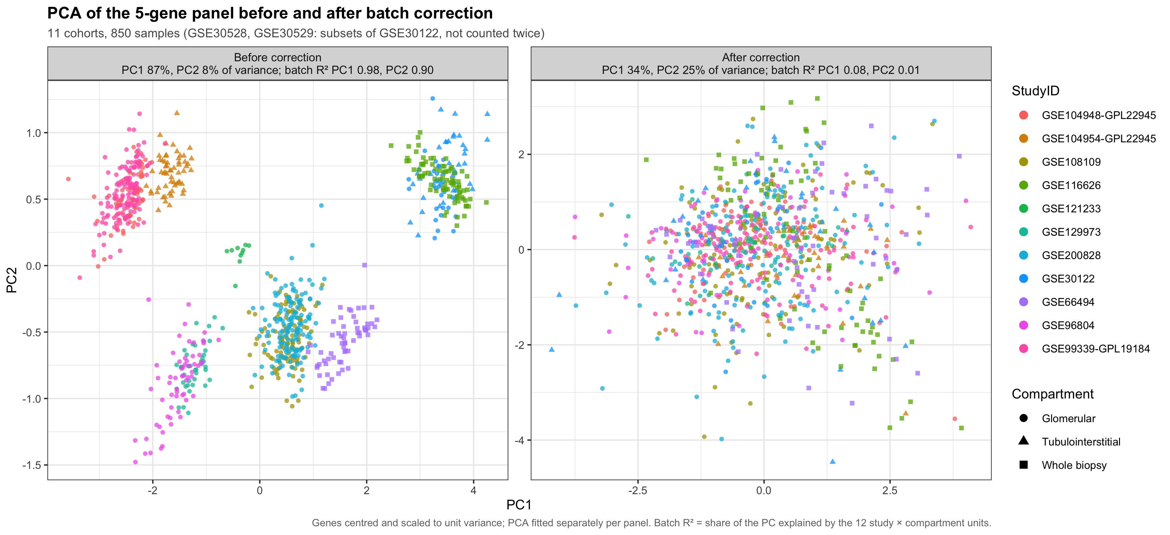
Figure 1. PCA of the 5-gene panel before and after batch correction (plan §7 Plot 1).
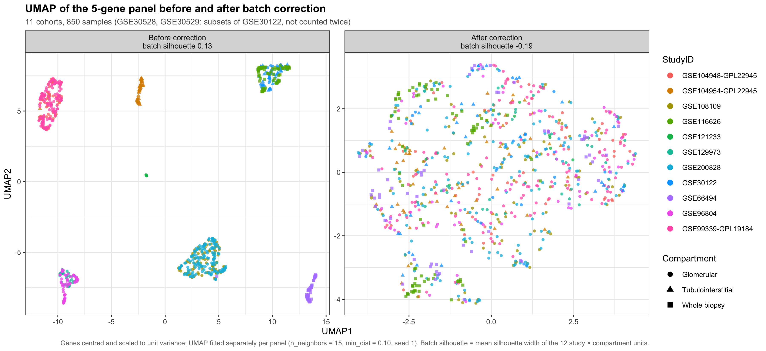
Figure 2. UMAP of the 5-gene panel before and after batch correction (plan §7 Plot 1).

3.3 Results — harmonised expression
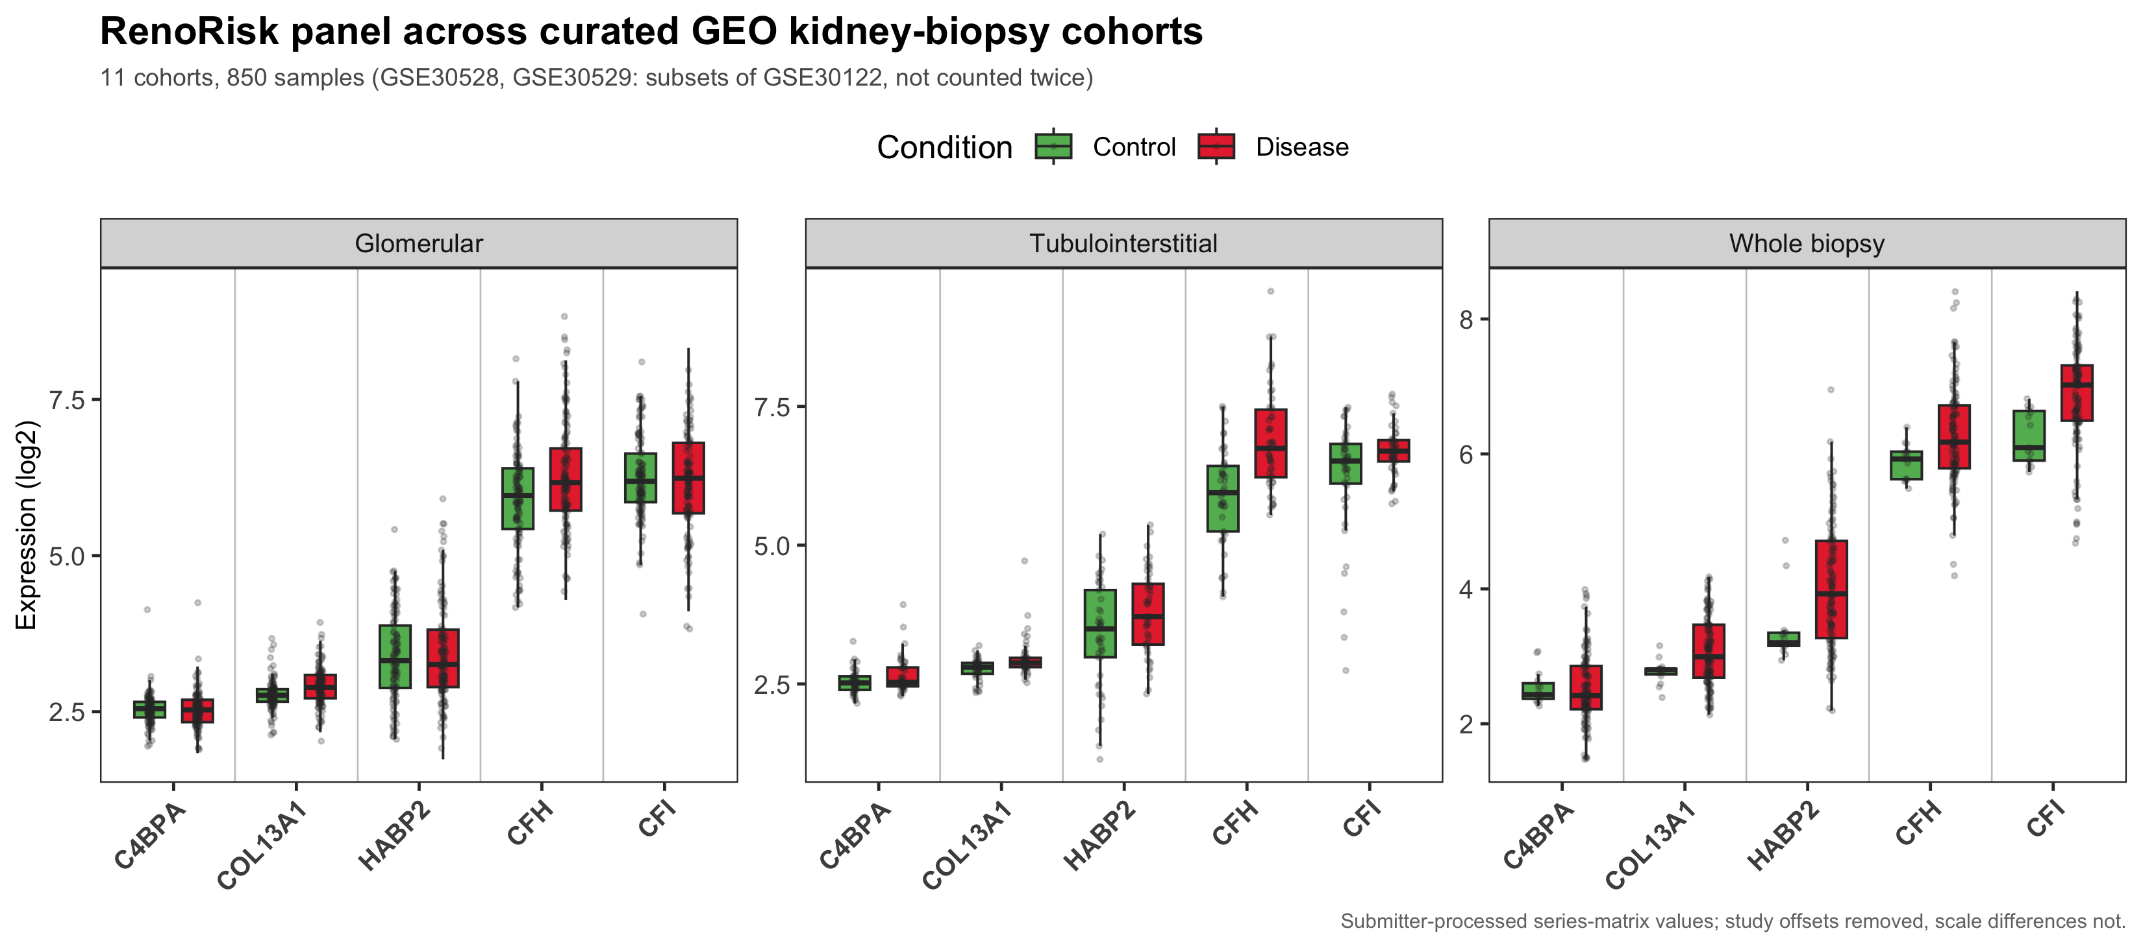
Figure 3. Batch-corrected expression of the five genes by compartment and condition. The Y axis is relative: three cohorts are per-gene centred, and levels are comparable within a compartment only.

3.4 Results — residual spread after correction
Batch correction aligns the study means but not their spread. Even after correction, the residual standard deviation of a gene differs by up to ${SDMAX}-fold between studies (COL13A1 in glomeruli).
Table 4. Largest and smallest residual SD across studies, per compartment and gene (residual_sd_ratio.xlsx).
Compartment | Gene | Min SD | Max SD | Max/min ratio
Glomerular | COL13A1 | 0.07 | 0.45 | 6.4
Glomerular | CFH | 0.32 | 1.29 | 4.1
Glomerular | C4BPA | 0.10 | 0.38 | 3.7
Tubulointerstitial | COL13A1 | 0.13 | 0.46 | 3.5
Tubulointerstitial | CFI | 0.37 | 1.26 | 3.4
Glomerular | CFI | 0.34 | 1.00 | 2.9
Glomerular | HABP2 | 0.43 | 0.99 | 2.3
Whole biopsy | CFI | 0.47 | 1.04 | 2.2
Whole biopsy | C4BPA | 0.30 | 0.61 | 2
Tubulointerstitial | CFH | 0.69 | 1.39 | 2
Whole biopsy | CFH | 0.49 | 0.90 | 1.8
Tubulointerstitial | HABP2 | 0.78 | 1.01 | 1.3
Tubulointerstitial | C4BPA | 0.26 | 0.30 | 1.2
Whole biopsy | COL13A1 | 0.46 | 0.52 | 1.1
Whole biopsy | HABP2 | 0.91 | 0.91 | 1

4. Stage 4 — Multi-Factor Statistical Modeling
Requirement — Plan §3 (verbatim)
Stage 4 — Multi-Factor Statistical Modeling: Model differential expression of the 5 RenoRisk genes controlling for tissue compartment (glomerular vs. tubulointerstitial) and patient clinical covariates.
Status: Implemented — Scripts/stage4_MF_stat_mod.R. Sex is the only patient covariate available in the data.

4.1 Implementation
- Input: Stage 2/3 values before removeBatchEffect. limma advises against modelling batch-corrected values, so study is modelled directly instead.
- Model, one per gene: Expression ~ 0 + Batch + Disease:Compartment + Sex, fitted by weighted least squares on the 850 aggregated samples (12 batch units; GSE30528/GSE30529 left out). Each batch unit is weighted by 1 / its residual variance, which accounts for the up-to-6.4-fold differences in spread (Section 3.4).
- Compartment is controlled by estimating the Disease effect separately in each compartment and testing the between-compartment differences of that effect. Compartment main effects are aliased with batch.
- Patient clinical covariates: none of the 13 series matrices contains eGFR, %TIF, proteinuria or age. The plan annex lists them for ERCB and GSE66494, but those values are held in Nephroseq, not in GEO. Sex was reported for GSE116626, GSE129973 and GSE96804 and inferred for the rest from XIST versus five Y-chromosome genes. The inference agreed with the reported sex in 40/40 samples for GSE129973 and 60/61 for GSE96804.
- Multiple testing: Benjamini–Hochberg FDR within each family (Disease, Difference, Sex).
Table 5. Sex by dataset (sex_by_cohort.xlsx). GSE30528/GSE30529 are listed for completeness; they do not enter the Stage 4 model.
Dataset | n | Source | Male | Female | Concordance with reported
GSE104948-GPL22945 | 71 | Inferred (XIST / Y genes) | 32 | 39 | –
GSE104954-GPL22945 | 60 | Inferred (XIST / Y genes) | 29 | 31 | –
GSE108109 | 111 | Inferred (XIST / Y genes) | 71 | 40 | –
GSE116626 | 81 | Reported | 52 | 29 | –
GSE121233 | 10 | Inferred (XIST / Y genes) | 8 | 2 | –
GSE129973 | 40 | Reported | 24 | 16 | 1.000
GSE200828 | 153 | Inferred (XIST / Y genes) | 103 | 50 | –
GSE30122 | 69 | Inferred (XIST / Y genes) | 27 | 42 | –
GSE30528 | 22 | Inferred (XIST / Y genes) | 9 | 13 | –
GSE30529 | 22 | Inferred (XIST / Y genes) | 7 | 15 | –
GSE66494 | 61 | Inferred (XIST / Y genes) | 36 | 25 | –
GSE96804 | 61 | Reported | 43 | 18 | 0.984
GSE99339-GPL19184 | 133 | Inferred (XIST / Y genes) | 74 | 59 | –

4.2 Results
Table 6. Stage 4 disease effects (log2FC, Disease vs Control) per compartment, and the sex effect, per gene (stage4_multifactor_results.xlsx). FDR < 0.05 in bold.
Gene | Term | log2FC | SE | p | FDR
C4BPA | Disease | Glomerular | 0.006 | 0.033 | 0.843 | 0.843
C4BPA | Disease | Tubulointerstitial | 0.109 | 0.059 | 0.065 | 0.101
C4BPA | Disease | Whole biopsy | 0.038 | 0.104 | 0.713 | 0.764
C4BPA | Sex (male vs female) | -0.006 | 0.021 | 0.776 | 0.862
COL13A1 | Disease | Glomerular | 0.105 | 0.019 | 3.5×10⁻⁸ | 5.2×10⁻⁷
COL13A1 | Disease | Tubulointerstitial | 0.053 | 0.040 | 0.188 | 0.256
COL13A1 | Disease | Whole biopsy | 0.292 | 0.129 | 0.024 | 0.044
COL13A1 | Sex (male vs female) | 0.003 | 0.015 | 0.862 | 0.862
HABP2 | Disease | Glomerular | 0.062 | 0.079 | 0.436 | 0.544
HABP2 | Disease | Tubulointerstitial | 0.372 | 0.163 | 0.023 | 0.044
HABP2 | Disease | Whole biopsy | 0.659 | 0.246 | 0.008 | 0.023
HABP2 | Sex (male vs female) | -0.413 | 0.051 | 1.7×10⁻¹⁵ | 8.3×10⁻¹⁵
CFH | Disease | Glomerular | 0.250 | 0.089 | 0.005 | 0.019
CFH | Disease | Tubulointerstitial | 0.726 | 0.176 | 4.0×10⁻⁵ | 3.0×10⁻⁴
CFH | Disease | Whole biopsy | 0.313 | 0.171 | 0.067 | 0.101
CFH | Sex (male vs female) | -0.196 | 0.052 | 1.6×10⁻⁴ | 4.0×10⁻⁴
CFI | Disease | Glomerular | 0.035 | 0.090 | 0.693 | 0.764
CFI | Disease | Tubulointerstitial | 0.307 | 0.095 | 0.001 | 0.006
CFI | Disease | Whole biopsy | 0.401 | 0.169 | 0.018 | 0.044
CFI | Sex (male vs female) | -0.115 | 0.047 | 0.014 | 0.023
Table 7. Does the disease effect differ between compartments? (Diff family)
Gene | Contrast | Δ log2FC | p | FDR
C4BPA | Tubulointerstitial-Glomerular | 0.103 | 0.129 | 0.242
C4BPA | Whole biopsy-Glomerular | 0.032 | 0.771 | 0.771
C4BPA | Whole biopsy-Tubulointerstitial | -0.071 | 0.555 | 0.694
COL13A1 | Tubulointerstitial-Glomerular | -0.052 | 0.243 | 0.365
COL13A1 | Whole biopsy-Glomerular | 0.187 | 0.150 | 0.251
COL13A1 | Whole biopsy-Tubulointerstitial | 0.239 | 0.077 | 0.198
HABP2 | Tubulointerstitial-Glomerular | 0.311 | 0.087 | 0.198
HABP2 | Whole biopsy-Glomerular | 0.597 | 0.021 | 0.159
HABP2 | Whole biopsy-Tubulointerstitial | 0.286 | 0.333 | 0.454
CFH | Tubulointerstitial-Glomerular | 0.476 | 0.016 | 0.159
CFH | Whole biopsy-Glomerular | 0.063 | 0.744 | 0.771
CFH | Whole biopsy-Tubulointerstitial | -0.413 | 0.093 | 0.198
CFI | Tubulointerstitial-Glomerular | 0.271 | 0.038 | 0.188
CFI | Whole biopsy-Glomerular | 0.365 | 0.056 | 0.198
CFI | Whole biopsy-Tubulointerstitial | 0.094 | 0.625 | 0.722
Interpretation. In the tubulointerstitium, CFH (+0.73 log2), HABP2 (+0.37) and CFI (+0.31) are up-regulated. In the whole biopsies, HABP2 (+0.66), CFI (+0.40) and COL13A1 (+0.29) are up-regulated. In the glomeruli, shifts are small but reach significance for COL13A1 (+0.10) and CFH (+0.25), because the glomerular stratum is large (n = 614). C4BPA has no significant disease effect in any compartment. The disease effect is nominally larger in the tubulointerstitium than in the glomeruli for CFH and CFI (p = 0.016 and 0.038), but no between-compartment difference survives FDR correction (all FDR > 0.15). Sex has a strong effect on HABP2 (−0.41 log2, male vs female) and smaller effects on CFH and CFI, so sex adjustment is needed for these genes.
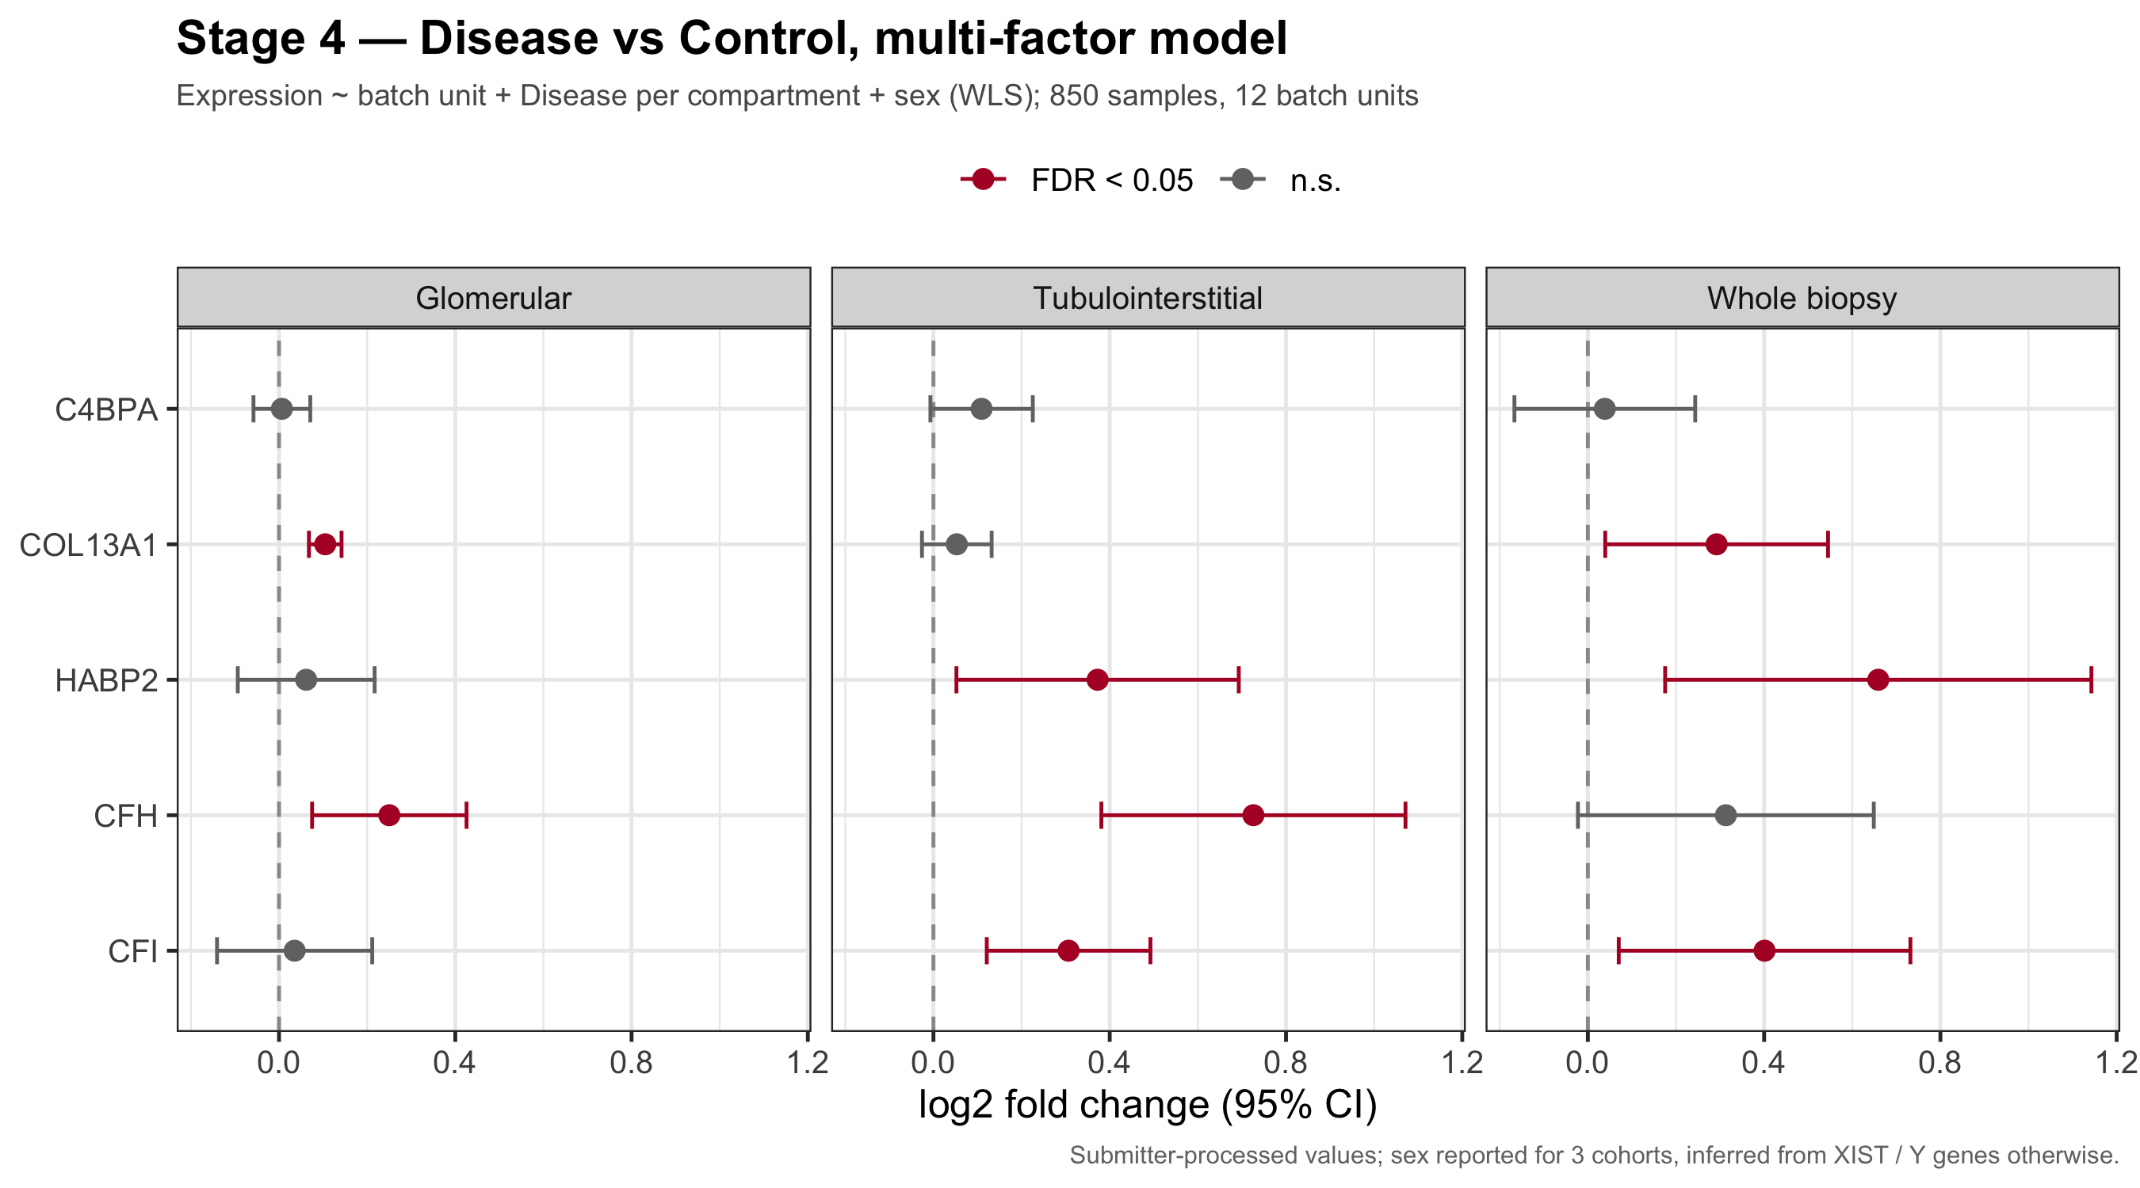
Figure 4. Stage 4 disease effects per gene and compartment, with 95% confidence intervals.

5. Cohort Stratification & GEO Dataset Inventory
Requirement — Plan §4 (verbatim)
The 32 datasets identified in the GEO repository search have been mapped to evaluate RenoRisk target performance across diverse clinical indications: see table in annex 1.
Requirement — Plan §7, Recommended Visualizations (verbatim)
Plot 4 — Indication Stratified Expression Heatmaps: Expression of C4BPB, COL13A1, HABP2, CFH, CFI across CKD, DKD, IgAN, FSGS, AKI, and Healthy Controls.
Status: Implemented — 16 datasets listed in the curated inventory (the same accessions as the plan annex), of which 13 are analysed. The plan's figure of 32 is the number of search hits, not the number of datasets selected.

5.1 Dataset selection (PRISMA)
Table 8. Dataset flow (prisma_counts.xlsx).
Step | Datasets
Listed in dataset inventory | 16
Excluded (no expression data) | 3
Included | 13
The three excluded series are the RNA-Seq datasets GSE137570, GSE142025 and GSE219185. Their GEO series matrices contain no expression data, so they could only be used through the retired Stage 1.
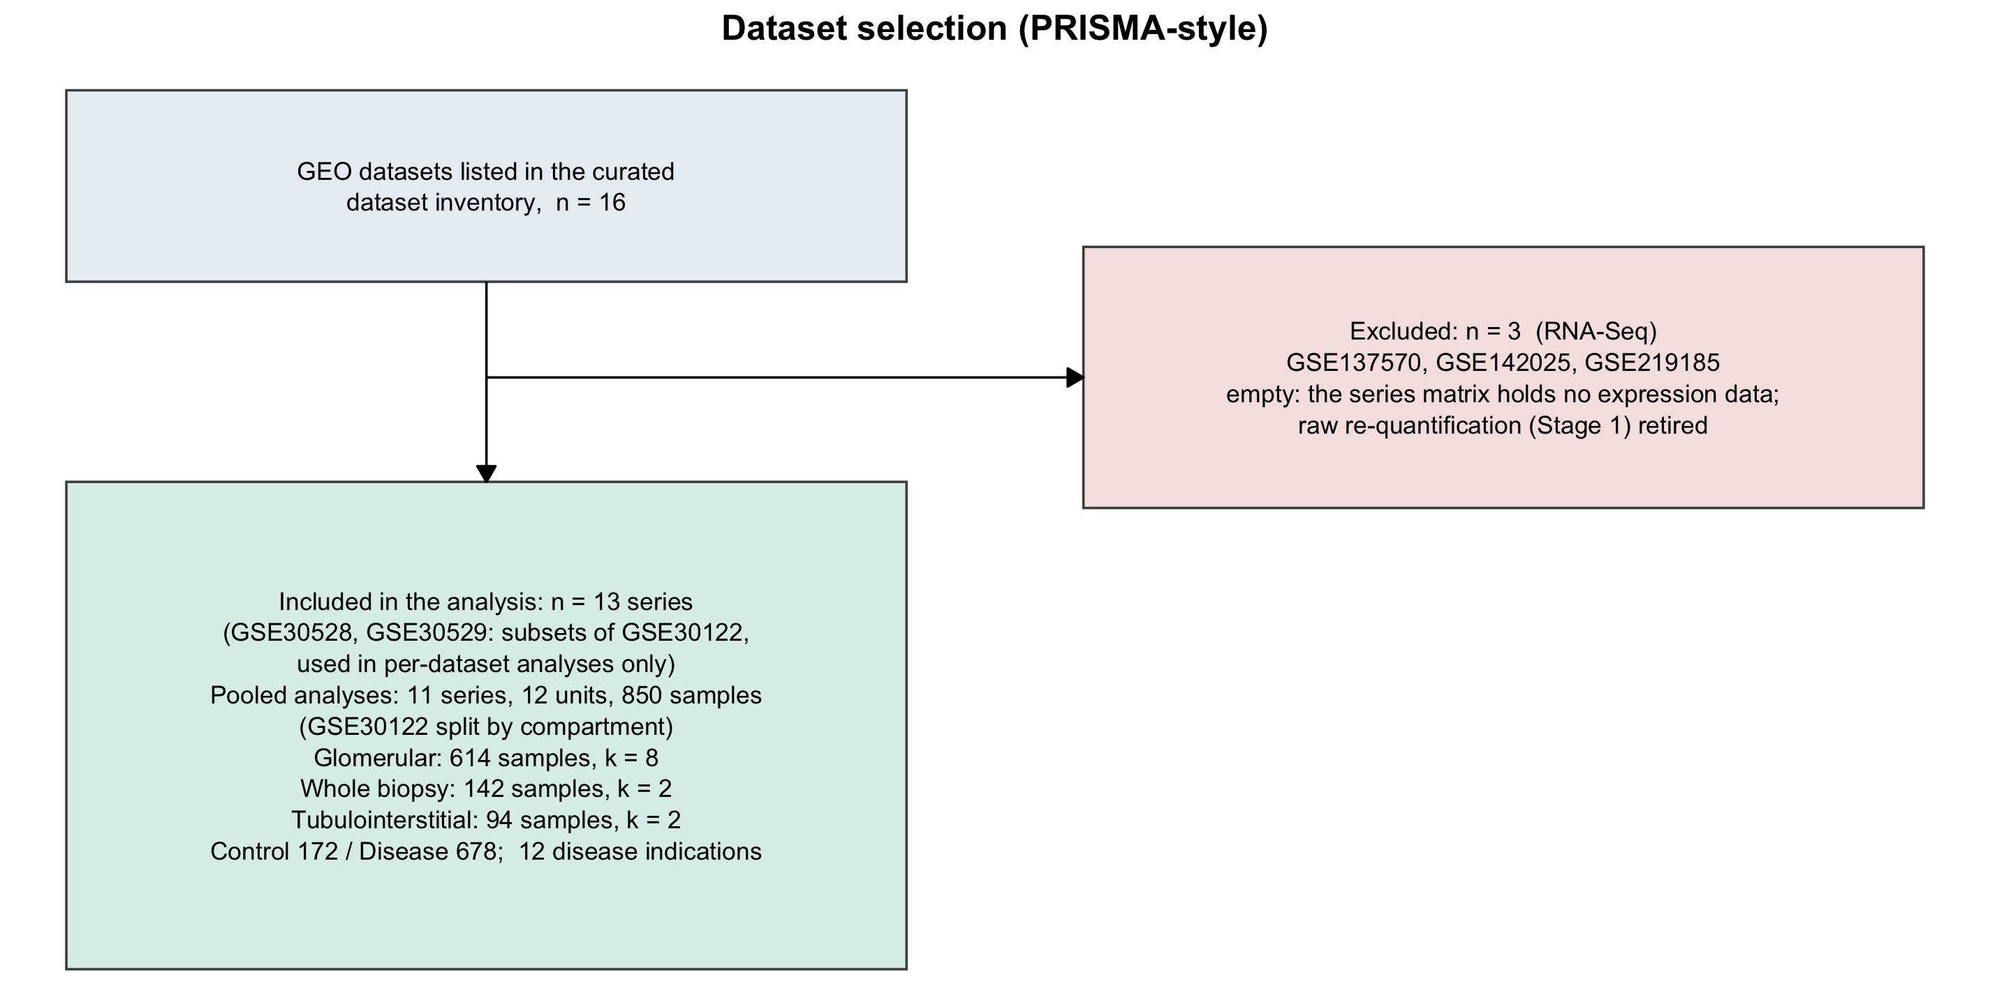
Figure 5. PRISMA flow of dataset selection.

5.2 Analysed cohorts
Table 9. The 13 analysed datasets: platform, compartment, scale as deposited, sample counts and indications.
Dataset | Platform (GPL) | Compartment | Scale | Ctrl | Dis. | Disease indications (n)
GSE104948-GPL22945 | Affymetrix custom CDF (GPL22945) | Glomerular | log2 | 21 | 50 | ANCA vasculitis (22), FSGS (10), DKD (7), FSGS/MCD (6), MCD (5)
GSE104954-GPL22945 | Affymetrix custom CDF (GPL22945) | Tubulointerstitial | log2 | 21 | 39 | ANCA vasculitis (21), DKD (7), FSGS/MCD (4), MCD (4), FSGS (3)
GSE108109 | Affymetrix custom CDF (GPL19983) | Glomerular | log2 | 6 | 105 | MN (44), FSGS (30), MCD (16), ANCA vasculitis (15)
GSE200828 | Affymetrix custom CDF (GPL19983) | Glomerular | log2 | 6 | 147 | MN (51), Other GN (46), FSGS (31), MCD (19)
GSE99339-GPL19184 | Affymetrix custom CDF (GPL19184) | Glomerular | log2 | 8 | 125 | Lupus nephritis (30), IgAN (26), MN (21), Hypertensive nephropathy (18), FSGS (12), MCD (8), DKD (7), Thin membrane disease (3)
GSE121233 | Affymetrix HTA 2.0 (GPL17586) | Glomerular | log2 | 5 | 5 | FSGS (5)
GSE129973 | Affymetrix HTA 2.0 (GPL17586) | Glomerular | log2 | 20 | 20 | FSGS (20)
GSE96804 | Affymetrix HTA 2.0 (GPL17586) | Glomerular | log2 | 20 | 41 | DKD (41)
GSE30122 | Affymetrix U133A 2.0 (GPL571) | Glom. + Tubulointerst. | per-gene centred | 50 | 19 | DKD (19)
GSE116626 | Illumina HT-12 WG-DASL (GPL14951) | Whole biopsy | per-gene centred | 7 | 74 | IgAN (52), Other GN (22)
GSE66494 | Agilent 4x44K (GPL6480) | Whole biopsy | linear → log2 | 8 | 53 | CKD (unspecified) (53)
GSE30528 | Affymetrix U133A 2.0 (GPL571) | Glomerular | per-gene centred | 13 | 9 | DKD (9)
GSE30529 | Affymetrix U133A 2.0 (GPL571) | Tubulointerstitial | per-gene centred | 12 | 10 | DKD (10)
Notes: (1) GSE30528 (22 glomerular samples) and GSE30529 (22 tubular samples) are complete subsets of GSE30122 (22/22 GSMs each). By instruction (19 October 2026), they are used only for calculations on one dataset: per-dataset plots, QC, sex inference and per-study effect sizes. Every calculation that aggregates across datasets leaves them out, so no sample is counted twice. (2) Controls are living donors, tumour-nephrectomy tissue or normal kidney, as each study defines them. In ERCB the tumour-nephrectomy samples are also counted as controls. (3) The condition label is stored in a different metadata field in each cohort, and each cohort's field is recorded in the registry in the script.

5.3 Stratification by compartment and indication
Table 10. Strata used in the aggregated analyses, and with the GSE30122 subsets added (single-dataset calculations only).
Compartment | Batch units | Samples | With subsets: units | With subsets: samples
Glomerular | 8 | 614 | 9 | 636
Tubulointerstitial | 2 | 94 | 3 | 116
Whole biopsy | 2 | 142 | 2 | 142
Total | 12 | 850 | 14 | 894
Table 11. Samples per indication in the aggregated analyses (sample_indication.xlsx, GSE30528/GSE30529 excluded).
Indication | Samples
Control | 172
MN | 116
FSGS | 111
DKD | 81
IgAN | 78
Other GN | 68
ANCA vasculitis | 58
CKD (unspecified) | 53
MCD | 52
Lupus nephritis | 30
Hypertensive nephropathy | 18
FSGS/MCD | 10
Thin membrane disease | 3
The plan's list of indications (CKD, DKD, IgAN, FSGS, AKI, healthy controls) is covered, except AKI: none of the 13 analysed series contains AKI biopsies. The cohorts also contain MN, MCD, ANCA vasculitis, lupus nephritis, hypertensive nephropathy and other glomerulonephritides. The indication-stratified heatmap (plan Plot 4) is shown in Section 6.5.
Clinical variables listed in the annex. The annex lists eGFR and %TIF for GSE66494 and the ERCB series, and MEST-C and NEPTUNE clinical data for other cohorts. None of these variables is present in the GEO series matrices. They are held in Nephroseq or NEPTUNE, so the eGFR/%TIF analyses (plan §6 Task 2, §7 Plot 5) cannot be done with the deposited data.

6. Methodology: Pooling Strategy for C4BPA, COL13A1, HABP2, CFH, CFI
Requirement — Plan §5 (verbatim)
To synthesize findings across Microarray and RNA-Seq cohorts without platform bias, we apply summary-level random-effects meta-analysis as the primary framework, complemented by mega-analysis within platform tiers.
Random-Effects Meta-Analysis Model
• Per-Study Effect Size: For each RenoRisk gene (C4BPB, COL13A1, HABP2, CFH, CFI), compute Hedges' g standardized mean difference (or log2 fold change) and variance in each dataset.
• Pooled Summary Estimate: Combine study effect sizes using DerSimonian-Laird random-effects models via the metafor package in R.
• Heterogeneity Evaluation: Evaluate Cochran's Q and I² statistics to measure biological and technical heterogeneity across cohorts.
Requirement — Plan §7, Recommended Visualizations (verbatim)
Plot 2 — Forest Plots for 5 RenoRisk Genes: Individual study effect sizes and pooled summary diamonds for C4BPB, COL13A1, HABP2, CFH, and CFI.
Status: Implemented as specified — random-effects meta-analysis in Scripts/pooling_strategy.R; mega-analysis in Scripts/mega_analysis.R. All cohorts are microarrays (no RNA-Seq, Section 1).

6.1 Per-study effect size
- Unit: the batch units. Effects are computed within each study, so the values before batch correction are used. Effect sizes are computed for all 14 units (a single-dataset calculation), but only the 12 units outside GSE30528/GSE30529 are pooled.
- Primary measure: Hedges' g (metafor::escalc, measure SMD) with its sampling variance. Hedges' g is scale-free, which matters because GSE30122 (and its subsets) and GSE116626 are per-gene centred.
- Secondary measure: log2 fold change (escalc, measure MD) with its variance.
- This gives 5 genes × 14 units = 70 effect sizes per measure, of which 60 (5 × 12) are pooled (pooling_study_effects.xlsx, column Pooled).

6.2 Pooled summary estimate (DerSimonian–Laird)
The effect sizes are pooled with metafor::rma(method = "DL"). The between-study variance tau² is estimated by DerSimonian–Laird, and each unit is weighted by 1 / (vᵢ + tau²). Pooling is done across all units and separately within each compartment. Each fit also reports a 95% prediction interval: the range expected for the true effect in a new study. FDR is Benjamini–Hochberg across the five genes within each subset.
Table 12. Pooled Hedges' g per gene: all units and per compartment (pooling_estimates.xlsx). PI = 95% prediction interval. FDR < 0.05 in bold.
Gene | Subset | k | g | 95% CI | 95% PI | FDR
C4BPA | All units | 12 | 0.13 | [-0.10, 0.37] | [-0.35, 0.62] | 0.338
C4BPA | Glomerular | 8 | 0.06 | [-0.18, 0.30] | [-0.18, 0.30] | 0.801
C4BPA | Tubulointerstitial | 2 | 0.64 | [-0.77, 2.04] | [-1.70, 2.97] | 0.375
C4BPA | Whole biopsy | 2 | 0.04 | [-0.50, 0.57] | [-0.50, 0.57] | 0.894
COL13A1 | All units | 12 | 0.59 | [0.24, 0.93] | [-0.40, 1.57] | 0.004
COL13A1 | Glomerular | 8 | 0.56 | [0.07, 1.05] | [-0.69, 1.81] | 0.125
COL13A1 | Tubulointerstitial | 2 | 0.64 | [-0.36, 1.65] | [-0.96, 2.25] | 0.258
COL13A1 | Whole biopsy | 2 | 0.60 | [0.06, 1.15] | [0.06, 1.15] | 0.048
HABP2 | All units | 12 | 0.25 | [-0.08, 0.58] | [-0.69, 1.19] | 0.234
HABP2 | Glomerular | 8 | 0.07 | [-0.36, 0.51] | [-0.99, 1.14] | 0.801
HABP2 | Tubulointerstitial | 2 | 0.46 | [0.02, 0.89] | [0.02, 0.89] | 0.099
HABP2 | Whole biopsy | 2 | 0.72 | [0.18, 1.27] | [0.18, 1.27] | 0.038
CFH | All units | 12 | 0.39 | [-0.07, 0.86] | [-1.09, 1.88] | 0.234
CFH | Glomerular | 8 | 0.13 | [-0.46, 0.72] | [-1.46, 1.73] | 0.801
CFH | Tubulointerstitial | 2 | 1.38 | [-0.38, 3.13] | [-1.56, 4.32] | 0.206
CFH | Whole biopsy | 2 | 0.47 | [-0.07, 1.01] | [-0.07, 1.01] | 0.107
CFI | All units | 12 | 0.20 | [-0.21, 0.61] | [-1.08, 1.48] | 0.344
CFI | Glomerular | 8 | -0.07 | [-0.60, 0.47] | [-1.48, 1.34] | 0.801
CFI | Tubulointerstitial | 2 | 0.73 | [0.28, 1.17] | [0.28, 1.17] | 0.007
CFI | Whole biopsy | 2 | 0.72 | [0.14, 1.31] | [0.07, 1.38] | 0.038
Table 13. Pooled log2 fold change (secondary measure).
Gene | Subset | k | log2FC | 95% CI | 95% PI | FDR
C4BPA | All units | 12 | 0.02 | [-0.04, 0.07] | [-0.08, 0.11] | 0.624
C4BPA | Glomerular | 8 | -0.01 | [-0.06, 0.05] | [-0.06, 0.05] | 0.864
C4BPA | Tubulointerstitial | 2 | 0.16 | [-0.20, 0.52] | [-0.44, 0.76] | 0.389
C4BPA | Whole biopsy | 2 | 0.02 | [-0.16, 0.19] | [-0.22, 0.26] | 0.859
COL13A1 | All units | 12 | 0.13 | [0.05, 0.21] | [-0.10, 0.36] | 0.006
COL13A1 | Glomerular | 8 | 0.10 | [0.00, 0.20] | [-0.14, 0.34] | 0.221
COL13A1 | Tubulointerstitial | 2 | 0.21 | [-0.24, 0.66] | [-0.52, 0.94] | 0.389
COL13A1 | Whole biopsy | 2 | 0.28 | [0.17, 0.40] | [0.17, 0.40] | 7.2×10⁻⁶
HABP2 | All units | 12 | 0.24 | [-0.07, 0.55] | [-0.77, 1.25] | 0.220
HABP2 | Glomerular | 8 | 0.05 | [-0.27, 0.36] | [-0.74, 0.83] | 0.864
HABP2 | Tubulointerstitial | 2 | 0.43 | [0.05, 0.81] | [-0.03, 0.88] | 0.129
HABP2 | Whole biopsy | 2 | 0.73 | [0.43, 1.04] | [0.34, 1.13] | 7.2×10⁻⁶
CFH | All units | 12 | 0.31 | [-0.01, 0.63] | [-0.76, 1.38] | 0.140
CFH | Glomerular | 8 | 0.11 | [-0.33, 0.54] | [-1.12, 1.34] | 0.864
CFH | Tubulointerstitial | 2 | 1.26 | [-0.57, 3.10] | [-1.86, 4.39] | 0.296
CFH | Whole biopsy | 2 | 0.34 | [-0.07, 0.75] | [-0.33, 1.02] | 0.173
CFI | All units | 12 | 0.09 | [-0.27, 0.45] | [-1.15, 1.34] | 0.624
CFI | Glomerular | 8 | -0.14 | [-0.62, 0.34] | [-1.51, 1.23] | 0.864
CFI | Tubulointerstitial | 2 | 0.39 | [-0.01, 0.80] | [-0.19, 0.98] | 0.146
CFI | Whole biopsy | 2 | 0.60 | [-0.20, 1.40] | [-0.77, 1.97] | 0.180

6.3 Heterogeneity evaluation (Cochran's Q, I², tau²)
Table 14. Heterogeneity of the pooled Hedges' g.
Gene | Subset | k | Q | df | Q p | I² | tau²
C4BPA | All units | 12 | 15.09 | 11 | 0.178 | 27.1% | 0.046
C4BPA | Glomerular | 8 | 4.27 | 7 | 0.748 | 0.0% | 0.000
C4BPA | Tubulointerstitial | 2 | 8.47 | 1 | 0.004 | 88.2% | 0.909
C4BPA | Whole biopsy | 2 | 0.64 | 1 | 0.424 | 0.0% | 0.000
COL13A1 | All units | 12 | 29.95 | 11 | 0.002 | 63.3% | 0.223
COL13A1 | Glomerular | 8 | 25.14 | 7 | 7.2×10⁻⁴ | 72.2% | 0.346
COL13A1 | Tubulointerstitial | 2 | 4.44 | 1 | 0.035 | 77.5% | 0.406
COL13A1 | Whole biopsy | 2 | 0.01 | 1 | 0.912 | 0.0% | 0.000
HABP2 | All units | 12 | 28.92 | 11 | 0.002 | 62.0% | 0.203
HABP2 | Glomerular | 8 | 20.41 | 7 | 0.005 | 65.7% | 0.245
HABP2 | Tubulointerstitial | 2 | 0.46 | 1 | 0.497 | 0.0% | 0.000
HABP2 | Whole biopsy | 2 | 0.57 | 1 | 0.449 | 0.0% | 0.000
CFH | All units | 12 | 54.62 | 11 | 9.1×10⁻⁸ | 79.9% | 0.520
CFH | Glomerular | 8 | 37.12 | 7 | 4.5×10⁻⁶ | 81.1% | 0.569
CFH | Tubulointerstitial | 2 | 10.82 | 1 | 0.001 | 90.8% | 1.453
CFH | Whole biopsy | 2 | 0.38 | 1 | 0.539 | 0.0% | 0.000
CFI | All units | 12 | 44.59 | 11 | 5.7×10⁻⁶ | 75.3% | 0.384
CFI | Glomerular | 8 | 31.23 | 7 | 5.6×10⁻⁵ | 77.6% | 0.443
CFI | Tubulointerstitial | 2 | 0.15 | 1 | 0.703 | 0.0% | 0.000
CFI | Whole biopsy | 2 | 1.15 | 1 | 0.283 | 13.2% | 0.024
Across all units, heterogeneity is substantial for COL13A1, HABP2, CFH and CFI (I² 62–80%, Q p ≤ 0.003), and every prediction interval crosses zero. C4BPA is homogeneous (I² = 27%, Q p = 0.18) but has no effect. In the glomeruli, C4BPA is homogeneous and the other four genes have I² 66–81%. Within the tubulointerstitium, CFI and HABP2 are homogeneous (I² = 0%), while CFH (91%) and C4BPA (88%) differ strongly between the two series. The tubulointerstitial and whole-biopsy strata each have only k = 2, so tau² and I² there are imprecise.
Does compartment explain the heterogeneity? This was tested with a mixed-effects meta-regression, rma(mods = ~ Compartment).
Table 15. Compartment moderator test (pooling_compartment_moderator.xlsx).
Gene | Measure | QM | df | p | FDR | Residual I²
C4BPA | g | 1.72 | 2 | 0.422 | 0.528 | 32.7%
C4BPA | log2FC | 1.59 | 2 | 0.452 | 0.452 | 23.3%
COL13A1 | g | 0.02 | 2 | 0.989 | 0.989 | 69.6%
COL13A1 | log2FC | 2.77 | 2 | 0.250 | 0.312 | 83.0%
HABP2 | g | 2.64 | 2 | 0.267 | 0.446 | 58.0%
HABP2 | log2FC | 4.82 | 2 | 0.090 | 0.272 | 72.3%
CFH | g | 3.12 | 2 | 0.210 | 0.446 | 81.4%
CFH | log2FC | 4.43 | 2 | 0.109 | 0.272 | 90.7%
CFI | g | 3.44 | 2 | 0.179 | 0.446 | 72.3%
CFI | log2FC | 3.00 | 2 | 0.223 | 0.312 | 92.3%
No gene's disease effect differs significantly between compartments (all FDR ≥ 0.27). For COL13A1 the compartment estimates are almost identical (p = 0.99 for Hedges' g). Residual I² stays at 58–92% for every gene except C4BPA, so compartment does not explain the heterogeneity. With k = 2 in two of the three strata, the test has little power.
Leave-one-out robustness. Each of the 12 pooled units was dropped in turn and the analysis repeated (pooling_leave1out.xlsx).
Table 16. Range of the pooled Hedges' g (all units) when each unit is omitted.
Gene | Min g | Max g | Largest p | I² range
C4BPA | 0.04 | 0.16 | 0.703 | 0–34%
COL13A1 | 0.47 | 0.64 | 0.004 | 40–67%
HABP2 | 0.15 | 0.34 | 0.332 | 49–65%
CFH | 0.24 | 0.51 | 0.253 | 74–82%
CFI | 0.13 | 0.33 | 0.564 | 67–78%
COL13A1 stays significant whichever unit is omitted (largest p = 0.004). C4BPA and CFI are not significant with any unit omitted. HABP2 (in 1 of 12 omissions) and CFH (in 3 of 12) become nominally significant when a single study is dropped, so their pooled effects depend on individual studies.

6.4 Forest plots (Plot 2)
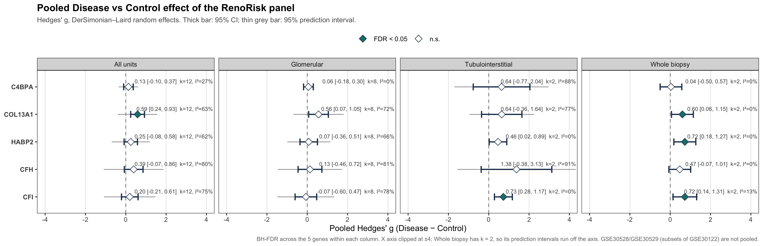
Figure 6. Pooled Hedges' g for all genes and compartments, showing the 95% CI and the 95% prediction interval.
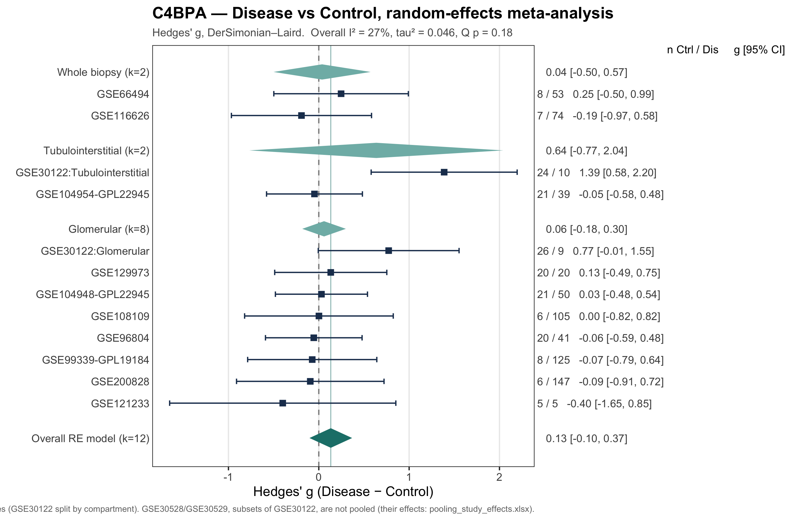
Figure 7. Forest plot for C4BPA: study effect sizes (Hedges' g) with the pooled random-effects diamond.
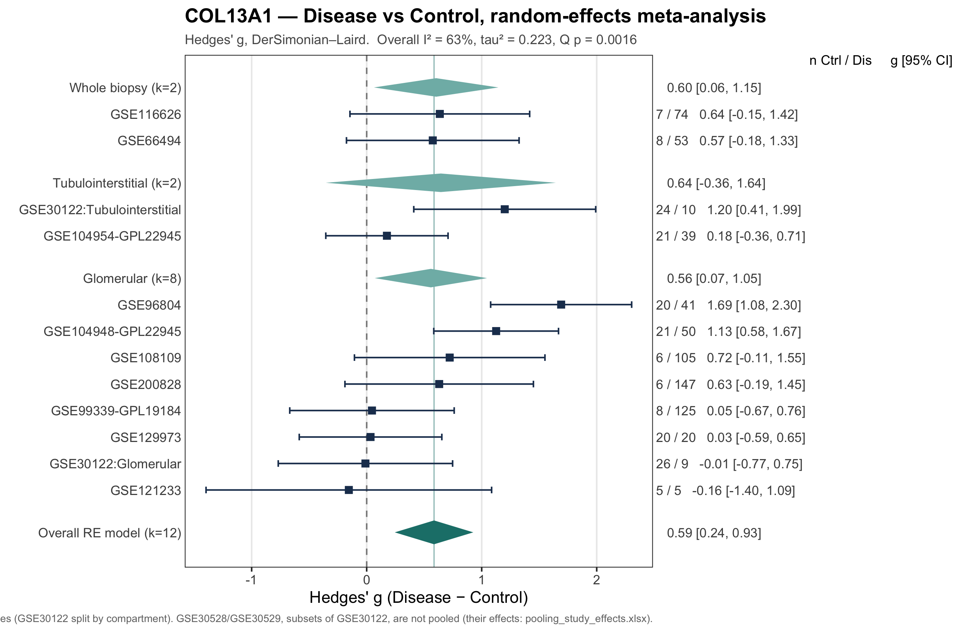
Figure 8. Forest plot for COL13A1: study effect sizes (Hedges' g) with the pooled random-effects diamond.
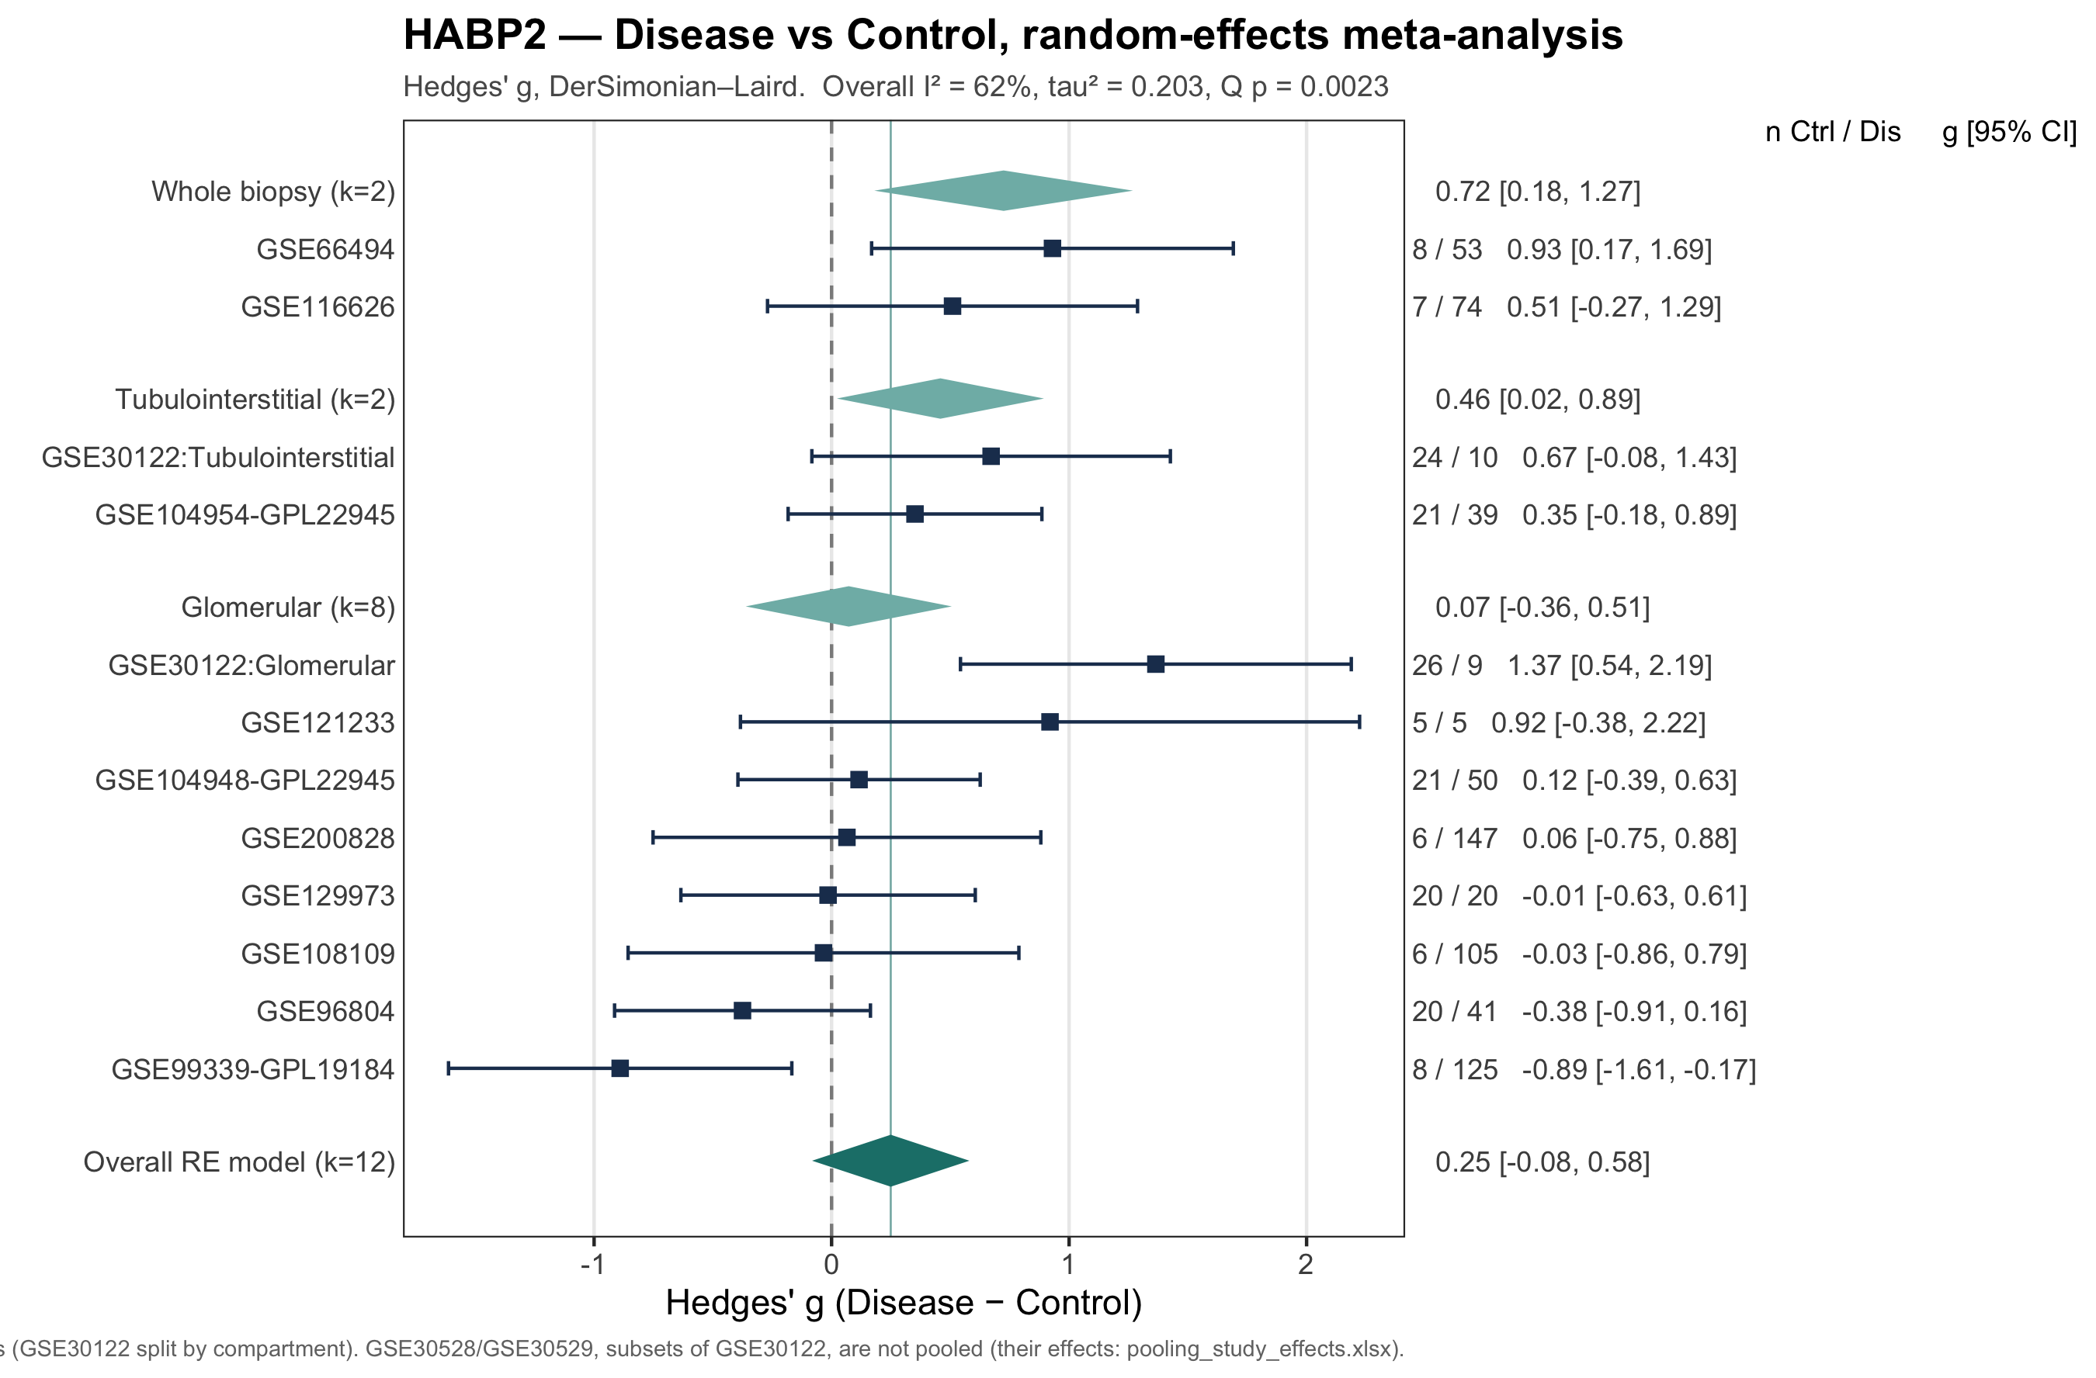
Figure 9. Forest plot for HABP2: study effect sizes (Hedges' g) with the pooled random-effects diamond.
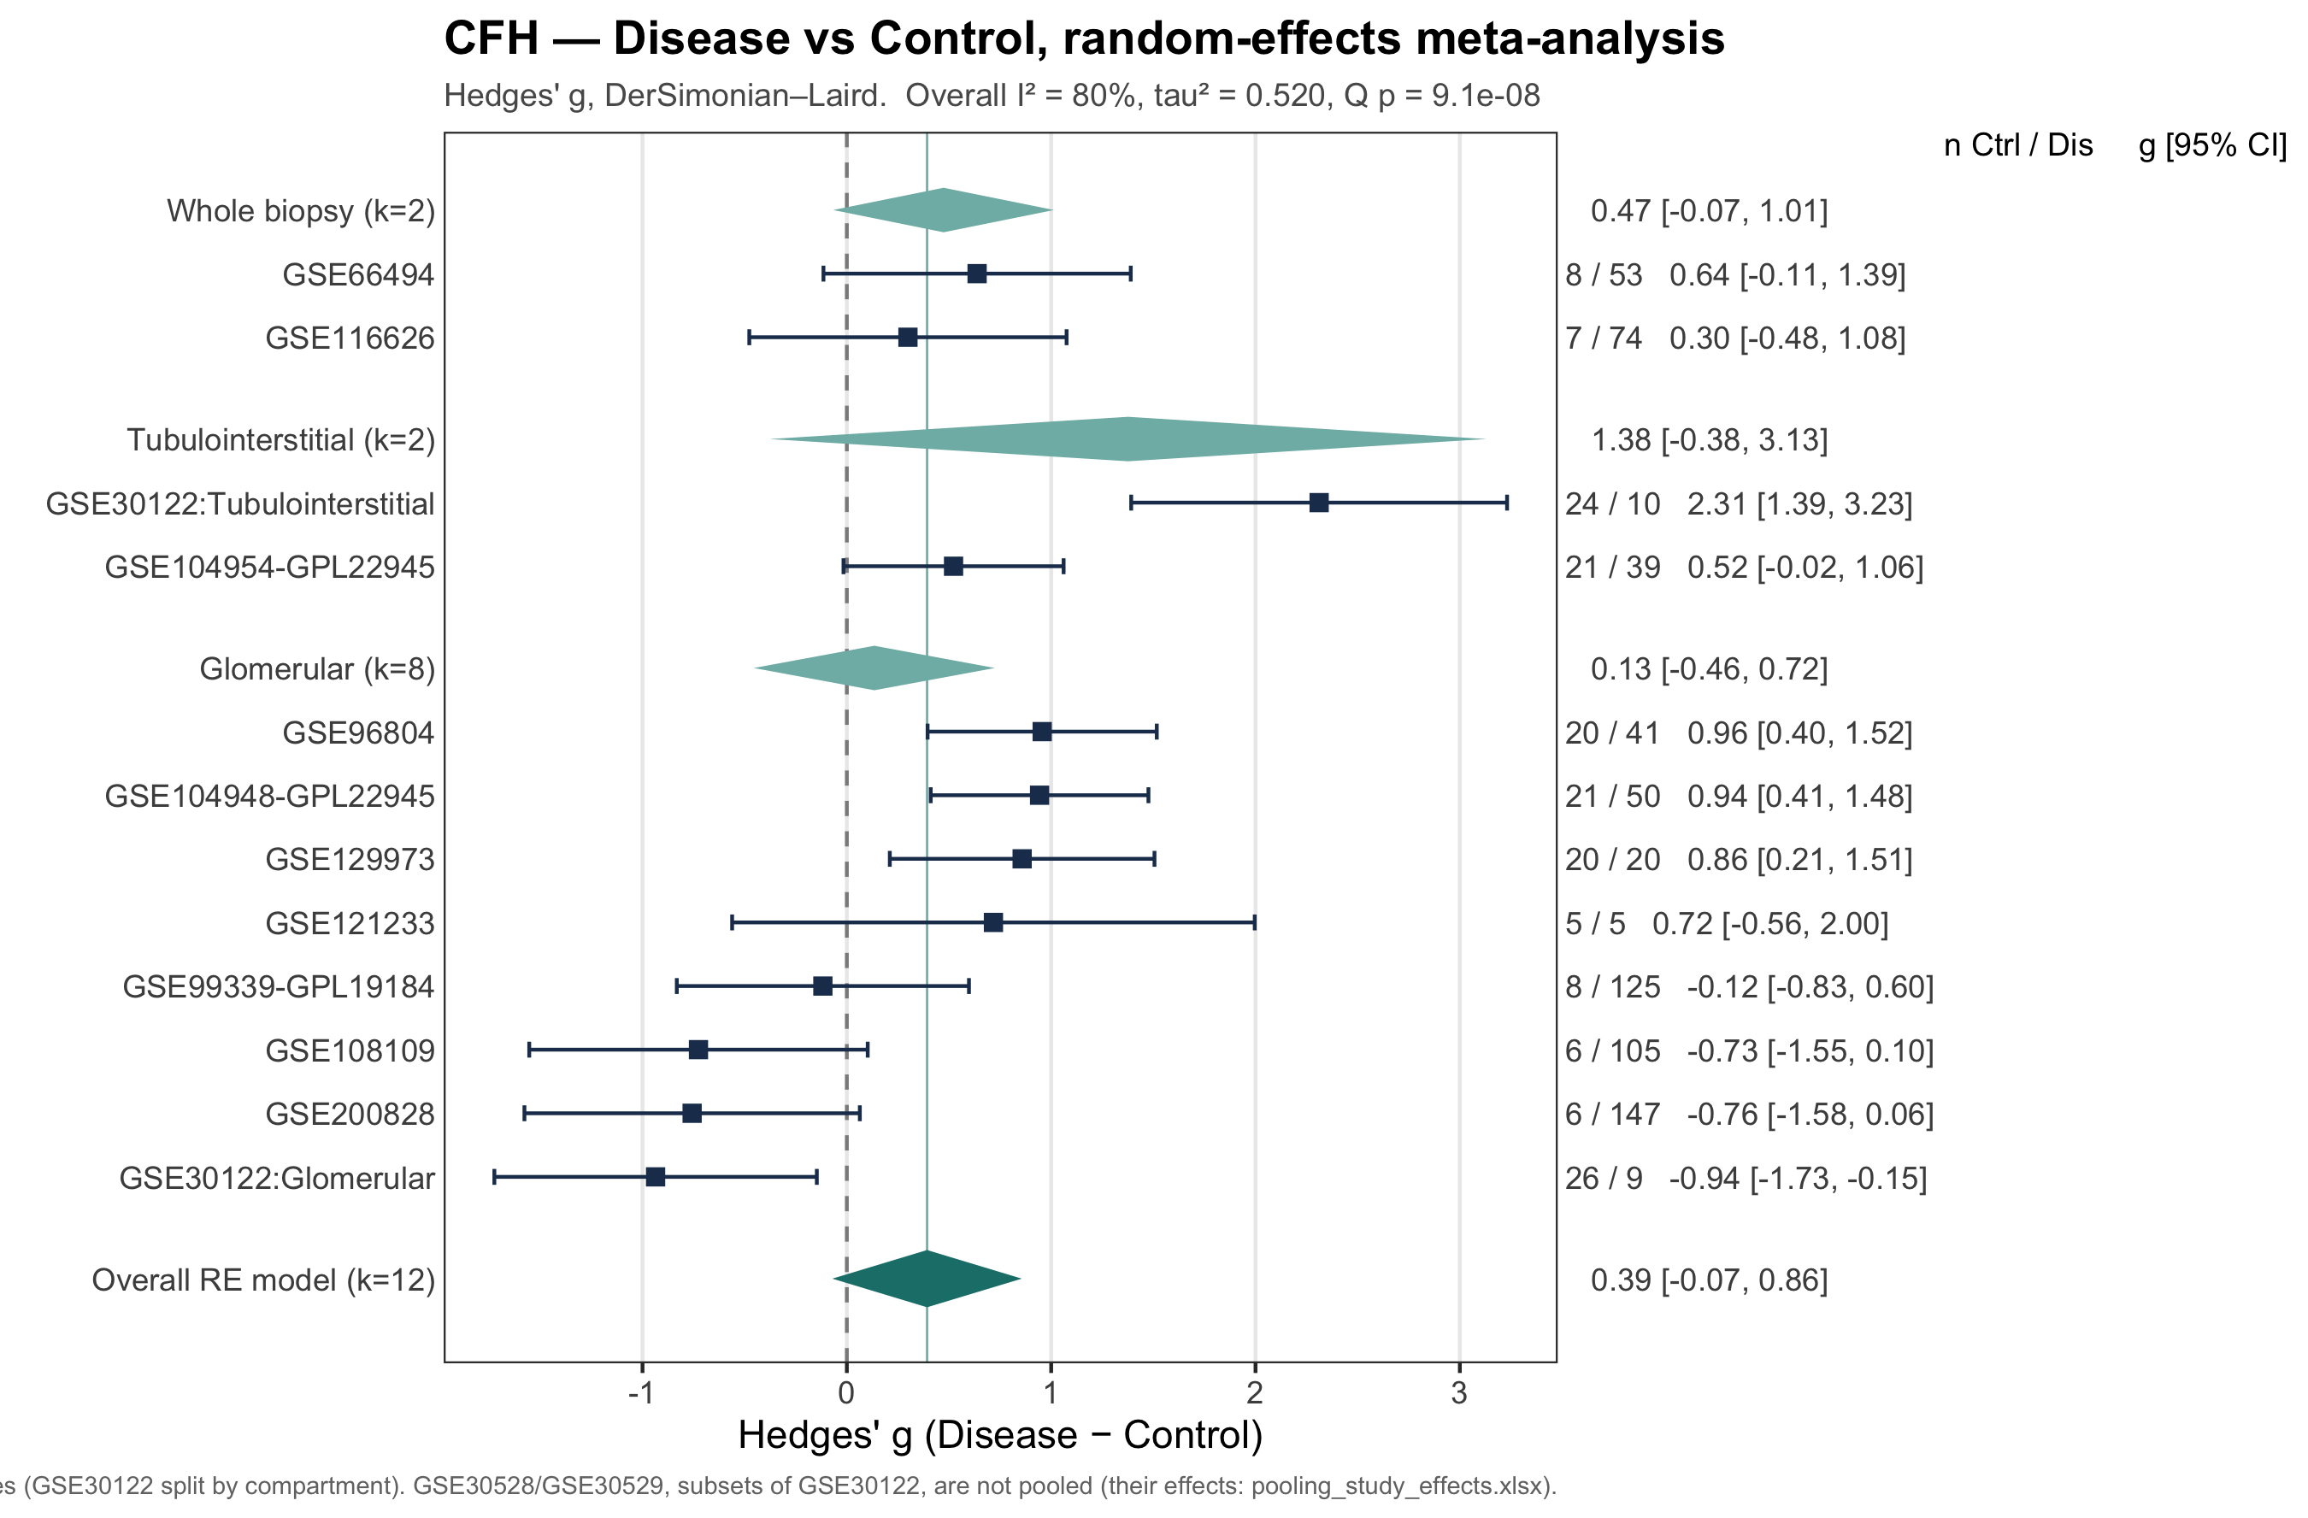
Figure 10. Forest plot for CFH: study effect sizes (Hedges' g) with the pooled random-effects diamond.
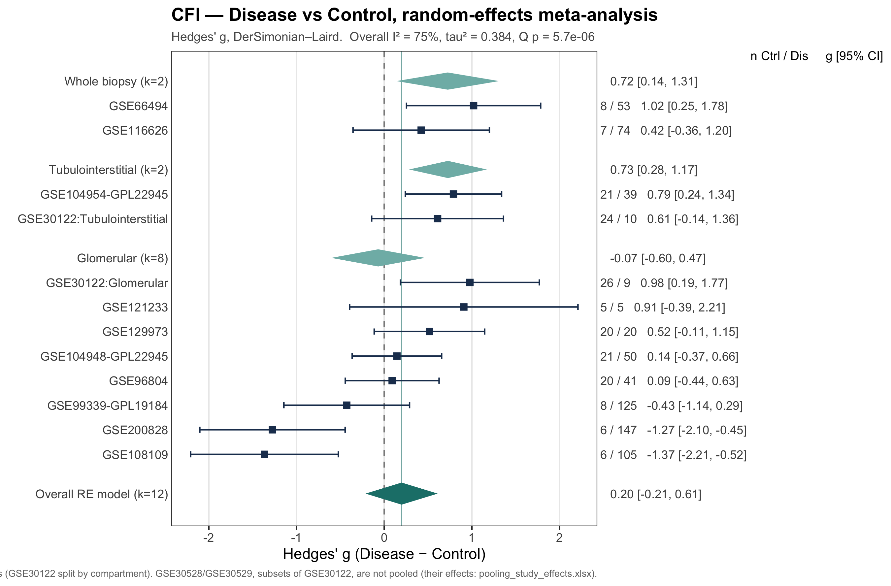
Figure 11. Forest plot for CFI: study effect sizes (Hedges' g) with the pooled random-effects diamond.

6.5 Indication-stratified effects (Plot 4)
Hedges' g was computed for each indication against the controls of the same study, then DL-pooled across studies (pooling_by_indication.xlsx). Indication-level effects at FDR < 0.05:
Table 17. Significant indication-specific effects.
Gene | Compartment | Indication | k | n disease | g | 95% CI | FDR
C4BPA | Tubulointerstitial | DKD | 2 | 17 | 1.17 | [0.57, 1.76] | 0.003
CFI | Tubulointerstitial | ANCA vasculitis | 1 | 21 | 1.30 | [0.64, 1.97] | 0.003
CFI | Glomerular | MN | 3 | 116 | -1.22 | [-1.75, -0.70] | 4.3×10⁻⁴
COL13A1 | Glomerular | FSGS/MCD | 1 | 6 | 2.15 | [1.08, 3.23] | 0.003
The direction of some effects depends on the indication. CFI is down-regulated in membranous nephropathy glomeruli (g = −1.22, k = 3) but up-regulated in ANCA-vasculitis tubulointerstitium (g = +1.30). This helps explain the high heterogeneity when indications are pooled. C4BPA is up-regulated in DKD tubulointerstitium (g = +1.17, k = 2, I² = 0%), its only significant effect anywhere. Two of the four findings rest on a single study (k = 1), and the COL13A1 FSGS/MCD effect on only 6 disease samples.
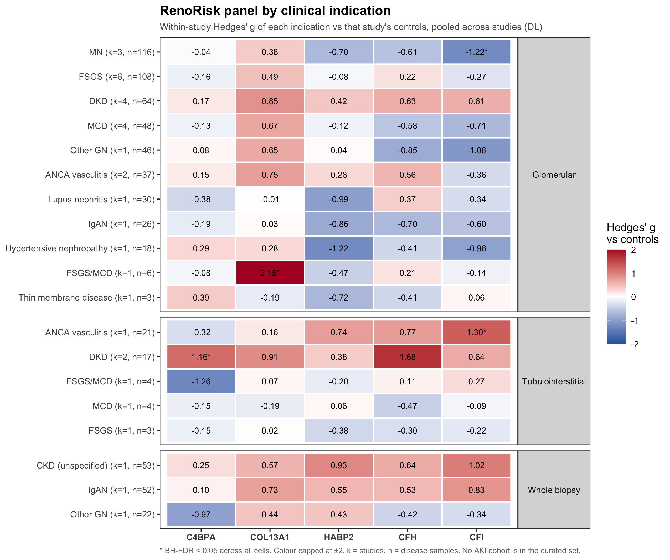
Figure 12. Indication-stratified heatmap of pooled Hedges' g (plan §7 Plot 4). AKI is absent from the analysed cohorts.

6.6 Sensitivity: type of control tissue
Studies use either living-donor or tumour-nephrectomy tissue as controls. The glomerular studies were grouped by control type (living donor k = 3, tumour nephrectomy k = 4), and the difference in pooled g between the groups was tested with a moderator.
Table 18. Control-type moderator in the glomerular stratum (pooling_control_type_test.xlsx).
Gene | k LD | k TN | Δg (TN − LD) | 95% CI | p | FDR
C4BPA | 3 | 4 | -0.03 | [-0.55, 0.49] | 0.916 | 0.916
COL13A1 | 3 | 4 | -0.40 | [-1.55, 0.75] | 0.493 | 0.616
HABP2 | 3 | 4 | -0.34 | [-0.97, 0.30] | 0.297 | 0.495
CFH | 3 | 4 | 0.73 | [-0.46, 1.92] | 0.227 | 0.495
CFI | 3 | 4 | 0.97 | [-0.06, 2.01] | 0.064 | 0.321
No gene's effect differs by control type (all FDR ≥ 0.32), so the choice of control tissue does not drive the results. With k = 3 versus k = 4, the test has little power.
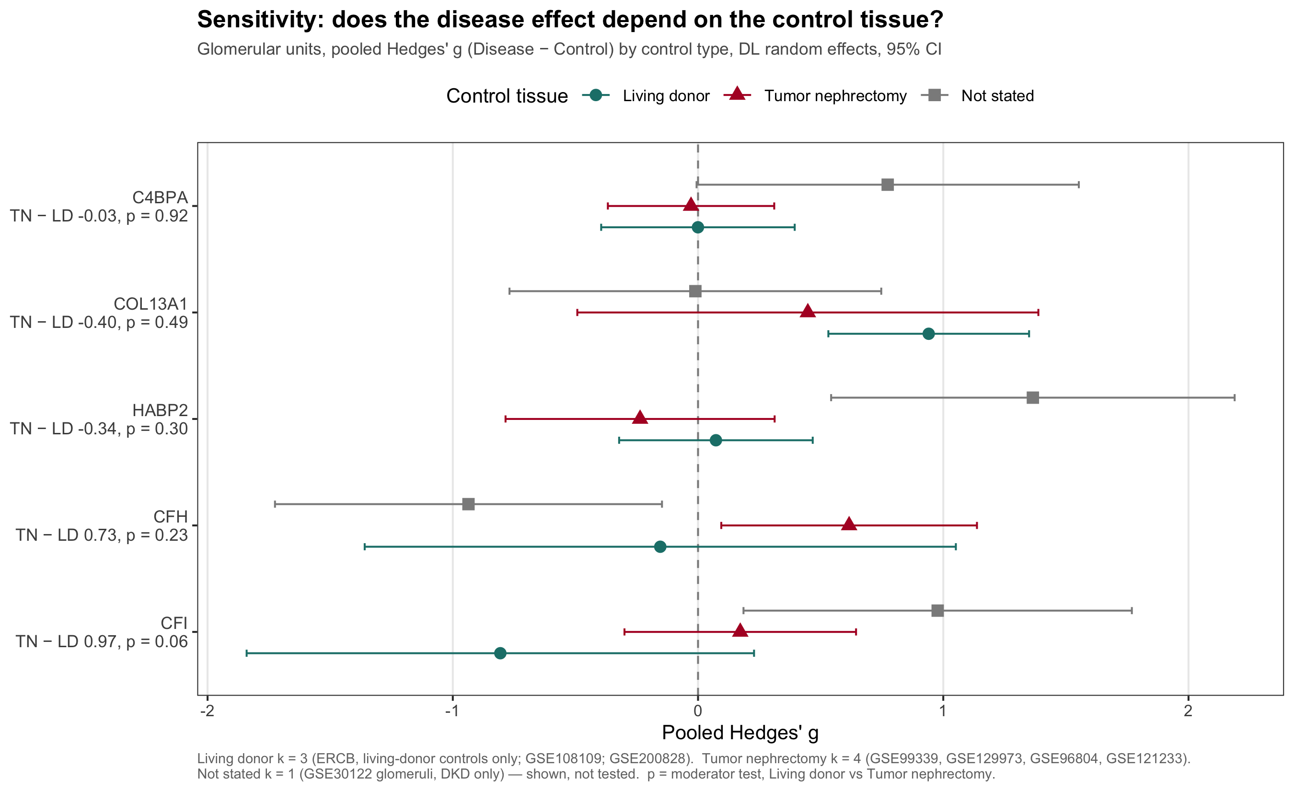
Figure 13. Pooled glomerular Hedges' g by type of control tissue (living donor vs tumour nephrectomy).

6.7 Mega-analysis within platform tiers
The plan complements the summary-level meta-analysis with a mega-analysis on the individual samples within each platform tier. For each tier × gene, one nlme::lme model is fitted (REML) on log2 values before batch correction, over the aggregated samples only (GSE30528/GSE30529 left out):
- Fixed effects: Expression ~ 0 + Compartment + Compartment:Disease.
- Random effects: an intercept and a Disease slope per batch unit (pdDiag). The slope is the sample-level counterpart of the meta-analysis tau². If it does not converge, the model falls back to a random intercept only.
- Residual variance is estimated per study (varIdent).
- A tier with one study is fitted with lm(Expression ~ Disease).
Table 19. Platform tiers (mega_tiers.xlsx).
Tier | Batch units | Studies | Samples | Compartments
Affymetrix | 10 | 9 | 708 | Glomerular, Tubulointerstitial
Illumina | 1 | 1 | 81 | Whole biopsy
Agilent | 1 | 1 | 61 | Whole biopsy
Only the Affymetrix tier (9 series, 10 units, 708 samples) pools several studies. The Illumina (GSE116626) and Agilent (GSE66494) tiers are single studies.
Table 20. Mega-analysis disease effects (log2FC), 11 series with GSE30528/GSE30529 not pooled (mega_estimates.xlsx). tau = between-study SD of the disease slope. FDR < 0.05 in bold.
Tier | Gene | Compartment | k | n | log2FC | 95% CI | FDR | tau
Affymetrix | C4BPA | Glomerular | 8 | 614 | 0.013 | [-0.078, 0.104] | 0.776 | 0.084
Affymetrix | C4BPA | Tubulointerstitial | 2 | 94 | 0.145 | [-0.019, 0.310] | 0.208 | 0.084
Affymetrix | COL13A1 | Glomerular | 8 | 614 | 0.102 | [-0.006, 0.210] | 0.316 | 0.130
Affymetrix | COL13A1 | Tubulointerstitial | 2 | 94 | 0.168 | [-0.052, 0.387] | 0.223 | 0.130
Affymetrix | HABP2 | Glomerular | 8 | 614 | 0.070 | [-0.239, 0.378] | 0.776 | 0.360
Affymetrix | HABP2 | Tubulointerstitial | 2 | 94 | 0.434 | [-0.201, 1.070] | 0.225 | 0.360
Affymetrix | CFH | Glomerular | 8 | 614 | 0.120 | [-0.422, 0.663] | 0.776 | 0.734
Affymetrix | CFH | Tubulointerstitial | 2 | 94 | 1.221 | [0.132, 2.310] | 0.140 | 0.734
Affymetrix | CFI | Glomerular | 8 | 614 | -0.074 | [-0.475, 0.328] | 0.776 | 0.516
Affymetrix | CFI | Tubulointerstitial | 2 | 94 | 0.451 | [-0.370, 1.272] | 0.281 | 0.516
Illumina | C4BPA | Whole biopsy | 1 | 81 | -0.119 | [-0.604, 0.366] | 0.626 | –
Illumina | COL13A1 | Whole biopsy | 1 | 81 | 0.331 | [-0.075, 0.737] | 0.475 | –
Illumina | HABP2 | Whole biopsy | 1 | 81 | 0.466 | [-0.247, 1.178] | 0.475 | –
Illumina | CFH | Whole biopsy | 1 | 81 | 0.147 | [-0.237, 0.532] | 0.559 | –
Illumina | CFI | Whole biopsy | 1 | 81 | 0.199 | [-0.169, 0.566] | 0.475 | –
Agilent | C4BPA | Whole biopsy | 1 | 61 | 0.076 | [-0.155, 0.308] | 0.512 | –
Agilent | COL13A1 | Whole biopsy | 1 | 61 | 0.264 | [-0.080, 0.609] | 0.163 | –
Agilent | HABP2 | Whole biopsy | 1 | 61 | 0.826 | [0.161, 1.492] | 0.040 | –
Agilent | CFH | Whole biopsy | 1 | 61 | 0.569 | [-0.100, 1.239] | 0.157 | –
Agilent | CFI | Whole biopsy | 1 | 61 | 1.016 | [0.269, 1.763] | 0.040 | –
All Affymetrix random-slope models converged. No Affymetrix estimate survives FDR correction. The largest is CFH in the tubulointerstitium (+1.22 log2, nominal p = 0.028, FDR 0.14). This stratum has only two series (94 samples), and the between-study SD of the CFH disease slope is large (tau = 0.73). In the Agilent cohort (GSE66494), HABP2 and CFI are up-regulated (FDR 0.040). The previous report's significant tubulointerstitial mega-analysis effects depended on counting the GSE30122 subsets twice. With those subsets removed, the tubulointerstitial findings rest on two independent patient series.

6.8 Agreement between methods
Table 21. Agreement between the meta-analysis, the mega-analysis and Stage 4.
Comparison | n estimates | Pearson r | Same sign | Max |difference| (log2)
Mega-analysis vs meta-analysis (pooled log2FC) | 10 | 0.997 | 90% | 0.065
Stage 4 vs meta-analysis — per study unit (all 14 units) | 70 | 0.993 | 96% | 0.248
Stage 4 vs meta-analysis — pooled per compartment | 15 | 0.938 | 87% | 0.537
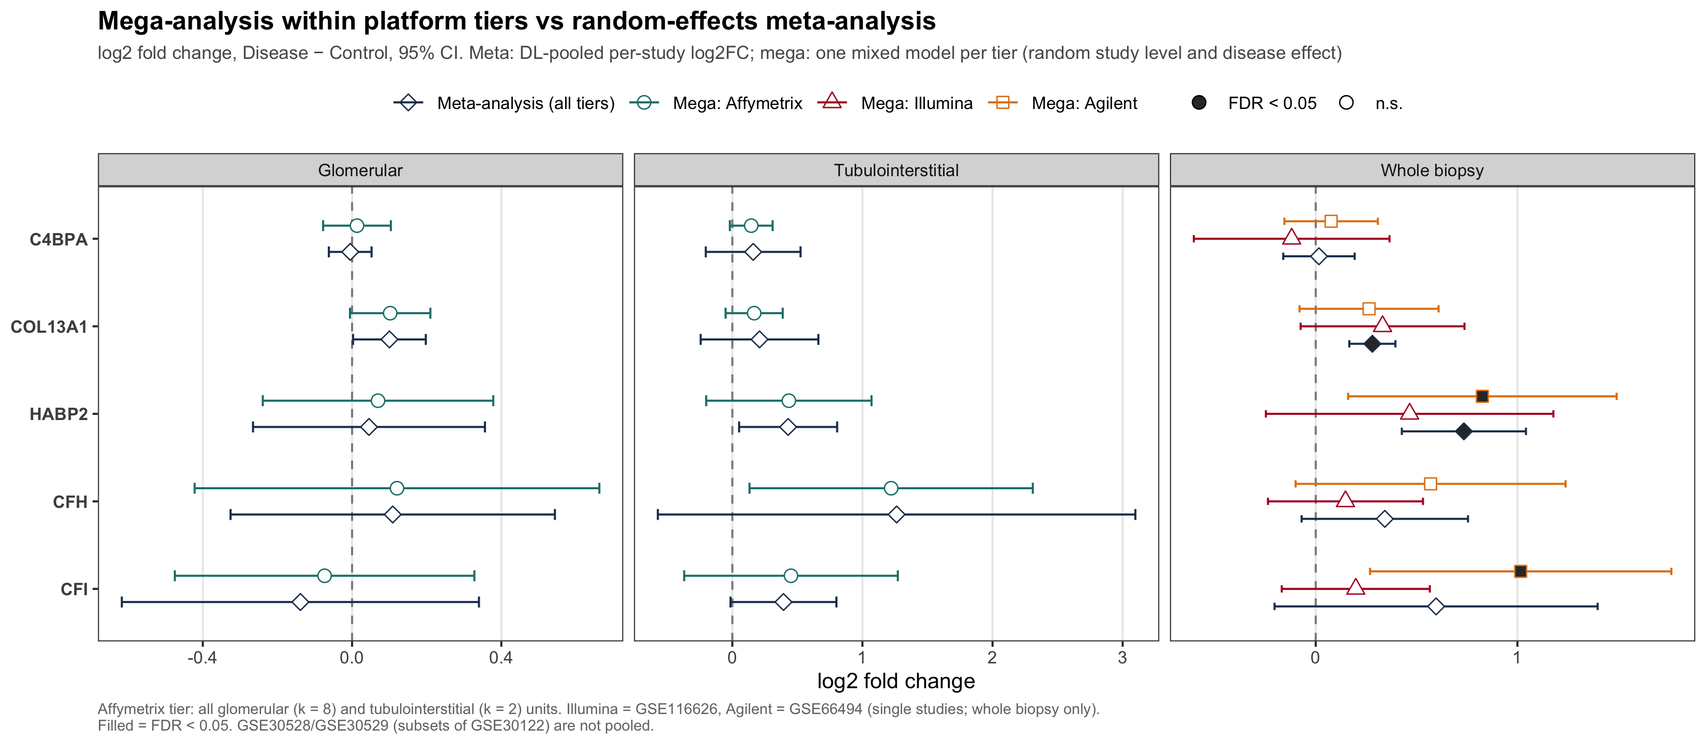
Figure 14. Mega-analysis versus random-effects meta-analysis: pooled log2FC per gene and compartment.
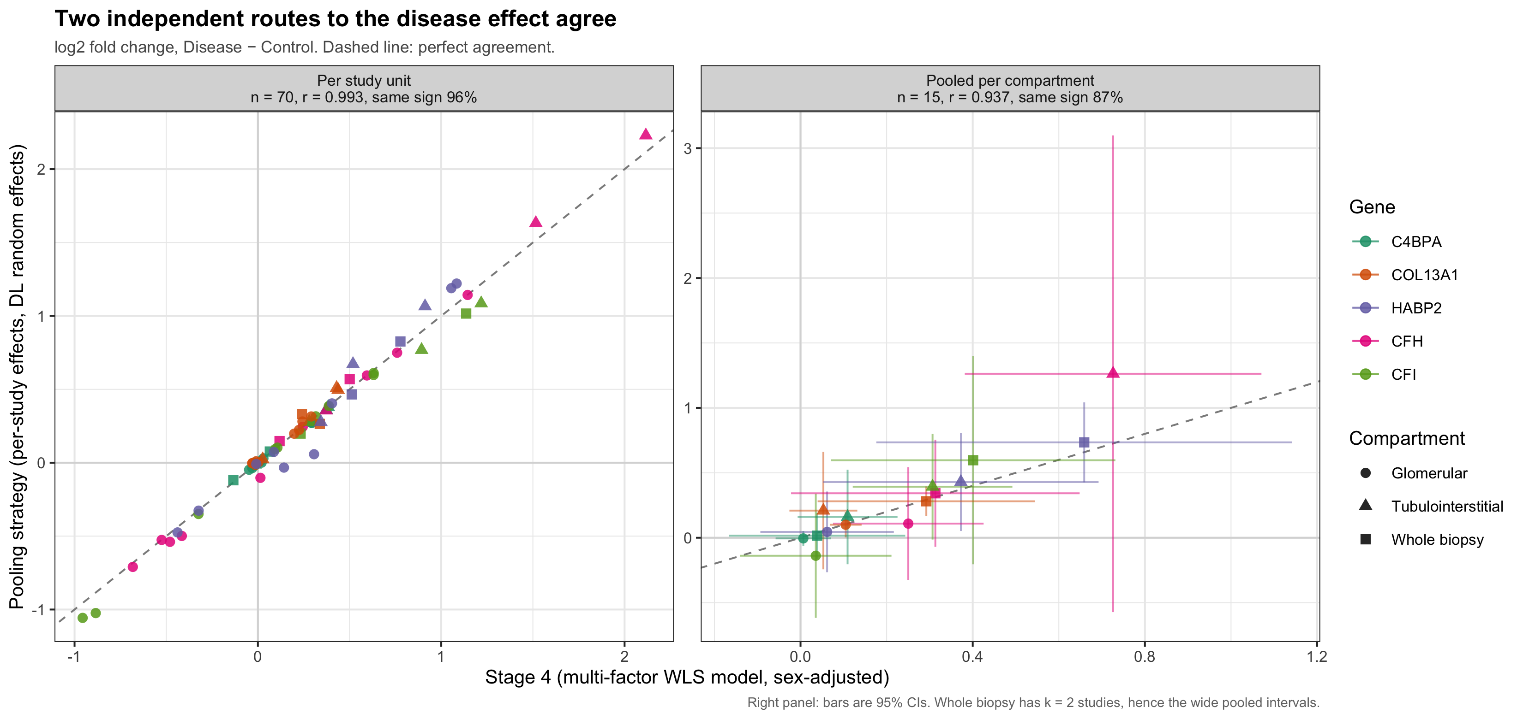
Figure 15. Stage 4 multi-factor model versus the pooling strategy.
Three methods with different assumptions give nearly the same estimates: a fixed-study WLS model (Stage 4), a summary-level random-effects meta-analysis, and a sample-level mixed model. The conclusions therefore do not depend on which pooling method is chosen.

7. Deviations from the plan and limitations
Table 22. Deviations from the analysis plan.
Plan requirement | Deviation | Reason
Stage 2: genes C4BPB, COL13A1, HABP2, CFH, CFI | C4BPA analysed instead of C4BPB | Replaced at the request of the Project Lead
Stage 1: uniform re-quantification (RMA / GRCh38) | Not performed | Stage 1 retired (7 Oct 2026); submitter-processed values used
Stage 3: ComBat-seq for RNA-Seq | Not applicable | No RNA-Seq expression data in the series matrices
Stage 3: ~ StudyID + Condition | Condition effect protected per compartment | Compartment is nested in study; disease effect may differ by compartment
Stage 4: patient clinical covariates | Sex only | eGFR, %TIF, proteinuria and age are absent from GEO (held in Nephroseq/NEPTUNE)
§4: 32 datasets | 16 listed, 13 analysed | 32 = search hits; 3 RNA-Seq series are empty
§5: Microarray and RNA-Seq cohorts | Microarray only | As above
§7 Plot 4: includes AKI | No AKI | No AKI biopsies in the analysed cohorts

Limitations
- The input values come from five different submitter pipelines, and three cohorts are per-gene centred. Absolute expression is not comparable across all cohorts, so Hedges' g (scale-free) is the primary effect size.
- GSE30528 and GSE30529 duplicate GSE30122. They are used only for single-dataset results, so no aggregated estimate counts a patient twice. Their per-dataset results are not independent evidence and should not be read alongside GSE30122 as a replication.
- The tubulointerstitial and whole-biopsy strata each have only two studies (k = 2), so heterogeneity estimates there are imprecise, and the compartment and control-type moderator tests have little power.
- Batch correction removes differences in level between compartments. Expression levels should be compared within a compartment only.
- Without eGFR or %TIF, the prognostic and regression analyses of plan §6 Task 2 and §7 Plot 5 cannot be performed with GEO data alone.

Output inventory
- Results/Stage23/ — Stage 2/3 tables and figures (cohort_qc, pca_batch_r2, umap_batch_silhouette, residual_sd_ratio, panel_*_long, PCA/UMAP/boxplot figures)
- Results/Stage4/ — stage4_multifactor_results, stage4_per_study_effects, sex_by_cohort/sample, stage4_disease_effects.png
- Results/PoolingStrategy/ — pooling_study_effects, pooling_estimates, pooling_compartment_moderator, pooling_leave1out, pooling_by_indication, control-type sensitivity, forest plots, heatmap
- Results/MegaAnalysis/ — mega_estimates, mega_tiers, mega_vs_meta(_agreement), mega_vs_meta.png
- Results/Summary/ — prisma_counts, prisma_flow.png, method_agreement(_stats), method_agreement.png

